# **HW_1ab – programs**

**HW_1a**

1. Create a new project and name it: **HW_1a**
2. Create a new file and name it: **Source.cpp**
3. Include these 3 functions:

* **getSalesAmt**
  + This function prompts the user to enter a monthly sales amount. (see output)
  + The amount is read and assigned to a variable.
  + The value is then returned to *main()*
* **calcCommission**
  + This function calculates the commission based on the sales amount.
    - If a salesperson sells more than $50,000. per month, the commission is 2% of the

sales amount.

* + - If the sales are between $25,000. and $50,000., then the commission is 1.5% of

the sales amount.

* + - However, if the sales are less than $25,000., there is no commission.
    - The value is returned to *main()*.
* **calcPay**
  + This function calculates the total monthly pay for a salesperson.
    - A salesperson gets a monthly salary of $2,500. plus a commission, if the person as

earned a commission.

* + - The value is returned to *main()*.
* **displayPay** - This function displays the

total monthly pay for salesperson.

(see output)

* + - Format the output to two decimal places,

and with the amounts aligned as shown.

1. 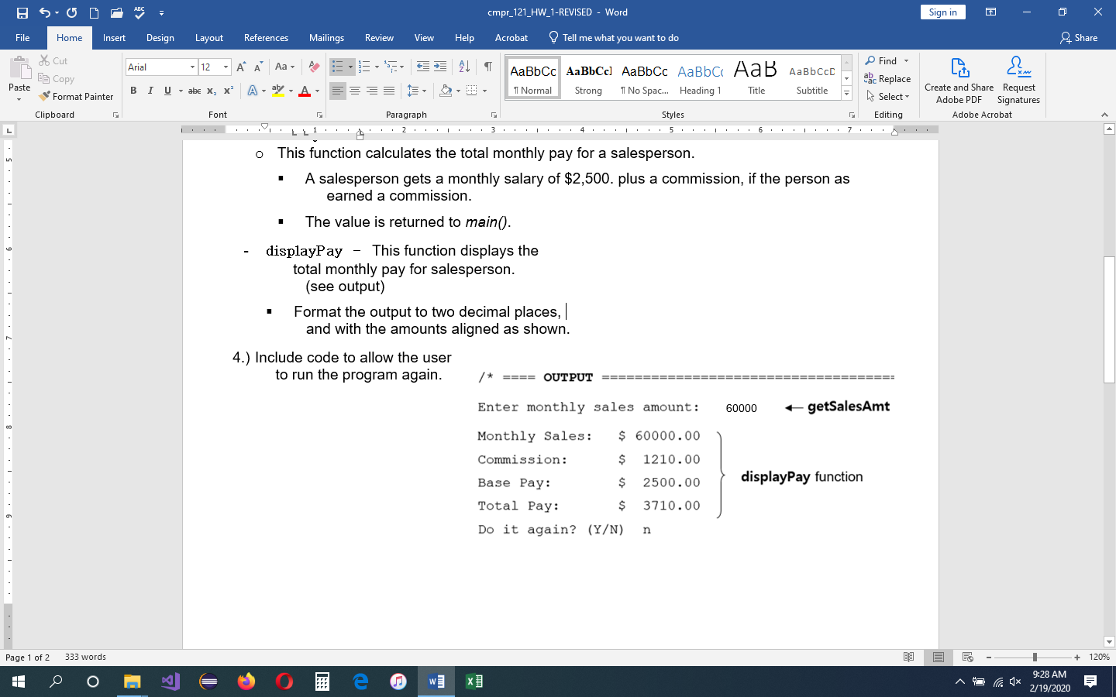Include code to allow the user

to run the program again.

**HW_1b** - The program prompts the user to enter temperatures in three cities. (see output below).

* Only one function is used to get all three values.
* The average temperature of all three cities is displayed on the screen.
* Create a new project and name it: HW_1b
* Create a new file and name it: Source.cpp
* The following 3 functions are called in main():
  + **getTemps()**
    - The function prompts the user to enter three temperatures.
    - The numbers are read and assigned to variables.
    - The function is a void-returning function.
  + **calcAvg()** - The function calculates the

average temperature of 3 cities.

* + - The value is returned to *main().*
  + **displayAvg()** - The function displays the information. (see output)

