Orange County Public Schools
Algebra 1 Honors End-of-Course Review (2010-2011)*

Directions: Select the correct response for each question. You may use a 4-function calculator, the Algebra 1 End-of-Course and Geometry End-of-Course Assessments Reference Sheet, and your graph paper.

1. Which relation is a function?
a. | 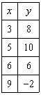 | c. | 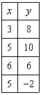
b. | 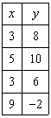 | d. | 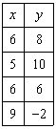

2. Which relation is a function?
a. | 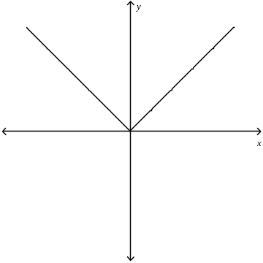 | c. | 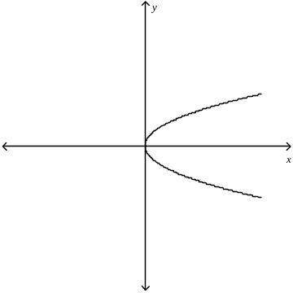
b. | 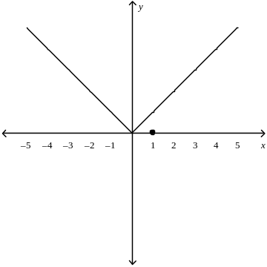 | d. | 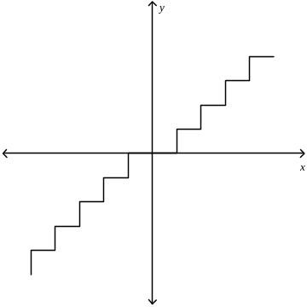

3. Write an algebraic expression for the verbal expression.
35 less the product of 4 and x

4. Write a verbal expression for the algebraic expression.

5. Evaluate the following expression if x = 10, y = 6, and z = 8.
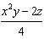

6. Name the property used in the equation. Then find the value of n.

7. Simplify the expression. If not possible, write simplified.

8. Simplify the expression.

Use the following table for problems 9-12.
The following table shows car sales for the first seven days of October at a local car dealership.

Day | 1 | 2 | 3 | 4 | 5 | 6 | 7
Sales | 3 | 4 | 6 | 7 | 9 | 10 | 12

9. Write the ordered pairs that represent the car sales for the first week of October.

10. Draw a graph to show car sales for the first seven days of October.

11. Use the data in the October car sales table to predict the number of cars sold on days 8 and 9.

12. Identify the independent and dependent variables in the October car sales table.

13. Find the product.

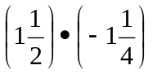
14. Find the quotient.
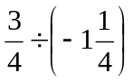
15. Write the set of numbers in order from greatest to least.
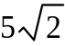, 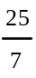, 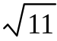
16. Use the set of data to make a stem-and-leaf plot.

45 | 51 | 32 | 49 | 44 | 50 | 47 | 36 | 57 | 37 | 41 | 45

Use following data for problems 17 and 18.
Anthony’s math scores for the quarter are 90, 91, 72, 91, 92, 92, 92, 91, 90, 90, and 91.

17 Find the mean, median, and mode of Anthony’s math scores. Round answers to the nearest tenth if necessary.

18. Which measure of central tendency best represents Anthony’s grade?

For # 19 and 20, solve the equations. Then check your solutions.

19. k – 5 = –7 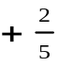k 20.

21. Solve the proportion. If necessary, round to the nearest hundredth.
Eduardo did 28 math problems in one hour. At this rate, how many problems can he do in hours?

22. Solve the equation or formula for the variable specified.

for f

23. Draw a box-and-whisker plot for the set of data.
3.9, 14.9, 21.2, 15.7, 23.1, 10.4, 83.1, 61.9, 3.8, 14.6, 54.7, 40.9, 25.9

24. A deli serves six kinds of lunch meat, three kinds of bread, and four types of sauce. How many sandwiches can be created with one type of lunch meat, one type of bread, and one type of sauce?

25. Evaluate the expression.

26. Evaluate the expression.

Use for #27 -29 the bin contains seven red chips, nine green chips, three yellow chips, and six blue chips. Find each probability.

27. Drawing a red chip, replacing it, then drawing a blue chip

28. Drawing a red chip, not replacing it, then drawing a blue chip

29. Selecting two blue chips without replacement

For # 30 and 31, find the coordinates of the vertices of the figure after the given transformation is performed. Then graph the preimage and its image.

- trapezoid ABCD with A(–5, –2), B(–4, 2), C(–2, 2), and D(–1, –2) translated 4 units right and 3 units up.

31. triangle LMN with L(–2, –2), M(0, 2), N(2, –2) dilated by a scale factor of 2.

Use for # 32 and 33, the students in Mr. Johnson’s science class recorded the average monthly high temperature for September through February. They used the data to draw the following bar graph.

Average Monthly High Temperature
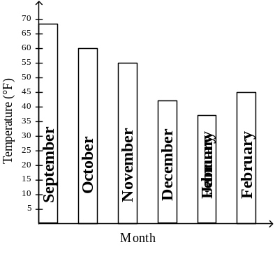

32. Use the graph above. For the average monthly high temperature, which month had the second highest high temperature?

33. How much warmer was the average high temperature in October than in February?

Television Set Sales
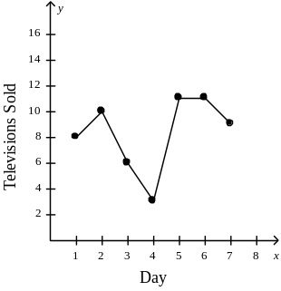

For # 34 and 35 use the graph above.

34. How many television sets were sold on the fourth day?

35. What is the difference in the number of sets sold on the best sales day and the worst sales day?

36. Express the relation as a table and a graph. Then determine the domain and range.

{(5, –2), (4, 4), (2, –3), (0, 5), (1, 5)}

37. , find .

38. In a right triangle if the length of the hypotenuse is 73 and a leg is 25, find the length of the missing side. If necessary, round to the nearest hundredth.

39. Find the distance between the pair of points whose coordinates are given. Express as a decimal approximation rounded to the nearest hundredth if necessary.
,

40. Find the slope of the line that passes through the pair of points.
(2, –3), (–5, 1)

41. In 1994, school lunch at Rockwell High School was $1.20. In 1999, the cost increased to $2.25.
Find the annual rate of change in the price for school lunch from 1994 to 1999.

42. Write an equation of the line that passes through each point with the given slope.

43. Write an equation of the line that passes through the pair of points.

44. Write the equation in standard form.
y + 6 = (x + 4)

45. Write the equation in standard form.
y + 6 = (x + 2)

46. Write the equation in slope-intercept form.
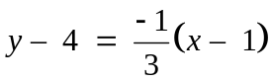

47. Write the slope-intercept form of an equation of the line that passes through the given point and is parallel to the graph of the equation.

(–5, –3), 5x – 4y = 8

48. Write the slope-intercept form of an equation that passes through the given point and is perpendicular to the graph of the equation.

(–5, –2), 2x + y = –3

49. Solve the inequality.

50. Solve the inequality.

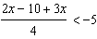

51. Solve the compound inequality and graph the solution set.

and

52. Solve the compound inequality and graph the solution set.

or

53. Solve the open sentence and graph the solution.

|s – 7| = 2

54. Graph the inequality.

55. The weight limit on an elevator is 2500 pounds. Assume that the average weight of a man is 190 pounds and the average weight of a woman is 125 pounds. Write an inequality to show how many men and women can get on the elevator at the same time.

56. Graph the system of equations. Then determine whether the system has no solution, one solution, or infinitely many solutions. If the system has one solution, name it.

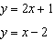

57. Use substitution to solve the system of equations.
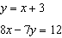

58. Use elimination to solve the system of equations.

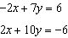

59. Determine the best method to solve the system of equations. Then solve the system.
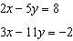

60. Solve the system of inequalities by graphing.

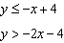

61. The sum of two positive integers is less than 80 and their difference is more than 10. Write a system of inequalities to represent this situation.

- Simplify.

63. Simplify. Assume that no denominator is equal to zero.
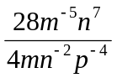

64. Evaluate. Express the result in scientific notation.

65. Evaluate. Express the result in scientific notation.

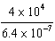

66. Find the sum.

67. Find the difference.

68. Find the product.

69. Find the product.

70. Factor the polynomial.
20 a³ b² – 35 a⁷ b⁵ + 60 a² b

71. Solve the equation.

72. Factor the trinomial.

73. Solve the trinomial equation.

74. Solve the trinomial equation.

75. Factor the trinomial, if possible. If the trinomial cannot be factored using integers, write prime.

76. Graph the function.
77. Write the equation of the axis of symmetry.

78. Solve the quadratic equation by completing the square.

79. Solve the equation by using the Quadratic Formula. Round to the nearest tenth if necessary.

80. Simplify the expression.

81. Simplify the expression.

82. Simplify the expression.

83. State the excluded values for the rational expression.
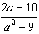

84. Simplify the expression. State the excluded values of the variables.
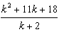

85. Find the quotient.
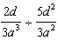

Algebra I Honors Review Answers

1. A

2. A

3. 35 – 4x
4. 2 times x cubed minus 4 times x

5. 146
6. Additive Identity; 0
7.

8.

9. (1, 3), (2, 4), (3, 6), (4, 7), (5, 9), (6, 10), (7, 12)

10. 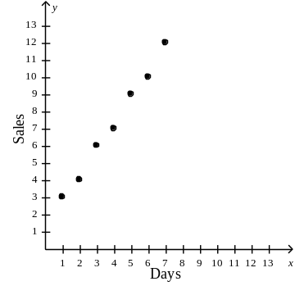
11. 13 and 15

12. independent – Day
dependent – Sales
13. 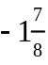

14. 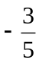
15. 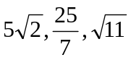
16. 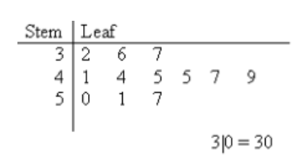

17. mean 89.3, median 91, mode 91

18. median and mode

19. k = – 5
20. g = 5.2
21. 42 problems
22. 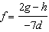

23.

24. 72

25. 1,680

26. 715

27. 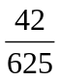

28. 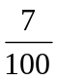

29. 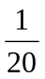

30. A′(–1, 1), B′(0, 5), C′(2, 5), and D′(3, 1)
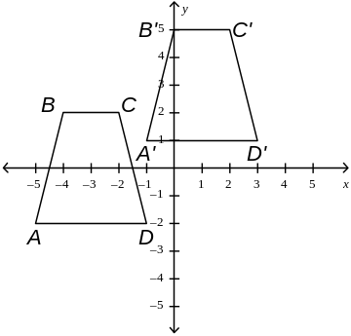
31. L′(–4, –4), M′(0, 4), N′(4, –4)
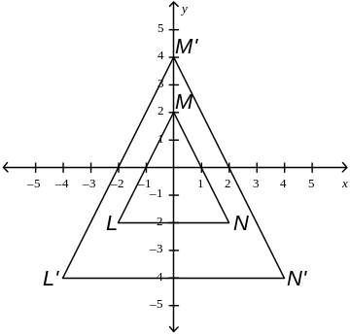
32. October

33. 15°

34. 3

35. 8
36. 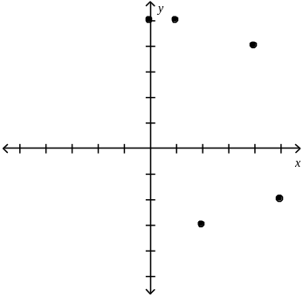

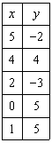

D = {0, 1, 2, 4, 5}; R = {–3, –2, 4, 5}

37. 17
38. 68.59

39. 7.07

40. 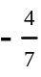

41. $0.21 per year

42.

43. 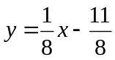

44. x – y = 2

45. x – 4y = 22

46. 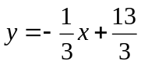
47. 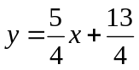
48. 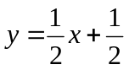

49.
50.

51. 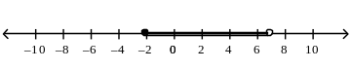

52. 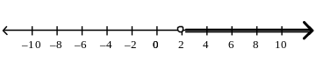

53. s = 9 and s = 5 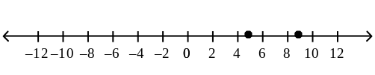
54. 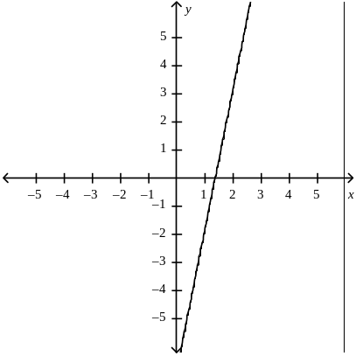

55.

56. one solution; (–3, –5)
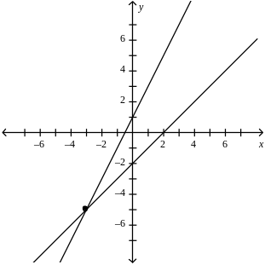
57. (33, 36)

58. (–3, 0)
59. elimination using multiplication; (14, 4)
Use elimination by multiplication.
Multiply the top equation by 3 and the bottom equation by –2.

60. 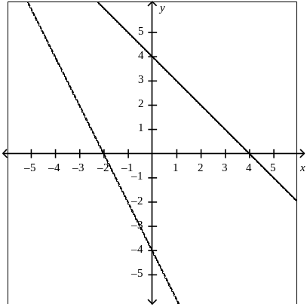
61. 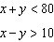

62. – 15 h³ i⁴ j⁷
63. 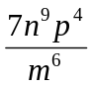

64.

65.

66.

67.

68.
69.

70. 5 a²b (4a b – 7a⁵ b⁴ + 12)

71.

72. (g + 2)(g – 11)
73.

74.

75. (3t + 4)( t + 2)

76. 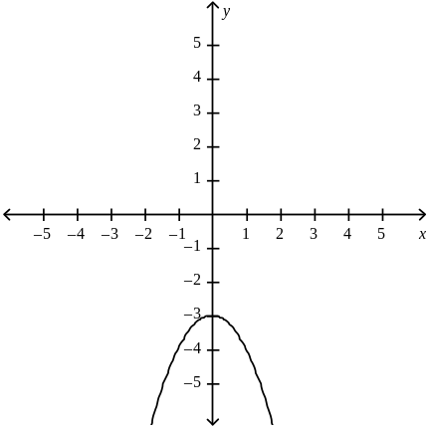

77. x = –1
78. 12.69, 3.31
79.

80.

81. 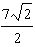

82.

83. –3, 3

84. ; –2

85.

