Algebra 1 Honors … Practice Exam 1

Multiple Choice
Identify the choice that best completes the statement or answers the question.

What is an algebraic expression for the word phrase?

- the quotient of 2 and the difference of f and x

a. | 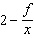 | b. | 2f + x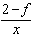 | c. | 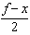 | d. | 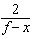

- Evaluate u + xy, for u = 3, x = 8, and y = 5.

a. | 55 | b. | 29 | c. | 43 | d. | 16

What is the simplified form of the expression?

- 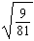

a. | 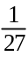 | b. |  | c. |  | d.

- To which subsets of the real numbers does the number 1.68 belong?

a. | rational numbers
b. | natural numbers, whole numbers, integers, rational numbers
c. | rational numbers, irrational numbers
d. | none of the above

- What is the order of , 0.5, , 1.6, from least to greatest?

a. | , 0.5, 1.6, , | c. | 1.6, , , , 0.5
b. | , , 1.6, , 0.5 | d. | 0.5, 1.6, , ,

What property is illustrated by the statement below?

- –6 + (5 + 1) = (–6 + 5) + 1

a. | Associative Property of Addition
b. | Commutative Property of Addition
c. | Commutative Property of Multiplication
d. | Inverse Property of Addition

Simplify the following expression.

7. 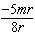

a. | r | c. | m
b. | r | d. | m

What sum is equivalent to the following expression?

8. 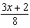

a. | x + | b. | x + | c. | x | d.

What is the simplified form of the expression?

9.

a. |  | b. |  | c. |  | d.

What is the solution of the equation?

10. –3 = 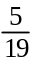

a. | 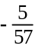 | c. | 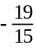
b. | 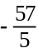 | d. | 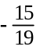

11. Manny and Emma are both competing in a long jump competition at their school. Manny can jump four fifths of the distance that Emma can jump. Manny can jump 36 inches. How far can Emma jump?

a. | 35.2 inches | c. | 28.8 inches
b. | 45 inches | d. | 36.8 inches

What is the solution of the equation?

12. 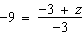

a. | 24 | b. | 6 | c. | 30 | d. | 0

13. Which property of equality justifies step f?

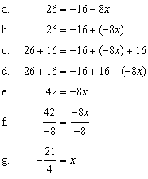

a. | Multiplication Property of Equality
b. | Subtraction Property of Equality
c. | Division Property of Equality
d. | Addition Property of Equality

What is the solution of the equation?

14. 7d – 4d – d – 7 5d = 0

a. | 7 | b. |  | c. | –7 | d. | 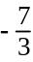

What is the solution of the equation?

15. 70 = –7(–2 – 2z)

a. | 4 | b. | –28 | c. | –112 | d. | 784

16. 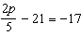

a. |  | b. | 14 | c. | 10 | d. | 3

17. Which equation has no solution?

a. |  | c.
b. |  | d.

18. What equation do you get when you solve for x?

a. | 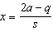 | c. | 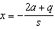
b. | 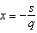 | d. | 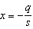

19. A flock of Canadian geese migrated 1623 miles in 28 days. What was the average rate at which these geese traveled in miles per day?

a. | 73 miles per day | c. | 47 miles per day
b. | 113 miles per day | d. | 58 miles per day

20. An office building is 111 ft high. About how tall is this in meters?

a. | 333 m | c. | 33.84 m
b. | 39.64 m | d. | 364.1 m

What is the solution of the proportion?

21. 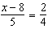

a. |  | b. |  | c. | 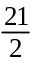 | d.

In the diagram, the figures are similar. What is x?

22. 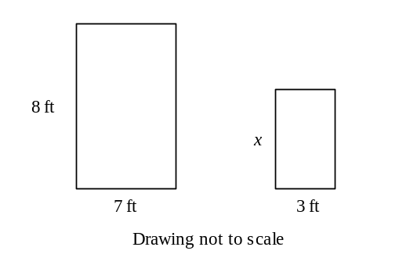

a. | 3.4 ft | b. | 0.4 ft | c. | 2.3 ft | d. | 2.6 ft

23. A flagpole casts a shadow 10 ft long. A girl standing next to the flagpole casts a shadow 2.5 ft. long. If the girl is 5 ft. tall, how tall is the flagpole?

a. | 18 ft | b. | 12.5 ft | c. | 15 ft | d. | 20 ft

What are the solutions of the inequality? Graph and check the solutions.

24. 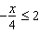

a. | 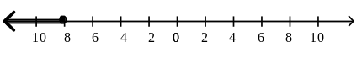
b. | 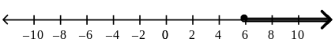
c. | 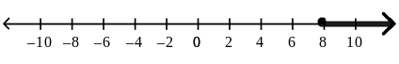
d. | 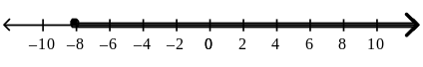

What are the solutions of the inequality? Check the solutions.

25. – x – 9 < 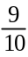

a. | x > 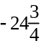 | b. | x < 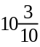 | c. | x < 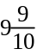 | d. | x < 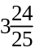

What are the solutions of the inequality?

26. 12x – 3x + 11 > 4x – (17 – 9x)

a. | x > –7 | b. | x < 7 | c. | 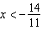 | d. | 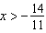

What are the solutions of the compound inequality? Graph the solutions.

27.

a. | 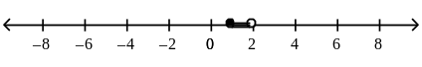
b. | 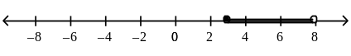
c. | 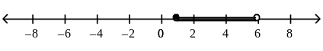
d. | 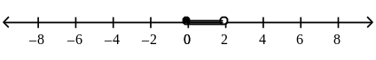
28. A student scored 77 and 98 on her first two quizzes. Write and solve a compound inequality to find the possible values for a third quiz score that would give her an average between 80 and 90, inclusive.

a. | 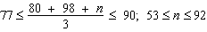
b. | 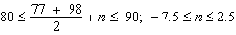
c. | 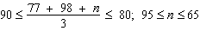
d. | 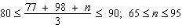

What are the solutions of the compound inequality? Graph the solutions.

29. 12x – 5 < –17 or 3x + 8 > 14

a. | x < –1 or x >  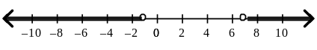
b. | x < –1 or x > 2  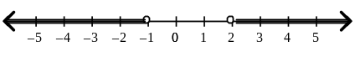
c. | x < –24 or x > 3  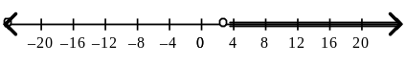
d. | x < 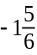 or x >  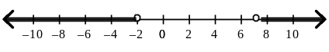

30. How do you write and in interval notation?

a. | [7, 10) | c. | (7, 10)
b. | [7, 10] | d. | (7, 10]

31. The ordered pairs (1, 81), (2, 100), (3, 121), (4, 144), and (5, 169) represent a function. What is a rule that represents this function?

a. |  | c.
b. |  | d.

What is the graph of the function rule?

32.

a. | 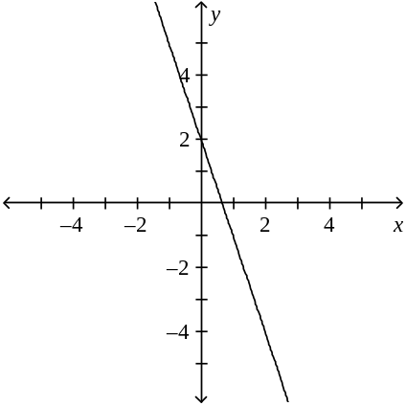 | c. | 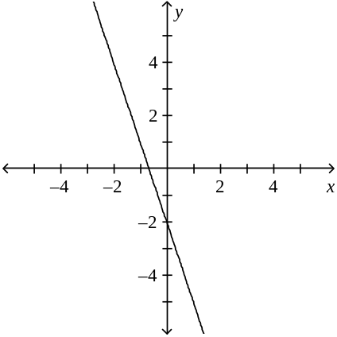
b. | 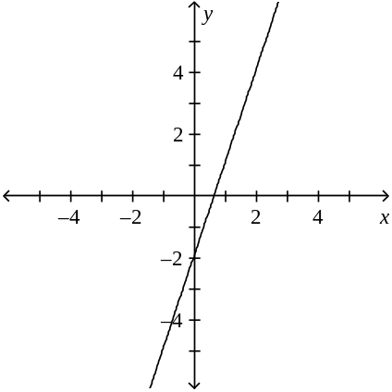 | d. | 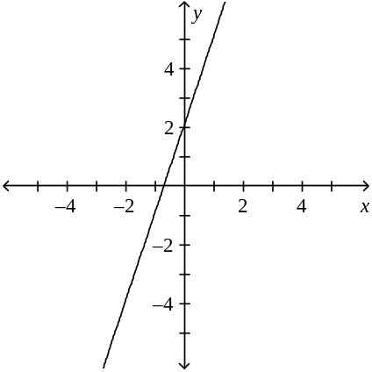

Write a function for the situation. Is the graph continuous or discrete?

33. A movie store sells DVDs for $11 each. What is the cost, C, of n DVDs?

a. | C = 11n; continuous | c. | C = 11 + n; continuous
b. | C = 11 + n; discrete | d. | C = 11n; discrete

What is the graph of the function rule?

34.

a. | 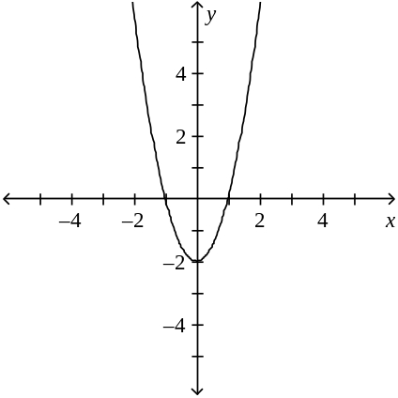 | c. | 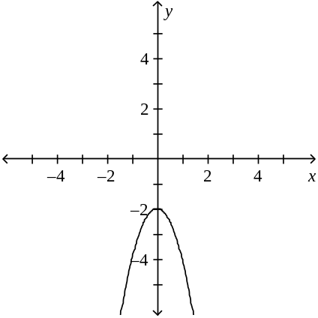
b. | 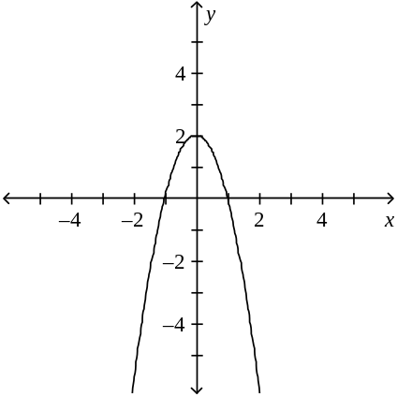 | d. | 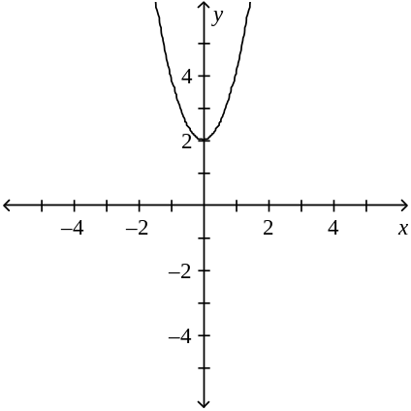

35. A snail travels at a rate of 2.35 feet per minute.

• Write a rule to describe the function.
• How far will the snail travel in 5 minutes?

a. | ; 11.75 ft | c. | 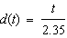; 2.13 ft
b. | ; 7.35 ft | d. | ; 11.75 ft

36. Identify the mapping diagram that represents the relation and determine whether the relation is a function.

a. | 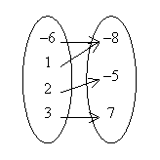  The relation is a function. | c. | The relation is not a function
b. | 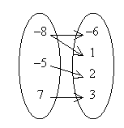  The relation is a function. | d. | The relation is not a function.

Find the slope of the line.

_{37.} 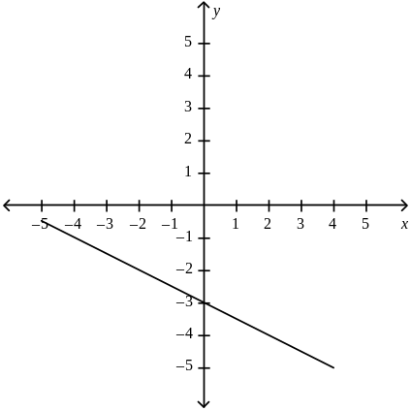
a. |  | b. | 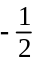 | c. |  | d.

What is the slope of the line that passes through the pair of points?

38. (1, 7), (10, 1)

a. |  | b. | 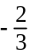 | c. | 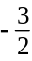 | d.

What is the slope of the line?

39. 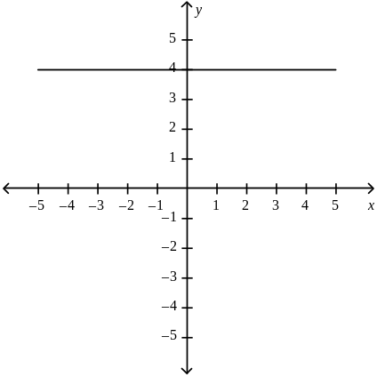

a. | undefined | b. | 0

What are the slope and y-intercept of the graph of the given equation?

40. y = x 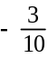

a. | The slope is 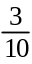 and the y-intercept is .
b. | The slope is and the y-intercept is .
c. | The slope is 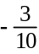 and the y-intercept is .
d. | The slope is and the y-intercept is .

Write an equation of a line with the given slope and y-intercept.

41. m = –4.4, b = 6.8

a. | y = –4.4x – 6.8 | c. | y = 6.8x – 4.4
b. | y = 4.4x + 6.8 | d. | y = –4.4x + 6.8

Write the slope-intercept form of the equation for the line.

42. 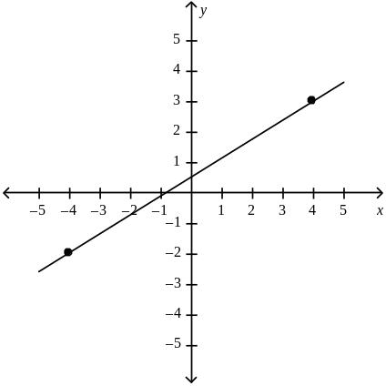

a. | y = 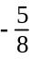x 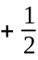 | c. | y = x
b. | y = x 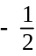 | d. | y = x

What equation in slope intercept form represents the line that passes through the two points?

43. (2, 5), (9, 2)

a. | y = x 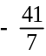 | c. | y = x 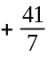
b. | y = x | d. | y = 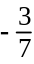x

Write an equation in point-slope form for the line through the given point with the given slope.

44. (8, 3); m = 6

a. |  | c.
b. |  | d.

Find the x- and y-intercept of the line.

45. x 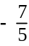y = –4
a. | x-intercept is ; y-intercept is 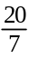 | c. | x-intercept is ; y-intercept is 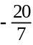
b. | x-intercept is ; y-intercept is | d. | x-intercept is ; y-intercept is

Graph the equation.

46. y = –x – 2

a. | 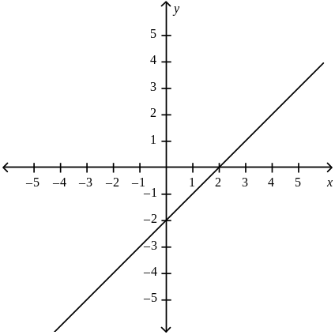 | c. | 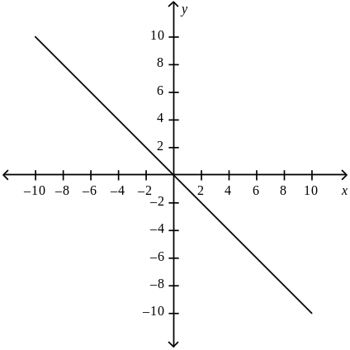
b. | 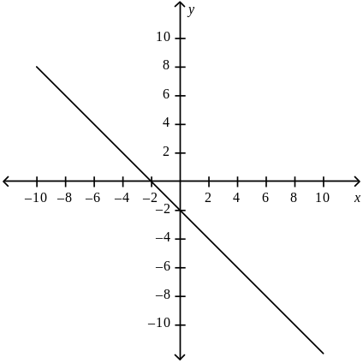 | d. | 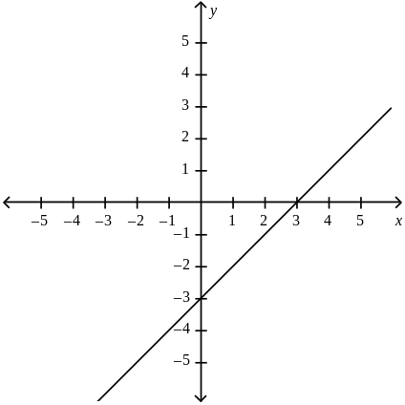

47. Write y = x + 7 in standard form using integers.

a. | –2x + 3y = 21 | c. | –2x – 3y = 21
b. | 3x – 2y = 21 | d. | –2x + 3y = 7

Graph the equation.

48. y + 5 = (x – 4)

a. | 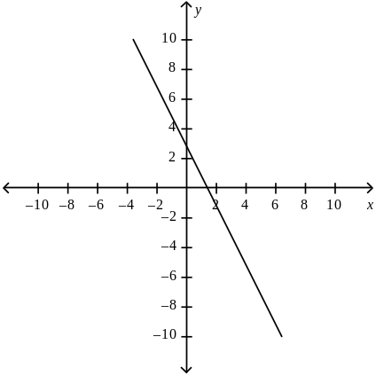 | c. | 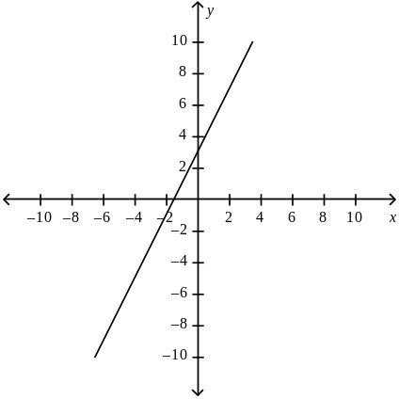
b. | 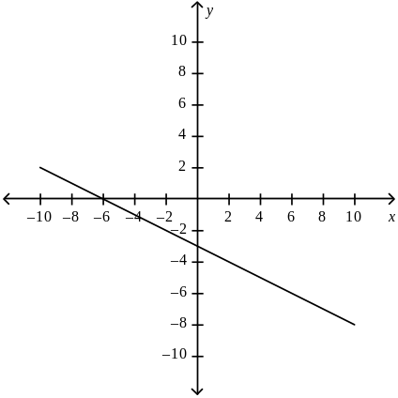 | d. | 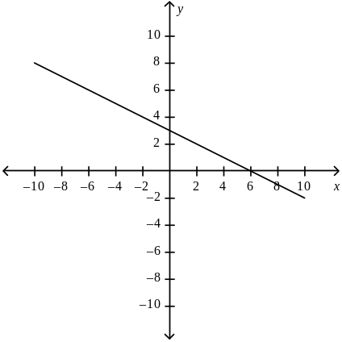

Write an equation for the line that is parallel to the given line and passes through the given point.

49. y = x + 10; (2, 14)

a. | y = x + 4 | c. | y = x
b. | y = 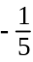x – 4 | d. | y = x + 4

Write the equation of a line that is perpendicular to the given line and that passes through the given point.

50. 4x – 12y = 2; (10, –1)

a. | y = x + 29 | c. | y = x + 29
b. | y = 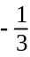x + 29 | d. | y = x + 7

