CALIFORNIA YMCA YOUTH & GOVERNMENT

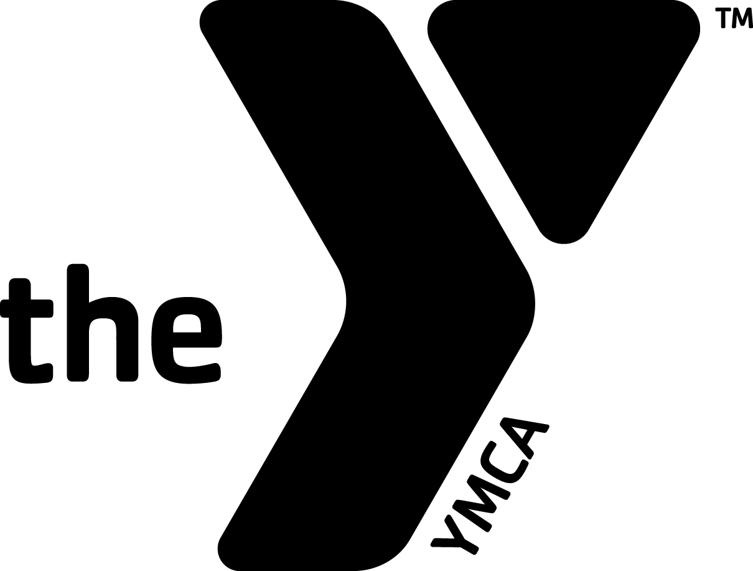

CALIFORNIA YMCA YOUTH & GOVERNMENT

MOTTO

“Democracy Must Be Learned By Each Generation”

MISSION

We build values-based leadership and civic engagement in
California’s youth to strengthen our democracy.

Adopted by the Board of Directors: March 2010

PARENT HANDBOOK

WHY YOUTH & GOVERNMENT?

In California, an informed and participating electorate, which shares a common value system, is crucial for building strong communities. Young people need to understand that they can have an effect on their communities, their state, and their country, through their actions. Youth & Government strives to give youth both the tools and the values, which will empower them to solve problems within the established system of government. Participants in the Model Legislature & Court are provided an arena to test their beliefs, to share their frustrations, to examine their ethics, and broaden their knowledge. .

WHAT IS YOUTH & GOVERNMENT?

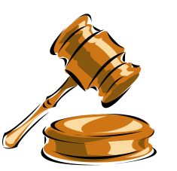The California YMCA Model Legislature & Court is a statewide youth educational program involving more than 2,300 high school students, in a nine-month "hands on" experience. Since its inception, the program has used a variety of activities to build, encourage, and strengthen the character traits that will help high school youth become involved, responsible adults who are respected citizens. The tool used is a high quality experiential and educational simulation based upon California's State government. The program is very comprehensive, and its impact on the youth participants is dramatic.

The Model Legislature & Court teaches the values of democracy by creating citizen leaders from a cross-section of the State's high school population, providing them with the opportunity to experience government first hand and to learn how to solve community problems through the democratic process. The program also helps develop within these youth an attitude of self-help and self-confidence for their personal futures.

HOW THE MODEL LEGISLATURE & COURT PROGRAM WORKS

The program begins in September when 2,300 young people and 300 volunteers at approximately 90 locations throughout the State, meet as individual delegations to discuss issues facing California, as well as ways to implement their solutions through the legislative and judicial processes. During a nine-month period, the teen delegates write bills, prepare briefs, and select governmental positions to role-play, attend statewide training conferences, and run for various elected offices. The program reaches its peak in Sacramento at the State Capitol with the convening of the five day Model Legislature & Court each February. There, "real" government moves over and the teen delegates "take over", using the historic halls, chambers, and offices of our State Capitol, Supreme Court, and Governor's Office.

California YMCA Youth & Government operates as an independently chartered YMCA. A Board of Directors is responsible for determining policy and directional emphasis of the program. Participation is by YMCA youth delegations being sponsored through local community YMCAs.

THE CONFERENCES



ADVISOR DEVELOPMENT CONFERENCE:

This conference is held at the beginning of the school year and is designed to inform and instruct adult advisors who will lead delegations to the YMCA Model Legislature & Court. Workshops include Bill Development, Risk Management, Values and Ethics, Code of Conduct, Working with Teens, and Program Administration.

TRAINING & ELECTIONS I CONFERENCE:

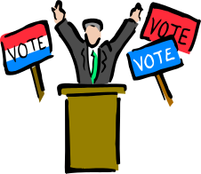
This conference provides an overview of the YMCA Model Legislature & Court for new and returning delegates, with specific training in debate and parliamentary procedure. Returning delegates brush up on their debate skills and attend sessions on value, ethics, and peer pressure. All delegates participate in elections for officers for the program. Attendance is not required in order to attend the Model Legislature & Court. This conference is held over the Veterans Day Holiday Weekend in November.



TRAINING & ELECTIONS II CONFERENCE:

All youth and adults who plan to participate in the YMCA Model Legislature & Court in Sacramento must attend this conference. Everyone is trained in his or her roles and the remainder of the officers are elected. This conference is held during the Martin Luther King weekend in January.

YMCA MODEL LEGISLATURE & COURT
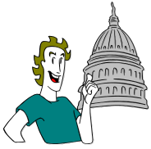
Nearly 2,900 delegates, advisors, and staff travel to Sacramento to participate in a five-day program that encompasses most aspects of state government. Delegates are privileged to use the actual state legislative and judicial chambers. Youth & Government is the only youth program allowed to use the actual capitol chambers. This program is held over the Presidents’ Day weekend.

SPRING MODEL LEGISLATURE & COURT CONFERENCE:

This less formal program is held in Corcoran in the middle of the state. Designed as a recruitment tool for new delegates, including freshmen, the program features both parliamentary procedure and debate. It also includes swimming and other recreational activities. The program is held at the end of April each year.

YMCA YOUTH CONFERENCE ON NATIONAL AFFAIRS:


Sponsored by the Southeast Field of the National YMCA, this conference is held at the picturesque Blue Ridge Assembly, in Black Mountain, North Carolina. California selects twenty-five delegates and five adults to join with 350 other youth from more than twenty states for an intense debate competition centered around proposals written by the delegates on issues of national or international importance.

HOW ADULTS ARE INVOLVED IN THE PROGRAM

DELEGATION ADVISORS:

Delegation Advisors provide leadership to their own local youth delegations in preparing them for their participation in the program. They also accompany their delegation to the various conferences, providing direct supervision to their delegation. Delegation Advisors also assist the Director in conducting the Elections & Training and Model Legislature & Court programs, serving as parliamentarians to Legislative Committees, assisting Deans with supervision, taking elevator duty, manning information desks, and working in the Conference Office during the Model Legislature & Court. Each local YMCA must meet the Governing Board’s requirement that each delegation maintain adult to youth ratio of 1:12 or 1:10 for certified advisors, and 1:8 for non-certified advisors. This year, over 300 adult advisors will be involved statewide.

VOLUNTEER STAFF:

Each year the Director of the ML/C program recruits volunteers to serve as “staff” to particular parts of the program. Over 150 volunteers from throughout the state plan and conduct activities, advise youth delegates on their roles, and in general assist the Director in the operation of the different program areas (i.e. Court, Legislature, Media, Lobbyists, etc.) The volunteer staff includes teachers, college students, attorneys, business executives, YMCA professionals, media experts, and law enforcement personnel.

YMCA MODEL LEGISLATURE & COURT GOVERNING BOARD:

California YMCA Youth & Government is an independently chartered YMCA. It is commissioned to conduct the Model Legislature & Court and the other programs for California YMCAs. Board Members are appointed each year and represent State Government, the Judiciary, businesses, YMCAs, and some are former youth officers and current participants of the Model Legislature & Court.

DIRECTOR / CORE STAFF:

The President/CEO of California YMCA Youth & Government is employed by the Board of Directors to administer the policies and practices of the program and to act as liaison between local YMCAs and the Board. The President/CEO, in turn, employs a small core staff to conduct the Model Legislature & Court, Model United Nations and other training programs. Currently there are six full-time employees.

SCHOOL ABSENCE

In 2008 Governor Schwarzenegger signed SB 278 (Lowenthal) into law allowing Youth & Government events to be considered for excused absences from school. The full text of the section is below and may also be found at http://leginfo.ca.gov by searching the education code for section 48205.

48205. (a) Notwithstanding Section 48200, a pupil shall be excused from school when the absence is:
(1) Due to his or her illness.
(2) Due to quarantine under the direction of a county or city health officer.
(3) For the purpose of having medical, dental, optometric, or chiropractic services rendered.
(4) For the purpose of attending the funeral services of a member of his or her immediate family, so long as the absence is not more than one day if the service is conducted in California and not more than three days if the service is conducted outside California.
(5) For the purpose of jury duty in the manner provided for by law.
(6) Due to the illness or medical appointment during school hours of a child of whom the pupil is the custodial parent.
(7) For justifiable personal reasons, including, but not limited to, an appearance in court, attendance at a funeral service, observance of a holiday or ceremony of his or her religion, attendance at religious retreats, attendance at an employment conference, or attendance at an educational conference on the legislative or judicial process offered by a nonprofit organization when the pupil's absence is requested in writing by the parent or guardian and approved by the principal or a designated representative pursuant to uniform standards established by the governing board.

The decision of whether or not to excused absences and award course credit for Youth & Government is up to each district. State Superintendent Tom Torlakson’s letter in support of awarding course credit for Y&G is available through the Youth & Government office.

California YMCA Youth & Government
CODE OF CONDUCT

“The purpose of California YMCA Youth & Government is to develop within our youth a dedication to the values of democracy and an awareness of the need for their participation and leadership in the democratic process.”

BASIC PHILOSOPHY OF RESPONSIBLE CONDUCT
Essential to the California YMCA Youth & Government (Y&G) is the concern of each participant for the rights of every individual. Being responsible for one's own behavior at all times is a necessary part of self-government. It is critical that all delegates, advisors, and staff act responsibly to ensure that their own conduct and attitude is beneficial not only to themselves and their fellow delegates, but also to ensure the continuation of Y&G’s programs.
The Code of Conduct shall be observed by both youth and adults. There will be no double standard. By choosing to participate in the programs of Y&G, each individual agrees that they have read, understand, and will follow the Code of Conduct while attending any part of the program. Each participant is accountable for preserving the reputation and high standard of his/her YMCA delegation and Y&G.
All participants share equally the responsibility for their actions when violations of the Code are witnessed. Those who decide to be present when a violation occurs shall, by their own choice, be considered a participant in the violation. In this program, there are no "innocent bystanders".
- GENERAL RULES
Infractions of General Rules A-G shall result in expulsion from Y&G functions and conferences. In order to ensure the safety of all participants Y&G reserves the right to conduct searches of baggage, rooms and persons to include the use of breathalyzers in accordance with its polices. In addition, local law enforcement agencies may be contacted and the delegate/advisor/staff member turned over to them as appropriate:
  - All public and private facilities placed at the disposal of Y&G to conduct its programs are to be given the greatest care and attention by everyone. It is a PRIVILEGE to use them; treat them with respect. Any act of vandalism, destruction of property, or misuse of a facility may be a crime and will be treated as such.
  - Possession and/or consumption of alcoholic beverages or illegal drugs are strictly prohibited.
  - Weapons of any kind and items that could cause injury or damage to participants and/or property are strictly forbidden.
  - Any violation of State or Federal laws will be treated as such and the proper authorities may be notified.
  - Activities which endanger the health and safety of the individual or others are prohibited.
  - Inappropriate or uninvited physical contact between any Y&G participants, staff member, or guests is not allowed. Intimate sexual behavior is inappropriate and not allowed.
  - Possession and/or the use of any tobacco products is not permitted.
Infractions of General Rules H-O may result in expulsion from Y&G functions and conferences:
  - Laws of the state, county, and city governments are to be observed.
  - Badges shall only be worn by the individual whose name is on that badge. BADGE SWITCHING OR SHARING IS STRICTLY PROHIBITED. Participants will wear their assigned badges at all times when they are not in their sleeping rooms, and badges are to be worn above the waist and must be visible. Badges are not to be defaced, decorated, or altered in any way. Only advisors may request replacement badges. There may be a charge for replacement badges.
  - Specific rules as set by the individual facilities (i.e., YMCA, State Capitol, Hotels, California National Guard facilities, etc.) are to be observed.
  - Participants must be present and punctual at all meetings where their involvement is required.
  - Participants shall observe all curfews and be in their assigned sleeping rooms at the established curfew times.
  - No delegate shall be in the barrack of the opposite sex at the Training & Elections Conferences. In Sacramento, no delegate shall be present in the hotel room with a member of the opposite sex at any time, unless an advisor is present in the room, or there are five or more delegates present in the room, two of which are the same sex (3-2 rule).
  - Y&G does not permit delegates to drive vehicles to or from any of its related conferences. Any delegation seeking an exception must clear it in advance with their local YMCA Executive Director or, in school based delegations, School Principal, and must provide proof in writing to the Y&G office prior to the related conference. DELEGATES MAY NOT DRIVE ANY VEHICLE WHILE AT A CONFERENCE. Advisors seeking to drive during a conference shall obtain clearance through Y&G. IN ALL CASES, LIABILITY IS ASSUMED BY THE SPONSORING LOCAL YMCA OR SCHOOL.
  - All electronic devices (except those used by the Y&G staff) must be turned off during all sessions, meetings, and hearings in all program areas. Advisors/staff may leave devices on, but inaudible, for emergency contact reasons. They must leave the session/area in order to answer a call.
  - Falsification of records threatens the integrity of the program and will be considered a serious breach of contract. The result will include a range of penalties up to dismissal from the program.
- DRESS RULES FOR OFFICIALLY SCHEDULED SESSIONS
  - Sacramento Model Legislature & Model Court - All participants are to maintain a professional and business-like appearance by dressing in business and professional attire during the Model Legislature/Court business day (8 a.m. - 10:00 p.m.) and other such hours as designated by the program schedule. The CEO and his/her designee has the authority to determine both the appropriateness of appearance and attire of participants.
  - Other Conferences & Meetings – Participants must wear clean, tidy school attire. No open toed shoes are allowed outside of an individual’s own barrack at Camp Roberts.
  - Refer to Dress Code Supplement for specific requirements for both the Model Legislature/Court and other conferences and meetings.
- DISCIPLINARY ACTIONS
  - The Code of Conduct is binding on all delegates, advisors, and staff. Each participant will be accountable for his/her actions. In addition, each YMCA or school and its advisors shall be held accountable for the conduct of their delegation.
  - THE CEO HAS THE AUTHORITY TO INTERPRET THE CODE OF CONDUCT AND ADMINISTER ANY DISCIPLINARY ACTION DEEMED NECESSARY.
  - The CEO has the authority to delegate his/her disciplinary powers to any staff person deemed appropriate.
  - ALL EXPENSES AND ARRANGEMENTS RELATED TO ANY DISCIPLINARY ACTION ARE THE SOLE RESPONSIBILITY OF THE LOCAL YMCA OR SCHOOL, THE DELEGATION, AND THE ADVISOR, WHO SHALL BE REIMBURSED BY THE PARENT OR GUARDIAN. YMCAs MUST BE PREPARED TO ASSUME ANY AND ALL FINANCIAL OBLIGATIONS IMMEDIATELY.
- LOCAL YMCA RULES
  - Each local YMCA or school may outline more stringent rules of conduct in conformance with this Code of Conduct for its delegation. These additional rules and the Y&G Code of Conduct are binding. Violation of either could subject the offender to termination from the program. Delegation advisors shall be responsible for enforcing such additional rules of their local YMCA.

Amended May 2, 2009

THE PARTNERSHIP THAT WORKS

Youth & Government is a joint effort between your local YMCA (or high school) and the statewide Youth & Government office. Working together, we strive to offer each delegate a quality learning and social experience which will enhance their high school years.

WHAT YOUR LOCAL DELEGATION PROVIDES THE DELEGATE:

- Local YMCAs organize and run each delegation in a safe appropriate setting. A YMCA professional or a trained volunteer works with participants weekly starting in September.

- Local YMCAs are responsible to conduct a program that is run in accordance with the rules and expectations of the state office. They are required to meet all deadlines set by the Y&G program.

- It is up to the local delegation to establish the criteria for participation in the program, running for office, and assignment to program roles within the guidelines set forth by Y&G.

- Local delegations organize transportation to and from each conference.

- Local YMCAs and parents are responsible for providing trip and/or medical insurance for the participants. (Y&G only has liability insurance coverage).

- Local YMCAs establish and collect fees necessary to conduct the program. Delegations set fees which may include: Fees paid to Y&G, transportation, additional meals needed, delegation awards, delegation sweatshirts, YMCA membership dues [if applicable], insurance, and costs for adult volunteers. Local delegations provide fundraising opportunities for youth to help defray the costs of participation.

- Local YMCAs are responsible for providing any additional training not provided by the statewide office.

- Local YMCAs are responsible for all communications regarding the program to the individual delegates.

- Local delegations are responsible for providing for the immediate removal of any delegate expelled by the Youth & Government Program. Y&G expects the local delegation to initially be prepared to cover any financial consequences involved with the understanding that these costs will ultimately be borne by the parents/guardian of the expelled child.

WHAT THE STATEWIDE YOUTH & GOVERNMENT PROGRAM PROVIDES THE DELEGATE:

- A well-established and highly regarded program with over 60 years of experience.

- A large cadre of experienced, trained volunteers who give countless hours each year to provide a quality experience for each participant.

- First rate supplies and equipment to be used by participants. This includes extensive printed material, and access to computers and state of the art audio-visual equipment.

- Y&G contracts with a well respected Food Service Company to provide meals at the Training and Elections Conferences. We provide ample variety to satisfy vegetarian participants but cannot cater to extreme dietary requirements.

- Y&G contracts with the State of California Military Department for the use of barracks and classrooms at Camp Roberts (about 15 miles north of Paso Robles). Accommodations are somewhat spartan, with barracks having 50 bunk beds and communal bathrooms. Delegates need to bring their own sleeping bags, towels, and toiletries, and be prepared for cold, wet, weather. Delegates are instructed not to bring any items of value, especially, cameras, radios, and iPods, since there are no facilities for securing these items. A special study room is available in the evening for delegates who need to spend time preparing for school.

- Y&G contracts with both the Hyatt Regency Hotel and the Sheraton Grand Hotel Inn to provide accommodations for the participants of the Model Legislature/Court in Sacramento. In order to house over 2400 people, the hotels will assign up to four people to each guest room. Delegations are required to bring at least 2 sleeping bags for each room occupied. The hotels supply extra towels to provide for one towel per day per person in each room. Delegates are encouraged to bring extra towels.

- Y&G has a volunteer EMT at each conference. Emergency medical assistance is always available. Copies of each participant’s medical forms are held in the conference headquarters, should the delegation’s advisor not be available in an emergency. Directions to the nearest medical facility are printed in each handbook.

- Y&G staffs each conference with up to 16 volunteer deans who are constantly on duty to monitor the behavior of the delegates when not in session. Y&G also contracts with the Sacramento Police Department for the services of off duty officers to patrol the general area of our conference in the evening hours. Adult Advisors are assigned to monitor every floor used by the group from 10:00 p.m. until 1:00 a.m.

- Y&G provides extensive training to each adult advisor working with the program. Y&G establishes a ratio of delegates/advisors that local delegations are required to meet. The current ratio is 1 Certified Advisor (ADC) to 12 youth, 1 certified (1 Day) advisor to 10 youth and 1 non-certified advisor for every 8 youth.

- Y&G provides access to scholarship funds for economically disadvantaged youth. Funding for scholarships is through the George Deukmejian Endowment Fund.

IF YOU HAVE ANY QUESTIONS PLEASE CONTACT YOUR LOCAL DELEGATION.

THE STAFF OF THE CALIFORNIA YMCA YOUTH & GOVERNMENT PROGRAM LOOK FORWARD TO WORKING WITH YOUR TEEN IN THE COMING YEAR.

EMERGENCY PHONE NUMBERS

CAMP ROBERTS Y&G OFFICE - (916) 756-0230 x 101

HYATT REGENCY HOTEL, Sacramento - (916) 443-1234

SHERATON GRAND HOTEL, Sacramento - (916) 447-1700

CORCORAN YMCA, Corcoran - (559) 992-5171

YMCA YOUTH & GOVERNMENT OFFICE- (916) 756-0230

CHECK OUT OUR WEB SITE – calymca.org



