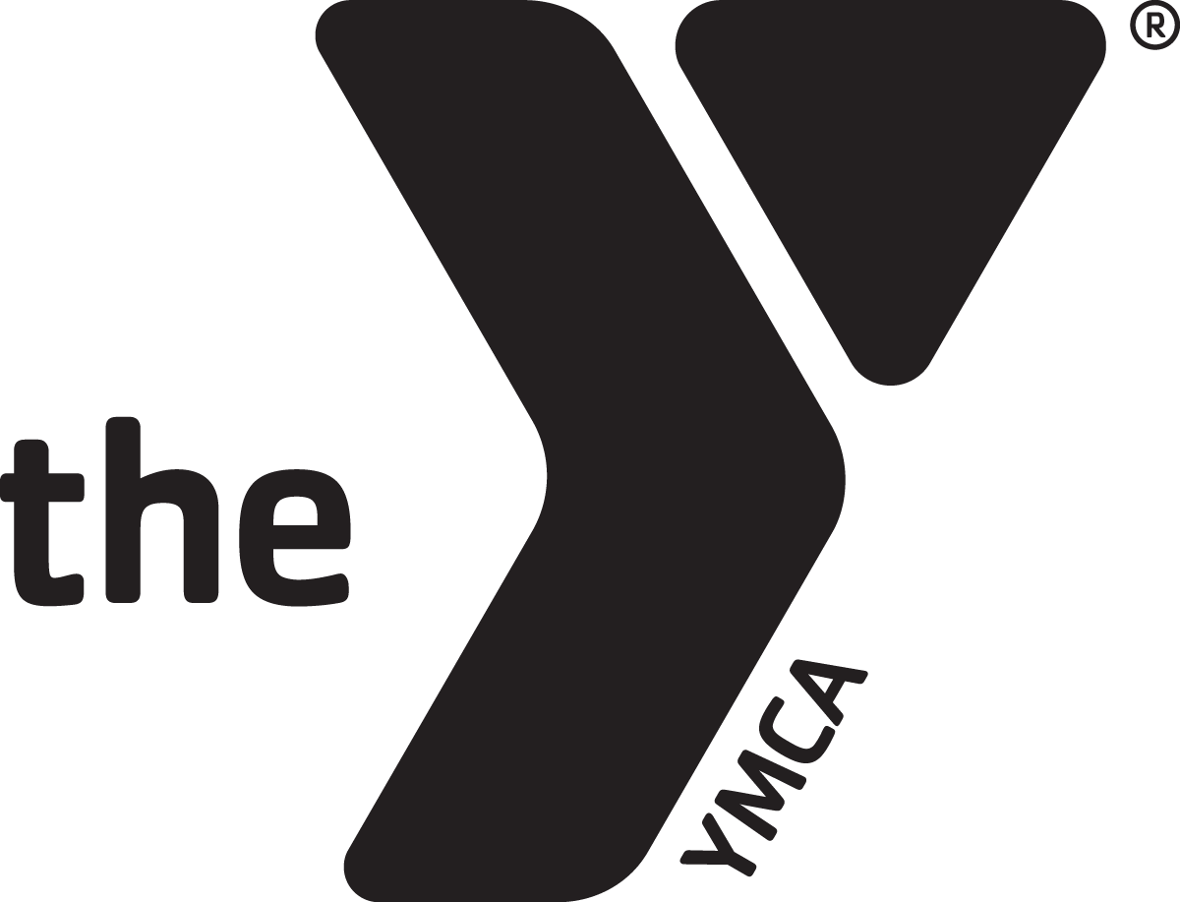
Every gift makes a difference.
Everyone has a role to play.
Together, we can achieve so much more.

California YMCA Youth & Government
2014 Annual Campaign
Campaigner Job Description

- Commit yourself to a successful campaign and agree to follow procedures, structures and deadlines! (see attached list of key dates)

- Complete and turn in your Commitment Form.

- Make your own pledge first!

- Become familiar with all pertinent campaign material.

- Make the necessary contacts to achieve your goal.

- Attend your division’s Kick-Off!

- Report your progress at each deadline on the Campaign Calendar.

- Tell the Youth & Government story! We have materials to help you, so don’t hesitate to ask the office for whatever you need.

- Complete the pledge card for each donor and ask returning donors for their INCREASED support. Be specific about the method of payment.

- Meet your goal by our Victory Celebration in Sacramento!

  - Please feel free to contact your Team Captain, Section Leader, or Kelsey Nolan (Kelsey@calymca.org or 916-756-0230 x 107)

Thank you for your willingness to help us in the 2014 Annual Campaign. You are a member of what Youth & Government promises to be a very successful Campaign Force!

We appreciate your TIME, TALENT and TENACITY!

