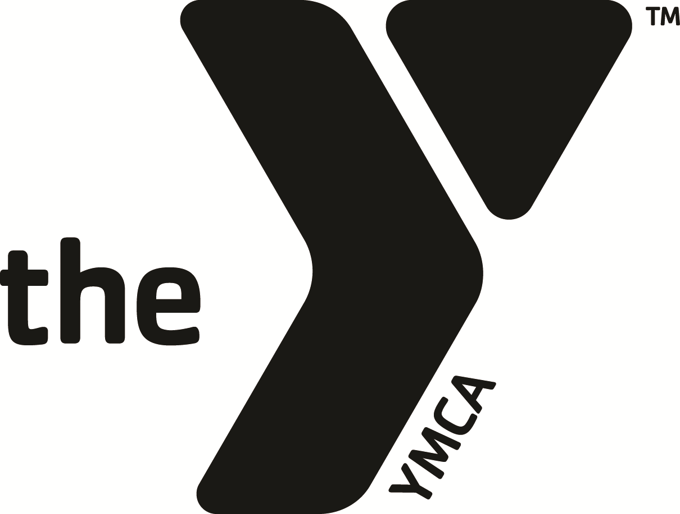
CALIFORNIA YMCA YOUTH & GOVERNMENT
2014 Annual Campaign

DONORS/ORGANIZATION NAME:___Bob Good Donor__________________________________ CAMPAIGNER NAME: Melissa Malone
ORGANIZATION CONTACT: __________________________________________________________
ID # : 123456

Address: 2555 Third Street #215
Sacramento, CA 95818
Home Phone: 916-756-0230
Cell Phone: 916-596-9333
Work Phone:
Email: bobdonor@calymca.org
What company do you work for? California YMCA Y&G
Do they have a Matching Gifts Program? Yes

Updated donor information:
Address: 6928 Owensmouth Ave. #101
Canoga Park, CA 91303
Home Phone:
Cell Phone:
Work Phone:
Email:
What company do you work for?
Do they have a Matching Gifts Program?

Pledge Information:
My/Our pledge to this campaign is: $100
Program History:
Donation History:
Year Pledged Paid
2013 $100 $100
2012 $100 $100
2011 $100 $100
Notes:
Please choose one of the following four payment methods:

Bill me/us the entire amount on _____/______
OR _____X_____ Quarterly [Mar, Jun, Sept, Dec]

OR ___________ Monthly [10 payments]

OR ___________ Don’t bill me, I’ve already made my pledge online

Credit Card Number:____________________________________________
Name on Card: :_________________________________________________
____Mastercard ____VISA ____AMEX ____Discover
Expiration Date:______/________
Please charge the card _______entire pledge amount
OR ___________ Quarterly [Mar, Jun, Sept, Nov]
OR ___________ Monthly [10 payments]

