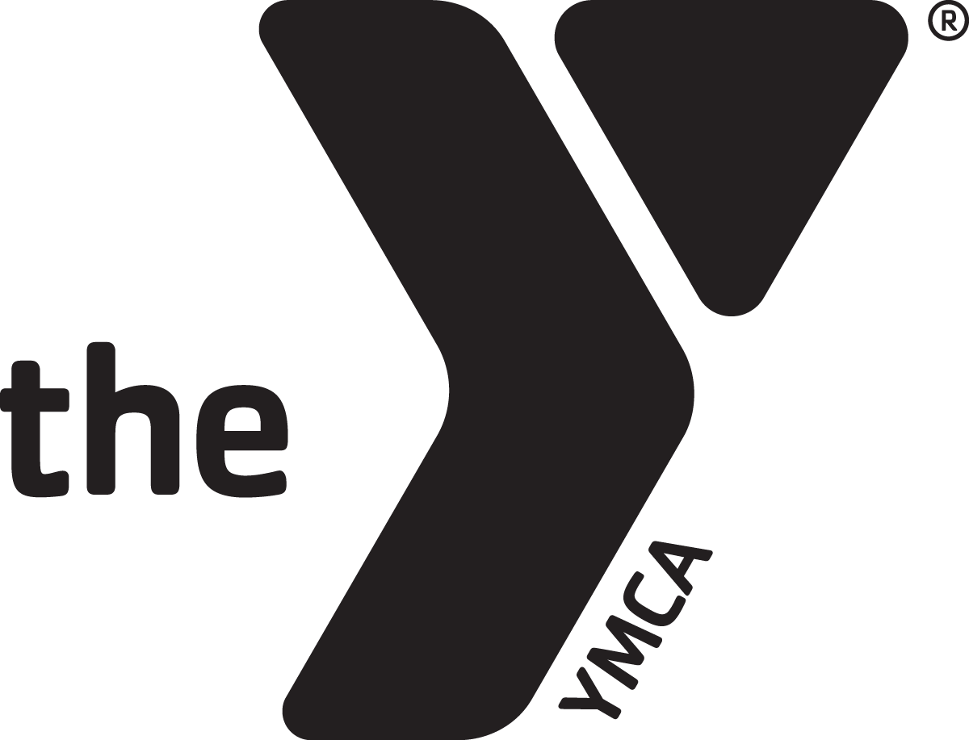
Every gift makes a difference.
Everyone has a role to play.
Together, we can achieve so much more.

California YMCA Youth & Government
2014 Annual Campaign
Team Captain Job Description

As a Team Captain
- Enlist Campaigners for your team and explain what is expected of them.

- Encourage them to attend the New Campaigner Training and the Campaign Kick-Off in January, and to contact their prospective donors early.

- Maintain weekly contact and actively supervise and motivate your campaigners!

As a Campaigner
- Commit yourself to a successful campaign and agree to follow procedures, structures and deadlines! (see attached list of key dates)

- Complete and turn in your Commitment Form.

- Make your own pledge first!

- Become familiar with all pertinent campaign material.

- Make the necessary contacts to achieve your goal.

- Attend your division’s Kick-Off!

- Report your progress at each deadline on the Campaign calendar.

- Tell the Youth & Government story! We have materials to help you, so don’t hesitate to ask the office for whatever you need.

- Complete the pledge card for each donor and ask returning donors for their INCREASED support. Be specific about the method of payment.

- Meet your goal by our Victory Celebration in Sacramento!

We appreciate your TIME, TALEN and TENACITY!

