California YMCA Youth & Government

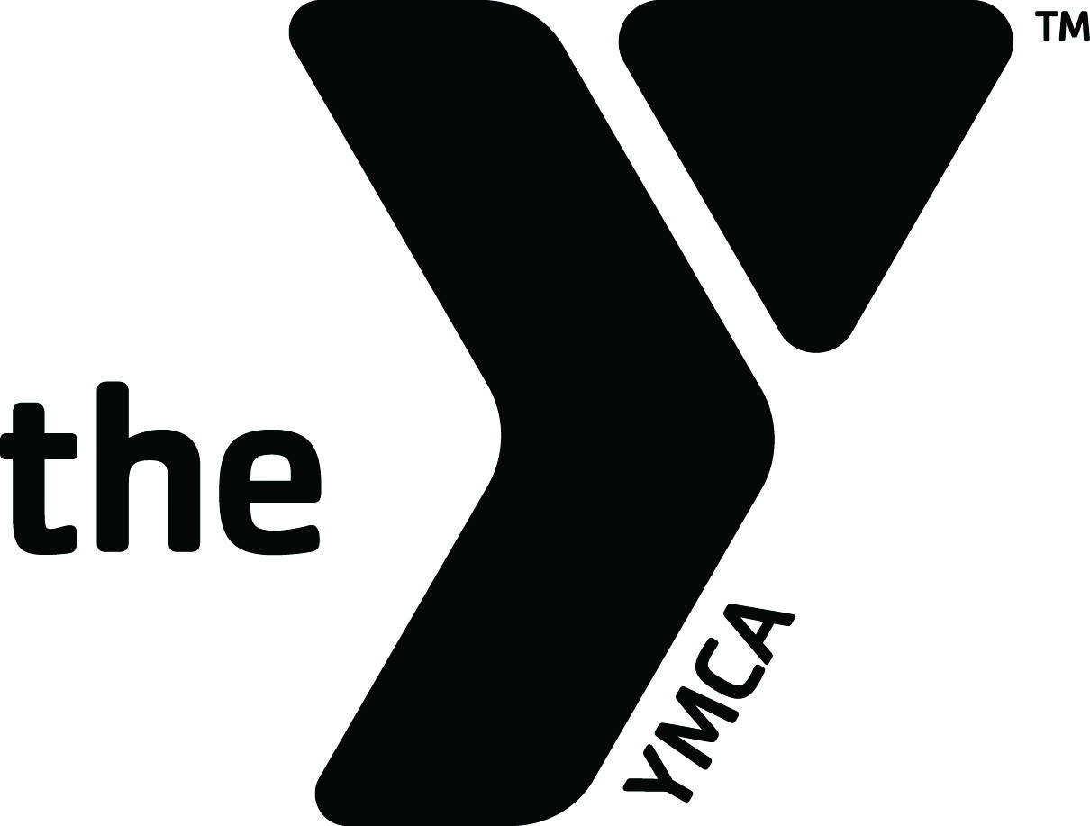
2014 Annual Campaign
Community Circle

TOGETHER WE CAN DO SO MUCH MORE.

Who To Contact For What…

Question? | Who
Need More Donor Sheets? | Kelsey Nolan
Want to know if someone else has a donor sheet? | Kelsey Nolan
Not sure how to start the conversation? | Your Team Captain or Division Manager
Need to know more about Y&G? | Kelsey Nolan
Not sure where/when to turn your stuff in? | Your Division Manager or Kelsey Nolan
Questions about dates and deadlines? | Your Team Captain, Division Manager or Kelsey Nolan
Want to be more involved? | LaVal Brewer
Questions about Why We Campaign? | Kelsey Nolan
Need ideas on who to ask? | Your Team Captain or Division Manager
Need help telling the Y&G Story? | Division Manager or LaVal
General Annual Campaign Questions? | Kelsey Nolan

LaVal Brewer  Community Campaign Chair  laval@lavalbrewer.com  949.945.3508 | Gov. Sam Leichenger  Youth Division Chair  sleichenger@yahoo.com  310.666.6405
Kelsey Nolan
Campaign Administrator
Kelsey@calymca.org
916.596.9333

Looking for more information about campaigning for the Annual Campaign?

You can find resources online at calymca.org/forms

These are the following documents available for download:

Blank Pledge Sheets

Campaigner Handbook

Campaigner Job Description

Campaign Case Statement

Key Dates

Donor Recognition Requirements

Donor Request Form

Facts at a Glance

Final Campaign Report Form

Helpful Hints

How to Fill Out a Pledge Sheet

Mid-Campaign Report Form

Sample Solicitation Letters

Sample Phone Solicitation Script

Sample Pledge Sheet

Section Leader Job Description

Team Captain Job Description

Who To Contact For What

