CALIFORNIA YMCA YOUTH & GOVERNMENT

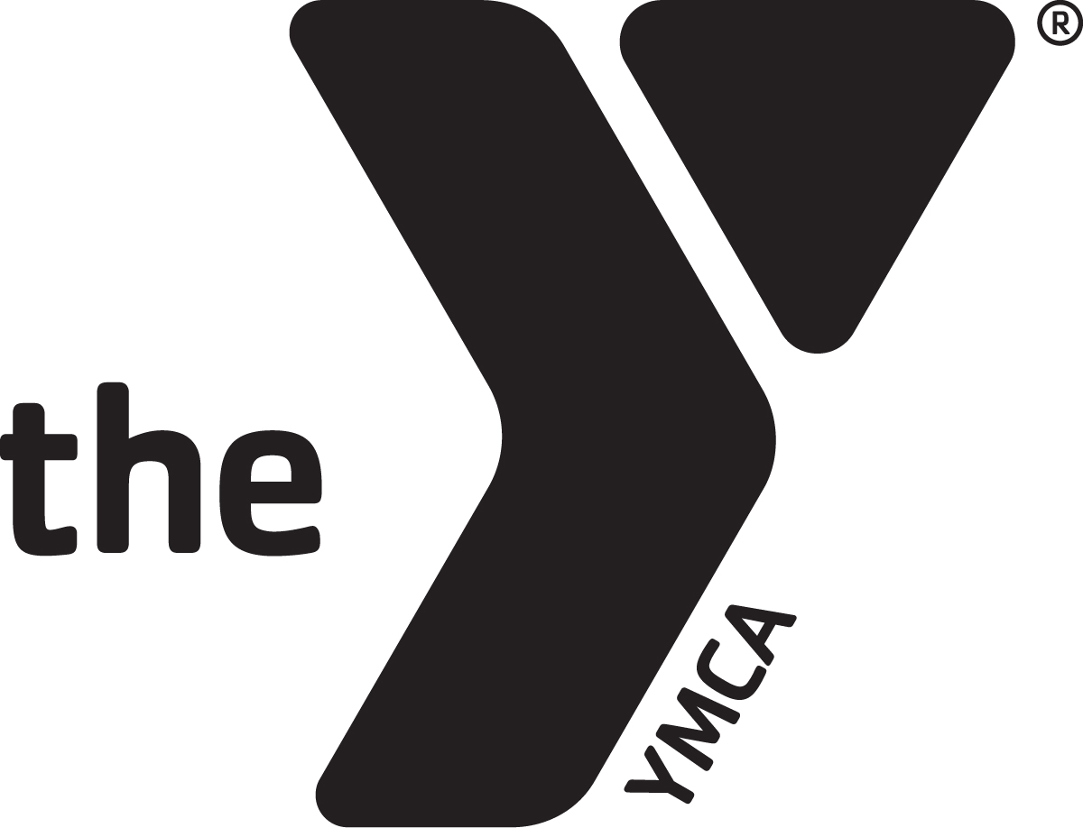HISTORY OF CALIFORNIA YMCA YOUTH & GOVERNMENT

**CALIFORNIA YMCA YOUTH & GOVERNMENT**

#### MOTTO

“Democracy Must Be Learned By Each Generation”

**MISSION**

We build values-based leadership and civic engagement in

California’s youth to strengthen our democracy.

*Adopted by the Board of Directors: March 2010*

**PARENT HANDBOOK**

In the mid 1930s, Clement “Pete” Duran, a YMCA Director from Albany, New York, wanted to find a meaningful experience for young people that might inspire them to become active and concerned participants in government as citizens. He struck upon the idea of a “model” legislature that would provide “hands on” learning. The slogan, “Democracy Must Be Learned By Each Generation,” was developed by Duran to interpret the purpose of the program. With encouragement from the National YMCA, the program spread rapidly to nearby states. The California YMCA Youth & Government program was initiated in 1948 and received immediate encouragement of then Governor, Earl Warren. From that point forward, California YMCA Y & G has received the full support of each successive governor.

California YMCA Youth & Government was chartered in January 2001 as an independent YMCA responsible for the statewide education and civic engagement programs for middle and high school students. As such, it continues to provide its specialized youth programs for YMCAs throughout California.

## HOW THE MODEL LEGISLATURE & COURT PROGRAM WORKS

over 2800 high school students from across 90 locations throughout the state meet in local delegations to discuss the major issues facing California, and how to solve them. Over the next six months participants will learn the following skills: writing, critical thinking, leadership, research and study skills. The delegates utilize the skills they are taught to draft legislation, prepare court briefs, select governmental positions to role-play (Senator, Appellate Court Justice, Board of Education member, etc.) attend three statewide events and run for statewide leadership. The MLC takes pride in the fact that almost all of our sessions, meetings and committees are run by the youth delegates themselves. However, this impressive display of youth leadership doesn’t just happen by itself. In the background, there are more than 150 program volunteers and 325 delegation advisors who give their time and expertise to guide and train our student delegates.

In addition to the six month training the students receive, California YMCA Y&G has used the facilities at Camp Roberts Army National Guard base near Paso Robles to train the delegates and elect the statewide leadership, since 1991. During the first Training & Elections weekend in November, new participants are shown the different program areas they can participate in (Lobbyist, Bench Trial, Assembly, Media, etc.) and get a feel for the overall program. Returning delegates get additional training in areas such as public speaking, diversity and ethics. The delegates also hold student elections for offices such as Supreme Court Chief Justice and Speaker Pro-Tem. In January, there is a second Training & Elections weekend. During this weekend, delegates receive training in the specific program they chose to participate in throughout the remainder of the program. This second weekend also prepares the students for the premiere event, Model Court & Legislature held in Sacramento each February.

The Model Court & Legislature, a five-day event is held at the State Capitol each February. There, the State government moves over and our delegates take over the historic halls, chambers, and offices of our State Capitol, Supreme Court, and Governor’s Office. Legislation will be debated, court cases decided and next year’s Youth Governor will be elected at the closing joint session. At the conclusion of the weekend, the Youth Governor is elected and has the opportunity to select his/her cabinet members. In additional to the Youth Governor, additional appointed leadership selections are made as well as the remainder of the year’s officers are elected.

The goal of the MLC program is to not only teach the delegates civics and leadership, but also to instill self-confidence and the knowledge that they have a voice and can make a difference in our judicial process.

## WHY Y&G?

California YMCA Youth & Government prides its self in providing quality educational and civic engagement programs that provide youth with the following skills to assist them transition and succeed with ease from Middle all the way through college graduation:

* Greater understanding of civic engagement and issues on statewide/national levels
* Leadership Skills
* Public Speaking
* Research/Writing Skills
* Critical Thinking

For over 65 years, California YMCA Youth & Government has offered our Model Legislature & Court (MLC) program to high school students. Currently, the MLC is serving more than 2800 participants from over 85 delegations across the state. In 2001, California YMCA Youth & Government expanded to offer a Model United Nations (MUN) program to Middle School students. The MUN program is currently serving more than 700 participants from over 40 delegations across the state. Our Intern Program is geared towards recent high school graduates who wish to continue their educational advancement as well as hone mentoring skills.

## THE EVENTS

## ADVISOR DEVELOPMENT TRAINING (ADT) September 12-14

This training is held at the beginning of the school year and is designed to inform and instruct adult advisors who will lead delegations to the YMCA Model Legislature & Court. Workshops include Bill Development, Risk Management, Values and Ethics, Code of Conduct, Working with Teens, and Program Administration.

## TRAINING & ELECTIONS I (T&E I) November 8-10

This training provides an overview of the YMCA Model Legislature & Court for new and returning delegates, with specific training in debate and parliamentary procedure. Returning delegates brush up on their debate skills and attend sessions on value, ethics, and peer pressure. All delegates participate in elections for officers for the program. Attendance is not required in order to attend the Model Legislature & Court. This conference is held over the Veterans Day Holiday Weekend in November.

## TRAINING & ELECTIONS II (T&E II) January 17-19

All youth and adults who plan to participate in the YMCA Model Legislature & Court in Sacramento must attend T&E II. Everyone is trained in his or her roles and the remainder of the officers are elected. This event is held during the Martin Luther King weekend in January.

## YMCA MODEL LEGISLATURE & COURT February 12-16

Over 3000 delegates, advisors, and volunteers travel to Sacramento to participate in a five-day program that encompasses most aspects of state government. Delegates are privileged to use the actual state legislative and judicial chambers. This event is held over the Presidents’ Day weekend.

## SPRING MODEL LEGISLATURE & COURT April 10-12

This less formal program is held in Corcoran in the middle of the state. Designed as a recruitment tool for new delegates, including freshmen, the program features both parliamentary procedure and debate. It also includes swimming and other recreational activities. The program is held at the end of April each year.

## YMCA YOUTH CONFERENCE ON NATIONAL AFFAIRS

Sponsored by the Southeast Field of the National YMCA, this conference is held at the picturesque Blue Ridge Assembly, in Black Mountain, North Carolina. California selects twenty-five delegates and five adults to join with 350 other youth from more than twenty states for an intense debate competition centered around proposals written by the delegates on issues of national or international importance.

## YMCA NATIONAL JUDICIAL PROGRAM

A partnership between the YMCA of the USA and the National Bar Association, this competition is held in Chicago, Illinois. California selects up to twenty-five delegates and five adults to join with 300 other youth from over twenty other states to compete in a mock trial court competition.

## KEEPING UP WITH WHAT’S GOING ON

## TO VISIT IT OR NOT TO VISIT

California YMCA Youth & Government discourages parents from visiting during the conferences for risk management reasons. The more people we have from outside of the program visiting, the harder it is to keep track of who is and isn’t suppose to be there. Additionally, we like to allow delegates the opportunity to be granted additional freedom and independence. If you have any questions regarding this policy, please contact the California YMCA Youth & Government office at info@calymca.org or 916-287-9622.

## FOLLOWING ALONG

If you’d like to follow along during our events, we will be posting the conference schedule in the resources section of our website, www.calymca.org. You can also follow us on Twitter (@calymca) or “like” our Facebook page (California YMCA Youth and Government). We will be posting things in both places.

## HOW ADULTS ARE INVOLVED IN THE PROGRAM

## DELEGATION ADVISORS

Delegation Advisors provide leadership to their own local youth delegations in preparing them for their participation in the program. They also accompany their delegation to the various events, providing direct supervision to their delegation. Delegation Advisors also assist the Director in conducting the Training & Elections and Model Legislature & Court programs, serving as parliamentarians to Legislative Committees, assisting Deans with supervision, taking elevator duty, manning information desks, and working in the Program Office during the Model Legislature & Court. Each local YMCA must meet the Governing Board’s requirement that each delegation maintain adult to youth ratio of 1-12 or 1-10 for certified advisors, and 1-7 for non-certified advisors. This year, over 300 adult advisors will be involved statewide. All delegations with more than 25 delegates are required to have a professional YMCA staff member, or long term volunteer (4+ years) as part of their delegation.

## PROGRAM VOLUNTEERS

Each year, over 150 volunteers from across the state serve as our Program Volunteers. They help plan and conduct activities, advise delegates on their roles, and in general assist the Core Staff in the operation of the different program areas (i.e. Court, Legislature, Media, Lobbyists, etc.). The Program Volunteers includes everyone from teachers to attorneys to business executives to YMCA professionals, and everyone in between.

## Y&G CORE STAFF

The President/CEO of California YMCA Youth & Government is employed by the Board of Directors to administer the policies and practices of the program and to act as liaison between local YMCAs and the Board. The President/CEO, in turn, employs a small core staff to conduct the Model Legislature & Court, Model United Nations and other training programs. Currently there are seven full-time employees.

## SCHOOL ABSENCE

In 2008 Governor Schwarzenegger signed SB 278 (Lowenthal) into law allowing Youth & Government events to be considered for excused absences from school. The full text of the section is below and may also be found at <http://leginfo.ca.gov> by searching the education code for section 48205.

**48205**. (a) Notwithstanding Section 48200, a pupil shall be excused from school when the absence is:

(1) Due to his or her illness.

(2) Due to quarantine under the direction of a county or city health officer.

(3) For the purpose of having medical, dental, optometric, or chiropractic services rendered.

(4) For the purpose of attending the funeral services of a member of his or her immediate family, so long as the absence is not more than one day if the service is conducted in California and not more than three days if the service is conducted outside California.

(5) For the purpose of jury duty in the manner provided for by law.

(6) Due to the illness or medical appointment during school hours of a child of whom the pupil is the custodial parent.

(7) For justifiable personal reasons, including, but not limited to, an appearance in court, attendance at a funeral service, observance of a holiday or ceremony of his or her religion, attendance at religious retreats, attendance at an employment conference, or attendance at an educational conference on the legislative or judicial process offered by a nonprofit organization when the pupil's absence is requested in writing by the parent or guardian and approved by the principal or a designated representative pursuant to uniform standards established by the governing board.

The decision of whether or not to excused absences and award course credit for Youth & Government is up to each district. The State Superintendent serves on our Advisory Board. His letter in support of awarding course credit for Y&G is available for download at [www.calymca.org](http://www.mlc.calymca.org).

**CODE OF CONDUCT**

**BASIC PHILOSOPHY OF RESPONSIBLE CONDUCT**

*It is essential to California YMCA Youth & Government (Y&G) that each participant enjoys the right to a safe, high quality environment. Being responsible for one's own behavior at all times is a necessary part of self-government. It is critical that all delegates, advisors and program volunteers act responsible. The Code of Conduct shall be observed by both youth and adults. There will be no double standards. By choosing to participate in Y&G’s programs, each individual agrees that they have read, understand, and will follow the Code of Conduct while attending Y&G conferences. Each participant is accountable for preserving the reputation and high standard of his/her YMCA delegation and Y&G.*

*All participants share equally in the responsibility for their actions when violations of the Code of Conduct are witnessed. Those who decide to be present when a violation occurs shall, by their own choice, be considered a participant in the violation. In this program, there are no "innocent bystanders".*

1. GENERAL RULES

Infractions of General Rules A-J ***shall*** result in expulsion from all Y&G functions and conferences. In order to ensure the safety of all participants Y&G reserves the right to conduct searches of baggage, rooms and persons; to include the use of breathalyzers in accordance with its polices. In addition, local law enforcement agencies may be contacted and the delegate, advisor and or program volunteer turned in as deemed appropriate:

* 1. All public and private facilities placed at the disposal of Y&G are to be given the greatest care and attention by everyone. It is a PRIVILEGE to use the given facilities; treat them with respect. Any act of vandalism, destruction of property, or misuse of a facility may be thought of as a crime and will be treated as such.
  2. Possession and or consumption of illegal drugs is against the law and therefore strictly prohibited.
  3. Possession and or consumption of alcoholic beverages by persons under the age of 21 is against the law and therefore strictly prohibited.
  4. The consumption of alcohol is strictly prohibited by all advisors and program volunteers during the entirety of each given conference and or training, from the beginning of each conference and or training until the conference is over or your job complete and you have checked out of the event.
  5. Advisors and program volunteers (please see Volunteer Handbook) for additional rules regarding alcohol consumption.
  6. Weapons of any kind as well as items that could cause injury or damage to participants and or property are strictly forbidden.
  7. Any violation of local, State or Federal laws will be treated as such and the proper authorities may be notified.
  8. Activities that endanger the health and safety of the individual or others are prohibited.
  9. Inappropriate or uninvited physical contact between any Y&G participants, advisors, program volunteers or guests is prohibited. Intimate sexual behavior is inappropriate and not allowed.
  10. Possession and or the use of any tobacco products are not permitted.

Infractions of General Rules K-T ***may*** result in expulsion from Y&G functions and conferences:

* 1. Badges shall only be worn by the individual whose name is on their given badge. BADGE SWITCHING OR SHARING IS STRICTLY PROHIBITED. Participants will wear their assigned badges at all times when they are not in their sleeping rooms. Badges are to be worn above the waist and must be visible. Badges are not to be defaced, decorated, or altered in any way. Only advisors may request replacement badges. There may be a charge for replacement badges.
  2. Specific rules as set by the individual facilities (i.e., YMCA, State Capitol, Hotels, California National Guard facilities, etc.) are to be observed.
  3. Participants must be present and punctual to all meetings where their involvement is required.
  4. Participants shall observe all curfews and be in their assigned sleeping rooms at the established curfew times.
  5. Physical, psychological, verbal, nonverbal, written, or cyber bulling is prohibited.
  6. No delegate shall be in the barrack of the opposite sex at the Training & Elections Conferences.
  7. In conferences with hotels, no delegate shall be present in the hotel room with a member of the opposite sex. Unless an advisor is present in the room or there are five or more delegates present in the room, two of which are the same sex (3-2 rule).
  8. Y&G does not permit delegates to drive vehicles to or from any of its related conferences. Any delegation seeking an exception must clear it in advance with their local YMCA Executive Director or, in school based delegations, School Principal and must provide proof in writing to the Y&G office prior to the related conference. DELEGATES MAY NOT DRIVE ANY VEHICLE WHILE AT A CONFERENCE. Advisors seeking to drive during a conference shall obtain clearance through Y&G. IN ALL CASES, LIABILITY IS ASSUMED BY THE SPONSORING LOCAL YMCA OR SCHOOL.
  9. All electronic devices (except those used by the Y&G staff and program volunteers) must be turned off during all sessions, meetings, and hearings in all program areas. Advisors and program volunteers may leave devices on, but silenced, for emergency contact reasons and must leave the session/area in order to answer a call.
  10. Falsification of records threatens the integrity of the program and will be considered a serious breach of contract. The result will include a range of penalties up to dismissal from the program.

1. DRESS RULES FOR OFFICIALLY SCHEDULED SESSIONS
   1. Sacramento Model Legislature & Model Court - All participants, advisors, and program volunteers are to maintain a professional and business-like appearance by dressing in business and professional attire during the Model Legislature & Court business day (8 a.m. - 10:00 p.m.) as well as any additional hours designated by the program schedule.
   2. Model United Nations Summit- All participants, advisors, and program volunteers are to adhere to business-casual dress during the Model United Nations business day (8 a.m. – 9:00 p.m.) and other such hours as designated by the program schedule.
   3. Camp Roberts – Participants, advisors, and program volunteers must wear appropriate, clean and tidy attire. No open toed shoes are allowed outside of an individual’s own barrack at Camp Roberts.
   4. Refer to *Dress Code Supplements* for specific requirements of the Model Legislature & Court, Model United Nations, and other conferences and meetings.
   5. Y&G’s CEO has the authority to determine both the appropriateness of appearance and attire of participants, advisors and program volunteers.
2. DISCIPLINARY ACTIONS
   1. The Code of Conduct is binding for all delegates, advisors and program volunteers. Each person will be accountable for his/her actions. In addition, each YMCA or school and its advisors shall be held accountable for the conduct of their delegation.
   2. Y&G’s CEO HAS THE AUTHORITY TO INTERPRET THE CODE OF CONDUCT AND ADMINISTER ANY DISCIPLINARY ACTION DEEMED NECESSARY.
   3. Y&G’s CEO has the authority to delegate his/her disciplinary powers to any person deemed appropriate.
   4. ALL EXPENSES AND ARRANGEMENTS RELATED TO ANY DISCIPLINARY ACTION ARE THE SOLE RESPONSIBILITY OF THE LOCAL YMCA OR SCHOOL. YMCAs MUST BE PREPARED TO ASSUME ANY AND ALL FINANCIAL OBLIGATIONS FOR COSTS INCURRED BY DISCIPLINARY ACTIONS IMMEDIATELY.
3. LOCAL YMCA RULES
   1. Each YMCA or school may outline additional rules of conduct in conformance with Y&G’s Code of Conduct for its delegation. Violation of either the Y&G Code of Conduct or the local delegation’s rules can subject the offender to termination from the program. Delegation advisors shall be responsible for enforcing such additional rules of their local YMCA or school.

*Amended July 23, 2014*

## THE PARTNERSHIP THAT WORKS

Youth & Government is a joint effort between your local YMCA (or high school) and the statewide Y&G office. Working together, we strive to offer each delegate a quality learning and social experience which will enhance their high school years.

## WHAT YOUR LOCAL DELEGATION PROVIDES THE DELEGATE:

* Local YMCAs organize and run each delegation in a safe appropriate setting. A YMCA professional or a trained volunteer works with participants weekly starting in September.
* Local YMCAs are responsible to conduct a program that is run in accordance with the rules and expectations of the state office. They are required to meet all deadlines set by the Y&G program.
* It is up to the local delegation to establish the criteria for participation in the program, running for office, and assignment to program roles within the guidelines set forth by Y&G.
* Local delegations organize transportation to and from each event.
* Local YMCAs and parents are responsible for providing trip and/or medical insurance for the participants. (Y&G only has liability insurance coverage).
* Local YMCAs establish and collect fees necessary to conduct the program. Delegations set fees which may include: Fees paid to Y&G, transportation, additional meals needed, delegation awards, delegation sweatshirts, YMCA membership dues [if applicable], insurance, and costs for adult volunteers. Local delegations provide fundraising opportunities for youth to help defray the costs of participation.
* Local YMCAs are responsible for providing any additional training not provided by the statewide office.
* Local YMCAs are responsible for all communications regarding the program to the individual delegates.
* Local delegations are responsible for providing for the immediate removal of any delegate expelled by the Youth & Government Program. Y&G expects the local delegation to initially be prepared to cover any financial consequences involved with the understanding that these costs will ultimately be borne by the parents/guardian of the expelled child.

## WHAT CALIFORNIA YMCA YOUTH & GOVERNMENT PROGRAM PROVIDES THE DELEGATES:

* A well-established and highly regarded program with over 65 years of experience.
* A large cadre of experienced, trained volunteers who give countless hours each year to provide a quality experience for each participant.
* First rate supplies and equipment to be used by participants. This includes extensive printed material, and access to computers and state of the art audio-visual equipment.
* Y&G contracts with a well respected Food Service Company to provide meals at the Training and Elections events. We provide ample variety to satisfy vegetarian participants but cannot cater to other dietary requirements.
* Y&G contracts with the State of California Military Department for the use of barracks and classrooms at Camp Roberts (about 15 miles north of Paso Robles). Accommodations are somewhat spartan, with barracks having 50 bunk beds and communal bathrooms. Delegates need to bring their own sleeping bags, towels, and toiletries, and be prepared for cold, wet, weather. Delegates are instructed not to bring any items of value, especially, cameras, radios, and iPods, since there are no facilities for securing these items. A special study room is available in the evening for delegates who need to spend time preparing for school.
* Y&G contracts with both the Hyatt Regency Hotel and the Sheraton Grand Hotel Inn to provide accommodations for the participants of the Model Legislature/Court in Sacramento. In order to house over 2800 people, the hotels will assign up to four people to each guest room. Delegations are required to bring at least 2 sleeping bags for each room occupied. The hotels supply extra towels to provide for one towel per day per person in each room. Delegates are encouraged to bring extra towels.
* Y&G has a volunteer EMT at each event. Emergency medical assistance is always available. Copies of each participant’s medical forms are held in the program headquarters, should the delegation’s advisor not be available in an emergency. Directions to the nearest medical facility are printed in each handbook.
* Y&G staffs each event with up to 20 volunteer deans who are constantly on duty to monitor the behavior of the delegates when not in session. Y&G also contracts with the Sacramento Police Department for the services of off duty officers to patrol the general area of our conference in the evening hours. Adult Advisors are assigned to monitor every floor used by the group from 10:00 p.m. until 1:00 a.m.
* Y&G provides extensive training to each adult advisor working with the program. Y&G establishes a ratio of delegates/advisors that local delegations are required to meet. The current ratio is 1 Certified Advisor (ADC) to 12 youth, 1 certified (1 Day) advisor to 10 youth and 1 non-certified advisor for every 7 youth.
* Y&G provides access to scholarship funds for economically disadvantaged youth. Funding for scholarships is through the George Deukmejian Endowment Fund.

**OPTIONAL ITEMS TO ADD TO YOUR HANDBOOK**

**DELEGATION CALENDAR**

Enter the dates that are important to your delegation. Examples include:

* Delegation meeting dates/times
* Event dates
* Registration deadlines
* Payment deadlines
* Fund raisers
* Delegation events

**DELEGATION EXPECTATIONS**

List the requirements you have for delegates to be in good standing, and what your expectations are of everyone. Some examples include:

* Miss no more than 2 meetings
* Don’t be late for meetings/sessions
* Actively participate in meetings/sessions