

**INSTALLATION & USAGE INSTRUCTIONS**

Prerequisites:

* IBM i 7.2 or higher.
* IBM Rational Development Studio for i (5770-WDS)
* DB2 Query Manager and SQL Development Kit (5770-ST1)

Download the installation save file STDXREFINS.SAVF to your hard drive in an easy to reach directory, preferably one at the root level of C. For example: C:\mydir

On your IBM i:

* Create a save file on your IBM i: CRTSAVF FILE(MYLIB/STDXREFINS)

From your desktop PC:

* Open the DOS command prompt
* FTP a.b.c.d <enter> (where a.b.c.d is the IP address of your IBM i)
* Enter user and password as prompted
* BIN <enter>
* PUT C:\MYDIR\STDXREFINS.SAVF MYLIB/STDXREFINS.SAVF <enter>
* QUIT <enter>

Back to your IBM i:

* Sign on as a user with *SECOFR authority
* Restore the installation objects to QTEMP: RSTOBJ OBJ(*ALL) SAVLIB(STDXREFINS) DEV(*SAVF) SAVF(MYLIB/STDXREFINS) MBROPT(*ALL) ALWOBJDIF(*ALL) RSTLIB(QTEMP)
* Ensure that QTEMP is in your library list: ADDLIBLE LIB(QTEMP)
* Enter the command INSSTDXREF and prompt with F4.

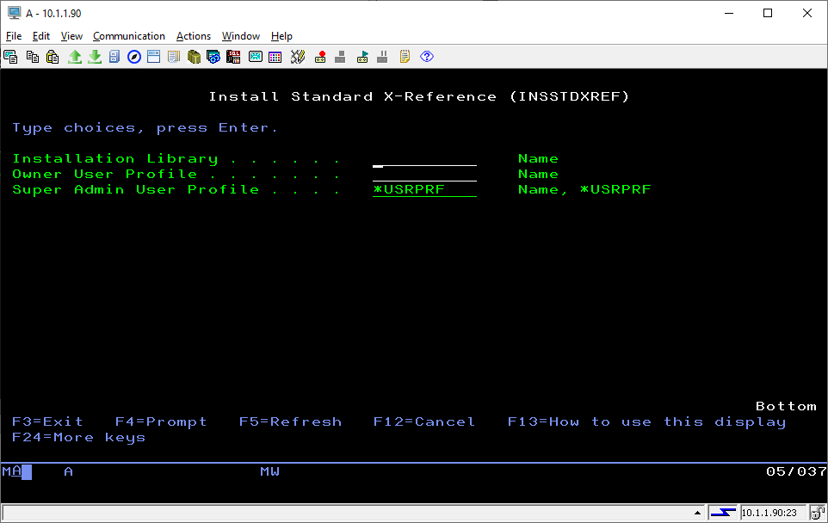

The three required parameters:

* The Installation Library is where the source code, service programs and SQL functions will go. It must not already exist on the system.
* The Owner User Profile will own all objects in the installation library. If it does not exist, a user profile of user class *PGMR will be created with a default password.
* The Super Admin User Profile will have full authority to create, maintain and delete reference tables, as well as delegating such rights to other users. This will default to match the Owner User Profile, or may be overridden with an existing user profile.

**Note:** Your system must be capable of compiling full freeform RPG. Therefore, IBM i release 7.2 or higher is required. Installing the latest available PTF cumulative and group packages is always recommended prior to installing STDXREF. The installation process will attempt to compile a program named VERIFYRPG to see if your system meets the prerequisites. If it does not, the installation will terminate immediately.

Once the command completes (generally under 1 minute), you will have the following:

* A standard SQL schema with the name specified as the installation library.
* Table STDXREF.
  + Associated indexes.
  + If the system is on V7R3 or higher, STDXREF is defined as a temporal table with a history file of STDXREFH automatically created.
* Service program STDXREFIOP, containing I/O and validation procedures (includes display file).
* Service program STDXREFFNC, containing functions for use in application programs.
* SQL functions for most exported procedures in both service program.
* 5250-based maintenance programs.
  + STDXREFMN2 (current version). Includes matching display file and command.
  + STDXREFMNT (legacy version). Includes matching display file and command.
* Command and C/L program STDXREFLST to provide spooled listing of table entries.
  + *CURRENT version uses function PRINTXREFTABLE in service program STDXREFIOP.
  + *LEGACY version uses Query Management Query and form STDXREFLST.
* Menu STDXREFS.

**Now, what do I do with it?**

Examples of how cross reference tables could be used:

* Codes/categories with associated descriptions.
* Codes/categories with associated percentage or unit price.
* Company number / keyword combination with associated value.
* Basically any 1-to-1 relationship where an identifier has a finite set of possibilities.
  + A much better alternative to traditional compile time tables in RPG, or to scores of tables whose sole purpose is to reflect a 1-to-1 relationship.
  + Also a better alternative to hard coding valid values in program code.
  + 2-to-1, 3-to-1, 1-to-2, 1-to-3, 2-to-3 and 3-2 relationships are supported, but 1-to-1 is the norm.

Some things you might want to consider:

* Table STDXREF and its associated indexes were created in the installation library. You might choose to move these objects into your live application data library as well as your test application data library.
* You might consider adding the installation library to your application library list. Or, if STDXREF is used across multiple applications, consider adding the library to QUSRLIBL.
* Since this is an open source project, please use the GitHub page to provide ideas for enhancements and to report any issues you may discover.

Start by building a cross reference table. Go to menu STDXREFS. The Technical Reference contains a section about the 5250-based maintenance utility.