**Report Mods Framework**

**INSTALLATION INSTRUCTIONS**

**Prerequisites:**

* IBM i 7.1 or higher. Latest cumulative PTF’s always recommended.
* 5770-TS1 (Transform Services for i) *BASE and option 1.
* 5770-WDS (IBM Rational Development Studio for i) option 31 (ILE RPG).

Download the installation save file RPTMODINS.SAVF to your hard drive in an easy to reach directory, preferably one at the root level of C. For example: C:\mydir

On your IBM i:

* Create a save file on your IBM i: CRTSAVF FILE(MYLIB/RPTMODINS)

From your desktop PC:

* Open the DOS command prompt
* FTP a.b.c.d <enter> (where a.b.c.d is the IP address of your IBM i)
* Enter user and password as prompted
* BIN <enter>
* PUT C:\MYDIR\RPTMODINS.SAVF MYLIB/RPTMODINS.SAVF <enter>
* QUIT <enter>

Back to your IBM i:

* Sign on as a user with *SECOFR authority
* Restore the installation objects to QTEMP:
  + RSTOBJ OBJ(*ALL) SAVLIB(RPTMODINS) DEV(*SAVF) SAVF(MYLIB/RPTMODINS) MBROPT(*ALL) ALWOBJDIF(*ALL) RSTLIB(QTEMP)
* Ensure that QTEMP is in your library list: ADDLIBLE LIB(QTEMP)
* Enter the command INSRMFSVR and prompt with F4.

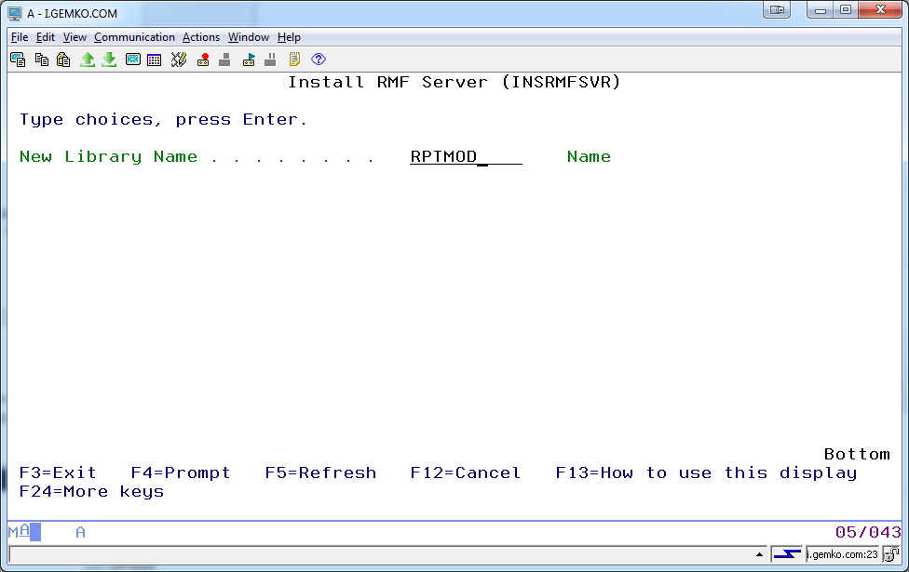

Enter the name of a new library which will contain the following objects upon completion:

* Subsystem description RPTMOD.
* Job description RPTMOD, to describe the auto start server job.
* Job queue RPTMOD, automatically associated with subsystem RPTMOD.
* Data queue RPTMOD, to receiving notifications from selected output queues.
* Server program RPTMOD, to process notifications from the data queue.
* SQL table RPTMOD and index RPTMODL1, to contain the rules for processing the notifications.
* SQL table SPLFGRID, used in the transfer of spooled file content to memory.
* Dummy physical file PCASCII, used in the creation of an ASCII stream file shell.
* Source physical files QCLSRC, QCMDSRC, QFTPSRC, QRPGLESRC and QTXTSRC.
* Physical file QOVLSRC for converted overlay source.
* Command CRTOVLSTMF and associated CL processing program of the same name.

To start the engine, simply start subsystem RPTMOD in the library name you specified. You might want to consider adding a STRSBS command to your QSTRUP job so that the subsystem starts at IPL.

See the User Guide for instructions on how to leverage this engine.

Copyright (C) 2004, 2017 Christopher F. Burns, Sr. c/o GEMKO Information Group (http://www.gemko.com)