Mike Harvey

CSCI165 Module 1

TASK: Install Java 13

Screenshot:

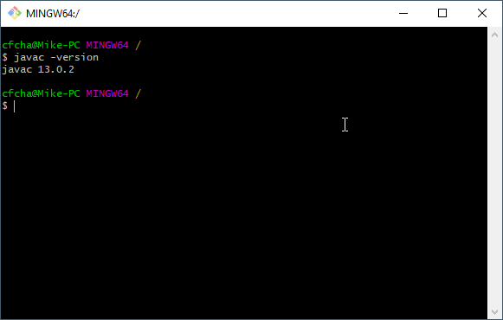

TASK: Set JAVA_HOME variable

Screenshot: 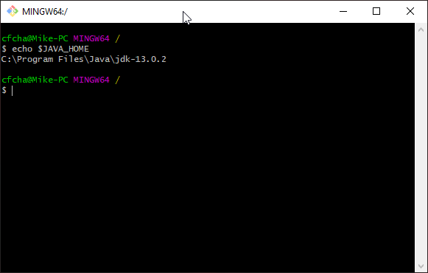

TASK: Set JAVAFX variable

Screenshot:

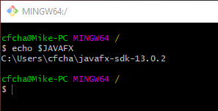

TASK: Test Installation

Screenshot:

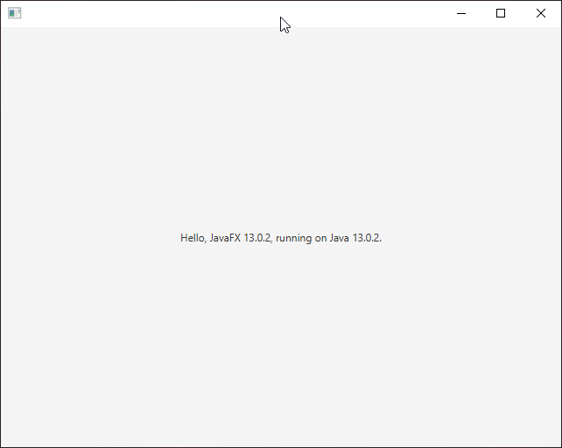

TASK: Hello World

Screenshot:

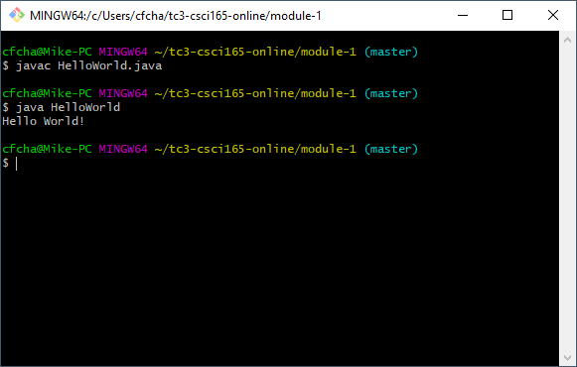

TASK: HelloWorld2: Enter the arguments

Screenshot:

