DESIGN SOLUTION

Project Title: Quality Control & Monitoring of Surgical Mask Production with Python

Revision: 0.1
Date: 23-10-2023

Description of Solution:
- The team is proposing a software program, written in Python language to support the Quality Control & Monitoring of surgical mask manufacturing.
- The screening process will be performed at the tail-end of the manufacturing process before endorsing whether to approve for the dispatching of the mask to warehouse for distribution to clients.
- The Python program will analyse the quality of the completed surgical mask through measurement of the sampled surgical mask against the golden reference dataset of selected parameters.

Evaluation of Solution Features and Functions:
- The program will allow the User (Quality Engineer) to load the measurement data of the surgical mask into the system.
- User can then perform statistical analysis for the new measured batch of surgical mask and inspect the quality of the output batch using computational analysis
- The program will by default determine whether the batch of surgical mask is approved for dispatch based on the quality analysis result.
- User can also perform manual overwrite for the approval status when abnormal data trend is observed by raising investigation report. The program will then set the batch to “hold” state while pending for investigation report to complete. Batch which has investigation report will have its analysis result append tagged with “I” (e.g., DDMMYY_BATCH_NO_RESULT_I). This will facilitate easier data query for future investigation process.
- The program will provide functions that allows User to perform the task of quality inspection for the surgical mask and also includes housekeeping of data records. The key functions are:
  - Add/Update of measurement dataset;
  - Add/Update golden reference dataset;
  - Perform and display statistical analysis of the new dataset;
  - Query 3-month moving average of performance measurement summary;
  - Add/Update/Remove investigation report;
  - Persist dataset to flat file.
- The program will allow insert of measured result for batch of surgical mask which the batch number is different from the current running sequence. As the batch analysis result are sorted in ascending order in the flat file (DDMMYY_BATCH_NO_RESULT), therefore, to insert a batch result which is earlier than the last entry (usually this is the latest analysed dataset) in the flat file, the program will search through the records and insert the result at the correct position in the flat file.
- The program will provide automatic feedback to User (Quality Engineer) when detected drifting in measurement against the golden reference data. (procedural programming)
- User will be able update through the program whether a batch is impacted by other ongoing investigations and provide an appropriate release decision status:
  - Fit for release to dispatch
  - Not fit for release to dispatch
- The data for that day will be saved and can be retrieved from the flat file for assessment if there are complaints from clients.

Design and Implementation Considerations:
- Design solution shall cover the following:
  - Include the UML diagram to describe the relationship between the key software modules interface.
  - Include the flow diagram to illustrate the sequencing of events for the software application.
  - The design solution shall achieve the project criteria as shown in Appendix A.
- The implementation approach for the program shall consider the followings:
  - Implementation of common functions in def and class
  - Data generated from the statistical analysis will be purged to CSV files
- The program solution shall not use external Python packages e.g. Numpy and Pandas

Supporting Documents
Assessment criteria for software application
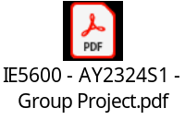

Sample dataset of measurement parameters for surgical mask:
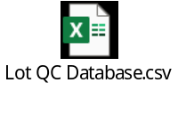

Sample dataset of Quality Control Specifications
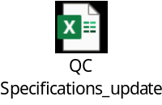

Inspection process flow for surgical mask manufacturing
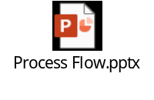

Proposed Use Cases
Refer to GP02(Submitted)_baselined_v1.0.docx in Teams.

Impact Analysis:
To be confirm

Testing | Description
Unit Test | Yes
Load Test | Yes
Performance Test | No

