Meta-análises

Clarissa F. D. Carneiro

2022-10-18

## Warning: Paket 'readxl' wurde unter R Version 4.1.3 erstellt

## Warning: Paket 'tidyverse' wurde unter R Version 4.1.3 erstellt

## -- Attaching packages --------------------------------------- tidyverse 1.3.2 --  
## v ggplot2 3.4.0 v purrr 1.0.0   
## v tibble 3.1.8 v dplyr 1.0.10  
## v tidyr 1.2.1 v stringr 1.5.0   
## v readr 2.1.3 v forcats 0.5.2

## Warning: Paket 'ggplot2' wurde unter R Version 4.1.3 erstellt

## Warning: Paket 'tibble' wurde unter R Version 4.1.3 erstellt

## Warning: Paket 'tidyr' wurde unter R Version 4.1.3 erstellt

## Warning: Paket 'readr' wurde unter R Version 4.1.3 erstellt

## Warning: Paket 'purrr' wurde unter R Version 4.1.3 erstellt

## Warning: Paket 'dplyr' wurde unter R Version 4.1.3 erstellt

## Warning: Paket 'stringr' wurde unter R Version 4.1.3 erstellt

## Warning: Paket 'forcats' wurde unter R Version 4.1.3 erstellt

## -- Conflicts ------------------------------------------ tidyverse_conflicts() --  
## x dplyr::filter() masks stats::filter()  
## x dplyr::lag() masks stats::lag()

## Warning: Paket 'metafor' wurde unter R Version 4.1.3 erstellt

## Lade nötiges Paket: Matrix

## Warning: Paket 'Matrix' wurde unter R Version 4.1.3 erstellt

##   
## Attache Paket: 'Matrix'  
##   
## Die folgenden Objekte sind maskiert von 'package:tidyr':  
##   
## expand, pack, unpack  
##   
## Lade nötiges Paket: metadat  
##   
## Loading the 'metafor' package (version 3.8-1). For an  
## introduction to the package please type: help(metafor)

## Warning: Paket 'metaviz' wurde unter R Version 4.1.3 erstellt

## Warning: Paket 'glmulti' wurde unter R Version 4.1.3 erstellt

## Lade nötiges Paket: rJava  
## Lade nötiges Paket: leaps

## Warning: Paket 'leaps' wurde unter R Version 4.1.3 erstellt

## Warning: Paket 'knitr' wurde unter R Version 4.1.3 erstellt

Depois da limpeza, importamos dados de volta para análises.

## Warning: Expecting numeric in V1216 / R1216C22: got '95.770; 79.780; 89.150;  
## 100.200; 105.100; 96.320; 102.400'

## Warning: Expecting numeric in X1216 / R1216C24: got '2.022; 4.228; 5.331; 2.390;  
## 2.757; 4.044; 3.125'

Para análises, precisamos da média e n dos dois grupos e da variacao no tratado, seja SEM, SD ou Unclear. Excluímos todos os casos em que falta pelo menos um desses valores.

Para montar um fluxograma: Número de comparações extraídas = 1652 Número de comparações excluídas por falta de dados = 453

Outras limpezas:

Como re-extraímos alguns valores durante a verificacao de outliers, precisamos usar esses valores corrigidos

Calculei SDs a partir de SEMs (se estava ‘unclear’, considerei SEM).

Para usar SMD, precisamos do SD dos dois grupos necessariamente - decidimos considerar sd do controle igual ao tratado (que vai ser igual ao pooled).

# 2-level

Meta-análise (2-level SMD)

##   
## Random-Effects Model (k = 1199; tau^2 estimator: REML)  
##   
## logLik deviance AIC BIC AICc   
## -3729.4212 7458.8424 7462.8424 7473.0192 7462.8524   
##   
## tau^2 (estimated amount of total heterogeneity): 12.2884 (SE = 0.6310)  
## tau (square root of estimated tau^2 value): 3.5055  
## I^2 (total heterogeneity / total variability): 91.86%  
## H^2 (total variability / sampling variability): 12.29  
##   
## Test for Heterogeneity:  
## Q(df = 1198) = 7182.0443, p-val < .0001  
##   
## Model Results:  
##   
## estimate se zval pval ci.lb ci.ub   
## -4.6388 0.1159 -40.0219 <.0001 -4.8660 -4.4116 ***   
##   
## ---  
## Signif. codes: 0 '***' 0.001 '**' 0.01 '*' 0.05 '.' 0.1 ' ' 1

##   
## estimate ci.lb ci.ub   
## tau^2 12.2884 23.4240 31.0726   
## tau 3.5055 4.8398 5.5743   
## I^2(%) 91.8632 95.5596 96.6156   
## H^2 12.2899 22.5205 29.5476

OBS: aqui tem mais uma exclusao de uma comparacao por causa de n=1

|  |
| --- |
| OBS: Outliers e limpezas adicionais |
| Sobre o alerta “Ratio of largest to smallest sampling variance extremely large. May not be able to obtain stable results.”, ver essa discussao: <https://stat.ethz.ch/pipermail/r-sig-meta-analysis/2019-February/001426.html> Ao observar esse erro, decidimos voltar e avaliar os outliers. Análises no script 3,5. |

Forest plot (SMD)

# 3-level

Meta-análise (3-level SMD)

##   
## Multivariate Meta-Analysis Model (k = 1199; method: REML)  
##   
## Variance Components:  
##   
## estim sqrt nlvls fixed factor   
## sigma^2.1 7.4350 2.7267 359 no rayyan.key   
## sigma^2.2 5.3878 2.3212 1199 no rayyan.key/Comparison_ID   
##   
## Test for Heterogeneity:  
## Q(df = 1198) = 7182.0443, p-val < .0001  
##   
## Model Results:  
##   
## estimate se zval pval ci.lb ci.ub   
## -5.2780 0.1864 -28.3164 <.0001 -5.6434 -4.9127 ***   
##   
## ---  
## Signif. codes: 0 '***' 0.001 '**' 0.01 '*' 0.05 '.' 0.1 ' ' 1

## $results  
## % of total variance I2  
## Level 1 7.824227 ---  
## Level 2 (exp) 38.729845 38.73  
## Level 3 (art) 53.445928 53.45  
##   
## $totalI2  
## [1] 92.17577  
##   
## $plot

##   
## attr(,"class")  
## [1] "mlm.variance.distribution" "list"

### excluindo n de replicatas ou outras unidades nao independentes

##   
## n_definition n   
## 1 assays 20   
## 2 biological replicates 5   
## 3 cell cultures 2   
## 4 determinations 8   
## 5 experiments 107   
## 6 independent determinations 13   
## 7 independent experimental measurements 6   
## 8 independent experiments 547   
## 9 independent repetitions 2   
## 10 independent replicates 2   
## 11 independent sets of studies 1   
## 12 observations 1   
## 13 replicates 218   
## 14 samples 12   
## 15 wells 24   
## 16 <NA> 231

##   
## Multivariate Meta-Analysis Model (k = 571; method: REML)  
##   
## Variance Components:  
##   
## estim sqrt nlvls fixed factor   
## sigma^2.1 8.1900 2.8618 170 no rayyan.key   
## sigma^2.2 5.1667 2.2730 571 no rayyan.key/Comparison_ID   
##   
## Test for Heterogeneity:  
## Q(df = 570) = 3026.8419, p-val < .0001  
##   
## Model Results:  
##   
## estimate se zval pval ci.lb ci.ub   
## -5.4876 0.2808 -19.5427 <.0001 -6.0380 -4.9372 ***   
##   
## ---  
## Signif. codes: 0 '***' 0.001 '**' 0.01 '*' 0.05 '.' 0.1 ' ' 1

## $results  
## % of total variance I2  
## Level 1 9.378013 ---  
## Level 2 (exp) 35.054800 35.05  
## Level 3 (art) 55.567187 55.57  
##   
## $totalI2  
## [1] 90.62199  
##   
## $plot

##   
## attr(,"class")  
## [1] "mlm.variance.distribution" "list"

## Publication bias

Trim-and-fill (only for 2-level model)

Funnel plot

## Warning: Removed 1 rows containing missing values (`geom_point()`).

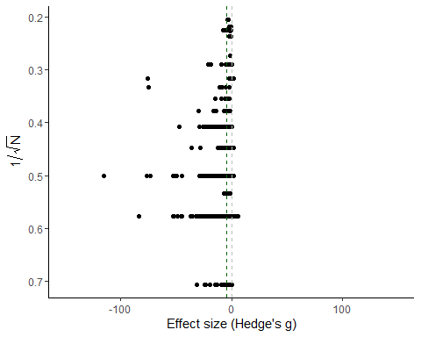

Egger’s regression

##   
## Regression Test for Funnel Plot Asymmetry  
##   
## Model: mixed-effects meta-regression model  
## Predictor: inverse of the square root sample size  
##   
## Test for Funnel Plot Asymmetry: z = -2.4498, p = 0.0143  
## Limit Estimate (as ni -> inf): b = -3.1224 (CI: -4.3534, -1.8913)

# Meta-regressions (3-level)

Differentiation

##   
## Multivariate Meta-Analysis Model (k = 1199; method: REML)  
##   
## Variance Components:  
##   
## estim sqrt nlvls fixed factor   
## sigma^2.1 7.5328 2.7446 359 no rayyan.key   
## sigma^2.2 5.3688 2.3171 1199 no rayyan.key/Comparison_ID   
##   
## Test for Residual Heterogeneity:  
## QE(df = 1193) = 7112.4773, p-val < .0001  
##   
## Test of Moderators (coefficients 2:6):  
## QM(df = 5) = 9.5094, p-val = 0.0904  
##   
## Model Results:  
##   
## estimate   
## intrcpt -5.4078   
## relevel(factor(dados_meta_smd$Diferentiation_method), ref = "No differentiation")ATRA 1.2629   
## relevel(factor(dados_meta_smd$Diferentiation_method), ref = "No differentiation")ATRA plus -0.5433   
## relevel(factor(dados_meta_smd$Diferentiation_method), ref = "No differentiation")Other 0.0195   
## relevel(factor(dados_meta_smd$Diferentiation_method), ref = "No differentiation")unclear 4.9547   
## relevel(factor(dados_meta_smd$Diferentiation_method), ref = "No differentiation")Unclear -1.0424   
## se   
## intrcpt 0.2054   
## relevel(factor(dados_meta_smd$Diferentiation_method), ref = "No differentiation")ATRA 0.5350   
## relevel(factor(dados_meta_smd$Diferentiation_method), ref = "No differentiation")ATRA plus 0.7357   
## relevel(factor(dados_meta_smd$Diferentiation_method), ref = "No differentiation")Other 1.3416   
## relevel(factor(dados_meta_smd$Diferentiation_method), ref = "No differentiation")unclear 2.9069   
## relevel(factor(dados_meta_smd$Diferentiation_method), ref = "No differentiation")Unclear 2.1143   
## zval   
## intrcpt -26.3334   
## relevel(factor(dados_meta_smd$Diferentiation_method), ref = "No differentiation")ATRA 2.3604   
## relevel(factor(dados_meta_smd$Diferentiation_method), ref = "No differentiation")ATRA plus -0.7385   
## relevel(factor(dados_meta_smd$Diferentiation_method), ref = "No differentiation")Other 0.0146   
## relevel(factor(dados_meta_smd$Diferentiation_method), ref = "No differentiation")unclear 1.7045   
## relevel(factor(dados_meta_smd$Diferentiation_method), ref = "No differentiation")Unclear -0.4930   
## pval   
## intrcpt <.0001   
## relevel(factor(dados_meta_smd$Diferentiation_method), ref = "No differentiation")ATRA 0.0183   
## relevel(factor(dados_meta_smd$Diferentiation_method), ref = "No differentiation")ATRA plus 0.4602   
## relevel(factor(dados_meta_smd$Diferentiation_method), ref = "No differentiation")Other 0.9884   
## relevel(factor(dados_meta_smd$Diferentiation_method), ref = "No differentiation")unclear 0.0883   
## relevel(factor(dados_meta_smd$Diferentiation_method), ref = "No differentiation")Unclear 0.6220   
## ci.lb   
## intrcpt -5.8103   
## relevel(factor(dados_meta_smd$Diferentiation_method), ref = "No differentiation")ATRA 0.2143   
## relevel(factor(dados_meta_smd$Diferentiation_method), ref = "No differentiation")ATRA plus -1.9851   
## relevel(factor(dados_meta_smd$Diferentiation_method), ref = "No differentiation")Other -2.6100   
## relevel(factor(dados_meta_smd$Diferentiation_method), ref = "No differentiation")unclear -0.7426   
## relevel(factor(dados_meta_smd$Diferentiation_method), ref = "No differentiation")Unclear -5.1863   
## ci.ub   
## intrcpt -5.0053   
## relevel(factor(dados_meta_smd$Diferentiation_method), ref = "No differentiation")ATRA 2.3115   
## relevel(factor(dados_meta_smd$Diferentiation_method), ref = "No differentiation")ATRA plus 0.8986   
## relevel(factor(dados_meta_smd$Diferentiation_method), ref = "No differentiation")Other 2.6491   
## relevel(factor(dados_meta_smd$Diferentiation_method), ref = "No differentiation")unclear 10.6521   
## relevel(factor(dados_meta_smd$Diferentiation_method), ref = "No differentiation")Unclear 3.1015   
##   
## intrcpt ***   
## relevel(factor(dados_meta_smd$Diferentiation_method), ref = "No differentiation")ATRA *   
## relevel(factor(dados_meta_smd$Diferentiation_method), ref = "No differentiation")ATRA plus   
## relevel(factor(dados_meta_smd$Diferentiation_method), ref = "No differentiation")Other   
## relevel(factor(dados_meta_smd$Diferentiation_method), ref = "No differentiation")unclear .   
## relevel(factor(dados_meta_smd$Diferentiation_method), ref = "No differentiation")Unclear   
##   
## ---  
## Signif. codes: 0 '***' 0.001 '**' 0.01 '*' 0.05 '.' 0.1 ' ' 1

Differentiation bubble plot

## Warning in geom_abline(yintercept = 0, slope = 0, linetype = "dashed", color =  
## "grey"): Ignoring unknown parameters: `yintercept`

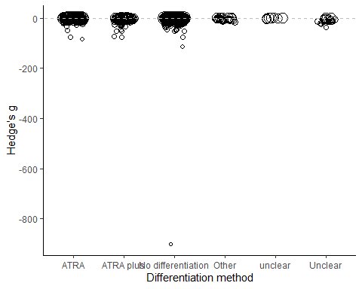

Diff. duration

## Warning: Rows with NAs omitted from model fitting.

##   
## Multivariate Meta-Analysis Model (k = 237; method: REML)  
##   
## Variance Components:  
##   
## estim sqrt nlvls fixed factor   
## sigma^2.1 23.2132 4.8180 62 no rayyan.key   
## sigma^2.2 3.6187 1.9023 237 no rayyan.key/Comparison_ID   
##   
## Test for Residual Heterogeneity:  
## QE(df = 225) = 1299.8106, p-val < .0001  
##   
## Test of Moderators (coefficients 2:12):  
## QM(df = 11) = 19.7929, p-val = 0.0483  
##   
## Model Results:  
##   
## estimate se zval   
## intrcpt -7.8424 2.4113 -3.2523   
## dados_meta_smd$Diferentiation_duration_days10.0 -4.1827 3.6715 -1.1392   
## dados_meta_smd$Diferentiation_duration_days12.0 5.0532 5.8276 0.8671   
## dados_meta_smd$Diferentiation_duration_days14.0 2.9320 4.2731 0.6862   
## dados_meta_smd$Diferentiation_duration_days3.0 -0.0437 3.0803 -0.0142   
## dados_meta_smd$Diferentiation_duration_days4.0 6.4112 3.2967 1.9447   
## dados_meta_smd$Diferentiation_duration_days5.0 -0.6896 3.1944 -0.2159   
## dados_meta_smd$Diferentiation_duration_days6.0 3.3771 2.7549 1.2259   
## dados_meta_smd$Diferentiation_duration_days7.0 4.6439 2.7454 1.6915   
## dados_meta_smd$Diferentiation_duration_days8.0 3.4484 3.0513 1.1302   
## dados_meta_smd$Diferentiation_duration_days9.0 5.8111 5.5294 1.0509   
## dados_meta_smd$Diferentiation_duration_daysUnclear 1.0967 3.3573 0.3267   
## pval ci.lb ci.ub   
## intrcpt 0.0011 -12.5685 -3.1163   
## dados_meta_smd$Diferentiation_duration_days10.0 0.2546 -11.3787 3.0133   
## dados_meta_smd$Diferentiation_duration_days12.0 0.3859 -6.3687 16.4752   
## dados_meta_smd$Diferentiation_duration_days14.0 0.4926 -5.4431 11.3071   
## dados_meta_smd$Diferentiation_duration_days3.0 0.9887 -6.0809 5.9935   
## dados_meta_smd$Diferentiation_duration_days4.0 0.0518 -0.0503 12.8727   
## dados_meta_smd$Diferentiation_duration_days5.0 0.8291 -6.9506 5.5713   
## dados_meta_smd$Diferentiation_duration_days6.0 0.2203 -2.0224 8.7765   
## dados_meta_smd$Diferentiation_duration_days7.0 0.0907 -0.7369 10.0248   
## dados_meta_smd$Diferentiation_duration_days8.0 0.2584 -2.5319 9.4288   
## dados_meta_smd$Diferentiation_duration_days9.0 0.2933 -5.0264 16.6486   
## dados_meta_smd$Diferentiation_duration_daysUnclear 0.7439 -5.4834 7.6768   
##   
## intrcpt **   
## dados_meta_smd$Diferentiation_duration_days10.0   
## dados_meta_smd$Diferentiation_duration_days12.0   
## dados_meta_smd$Diferentiation_duration_days14.0   
## dados_meta_smd$Diferentiation_duration_days3.0   
## dados_meta_smd$Diferentiation_duration_days4.0 .   
## dados_meta_smd$Diferentiation_duration_days5.0   
## dados_meta_smd$Diferentiation_duration_days6.0   
## dados_meta_smd$Diferentiation_duration_days7.0 .   
## dados_meta_smd$Diferentiation_duration_days8.0   
## dados_meta_smd$Diferentiation_duration_days9.0   
## dados_meta_smd$Diferentiation_duration_daysUnclear   
##   
## ---  
## Signif. codes: 0 '***' 0.001 '**' 0.01 '*' 0.05 '.' 0.1 ' ' 1

Diff. duration bubble plot

## Warning in FUN(X[[i]], ...): NAs durch Umwandlung erzeugt

## Warning: Removed 976 rows containing missing values (`geom_point()`).

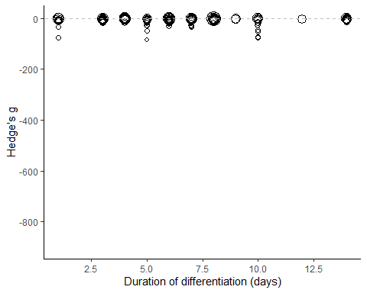

Aggregation

## Warning: Rows with NAs omitted from model fitting.

##   
## Multivariate Meta-Analysis Model (k = 1198; method: REML)  
##   
## Variance Components:  
##   
## estim sqrt nlvls fixed factor   
## sigma^2.1 7.4586 2.7310 359 no rayyan.key   
## sigma^2.2 5.2419 2.2895 1198 no rayyan.key/Comparison_ID   
##   
## Test for Residual Heterogeneity:  
## QE(df = 1194) = 6923.1126, p-val < .0001  
##   
## Test of Moderators (coefficients 2:4):  
## QM(df = 3) = 18.6768, p-val = 0.0003  
##   
## Model Results:  
##   
## estimate   
## intrcpt -5.6801   
## relevel(factor(dados_meta_smd$Abeta_aggregation), ref = "Unclear")Fibers -0.2812   
## relevel(factor(dados_meta_smd$Abeta_aggregation), ref = "Unclear")Monomers 1.8739   
## relevel(factor(dados_meta_smd$Abeta_aggregation), ref = "Unclear")Oligomers 0.9218   
## se   
## intrcpt 0.2501   
## relevel(factor(dados_meta_smd$Abeta_aggregation), ref = "Unclear")Fibers 0.5167   
## relevel(factor(dados_meta_smd$Abeta_aggregation), ref = "Unclear")Monomers 0.5819   
## relevel(factor(dados_meta_smd$Abeta_aggregation), ref = "Unclear")Oligomers 0.3566   
## zval   
## intrcpt -22.7069   
## relevel(factor(dados_meta_smd$Abeta_aggregation), ref = "Unclear")Fibers -0.5443   
## relevel(factor(dados_meta_smd$Abeta_aggregation), ref = "Unclear")Monomers 3.2201   
## relevel(factor(dados_meta_smd$Abeta_aggregation), ref = "Unclear")Oligomers 2.5845   
## pval   
## intrcpt <.0001   
## relevel(factor(dados_meta_smd$Abeta_aggregation), ref = "Unclear")Fibers 0.5862   
## relevel(factor(dados_meta_smd$Abeta_aggregation), ref = "Unclear")Monomers 0.0013   
## relevel(factor(dados_meta_smd$Abeta_aggregation), ref = "Unclear")Oligomers 0.0098   
## ci.lb   
## intrcpt -6.1704   
## relevel(factor(dados_meta_smd$Abeta_aggregation), ref = "Unclear")Fibers -1.2939   
## relevel(factor(dados_meta_smd$Abeta_aggregation), ref = "Unclear")Monomers 0.7333   
## relevel(factor(dados_meta_smd$Abeta_aggregation), ref = "Unclear")Oligomers 0.2228   
## ci.ub   
## intrcpt -5.1898   
## relevel(factor(dados_meta_smd$Abeta_aggregation), ref = "Unclear")Fibers 0.7314   
## relevel(factor(dados_meta_smd$Abeta_aggregation), ref = "Unclear")Monomers 3.0144   
## relevel(factor(dados_meta_smd$Abeta_aggregation), ref = "Unclear")Oligomers 1.6208   
##   
## intrcpt ***   
## relevel(factor(dados_meta_smd$Abeta_aggregation), ref = "Unclear")Fibers   
## relevel(factor(dados_meta_smd$Abeta_aggregation), ref = "Unclear")Monomers **   
## relevel(factor(dados_meta_smd$Abeta_aggregation), ref = "Unclear")Oligomers **   
##   
## ---  
## Signif. codes: 0 '***' 0.001 '**' 0.01 '*' 0.05 '.' 0.1 ' ' 1

Aggregation bubble plot

## Warning in geom_abline(yintercept = 0, slope = 0, linetype = "dashed", color =  
## "grey"): Ignoring unknown parameters: `yintercept`

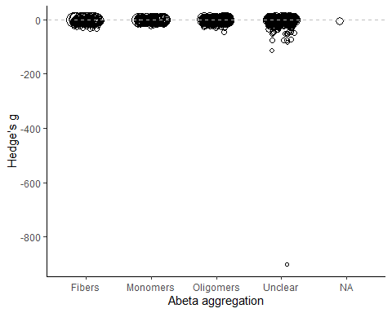

Abeta concentration

##   
## Multivariate Meta-Analysis Model (k = 1181; method: REML)  
##   
## Variance Components:  
##   
## estim sqrt nlvls fixed factor   
## sigma^2.1 7.0196 2.6494 352 no rayyan.key   
## sigma^2.2 5.5220 2.3499 1181 no rayyan.key/Comparison_ID   
##   
## Test for Residual Heterogeneity:  
## QE(df = 1179) = 7073.6479, p-val < .0001  
##   
## Test of Moderators (coefficient 2):  
## QM(df = 1) = 17.6891, p-val < .0001  
##   
## Model Results:  
##   
## estimate se zval pval   
## intrcpt -5.0507 0.1907 -26.4801 <.0001   
## dados_meta_smd_max2500$Concentration_uM -0.0150 0.0036 -4.2058 <.0001   
## ci.lb ci.ub   
## intrcpt -5.4245 -4.6769 ***   
## dados_meta_smd_max2500$Concentration_uM -0.0220 -0.0080 ***   
##   
## ---  
## Signif. codes: 0 '***' 0.001 '**' 0.01 '*' 0.05 '.' 0.1 ' ' 1

Abeta concentration bubble plot 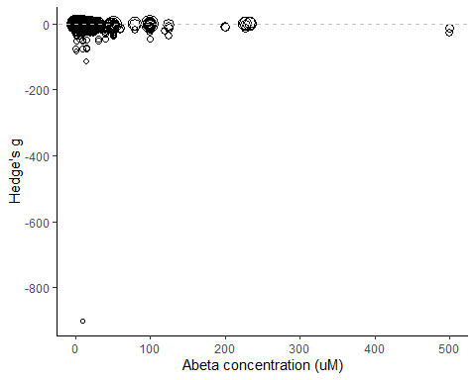

Abeta duration of exposure

## Warning: Rows with NAs omitted from model fitting.

##   
## Multivariate Meta-Analysis Model (k = 1188; method: REML)  
##   
## Variance Components:  
##   
## estim sqrt nlvls fixed factor   
## sigma^2.1 7.6266 2.7616 353 no rayyan.key   
## sigma^2.2 5.2529 2.2919 1188 no rayyan.key/Comparison_ID   
##   
## Test for Residual Heterogeneity:  
## QE(df = 1186) = 7119.4679, p-val < .0001  
##   
## Test of Moderators (coefficient 2):  
## QM(df = 1) = 16.1797, p-val < .0001  
##   
## Model Results:  
##   
## estimate se zval pval   
## intrcpt -4.1984 0.3317 -12.6570 <.0001   
## as.numeric(dados_meta_smd$Duration_hours) -0.0339 0.0084 -4.0224 <.0001   
## ci.lb ci.ub   
## intrcpt -4.8485 -3.5482 ***   
## as.numeric(dados_meta_smd$Duration_hours) -0.0504 -0.0174 ***   
##   
## ---  
## Signif. codes: 0 '***' 0.001 '**' 0.01 '*' 0.05 '.' 0.1 ' ' 1

Abeta duration bubble plot

## Warning: Removed 11 rows containing missing values (`geom_point()`).

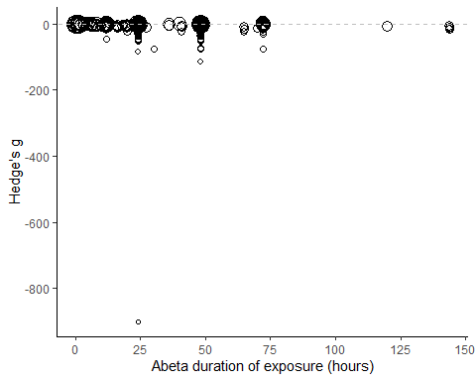

Assay

## Warning: Rows with NAs omitted from model fitting.

##   
## Multivariate Meta-Analysis Model (k = 1192; method: REML)  
##   
## Variance Components:  
##   
## estim sqrt nlvls fixed factor   
## sigma^2.1 7.4783 2.7346 358 no rayyan.key   
## sigma^2.2 5.5075 2.3468 1192 no rayyan.key/Comparison_ID   
##   
## Test for Residual Heterogeneity:  
## QE(df = 1186) = 7095.0321, p-val < .0001  
##   
## Test of Moderators (coefficients 2:6):  
## QM(df = 5) = 2.5776, p-val = 0.7648  
##   
## Model Results:  
##   
## estimate se   
## intrcpt -5.4025 0.2060   
## relevel(factor(dados_meta_smd$Assay), ref = "MTT")CCK-8 -0.0048 0.9684   
## relevel(factor(dados_meta_smd$Assay), ref = "MTT")EZ4U -0.2371 2.9840   
## relevel(factor(dados_meta_smd$Assay), ref = "MTT")MTS 0.1711 0.9262   
## relevel(factor(dados_meta_smd$Assay), ref = "MTT")WST 1.1639 0.7417   
## relevel(factor(dados_meta_smd$Assay), ref = "MTT")XTT 0.5414 1.5561   
## zval pval   
## intrcpt -26.2304 <.0001   
## relevel(factor(dados_meta_smd$Assay), ref = "MTT")CCK-8 -0.0049 0.9961   
## relevel(factor(dados_meta_smd$Assay), ref = "MTT")EZ4U -0.0795 0.9367   
## relevel(factor(dados_meta_smd$Assay), ref = "MTT")MTS 0.1848 0.8534   
## relevel(factor(dados_meta_smd$Assay), ref = "MTT")WST 1.5692 0.1166   
## relevel(factor(dados_meta_smd$Assay), ref = "MTT")XTT 0.3479 0.7279   
## ci.lb ci.ub   
## intrcpt -5.8061 -4.9988 ***   
## relevel(factor(dados_meta_smd$Assay), ref = "MTT")CCK-8 -1.9028 1.8933   
## relevel(factor(dados_meta_smd$Assay), ref = "MTT")EZ4U -6.0857 5.6114   
## relevel(factor(dados_meta_smd$Assay), ref = "MTT")MTS -1.6442 1.9865   
## relevel(factor(dados_meta_smd$Assay), ref = "MTT")WST -0.2898 2.6175   
## relevel(factor(dados_meta_smd$Assay), ref = "MTT")XTT -2.5084 3.5913   
##   
## ---  
## Signif. codes: 0 '***' 0.001 '**' 0.01 '*' 0.05 '.' 0.1 ' ' 1

Assay bubble plot

## Warning in geom_abline(yintercept = 0, slope = 0, linetype = "dashed", color =  
## "grey"): Ignoring unknown parameters: `yintercept`

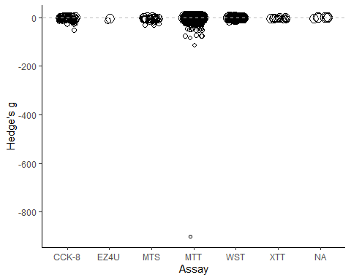

Cell density

## Warning: Rows with NAs omitted from model fitting.

##   
## Multivariate Meta-Analysis Model (k = 694; method: REML)  
##   
## Variance Components:  
##   
## estim sqrt nlvls fixed factor   
## sigma^2.1 8.2272 2.8683 211 no rayyan.key   
## sigma^2.2 5.8980 2.4286 694 no rayyan.key/Comparison_ID   
##   
## Test for Residual Heterogeneity:  
## QE(df = 692) = 4104.3383, p-val < .0001  
##   
## Test of Moderators (coefficient 2):  
## QM(df = 1) = 0.0027, p-val = 0.9588  
##   
## Model Results:  
##   
## estimate se zval pval   
## intrcpt -5.5833 0.2611 -21.3867 <.0001   
## as.numeric(dados_meta_smd$Cell_density) 0.0000 0.0000 0.0517 0.9588   
## ci.lb ci.ub   
## intrcpt -6.0950 -5.0716 ***   
## as.numeric(dados_meta_smd$Cell_density) -0.0000 0.0000   
##   
## ---  
## Signif. codes: 0 '***' 0.001 '**' 0.01 '*' 0.05 '.' 0.1 ' ' 1

Cell density bubble plot

## Warning: Removed 505 rows containing missing values (`geom_point()`).

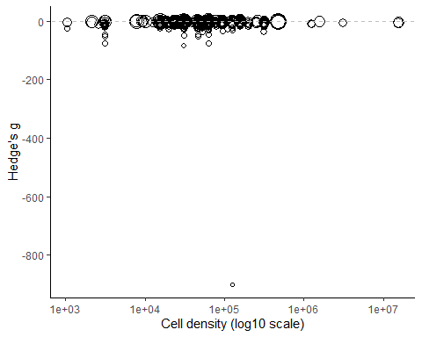

# Multivariate Meta-regressions (3-level)

“All combinations of variables from the selected list were tested in multivariable models, and the best models were ranked by corrected Akaike Information Criteria (AICc). For each best model selected (for complete, training and reactivation datasets with 2- and 3-level analyses), we decomposed the R2 value for each moderator included. For this, we calculated the mean of the differences between R2 from models with and without the moderator in all possible orders of moderator inclusion. Additionally, we performed a Q test of moderators for each variable (including all dummy variables for each categorical moderator) to obtain p-values for individual variables.”

Functions to decompose R2 (3-level)

Como a gente só pode usar as comparacoes que tenham a descricao completa de todas as variáveis testadas, precisamos filtrar os dadose conferir se seguimos com N suficiente.

Considering all pre-registered variables, we’d have 99 experiments available (i.e. 1100 exclusions due to missing data). As we have 7 variables, we should have at least 70 comparisons - so can use all of them now. There are 128 possible models.

## Initialization...  
## TASK: Exhaustive screening of candidate set.  
## Fitting...  
##   
## After 50 models:  
## Best model: yi~1+Diferentiation_duration_days+Concentration_uM  
## Crit= 589.848133386275  
## Mean crit= 611.101638609329  
##   
## After 100 models:  
## Best model: yi~1+Diferentiation_duration_days+Concentration_uM+Duration_hours  
## Crit= 586.616231016249  
## Mean crit= 609.767956837361  
##   
## After 150 models:  
## Best model: yi~1+Diferentiation_duration_days+Concentration_uM+Duration_hours  
## Crit= 586.616231016249  
## Mean crit= 609.017884044364  
## Completed.

## glmulti.analysis  
## Method: h / Fitting: rma.mv.glmulti / IC used: aicc  
## Level: 1 / Marginality: FALSE  
## From 128 models:  
## Best IC: 586.616231016249  
## Best model:  
## [1] "yi ~ 1 + Diferentiation_duration_days + Concentration_uM + Duration_hours"  
## Evidence weight: 0.31797522856754  
## Worst IC: 631.18949715955  
## 2 models within 2 IC units.  
## 12 models to reach 95% of evidence weight.

Decomposing R2 for the best model:

## [1] "Running models for Diferentiation_duration_days"  
## [1] "Running models for Concentration_uM"  
## [1] "Running models for Duration_hours"  
## [1] "Running models for Cell_density"

Resultados:

### excluindo outliers de concentracao de abeta:

Como a gente só pode usar as comparacoes que tenham a descricao completa de todas as variáveis testadas, precisamos filtrar os dadose conferir se seguimos com N suficiente.

Considering all pre-registered variables, we’d have 99 experiments available (i.e. 1082 exclusions due to missing data). As we have 7 variables, we should have at least 70 comparisons - so can use all of them now. There are 128 possible models.

Decomposing R2 for the best model:

Resultados:

# Controle de qualidade dos dados

Revisor como moderador

##   
## Created.By n   
## 1 Adriano Sebollela 37   
## 2 Ana Paula Sampaio 77   
## 3 Antônio Felix 133   
## 4 Clarissa Franca Dias Carneiro 43   
## 5 Giovanna Nogueira 142   
## 6 Giulia Scarcella Cancelliero 140   
## 7 Glaucia Maria Almeida 136   
## 8 Nathalia Fernandes 122   
## 9 Nathalia Pinheiro 217   
## 10 Samantha Martins 152

##   
## Multivariate Meta-Analysis Model (k = 1199; method: REML)  
##   
## Variance Components:  
##   
## estim sqrt nlvls fixed factor   
## sigma^2.1 7.5533 2.7483 359 no rayyan.key   
## sigma^2.2 5.4008 2.3240 1199 no rayyan.key/Comparison_ID   
##   
## Test for Residual Heterogeneity:  
## QE(df = 1189) = 6963.8167, p-val < .0001  
##   
## Test of Moderators (coefficients 2:10):  
## QM(df = 9) = 12.3658, p-val = 0.1935  
##   
## Model Results:  
##   
## estimate   
## intrcpt -5.8458   
## relevel(factor(dados_meta_smd$Created.By), ref = "Adriano Sebollela")Ana Paula Sampaio 1.9722   
## relevel(factor(dados_meta_smd$Created.By), ref = "Adriano Sebollela")Antônio Felix 0.6644   
## relevel(factor(dados_meta_smd$Created.By), ref = "Adriano Sebollela")Clarissa Franca Dias Carneiro 0.2427   
## relevel(factor(dados_meta_smd$Created.By), ref = "Adriano Sebollela")Giovanna Nogueira 0.4489   
## relevel(factor(dados_meta_smd$Created.By), ref = "Adriano Sebollela")Giulia Scarcella Cancelliero -0.0727   
## relevel(factor(dados_meta_smd$Created.By), ref = "Adriano Sebollela")Glaucia Maria Almeida 1.0564   
## relevel(factor(dados_meta_smd$Created.By), ref = "Adriano Sebollela")Nathalia Fernandes 0.7342   
## relevel(factor(dados_meta_smd$Created.By), ref = "Adriano Sebollela")Nathalia Pinheiro 1.0432   
## relevel(factor(dados_meta_smd$Created.By), ref = "Adriano Sebollela")Samantha Martins -0.5121   
## se   
## intrcpt 0.9009   
## relevel(factor(dados_meta_smd$Created.By), ref = "Adriano Sebollela")Ana Paula Sampaio 1.1177   
## relevel(factor(dados_meta_smd$Created.By), ref = "Adriano Sebollela")Antônio Felix 1.0265   
## relevel(factor(dados_meta_smd$Created.By), ref = "Adriano Sebollela")Clarissa Franca Dias Carneiro 1.2237   
## relevel(factor(dados_meta_smd$Created.By), ref = "Adriano Sebollela")Giovanna Nogueira 1.0637   
## relevel(factor(dados_meta_smd$Created.By), ref = "Adriano Sebollela")Giulia Scarcella Cancelliero 1.0501   
## relevel(factor(dados_meta_smd$Created.By), ref = "Adriano Sebollela")Glaucia Maria Almeida 1.0501   
## relevel(factor(dados_meta_smd$Created.By), ref = "Adriano Sebollela")Nathalia Fernandes 1.1071   
## relevel(factor(dados_meta_smd$Created.By), ref = "Adriano Sebollela")Nathalia Pinheiro 1.0479   
## relevel(factor(dados_meta_smd$Created.By), ref = "Adriano Sebollela")Samantha Martins 1.0459   
## zval   
## intrcpt -6.4886   
## relevel(factor(dados_meta_smd$Created.By), ref = "Adriano Sebollela")Ana Paula Sampaio 1.7645   
## relevel(factor(dados_meta_smd$Created.By), ref = "Adriano Sebollela")Antônio Felix 0.6472   
## relevel(factor(dados_meta_smd$Created.By), ref = "Adriano Sebollela")Clarissa Franca Dias Carneiro 0.1984   
## relevel(factor(dados_meta_smd$Created.By), ref = "Adriano Sebollela")Giovanna Nogueira 0.4220   
## relevel(factor(dados_meta_smd$Created.By), ref = "Adriano Sebollela")Giulia Scarcella Cancelliero -0.0692   
## relevel(factor(dados_meta_smd$Created.By), ref = "Adriano Sebollela")Glaucia Maria Almeida 1.0060   
## relevel(factor(dados_meta_smd$Created.By), ref = "Adriano Sebollela")Nathalia Fernandes 0.6631   
## relevel(factor(dados_meta_smd$Created.By), ref = "Adriano Sebollela")Nathalia Pinheiro 0.9955   
## relevel(factor(dados_meta_smd$Created.By), ref = "Adriano Sebollela")Samantha Martins -0.4896   
## pval   
## intrcpt <.0001   
## relevel(factor(dados_meta_smd$Created.By), ref = "Adriano Sebollela")Ana Paula Sampaio 0.0777   
## relevel(factor(dados_meta_smd$Created.By), ref = "Adriano Sebollela")Antônio Felix 0.5175   
## relevel(factor(dados_meta_smd$Created.By), ref = "Adriano Sebollela")Clarissa Franca Dias Carneiro 0.8428   
## relevel(factor(dados_meta_smd$Created.By), ref = "Adriano Sebollela")Giovanna Nogueira 0.6730   
## relevel(factor(dados_meta_smd$Created.By), ref = "Adriano Sebollela")Giulia Scarcella Cancelliero 0.9448   
## relevel(factor(dados_meta_smd$Created.By), ref = "Adriano Sebollela")Glaucia Maria Almeida 0.3144   
## relevel(factor(dados_meta_smd$Created.By), ref = "Adriano Sebollela")Nathalia Fernandes 0.5073   
## relevel(factor(dados_meta_smd$Created.By), ref = "Adriano Sebollela")Nathalia Pinheiro 0.3195   
## relevel(factor(dados_meta_smd$Created.By), ref = "Adriano Sebollela")Samantha Martins 0.6244   
## ci.lb   
## intrcpt -7.6116   
## relevel(factor(dados_meta_smd$Created.By), ref = "Adriano Sebollela")Ana Paula Sampaio -0.2185   
## relevel(factor(dados_meta_smd$Created.By), ref = "Adriano Sebollela")Antônio Felix -1.3476   
## relevel(factor(dados_meta_smd$Created.By), ref = "Adriano Sebollela")Clarissa Franca Dias Carneiro -2.1557   
## relevel(factor(dados_meta_smd$Created.By), ref = "Adriano Sebollela")Giovanna Nogueira -1.6359   
## relevel(factor(dados_meta_smd$Created.By), ref = "Adriano Sebollela")Giulia Scarcella Cancelliero -2.1308   
## relevel(factor(dados_meta_smd$Created.By), ref = "Adriano Sebollela")Glaucia Maria Almeida -1.0017   
## relevel(factor(dados_meta_smd$Created.By), ref = "Adriano Sebollela")Nathalia Fernandes -1.4358   
## relevel(factor(dados_meta_smd$Created.By), ref = "Adriano Sebollela")Nathalia Pinheiro -1.0107   
## relevel(factor(dados_meta_smd$Created.By), ref = "Adriano Sebollela")Samantha Martins -2.5620   
## ci.ub   
## intrcpt -4.0800   
## relevel(factor(dados_meta_smd$Created.By), ref = "Adriano Sebollela")Ana Paula Sampaio 4.1629   
## relevel(factor(dados_meta_smd$Created.By), ref = "Adriano Sebollela")Antônio Felix 2.6764   
## relevel(factor(dados_meta_smd$Created.By), ref = "Adriano Sebollela")Clarissa Franca Dias Carneiro 2.6412   
## relevel(factor(dados_meta_smd$Created.By), ref = "Adriano Sebollela")Giovanna Nogueira 2.5338   
## relevel(factor(dados_meta_smd$Created.By), ref = "Adriano Sebollela")Giulia Scarcella Cancelliero 1.9854   
## relevel(factor(dados_meta_smd$Created.By), ref = "Adriano Sebollela")Glaucia Maria Almeida 3.1145   
## relevel(factor(dados_meta_smd$Created.By), ref = "Adriano Sebollela")Nathalia Fernandes 2.9041   
## relevel(factor(dados_meta_smd$Created.By), ref = "Adriano Sebollela")Nathalia Pinheiro 3.0970   
## relevel(factor(dados_meta_smd$Created.By), ref = "Adriano Sebollela")Samantha Martins 1.5378   
##   
## intrcpt ***   
## relevel(factor(dados_meta_smd$Created.By), ref = "Adriano Sebollela")Ana Paula Sampaio .   
## relevel(factor(dados_meta_smd$Created.By), ref = "Adriano Sebollela")Antônio Felix   
## relevel(factor(dados_meta_smd$Created.By), ref = "Adriano Sebollela")Clarissa Franca Dias Carneiro   
## relevel(factor(dados_meta_smd$Created.By), ref = "Adriano Sebollela")Giovanna Nogueira   
## relevel(factor(dados_meta_smd$Created.By), ref = "Adriano Sebollela")Giulia Scarcella Cancelliero   
## relevel(factor(dados_meta_smd$Created.By), ref = "Adriano Sebollela")Glaucia Maria Almeida   
## relevel(factor(dados_meta_smd$Created.By), ref = "Adriano Sebollela")Nathalia Fernandes   
## relevel(factor(dados_meta_smd$Created.By), ref = "Adriano Sebollela")Nathalia Pinheiro   
## relevel(factor(dados_meta_smd$Created.By), ref = "Adriano Sebollela")Samantha Martins   
##   
## ---  
## Signif. codes: 0 '***' 0.001 '**' 0.01 '*' 0.05 '.' 0.1 ' ' 1

## Warning in geom_abline(yintercept = 0, slope = 0, linetype = "dashed", color =  
## "grey"): Ignoring unknown parameters: `yintercept`

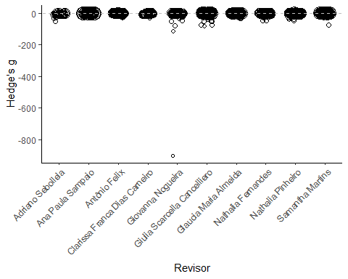

# Análises descritivas

## Warning: Removed 1 rows containing missing values (`geom_bar()`).

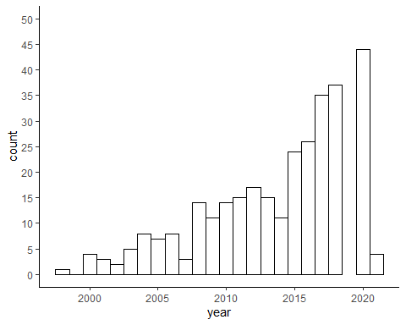

Article-level info:

| Feature | Count | Percent |
| --- | --- | --- |
| Studies testing reversal | 250 | 69.6 |
| Provides sample size calculation | 0 | 0.0 |
| Includes conflict of interest statement | 182 | 50.7 |
| Has pre-registered | 11 | 3.1 |

Experiment-level info

Assay

| Assay | n |
| --- | --- |
| MTT | 1011 |
| WST | 81 |
| CCK-8 | 51 |
| MTS | 32 |
| XTT | 15 |
| NA | 7 |
| EZ4U | 2 |

Cell line

| Cell_source | n |
| --- | --- |
| Cell bank | 646 |
| Unclear | 471 |
| Donation | 82 |

| Cell_bank | n |
| --- | --- |
| American Type Culture Collection (ATCC) | 302 |
| European Collection of Authenticated Cell Cultures (ECACC) | 192 |
| Chinese Academy of Sciences | 44 |
| Leibniz Institute DSMZ - German Collection of Microorganisms and Cell Cultures GmbH | 29 |
| Riken Cell Bank | 28 |
| National Centre for Cell Science (NCCS) | 15 |
| Sigma-Aldrich | 8 |
| Institute of Biochemistry and Cell Biology | 7 |
| Invitrogen | 5 |
| Pasteur Institute of Iran | 5 |
| Korean Cell Line Bank | 4 |
| NA | 3 |
| cells were purchased from Zhong Qiao Xin Zhou Biotec Co., Ltd (Shanghai, China) | 2 |
| LGC Promo-chem | 1 |
| The Cell Resource Centre of Institute of Basic Medicine | 1 |

| Cell_authentication | n |
| --- | --- |
| No | 1176 |
| Yes, no protocol | 17 |
| NA | 6 |

| Cell_mycoplasma | n |
| --- | --- |
| No | 1175 |
| Yes, no protocol | 18 |
| NA | 6 |

| Serum_type | n |
| --- | --- |
| FBS | 773 |
| FCS | 233 |
| Unclear | 184 |
| FBS and HS | 3 |
| CS | 2 |
| NO SERUM | 2 |
| FCS and FHS | 1 |
| FCS and HS | 1 |

| Serum_concentration | n |
| --- | --- |
| 0.1 | 765 |
| 0.15 | 205 |
| NA | 192 |
| 0.05 | 7 |
| 0.18 | 7 |
| 0.17 | 6 |
| 0.2 | 5 |
| 0.02 | 4 |
| 5% of each | 3 |
| 5% or 10 % | 2 |
| 0.12 | 1 |
| 10% and 5% | 1 |
| 5% and 10% | 1 |

Treatment

| Control_description | n |
| --- | --- |
| Unclear | 524 |
| Vehicle | 345 |
| Medium only | 289 |
| Other | 41 |

| Abeta_sequence | n |
| --- | --- |
| 1-42 | 961 |
| 1-40 | 218 |
| 1-43 | 10 |
| NA | 8 |
| 1-38 | 2 |

| Abeta_origin | n |
| --- | --- |
| Unclear | 625 |
| synthetic | 522 |
| recombinant | 52 |

| Abeta_species | n |
| --- | --- |
| Unclear | 964 |
| Human | 230 |
| Rat | 5 |

| Abeta_aggregation | n |
| --- | --- |
| Unclear | 539 |
| Oligomers | 463 |
| Fibers | 105 |
| Monomers | 91 |
| NA | 1 |

| Single_exposure | n |
| --- | --- |
| Yes, single | 1197 |
| Unclear | 1 |
| NA | 1 |

## # A tibble: 1 x 1  
## `mean(Duration_hours, na.rm = T)`  
## <dbl>  
## 1 33.1

## # A tibble: 1 x 1  
## `sd(Duration_hours, na.rm = T)`  
## <dbl>  
## 1 16.8

## # A tibble: 1 x 1  
## `median(Duration_hours, na.rm = T)`  
## <dbl>  
## 1 24

## # A tibble: 1 x 1  
## `min(Duration_hours, na.rm = T)`  
## <dbl>  
## 1 0

## # A tibble: 1 x 1  
## `max(Duration_hours, na.rm = T)`  
## <dbl>  
## 1 144

## Warning: Removed 11 rows containing non-finite values (`stat_bin()`).

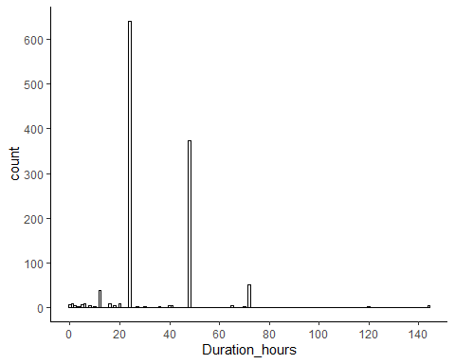

## # A tibble: 1 x 1  
## `mean(Concentration_uM, na.rm = T)`  
## <dbl>  
## 1 41.3

## # A tibble: 1 x 1  
## `sd(Concentration_uM, na.rm = T)`  
## <dbl>  
## 1 873.

## # A tibble: 1 x 1  
## `median(Concentration_uM, na.rm = T)`  
## <dbl>  
## 1 8

## # A tibble: 1 x 1  
## `min(Concentration_uM, na.rm = T)`  
## <dbl>  
## 1 0

## # A tibble: 1 x 1  
## `max(Concentration_uM, na.rm = T)`  
## <dbl>  
## 1 30000

## Warning: Removed 17 rows containing non-finite values (`stat_bin()`).

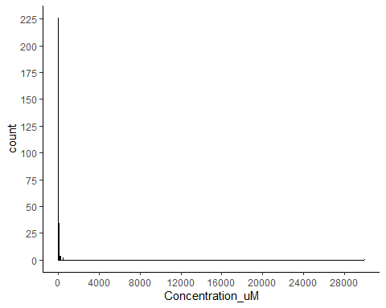

Diferenciacao

| Diferentiation_method | n |
| --- | --- |
| No differentiation | 928 |
| ATRA | 141 |
| ATRA plus | 79 |
| Other | 25 |
| Unclear | 19 |
| unclear | 7 |

Reporting

| Feature | Count | Percent |
| --- | --- | --- |
| Describes cell source | 728 | 60.7 |
| Describes cell authentication | 17 | 1.4 |
| Describes mycoplasma testing | 18 | 1.5 |
| Control group is clear | 524 | 43.7 |
| Describes Abeta sequence | 1191 | 99.3 |
| Describes Abeta origin | 625 | 52.1 |
| Describes Abeta species | 964 | 80.4 |
| Describes Abeta aggregation | 539 | 45.0 |
| Has single exposure | 1197 | 99.8 |
| Describes duration of Abeta exposure | 1188 | 99.1 |
| Describes concentration of Abeta | 1182 | 98.6 |