Meta-análises com ROMC

Clarissa F. D. Carneiro

2025-03-31

## ── Attaching core tidyverse packages ──────────────────────── tidyverse 2.0.0 ──  
## ✔ dplyr 1.1.4 ✔ readr 2.1.5  
## ✔ forcats 1.0.0 ✔ stringr 1.5.1  
## ✔ ggplot2 3.5.1 ✔ tibble 3.2.1  
## ✔ lubridate 1.9.4 ✔ tidyr 1.3.1  
## ✔ purrr 1.0.4   
## ── Conflicts ────────────────────────────────────────── tidyverse_conflicts() ──  
## ✖ dplyr::filter() masks stats::filter()  
## ✖ dplyr::lag() masks stats::lag()  
## ℹ Use the conflicted package (<http://conflicted.r-lib.org/>) to force all conflicts to become errors  
## Carregando pacotes exigidos: Matrix  
##   
##   
## Anexando pacote: 'Matrix'  
##   
##   
## Os seguintes objetos são mascarados por 'package:tidyr':  
##   
## expand, pack, unpack  
##   
##   
## Carregando pacotes exigidos: metadat  
##   
## Carregando pacotes exigidos: numDeriv  
##   
##   
## Loading the 'metafor' package (version 4.8-0). For an  
## introduction to the package please type: help(metafor)  
##   
##   
## Carregando pacotes exigidos: rJava  
##   
## Carregando pacotes exigidos: leaps

This script runs all analyses with effect size measures for ratios.

Where the publications present a measure of variation for the control group, we are using the ROM (log transformed ratio of means) as the effect size measure, and in the cases where no variation is presented we are using ROMC (log transformed ratio of mean change), given sd control=0 and correlation = 0.

# 2-level

##   
## Random-Effects Model (k = 1192; tau^2 estimator: REML)  
##   
## logLik deviance AIC BIC AICc   
## -533.4585 1066.9170 1070.9170 1081.0821 1070.9271   
##   
## tau^2 (estimated amount of total heterogeneity): 0.1306 (SE = 0.0056)  
## tau (square root of estimated tau^2 value): 0.3613  
## I^2 (total heterogeneity / total variability): 99.65%  
## H^2 (total variability / sampling variability): 284.66  
##   
## Test for Heterogeneity:  
## Q(df = 1191) = 190509.8820, p-val < .0001  
##   
## Model Results:  
##   
## estimate se zval pval ci.lb ci.ub   
## -0.4632 0.0107 -43.2419 <.0001 -0.4842 -0.4422 ***   
##   
## ---  
## Signif. codes: 0 '***' 0.001 '**' 0.01 '*' 0.05 '.' 0.1 ' ' 1

##   
## estimate ci.lb ci.ub   
## tau^2 0.1306 0.1255 0.1494   
## tau 0.3613 0.3542 0.3866   
## I^2(%) 99.6487 99.6344 99.6929   
## H^2 284.6572 273.5326 325.6407

Exact p value: 0 Exact Q test p value 0

Effect (% of control): 0.6292892 CI.lb (%): 0.6162161 CI.ub (%): 0.6426396

Orchard Plot

## Warning: Group 'Comparison_ID' is a numeric variable.

## Scale for colour is already present.  
## Adding another scale for colour, which will replace the existing scale.  
## Scale for fill is already present.  
## Adding another scale for fill, which will replace the existing scale.

## Warning: Using `size` aesthetic for lines was deprecated in ggplot2 3.4.0.  
## ℹ Please use `linewidth` instead.  
## This warning is displayed once every 8 hours.  
## Call `lifecycle::last_lifecycle_warnings()` to see where this warning was  
## generated.

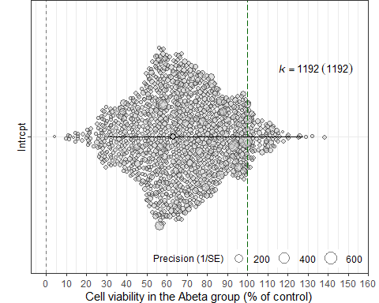

## Publication bias

Trim-and-fill

##   
## Estimated number of missing studies on the right side: 86 (SE = 13.1909)  
## Test of H0: no missing studies on the right side: p-val < .0001  
##   
## Random-Effects Model (k = 1278; tau^2 estimator: REML)  
##   
## tau^2 (estimated amount of total heterogeneity): 0.1910 (SE = 0.0078)  
## tau (square root of estimated tau^2 value): 0.4370  
## I^2 (total heterogeneity / total variability): 99.74%  
## H^2 (total variability / sampling variability): 390.43  
##   
## Test for Heterogeneity:  
## Q(df = 1277) = 200484.0217, p-val < .0001  
##   
## Model Results:  
##   
## estimate se zval pval ci.lb ci.ub   
## -0.3984 0.0125 -31.9877 <.0001 -0.4228 -0.3739 ***   
##   
## ---  
## Signif. codes: 0 '***' 0.001 '**' 0.01 '*' 0.05 '.' 0.1 ' ' 1

## [,1]  
## intrcpt 0.6714258

## [1] 0.655236

## [1] 0.6880156

##   
## Estimated number of missing studies on the right side: 0 (SE = 18.6754)  
##   
## Random-Effects Model (k = 1192; tau^2 estimator: REML)  
##   
## tau^2 (estimated amount of total heterogeneity): 0.1306 (SE = 0.0056)  
## tau (square root of estimated tau^2 value): 0.3613  
## I^2 (total heterogeneity / total variability): 99.65%  
## H^2 (total variability / sampling variability): 284.66  
##   
## Test for Heterogeneity:  
## Q(df = 1191) = 190509.8820, p-val < .0001  
##   
## Model Results:  
##   
## estimate se zval pval ci.lb ci.ub   
## -0.4632 0.0107 -43.2419 <.0001 -0.4842 -0.4422 ***   
##   
## ---  
## Signif. codes: 0 '***' 0.001 '**' 0.01 '*' 0.05 '.' 0.1 ' ' 1

## [,1]  
## intrcpt 0.6292892

## [1] 0.6162161

## [1] 0.6426396

Funnel plot

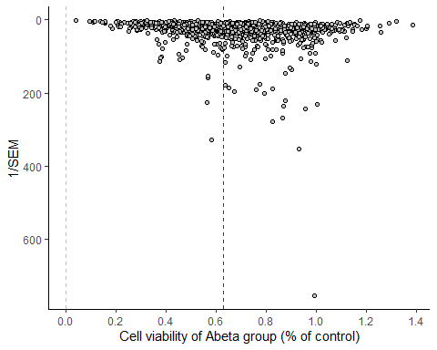

## Saving 5 x 4 in image

Egger’s regression

##   
## Regression Test for Funnel Plot Asymmetry  
##   
## Model: mixed-effects meta-regression model  
## Predictor: inverse of the square root sample size  
##   
## Test for Funnel Plot Asymmetry: z = -1.4094, p = 0.1587  
## Limit Estimate (as ni -> inf): b = -0.3770 (CI: -0.4986, -0.2554)

# 3-level

##   
## Multivariate Meta-Analysis Model (k = 1192; method: REML)  
##   
## Variance Components:  
##   
## estim sqrt nlvls fixed factor   
## sigma^2.1 0.0439 0.2094 359 no rayyan.key   
## sigma^2.2 0.0872 0.2953 1192 no rayyan.key/Comparison_ID   
##   
## Test for Heterogeneity:  
## Q(df = 1191) = 190509.8820, p-val < .0001  
##   
## Model Results:  
##   
## estimate se zval pval ci.lb ci.ub   
## -0.4989 0.0157 -31.6775 <.0001 -0.5298 -0.4680 ***   
##   
## ---  
## Signif. codes: 0 '***' 0.001 '**' 0.01 '*' 0.05 '.' 0.1 ' ' 1

##   
## estimate ci.lb ci.ub   
## sigma^2.1 0.0439 0.0331 0.0572   
## sigma.1 0.2094 0.1819 0.2392   
##   
## estimate ci.lb ci.ub   
## sigma^2.2 0.0872 0.0789 0.0965   
## sigma.2 0.2953 0.2809 0.3106

Exact p value: 3.169049^{-220} Exact Q test p value 0

Effect (% of control): 0.6072051 CI.lb (%): 0.5887486 CI.ub (%): 0.6262402

## $results  
## % of total variance I2  
## Level 1 0.3500278 ---  
## Level 2 (exp) 66.2965933 66.3  
## Level 3 (art) 33.3533789 33.35  
##   
## $totalI2  
## [1] 99.64997  
##   
## $plot

##   
## attr(,"class")  
## [1] "mlm.variance.distribution" "list"

### excluindo n de replicatas ou outras unidades nao independentes

| n_definition | n |
| --- | --- |
| assays | 19 |
| biological replicates | 5 |
| cell cultures | 2 |
| determinations | 8 |
| experiments | 108 |
| independent determinations | 13 |
| independent experimental measurements | 6 |
| independent experiments | 542 |
| independent repetitions | 2 |
| independent replicates | 2 |
| independent runs | 1 |
| independent sets of studies | 1 |
| observations | 1 |
| replicates | 217 |
| samples | 12 |
| wells | 24 |
| NA | 229 |

# Meta-regressions (3-level)

Differentiation

##   
## Multivariate Meta-Analysis Model (k = 1192; method: REML)  
##   
## Variance Components:  
##   
## estim sqrt nlvls fixed factor   
## sigma^2.1 0.0443 0.2104 359 no rayyan.key   
## sigma^2.2 0.0871 0.2951 1192 no rayyan.key/Comparison_ID   
##   
## Test for Residual Heterogeneity:  
## QE(df = 1190) = 176872.8336, p-val < .0001  
##   
## Test of Moderators (coefficient 2):  
## QM(df = 1) = 0.6938, p-val = 0.4049  
##   
## Model Results:  
##   
## estimate   
## intrcpt -0.5052   
## relevel(factor(dados_meta_ratios$Diferentiation_method_YN), ref = "No")Yes 0.0301   
## se   
## intrcpt 0.0174   
## relevel(factor(dados_meta_ratios$Diferentiation_method_YN), ref = "No")Yes 0.0361   
## zval   
## intrcpt -28.9692   
## relevel(factor(dados_meta_ratios$Diferentiation_method_YN), ref = "No")Yes 0.8330   
## pval   
## intrcpt <.0001   
## relevel(factor(dados_meta_ratios$Diferentiation_method_YN), ref = "No")Yes 0.4049   
## ci.lb   
## intrcpt -0.5393   
## relevel(factor(dados_meta_ratios$Diferentiation_method_YN), ref = "No")Yes -0.0407   
## ci.ub   
## intrcpt -0.4710   
## relevel(factor(dados_meta_ratios$Diferentiation_method_YN), ref = "No")Yes 0.1009   
##   
## intrcpt ***   
## relevel(factor(dados_meta_ratios$Diferentiation_method_YN), ref = "No")Yes   
##   
## ---  
## Signif. codes: 0 '***' 0.001 '**' 0.01 '*' 0.05 '.' 0.1 ' ' 1

## $results  
## % of total variance I2  
## Level 1 0.3491829 ---  
## Level 2 (exp) 66.0594599 66.06  
## Level 3 (art) 33.5913571 33.59  
##   
## $totalI2  
## [1] 99.65082  
##   
## $plot

## Warning in is.na(x): is.na() aplicado a um objeto diferente de lista ou vetor  
## de tipo 'language'  
## Warning in is.na(x): is.na() aplicado a um objeto diferente de lista ou vetor  
## de tipo 'language'  
## Warning in is.na(x): is.na() aplicado a um objeto diferente de lista ou vetor  
## de tipo 'language'

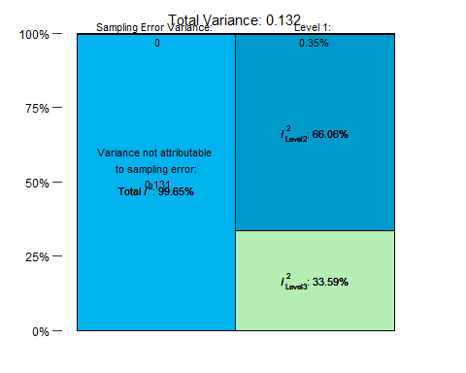

##   
## attr(,"class")  
## [1] "mlm.variance.distribution" "list"

Exact p value: 1.6078607^{-184}, 0.4048602 Exact Q test p value 0

intercept Effect (% of control): 0.6034044 CI.lb (%): 0.5831297 CI.ub (%): 0.6243841 moderator: Effect (% of control): 1.0305581 CI.lb (%): 0.9600929 CI.ub (%): 1.106195

Differentiation bubble plot

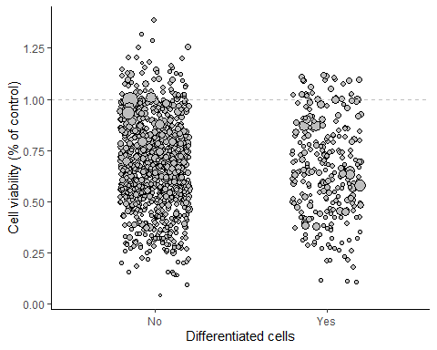

Diff. duration

## Warning: 970 rows with NAs omitted from model fitting.

##   
## Multivariate Meta-Analysis Model (k = 222; method: REML)  
##   
## Variance Components:  
##   
## estim sqrt nlvls fixed factor   
## sigma^2.1 0.0623 0.2497 56 no rayyan.key   
## sigma^2.2 0.0817 0.2859 222 no rayyan.key/Comparison_ID   
##   
## Test for Residual Heterogeneity:  
## QE(df = 220) = 34559.1779, p-val < .0001  
##   
## Test of Moderators (coefficient 2):  
## QM(df = 1) = 3.0629, p-val = 0.0801  
##   
## Model Results:  
##   
## estimate se   
## intrcpt -0.6363 0.0980   
## as.numeric(dados_meta_ratios$Diferentiation_duration_days) 0.0248 0.0142   
## zval pval   
## intrcpt -6.4966 <.0001   
## as.numeric(dados_meta_ratios$Diferentiation_duration_days) 1.7501 0.0801   
## ci.lb ci.ub   
## intrcpt -0.8283 -0.4444   
## as.numeric(dados_meta_ratios$Diferentiation_duration_days) -0.0030 0.0527   
##   
## intrcpt ***   
## as.numeric(dados_meta_ratios$Diferentiation_duration_days) .   
##   
## ---  
## Signif. codes: 0 '***' 0.001 '**' 0.01 '*' 0.05 '.' 0.1 ' ' 1

## $results  
## % of total variance I2  
## Level 1 0.2896992 ---  
## Level 2 (exp) 56.5635276 56.56  
## Level 3 (art) 43.1467732 43.15  
##   
## $totalI2  
## [1] 99.7103  
##   
## $plot

## Warning in is.na(x): is.na() aplicado a um objeto diferente de lista ou vetor  
## de tipo 'language'

## Warning in is.na(x): is.na() aplicado a um objeto diferente de lista ou vetor  
## de tipo 'language'  
## Warning in is.na(x): is.na() aplicado a um objeto diferente de lista ou vetor  
## de tipo 'language'

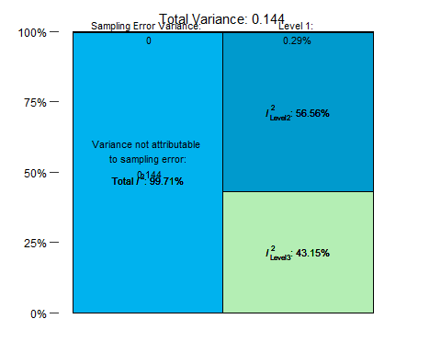

##   
## attr(,"class")  
## [1] "mlm.variance.distribution" "list"

Exact p value: 8.2177001^{-11}, 0.0801008 Exact Q test p value 0

intercept Effect (% of control): 0.5292237 CI.lb (%): 0.4367806 CI.ub (%): 0.6412321 moderator: Effect (% of control): 1.0251509 CI.lb (%): 0.9970258 CI.ub (%): 1.0540694

Diff. duration bubble plot

## Warning: Removed 970 rows containing missing values or values outside the scale range  
## (`geom_point()`).

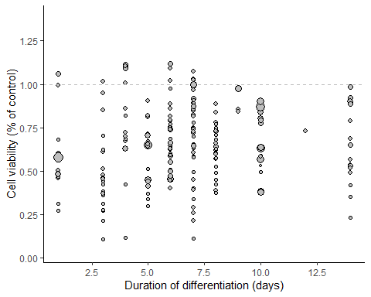

## Warning: Removed 970 rows containing missing values or values outside the scale range  
## (`geom_point()`).

Aggregation

##   
## Multivariate Meta-Analysis Model (k = 1192; method: REML)  
##   
## Variance Components:  
##   
## estim sqrt nlvls fixed factor   
## sigma^2.1 0.0415 0.2037 359 no rayyan.key   
## sigma^2.2 0.0866 0.2944 1192 no rayyan.key/Comparison_ID   
##   
## Test for Residual Heterogeneity:  
## QE(df = 1188) = 189533.2699, p-val < .0001  
##   
## Test of Moderators (coefficients 2:4):  
## QM(df = 3) = 18.3247, p-val = 0.0004  
##   
## Model Results:  
##   
## estimate   
## intrcpt -0.3818   
## relevel(factor(dados_meta_ratios$Abeta_aggregation), ref = "Monomers")Fibers -0.2402   
## relevel(factor(dados_meta_ratios$Abeta_aggregation), ref = "Monomers")Oligomers -0.0829   
## relevel(factor(dados_meta_ratios$Abeta_aggregation), ref = "Monomers")Unclear -0.1312   
## se   
## intrcpt 0.0504   
## relevel(factor(dados_meta_ratios$Abeta_aggregation), ref = "Monomers")Fibers 0.0626   
## relevel(factor(dados_meta_ratios$Abeta_aggregation), ref = "Monomers")Oligomers 0.0539   
## relevel(factor(dados_meta_ratios$Abeta_aggregation), ref = "Monomers")Unclear 0.0545   
## zval   
## intrcpt -7.5774   
## relevel(factor(dados_meta_ratios$Abeta_aggregation), ref = "Monomers")Fibers -3.8383   
## relevel(factor(dados_meta_ratios$Abeta_aggregation), ref = "Monomers")Oligomers -1.5383   
## relevel(factor(dados_meta_ratios$Abeta_aggregation), ref = "Monomers")Unclear -2.4085   
## pval   
## intrcpt <.0001   
## relevel(factor(dados_meta_ratios$Abeta_aggregation), ref = "Monomers")Fibers 0.0001   
## relevel(factor(dados_meta_ratios$Abeta_aggregation), ref = "Monomers")Oligomers 0.1240   
## relevel(factor(dados_meta_ratios$Abeta_aggregation), ref = "Monomers")Unclear 0.0160   
## ci.lb   
## intrcpt -0.4805   
## relevel(factor(dados_meta_ratios$Abeta_aggregation), ref = "Monomers")Fibers -0.3629   
## relevel(factor(dados_meta_ratios$Abeta_aggregation), ref = "Monomers")Oligomers -0.1884   
## relevel(factor(dados_meta_ratios$Abeta_aggregation), ref = "Monomers")Unclear -0.2380   
## ci.ub   
## intrcpt -0.2830   
## relevel(factor(dados_meta_ratios$Abeta_aggregation), ref = "Monomers")Fibers -0.1176   
## relevel(factor(dados_meta_ratios$Abeta_aggregation), ref = "Monomers")Oligomers 0.0227   
## relevel(factor(dados_meta_ratios$Abeta_aggregation), ref = "Monomers")Unclear -0.0244   
##   
## intrcpt ***   
## relevel(factor(dados_meta_ratios$Abeta_aggregation), ref = "Monomers")Fibers ***   
## relevel(factor(dados_meta_ratios$Abeta_aggregation), ref = "Monomers")Oligomers   
## relevel(factor(dados_meta_ratios$Abeta_aggregation), ref = "Monomers")Unclear *   
##   
## ---  
## Signif. codes: 0 '***' 0.001 '**' 0.01 '*' 0.05 '.' 0.1 ' ' 1

## $results  
## % of total variance I2  
## Level 1 0.3579935 ---  
## Level 2 (exp) 67.3822779 67.38  
## Level 3 (art) 32.2597285 32.26  
##   
## $totalI2  
## [1] 99.64201  
##   
## $plot

## Warning in is.na(x): is.na() aplicado a um objeto diferente de lista ou vetor  
## de tipo 'language'  
## Warning in is.na(x): is.na() aplicado a um objeto diferente de lista ou vetor  
## de tipo 'language'  
## Warning in is.na(x): is.na() aplicado a um objeto diferente de lista ou vetor  
## de tipo 'language'

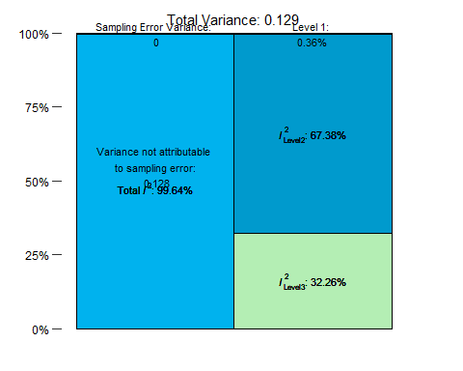

##   
## attr(,"class")  
## [1] "mlm.variance.distribution" "list"

Exact p value: 3.5244588^{-14}, 1.2388017^{-4}, 0.1239746, 0.0160193 Exact Q test p value 0

intercept Effect (% of control): 0.6826498 CI.lb (%): 0.6184605 CI.ub (%): 0.7535012 moderator/fibers: Effect (% of control): 0.786444 CI.lb (%): 0.6956529 CI.ub (%): 0.8890846 moderator/oligomers: Effect (% of control): 0.9204853 CI.lb (%): 0.8282672 CI.ub (%): 1.0229709 moderator/unclear: Effect (% of control): 0.9204853 CI.lb (%): 0.8282672 CI.ub (%): 1.0229709

Aggregation bubble plot

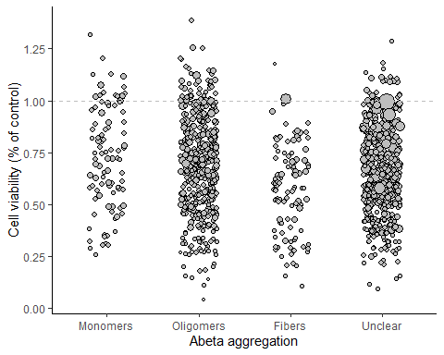

Abeta concentration (só até 100 uM)

##   
## Multivariate Meta-Analysis Model (k = 1123; method: REML)  
##   
## Variance Components:  
##   
## estim sqrt nlvls fixed factor   
## sigma^2.1 0.0442 0.2103 345 no rayyan.key   
## sigma^2.2 0.0663 0.2574 1123 no rayyan.key/Comparison_ID   
##   
## Test for Residual Heterogeneity:  
## QE(df = 1121) = 143561.5639, p-val < .0001  
##   
## Test of Moderators (coefficient 2):  
## QM(df = 1) = 213.2563, p-val < .0001  
##   
## Model Results:  
##   
## estimate se zval pval   
## intrcpt -0.3532 0.0180 -19.6688 <.0001   
## dados_meta_ratios_max100$Concentration_uM -0.0130 0.0009 -14.6033 <.0001   
## ci.lb ci.ub   
## intrcpt -0.3884 -0.3180 ***   
## dados_meta_ratios_max100$Concentration_uM -0.0147 -0.0112 ***   
##   
## ---  
## Signif. codes: 0 '***' 0.001 '**' 0.01 '*' 0.05 '.' 0.1 ' ' 1

## $results  
## % of total variance I2  
## Level 1 0.4022288 ---  
## Level 2 (exp) 59.7349130 59.73  
## Level 3 (art) 39.8628582 39.86  
##   
## $totalI2  
## [1] 99.59777  
##   
## $plot

## Warning in is.na(x): is.na() aplicado a um objeto diferente de lista ou vetor  
## de tipo 'language'  
## Warning in is.na(x): is.na() aplicado a um objeto diferente de lista ou vetor  
## de tipo 'language'  
## Warning in is.na(x): is.na() aplicado a um objeto diferente de lista ou vetor  
## de tipo 'language'

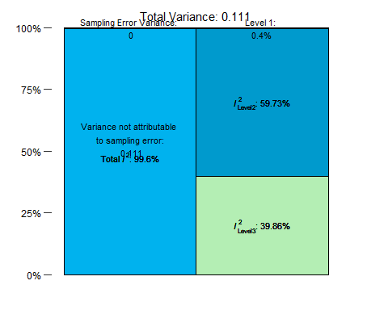

##   
## attr(,"class")  
## [1] "mlm.variance.distribution" "list"

Exact p value: 3.9895593^{-86}, 2.6758363^{-48} Exact Q test p value 0

intercept Effect (% of control): 0.7024283 CI.lb (%): 0.678135 CI.ub (%): 0.7275919 moderator: Effect (% of control): 0.987095 CI.lb (%): 0.9853757 CI.ub (%): 0.9888173

Abeta concentration bubble plot

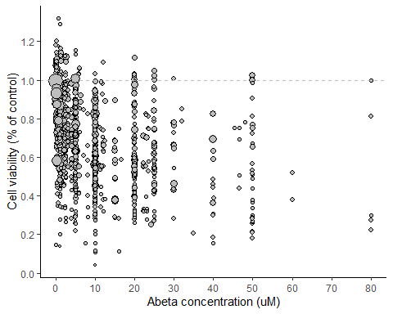

Abeta duration of exposure

## Warning: 12 rows with NAs omitted from model fitting.

##   
## Multivariate Meta-Analysis Model (k = 1180; method: REML)  
##   
## Variance Components:  
##   
## estim sqrt nlvls fixed factor   
## sigma^2.1 0.0441 0.2101 352 no rayyan.key   
## sigma^2.2 0.0834 0.2888 1180 no rayyan.key/Comparison_ID   
##   
## Test for Residual Heterogeneity:  
## QE(df = 1178) = 170463.5738, p-val < .0001  
##   
## Test of Moderators (coefficient 2):  
## QM(df = 1) = 34.0280, p-val < .0001  
##   
## Model Results:  
##   
## estimate se zval pval   
## intrcpt -0.3546 0.0292 -12.1353 <.0001   
## as.numeric(dados_meta_ratios$Duration_days) -0.1055 0.0181 -5.8334 <.0001   
## ci.lb ci.ub   
## intrcpt -0.4119 -0.2974 ***   
## as.numeric(dados_meta_ratios$Duration_days) -0.1409 -0.0700 ***   
##   
## ---  
## Signif. codes: 0 '***' 0.001 '**' 0.01 '*' 0.05 '.' 0.1 ' ' 1

## $results  
## % of total variance I2  
## Level 1 0.3568016 ---  
## Level 2 (exp) 65.1586116 65.16  
## Level 3 (art) 34.4845868 34.48  
##   
## $totalI2  
## [1] 99.6432  
##   
## $plot

## Warning in is.na(x): is.na() aplicado a um objeto diferente de lista ou vetor  
## de tipo 'language'

## Warning in is.na(x): is.na() aplicado a um objeto diferente de lista ou vetor  
## de tipo 'language'  
## Warning in is.na(x): is.na() aplicado a um objeto diferente de lista ou vetor  
## de tipo 'language'

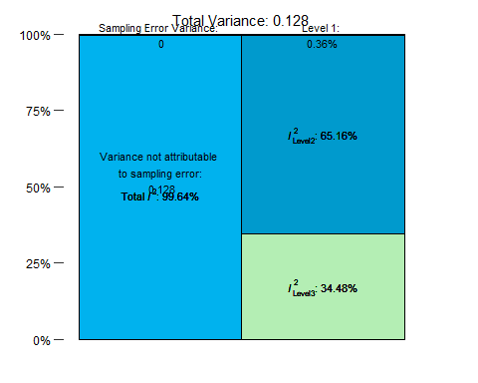

##   
## attr(,"class")  
## [1] "mlm.variance.distribution" "list"

Exact p value: 6.8663482^{-34}, 5.4325164^{-9} Exact Q test p value 0

intercept Effect (% of control): 0.7014348 CI.lb (%): 0.6623885 CI.ub (%): 0.7427827 moderator: Effect (% of control): 0.8999139 CI.lb (%): 0.8685859 CI.ub (%): 0.9323717

Abeta duration bubble plot

## Warning: Removed 12 rows containing missing values or values outside the scale range  
## (`geom_point()`).

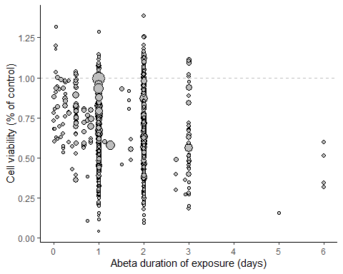

## Warning: Removed 12 rows containing missing values or values outside the scale range  
## (`geom_point()`).

Assay

##   
## Multivariate Meta-Analysis Model (k = 1192; method: REML)  
##   
## Variance Components:  
##   
## estim sqrt nlvls fixed factor   
## sigma^2.1 0.0441 0.2100 359 no rayyan.key   
## sigma^2.2 0.0872 0.2954 1192 no rayyan.key/Comparison_ID   
##   
## Test for Residual Heterogeneity:  
## QE(df = 1185) = 184785.3343, p-val < .0001  
##   
## Test of Moderators (coefficients 2:7):  
## QM(df = 6) = 5.5461, p-val = 0.4759  
##   
## Model Results:  
##   
## estimate   
## intrcpt -0.4960   
## relevel(factor(dados_meta_ratios$Assay), ref = "MTT")CCK-8 0.0198   
## relevel(factor(dados_meta_ratios$Assay), ref = "MTT")EZ4U -0.1085   
## relevel(factor(dados_meta_ratios$Assay), ref = "MTT")MTS -0.0166   
## relevel(factor(dados_meta_ratios$Assay), ref = "MTT")Resazurin 0.4474   
## relevel(factor(dados_meta_ratios$Assay), ref = "MTT")WST -0.0805   
## relevel(factor(dados_meta_ratios$Assay), ref = "MTT")XTT 0.0381   
## se   
## intrcpt 0.0173   
## relevel(factor(dados_meta_ratios$Assay), ref = "MTT")CCK-8 0.0797   
## relevel(factor(dados_meta_ratios$Assay), ref = "MTT")EZ4U 0.2764   
## relevel(factor(dados_meta_ratios$Assay), ref = "MTT")MTS 0.0805   
## relevel(factor(dados_meta_ratios$Assay), ref = "MTT")Resazurin 0.2389   
## relevel(factor(dados_meta_ratios$Assay), ref = "MTT")WST 0.0639   
## relevel(factor(dados_meta_ratios$Assay), ref = "MTT")XTT 0.1333   
## zval   
## intrcpt -28.6601   
## relevel(factor(dados_meta_ratios$Assay), ref = "MTT")CCK-8 0.2488   
## relevel(factor(dados_meta_ratios$Assay), ref = "MTT")EZ4U -0.3926   
## relevel(factor(dados_meta_ratios$Assay), ref = "MTT")MTS -0.2069   
## relevel(factor(dados_meta_ratios$Assay), ref = "MTT")Resazurin 1.8726   
## relevel(factor(dados_meta_ratios$Assay), ref = "MTT")WST -1.2586   
## relevel(factor(dados_meta_ratios$Assay), ref = "MTT")XTT 0.2857   
## pval ci.lb   
## intrcpt <.0001 -0.5299   
## relevel(factor(dados_meta_ratios$Assay), ref = "MTT")CCK-8 0.8035 -0.1363   
## relevel(factor(dados_meta_ratios$Assay), ref = "MTT")EZ4U 0.6946 -0.6502   
## relevel(factor(dados_meta_ratios$Assay), ref = "MTT")MTS 0.8361 -0.1744   
## relevel(factor(dados_meta_ratios$Assay), ref = "MTT")Resazurin 0.0611 -0.0209   
## relevel(factor(dados_meta_ratios$Assay), ref = "MTT")WST 0.2082 -0.2058   
## relevel(factor(dados_meta_ratios$Assay), ref = "MTT")XTT 0.7751 -0.2232   
## ci.ub   
## intrcpt -0.4620 ***   
## relevel(factor(dados_meta_ratios$Assay), ref = "MTT")CCK-8 0.1760   
## relevel(factor(dados_meta_ratios$Assay), ref = "MTT")EZ4U 0.4332   
## relevel(factor(dados_meta_ratios$Assay), ref = "MTT")MTS 0.1411   
## relevel(factor(dados_meta_ratios$Assay), ref = "MTT")Resazurin 0.9156 .   
## relevel(factor(dados_meta_ratios$Assay), ref = "MTT")WST 0.0448   
## relevel(factor(dados_meta_ratios$Assay), ref = "MTT")XTT 0.2994   
##   
## ---  
## Signif. codes: 0 '***' 0.001 '**' 0.01 '*' 0.05 '.' 0.1 ' ' 1

## $results  
## % of total variance I2  
## Level 1 0.3492755 ---  
## Level 2 (exp) 66.1892443 66.19  
## Level 3 (art) 33.4614802 33.46  
##   
## $totalI2  
## [1] 99.65072  
##   
## $plot

## Warning in is.na(x): is.na() aplicado a um objeto diferente de lista ou vetor  
## de tipo 'language'  
## Warning in is.na(x): is.na() aplicado a um objeto diferente de lista ou vetor  
## de tipo 'language'  
## Warning in is.na(x): is.na() aplicado a um objeto diferente de lista ou vetor  
## de tipo 'language'

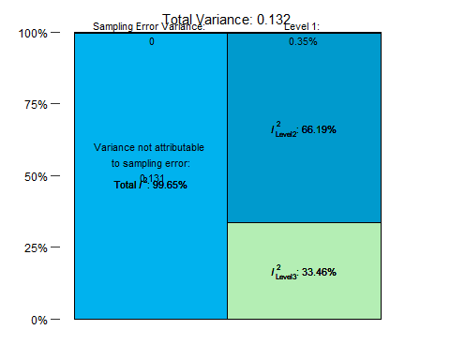

##   
## attr(,"class")  
## [1] "mlm.variance.distribution" "list"

Exact p value: 1.2014105^{-180}, 0.8035274, 0.694596, 0.8361244, 0.0611227, 0.2081617, 0.7751328 Exact Q test p value 0

intercept Effect (% of control): 0.6089889 CI.lb (%): 0.5886803 CI.ub (%): 0.6299981 moderator/cck-8: Effect (% of control): 1.0200169 CI.lb (%): 0.872564 CI.ub (%): 1.1923875 moderator/ez4u: Effect (% of control): 0.8971718 CI.lb (%): 0.5219556 CI.ub (%): 1.5421184 moderator/mts: Effect (% of control): 0.9834932 CI.lb (%): 0.8399998 CI.ub (%): 1.151499 moderator/resazurin: Effect (% of control): 1.564221 CI.lb (%): 0.9793457 CI.ub (%): 2.4983898 moderator/wst: Effect (% of control): 0.9226668 CI.lb (%): 0.8139774 CI.ub (%): 1.0458693 moderator/xtt: Effect (% of control): 1.038815 CI.lb (%): 0.7999622 CI.ub (%): 1.3489845

Assay bubble plot

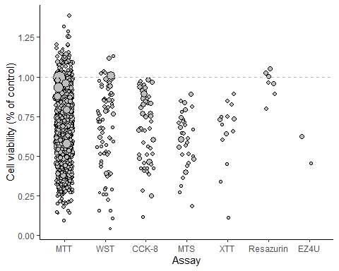

Cell density

## Warning: 502 rows with NAs omitted from model fitting.

##   
## Multivariate Meta-Analysis Model (k = 690; method: REML)  
##   
## Variance Components:  
##   
## estim sqrt nlvls fixed factor   
## sigma^2.1 0.0326 0.1805 211 no rayyan.key   
## sigma^2.2 0.0992 0.3150 690 no rayyan.key/Comparison_ID   
##   
## Test for Residual Heterogeneity:  
## QE(df = 688) = 77185.7090, p-val < .0001  
##   
## Test of Moderators (coefficient 2):  
## QM(df = 1) = 0.0654, p-val = 0.7982  
##   
## Model Results:  
##   
## estimate se zval pval   
## intrcpt -0.5045 0.0200 -25.2226 <.0001   
## as.numeric(dados_meta_ratios$Cell_density) -0.0000 0.0000 -0.2556 0.7982   
## ci.lb ci.ub   
## intrcpt -0.5437 -0.4653 ***   
## as.numeric(dados_meta_ratios$Cell_density) -0.0000 0.0000   
##   
## ---  
## Signif. codes: 0 '***' 0.001 '**' 0.01 '*' 0.05 '.' 0.1 ' ' 1

## $results  
## % of total variance I2  
## Level 1 0.5130178 ---  
## Level 2 (exp) 74.8862444 74.89  
## Level 3 (art) 24.6007378 24.6  
##   
## $totalI2  
## [1] 99.48698  
##   
## $plot

## Warning in is.na(x): is.na() aplicado a um objeto diferente de lista ou vetor  
## de tipo 'language'

## Warning in is.na(x): is.na() aplicado a um objeto diferente de lista ou vetor  
## de tipo 'language'  
## Warning in is.na(x): is.na() aplicado a um objeto diferente de lista ou vetor  
## de tipo 'language'

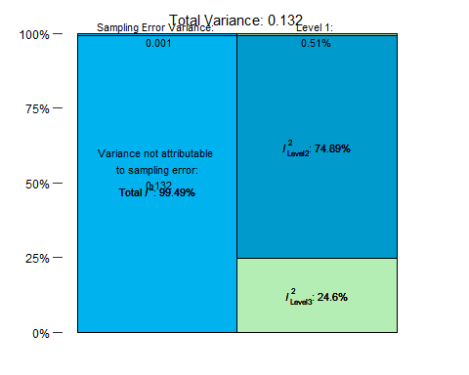

##   
## attr(,"class")  
## [1] "mlm.variance.distribution" "list"

Exact p value: 2.2657163^{-140}, 0.798231 Exact Q test p value 0

intercept Effect (% of control): 0.6038054 CI.lb (%): 0.5805922 CI.ub (%): 0.6279467 moderator: Effect (% of control): 1 CI.lb (%): 1 CI.ub (%): 1

Cell density bubble plot

## Warning: Removed 502 rows containing missing values or values outside the scale range  
## (`geom_point()`).

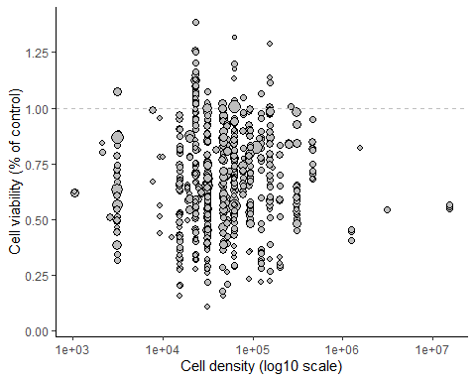

## Warning: Removed 502 rows containing missing values or values outside the scale range  
## (`geom_point()`).

# Multivariate Meta-regressions (3-level)

All combinations of variables from the selected list are tested in multivariable models, and the best models are ranked by corrected Akaike Information Criteria (AICc). For each best model selected, we decompose the R2 value for each moderator included. For this, we calculate the mean of the differences between R2 from models with and without the moderator in all possible orders of moderator inclusion. Additionally, we performed a Q test of moderators for each variable (including all dummy variables for each categorical moderator) to obtain p-values for individual variables.

Functions to decompose R2 (3-level)

For the multivariate analyses, we can only use the comparisons for which all variables of interest are reported.

Considering all pre-registered variables, we’d have 84 experiments available (i.e. 1108 exclusions due to missing data). As we have 7 variables, we should have at least 70 comparisons - so can use all of them now. There are 128 possible models.

## Initialization...  
## TASK: Exhaustive screening of candidate set.  
## Fitting...  
##   
## After 50 models:  
## Best model: yi~1+Diferentiation_method+Abeta_aggregation+Assay+Concentration_uM  
## Crit= 57.1481639479861  
## Mean crit= 71.0636702018485  
##   
## After 100 models:  
## Best model: yi~1+Diferentiation_method+Abeta_aggregation+Assay+Concentration_uM+Cell_density  
## Crit= 57.0482093681005  
## Mean crit= 69.7956671769224  
##   
## After 150 models:  
## Best model: yi~1+Diferentiation_method+Abeta_aggregation+Assay+Concentration_uM+Cell_density  
## Crit= 57.0482093681005  
## Mean crit= 70.0794334660234  
## Completed.

## glmulti.analysis  
## Method: h / Fitting: rma.mv.glmulti / IC used: aicc  
## Level: 1 / Marginality: FALSE  
## From 128 models:  
## Best IC: 57.0482093681005  
## Best model:  
## [1] "yi ~ 1 + Diferentiation_method + Abeta_aggregation + Assay + "  
## [2] " Concentration_uM + Cell_density"   
## Evidence weight: 0.186995174936566  
## Worst IC: 82.3698806635015  
## 4 models within 2 IC units.  
## 31 models to reach 95% of evidence weight.

Top models (within 2 IC units of best model)

## model  
## 1 yi ~ 1 + Diferentiation_method + Abeta_aggregation + Assay + Concentration_uM + Cell_density  
## 2 yi ~ 1 + Diferentiation_method + Abeta_aggregation + Assay + Concentration_uM  
## 3 yi ~ 1 + Diferentiation_method + Abeta_aggregation + Assay + Diferentiation_duration_days + Concentration_uM + Cell_density  
## 4 yi ~ 1 + Diferentiation_method + Abeta_aggregation + Assay + Diferentiation_duration_days + Concentration_uM  
## aicc weights  
## 1 57.04821 0.18699517  
## 2 57.14816 0.17787935  
## 3 58.01699 0.11520249  
## 4 58.39454 0.09538484

Decomposing R2 for the best model:

## [1] "Running models for Diferentiation_method"  
## [1] "Running models for Abeta_aggregation"  
## [1] "Running models for Assay"  
## [1] "Running models for Concentration_uM"  
## [1] "Running models for Cell_density"

Resultados:

##   
## Multivariate Meta-Analysis Model (k = 84; method: ML)  
##   
## Variance Components:  
##   
## estim sqrt nlvls fixed factor   
## sigma^2.1 0.0000 0.0000 23 no rayyan.key   
## sigma^2.2 0.0744 0.2728 84 no rayyan.key/Comparison_ID   
##   
## Test for Residual Heterogeneity:  
## QE(df = 74) = 7226.2737, p-val < .0001  
##   
## Test of Moderators (coefficients 2:10):  
## QM(df = 9) = 65.2040, p-val < .0001  
##   
## Model Results:  
##   
## estimate se zval pval ci.lb   
## intrcpt -0.1122 0.3261 -0.3440 0.7308 -0.7514   
## Diferentiation_methodATRA plus 0.2029 0.0754 2.6907 0.0071 0.0551   
## Diferentiation_methodOther -0.4695 0.1169 -4.0164 <.0001 -0.6986   
## Abeta_aggregationMonomers 0.0448 0.1845 0.2431 0.8079 -0.3168   
## Abeta_aggregationOligomers 0.4087 0.1259 3.2473 0.0012 0.1620   
## Abeta_aggregationUnclear 0.1813 0.1207 1.5019 0.1331 -0.0553   
## AssayMTT -0.5210 0.3088 -1.6870 0.0916 -1.1262   
## AssayWST -1.4536 0.3639 -3.9944 <.0001 -2.1669   
## Concentration_uM -0.0081 0.0020 -3.9645 <.0001 -0.0121   
## Cell_density 0.0000 0.0000 1.6952 0.0900 -0.0000   
## ci.ub   
## intrcpt 0.5270   
## Diferentiation_methodATRA plus 0.3506 **   
## Diferentiation_methodOther -0.2404 ***   
## Abeta_aggregationMonomers 0.4064   
## Abeta_aggregationOligomers 0.6554 **   
## Abeta_aggregationUnclear 0.4179   
## AssayMTT 0.0843 .   
## AssayWST -0.7404 ***   
## Concentration_uM -0.0041 ***   
## Cell_density 0.0000 .   
##   
## ---  
## Signif. codes: 0 '***' 0.001 '**' 0.01 '*' 0.05 '.' 0.1 ' ' 1

##   
## estimate ci.lb ci.ub   
## sigma^2.1 0.0000 0.0000 0.0312   
## sigma.1 0.0000 0.0000 0.1766   
##   
## estimate ci.lb ci.ub   
## sigma^2.2 0.0744 0.0506 0.1051   
## sigma.2 0.2728 0.2249 0.3242

## $results  
## % of total variance I2  
## Level 1 5.208446e-01 ---  
## Level 2 (exp) 9.947916e+01 99.48  
## Level 3 (art) 3.623795e-08 0  
##   
## $totalI2  
## [1] 99.47916  
##   
## $plot

## Warning in is.na(x): is.na() aplicado a um objeto diferente de lista ou vetor  
## de tipo 'language'  
## Warning in is.na(x): is.na() aplicado a um objeto diferente de lista ou vetor  
## de tipo 'language'  
## Warning in is.na(x): is.na() aplicado a um objeto diferente de lista ou vetor  
## de tipo 'language'

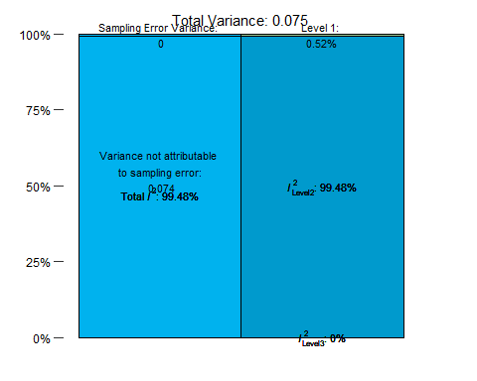

##   
## attr(,"class")  
## [1] "mlm.variance.distribution" "list"

## [1] 43.21296

## [1] "Running models for Diferentiation_method"  
## [1] "Running models for Abeta_aggregation"  
## [1] "Running models for Assay"  
## [1] "Running models for Concentration_uM"

Resultados:

##   
## Multivariate Meta-Analysis Model (k = 84; method: ML)  
##   
## Variance Components:  
##   
## estim sqrt nlvls fixed factor   
## sigma^2.1 0.0000 0.0000 23 no rayyan.key   
## sigma^2.2 0.0772 0.2778 84 no rayyan.key/Comparison_ID   
##   
## Test for Residual Heterogeneity:  
## QE(df = 75) = 7845.0721, p-val < .0001  
##   
## Test of Moderators (coefficients 2:9):  
## QM(df = 8) = 60.4860, p-val < .0001  
##   
## Model Results:  
##   
## estimate se zval pval ci.lb   
## intrcpt -0.1080 0.3312 -0.3259 0.7445 -0.7572   
## Diferentiation_methodATRA plus 0.1946 0.0765 2.5429 0.0110 0.0446   
## Diferentiation_methodOther -0.4761 0.1187 -4.0112 <.0001 -0.7087   
## Abeta_aggregationMonomers 0.0435 0.1873 0.2324 0.8162 -0.3236   
## Abeta_aggregationOligomers 0.4146 0.1279 3.2415 0.0012 0.1639   
## Abeta_aggregationUnclear 0.2010 0.1222 1.6455 0.0999 -0.0384   
## AssayMTT -0.5146 0.3136 -1.6408 0.1008 -1.1293   
## AssayWST -1.4273 0.3692 -3.8657 0.0001 -2.1509   
## Concentration_uM -0.0081 0.0021 -3.9039 <.0001 -0.0122   
## ci.ub   
## intrcpt 0.5413   
## Diferentiation_methodATRA plus 0.3447 *   
## Diferentiation_methodOther -0.2435 ***   
## Abeta_aggregationMonomers 0.4107   
## Abeta_aggregationOligomers 0.6653 **   
## Abeta_aggregationUnclear 0.4404 .   
## AssayMTT 0.1001   
## AssayWST -0.7036 ***   
## Concentration_uM -0.0040 ***   
##   
## ---  
## Signif. codes: 0 '***' 0.001 '**' 0.01 '*' 0.05 '.' 0.1 ' ' 1

##   
## estimate ci.lb ci.ub   
## sigma^2.1 0.0000 0.0000 0.0377   
## sigma.1 0.0000 0.0000 0.1942   
##   
## estimate ci.lb ci.ub   
## sigma^2.2 0.0772 0.0510 0.1089   
## sigma.2 0.2778 0.2258 0.3300

## $results  
## % of total variance I2  
## Level 1 5.024677e-01 ---  
## Level 2 (exp) 9.949753e+01 99.5  
## Level 3 (art) 1.072047e-07 0  
##   
## $totalI2  
## [1] 99.49753  
##   
## $plot

## Warning in is.na(x): is.na() aplicado a um objeto diferente de lista ou vetor  
## de tipo 'language'  
## Warning in is.na(x): is.na() aplicado a um objeto diferente de lista ou vetor  
## de tipo 'language'  
## Warning in is.na(x): is.na() aplicado a um objeto diferente de lista ou vetor  
## de tipo 'language'

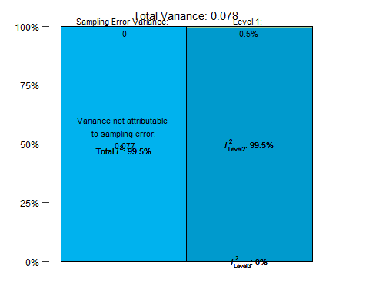

##   
## attr(,"class")  
## [1] "mlm.variance.distribution" "list"

## [1] 41.1252

# Mudando diferenciação para sim/não, tirando Assay e duração da diferenciação

## Initialization...  
## TASK: Exhaustive screening of candidate set.  
## Fitting...  
##   
## After 50 models:  
## Best model: yi~1+Abeta_aggregation+Concentration_uM+Duration_days  
## Crit= 360.832263277365  
## Mean crit= 432.358723791199  
## Completed.

## glmulti.analysis  
## Method: h / Fitting: rma.mv.glmulti / IC used: aicc  
## Level: 1 / Marginality: FALSE  
## From 32 models:  
## Best IC: 360.832263277365  
## Best model:  
## [1] "yi ~ 1 + Abeta_aggregation + Concentration_uM + Duration_days"  
## Evidence weight: 0.53923565272633  
## Worst IC: 503.479024813389  
## 1 models within 2 IC units.  
## 3 models to reach 95% of evidence weight.

Top models (within 2 IC units of best model)

## model aicc  
## 1 yi ~ 1 + Abeta_aggregation + Concentration_uM + Duration_days 360.8323  
## weights  
## 1 0.5392357

Decomposing R2 for the best model:

## [1] "Running models for Abeta_aggregation"  
## [1] "Running models for Concentration_uM"  
## [1] "Running models for Duration_days"

Resultados:

##   
## Multivariate Meta-Analysis Model (k = 641; method: ML)  
##   
## Variance Components:  
##   
## estim sqrt nlvls fixed factor   
## sigma^2.1 0.0406 0.2015 201 no rayyan.key   
## sigma^2.2 0.0697 0.2641 641 no rayyan.key/Comparison_ID   
##   
## Test for Residual Heterogeneity:  
## QE(df = 635) = 53786.9235, p-val < .0001  
##   
## Test of Moderators (coefficients 2:6):  
## QM(df = 5) = 176.4910, p-val < .0001  
##   
## Model Results:  
##   
## estimate se zval pval ci.lb   
## intrcpt -0.3122 0.0597 -5.2290 <.0001 -0.4292   
## Abeta_aggregationMonomers 0.2542 0.0700 3.6318 0.0003 0.1170   
## Abeta_aggregationOligomers 0.1352 0.0539 2.5075 0.0122 0.0295   
## Abeta_aggregationUnclear 0.0499 0.0561 0.8891 0.3740 -0.0601   
## Concentration_uM -0.0126 0.0011 -11.5564 <.0001 -0.0148   
## Duration_days -0.0941 0.0223 -4.2182 <.0001 -0.1378   
## ci.ub   
## intrcpt -0.1952 ***   
## Abeta_aggregationMonomers 0.3913 ***   
## Abeta_aggregationOligomers 0.2409 *   
## Abeta_aggregationUnclear 0.1598   
## Concentration_uM -0.0105 ***   
## Duration_days -0.0504 ***   
##   
## ---  
## Signif. codes: 0 '***' 0.001 '**' 0.01 '*' 0.05 '.' 0.1 ' ' 1

##   
## estimate ci.lb ci.ub   
## sigma^2.1 0.0406 0.0266 0.0595   
## sigma.1 0.2015 0.1630 0.2440   
##   
## estimate ci.lb ci.ub   
## sigma^2.2 0.0697 0.0605 0.0807   
## sigma.2 0.2641 0.2459 0.2841

## $results  
## % of total variance I2  
## Level 1 0.6086564 ---  
## Level 2 (exp) 62.8131216 62.81  
## Level 3 (art) 36.5782220 36.58  
##   
## $totalI2  
## [1] 99.39134  
##   
## $plot

## Warning in is.na(x): is.na() aplicado a um objeto diferente de lista ou vetor  
## de tipo 'language'  
## Warning in is.na(x): is.na() aplicado a um objeto diferente de lista ou vetor  
## de tipo 'language'  
## Warning in is.na(x): is.na() aplicado a um objeto diferente de lista ou vetor  
## de tipo 'language'

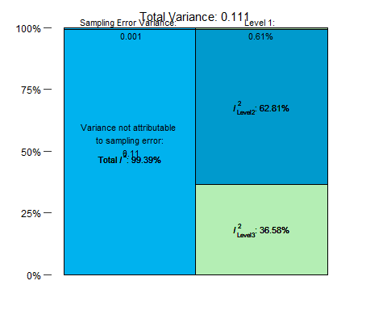

##   
## attr(,"class")  
## [1] "mlm.variance.distribution" "list"

## [1] 15.79888

# Mudando diferenciação para sim/não, tirando Assay; duração da diferenciação igual a zero para não diferenciados

## Initialization...  
## TASK: Exhaustive screening of candidate set.  
## Fitting...  
##   
## After 50 models:  
## Best model: yi~1+Abeta_aggregation+Concentration_uM+Duration_days  
## Crit= 324.149640321834  
## Mean crit= 394.160733652584  
## Completed.

## glmulti.analysis  
## Method: h / Fitting: rma.mv.glmulti / IC used: aicc  
## Level: 1 / Marginality: FALSE  
## From 64 models:  
## Best IC: 324.149640321834  
## Best model:  
## [1] "yi ~ 1 + Abeta_aggregation + Concentration_uM + Duration_days"  
## Evidence weight: 0.279461774529108  
## Worst IC: 457.07793290839  
## 3 models within 2 IC units.  
## 7 models to reach 95% of evidence weight.

Top models (within 2 IC units of best model)

## model  
## 1 yi ~ 1 + Abeta_aggregation + Concentration_uM + Duration_days  
## 2 yi ~ 1 + Diferentiation_method_YN + differentiation_duration_adjust + Abeta_aggregation + Concentration_uM + Duration_days  
## 3 yi ~ 1 + differentiation_duration_adjust + Abeta_aggregation + Concentration_uM + Duration_days  
## aicc weights  
## 1 324.1496 0.2794618  
## 2 324.7442 0.2075925  
## 3 325.6140 0.1343818

Decomposing R2 for the best model:

## [1] "Running models for Abeta_aggregation"  
## [1] "Running models for Concentration_uM"  
## [1] "Running models for Duration_days"

Resultados:

##   
## Multivariate Meta-Analysis Model (k = 621; method: ML)  
##   
## Variance Components:  
##   
## estim sqrt nlvls fixed factor   
## sigma^2.1 0.0402 0.2004 197 no rayyan.key   
## sigma^2.2 0.0655 0.2560 621 no rayyan.key/Comparison_ID   
##   
## Test for Residual Heterogeneity:  
## QE(df = 615) = 47486.2889, p-val < .0001  
##   
## Test of Moderators (coefficients 2:6):  
## QM(df = 5) = 161.6736, p-val < .0001  
##   
## Model Results:  
##   
## estimate se zval pval ci.lb   
## intrcpt -0.3209 0.0593 -5.4107 <.0001 -0.4371   
## Abeta_aggregationMonomers 0.2058 0.0710 2.8980 0.0038 0.0666   
## Abeta_aggregationOligomers 0.1495 0.0540 2.7712 0.0056 0.0438   
## Abeta_aggregationUnclear 0.0620 0.0561 1.1045 0.2694 -0.0480   
## Concentration_uM -0.0123 0.0011 -11.0227 <.0001 -0.0145   
## Duration_days -0.0963 0.0219 -4.3948 <.0001 -0.1392   
## ci.ub   
## intrcpt -0.2047 ***   
## Abeta_aggregationMonomers 0.3451 **   
## Abeta_aggregationOligomers 0.2553 **   
## Abeta_aggregationUnclear 0.1720   
## Concentration_uM -0.0101 ***   
## Duration_days -0.0533 ***   
##   
## ---  
## Signif. codes: 0 '***' 0.001 '**' 0.01 '*' 0.05 '.' 0.1 ' ' 1

##   
## estimate ci.lb ci.ub   
## sigma^2.1 0.0402 0.0264 0.0588   
## sigma.1 0.2004 0.1624 0.2425   
##   
## estimate ci.lb ci.ub   
## sigma^2.2 0.0655 0.0566 0.0762   
## sigma.2 0.2560 0.2379 0.2760

## $results  
## % of total variance I2  
## Level 1 0.6333147 ---  
## Level 2 (exp) 61.5994845 61.6  
## Level 3 (art) 37.7672008 37.77  
##   
## $totalI2  
## [1] 99.36669  
##   
## $plot

## Warning in is.na(x): is.na() aplicado a um objeto diferente de lista ou vetor  
## de tipo 'language'  
## Warning in is.na(x): is.na() aplicado a um objeto diferente de lista ou vetor  
## de tipo 'language'  
## Warning in is.na(x): is.na() aplicado a um objeto diferente de lista ou vetor  
## de tipo 'language'

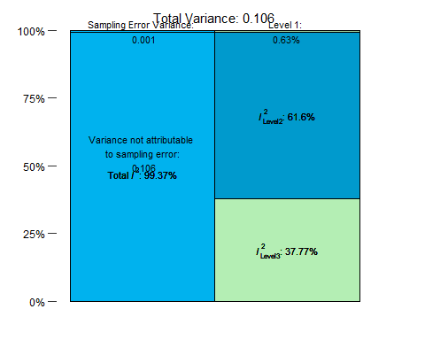

##   
## attr(,"class")  
## [1] "mlm.variance.distribution" "list"

## [1] 19.33209