Comparação SMD e SMCC

Clarissa F. D. Carneiro

2024-07-12

library(readxl)  
library(tidyverse)  
library(metafor)  
library(orchaRd)  
#library(metaviz)  
#library(glmulti)  
#library(knitr)

load("dados_analise.R")

### Comparação SMD e SMCC

dados_two_sample = dados_analise %>% filter(!is.na(control_sd)) %>% filter(control_sd!=0)  
  
dados_one_sample = dados_analise %>% filter(is.na(control_sd)|control_sd==0)

Tem 5 comparações em que os Ns não são iguais entre os grupos nos dados ‘one-sample’. Excluo essas comparações.

dados_one_sample = dados_one_sample %>% mutate(dif_n = if_else(control_n==treated_n, TRUE, FALSE))  
  
dados_one_sample %>% count(dif_n)

## # A tibble: 2 × 2  
## dif_n n  
## <lgl> <int>  
## 1 FALSE 5  
## 2 TRUE 533

dados_one_sample = dados_one_sample %>% filter(dif_n!=FALSE) %>% select(-c("dif_n"))

Para usar SMD, considero sd do controle igual ao tratado (que vai ser igual ao pooled).

dados_two_sample_smd = escalc(measure = "SMD", m1i = as.numeric(treated_mean), m2i = as.numeric(control_mean), sd1i = as.numeric(treated_sd), sd2i = as.numeric(control_sd), n1i = as.numeric(treated_n), n2i = as.numeric(control_n), data = dados_two_sample)  
  
dados_one_sample_smd = escalc(measure = "SMD", m1i = as.numeric(treated_mean), m2i = as.numeric(control_mean), sd1i = as.numeric(treated_sd), sd2i = rep(c(0), nrow(dados_one_sample)), n1i = as.numeric(treated_n), n2i = as.numeric(control_n), data = dados_one_sample)  
  
dados_meta_smd = rbind(dados_two_sample_smd, dados_one_sample_smd)

Tamanho de efeito SMCC (comparações com n=2 são excluídas)

dados_one_sample_smcc = escalc(measure = "SMCC", m1i = as.numeric(treated_mean), m2i = as.numeric(control_mean), sd1i = as.numeric(treated_sd), sd2i = rep(0, length(dados_one_sample$control_mean)), ri = rep(0, length(dados_one_sample$control_mean)), ni = as.numeric(treated_n), data = dados_one_sample)

Tamanhos de efeito mistos

dados_meta_misto = rbind(dados_two_sample_smd, dados_one_sample_smcc)

Meta-análise (2-level SMD)

dados completos (excluindo n=2)

meta1 = rma(yi=yi, vi=vi, data = dados_meta_smd %>% filter(treated_n>2), measure = "SMD", method = "REML", slab = rayyan.key)  
summary(meta1)

##   
## Random-Effects Model (k = 1158; tau^2 estimator: REML)  
##   
## logLik deviance AIC BIC AICc   
## -3805.4564 7610.9128 7614.9128 7625.0200 7614.9232   
##   
## tau^2 (estimated amount of total heterogeneity): 18.0231 (SE = 0.9220)  
## tau (square root of estimated tau^2 value): 4.2454  
## I^2 (total heterogeneity / total variability): 93.97%  
## H^2 (total variability / sampling variability): 16.58  
##   
## Test for Heterogeneity:  
## Q(df = 1157) = 7740.3037, p-val < .0001  
##   
## Model Results:  
##   
## estimate se zval pval ci.lb ci.ub   
## -5.4673 0.1412 -38.7335 <.0001 -5.7439 -5.1906 ***   
##   
## ---  
## Signif. codes: 0 '***' 0.001 '**' 0.01 '*' 0.05 '.' 0.1 ' ' 1

#confint(meta1)  
  
orchard_plot(meta1, group = "Comparison_ID", xlab = "Effect size",  
 transfm = "none") +   
 scale_color_manual(values = "black") +   
 scale_fill_manual(values = "grey")

## Scale for colour is already present.  
## Adding another scale for colour, which will replace the existing scale.  
## Scale for fill is already present.  
## Adding another scale for fill, which will replace the existing scale.

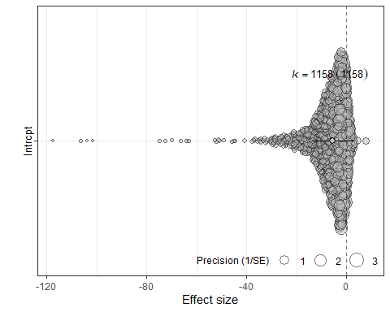

só dados one-sample (excluindo n=2)

meta2 = rma(yi=yi, vi=vi, data = dados_one_sample_smd %>% filter(treated_n>2), measure = "SMD", method = "REML", slab = rayyan.key)  
summary(meta2)

##   
## Random-Effects Model (k = 527; tau^2 estimator: REML)  
##   
## logLik deviance AIC BIC AICc   
## -1841.3599 3682.7197 3686.7197 3695.2503 3686.7427   
##   
## tau^2 (estimated amount of total heterogeneity): 28.7316 (SE = 2.1241)  
## tau (square root of estimated tau^2 value): 5.3602  
## I^2 (total heterogeneity / total variability): 94.57%  
## H^2 (total variability / sampling variability): 18.42  
##   
## Test for Heterogeneity:  
## Q(df = 526) = 3890.9735, p-val < .0001  
##   
## Model Results:  
##   
## estimate se zval pval ci.lb ci.ub   
## -6.5107 0.2600 -25.0366 <.0001 -7.0204 -6.0011 ***   
##   
## ---  
## Signif. codes: 0 '***' 0.001 '**' 0.01 '*' 0.05 '.' 0.1 ' ' 1

#confint(meta2)  
  
orchard_plot(meta2, group = "Comparison_ID", xlab = "Effect size",  
 transfm = "none") +   
 scale_color_manual(values = "black") +   
 scale_fill_manual(values = "grey")

## Scale for colour is already present.  
## Adding another scale for colour, which will replace the existing scale.  
## Scale for fill is already present.  
## Adding another scale for fill, which will replace the existing scale.

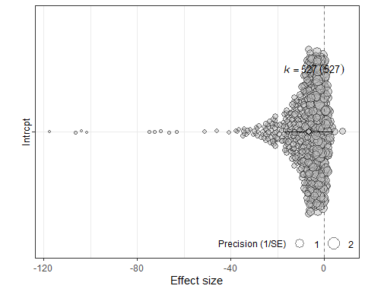

Meta-análise (2-level SMCC)

só dados one-sample

meta3 = rma(yi=yi, vi=vi, data = dados_one_sample_smcc %>% filter(treated_n>2), measure = "SMCC", method = "REML", slab = rayyan.key)  
summary(meta3)

##   
## Random-Effects Model (k = 527; tau^2 estimator: REML)  
##   
## logLik deviance AIC BIC AICc   
## -1439.7798 2879.5597 2883.5597 2892.0903 2883.5826   
##   
## tau^2 (estimated amount of total heterogeneity): 4.1338 (SE = 0.3756)  
## tau (square root of estimated tau^2 value): 2.0332  
## I^2 (total heterogeneity / total variability): 82.19%  
## H^2 (total variability / sampling variability): 5.61  
##   
## Test for Heterogeneity:  
## Q(df = 526) = 2055.8800, p-val < .0001  
##   
## Model Results:  
##   
## estimate se zval pval ci.lb ci.ub   
## -2.7002 0.1126 -23.9762 <.0001 -2.9210 -2.4795 ***   
##   
## ---  
## Signif. codes: 0 '***' 0.001 '**' 0.01 '*' 0.05 '.' 0.1 ' ' 1

#confint(meta3)  
  
orchard_plot(meta3, group = "Comparison_ID", xlab = "Effect size",  
 transfm = "none") +   
 scale_color_manual(values = "black") +   
 scale_fill_manual(values = "grey")

## Scale for colour is already present.  
## Adding another scale for colour, which will replace the existing scale.  
## Scale for fill is already present.  
## Adding another scale for fill, which will replace the existing scale.

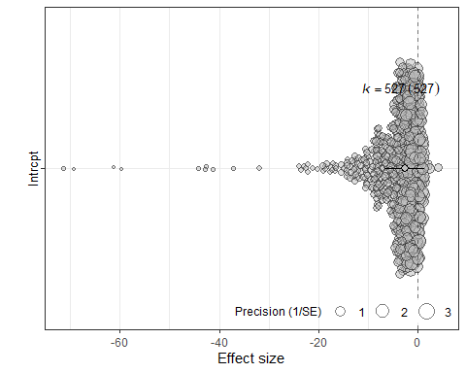

dados completos, ES misto, measure = SMCC

meta4 = rma(yi=yi, vi=vi, data = dados_meta_misto %>% filter(treated_n>2), measure = "SMCC", method = "REML", slab = rayyan.key)  
summary(meta4)

##   
## Random-Effects Model (k = 1158; tau^2 estimator: REML)  
##   
## logLik deviance AIC BIC AICc   
## -3419.6288 6839.2575 6843.2575 6853.3647 6843.2679   
##   
## tau^2 (estimated amount of total heterogeneity): 8.1638 (SE = 0.4502)  
## tau (square root of estimated tau^2 value): 2.8572  
## I^2 (total heterogeneity / total variability): 89.96%  
## H^2 (total variability / sampling variability): 9.96  
##   
## Test for Heterogeneity:  
## Q(df = 1157) = 6066.2568, p-val < .0001  
##   
## Model Results:  
##   
## estimate se zval pval ci.lb ci.ub   
## -3.8339 0.0996 -38.4935 <.0001 -4.0292 -3.6387 ***   
##   
## ---  
## Signif. codes: 0 '***' 0.001 '**' 0.01 '*' 0.05 '.' 0.1 ' ' 1

#confint(meta4)  
  
orchard_plot(meta4, group = "Comparison_ID", xlab = "Effect size",  
 transfm = "none") +   
 scale_color_manual(values = "black") +   
 scale_fill_manual(values = "grey")

## Scale for colour is already present.  
## Adding another scale for colour, which will replace the existing scale.  
## Scale for fill is already present.  
## Adding another scale for fill, which will replace the existing scale.

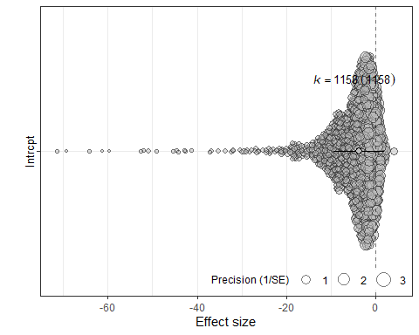

dados completos, ES misto, measure = SMD

meta5 = rma(yi=yi, vi=vi, data = dados_meta_misto %>% filter(treated_n>2), measure = "SMD", method = "REML", slab = rayyan.key)  
summary(meta5)

##   
## Random-Effects Model (k = 1158; tau^2 estimator: REML)  
##   
## logLik deviance AIC BIC AICc   
## -3419.6288 6839.2575 6843.2575 6853.3647 6843.2679   
##   
## tau^2 (estimated amount of total heterogeneity): 8.1638 (SE = 0.4502)  
## tau (square root of estimated tau^2 value): 2.8572  
## I^2 (total heterogeneity / total variability): 89.96%  
## H^2 (total variability / sampling variability): 9.96  
##   
## Test for Heterogeneity:  
## Q(df = 1157) = 6066.2568, p-val < .0001  
##   
## Model Results:  
##   
## estimate se zval pval ci.lb ci.ub   
## -3.8339 0.0996 -38.4935 <.0001 -4.0292 -3.6387 ***   
##   
## ---  
## Signif. codes: 0 '***' 0.001 '**' 0.01 '*' 0.05 '.' 0.1 ' ' 1

#confint(meta5)  
  
orchard_plot(meta5, group = "Comparison_ID", xlab = "Effect size",  
 transfm = "none") +   
 scale_color_manual(values = "black") +   
 scale_fill_manual(values = "grey")

## Scale for colour is already present.  
## Adding another scale for colour, which will replace the existing scale.  
## Scale for fill is already present.  
## Adding another scale for fill, which will replace the existing scale.



Meta-análise (3-level SMD)

meta1_3l = rma.mv(yi=yi, V=vi, data = dados_meta_smd %>% filter(treated_n>2), method = "REML", random = ~1|rayyan.key/Comparison_ID)  
meta1_3l

##   
## Multivariate Meta-Analysis Model (k = 1158; method: REML)  
##   
## Variance Components:  
##   
## estim sqrt nlvls fixed factor   
## sigma^2.1 10.7015 3.2713 346 no rayyan.key   
## sigma^2.2 8.3472 2.8892 1158 no rayyan.key/Comparison_ID   
##   
## Test for Heterogeneity:  
## Q(df = 1157) = 7740.3037, p-val < .0001  
##   
## Model Results:  
##   
## estimate se zval pval ci.lb ci.ub   
## -6.1764 0.2277 -27.1194 <.0001 -6.6228 -5.7300 ***   
##   
## ---  
## Signif. codes: 0 '***' 0.001 '**' 0.01 '*' 0.05 '.' 0.1 ' ' 1

#confint(meta_3l)

meta2_3l = rma.mv(yi=yi, V=vi, data = dados_one_sample_smd %>% filter(treated_n>2), method = "REML", random = ~1|rayyan.key/Comparison_ID)  
meta2_3l

##   
## Multivariate Meta-Analysis Model (k = 527; method: REML)  
##   
## Variance Components:  
##   
## estim sqrt nlvls fixed factor   
## sigma^2.1 17.2223 4.1500 135 no rayyan.key   
## sigma^2.2 13.8912 3.7271 527 no rayyan.key/Comparison_ID   
##   
## Test for Heterogeneity:  
## Q(df = 526) = 3890.9735, p-val < .0001  
##   
## Model Results:  
##   
## estimate se zval pval ci.lb ci.ub   
## -7.7576 0.4531 -17.1203 <.0001 -8.6458 -6.8695 ***   
##   
## ---  
## Signif. codes: 0 '***' 0.001 '**' 0.01 '*' 0.05 '.' 0.1 ' ' 1

Meta-análise (3-level SMCC)

meta3_3l = rma.mv(yi=yi, V=vi, data = dados_one_sample_smcc %>% filter(treated_n>2), method = "REML", random = ~1|rayyan.key/Comparison_ID)  
meta3_3l

##   
## Multivariate Meta-Analysis Model (k = 527; method: REML)  
##   
## Variance Components:  
##   
## estim sqrt nlvls fixed factor   
## sigma^2.1 3.1920 1.7866 135 no rayyan.key   
## sigma^2.2 1.7763 1.3328 527 no rayyan.key/Comparison_ID   
##   
## Test for Heterogeneity:  
## Q(df = 526) = 2055.8800, p-val < .0001  
##   
## Model Results:  
##   
## estimate se zval pval ci.lb ci.ub   
## -3.4223 0.2034 -16.8255 <.0001 -3.8209 -3.0236 ***   
##   
## ---  
## Signif. codes: 0 '***' 0.001 '**' 0.01 '*' 0.05 '.' 0.1 ' ' 1

meta4_3l = rma.mv(yi=yi, V=vi, data = dados_meta_misto %>% filter(treated_n>2), method = "REML", random = ~1|rayyan.key/Comparison_ID)  
meta4_3l

##   
## Multivariate Meta-Analysis Model (k = 1158; method: REML)  
##   
## Variance Components:  
##   
## estim sqrt nlvls fixed factor   
## sigma^2.1 6.0075 2.4510 346 no rayyan.key   
## sigma^2.2 3.0497 1.7463 1158 no rayyan.key/Comparison_ID   
##   
## Test for Heterogeneity:  
## Q(df = 1157) = 6066.2568, p-val < .0001  
##   
## Model Results:  
##   
## estimate se zval pval ci.lb ci.ub   
## -4.5716 0.1678 -27.2482 <.0001 -4.9004 -4.2427 ***   
##   
## ---  
## Signif. codes: 0 '***' 0.001 '**' 0.01 '*' 0.05 '.' 0.1 ' ' 1

### variabilidade entre diferenças e entre grupos

library(ggplot2)  
  
ggplot(dados_one_sample, aes(y = treated_sd)) +  
 geom_jitter(aes(x=1)) +   
 labs(title = "sd das diferenças") +  
 scale_y_continuous(limits = c(0, 110))

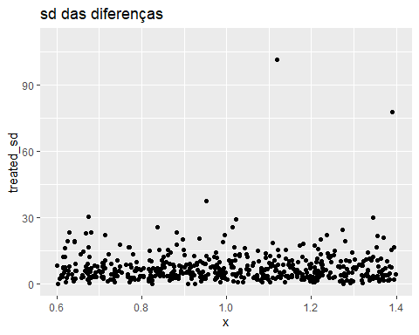

dados_sd_grupo = dados_two_sample %>% select(c("treated_sd", "control_sd", "Comparison_ID"))  
dados_sd_grupo = reshape2::melt(dados_sd_grupo, id.vars = "Comparison_ID")  
  
ggplot(dados_sd_grupo, aes(y = value, x = variable)) +  
 geom_jitter() +   
 labs(title = "sd de cada grupo") +  
 scale_y_continuous(limits = c(0, 110))

