  For office use only
  T1 | ________________
  T2 | ________________
  T3 | ________________
  T4 | ________________
  Team Control Number
  111111
  Problem Chosen
  C
  For office use only
  F1 | ________________
  F2 | ________________
  F3 | ________________
  F4 | ________________
2008
Mathematical Contest in Modeling (MCM/ICM) Summary Sheet
Finding the Good in Health Care Systems
Summary
Health Care System not only effects national health, but also dominates in life quality and life expectancy. In order to provide an improving scheme of Health Care System to guide every countries, this essay researches 11 metrics of 16 countries and establish three models for evaluation and prediction.
Firstly, based on Principal Component Analysis, we found an Evaluation Model to represent the Health Care System level of each country. And the result shows that some countries such as Japan, Norway and Germany have a perfect Health Care System, while some African countries like Congo and Kenya are of poor system and demand an immediate improvement. The rank of Health Care System is consistent with the result given by World Health Organization.
Secondly, to research the effective degree on the Health Care System with the 11 metrics, we build a metrics analysis model with the method of Grey Relational Analysis. With analysis of correlation degree among metrics, we confirm major metrics as below: general government expenditure on health as a percentage of GDP, prevalence of tuberculosis and Sanitation facility access. Our model can not only evaluate health care level among different countries but also describe changes of the Health Care System of one country in history. We evaluate USA, Norway and India with this 3 metrics and the result fits the formal conclusion. Then we use the simplified model to analyze the change of Health Care System in China. The result shows that China really makes some endeavor to improve its Health Care System, which provide paradigm to other countries.
Thirdly we build a classifying system based on Hopfield Neural Network for the Health Care System and then we build a predicting model. We establish multiple recombination patterns for the Health Care System of the US and make estimation separately. Finally we obtain the scheme to promote the level of the US Health Care System.

Introduction
Our aim is to find some of the most important metrics and then we can build a evaluation model of Health Care System. Principal Component Analysis is a way of identifying patterns in data, and expressing the data in such a way to highlight their similarities and differences. Since patterns in data are hard to find in high dimensions, where the luxury of graphical representation is not available, PCA is a powerful tool for analyzing data. The other main advantages of PCA are that once you have found these patterns in the data, you can compress the data. We also consider using Gray Rational Analysis method to determine the metrics which have more relevance to the Synthetical evaluation values, so that the evaluation model can be simplified. For the Health Care System of the US is a complex system, the existing model can’t be described accurately. With these issues, we think Hopfield Neural Network is a good choice. A Hopfield Network is a form of recurrent artificial neural network.
Background
Nations have systems for providing health care for their residents. Issues that are often of concern to people and are often in the news include which systems are better and whether current systems can be improved. Aspects of these systems vary widely between nations: how they are funded; whether services are delivered through public, private, or non-profit organizations; whether public insurance is universal for all residents; who is eligible for assistance; what care is covered; whether the latest medical procedures are available; and how much is required as user fees.
Factors that are often debated in determining the quality of care include: coverage for complementary care ( glasses, dental, prostheses, prescription drugs, etc ); which diseases are the most critical in affecting overall health; percentage of GDP spent on health care; percentage of health care costs that goes toward labor/administrative/malpractice insurance; ratio of public to private spending on health care; per capita spending on health care; growth of per capita spending on health care; number of participating physicians; per capita sick days; fairness of care in terms of age, race, gender, socio-economic class; and many more. Adding to the complications are health-related factors such as personal exercise, food availability, climate, occupations of citizens, and smoking habits.
General Assumptions
·The data we select is representative for all countries.
·The data we use is authentic.
·Assume that there is no extreme metrics in a Health Care System compared with the overall evaluation

Notations
Variable | Description
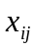 | Values of the th metric of the th object
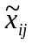 | Values of standardized metrics
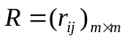 | Correlation coefficient matrix
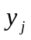 | The th principal component
 | Synthetical evaluation values
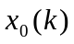 | The reference numeral in the moment
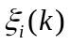 | Correlation coefficient of the th sequence in the moment
 | Relational degree of the th sequence to the reference numeral
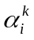 | The ideal evaluation index of the th metrics in the th class
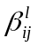 | Improvement Percentage for improving to class
Note: other symbols will be described detailedly in the following article.
Metrics for Determining Health Care System
Metrics for determining Health Care System are usually classified as basic medical equipment metric, prevalence of disease metric, financial metric and so on. According to annual statistics from WHO, we confirm the 11 metrics of Health Care System below:
Table 1.
Metrics to evaluate the Health Care System
Num | Metrics
1 | life expectancy at birth
2 | general government expenditure on health as a percentage of GDP
3 | the ratio of private and general government expenditure on health
4 | adult mortality rate (between 15 and 60) per 1000population
5 | under-five mortality rate (per 1000 live births)
6 | maternal mortality ratio (per 100000 live births)
7 | prevalence of tuberculosis(per 100000 population)
8 | obesity -adult prevalence rate
9 | physicians density(per 10000 population )
10 | hospital bed density(per 1000 population)
11 | Sanitation facility access

In addition to this, we consult sixteen countries’ statistic data, including the US, China, Congo, Germany, Norway, India, Japan, Switzerland, Canada, Cuba, Brazil, Pakistan, Kenya, Russia, Israel and South Africa.
Model 1. A Evaluation Model based on PCA
On account of the large number of evaluation metrics, less metrics measuring the overall evaluation of value seems to be distinct. We bring in PCA (principal component analysis) method to select principal component and then make comprehensive evaluate with Health Care System of some of the countries.
The steps of PCA are as follows:
Step 1: Standardized Original Data
We need to standardize the original data to use the Principal Component Analysis method. Assume that there are m variables, n evaluation subjects, 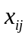 is the value of the th metric of the th object. We standardize to 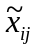 as the formula below:
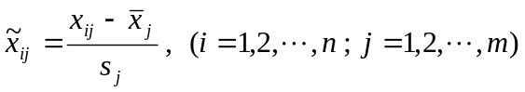
in which, 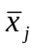 and 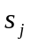 is the sample mean and sample standard deviation of the th metrics, which means
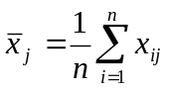，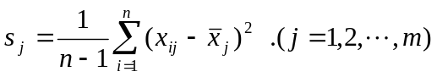
And we call
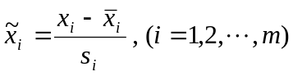
is the standardized metrics variables.
We also notice that, the metrics listed in Table 1 can be divided into two categories which one category is of positive relationship with the evaluation of Health Care System and another is just of the inverse relationship. In order to unify the evaluation criterion, we do a reciprocal transformation for the second metrics as the formula below:
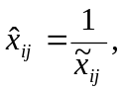
Without loss of generality, we consider all with the same evaluation criterion.
Step 2 : Calculating the Correlation Coefficient Matrix 
Assume the Correlation Matrix is , which the correlation coefficient is defined by
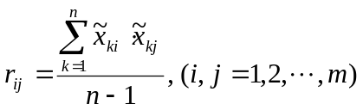
and we have 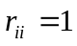 and 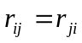 established. 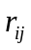 is the correlation coefficient of the th and th metric.
Step 3 : Calculate the Eigenvalue and Eigenvector
We assume that the eigenvalue of matrix is 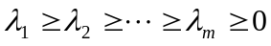, the corresponding eigenvectors is 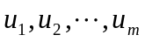, in which 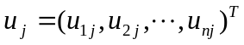. There are m new metrics composed by eigenvectors
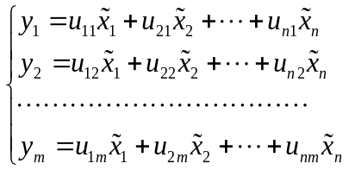
in which, 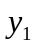 is the first principal component, 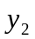 is the second principal component,…, 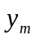 is the th principal component.
Step 4 :select  principal components, calculate the Synthetical evaluation values
We first calculate the information contribution and accumulative contribution rate of eigenvalue 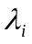, we call
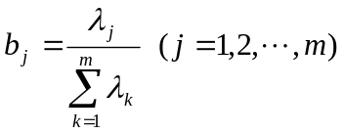
as the information contribution of principal component ,we call
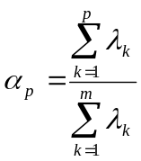
as the accumulative contribution of principal components 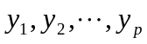, when 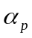 approaches to 1, we choose the first metrics as principal components to replace the original m metrics, so that we can conduct a comprehensive analysis using these p principal components. At last, we calculate the Synthetical evaluation values , which
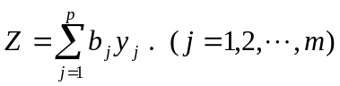
So that we establish a Evaluation Model based on Principal Component Analysis.
Model Results
We firstly list the raw data of the metrics in Table 2.
Table 2.
Original Data of the Metrics of 16 Countries in Table 1
Metrics | US | China | Congo | Germany | Norway | India | Japan | Switzerland
1 | 79 | 73.5 | 49 | 81 | 73.5 | 65 | 83 | 82
2 | 0.179 | 0.052 | 0.085 | 0.111 | 0.091 | 0.039 | 0.093 | 0.109
3 | 1.179 | 0.523 | 0.488 | 0.318 | 0.170 | 2.226 | 0.250 | 0.529
4 | 104 | 96.5 | 384.5 | 73.5 | 63 | 203 | 46 | 58.5
5 | 8 | 15.6 | 146 | 4 | 3 | 61 | 3 | 4
6 | 21 | 26.1 | 540 | 7 | 7 | 200 | 5 | 8
7 | 4.7 | 104 | 512 | 5.7 | 7.7 | 249 | 26 | 6
8 | 0.33 | 0.057 | 0.017 | 0.251 | 0.215 | 0.019 | 0.05 | 0.175
9 | 36.9 | 18 | 1.5 | 36.01 | 49 | 6.49 | 21.42 | 40.7
10 | 3 | 3.836 | 0.8 | 8.3 | 3.3 | 0.9 | 13.7 | 5.3
11 | 1 | 0.64 | 0.24 | 1 | 1 | 0.34 | 1 | 1
Metrics | Canada | Cuba | Brazil | Pakistan | Kenya | Russia | Israel | South Africa
1 | 81 | 78 | 73.5 | 63 | 60 | 69.85 | 82 | 74
2 | 0.112 | 0.1 | 0.089 | 0.025 | 0.045 | 0.062 | 0.077 | 0.085
3 | 0.420 | 0.056 | 1.188 | 2.704 | 1.525 | 0.675 | 0.572 | 1.096
4 | 70 | 97 | 153.5 | 207 | 320 | 241 | 59.5 | 151
5 | 6 | 6 | 21 | 87 | 84 | 10 | 4 | 14
6 | 12 | 73 | 56 | 260 | 360 | 34 | 7 | 300
7 | 5.6 | 12 | 46 | 350 | 291 | 124 | 7.1 | 46
8 | 0.262 | 0.215 | 0.188 | 0.055 | 0.042 | 0.265 | 0.262 | 0.313
9 | 19.1 | 67.2 | 17.2 | 8.1 | 1.4 | 43.09 | 31.08 | 7.58
10 | 3.4 | 5.1 | 2.4 | 0.6 | 1.4 | 9.7 | 3.4 | 2.8
11 | 1 | 0.91 | 0.8 | 0.45 | 0.31 | 0.7 | 1 | 0.79

we get the correlation coefficient matrix and the information contribution and accumulative contribution rate of eigenvalues by substituting in model 1.
Table 3.
Eigenvalue , Proportion and Contribution we Calculated
Num | 1 | 2 | 3 | 4 | 5 | 6 | 7 | 8 | 9 | 10 | 11
eigenvalue | 6.67 | 1.39 | 1.23 | 0.73 | 0.49 | 0.25 | 0.13 | 0.07 | 0.02 | 0.01 | 0.01
proportion | 0.61 | 0.13 | 0.11 | 0.07 | 0.04 | 0.02 | 0.01 | 0.01 | 0 | 0 | 0
contribution | 0.61 | 0.74 | 0.85 | 0.92 | 0.96 | 0.98 | 0.99 | 1 | 1 | 1 | 1

We can see from Table 3, accumulative contribution rate of the first four metrics is more than 90%, which means the four elements can reflect overall behavior. So we choose the first four elements for evaluation. And the feature vectors are listed in the following Table 4.
Table 4.
The First Four Principal Components and Their Eigenvectors of Standardized Metrics
 | 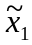 | 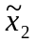 | 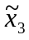 | 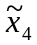 | 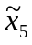 | 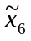 | 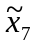 | 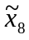 | 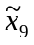 | 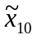 | 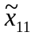
Eig 1 | 0.35 | 0.25 | 0.15 | 0.34 | 0.35 | 0.32 | 0.30 | -0.28 | 0.29 | 0.24 | 0.38
Eig 2 | 0.02 | -0.27 | -0.48 | 0.30 | 0.21 | 0.45 | -0.17 | 0.25 | -0.41 | 0.31 | -0.06
Eig 3 | -0.09 | -0.40 | 0.59 | 0.05 | 0.14 | 0.04 | -0.43 | 0.14 | 0.30 | 0.40 | -0.12
Eig 4 | -0.30 | 0.32 | 0.28 | 0.17 | 0.20 | 0.20 | 0.30 | 0.67 | 0.02 | -0.24 | -0.15

Then we get four principal components:
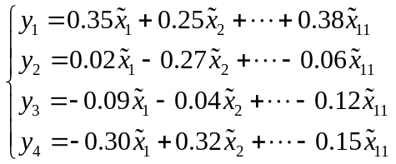
And we build Comprehensive evaluation principal component model by taking contribution rate of four principal components as weight:
We substituted the standardized data of every country in the evaluation model. And we got ranking and evaluation by calculating (Table 5).
Table 5.
Evaluation Values and Ranks of 7 Countries’ Health Care System
Countries | US | China | Congo | Germany | Norway | India | Japan | Switzerland
Values | 0.67 | -0.65 | -2.45 | 1.68 | 1.58 | -2.02 | 2.39 | 1.59
Ranks | 8 | 10 | 16 | 2 | 4 | 14 | 1 | 3
Countries | Canada | Cuba | Brazil | Pakistan | Kenya | Russia | Israel | South Africa
Values | 0.84 | 0.97 | -0.79 | -1.90 | -2.11 | -0.29 | 1.33 | -0.83
Ranks | 7 | 6 | 11 | 13 | 15 | 9 | 5 | 12

In order to express our model results more intuitively we draw a statistical graph (Figure 1) with data in Table 5 as below:
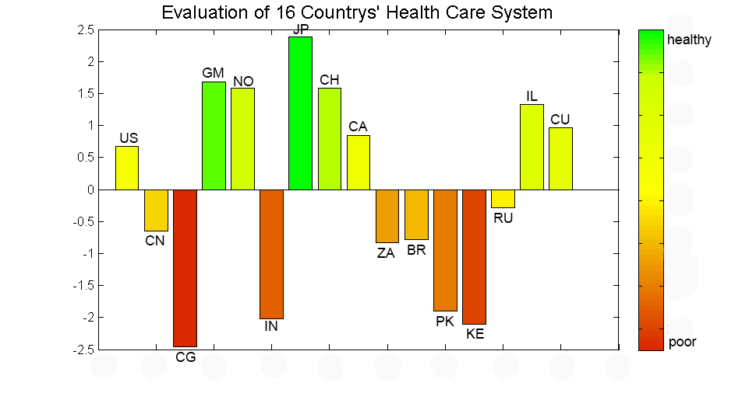
Figure 1.Bar Graph of Evaluation of 16 Countries’ Health Care System
Analyzing the Model
For the first principal component , none metric weight is too big or too small, weights are close to each other. It arrives at the fact that is correlated with all evaluation metrics. We consider that this principal component represent the basic level of the country‘s Health Care System. For the second principal component , the weights of ,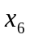 and 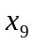 are greater, directly reflects the promotion of the Health Care System and restraint to infectious diseases. For the third principal component 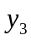, the weights of ,,and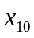 are greater, directly reflects the promotion of the Health Care System and restraint to infectious diseases. For the forth principal component 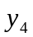,,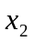 and 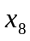 weight much more, directly represent the effect of the govern investment in the Health Care System and the harm to life by obesity.
We compare our ranking with data from WTO and find out that our result is basically identical with the official.
After analyzing our model we know that PCA can evaluate Health Care System effectively. But we need to process a large number of metrics and a complex model. We need to bring in a method of dimension reduction to simplify our evaluation model.

Model 2. A Metrics Analysis Model based on GRA
From model 1 we can see that it is hard to build a objective physical model of the Health Care System for the concealed relation between internal factors, which means that this is a gray model. We need to use Gray Rational Analysis method to distinguish correlation between metrics and then simplify our evaluation model.
Firstly we select the reference sequence
in which represents a moment. Assume that there are comparison sequences
and we call
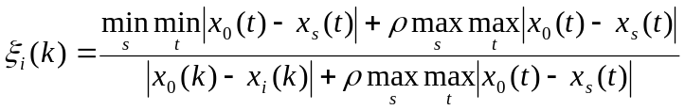
is the correlation coefficient with  and 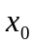,and 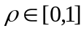 is the distinguishing coefficient, we call 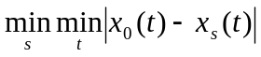 is the minimum differential of the two levels and 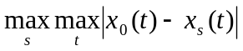 is the maximum differential of the two levels. Generally, the bigger  is, the greater distinguish ability is, and vice versa.
We define
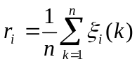
as the correlative degree, namely to describe the influence on caused by the change of . Then we build a metrics analysis model based on GRA. We reserve the metric that has a higher degree and then we can simplify the Evaluation Model 1.
Model Results
We take evaluation values in Table 5 as the reference sequence and standardize the original data from Table 2 as 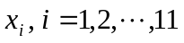. Then we substitute the value into the model and we obtain correlation degree between metrics (Table 6).And we draw a bar graph of relational degree of metrics(Figure 2).
Table 6.
Relational Degree of the Metrics in Table 1
Num | 1 | 2 | 3 | 4 | 5 | 6 | 7 | 8 | 9 | 10 | 11
relational degree | 0.917 | 0.936 | 0.780 | 0.889 | 0.875 | 0.852 | 0.928 | 0.656 | 0.918 | 0.865 | 0.920
Ranks | 5 | 1 | 10 | 6 | 7 | 9 | 2 | 11 | 4 | 8 | 3
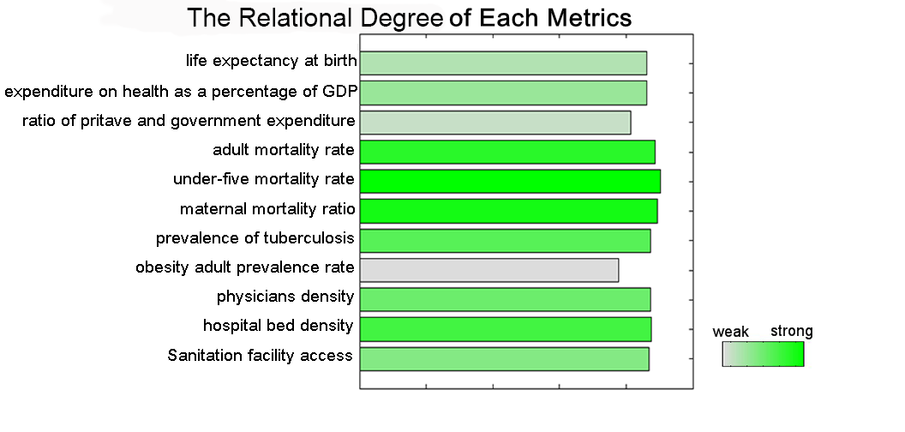
Figure 2. Bar Graph of Relational Degree of Metrics

We can get the conclusion that there are five metrics whose relational degree surpass 0.9 from which we know they are the most important metrics to evaluate the Health Care System. We choose 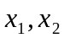 and 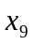( life expectancy at birth，general government expenditure on health as a percentage of GDP and physicians density)to be our new evaluation metrics.
Model Tests
To test whether the simplified evaluation model can measure s country’s Health Care System of historical change, we use weights in model 1 to process data from China in 1990, 2000, 2010, and obtain synthetical evaluate value as below(Table 7). And we draw a bar graph of Evaluation values of China’s Health Care System (figure 3).
Table 7.
Change of Evaluation Values of China’s Health Care System
Year | 1990 | 2000 | 2010 | 2011
Evaluation values | -1.39 | -0.74 | 0.78 | 1.35
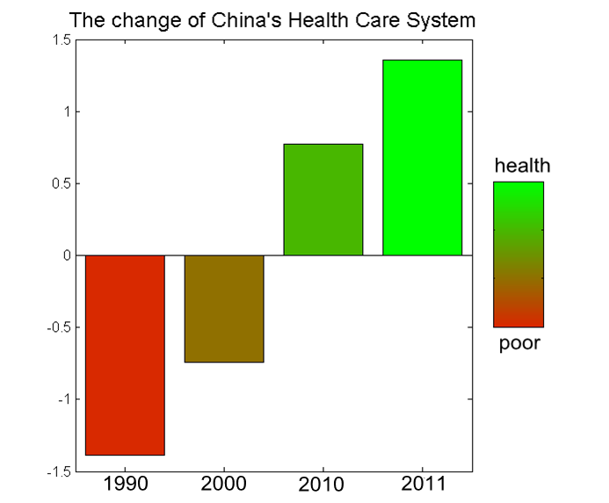
Figure 3. Change of Evaluation Values of China’s Health Care System
From result as above we can see obviously that evaluation value rise and it tallies with the current situation.
In order to further illustrate that the simplified evaluation model is also true for other countries, we select Norway who get a high evaluation in the result of model 1 and India with a low evaluation to compare with the US. The comprehensive evaluation value calculated by the model is showed as below (Table 8):
Table 8.
Evaluation of 3 Countries’ Health Care System
Countries | US | Norway | India
Evaluation values | 0.49 | 2.00 | -2.50
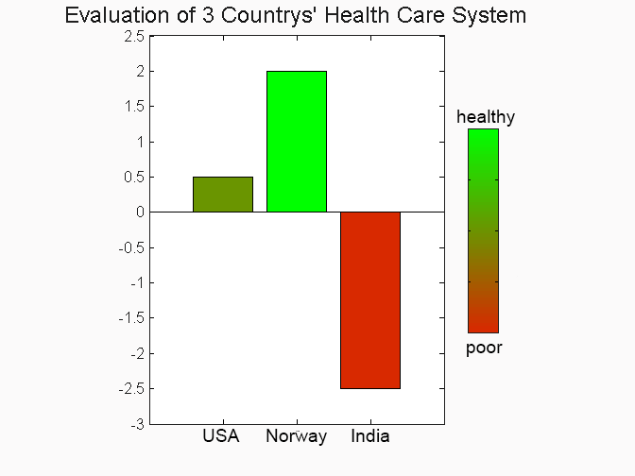
Figure 4. Evaluation of 3 Countries’ Health Care System
We find that our results of simplified model tallies with previous result. The Health Care System of the US is better than India but worse than Norway.
Analyzing the model
Table 6 shows that correlation degree of five metrics (general government expenditure on health as a percentage of GDP, prevalence of tuberculosis, Sanitation facility access, physician density and life expectancy at birth) are bigger than 0.9, which illustrates these metrics are obvious in evaluating. In the meanwhile we get to know three smallest correlation degree metrics are , and . We can arrive at the conclusion that this evaluation this evaluation is low in the US whose level of health care is high after analyzing the original data in Table2. But in Congo who is undeveloped this metric locates in the forefront. So this metric is greatly influenced by national system and economic structure and it doesn’t have a big correlation with Health Care System. is affected by the factors such as religion, eating habits and so on.
Model 3. A Predicting Model based on Hopfield Neural Network
In the predicting problem we introduce Hopfield Neural Network predicting model. Because the previous evaluation model which based on PCA has passive effect on quantitative research system. The evaluation to Health Care System of all the countries is based on relative index and there is not any absolute standard to weigh the system, that is, when country or index changes, relative standard changes as well. What is more, the Health Care System contains many indexes which are correlative, complex and of high nonlinearity. As a consequence, traditional mathematics model cannot meet the requirement of prediction. However the disperse neural network have associative memory and maintain high ability of recognition even with interference and without complete information. So we adopt Hopfield Neural Network to the Health Care System evaluation problem. According to our assumption that when a country’s Health Care System of high class, its each index will not be so bad, which ensure the applicability of Hopfield Neural Network. So Hopfield Neural Network is suiTable this problem.
We can see the flow diagram of Hopfield Neural Network illustrated by(Figure 5): At first, Balance Point was designed as evaluation index which stands for several representative levels. Then training of network makes the evaluation index inclined to the Balance Point of Hopfield Neural Network and encodes the ideal level evaluation index. After that, the Balance Point stored by the Network is the evaluation index. When one inputs the index of a country, the Hopfield Neural Network will approach one of the balance point via its strong associative memory and judge the classified level after simulation and analyzing.

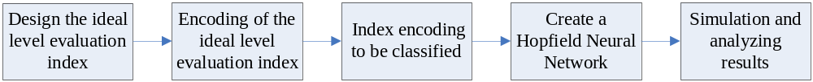
Figure 5. Flow Diagram of Building a Hopfield Neural Network

Considering the evaluation established in Model1 is global representative, we classify Health Care System into three levels: I,II and III(stand for bad, medium and good) as Table 5. The standard of classification is illustrated with Table9.
Table 9.
Values Interval of Three Classifications
Classification | Ⅰ | Ⅱ | Ⅲ
Values Interval | (-2.5,-0.8] | (-0.8,0.8] | (0.8,2.5]

According to the standards, we resettle the evaluating data and fill in Table10.
Table 10.
16 Countries and Their Classifications
Country | Evaluation values | Classification | Country | Evaluation values | Classification
Japan | 2.39 | Ⅲ | Russia | -0.29 | Ⅱ
Germany | 1.68 | Ⅲ | China | -0.65 | Ⅱ
Switzerland | 1.59 | Ⅲ | Brazil | -0.79 | Ⅱ
Norway | 1.58 | Ⅲ | South Africa | -0.83 | Ⅰ
Israel | 1.33 | Ⅲ | Pakistan | -1.9 | Ⅰ
Cuba | 0.97 | Ⅲ | India | -2.02 | Ⅰ
Canada | 0.84 | Ⅲ | Kenya | -2.11 | Ⅰ
US | 0.67 | Ⅱ | Congo | -2.45 | Ⅰ

In this model, we judge a country’s Health Care System via three levels rather than the Evaluating Value, that is, the improvement of Health Care System projected in the promotion of levels in Table9.
We regard the mean of each evaluation index of a class as the class’ ideal index that is Balance Point of Hopfield Neural Network. And it is listed in Table 11.
Table 11.
The Ideal Evaluation Index of Three Levels
Metrics | 1 | 2 | 3 | 4 | 5 | 6 | 7 | 8 | 9 | 10 | 11
Ⅰ | 62.20 | 0.06 | 1.13 | 226.19 | 42.35 | 297.46 | 147.05 | 0.03 | 5.01 | 1.30 | 0.43
Ⅱ | 73.96 | 0.10 | 0.79 | 130.54 | 11.88 | 30.03 | 15.86 | 0.13 | 28.80 | 4.73 | 0.79
Ⅲ | 80.07 | 0.10 | 0.19 | 63.80 | 4.00 | 8.23 | 7.67 | 0.15 | 37.79 | 6.07 | 0.99

Because the state of Discrete Hopfield Neural Network nerve cell is binary(1 and -1), we need to encode to project the evaluation index into the state of nerve cell.
Encoding Rule: If the index is equal or greater than the target of a class, the state of nerve cell was set ‘+1’, otherwise set ‘-1’. Ideal classification is like the following Figure6. If the state is ‘+1’ we marked ‘●’ in the figure, otherwise use ‘○’.
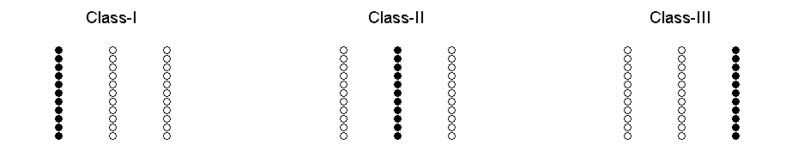
Figure 6. the Encoding Figure of the Ideal Level Evaluation Index

In this way, when we resettle the index structure, we measure range of an index with Ideal Evaluation Index of higher level.
We define the Ideal Evaluation Index in k^{th} level of i^{th} index as. When a country’s i^{th} index was improved from 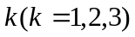to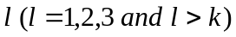, the improvement percentage of index is:
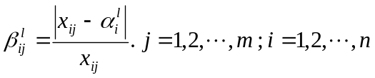
Model Results
From Table10, we can see that the US has the highest value in class II. So we choose Health Care System of US and restructure it to improve the system based on our metrics to see if it can be improved to class III.
We figure out two improving scheme and calculate by Hopfield Neural Network model. The result was listed in Table12, and the Simulation Encoding Figure is like Figure7.
Table 12
Two Groups of Improvements and New Classifications
Metrics | Improvement Percentage | Metrics | Improvement Percentage
3 | 49.78% | 5 | 100%
8 | 144.75% | 6 | 155%
9 | 2.38% | 9 | 2.38%
Classifications | Ⅱ | Classifications | Ⅲ
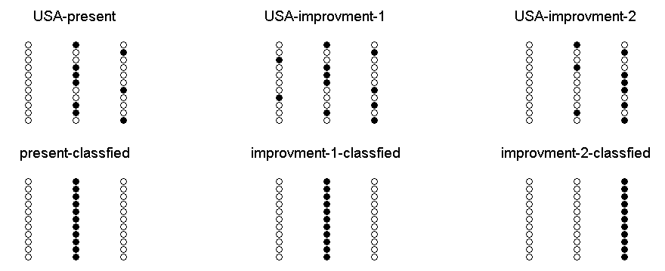
Figure 7. The Simulation Encoding Figure of Two Groups of Improvements

We can see from column 2 in Figure 7, that the change in the ratio of private and government expenditure, obesity prevalence rate and physicians density seems have little to do with overall Health Care System. Calculation shows that the bottleneck of America’s Health Care System lies in the metrics of class II. After improvement of under-five mortality rate, maternal mortality ratio and physicians density, as we see, the Evaluating Value of the US was raised to III from II.
Analyzing the model
We can see from Table 12 that though we improve the worst index of US, it cannot promote overall classification. Only by improving the indexes at the same level as the overall ranking, which is considered as the bottleneck of the US’s Health Care System, can the overall ranking be promote effectively. However, some of the Improvement Percentage in Table12 is over 100%. That is because we divide the metrics into three classes roughly. We can draw a more precise conclusion of improvement if we obtain more countries’ data and classify precisely.
Conclusion
Health Care System of countries around the world varies considerably. Some countries have perfect Health Care System such as Norway and Japan, some demand an immediate improvement such as Congo, Kenya and India. However, some countries develop very fast in economy but neglect the importance of Health Care System like China, and even the US --the most powerful country in this world, has a relatively low evaluation because of some serious defects of the system. Why Health Care System is so important? Because it not only effects national health, but also dominate in life quality and life expectancy (according to the Correlation coefficient matrix in Model 2). Fortunately, we found that Health Care System can be improved in several major aspects: government expenditure on health as a percentage of GDP, physicians density, hospital bed density and so on. As long as a country makes efforts to improve these metrics, the countries and her people could grow up healthy.
The solution mentioned in our model is just applied to a general situation, for different countries, one should make policies according to their own situation of nations and national economic level.
As for the US, from the data in Table 2 we know that the US has the greatest value in government expenditure on health as a percentage of GDP, while the second least value in the ratio of private and general government expenditure. Although the US government has put a large number of revenue on Health, but most of the money are used in researching medical equipment and drug development. What’s more, drugs are very expensive in the US. That why the ratio of private and general government expenditure is so low, and that’s because of America’s marketization of medical service mode.
Strength and Weakness
Strength
·Evaluation model is correct and effective;
·Correlation degree analysis simplifies the evaluation model validly;
·Introduction of evaluation level establish absolute metrics for determination of the Health Care System after recombination
·Use of neural network solves the discrete data prediction problem effectively.
Weakness
·We need to recalculate when evaluation objects in PCA change;
·The number country sample is too little to reflect global Health Care System;
·Classification of neural net is not distinct enough to show differences among countries in the same level.

Reference
[1] Tandon A, Murray C J, Lauer J A, etal. MEASURING OVERALL HEALTH SYSTEM PERFORMANCE FOR 191 COUNTRIES[J]. GPE Discussion Paper Series, 2010(30).
[2] Li Xingming, Wu Guowei. Sensitive analysis of the index of investable environment Evaluation.
[3] OECD Health Data, 2005
http://www.oecd-ilibrary.org/;jsessionid=ej6btkq1liebo.x-oecd-live-01
[4] OECD, The Reform of Health Care System. United States of America.
[5] Health Care System of USA, American Chinese Business Association
[6] Yin Aitian, Li Shuguang, Zhang Xingxu, Assessment of the medical quality evaluation index system .Research Center for Health Management and Policy Study, Shandong University, Jinan, China
[7] Index Mundi-Country Facts
http://www.indexmundi.com/
[8] World Health Organization, The world health report 2000-Health Systems: Improving Performance (Geneva : WHO, 2000)
[9] National data
http://data.stats.gov.cn/workspace/index?m=hgnd
[10] Zhaohui J. The Comparison and Evaluation of International Medical Security Schemes, University of international business and economics, 2005
[11] World Health Organization
http://www.who.int/en/

