  For office use only
  T1 | ________________
  T2 | ________________
  T3 | ________________
  T4 | ________________
  Team Control Number
  111111
  Problem Chosen
  A
  For office use only
  F1 | ________________
  F2 | ________________
  F3 | ________________
  F4 | ________________
2011
Mathematical Contest in Modeling (MCM/ICM) Summary Sheet

Perform better in the half-pipe
Summary

1 Introduction
为了设计出使运动员腾空高度最大化的half-pipe，我们必须要对运动过程中的运动员进行受力分析，找出腾空高度和场地参数之间的关系。

2 Background
半管滑雪是集合竞技性与观赏性的一项冬季运动会运动项目. 半管滑雪的场地是一个U 型雪槽, 滑雪者通过从与U 型管相连接的助滑道滑入, 以一定的初速度到达U 型管边缘, 之后运动员在槽中进行往返滑行, 当其每次滑离U 型管的边缘后可在空中做出翻转, 弹跳等动作以完成表演。运动员飞得越高，就有更多的时间去完成一个漂亮和复杂的动作。运动员的飞行高度限制着动作的难度和动作完成的质量。运动员的技术决定了他的表演程度，但标准的滑雪场地影响着运动员的发挥水平。由于半管滑雪场是一个新兴的运动项目，所以按照国际规定的指标范围，主要滑雪场地的平衡指标是不够的，从而使得运动员不能正常的展现自己的水平，所以如何设计一个合理的U型滑雪道，设计坡度，弧长和场地长度等是一个重要的问题。A half-pipe usually consists of several parts, including a entry ramp (leads skier in the half-pipe with a proper velocity), a half-pipe slope with a flat at the bottom and a vertical wall on each side of the pipe, two platform adjoining to the walls which the turning corner is called lip.普通的half-pipe示意图如下(Figure 1):
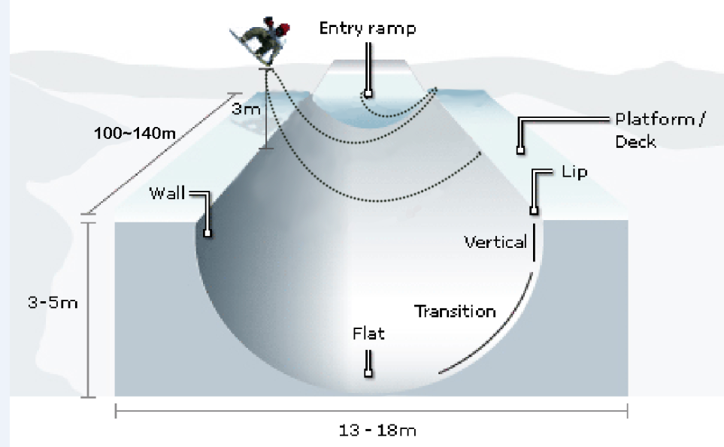
Figure 1. Sketch Map of the Half-pipe Ski Venue
3 General Assumptions
●我们忽略板和人之间滑动、碰撞等因素，将滑板和运动员视为一个整体，所有作用在板上的力都视为作用在板的重心;
●忽略空气阻力的影响;
●雪场的摩擦系数恒定不变，天气环境恒定不变;
●Assume the surface of the ski venue remains smooth;
●We neglect the influence of the wind;
●
4 Notations
Variable | Description
 | The quality of the athletes
 | Acceleration of gravity
 | The friction coefficient of the skateboard and snow
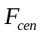 | Centripetal force
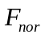 | Normal force
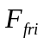 | Slide friction
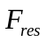 | Resultant force
 | The kinetic energy of the athletes
 | Arc length of glide trajectory
 | Radius of curvature
 | The included angle of trail’s tangent and vertical direction
 | Work of the skier
 | Skier’s velocity when he or she is leaving the half-pipe
 | The angel between velocity and the edge of the half-pipe when skier is leaving the half-pipe
 | Inclination of the flat bottom
 | The path length that the skier go through
 | Central angle of path corresponding to the axis on the cross-section
 | The width of the inclined flat bottom
 | The length of the inclined flat bottom
Note: other symbols will be described detailedly in the following article.
5 Model 1: A Horizontal Half-pipe
horizontal half-pipe场地受力分析较为简单，我们首先对这种条件下的场地进行建模，分析简单条件下的Vertical air问题。
5.1 Force Analysis
我们分析滑板和人组成的系统在沿着管壁向上运动时的受力情况，受力示意图如下(Figure 2)
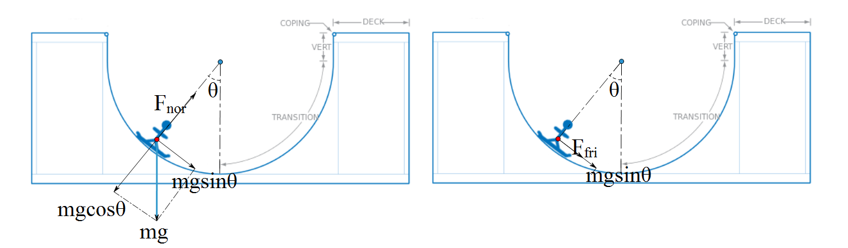
Figure 2. The schematic diagram of stress analysis on a horizontal half-pipe (system is force balance in the radial direction and the resultant is in the tangential direction)
径向上，支持力抵消了重力的分力，并且提供了向心力,所以有
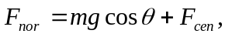
由Newton's second law知道向心力和速度的关系是
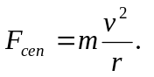
切向上，滑板在只受到摩擦力，satisfying
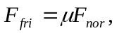
因为人和滑板的整体在径向上受力平衡，所以系统受到的合力为
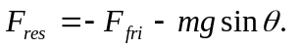
5.2 Energy Equations
因为运动员的运动轨迹是曲线，在不同位置的受力情况都不相同，所以我们无法直接写出整个过程的能量方程。我们先对极短时间内的能量转移进行分析，然后积分得出整个滑行过程的能量方程。
设运动员的位移是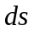，那么运动员的瞬时功率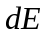等于合力与瞬时速度的乘积：
动能公式是
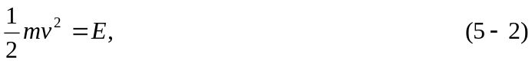
曲率半径公式是
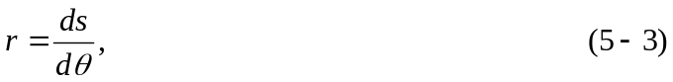
设运动员进入滑道时的初始速度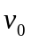，初始动能为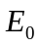，将(5-2) and (5-3)代入(5-1)，由能量守恒定律得
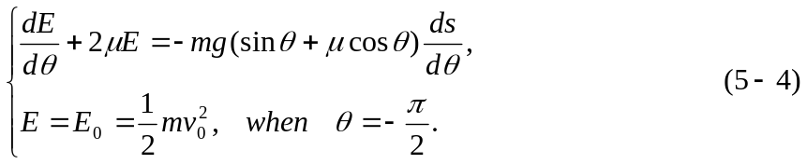
求解(5-4)得
因为half-pipe的横截面的cross-section是半圆，所以有
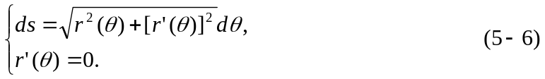
成立，将(5-6)代入(5-5)，得到
设运动员滑行过程中对外做的功为，将(5-3)代入(5-7)，得到
运动员脱离滑道时，动能完全转化为重力势能，并且速度方向竖直向上，那么有
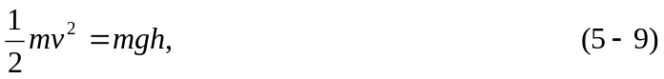
将(5-9)代入(5-8)，解出’vertical air’的表达式
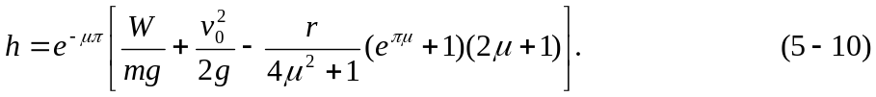
5.3 Model Results and Sensitivity Analysis
从(5-10)式我们看到，决定’vertical air’的因素有很多，其中场地因素有half-pipe的曲率半径，雪地和滑板的摩擦系数，运动员自身的因素有做功量和初始速度等因素。我们分别讨论这几种因素对的影响：
●Radius of Curvature: 和是负相关的关系，当越小时，越大，但是考虑到场地的实际情况，不可能无限小。radius较小时，滑板表面和场地的切合程度小，不利于滑行，radius较大时，因为摩擦带来的能量损失较大，较小，甚至会为负数；
●Friction Coefficient: 雪的摩擦系数和温度有关，为0.03-0.2，越小，越大；
●Work: 运动员在滑雪过程中通过调整自身的重心高度，完成了对外做功，从而增加了自己的能量，越大，越大。
●Initial Velocity:运动员的初始速度是通过the entry ramp后获得的，越大，越大，考虑到比赛中的起点和half-pipe进入点是相同的，同一个skier的总是确定的。
为了准确分析各个因素对的影响，我们选择control variable method，对上述因素进行sensitivity analysis。我们假设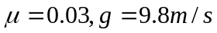,画出不同条件下的曲线。
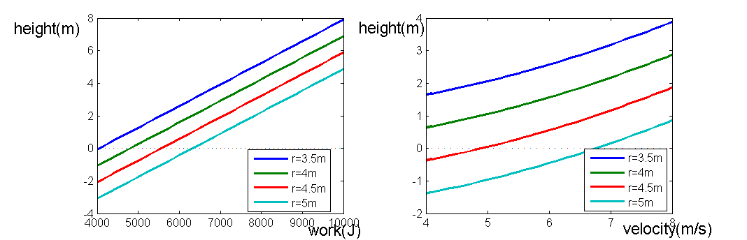
Figure 3(a). Sample curves for 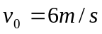 Figure 3(b). Sample curves for 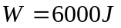
Figure 3. Sample curves for constant variables

6 Model 2: A Inclined Half-pipe
In a practical competition, the structure is more complex. The half-pipe is inclined and there is an inclined flat bottom for skier’s adjustment. So when skier is moving, he or she will move in section direction and move forward the low side of the half-pipe. In order to exactly explain the complex movement, we divide half-pipe into three paths, and the vertical view is as follow:我们考虑更加复杂的情况that the half-pipe is inclined，并且在half-pipe底端有一段inclined flat bottom。运动员在滑行时，不仅会在pipe的横截面方向上运动，而且会沿着轴向向the low side of the half-pipe运动。为了更准确的讨论这种复杂运动，我们将half-pipe划分为三段，俯视示意图如下(Figure ):
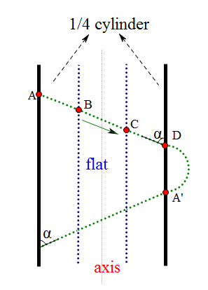
Figure 4. The aerial view of the inclined half-pipe and Glide trajectory on it
We classify a single move into three sections including A to B, B to C and C to D. Skier drops into quarter cylinder at A, then moves into inclined flat, after that ascend in quarter cylinder at D, afterward jumps into air and perform his or her act, then drops back into quarter cylinder at A’ where is the initial point of next move.
A to B, B to C and C to D,我们将运动员的单次滑动(from A to D)按照场地类型分为三段:A to B, B to C and C to D, 运动员在A点进入下降的a quarter cylinder, 在B点进入inclined flat, 在C点进入上升的a quarter cylinder, 然后在D点腾空跃起做出表演动作，然后在A’点处返回雪道，A’则作为下一次滑动的起始点。
6.1 Force Analysis
In order to find exactly relation between parameter of venue and velocity of skier in complex situation we analyze force situation of skier-board system when it moves from C to D. Force analysis is like the following diagram:
为了找到复杂情况下，skier速度和场地参数之间的准确关系，我们首先分析滑板和人组成的系统在C to D运动时的受力情况,受力示意图如下:
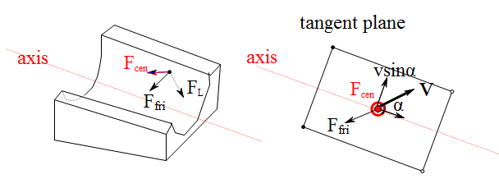
Figure 5. The schematic diagram of stress analysis on a inclined half-pipe
向心力为centripetal force is
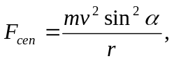
重力沿横截面径向的分量为component force of gravity along radial of cross section is:
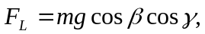
所以摩擦力为so friction is:
6.2 Energy Equations
We consider change of energy in a very short arc and the motion is like the following sketch. 我们考虑skier经过一个极短的弧线的过程中的能量变化，运动示意图如下:

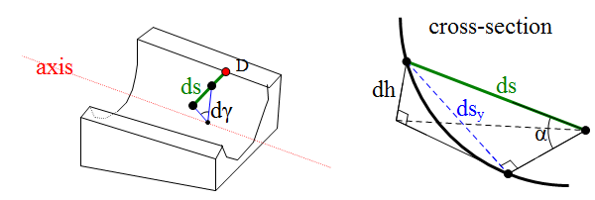
Figure 6. Schematic diagram of an extremely short path and its motion decomposition ( not only has a component in the vertical direction, but also has components in the axial and radial direction).

If skier moves by , he moves by 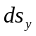 on transversal surface and the radius angle changes by 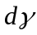. Then we have: 设skier滑行了，在横截面上滑行了，圆心角变化为，那么有
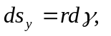
所以有so we can derive:
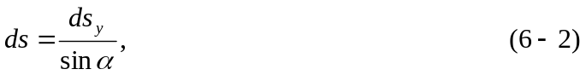
所以摩擦力做功为the work of friction is:
运动员竖直向上的高度改变量为so skier can go above the lip for:
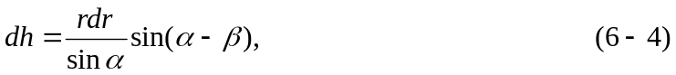
所以重力做功为the work of gravity is:
由Theorem of Kinetic Energy知，we can infer from Theorem of Kinetic Energy:
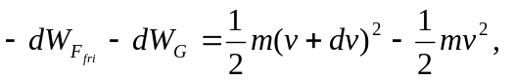
考虑到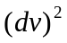 is a infinitesimal of higher order,(6-9)化简为Considering that is a infinitesimal of higher order, (6-9) can be simplified as following equation:
将formula (6-2),( 6-3),( 6-4) and (6-5)代入(6-6)得到We can get (6-7) by substituting formula (6-2),( 6-3),( 6-4) and (6-5) in (6-6).
6.3 Velocity Equations
formula (6-7)是model 2的基本公式，它描述了复杂场景下，skier在from C to D过程中的速度与场地参数之间的准确关系。下面我们分别计算Figure 4提出的三段路径的速度公式,三段路径的示意图如下:
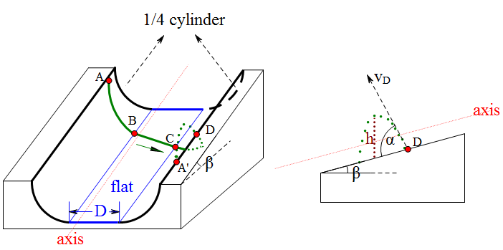
Figure 7. Schematic diagram of three paths and vertical air

6.3.1 A to B
根据AB段的实际受力情况，我们将式(6-7)改写为
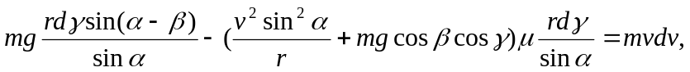
两边积分，求得
6.3.2 B to C
BC段的受力较为简单，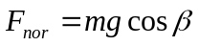,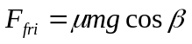,摩擦力和重力做功为
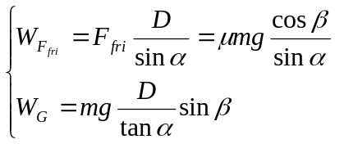
由Theorem of Kinetic Energy知，
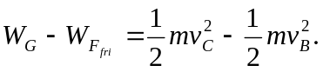
解得
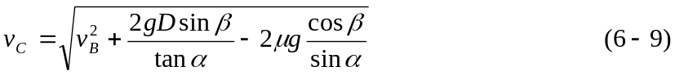
6.3.3 C to D
对formula (6-7)两边积分，并且考虑skier在这个过程中做功,求得
根据斜抛运动的原理，求得运动员上升的距离为:
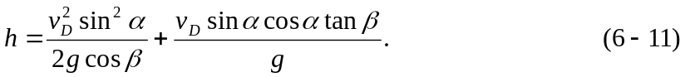
6.4 Model Results and Sensitivity Analysis

除了5.3中分析出的因素之外，影响model 2高度的因素还有width of the flat bottom , inclination of the flat bottom ，and the angel between velocity and the edge of the half-pipe .因为公式较为复杂，我们通过数值计算来进行Sensitivity Analysis。

我们首先计算在情况下的上升高度，经过计算有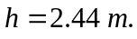
Table 1. Height alteration for different changes
parameters | Initial  values | Height with 10% positive Adjustment | Height  alteration | Height with 10% negative Adjustment | Height  alteration
 | 4 | 1.32 | -45.89% | 3.56 | 45.68%
 | 5 | 2.35 | -3.87% | 2.54 | 3.87%
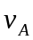 | 5 | 3.07 | 25.53% | 1.88 | -23.25%
 | 60 | 2.29 | -6.41% | 2.57 | 5.07%
 | 14 | 2.64 | 8.17% | 2.25 | -7.7%
 | 10000 | 3.59 | 46.90% | 1.29 | -47.11%

●Radius of curvature and Work: the most sensitive parameters for ,说明场地的曲面尺寸、选手在滑行中对身体姿势的调整对选手的发挥起了至关重要的作用；
●Initial velocity: a very sensitive parameter for ,但是对于固定的比赛场地，选手进入half-pipe的初始速度相差不会太大；
●Inclination of the flat bottom: a low sensitive parameter, 如果较大，虽然会使得高度变大，但是skier的速度会很大，超过比赛的安全要求，而且会使得场地的造价过高;
●The angel between velocity and the edge of the half-pipe: a low sensitive parameter, 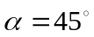时的高度是最大的，说明选手选择适当的滑行角度，有助于提高自己的高度;
●Width of the flat bottom: a low sensitive parameter, 增大时，减小，这是因为width越大，摩擦力做功越多，消耗的能量越多.
7 Discussions
If we want to build a practical course, we need to consider several more parameters. 正式场地的建造，不仅要考虑影响运动员发挥的因素，还要考虑自身建设的成本，我们还需要对场地flat bottom的长()和宽()进行讨论。设计flat bottom的原因是给运动员一段平缓的滑道，便于调整自己的身体状态。但是的值不能太大，因为会使得摩擦力消耗更多的能量，我们假设运动员的反应时间为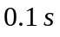，通过model 2我们估计运动员在flat bottom上的速度为8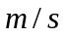，滑板长度为1.5，所以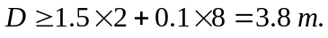在国际比赛中，选手们一般会做6-8组动作，所以half-pipe的长度应该要保证运动员能够完成比赛。
空气阻力

8. Conclusion
决定half-pipe滑雪场的因素有很多，其中起主要因素的有曲率半径和运动员做功。经过我们计算，确定了场地parameters的取值范围:
●曲率半径:3.5 m to 5m;
●Width of the flat bottom: 3.8m to 5 m;
●The angel between velocity and the edge of the half-pipe: 45;
●Inclination of the flat bottom: 14 to 18;
●Length of the inclined flat bottom: 100 m to 140 m;
●以上条件都在客观上为skier创造了良好的运动条件，其它主观因素比如运动员做功和初速度，都是越大越好，这都取决于运动员的正常发挥。

9. Strength and Weakness
Strength
●本文对两种不同场地下的受力情况进行了讨论，均得到了准确的结果;
●在计算曲面上的能量转换时，通过将微元方程积分的方法，得出了整个过程的能量方程;
●在inclined half-pipe情况下，将滑道按形状分为三部分，分别建立方程求解能量共识，最终得到了准确的高度公式;
●本文采用数值计算方法得出准确的高度结果;
●The model not only considers objective parameters of the venue, but also takes the skiers’ subjective influence into account;
Weakness
●模型没有详细分析运动员在滑行过程中的做功情况；
●模型近似地计算曲线积分，误差较大;
●模型没有考虑skier在performance中的具体受力情况;

10. Reference
[1] SKI CONGRESS. THE INTERNATIONAL SNOWBOARD COMPETITION RULES (ICR) [C]. ANTALYA (TUR): THE 47TH INTERNATIONAL SKI CONGRESS, 2010.
[2] Chen, J., R. Li, and Z. Guan. 1992. Study of the coefficient of friction between snow-boards and snow in skiing sports. China Winter Sports 1992 (4).
[3] Yan, Hongguang, Ping Liu, and Feng Guo. 2009. Factors influencing velocity away from decks in snowboard half-pipe. Journal of Shenyang Sport university 2009 (3).
[4] Yan, Nai-peng. 2006. Primary determinant influencing the skiing resistance
against the alpine skier. China Winter Sports 2006 (5).

