SIT315 M2.T1P: Parallel Matrix Multiplication with pthreads and OMP

Codey Funston | S222250824

Part : Program Parallelisation and Decomposition

A matrix is simply a vector of vectors, and this is how I implemented them in my program. However, it is gets complex if you try and move through a matrix left to right, top to bottom if you want to end at an entry like (3, x) where x is not the last column. Therefore, in my implementation for the *pthreads* section I assigned a set number of rows to each thread as they “requested” it and worked through each column in those rows. This technique was used for both filling and multiplying matrices, and the only shared variable that had to be locked was the index. When the index is shared properly, matrix access can be done simultaneously like in the vector addition program since the entries being accessed are all separate.

Part 2: Evaluation of pthreads and OMP Performance Against Sequential Version

The programs were tested with matrix dimension sizes of 100, 500, 1000, and 2000. Initially the parallel versions used partition/chunk sizes of $\frac{number of elements in matrix}{number of cores}$, then it was changed to $\frac{number of elements in matrix}{20}$ so that that *pthreads* implementation with its continual chunk requests from each thread could be taken advantage of. The terminal output was produced from the shell script below. I set the dimensions in each of the three files, ran this script, then changed the dimensions and repeated.

|  |
| --- |
| #!/bin/zsh  # Compiles each version.  g++-14 -std=c++11 /Users/codey/od/315/Module2/pt1/seq/Sequential.cpp -o seqx  g++-14 -std=c++11 /Users/codey/od/315/Module2/pt1/par/Parallel.cpp -o parx -lpthread  g++-14 -std=c++11 /Users/codey/od/315/Module2/pt1/omp/OMP.cpp -o ompx -fopenmp  # Run sequential version.  for _ in {1..5}; do  ./seqx | grep time  done  # Run pthreads version.  for _ in {1..5}; do  ./parx | grep time  done  # Run OMP version.  for _ in {1..5}; do  ./ompx | grep time  done |

The results for each dimension were:

100.

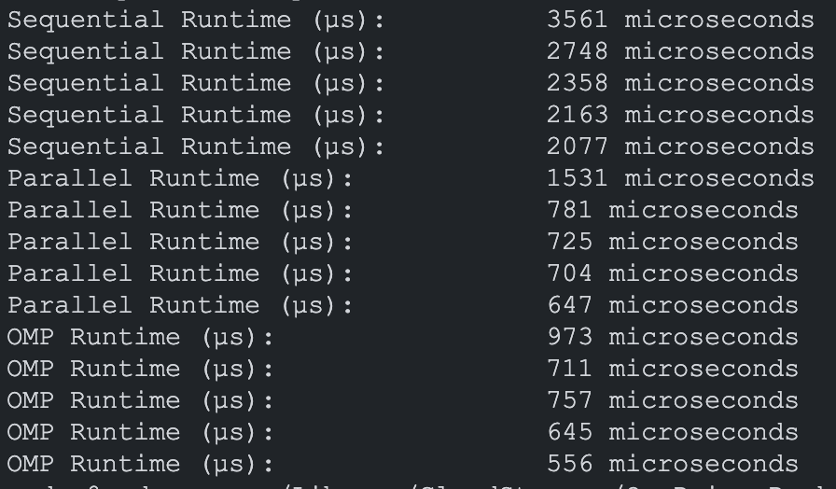

500.

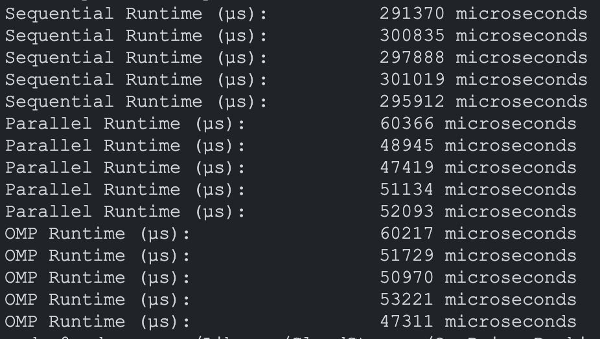

1000.

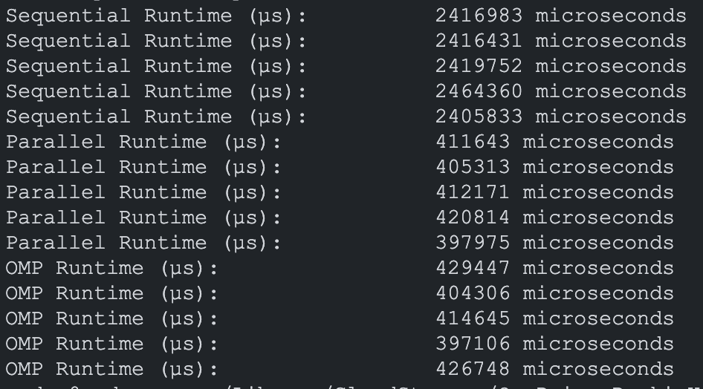

2000.

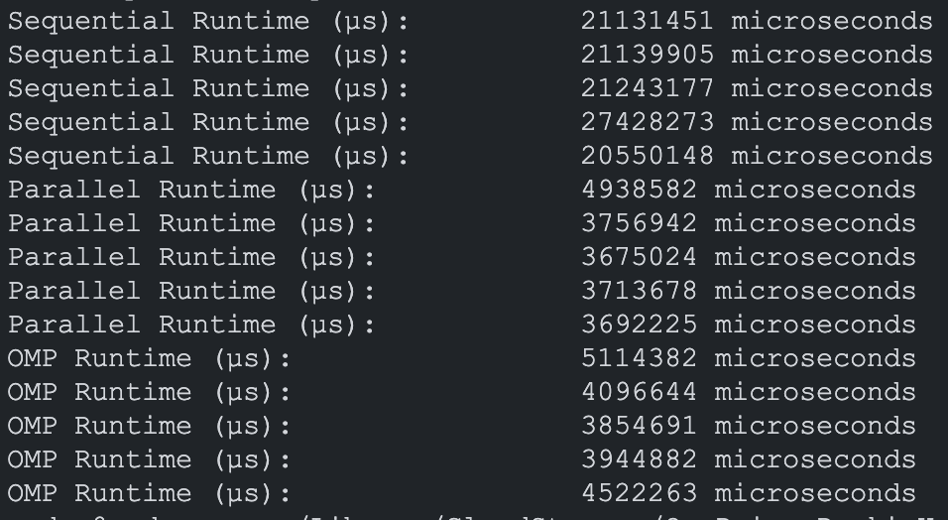

The matrix files are much too large to put in a word document, but they can be viewed if necessary, here with N = 100:

https://github.com/cfeng44/SIT-315/tree/main/Module2/pt1/matrix_outputs

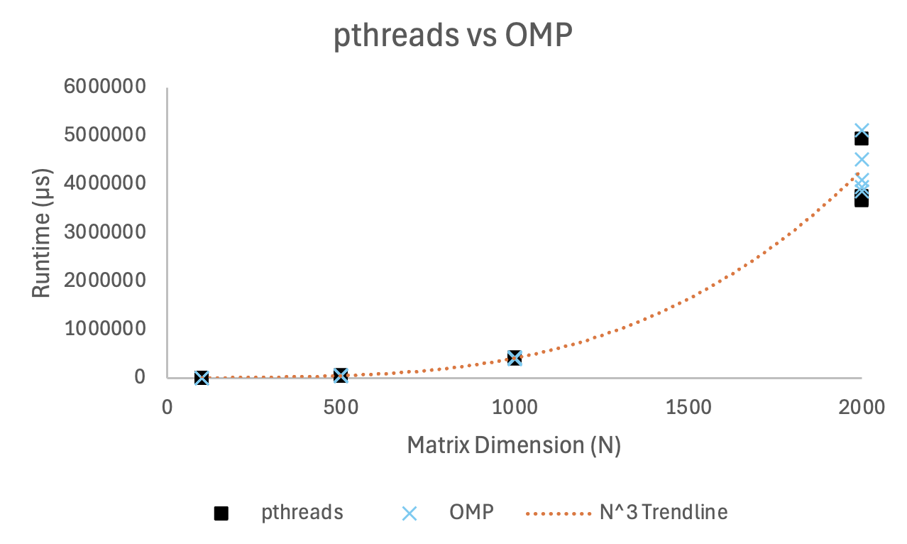

This graph shows that the runtime is close to $N^{3}$ even when paralellising, this makes sense since in doing so we are not changing the structure of the code ie any data structures or algorithms, we are just assigning threads to do the same thing, only changing the runtime complexity to $O( {\frac{1}{c}N}^{3})$, where c is a constant (5 in this case). Therefore, the program is still in $O( N^{3})$.

Looking at the results both *pthreads* and OMP achieve a speed up of roughly 5 times. This is as expected given that filling and multiplying matrices is a very parallelisable task. Also I set the OMP version to do dynamic scheduling with the same chunk size and number of threads as in the *pthreads* one to see how they compared. Based on rearranging Amdahl’s law tells us that the proportion that is done in parallel with my 11 cores is:

$$S=\frac{1}{\left(1-P\right)+ \frac{P}{N}}$$

$$5≈\frac{1}{\left(1-P\right)+ \frac{P}{11}}$$

$$5≈\frac{1}{ \frac{11-11P+P}{11}}$$

$$55-55P+5P≈11$$

$$∴P≈0.88$$

When using a smaller number of threads, which was 2, 4, 6, 8 here, the respective speed increases are predicted to be 1.78, 2.94, 3.75, and 4.35. Since the *pthreads* and OMP versions showed very similar results earlier I ran the test with the *pthreads* version with a dimension of 2000 and got the following:

Average runtime from sequential program: 22298590

2 threads: 10217577 = 2.18 speed up

4 threads: 5732758 = 3.89 speed up

6 threads: 4809263= 4.64 speed up

8 threads: 4175345 = 5.34 speed up

The is roughly in line with the theoretical values and makes sense since the program is such that adding more threads is more efficient, especially with a dimension as large as 2000.