1. INTRODUCTION

1.1. A brief history of sequencing.
The finding of the 3D structure of Deoxyribonucleic Acid (DNA) composed of four bases {A, T, C, G} in 1953 by James Watson, Francis Crik, Maurice Wilkins and Rosalind Franklin was one of the most important events in the history of molecular biology to which contributed to a conceptual framework for both DNA replication and encoding proteins in nucleic acids (1,2)⁠. This important discovery has led to the decoding of genomic sequences and know DNA composition of organisms The DNA sequencing is the discovery that uses the DNA composition to understand and decrypt the code to all biological life on earth as well as to understand and treat genetic diseases (1)⁠.
1.1.1. First-generation sequencing.
Initial efforts focused on sequencing the most readily available populations of RNA species to produce fully and partially degraded RNA fragments(2)⁠. In 1965 Robert Holley and colleagues produced the first whole nucleic acid sequence of alanine tRNA from Saccharomyces cerevisiae. In parallel, Fred Sanger and colleagues developed a related technique based on the detection of radiolabelled partial-digestion fragments after two-dimensional (2-D) fractionation. It was also by using this 2-D fractionation method that Walter Fiers' laboratory started to produce the first complete protein coding gene sequence in 1972 followed four years later by its complete genome.
It was around this time that researchers began to adapt their methods in order to sequence DNA, aided by the recent purification of bacteriophages with DNA genomes. Ray Wu and Dale Kaiser used DNA polymerase to fill the ends in with radioactive nucleotides, supplying each nucleotide one at a time and measuring incorporation to deduce sequence. This principle was generalized through the use of specific oligonucleotides to prime the DNA polymerase. Incorporation of radioactive nucleotides started to be used to infer the order of nucleotides anywhere.
The next practical change to make a large impact was the replacement of 2-D fractionation (which often consisted of both electrophoresis and chromatography) with a single separation by polynucleotide length via electrophoresis through polyacrylamide gels, which provided much greater resolving power (2)⁠. This technique was used in two complex protocols from the mid-1970s: Alan Coulson and Sanger's ‘plus and minus’ system in 1975 and Allan Maxam and Walter Gilbert's chemical cleavage technique (1)⁠. These protocols used DNA polymerase to synthesize from a primer, incorporating radiolabelled nucleotides, before performing two second polymerisation reactions. By running the products on a polyacrylamide gel and comparing between the eight lanes, one is able to infer the position of nucleotides at each position in the covered sequence. It was using this technique that Sanger and colleagues sequenced the first DNA genome of bacteriophage ϕX174. This was the birth of first-generation DNA sequencing and opened the door to study the genetic code of living beings and to the development of faster and efficient sequencing technology (1,2)⁠.
However the major breakthrough that altered the progress of DNA sequencing technology came in 1977, with the development of Sanger's ‘chain-termination’ or dideoxy technique (2,3)⁠. The chain termination technique makes use of Dideoxynucleotides (ddNTPs). Mixing radiolabelled ddNTPs into a DNA extension reaction at a fraction of the concentration of standard dNTPs results in DNA strands of each possible length being produced, as the dideoxy nucleotides get randomly incorporated as the strand extends, halting further progression. By performing four parallel reactions containing each individual ddNTP base and running the results on four lanes of a polyacrylamide gel we can infer what the nucleotide sequence in the original template was, as there will a radioactive band in the corresponding lane at that position of the gel. While working on the same principle as other techniques, the accuracy, robustness and ease of use led to the dideoxy chain-termination method – or simply, Sanger sequencing – to become the most common technology used to sequence DNA for years to come (2)⁠.
1.1.2. Second-generation or Next-Generation Sequencing (NGS).
Sanger and Maxam-Gilbert sequencing technologies were the most common sequencing technologies used by biologists until the emergence of a new era of sequencing technologies opening new perspectives for genomes exploration and analysis (1)⁠. A number of improvements were made in the following years and contributed to the development of increasingly automated DNA sequencing machines and subsequently the first crop of commercial DNA sequencing machines which were used to sequence the genomes of increasingly complex species . These DNA sequencing machines produce reads slightly less than one kilobase (kb) in length. The development of techniques such as polymerase chain reaction (PCR) and recombinant DNA technologies further aided the genomics revolution by providing means of generating the high concentrations of pure DNA species required for sequencing. Also, more sequenced genomes and tools for genetic manipulation provided the resources to find polymerases that were better at accommodating the additional chemical moeities of the increasingly modified dNTPs used for sequencing. Eventually, newer dideoxy sequencers came to be used in the Human Genome Project.
Concurrent with the development of large-scale dideoxy sequencing efforts, another technique appeared that set the stage for the first wave of DNA sequencers. Researchers utilized a recently discovered luminescent method for measuring pyrophosphate synthesis. This approach was used to infer sequence by measuring pyrophosphate production as each nucleotide is washed through the system in turn over the template DNA affixed to a solid phase. This technique could be performed using natural nucleotides (instead of the heavily-modified dNTPs used in the chaintermination protocols), and observed in real time (instead of requiring lengthy electrophoreses). Pyrosequencing was later licensed to 454 Life Sciences (later purchased by Roche), where it evolved into the first major successful commercial ‘next-generation sequencing’ (NGS) technology (1,2)⁠.
(...)
1.1.3. Sequencing applications.
As we have seen before, the platforms for DNA sequencing have changed dramatically over the years. Yet the trajectories of other technologies for which there is a seemingly insatiable demand — smartphones, the Internet, digital photography — suggest that the real disrupters will be the resulting applications, not the new technologies(4)⁠.
(...)
1.1.3. Sequencing data management.
The study of genomics increasingly is becoming a field that is dominated by the growth in the size of data and the responses by the broader scientific community to effectively use and manage the resulting derived information (5)⁠.
The management of the big amount of data generated is an important challenge of the use of sequencing, specially NGS approach in clinical diagnostic. Indeed generation, analysis and also storage of sequencing data require sophisticated bioinformatics infrastructure to manage and analyze the data, and so both computing infrastructure and manpower impact on costs of applications in clinical diagnostics.

1.2. Laboratory Information Management Systems (LIMS)
A LIMS is a specific software that allows the acquisition and management of the information generated in a laboratory. Until 1970’s management of laboratory samples and their associated analysis and reporting was a time-consuming manual processes so some organizations custom their own solutions for individual laboratories, while some enterprising entities at the same time sought to develop a more commercial reporting solution in the form of special instrument-based systems (6)⁠⁠.

The first generation products appeared in the 80’s as the same time of the development of automatization of the laboratories. They were introduced in the form of a single centralized minicomputer, which offered laboratories the first opportunity to utilize automated reporting tools. A second generation of LIMS were were tapping into relational databases to expand LIMS into more application-specific territory.

In the early 1990s, as personal computers became more powerful and prominent, a third generation of LIMS emerged. These new LIMS took advantage of the developing client/server architecture, allowing laboratories to implement better data processing and exchanges and processing of data anywhere on the network. Web-enabled LIMS were introduced the following years, enabling researchers to extend operations outside the confines of the laboratory.

By the early 2010s, some LIMS added additional characteristics that continued to shape how a LIMS was defined. Examples include the addition of clinical functionality and electronic laboratory notebook (ELN) functionality, as well a rise in the cloud-based software as a service (SaaS) distribution model (7)⁠.

Nowadays, their use has been expanded not only to sample and results management, but also to interface different systems and instruments. In addition, the importance of having a LIMS has increased due to quality regulations like ISO 17025 (8)⁠⁠. Because of that, a certified quality laboratory must have a software to audit trail implementation, authentication protocols, configuration management, data backup, data integrity, electronic signature implementation, encryption, information privacy and network security (9)⁠. LIMS can contribute to it.

1.2.1. Existing LIMS.
We can find different LIMS vendors and they can be classified according to the way we can use them:
- Commercial brand LIMS: some specialized in automatization brands offer their own LIMS. That is the example of Illumina, which has developed specific LIMS for manage sequencing data.
- LIMS specialized software companies: there are several companies which develop LIMS and offer different services to adapt the system for laboratory necessities. A licence membership is mandatory to use this kind of software. We can find examples in different companies, such as LabWare, Thermo Fischer Scientific, Abbot Informatics (STARLIMS), etc.
- Open source: there are some LIMS open to all the community interested in implementing a software for managing laboratory data. This kind of LIMS are free and customizable, so is a low-cost alternative. Senaite/Bika LIMS, Free LIMS, Open LIMS are some of the examples.

1.2.2. Senaite-LIMS.
Senaite-LIMS is a web-based Open Source LIMS for enterprise environments, especially focused to behave with excellent performance and stability (10)⁠. It was launched on GitHub in October 2017 and deployed and maintained by two start-up companies, Naralabs (Barcelona, Spain) and Rinding Bytes (Nuremberg, Germany).

The software is a derivative work of another open source LIMS (Bika LIMS), built on top of Plone CMS with Python as its main programming language. The principle architectural changes with respect to its predecessor Bika LIMS is that they have developed Senaite as a system of independent add-ons. This, combined with quality code standards, makes the application much easier to maintain and to contribute to and allows it to stay level with emerging laboratory requirements. To help in achieving so, Senaite is developed under the paradigm of continuous integration (CI) and continuous delivery (CD).

(...)

1.3. Agile methodology for software development.
(...)

2. REQUIREMENTS AND OBJECTIVES.

2.1. Requirements.

2.2. Primary objetives.

1. Configure an Open Source LIMS system to manage sequencing data.

2. Manage the project using agile tools.

2.3. Secondary objectives.

1. Select a LIMS system.

2. Select agile tools to manage the project.

3. Find real sequencing data.

4. Install the LIMS selected.

5. Configure LIMS.

6. Configure result reports.

7. Create and develop interfaces.

8. Test the system.

9. To put LIMS into operation.

10. To write the final report and do the presentation.

3. METHODS

3.1. Project plan.
We followed the development of the system by agile methodology. A requirements matrix was made by a MoSCow chart. Furthermore, a Grant diagram was create to set project schedule, millstones and deliverables. We divided the project in three phases. In addition, a risks matrix was made to determine possible risks and their impact. All of these was transfer to JIRA software.
Finally, we created a GitHub repository to control versions of the objects and deliverables.

3.2. LIMS selection.
We selected Open Source Senaite-LIMS based on the next must-be criteria:
- Free and open source software.
- Customizable.
- Safety and back up.
- Trustworthy.
- Allow sample tracking.
- Identify who is using the application and what changes have done.
A search information about the different open source LIMS was done using the web page LIMS Wiki, which is a WIKI where we could find detailed information about laboratory systems.

3.2. Installation.
First, we install an Ubuntu 20.04.1 64-bit operative system in Oracle Virtual Machine 6.1.14. Then, we installed Senaite 1.3.4 following the instructions of Senaite web page (11)⁠ and using virtual Python environment Miniconda.
As requirement of the software we use Plone 4.3.19, which is an open source and free content management system build on top of the Zope application server. Zope is a web application storage server written in Python language. The database management system used is ZODB (Zope Database) which is a database native to Python and makes it very fast for query or read operations because the language is not separate from it. In addition, ZODB provides a JSON-API for integrate Senaite and other systems. We use Python 2.7.18 and Zope 2.13.29.
In addition, we have installed some available add-ons according to our necessities. These add-ons were added on buildout.cfg file. This file is necessary for install Senaite in our operative system.

3.3. LIMS configuration.
After the installation we run the server instance and we configure the non-coding parts of the software. Senaite allows admin user to make this configurations through setup menu. In this menu we can find all the items to configure the software for laboratory necessities. The configuration was made following the user manuals of GitHub Senaite repository and the information of Senaite web site.
We adapt the software to the necessities and workflows of genomic laboratory services, based on some real genomic laboratory services workflows and equipment of Servicio de Genómica de la Universidad Complutense de Madrid (12)⁠, Laboratorio de Secuenciación del Instituto de Investigación Hospital Universitario La Paz (9) and Servicio de Secuenciación ADN, genómica y Proteómica de la Universidad de Salamanca (14)⁠ and Sanger Sequencing Service of Macrogen (15)⁠.
We divided the configurations in six groups:
- Laboratory departments, users, privileges and clients.
- Samples and analysis.
- Specifications and methods.
- Specifications and instruments.
- Batches and worksheets.
- Reports.

3.4. LIMS modifications.
As we detailed on the Introduction section, Senaite LIMS administrator is allowed to modify its code through senaite.core. So, we make some changes using this add-on to add some fields or change others of the analysis request template, in order to adapt sample registration to our necessities.
On the other hand, Senaite LIMS has an add-on called senaite.impress through which we could modify and set the reports generated. So, we modified the report template called Default.pt to adapt the reports to our necessities.

3.5. Functional tests and validation.
In order to test the software functionalities and its configurations we made technical documentation to control changes and user manuals to understand the workflows. All of these documents were copied and submitted on the GitHub repository. Also, a functional demonstration has been included in this final report to understand the workflows and functionality of our LIMS.

4. RESULTS

4.1. Project plan.
4.1.1. Requirements.

We focused in the requirements showing in the MoSCow method below (Table 1).

REQUIREMENTS | MuSCoW
Open agile tools | M
Open Access and customizable LIMS | M
Safety and backup | M
Trustworthy | M
Allow sample tracking | M
Identify who is using the application and what changes have done | M
Allow to print reports | S
Easy to use | S
Connected to sequencing equipment (instrument interfaces) | C
Sample automation | W
Table 1: MoSCow method of prioritization of requirements. M: must have; S: should have; C: could have; W: would not have.
4.1.2. Progress.
In the next table we show the progress of tasks of each phase:
(…?)
(4.1.2. Risk matrix.??)

4.2. LIMS selection.
Senaite LIMS was the chosen system, not only because satisfies the criteria detailed before, but also because there are extensive documentation and a big network support behind this brand. In addition, it has some additional characteristics that allows the developers and users to adapt the system to their necessities.

4.2. LIMS installation.
We followed the steps detailed on Senaite web site to install LIMS in our operative system. In addition, we had to modify the rights of the created user (senaite). For this reason, we modified sudoers.d Ubuntu file, giving all rights to senaite user:
#includedir /etc/sudoers.d
#Usuario actual
root ALL=(ALL:ALL) ALL
senaite ALL=(ALL:ALL) ALL
We also installed some available add-ons for Senaite. This add-ons must be indicated into bindout.fg file.
- senaite.core
- senaite.jsonapi
-senaite.impress

4.3. LIMS configuration.

4.3.1. Users, roles and clients.
To access into the system, four users have been configured (in addition to the admin role), all of them belong to the same laboratory: Sequencing Service.
- Laboratory Manager: this user can manage the LIMS from a functional perspective and have rights to modify analysis, instruments and also to verify and publish results and samples (user/password: labman).
- Laboratory Clerk: this user can manage basic setup such as clients and it has rights to register samples and verify results (user/password: labclerk).
- Laboratory Analyst and Laboratory Analyst 2: they have no rights to manage, only to enter analysis results (user/password: labanalyst - labanalyst2).
The permissions of each user are shown in the figure bellow ().
Also, we created two fictitious clients in order to identify the samples:
- North Hospital (NH).
- Public Health Institute (PHI).

4.3.2. Analysis.
We create two analysis categories to differentiate a total number of 10 analysis service were created. They were classified depending on when they are carrying out, before sequencing or during sequencing process itself (table ).
Analysis Categories | Analysis Service | Units | Result opction | Attachments
Pre-Sequencing | DNA – Extraction | A260/280 | Numeric | Permitted
Pre-Sequencing | PCR | pb | Numeric | Permitted
Standard Sequencing | Forward – Chromatogram | NA | Boolean (OK/Not OK) | Mandatory
Standard Sequencing | Forward - GC content | % | String | Permitted
Standard Sequencing | Forward – Length | pb | Numeric | Permitted
Standard Sequencing | Forward – Sequence | NA | String | Permitted
Table 2: Clasification of Analysis services, according to their categorization. pb: base pair; NA: not applicable.

Furthermore, Analysis Templates were created for services to appear by default when samples are requested:
- Tissue – Sequencing: to create samples with DNA Extraction, PCR, Forward and Standard Sequence services and Tissue as Sample Type.
- DNA – Sequencing: to create samples with PCR, Forward and Standard Sequence services and DNA as Sample Type.
- PCR Product – Sequencing: to create samples with Standard Sequence services and PCR Product as Sample Type.
4.3.5. Specifications and methods.
(table??...)
4.3.4. Instrument configuration.
Senaite LIMS allows users to configure instruments to import and export results. We create the next instruments and configure them to export and import results in CSV format.

4.3.6. Samples
For samples registration we modified the fields of the “Request new analysis” view keeping only the necessary ones. This configuration was made through
The following Sample Types were also created:
- Tissue: for samples that requires previous DNA extraction and amplification (PCR).
- DNA: for samples that requires previous DNA amplification (PCR).
- PCR Product: samples that are ready for sequencing.

4.3.7. Batches, worksheets and methods.
(...)

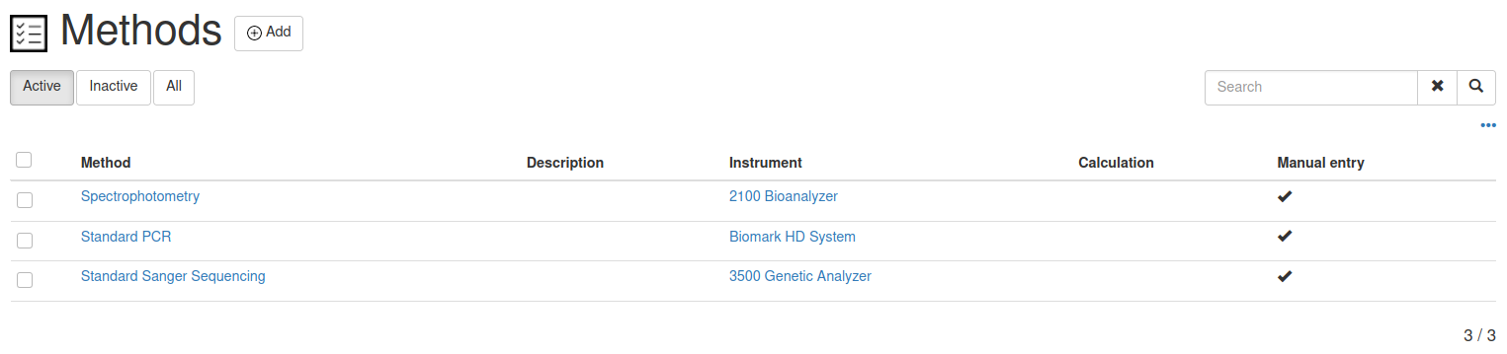
4.3.8. General configurations (SetUp menu)
Senaite LIMS allows admin user some general configurations through Setup menu. In our case, we made the modifications indicated in the table :
Set Up Tab | Modification
Security | Allow access to worksheets only to assigned analysts = False
 | Only lab managers can create and manage worksheets = False
Accounting | Include an display pricing information = False
Samples | Auto-receive samples = True
Analysis | Categorise analysis services = True
 | Default coun of sample to add = 1
Id Server | AnalysisRequest = {clientId}{sampleType}{yymmdd}_{year}-{seq:04d}
Table 3: Set up modifications.

4.4. Code modifications.
Senaite have some add-ons which allow add some extra functionalities according to the necessities of the laboratory workflows. Specifically, seniate.core allows access for advanced users to the files that contain the code of Senaite. So, we have made the next modifications bellow:
(...)

4.5. Functional demonstration.
In order to understand the functionality of the configured LIMS we detail the following steps to …
First of all, we have to log in to the system with Laboratory Clerk credentials (fig. ):

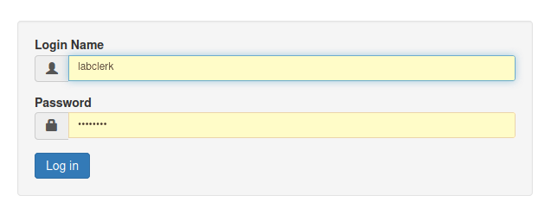Figure 1: log-in window. See section … to see the credentials.
The next step is to create samples. For that, we are going to create a batch for a client first. We must click on “Batches” tab and in “Add” button to create a new batch. Then, we must complete some information and click on “Save”. In the figure … we show an example with the information of a new batch for one of the clients (Public Health Institute) for a drug resistance study.
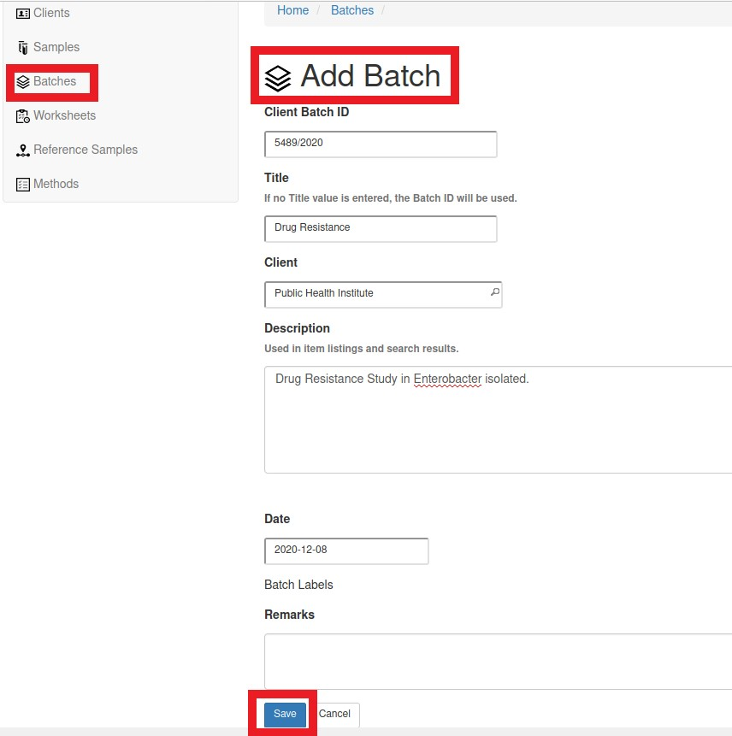Figure 2: “Batches” window.
Once we have created the new batch, we will be able to watch its information and to create samples related to it. Click on “Samples” tab and “Add” some samples:

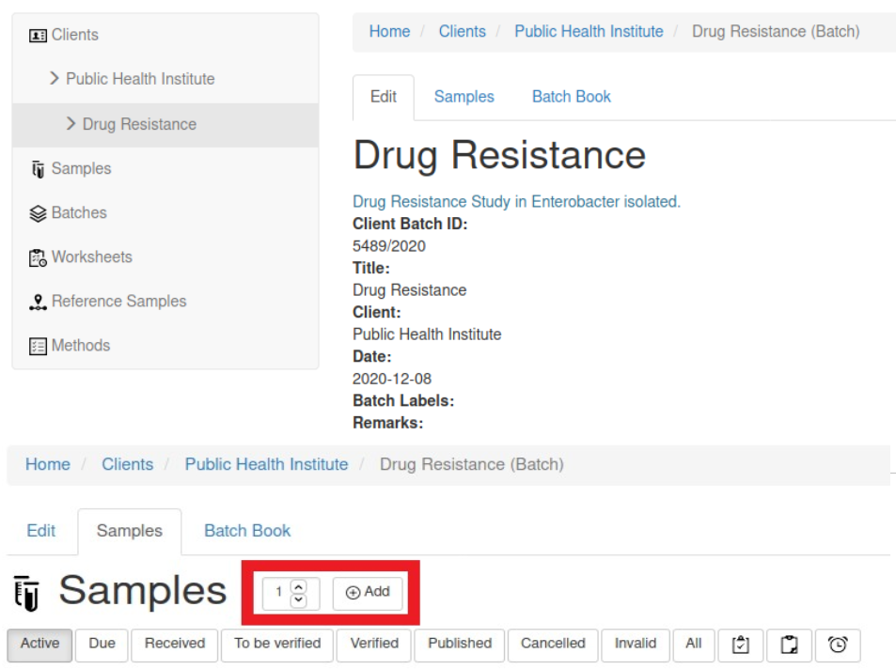Figura 3: Add samples window thorugh a batch.
We have selected 3 samples and a new window have opened. This window is the Analysis Request (AR) which is the sample registration template. We can select the information of the samples in this window. As you can see, there are some fields that are mandatory. In this example, we are going to create 3 samples of Tissue, so

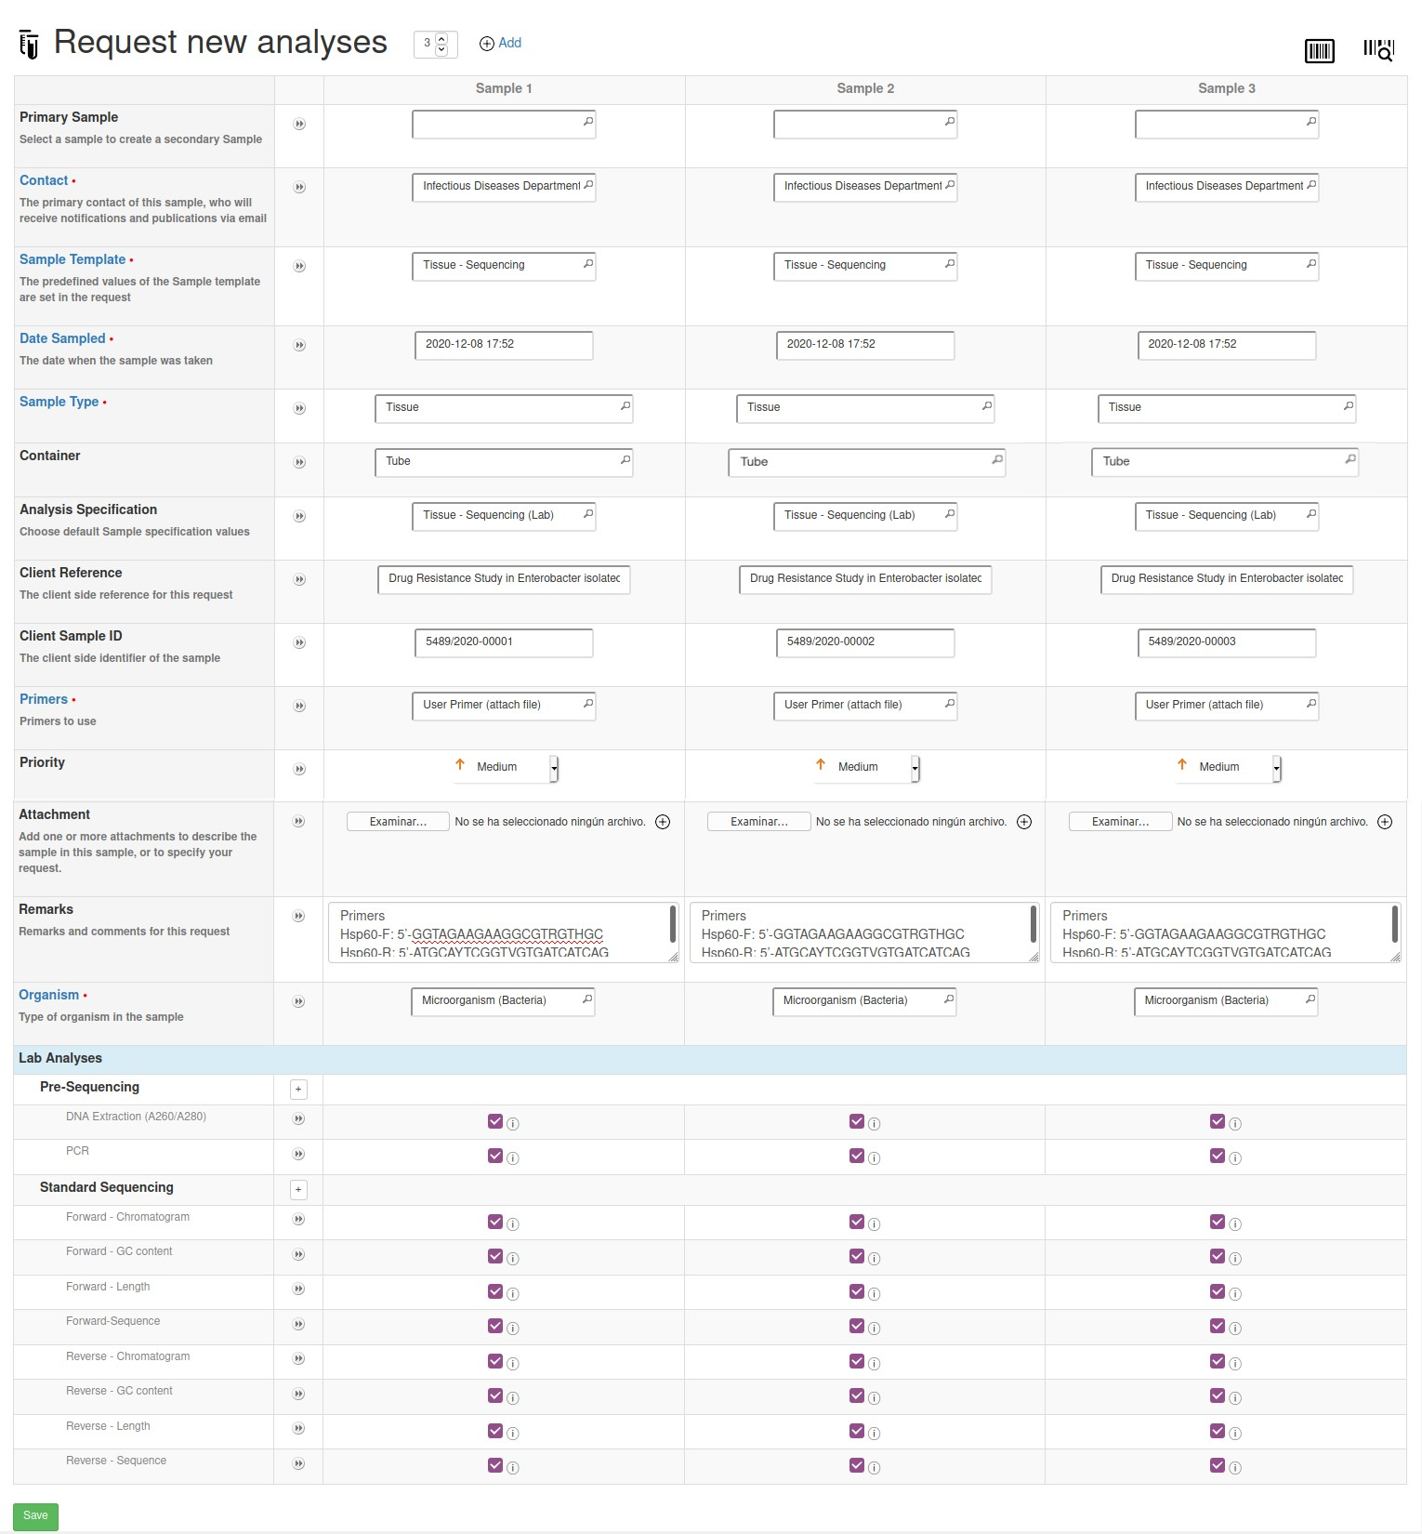
We can appreciate that all analysis are selected by default because Tissue samples include all of them. Nevertheless, if we select other sample type, analysis will be change. We click on “Save” and the three samples will be created inside the batch.
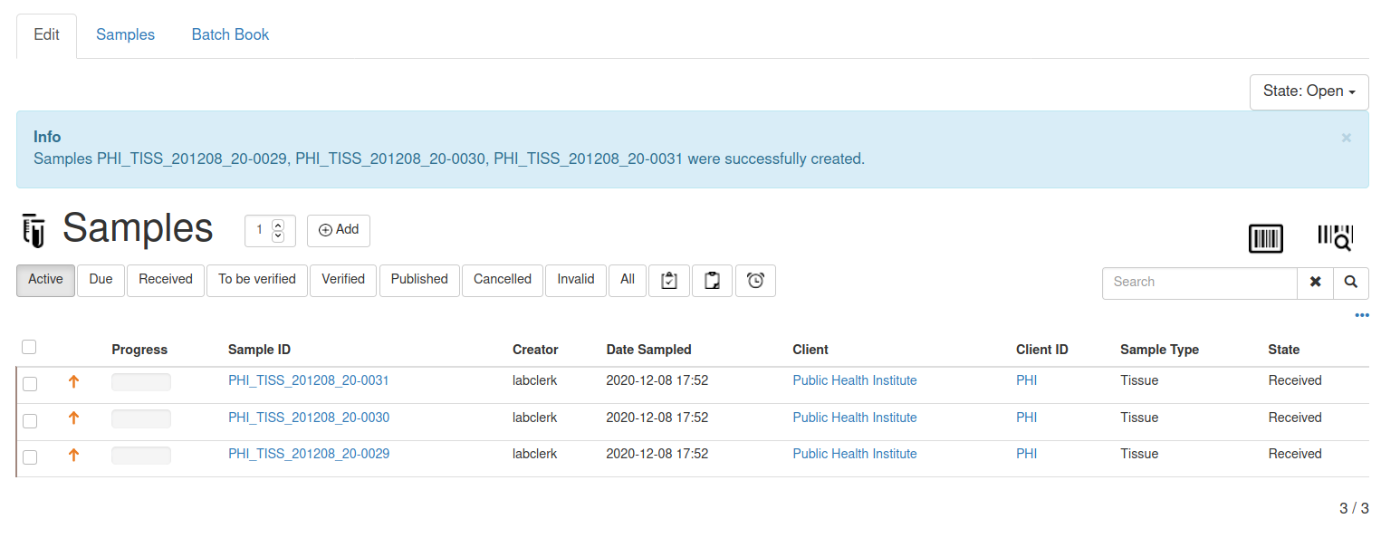
The batch will be in “Open” state and the samples in “Received” state. We can click on each sample to see or modify the information.
The next step is to create worksheets and to assign them to the analysts. So, we click on “Worksheets”, add a new one and assign it to labanalyst
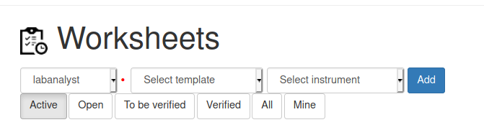
A new Worksheet has been created and we can add some analysis to it. In this first worksheet we are going to add the pre-sequencing analysis of the three samples created before. So, we can filter the analysis writing “Pre-Sequencing” on the searcher to select the analysis of DNA Extraction and PCR of the samples and click on “Assign”. This six analysis will be assigned to labanalyst.
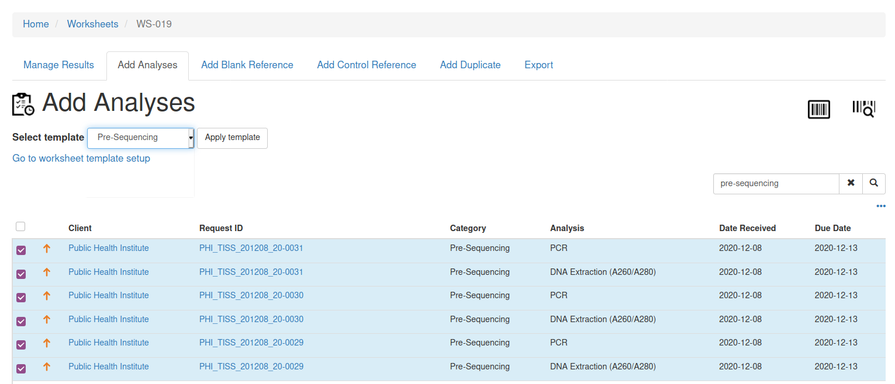
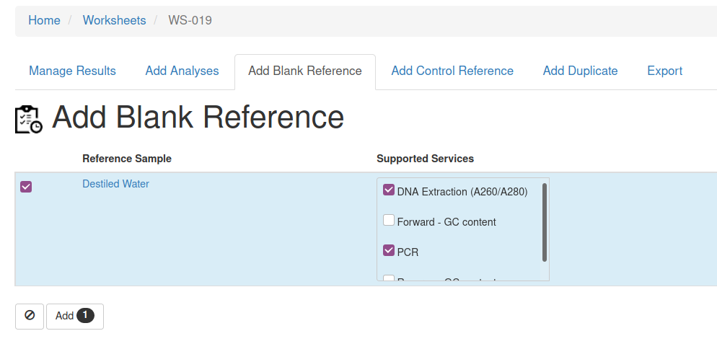
We also are going to add a blank reference sample as negative control using Destiled Water.
After that, we have a total of eight analysis in this worksheet, six of our samples and two of the blank sample.
At this point, we log out and log in as labanalyst. We click on “Worksheet” and select the one that we have created in the step before. We are ready to enter results. As you can see, the limits are established by the specifications.
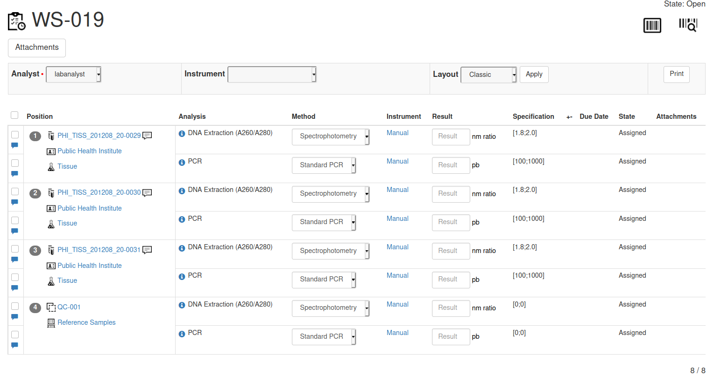
If the result intruduced is out of range or out of shoulder range Senaite will display an icon with a message.
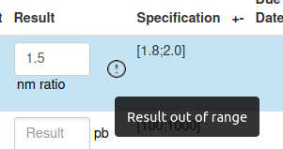

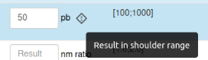

After entering the results, first we must click on “Save” and the analyst may change them if necessary (writing the modification in to the audit log). If the analyst is sure about the results he/she can click on “Submit” but results can not be modified (only by the Labman).
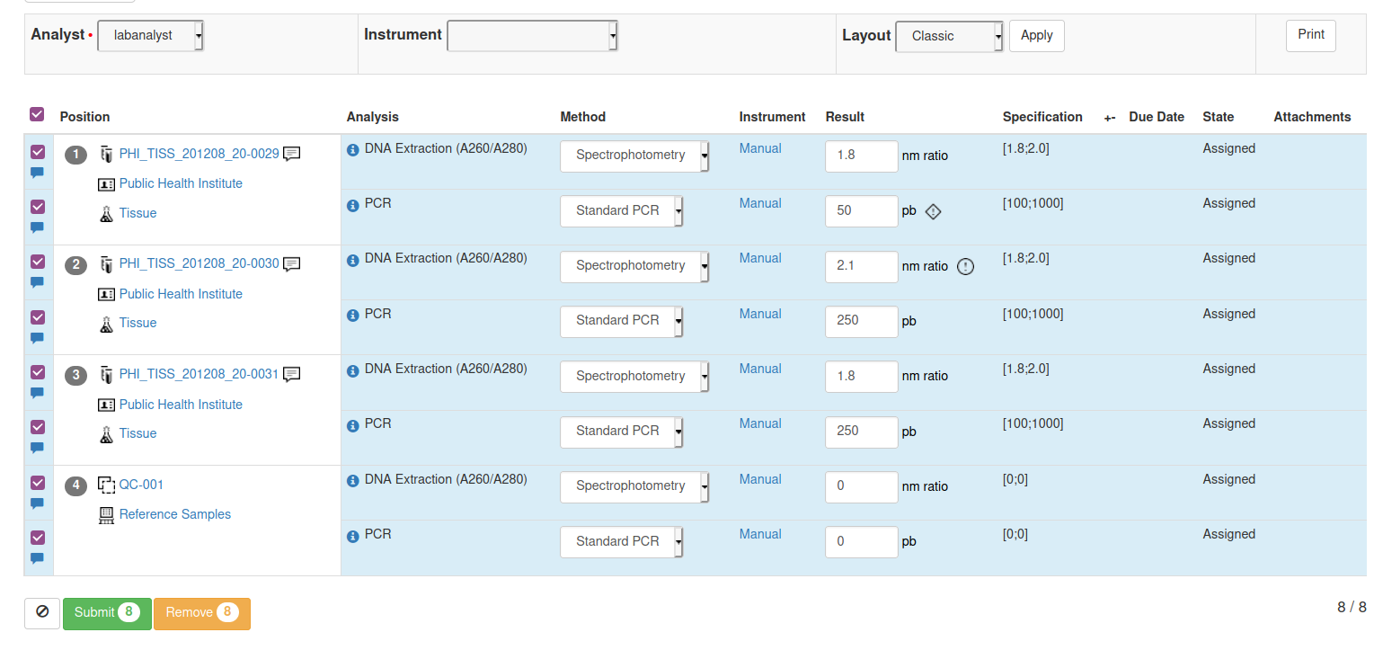
We are going to repeat the same steps but now we create a new worsheet with labclerk (W-020), including Sequencing analysis services and assigning them to labanalyst2 user. Also, we add a Blank Reference sample too, so a total of 28 analysis will be displayed on this worksheet, 24 related to the samples and 4 to blank control.

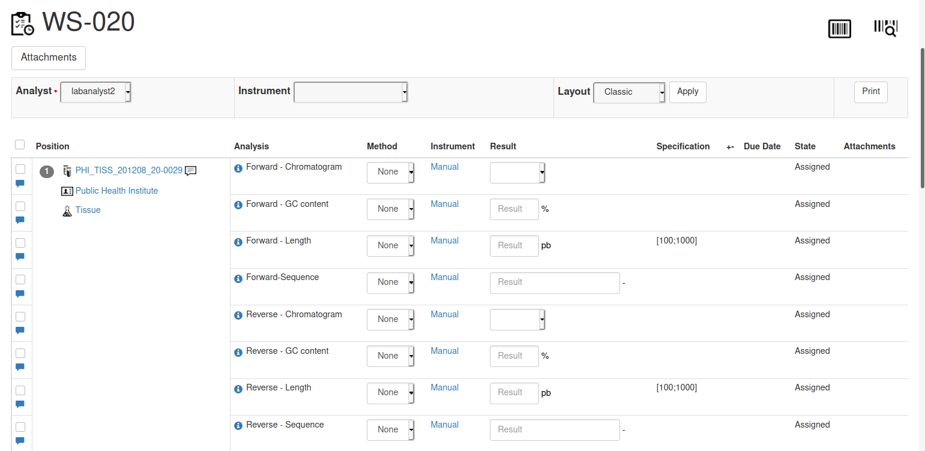
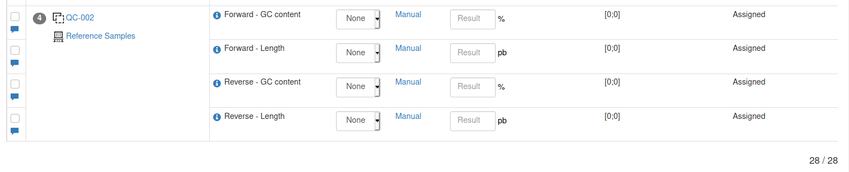
In this new Worksheet we must attach a file for Forward-Chromatogram and Reverse-Chromatogram services. The way to do this is clicking on “Attachments”. Then, we select a file and the analysis were we want to add it.
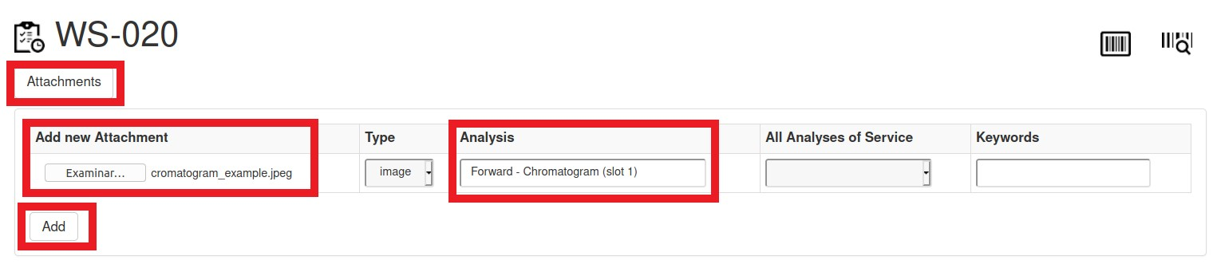
We can check that the attachments have been adding to the correct analysis.
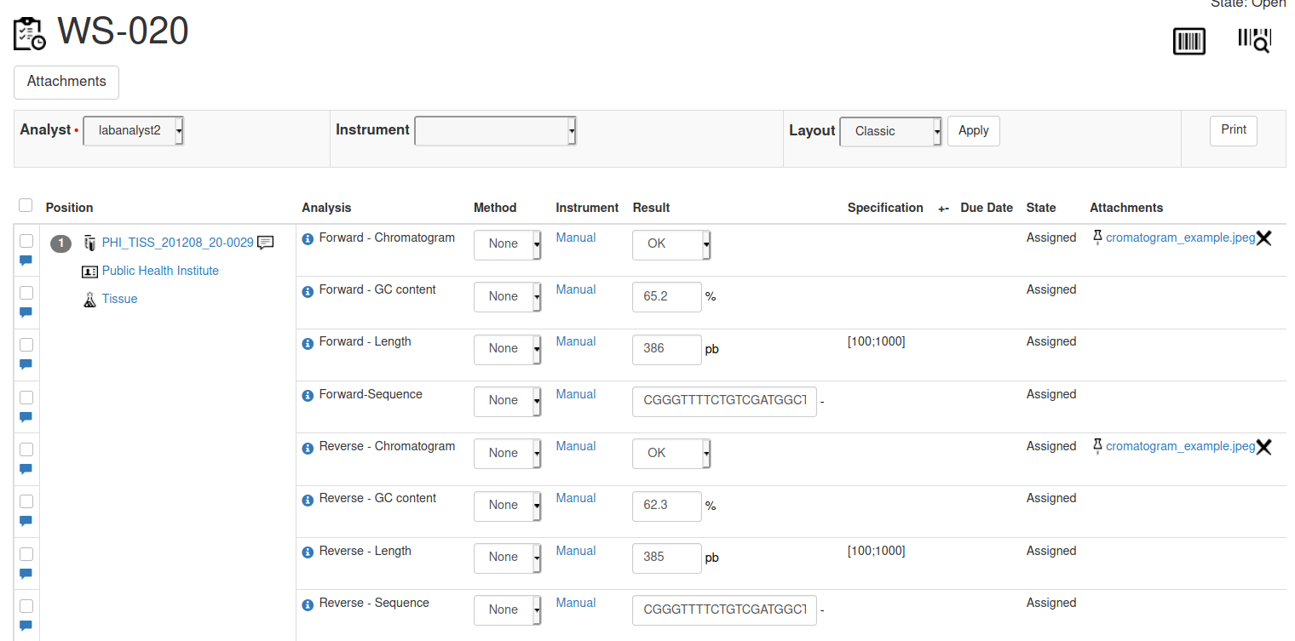
After enter the results and the attachments, we click on “Submit”.
Once labanalyst and labanalyst2 have been entered all the results in their worksheets, we log in to Senaite as labclerck again to verify the results. We click on “Batches” and select the batch we created before (). The analysis will be verified. If we click on “Worksheets” we can see that the two worksheets created before will change their state to “Verified” (100% of progress).

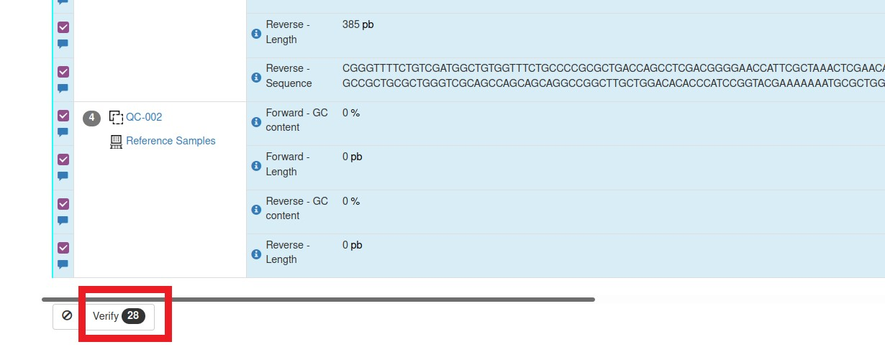
After that, log in to Senaite as labmanager and click on “Batches”. We can see our batch in a 94% of progress. If we click on “Samples” inside the batch we can see the three samples with a 95% of progress and verified. We can see the results and information clicking on each one.
The final step is to publish the results. We can select the three samples and click on “Publish”. We also can click on “Invalidate” if the results are incorrect. In this case, a repeat sample will be created and it will be mark with and “R” in the ID.

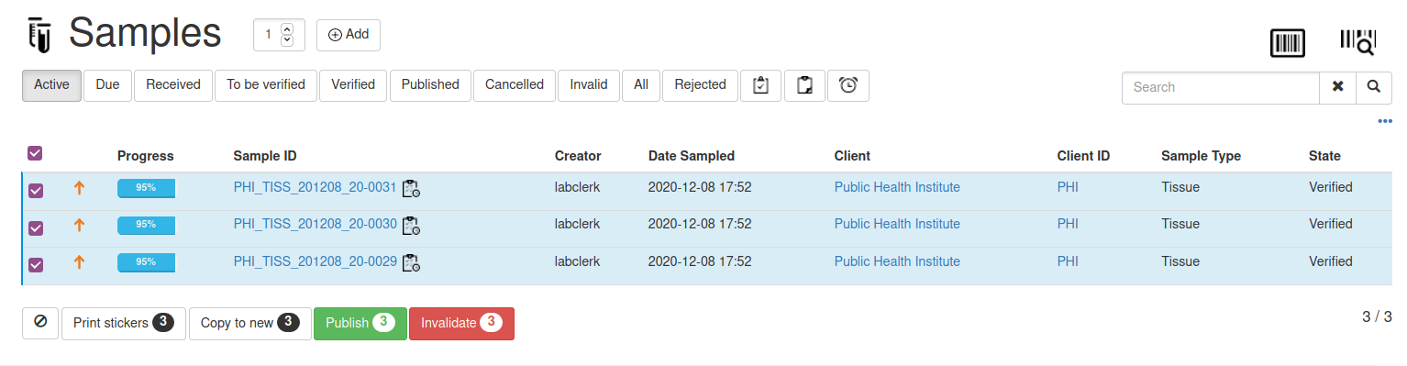
Click on “Publish”. A report will appear.
The first window to appear shows information about the samples and their states and client information. Also, we can choose dimensions and configuration of the report (landscape or portrait) and attachments per row (figure ).
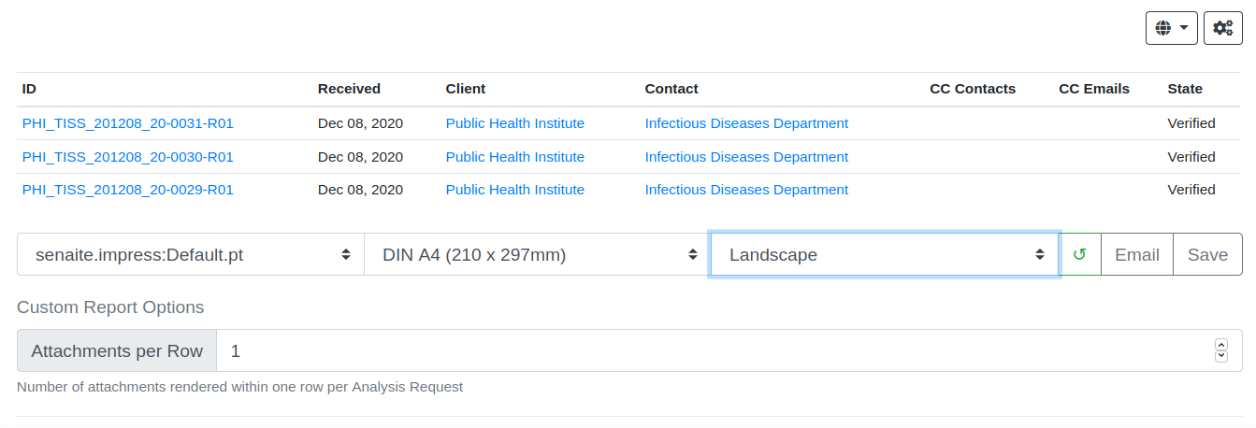
After the configuration options the report will appear. Information about our laboratory and the client will be showed on the first page (figure ).
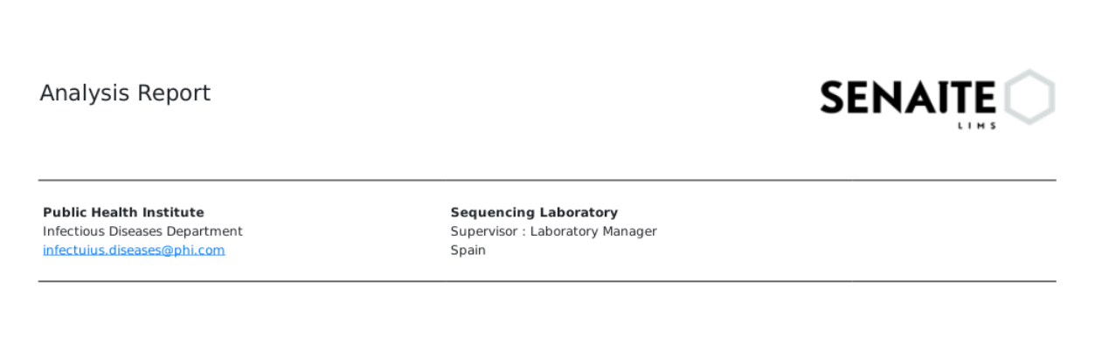

On second page of the report we can get some information about the sample (figure ).
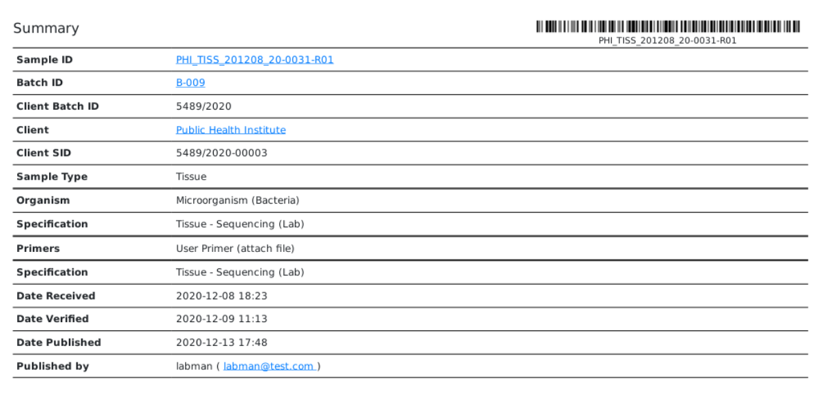
In the next pages we find information about the results and specifications. Also, we can check if the result is out of range (figure ).
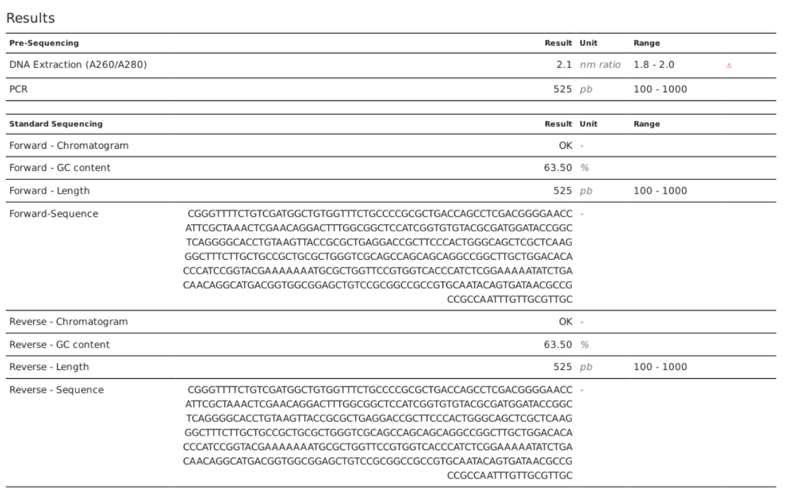
In the next pages we find the attachments (figure ).

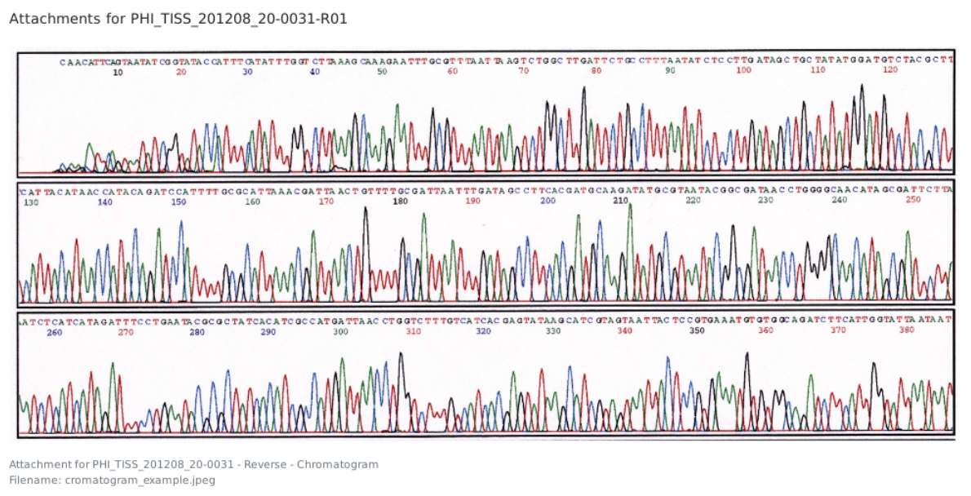
Finally, the last page shows the sign of the laboratory responsible and publisher.
Once we have check the preview of the report we can click on “Save” button and the three reports will be saved, one per sample. From “Analysis Report” tab we select the three samples and click on “Publish”. This step is mandatory to change the state of the samples to “Published” and 100% of progress. We can also download the PDF (figure ).
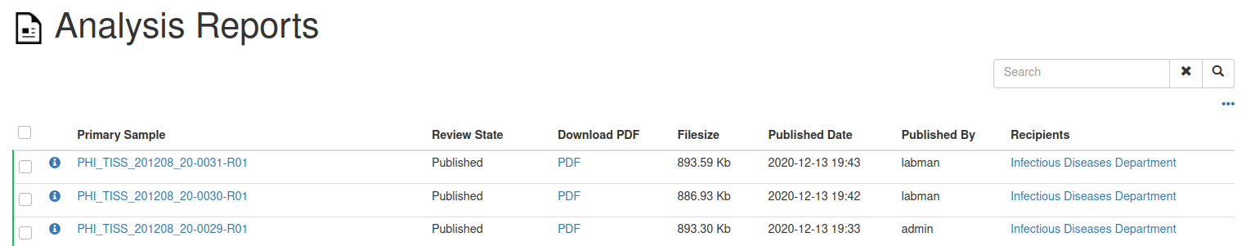
Finally, we must close the bacth created. Click on “Batches” and select the batch created before and click on “Close” (figure ). The bach will be closed now.
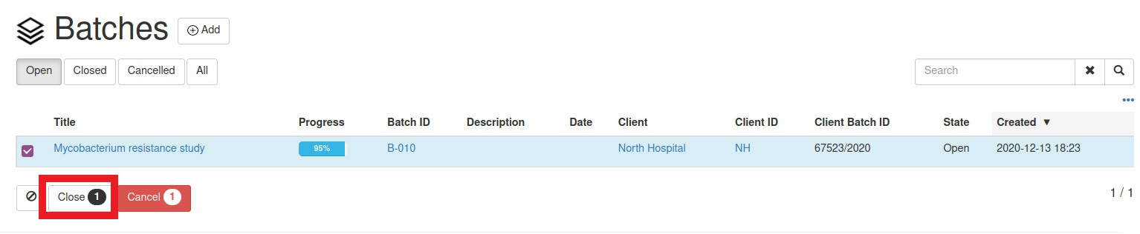

BIBLIOGRAPHY

1. Kchouk M, Gibrat JF, Elloumi M. Generations of Sequencing Technologies: From First to Next Generation. Biol Med. 2017;09(03).
2. Heather JM, Chain B. The sequence of sequencers: The history of sequencing DNA. Genomics. 2016;107(1):1–8.
3. Sanger F, Nicklen S, Coulson AR. DNA sequencing with chain-terminating inhibitors. Proc Natl Acad Sci U S A [Internet]. 1977 Dec;74(12):5463–7. Available from: https://pubmed.ncbi.nlm.nih.gov/271968
4. Green ED, Rubin EM, Olson M V. The future of DNA sequencing. Nat News. 2017;550(7675):179.
5. Kahn SD. On the future of genomic data. Science (80- ). 2011;331(6018):728–9.
6. Gibbon GA. A brief history of LIMS. Lab Autom Inf Manag. 1996;32(1):1–5.
7. Wood S. Comprehensive Laboratory Informatics : A Multilayer Approach. 2007;(September).
8. Standardization. IOBP (OBP). IO for. “ISO/IEC 17025:2017(en) - General requirements for the competence of testing and calibration laboratories”. 2017.
9. LIMSWiki. Laboratory information management system [Internet]. [cited 2020 Nov 2]. Available from: https://www.limswiki.org/index.php/Laboratory_information_management_system
10. Naralabs. SENAITE, Professional Open Source LIMS. The evolution of Bika LIMS. [Internet]. 2018 [cited 2020 Nov 11]. Available from: https://naralabs.com/en/blog/senaite-professional-open-source-lims-the-evolution-of-bika-lims
11. Senaite. Senaite LIMS installation [Internet]. [cited 2020 Oct 10]. Available from: https://www.senaite.com/docs/installation
12. Servicio de Genómica de la Universidad Complutense de Madrid. Genómica y Proteómica [Internet]. [cited 2020 Oct 5]. Available from: https://www.ucm.es/gyp/genomica-1
13. Laboratorio Secuenciación IdiPAZ. Guía práctica para el usuario de Secuenciación Sanger IdiPAZ [Internet]. [cited 2020 Feb 10]. Available from: https://www.idipaz.es/PaginaDinamica.aspx?IdPag=194&Lang=ES
14. Servicio de Secuenciación de la Universidad de Salamanca. Secuenciación de ADN [Internet]. [cited 2020 Oct 5]. Available from: https://nucleus.usal.es/es/secuenciacion/servicios
15. Macrogen. Standard Sequencing [Internet]. [cited 2020 Oct 5]. Available from: https://www.macrogen.com/en/business/ces_service1.php

