COMMAND PROMPT

ls

ir

cd..

cd

c..

cd\

mkdir

cls

echo $null >> first_app.py

code .

del first_app.py

rmdir deneme

rm dosyaadi

rm -r klasoradi

py first_app.py

PYTHON

type()

some_String[::] baş dahil son hariç, sıfırdan başla kaçar kaçar

“somes {} {}”.format(name, age)

“somes {0} {1}”.format(name, age)

“somes {1} {0}”.format(name, age)

“somes {n} {a}”.format(n=name, a=age)

f”somes {variable}”

“somes {r:10.3}”.format(r=result)

10 virgül öncesi için bırakılan boşluk, 3 virgül sonrasının digit sayısı

len()

Python'da dizeler üzerinde kullanabileceğiniz bir dizi yerleşik yöntem bulunur.

****Not:**** Tüm string metotları yeni değerler döndürür. Orijinal stringi değiştirmezler.

|  |  |
| --- | --- |
| **Method** | **Description** |
| [capitalize()](https://www.w3schools.com/python/ref_string_capitalize.asp) | Converts the first character to upper case |
| [casefold()](https://www.w3schools.com/python/ref_string_casefold.asp) | Converts string into lower case |
| [center()](https://www.w3schools.com/python/ref_string_center.asp) | Returns a centered string |
| [count()](https://www.w3schools.com/python/ref_string_count.asp) | Returns the number of times a specified value occurs in a string |
| [encode()](https://www.w3schools.com/python/ref_string_encode.asp) | Returns an encoded version of the string |
| [endswith()](https://www.w3schools.com/python/ref_string_endswith.asp) | Returns true if the string ends with the specified value |
| [expandtabs()](https://www.w3schools.com/python/ref_string_expandtabs.asp) | Sets the tab size of the string |
| [find()](https://www.w3schools.com/python/ref_string_find.asp) | Searches the string for a specified value and returns the position of where it was found |
| [format()](https://www.w3schools.com/python/ref_string_format.asp) | Formats specified values in a string |
| [format_map()](https://www.w3schools.com/python/ref_string_format_map.asp) | Formats specified values from a dictionary in a string |
| [index()](https://www.w3schools.com/python/ref_string_index.asp) | Searches the string for a specified value and returns the position of where it was found |
| [isalnum()](https://www.w3schools.com/python/ref_string_isalnum.asp) | Returns True if all characters in the string are alphanumeric |
| [isalpha()](https://www.w3schools.com/python/ref_string_isalpha.asp) | Returns True if all characters in the string are in the alphabet |
| [isascii()](https://www.w3schools.com/python/ref_string_isascii.asp) | Returns True if all characters in the string are ascii characters |
| [isdecimal()](https://www.w3schools.com/python/ref_string_isdecimal.asp) | Returns True if all characters in the string are decimals |
| [isdigit()](https://www.w3schools.com/python/ref_string_isdigit.asp) | Returns True if all characters in the string are digits |
| [isidentifier()](https://www.w3schools.com/python/ref_string_isidentifier.asp) | Returns True if the string is an identifier |
| [islower()](https://www.w3schools.com/python/ref_string_islower.asp) | Returns True if all characters in the string are lower case |
| [isnumeric()](https://www.w3schools.com/python/ref_string_isnumeric.asp) | Returns True if all characters in the string are numeric |
| [isprintable()](https://www.w3schools.com/python/ref_string_isprintable.asp) | Returns True if all characters in the string are printable |
| [isspace()](https://www.w3schools.com/python/ref_string_isspace.asp) | Returns True if all characters in the string are whitespaces |
| [istitle()](https://www.w3schools.com/python/ref_string_istitle.asp) | Returns True if the string follows the rules of a title |
| [isupper()](https://www.w3schools.com/python/ref_string_isupper.asp) | Returns True if all characters in the string are upper case |
| [join()](https://www.w3schools.com/python/ref_string_join.asp) | Converts the elements of an iterable into a string |
| [ljust()](https://www.w3schools.com/python/ref_string_ljust.asp) | Returns a left justified version of the string |
| [lower()](https://www.w3schools.com/python/ref_string_lower.asp) | Converts a string into lower case |
| [lstrip()](https://www.w3schools.com/python/ref_string_lstrip.asp) | Returns a left trim version of the string |
| [maketrans()](https://www.w3schools.com/python/ref_string_maketrans.asp) | Returns a translation table to be used in translations |
| [partition()](https://www.w3schools.com/python/ref_string_partition.asp) | Returns a tuple where the string is parted into three parts |
| [replace()](https://www.w3schools.com/python/ref_string_replace.asp) | Returns a string where a specified value is replaced with a specified value |
| [rfind()](https://www.w3schools.com/python/ref_string_rfind.asp) | Searches the string for a specified value and returns the last position of where it was found |
| [rindex()](https://www.w3schools.com/python/ref_string_rindex.asp) | Searches the string for a specified value and returns the last position of where it was found |
| [rjust()](https://www.w3schools.com/python/ref_string_rjust.asp) | Returns a right justified version of the string |
| [rpartition()](https://www.w3schools.com/python/ref_string_rpartition.asp) | Returns a tuple where the string is parted into three parts |
| [rsplit()](https://www.w3schools.com/python/ref_string_rsplit.asp) | Splits the string at the specified separator, and returns a list |
| [rstrip()](https://www.w3schools.com/python/ref_string_rstrip.asp) | Returns a right trim version of the string |
| [split()](https://www.w3schools.com/python/ref_string_split.asp) | Splits the string at the specified separator, and returns a list |
| [splitlines()](https://www.w3schools.com/python/ref_string_splitlines.asp) | Splits the string at line breaks and returns a list |
| [startswith()](https://www.w3schools.com/python/ref_string_startswith.asp) | Returns true if the string starts with the specified value |
| [strip()](https://www.w3schools.com/python/ref_string_strip.asp) | Returns a trimmed version of the string |
| [swapcase()](https://www.w3schools.com/python/ref_string_swapcase.asp) | Swaps cases, lower case becomes upper case and vice versa |
| [title()](https://www.w3schools.com/python/ref_string_title.asp) | Converts the first character of each word to upper case |
| [translate()](https://www.w3schools.com/python/ref_string_translate.asp) | Returns a translated string |
| [upper()](https://www.w3schools.com/python/ref_string_upper.asp) | Converts a string into upper case |
| [zfill()](https://www.w3schools.com/python/ref_string_zfill.asp) | Fills the string with a specified number of 0 values at the beginning |

****Not:**** Tüm string metotları yeni değerler döndürür. Orijinal stringi değiştirmezler.

## Liste Yöntemleri

Python'da listelerde kullanabileceğiniz bir dizi yerleşik yöntem bulunur.

|  |  |
| --- | --- |
| **Method** | **Description** |
| [append()](https://www.w3schools.com/python/ref_list_append.asp) | Adds an element at the end of the list |
| [clear()](https://www.w3schools.com/python/ref_list_clear.asp) | Removes all the elements from the list |
| [copy()](https://www.w3schools.com/python/ref_list_copy.asp) | Returns a copy of the list |
| [count()](https://www.w3schools.com/python/ref_list_count.asp) | Returns the number of elements with the specified value |
| [extend()](https://www.w3schools.com/python/ref_list_extend.asp) | Add the elements of a list (or any iterable), to the end of the current list |
| [index()](https://www.w3schools.com/python/ref_list_index.asp) | Returns the index of the first element with the specified value |
| [insert()](https://www.w3schools.com/python/ref_list_insert.asp) | Adds an element at the specified position |
| [pop()](https://www.w3schools.com/python/ref_list_pop.asp) | Removes the element at the specified position |
| [remove()](https://www.w3schools.com/python/ref_list_remove.asp) | Removes the item with the specified value |
| [reverse()](https://www.w3schools.com/python/ref_list_reverse.asp) | Reverses the order of the list |
| [sort()](https://www.w3schools.com/python/ref_list_sort.asp) | Sorts the list |

min()

max()

Python'da tuple'larda kullanabileceğiniz iki adet yerleşik metod vardır.

|  |  |
| --- | --- |
| **Method** | **Description** |
| [count()](https://www.w3schools.com/python/ref_tuple_count.asp) | Returns the number of times a specified value occurs in a tuple |
| [index()](https://www.w3schools.com/python/ref_tuple_index.asp) | Searches the tuple for a specified value and returns the position of where it was found |

tuplelar toplanabilir

Python has a set of built-in methods that you can use on dictionaries.

|  |  |
| --- | --- |
| **Method** | **Description** |
| [clear()](https://www.w3schools.com/python/ref_dictionary_clear.asp) | Removes all the elements from the dictionary |
| [copy()](https://www.w3schools.com/python/ref_dictionary_copy.asp) | Returns a copy of the dictionary |
| [fromkeys()](https://www.w3schools.com/python/ref_dictionary_fromkeys.asp) | Returns a dictionary with the specified keys and value |
| [get()](https://www.w3schools.com/python/ref_dictionary_get.asp) | Returns the value of the specified key |
| [items()](https://www.w3schools.com/python/ref_dictionary_items.asp) | Returns a list containing a tuple for each key value pair |
| [keys()](https://www.w3schools.com/python/ref_dictionary_keys.asp) | Returns a list containing the dictionary's keys |
| [pop()](https://www.w3schools.com/python/ref_dictionary_pop.asp) | Removes the element with the specified key |
| [popitem()](https://www.w3schools.com/python/ref_dictionary_popitem.asp) | Removes the last inserted key-value pair |
| [setdefault()](https://www.w3schools.com/python/ref_dictionary_setdefault.asp) | Returns the value of the specified key. If the key does not exist: insert the key, with the specified value |
| [update()](https://www.w3schools.com/python/ref_dictionary_update.asp) | Updates the dictionary with the specified key-value pairs |
| [values()](https://www.w3schools.com/python/ref_dictionary_values.asp) | Returns a list of all the values in the dictionary |

Learn more about dictionaries in our [Python Dictionaries Tutorial](https://www.w3schools.com/python/python_dictionaries.asp).

setler indekslenemez ve sıralanamaz, her eleman yalnızca bir kez bulunur

Python has a set of built-in methods that you can use on sets.

|  |  |  |
| --- | --- | --- |
| **Method** | **Shortcut** | **Description** |
| [add()](https://www.w3schools.com/python/ref_set_add.asp) |  | Adds an element to the set |
| [clear()](https://www.w3schools.com/python/ref_set_clear.asp) |  | Removes all the elements from the set |
| [copy()](https://www.w3schools.com/python/ref_set_copy.asp) |  | Returns a copy of the set |
| [difference()](https://www.w3schools.com/python/ref_set_difference.asp) | [-](https://www.w3schools.com/python/ref_set_difference.asp) | Returns a set containing the difference between two or more sets |
| [difference_update()](https://www.w3schools.com/python/ref_set_difference_update.asp) | [-=](https://www.w3schools.com/python/ref_set_difference_update.asp) | Removes the items in this set that are also included in another, specified set |
| [discard()](https://www.w3schools.com/python/ref_set_discard.asp) |  | Remove the specified item |
| [intersection()](https://www.w3schools.com/python/ref_set_intersection.asp) | [&](https://www.w3schools.com/python/ref_set_intersection.asp) | Returns a set, that is the intersection of two other sets |
| [intersection_update()](https://www.w3schools.com/python/ref_set_intersection_update.asp) | [&=](https://www.w3schools.com/python/ref_set_intersection_update.asp) | Removes the items in this set that are not present in other, specified set(s) |
| [isdisjoint()](https://www.w3schools.com/python/ref_set_isdisjoint.asp) |  | Returns whether two sets have a intersection or not |
| [issubset()](https://www.w3schools.com/python/ref_set_issubset.asp) | [<=](https://www.w3schools.com/python/ref_set_issubset.asp) | Returns True if all items of this set is present in another set |
|  | [<](https://www.w3schools.com/python/ref_set_lessthan.asp) | Returns True if all items of this set is present in another, larger set |
| [issuperset()](https://www.w3schools.com/python/ref_set_issuperset.asp) | [>=](https://www.w3schools.com/python/ref_set_issuperset.asp) | Returns True if all items of another set is present in this set |
|  | [>](https://www.w3schools.com/python/ref_set_greaterthan.asp) | Returns True if all items of another, smaller set is present in this set |
| [pop()](https://www.w3schools.com/python/ref_set_pop.asp) |  | Removes an element from the set |
| [remove()](https://www.w3schools.com/python/ref_set_remove.asp) |  | Removes the specified element |
| [symmetric_difference()](https://www.w3schools.com/python/ref_set_symmetric_difference.asp) | [^](https://www.w3schools.com/python/ref_set_symmetric_difference.asp) | Returns a set with the symmetric differences of two sets |
| [symmetric_difference_update()](https://www.w3schools.com/python/ref_set_symmetric_difference_update.asp) | [^=](https://www.w3schools.com/python/ref_set_symmetric_difference_update.asp) | Inserts the symmetric differences from this set and another |
| [union()](https://www.w3schools.com/python/ref_set_union.asp) | [|](https://www.w3schools.com/python/ref_set_union.asp) | Return a set containing the union of sets |
| [update()](https://www.w3schools.com/python/ref_set_update.asp) | [|=](https://www.w3schools.com/python/ref_set_update.asp) | Update the set with the union of this set and others |

Learn more about sets in our [Python Sets Tutorial](https://www.w3schools.com/python/python_sets.asp).

## Python Operators

|  |  |  |
| --- | --- | --- |
| **Operator** | **Name** | **Example** |
| + | Addition | x + y |
| - | Subtraction | x - y |
| * | Multiplication | x * y |
| / | Division | x / y |
| % | Modulus | x % y |
| ** | Exponentiation | x ** y |
| // | Floor division | x // y |

## Python Assignment Operators

Assignment operators are used to assign values to variables:

|  |  |  |
| --- | --- | --- |
| **Operator** | **Example** | **Same As** |
| = | x = 5 | x = 5 |
| += | x += 3 | x = x + 3 |
| -= | x -= 3 | x = x - 3 |
| *= | x *= 3 | x = x * 3 |
| /= | x /= 3 | x = x / 3 |
| %= | x %= 3 | x = x % 3 |
| //= | x //= 3 | x = x // 3 |
| **= | x **= 3 | x = x ** 3 |
| &= | x &= 3 | x = x & 3 |
| |= | x |= 3 | x = x | 3 |
| ^= | x ^= 3 | x = x ^ 3 |
| >>= | x >>= 3 | x = x >> 3 |
| <<= | x <<= 3 | x = x << 3 |
| := | print(x := 3) | x = 3 print(x) |

## Python Comparison Operators

Comparison operators are used to compare two values:

|  |  |  |
| --- | --- | --- |
| **Operator** | **Name** | **Example** |
| == | Equal | x == y |
| != | Not equal | x != y |
| > | Greater than | x > y |
| < | Less than | x < y |
| >= | Greater than or equal to | x >= y |
| <= | Less than or equal to | x <= y |

## Python Logical Operators

Logical operators are used to combine conditional statements:

|  |  |  |
| --- | --- | --- |
| **Operator** | **Description** | **Example** |
| and | Returns True if both statements are true | x < 5 and  x < 10 |
| or | Returns True if one of the statements is true | x < 5 or x < 4 |
| not | Reverse the result, returns False if the result is true | not(x < 5 and x < 10) |

## Python Identity Operators

Identity operators are used to compare the objects, not if they are equal, but if they are actually the same object, with the same memory location:

|  |  |  |
| --- | --- | --- |
| **Operator** | **Description** | **Example** |
| is | Returns True if both variables are the same object | x is y |
| is not | Returns True if both variables are not the same object | x is not y |

## Python Membership Operators

Membership operators are used to test if a sequence is presented in an object:

|  |  |  |
| --- | --- | --- |
| **Operator** | **Description** | **Example** |
| in | Returns True if a sequence with the specified value is present in the object | x in y |
| not in | Returns True if a sequence with the specified value is not present in the object | x not in y |

## Python Bitwise Operators

Bitwise operators are used to compare (binary) numbers:

|  |  |  |  |
| --- | --- | --- | --- |
| **Operator** | **Name** | **Description** | **Example** |
| & | AND | Sets each bit to 1 if both bits are 1 | x & y |
| | | OR | Sets each bit to 1 if one of two bits is 1 | x | y |
| ^ | XOR | Sets each bit to 1 if only one of two bits is 1 | x ^ y |
| ~ | NOT | Inverts all the bits | ~x |
| << | Zero fill left shift | Shift left by pushing zeros in from the right and let the leftmost bits fall off | x << 2 |
| >> | Signed right shift | Shift right by pushing copies of the leftmost bit in from the left, and let the rightmost bits fall off | x >> 2 |

## Operator Precedence

Operator precedence describes the order in which operations are performed.

The precedence order is described in the table below, starting with the highest precedence at the top:

|  |  |
| --- | --- |
| **Operator** | **Description** |
| () | Parentheses |
| ** | Exponentiation |
| +x  -x  ~x | Unary plus, unary minus, and bitwise NOT |
| *  /  //  % | Multiplication, division, floor division, and modulus |
| +  - | Addition and subtraction |
| <<  >> | Bitwise left and right shifts |
| & | Bitwise AND |
| ^ | Bitwise XOR |
| | | Bitwise OR |
| ==  !=  >  >=  <  <=  is  is not  in  not in | Comparisons, identity, and membership operators |
| not | Logical NOT |
| and | AND |
| or | OR |

If two operators have the same precedence, the expression is evaluated from left to right.

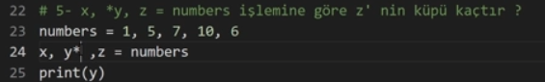

y ortadaki üç elemanı alır liste şeklinde

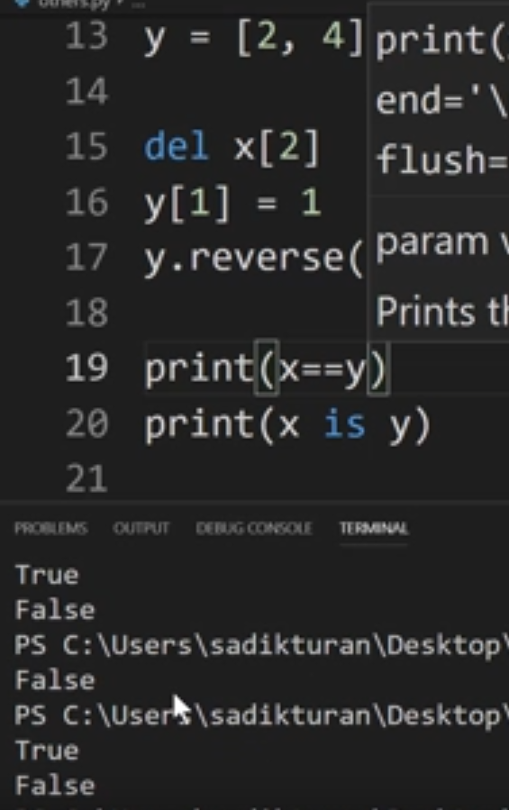

elemanları eşit olan iki liste == tir ama is değil çünkü adresleri farklı

import datetime

simdi = datetime.datetime.now

yenitarih = datetime.datetime(tarih[0], tarih[1], tarih[2])

yenitarih.days

dict = [ {“key”:value, “key2”: value2}

{“key”:value, “key2”: value2}

]

for i in dict:

i[“key”] olarak ulasilabilir

‘’ boş karakteri False olarak kabul edilir

range(::)

list(range(::)) ile liste de yapılabilir

import random

sayi = random.randint(1,100)

# Python Rastgele Modülü

Python'da rastgele sayılar üretmek için kullanabileceğiniz yerleşik bir modül bulunur.

Modülün random bir dizi yöntemi vardır:

|  |  |
| --- | --- |
| Method | Description |
| [seed()](https://www.w3schools.com/python/ref_random_seed.asp) | Initialize the random number generator |
| [getstate()](https://www.w3schools.com/python/ref_random_getstate.asp) | Returns the current internal state of the random number generator |
| [setstate()](https://www.w3schools.com/python/ref_random_setstate.asp) | Restores the internal state of the random number generator |
| [getrandbits()](https://www.w3schools.com/python/ref_random_getrandbits.asp) | Returns a number representing the random bits |
| [randrange()](https://www.w3schools.com/python/ref_random_randrange.asp) | Returns a random number between the given range |
| [randint()](https://www.w3schools.com/python/ref_random_randint.asp) | Returns a random number between the given range |
| [choice()](https://www.w3schools.com/python/ref_random_choice.asp) | Returns a random element from the given sequence |
| [choices()](https://www.w3schools.com/python/ref_random_choices.asp) | Returns a list with a random selection from the given sequence |
| [shuffle()](https://www.w3schools.com/python/ref_random_shuffle.asp) | Takes a sequence and returns the sequence in a random order |
| [sample()](https://www.w3schools.com/python/ref_random_sample.asp) | Returns a given sample of a sequence |
| [random()](https://www.w3schools.com/python/ref_random_random.asp) | Returns a random float number between 0 and 1 |
| [uniform()](https://www.w3schools.com/python/ref_random_uniform.asp) | Returns a random float number between two given parameters |
| [triangular()](https://www.w3schools.com/python/ref_random_triangular.asp) | Returns a random float number between two given parameters, you can also set a mode parameter to specify the midpoint between the two other parameters |
| betavariate() | Returns a random float number between 0 and 1 based on the Beta distribution (used in statistics) |
| expovariate() | Returns a random float number based on the Exponential distribution (used in statistics) |
| gammavariate() | Returns a random float number based on the Gamma distribution (used in statistics) |
| gauss() | Returns a random float number based on the Gaussian distribution (used in probability theories) |
| lognormvariate() | Returns a random float number based on a log-normal distribution (used in probability theories) |
| normalvariate() | Returns a random float number based on the normal distribution (used in probability theories) |
| vonmisesvariate() | Returns a random float number based on the von Mises distribution (used in directional statistics) |
| paretovariate() | Returns a random float number based on the Pareto distribution (used in probability theories) |
| weibullvariate() | Returns a random float number based on the Weibull distribution (used in statistics) |

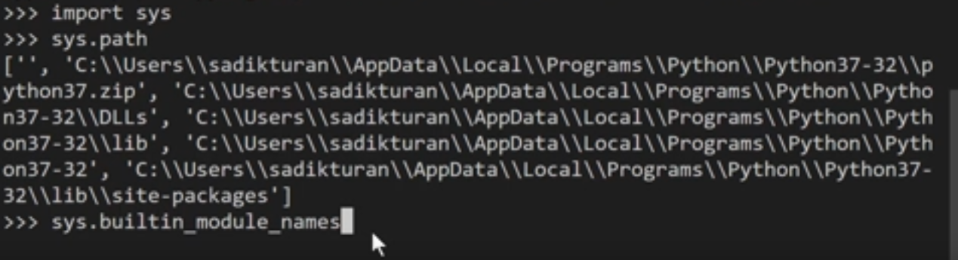

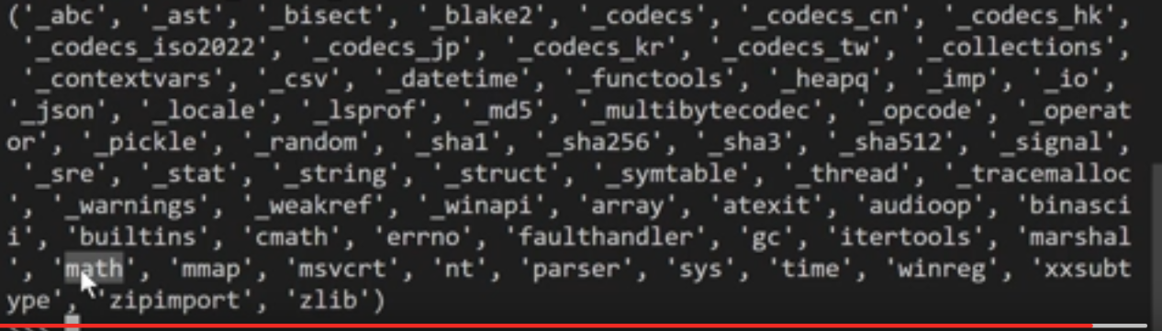

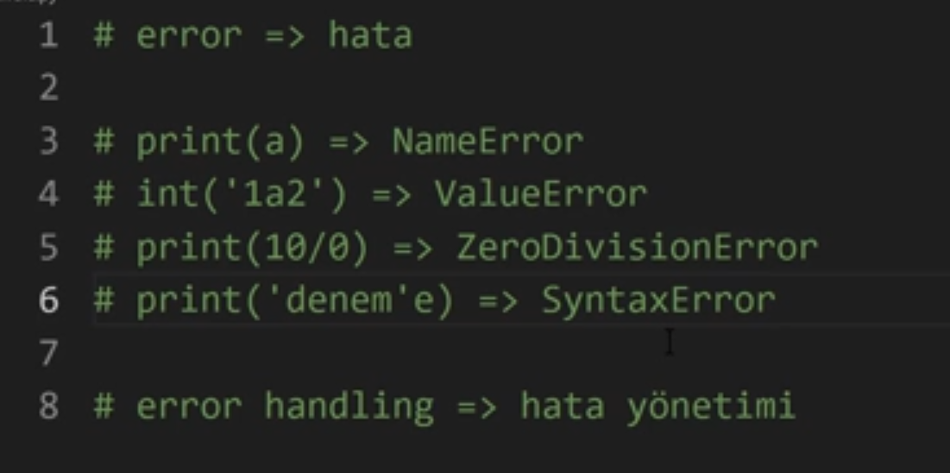

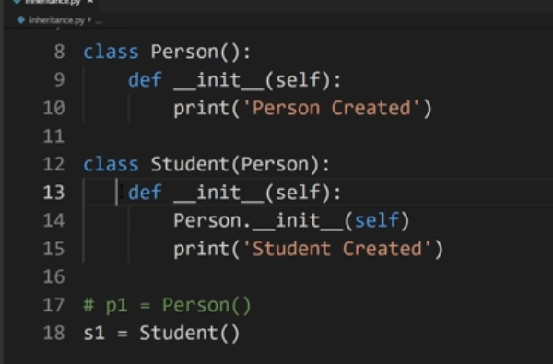

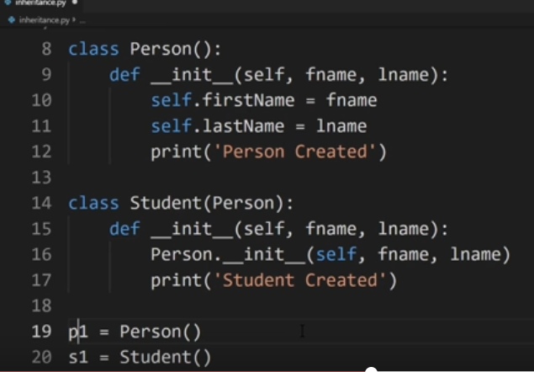

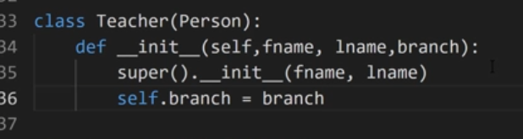

## Python Magic Methods

Below are the lists of Python magic methods and their uses.

**Initialization and Construction**

* **[__new__](https://www.geeksforgeeks.org/python/__new__-in-python/):** To get called in an object's instantiation.
* **[__init__](https://www.geeksforgeeks.org/python/__init__-in-python/):** To get called by the __new__ method.
* **[__del__](https://www.geeksforgeeks.org/python/python-__delete__-vs-__del__/):** It is the destructor.

**Numeric magic methods**

* **[__trunc__](https://www.geeksforgeeks.org/python/g-fact-35-truncate-in-python/)(self):** Implements behavior for math.trunc()
* **[__ceil__](https://www.geeksforgeeks.org/python/__call__-in-python/)(self):** Implements behavior for math.ceil()
* **[__floor__](https://www.geeksforgeeks.org/python/python-math-floor-function/)(self):** Implements behavior for math.floor()
* **[__round__](https://www.geeksforgeeks.org/python/round-function-python/)(self,n):** Implements behavior for the built-in round()
* **__invert__(self):** Implements behavior for inversion using the ~ operator.
* **__abs__(self):** Implements behavior for the built-in abs()
* **__neg__(self):** Implements behavior for negation
* **__pos__(self):** Implements behavior for unary positive

**Arithmetic operators**

* __add__(self, other): Implements behavior for the + operator (addition).
* __sub__(self, other): Implements behavior for the - operator (subtraction).
* __mul__(self, other): Implements behavior for the * operator (multiplication).
* __floordiv__(self, other): Implements behavior for the // operator (floor division).
* __truediv__(self, other): Implements behavior for the / operator (true division).
* __mod__(self, other): Implements behavior for the % operator (modulus).
* __divmod__(self, other): Implements behavior for the divmod() function.
* __pow__(self, other): Implements behavior for the ** operator (exponentiation).
* __lshift__(self, other): Implements behavior for the << operator (left bitwise shift).
* __rshift__(self, other): Implements behavior for the >> operator (right bitwise shift).
* __and__(self, other): Implements behavior for the & operator (bitwise and).
* __or__(self, other): Implements behavior for the | operator (bitwise or).
* __xor__(self, other): Implements behavior for the ^ operator (bitwise xor).
* __invert__(self): Implements behavior for bitwise NOT using the ~ operator.
* __neg__(self): Implements behavior for negation using the - operator.
* __pos__(self): Implements behavior for unary positive using the + operator.

**String Magic Methods**

* **[__str__](https://www.geeksforgeeks.org/python/str-vs-repr-in-python/)(self):** Defines behavior for when str() is called on an instance of your class.
* **[__repr_](https://www.geeksforgeeks.org/python/python-__repr__-magic-method/)_(self): T**o get called by built-int repr() method to return a machine readable representation of a type.
* **__unicode__(self):** This method to return an unicode string of a type.
* **__format__(self, formatstr):** return a new style of string.
* **[__hash_](https://www.geeksforgeeks.org/python/python-hash-method/)_(self):** It has to return an integer, and its result is used for quick key comparison in dictionaries.
* **__nonzero__(self):** Defines behavior for when bool() is called on an instance of your class.
* **[__dir_](https://www.geeksforgeeks.org/python/python-dir-function/)_(self):** This method to return a list of attributes of a class.
* **[__sizeof__(](https://www.geeksforgeeks.org/python/difference-between-__sizeof__-and-getsizeof-method-python/)self):** It return the size of the object.

**Comparison magic methods**

* **[__eq__](https://www.geeksforgeeks.org/python/difference-between-__eq__-vs-is-vs-in-python/)(self, other):** Defines behavior for the equality operator, ==.
* **__ne__(self, other):** Defines behavior for the inequality operator, !=.
* **[__lt__](https://www.geeksforgeeks.org/python/python-__lt__-magic-method/)(self, other):** Defines behavior for the less-than operator, <.
* **[__gt__](https://www.geeksforgeeks.org/python/customize-your-python-class-with-magic-or-dunder-methods/)(self, other):** Defines behavior for the greater-than operator, >.
* **__le__(self, other):** Defines behavior for the less-than-or-equal-to operator, <=.
* **[__ge__](https://www.geeksforgeeks.org/python/customize-your-python-class-with-magic-or-dunder-methods/)(self, other):** Defines behavior for the greater-than-or-equal-to operator, >=.

# Python Built in Functions

Python has a set of built-in functions.

|  |  |
| --- | --- |
| Function | Description |
| [abs()](https://www.w3schools.com/python/ref_func_abs.asp) | Returns the absolute value of a number |
| [all()](https://www.w3schools.com/python/ref_func_all.asp) | Returns True if all items in an iterable object are true |
| [any()](https://www.w3schools.com/python/ref_func_any.asp) | Returns True if any item in an iterable object is true |
| [ascii()](https://www.w3schools.com/python/ref_func_ascii.asp) | Returns a readable version of an object. Replaces none-ascii characters with escape character |
| [bin()](https://www.w3schools.com/python/ref_func_bin.asp) | Returns the binary version of a number |
| [bool()](https://www.w3schools.com/python/ref_func_bool.asp) | Returns the boolean value of the specified object |
| [bytearray()](https://www.w3schools.com/python/ref_func_bytearray.asp) | Returns an array of bytes |
| [bytes()](https://www.w3schools.com/python/ref_func_bytes.asp) | Returns a bytes object |
| [callable()](https://www.w3schools.com/python/ref_func_callable.asp) | Returns True if the specified object is callable, otherwise False |
| [chr()](https://www.w3schools.com/python/ref_func_chr.asp) | Returns a character from the specified Unicode code. |
| classmethod() | Converts a method into a class method |
| [compile()](https://www.w3schools.com/python/ref_func_compile.asp) | Returns the specified source as an object, ready to be executed |
| [complex()](https://www.w3schools.com/python/ref_func_complex.asp) | Returns a complex number |
| [delattr()](https://www.w3schools.com/python/ref_func_delattr.asp) | Deletes the specified attribute (property or method) from the specified object |
| [dict()](https://www.w3schools.com/python/ref_func_dict.asp) | Returns a dictionary (Array) |
| [dir()](https://www.w3schools.com/python/ref_func_dir.asp) | Returns a list of the specified object's properties and methods |
| [divmod()](https://www.w3schools.com/python/ref_func_divmod.asp) | Returns the quotient and the remainder when argument1 is divided by argument2 |
| [enumerate()](https://www.w3schools.com/python/ref_func_enumerate.asp) | Takes a collection (e.g. a tuple) and returns it as an enumerate object |
| [eval()](https://www.w3schools.com/python/ref_func_eval.asp) | Evaluates and executes an expression |
| [exec()](https://www.w3schools.com/python/ref_func_exec.asp) | Executes the specified code (or object) |
| [filter()](https://www.w3schools.com/python/ref_func_filter.asp) | Use a filter function to exclude items in an iterable object |
| [float()](https://www.w3schools.com/python/ref_func_float.asp) | Returns a floating point number |
| [format()](https://www.w3schools.com/python/ref_func_format.asp) | Formats a specified value |
| [frozenset()](https://www.w3schools.com/python/ref_func_frozenset.asp) | Returns a frozenset object |
| [getattr()](https://www.w3schools.com/python/ref_func_getattr.asp) | Returns the value of the specified attribute (property or method) |
| [globals()](https://www.w3schools.com/python/ref_func_globals.asp) | Returns the current global symbol table as a dictionary |
| [hasattr()](https://www.w3schools.com/python/ref_func_hasattr.asp) | Returns True if the specified object has the specified attribute (property/method) |
| hash() | Returns the hash value of a specified object |
| help() | Executes the built-in help system |
| [hex()](https://www.w3schools.com/python/ref_func_hex.asp) | Converts a number into a hexadecimal value |
| [id()](https://www.w3schools.com/python/ref_func_id.asp) | Returns the id of an object |
| [input()](https://www.w3schools.com/python/ref_func_input.asp) | Allowing user input |
| [int()](https://www.w3schools.com/python/ref_func_int.asp) | Returns an integer number |
| [isinstance()](https://www.w3schools.com/python/ref_func_isinstance.asp) | Returns True if a specified object is an instance of a specified object |
| [issubclass()](https://www.w3schools.com/python/ref_func_issubclass.asp) | Returns True if a specified class is a subclass of a specified object |
| [iter()](https://www.w3schools.com/python/ref_func_iter.asp) | Returns an iterator object |
| [len()](https://www.w3schools.com/python/ref_func_len.asp) | Returns the length of an object |
| [list()](https://www.w3schools.com/python/ref_func_list.asp) | Returns a list |
| [locals()](https://www.w3schools.com/python/ref_func_locals.asp) | Returns an updated dictionary of the current local symbol table |
| [map()](https://www.w3schools.com/python/ref_func_map.asp) | Returns the specified iterator with the specified function applied to each item |
| [max()](https://www.w3schools.com/python/ref_func_max.asp) | Returns the largest item in an iterable |
| [memoryview()](https://www.w3schools.com/python/ref_func_memoryview.asp) | Returns a memory view object |
| [min()](https://www.w3schools.com/python/ref_func_min.asp) | Returns the smallest item in an iterable |
| [next()](https://www.w3schools.com/python/ref_func_next.asp) | Returns the next item in an iterable |
| [object()](https://www.w3schools.com/python/ref_func_object.asp) | Returns a new object |
| [oct()](https://www.w3schools.com/python/ref_func_oct.asp) | Converts a number into an octal |
| [open()](https://www.w3schools.com/python/ref_func_open.asp) | Opens a file and returns a file object |
| [ord()](https://www.w3schools.com/python/ref_func_ord.asp) | Convert an integer representing the Unicode of the specified character |
| [pow()](https://www.w3schools.com/python/ref_func_pow.asp) | Returns the value of x to the power of y |
| [print()](https://www.w3schools.com/python/ref_func_print.asp) | Prints to the standard output device |
| property() | Gets, sets, deletes a property |
| [range()](https://www.w3schools.com/python/ref_func_range.asp) | Returns a sequence of numbers, starting from 0 and increments by 1 (by default) |
| repr() | Returns a readable version of an object |
| [reversed()](https://www.w3schools.com/python/ref_func_reversed.asp) | Returns a reversed iterator |
| [round()](https://www.w3schools.com/python/ref_func_round.asp) | Rounds a numbers |
| [set()](https://www.w3schools.com/python/ref_func_set.asp) | Returns a new set object |
| [setattr()](https://www.w3schools.com/python/ref_func_setattr.asp) | Sets an attribute (property/method) of an object |
| [slice()](https://www.w3schools.com/python/ref_func_slice.asp) | Returns a slice object |
| [sorted()](https://www.w3schools.com/python/ref_func_sorted.asp) | Returns a sorted list |
| staticmethod() | Converts a method into a static method |
| [str()](https://www.w3schools.com/python/ref_func_str.asp) | Returns a string object |
| [sum()](https://www.w3schools.com/python/ref_func_sum.asp) | Sums the items of an iterator |
| [super()](https://www.w3schools.com/python/ref_func_super.asp) | Returns an object that represents the parent class |
| [tuple()](https://www.w3schools.com/python/ref_func_tuple.asp) | Returns a tuple |
| [type()](https://www.w3schools.com/python/ref_func_type.asp) | Returns the type of an object |
| [vars()](https://www.w3schools.com/python/ref_func_vars.asp) | Returns the __dict__ property of an object |
| [zip()](https://www.w3schools.com/python/ref_func_zip.asp) | Returns an iterator, from two or more iterators |

## Python math Module

Python has a built-in module that you can use for mathematical tasks.

The math module has a set of methods and constants.

## Math Methods

|  |  |
| --- | --- |
| **Method** | **Description** |
| [math.acos()](https://www.w3schools.com/python/ref_math_acos.asp) | Returns the arc cosine of a number |
| [math.acosh()](https://www.w3schools.com/python/ref_math_acosh.asp) | Returns the inverse hyperbolic cosine of a number |
| [math.asin()](https://www.w3schools.com/python/ref_math_asin.asp) | Returns the arc sine of a number |
| [math.asinh()](https://www.w3schools.com/python/ref_math_asinh.asp) | Returns the inverse hyperbolic sine of a number |
| [math.atan()](https://www.w3schools.com/python/ref_math_atan.asp) | Returns the arc tangent of a number in radians |
| [math.atan2()](https://www.w3schools.com/python/ref_math_atan2.asp) | Returns the arc tangent of y/x in radians |
| [math.atanh()](https://www.w3schools.com/python/ref_math_atanh.asp) | Returns the inverse hyperbolic tangent of a number |
| [math.ceil()](https://www.w3schools.com/python/ref_math_ceil.asp) | Rounds a number up to the nearest integer |
| [math.comb()](https://www.w3schools.com/python/ref_math_comb.asp) | Returns the number of ways to choose k items from n items without repetition and order |
| [math.copysign()](https://www.w3schools.com/python/ref_math_copysign.asp) | Returns a float consisting of the value of the first parameter and the sign of the second parameter |
| [math.cos()](https://www.w3schools.com/python/ref_math_cos.asp) | Returns the cosine of a number |
| [math.cosh()](https://www.w3schools.com/python/ref_math_cosh.asp) | Returns the hyperbolic cosine of a number |
| [math.degrees()](https://www.w3schools.com/python/ref_math_degrees.asp) | Converts an angle from radians to degrees |
| [math.dist()](https://www.w3schools.com/python/ref_math_dist.asp) | Returns the Euclidean distance between two points (p and q), where p and q are the coordinates of that point |
| [math.erf()](https://www.w3schools.com/python/ref_math_erf.asp) | Returns the error function of a number |
| [math.erfc()](https://www.w3schools.com/python/ref_math_erfc.asp) | Returns the complementary error function of a number |
| [math.exp()](https://www.w3schools.com/python/ref_math_exp.asp) | Returns E raised to the power of x |
| [math.expm1()](https://www.w3schools.com/python/ref_math_expm1.asp) | Returns Ex - 1 |
| [math.fabs()](https://www.w3schools.com/python/ref_math_fabs.asp) | Returns the absolute value of a number |
| [math.factorial()](https://www.w3schools.com/python/ref_math_factorial.asp) | Returns the factorial of a number |
| [math.floor()](https://www.w3schools.com/python/ref_math_floor.asp) | Rounds a number down to the nearest integer |
| [math.fmod()](https://www.w3schools.com/python/ref_math_fmod.asp) | Returns the remainder of x/y |
| [math.frexp()](https://www.w3schools.com/python/ref_math_frexp.asp) | Returns the mantissa and the exponent, of a specified number |
| [math.fsum()](https://www.w3schools.com/python/ref_math_fsum.asp) | Returns the sum of all items in any iterable (tuples, arrays, lists, etc.) |
| [math.gamma()](https://www.w3schools.com/python/ref_math_gamma.asp) | Returns the gamma function at x |
| [math.gcd()](https://www.w3schools.com/python/ref_math_gcd.asp) | Returns the greatest common divisor of two integers |
| [math.hypot()](https://www.w3schools.com/python/ref_math_hypot.asp) | Returns the Euclidean norm |
| [math.isclose()](https://www.w3schools.com/python/ref_math_isclose.asp) | Checks whether two values are close to each other, or not |
| [math.isfinite()](https://www.w3schools.com/python/ref_math_isfinite.asp) | Checks whether a number is finite or not |
| [math.isinf()](https://www.w3schools.com/python/ref_math_isinf.asp) | Checks whether a number is infinite or not |
| [math.isnan()](https://www.w3schools.com/python/ref_math_isnan.asp) | Checks whether a value is NaN (not a number) or not |
| [math.isqrt()](https://www.w3schools.com/python/ref_math_isqrt.asp) | Rounds a square root number downwards to the nearest integer |
| [math.ldexp()](https://www.w3schools.com/python/ref_math_ldexp.asp) | Returns the inverse of [math.frexp()](https://www.w3schools.com/python/ref_math_frexp.asp) which is x * (2**i) of the given numbers x and i |
| [math.lgamma()](https://www.w3schools.com/python/ref_math_lgamma.asp) | Returns the log gamma value of x |
| [math.log()](https://www.w3schools.com/python/ref_math_log.asp) | Returns the natural logarithm of a number, or the logarithm of number to base |
| [math.log10()](https://www.w3schools.com/python/ref_math_log10.asp) | Returns the base-10 logarithm of x |
| [math.log1p()](https://www.w3schools.com/python/ref_math_log1p.asp) | Returns the natural logarithm of 1+x |
| [math.log2()](https://www.w3schools.com/python/ref_math_log2.asp) | Returns the base-2 logarithm of x |
| [math.perm()](https://www.w3schools.com/python/ref_math_perm.asp) | Returns the number of ways to choose k items from n items with order and without repetition |
| [math.pow()](https://www.w3schools.com/python/ref_math_pow.asp) | Returns the value of x to the power of y |
| [math.prod()](https://www.w3schools.com/python/ref_math_prod.asp) | Returns the product of all the elements in an iterable |
| [math.radians()](https://www.w3schools.com/python/ref_math_radians.asp) | Converts a degree value into radians |
| [math.remainder()](https://www.w3schools.com/python/ref_math_remainder.asp) | Returns the closest value that can make numerator completely divisible by the denominator |
| [math.sin()](https://www.w3schools.com/python/ref_math_sin.asp) | Returns the sine of a number |
| [math.sinh()](https://www.w3schools.com/python/ref_math_sinh.asp) | Returns the hyperbolic sine of a number |
| [math.sqrt()](https://www.w3schools.com/python/ref_math_sqrt.asp) | Returns the square root of a number |
| [math.tan()](https://www.w3schools.com/python/ref_math_tan.asp) | Returns the tangent of a number |
| [math.tanh()](https://www.w3schools.com/python/ref_math_tanh.asp) | Returns the hyperbolic tangent of a number |
| [math.trunc()](https://www.w3schools.com/python/ref_math_trunc.asp) | Returns the truncated integer parts of a number |

## Math Constants

|  |  |
| --- | --- |
| **Constant** | **Description** |
| [math.e](https://www.w3schools.com/python/ref_math_e.asp) | Returns Euler's number (2.7182...) |
| [math.inf](https://www.w3schools.com/python/ref_math_inf.asp) | Returns a floating-point positive infinity |
| [math.nan](https://www.w3schools.com/python/ref_math_nan.asp) | Returns a floating-point NaN (Not a Number) value |
| [math.pi](https://www.w3schools.com/python/ref_math_pi.asp) | Returns PI (3.1415...) |
| [math.tau](https://www.w3schools.com/python/ref_math_tau.asp) | Returns tau (6.2831...) |

## Exception hierarchy

The class hierarchy for built-in exceptions is:

BaseException

├── BaseExceptionGroup

├── GeneratorExit

├── KeyboardInterrupt

├── SystemExit

└── Exception

├── ArithmeticError

│ ├── FloatingPointError

│ ├── OverflowError

│ └── ZeroDivisionError

├── AssertionError

├── AttributeError

├── BufferError

├── EOFError

├── ExceptionGroup [BaseExceptionGroup]

├── ImportError

│ └── ModuleNotFoundError

├── LookupError

│ ├── IndexError

│ └── KeyError

├── MemoryError

├── NameError

│ └── UnboundLocalError

├── OSError

│ ├── BlockingIOError

│ ├── ChildProcessError

│ ├── ConnectionError

│ │ ├── BrokenPipeError

│ │ ├── ConnectionAbortedError

│ │ ├── ConnectionRefusedError

│ │ └── ConnectionResetError

│ ├── FileExistsError

│ ├── FileNotFoundError

│ ├── InterruptedError

│ ├── IsADirectoryError

│ ├── NotADirectoryError

│ ├── PermissionError

│ ├── ProcessLookupError

│ └── TimeoutError

├── ReferenceError

├── RuntimeError

│ ├── NotImplementedError

│ ├── PythonFinalizationError

│ └── RecursionError

├── StopAsyncIteration

├── StopIteration

├── SyntaxError

│ └── IndentationError

│ └── TabError

├── SystemError

├── TypeError

├── ValueError

│ └── UnicodeError

│ ├── UnicodeDecodeError

│ ├── UnicodeEncodeError

│ └── UnicodeTranslateError

└── Warning

├── BytesWarning

├── DeprecationWarning

├── EncodingWarning

├── FutureWarning

├── ImportWarning

├── PendingDeprecationWarning

├── ResourceWarning

├── RuntimeWarning

├── SyntaxWarning

├── UnicodeWarning

└── UserWarning

try:

#statements

except ZeroDivisionError, ValueError:

#statements

else:

#except çalışmazsa

finally:

#Her zaman çalışır

try:

except Exception as ex:

if ():

raise Exception(“if is satisfied”)

DOSYA İŞLEMLERİ

