DOCUMENT FRONT PAGE

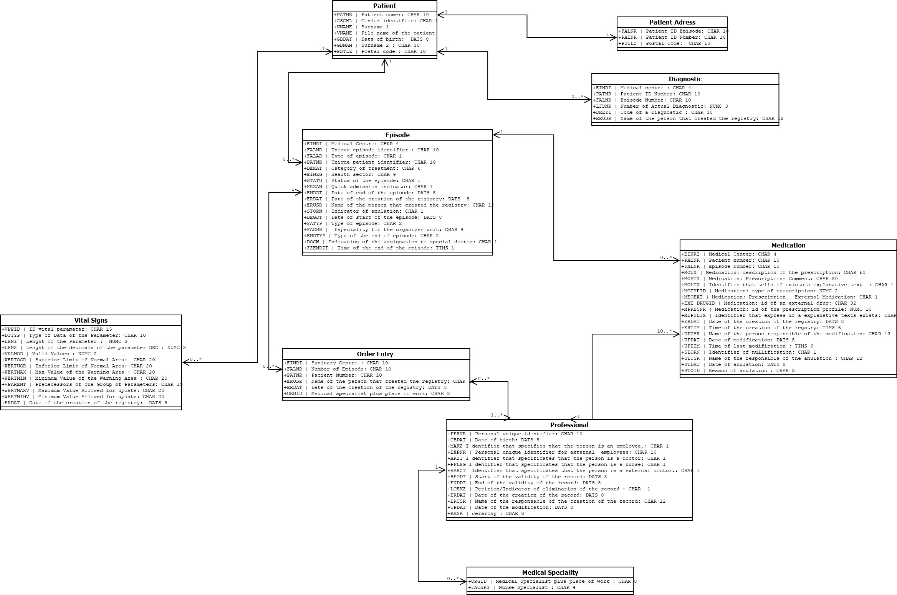

Elements of the Data Model

Pacient

|  |  |  |
| --- | --- | --- |
| **Field name** | **Description** | **Type of variable** |
| PATNR | Unique patient identifier. Number starting by ‘1’. | CHAR 10 |
| GSCHL | Gender identifier.   |  |  | | --- | --- | | M = Male | U = unknown | | F = Female |  | | CHAR 1 |
| NNAME | Surname 1. | CHAR 30 |
| VNAME | Pile name of the patient. | CHAR 30 |
| GBDAT | Date of birth. | DATS 8 |
| GBNAM | Surname 2. | CHAR 30 |
| PSTLZ | Postal code. Number of 5 characters that goes from 08000 to 43897. | CHAR 30 |

Names are a mixture of Spanish and Catalan names.

Episode

|  |  |  |
| --- | --- | --- |
| **Field name** | **Description** | **Type of variable** |
| EINRI | Medical Centre. Can be ‘HCPB’ (p=0.75), ‘BCL’ (p=0.15) or ‘HCM’ (p=0.10). | CHAR 4 |
| FALNR | Unique episode identifier. Number starting by ‘1000000001’ if it is BCL , starting by “2000000001” if it is from HCPB and “3000000001” if it is HCM | CHAR 10 |
| FALAR | Type of episode . This value can be : “1”,”2” or ”3” . Referring to “Episodio hospitaliz.” , “Epis.ambulante” or “Epis.en observación” | CHAR 1 |
| PATNR | Unique patient identifier. Number starting by ‘1’. | CHAR 10 |
| BEKAT | Category of the treatment. See ANNEX 1. | CHAR 6 |
| EINZG | Health sector. Grup of numbers starting by ‘000000001’. | CHAR 9 |
| STATU | Status of the episode. This can be :  “E” for concluded episode.  “I” for episode in developement.  “P” for planned episode. | CHAR 1 |
| KRZAN | Quick admission indicator. Can be:  “X” for Yes.  “” for No. | CHAR 1 |
| ENDDT | Date of end of episode. | DATS 8 |
| ERDAT | Date of the creation of registry. | DATS 8 |
| ERUSR | Name of the person that created the registry. | CHAR 12 |
| STORN | Indicator of anulation. Can be:  “X” for Yes.  “” for No. | CHAR 1 |
| BEGDT | Date of start of the episode. | DATS 8 |
| FATYP | See ANNEX 2. | CHAR 2 |
| FACHR | See ANNEX 3. | CHAR 4 |
| ENDTYP | Type of the end of episode.  See ANNEX 4. | CHAR 2 |
| DOCW | Indication of the assignation to special doctor. Can be:  “X” for Yes.  “” for No. | CHAR 1 |
| ZZENDZT | Time of the end of episode. | TIMS 1 |