|  |  |
| --- | --- |
| **Practicum Case** |  |
| ISYS6197  Business Application Development |
| **Computer Science** | **E1-ISYS6197-FW01** |
| ***Valid on*** *Even Semester Year 2018/2019* | **Revision 00** |

## Learning Outcomes

* Explain Object Oriented concept
* Solve the algorithm problem using Object Oriented concept

## Topic

* Session 03 - Inheritance I

## Sub Topics

* Sub Class
* Super Class
* Inheritance Concept

## Soal

*Case*

**CarMan**

You are asked to build an **object oriented** application called **CarMan** for vehicle management. You are assigned to make a program with the description below:

* Ask user to input **name**. Validate length of **name** must be between **5 – 25 characters**.
* Ask user to input **vehicle**. Validate **vehicle** must be **‘Car’** or **‘Truck’**.
* Ask user to input **vehicle brand**. If the **vehicle** is **Car**,validate **brand** must be **‘BMX’**, **‘Toyoda’**, or **‘Pissan**. If **vehicle** is **Truck**, validate **brand** must be **‘Wercedes’**, **‘Polpo’**, or **‘Lord’**

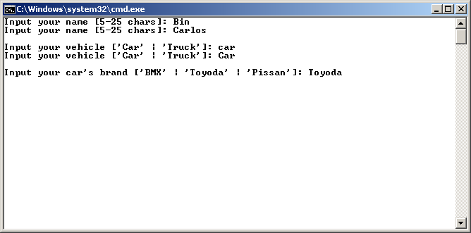



* After that, show the user’s name and menu. The program consists 5 menus:.
  1. **Drive**
  2. **Refill Gas**
  3. **Check Vehicle**
  4. **Change vehicle**
  5. **Exit**
* Ask user to input menu choice between **1** and **5**.
* If the user chooses **Drive** **(Menu 1)**:
* If the vehicle’s **fuel** is **empty**, ask user to refill **fuel**

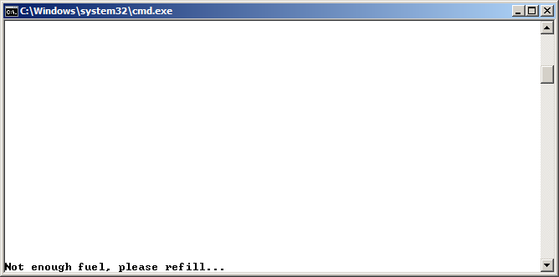

* If the vehicle’s **fuel** is **not** empty, ask user to input **distance**. Validate **distance** must be between **1** and **maximal distance**. The maximal distance formula is**:**

|  |
| --- |
| **Car Max Distance = Fuel * 15**  **Truck Max Distance = Fuel * 10** |

* + If vehicle is **Truck**, ask whether user want to **carry** item or not. Validate input must be **‘Y’** or **‘N’**.
  + If user want to **carry** item, ask user to input item **weight** to be carried. Validate **weight** must be between **1** and **1500**.
  + Calculate vehicle **speed** and **fuel** as the formula below:

|  |
| --- |
| **Car Speed = Random (51 – 100) + Random (0 - brand length)**  **Car fuel = Reduce 1 liter fuel for every 15 km** |

**Truck Speed = Random (36 - 85) + Random (0 - brand length) – (0.02 * weight)**

**Truck Fuel = Reduce 1 liter fuel for every 10 km**

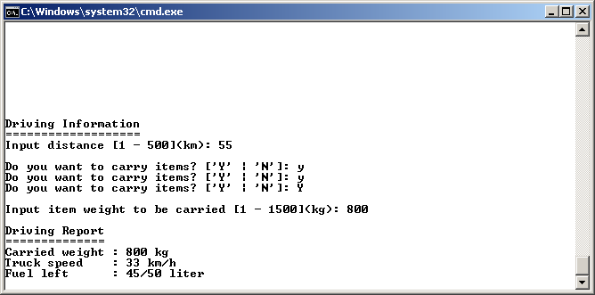

* If user choose **Refill Gas (Menu 2)**, program will refill the **fuel** of the vehicle. **Car’s** **fuel** will be filled to **20** and **Truck** will be filled to **50**. If the fuel is already full, show that gas is already full.
* If user choose **Check Vehicle (Menu 3)**, program will show the **Car Details** (Brand, fuel left/max fuel) or **Truck Details** (Brand, fuel left/max fuel, and carried weight/max weight).

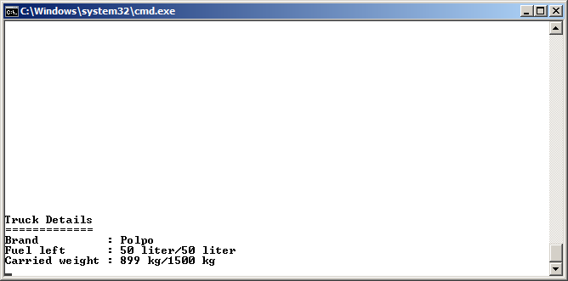

* If user choose **Change vehicle (Menu 4)**, the program will ask user to input **vehicle details** as shown at start of the program.
* If user choose **Exit (Menu 5)**, the program ends.

**Please run the EXE file to see the sample program.**