Ujian Akhir Praktikum - Semester Ganjil 2017/2018
Practicum Final Exam - Odd Semester Year 2017/2018
Matakuliah  Subject |  | COMP6178 – Introduction to Programming |  |  | 
Kelas  Class | : - |  | Tanggal  Date | : -
Dosen  Lecturer | : - |  | Waktu  Time | : -

PERATURAN UJIAN:
Exam Regulations:
- Mahasiswa tidak diperbolehkan membuka BUKU atau catatan apapun
Student is not allowed to open or use any books or notes
- Mahasiswa tidak diperbolehkan menggunakan disket/flash disk/tempat penyimpanan data apapun di dalam ruangan ujian
Student is not allowed to use disc/flash disc/or any other storage devices in exam room
- Mahasiswa tidak diperbolehkan berdiskusi dengan peserta ujian lainnya
Student is not allowed to discuss with other exam participants
- Asisten BERHAK memberi nilai 0 (NOL) bagi peserta ujian yang melakukan segala bentuk kecurangan
Assistant is able to give 0 (ZERO) score for exam participant who does any cheating actions
- Kumpulkan jawaban dan soal tepat pada waktunya
Submit the case and answer on time
- Bila Anda tidak membaca peraturan ini, maka Anda dianggap telah membaca dan menyetujuinya
If you have missed to read these regulations, so you are considered to have read and agreed on it

PERHATIAN!
Attention!
- Kerjakan sesuai dengan soal
Work in accordance with the exam case
- Bagi yang mengerjakan tidak sesuai dengan soal akan diberikan sanksi sebagai berikut:
For those who do not work in accordance with the exam case will be punished as follows:
      - Jika ada penilaian logika, maka penilaian logika adalah NOL (0)
If there is logic marking, it will be marked as ZERO (0)
      - Untuk penilaian yang lain (selain logika) akan dikalikan setengah dari nilai yang diperoleh
Another marking (beside logic) will be multiplied by half the value obtained

Soal
Case

Movie Rental
Movie Rental is a store that rents new Movies. Movie Rental needs an application to manage their products. As a programmer, you are asked to create the application. The application should be created with Java Programming Language based on the following specifications:
      - The application consists of 4 menus:
- Add New Movie
- View Movie (Sort by Title ascending)
- Rent Movie
- Exit
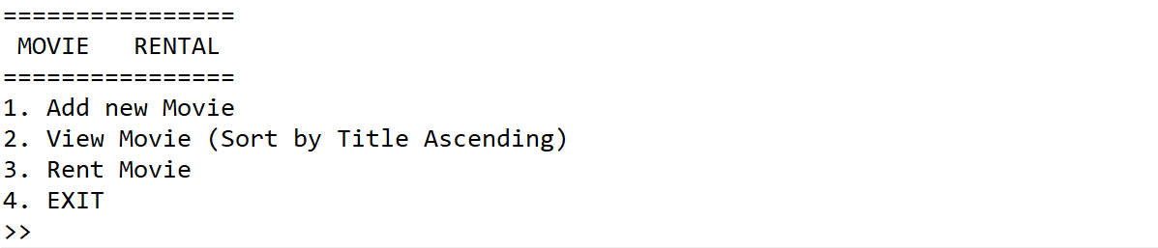
Figure 1. Screen for Main Menu
      - If the user chooses menu 1 (“Add New Movie”), the application will:
  - Ask user to input Movie’s Title. Validate that the Title’s length must be between 3 and 20 characters
  - Ask user to input Movie’s Genre. Validate that the Movie’s genre must be filled with either “Horror” , “Comedy”, or “Action” (case sensitive)
  - Ask user to input Movie Rating. Validate that the Movie’s Rating must be between 1 and 10
  - Generate the Movie’s ID based on the following format
XXYYY
Where
X = Random Character between A and Z
Y = Random Number between 0-9

Correct: AB123, BA223
Wrong: 1BAC2, B2J12

  - Determine the additional Price based on Genre:

Genre | Additional Price
Comedy | 3000
Action | 4000
Horror | 5000

  - The Program will Calculate the Total Price with following formula
Total Price = (Movie’s Title Char Length * 500) + Additional Price

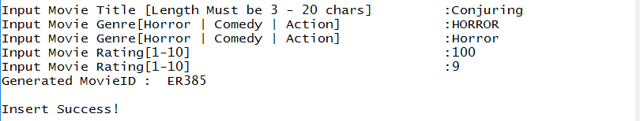
Figure 2. Screen for Input and Validation
      - If the user chooses menu 2 (“View Movie Sort by Title Ascending”):
        - If there is no Movie in the list, show a warning message “No Movie Found”
Figure 3. Screen for Warning Message
        - Otherwise, show all Movies in the list, sorted by title ascending
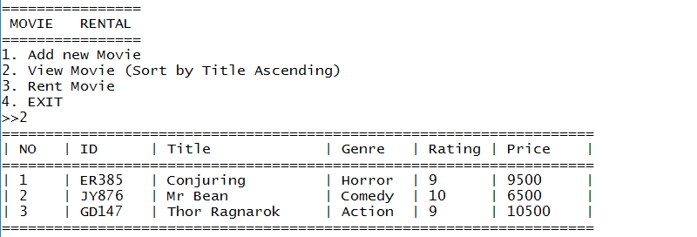
Figure 4. Screen for Movie List Sorted by Title Ascending

      - If the user chooses menu 3 (“Rent Movie”) :
        - If there is no Movie in the list, show a warning message “No Movie Found”
Figure 5. Screen for Warning Message
- Ask user to input Movie’s index to rent. Validate that the index must be between 1 and total of Movie’s and index must be numeric
- Ask user to input Money for paying rent. Validate that the money must be more than equals the Price then show success message “Pay Rent Successful with [change] Change”
- Delete the movie from the list afterwards
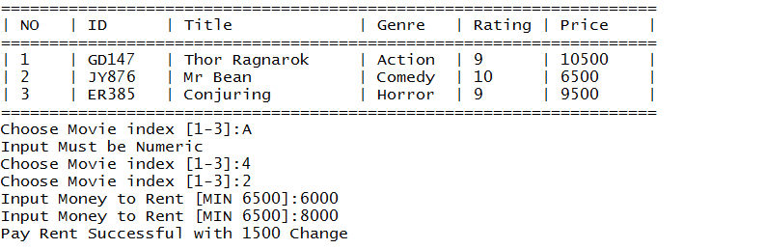
Figure 6. Screen for Menu Rent Movie
      - If user chooses menu 4 (“Exit”), the application will exit
Please run the .EXE file for more details

