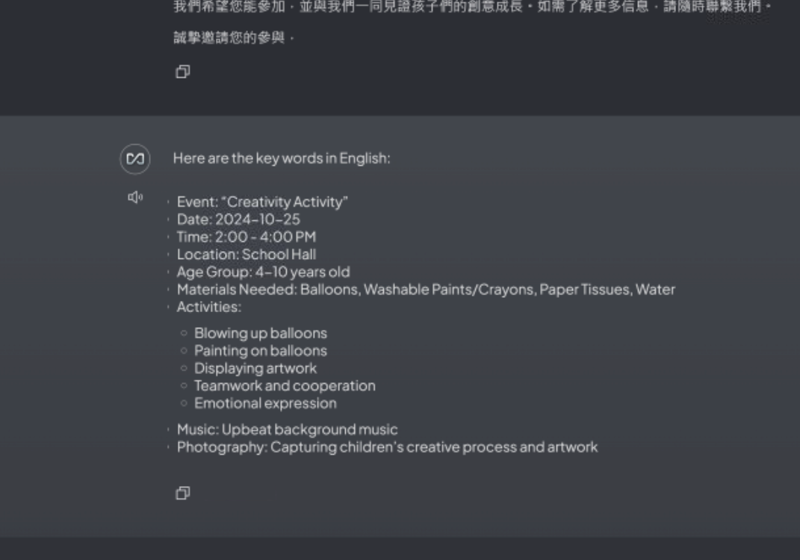

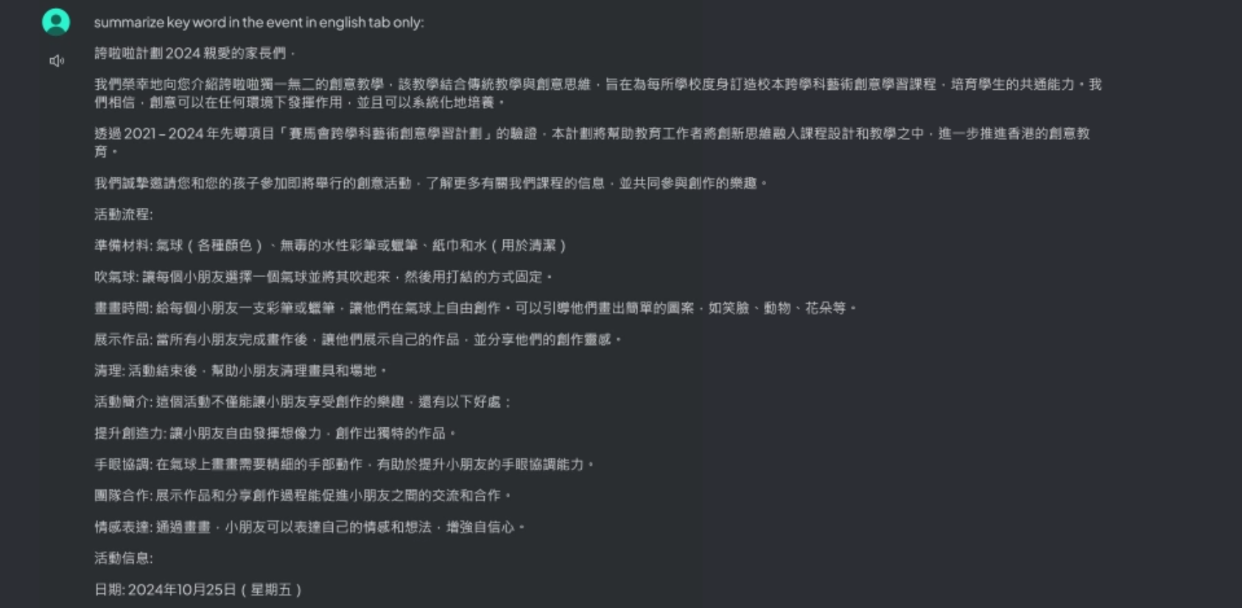

Prompt

summarize key word that the text have what element if there are no information can make extensive guesses . like:activity equipment. activity movements . those the tap often appear in one to two word only. and put at "" all should be english