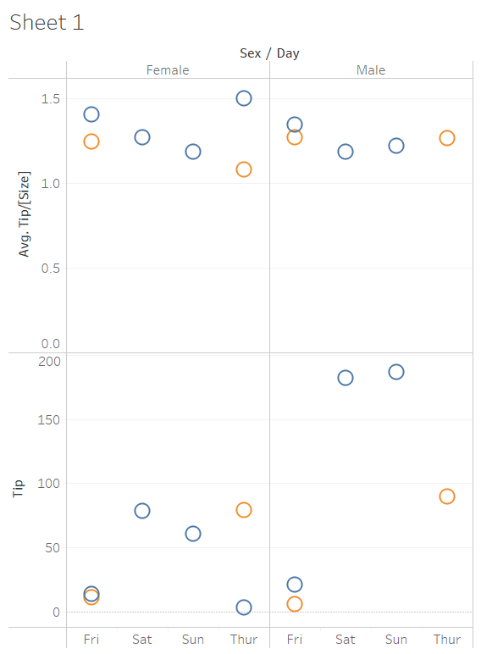

Tip in proportion to party size seems to larger for dinner (blue circles) parties.

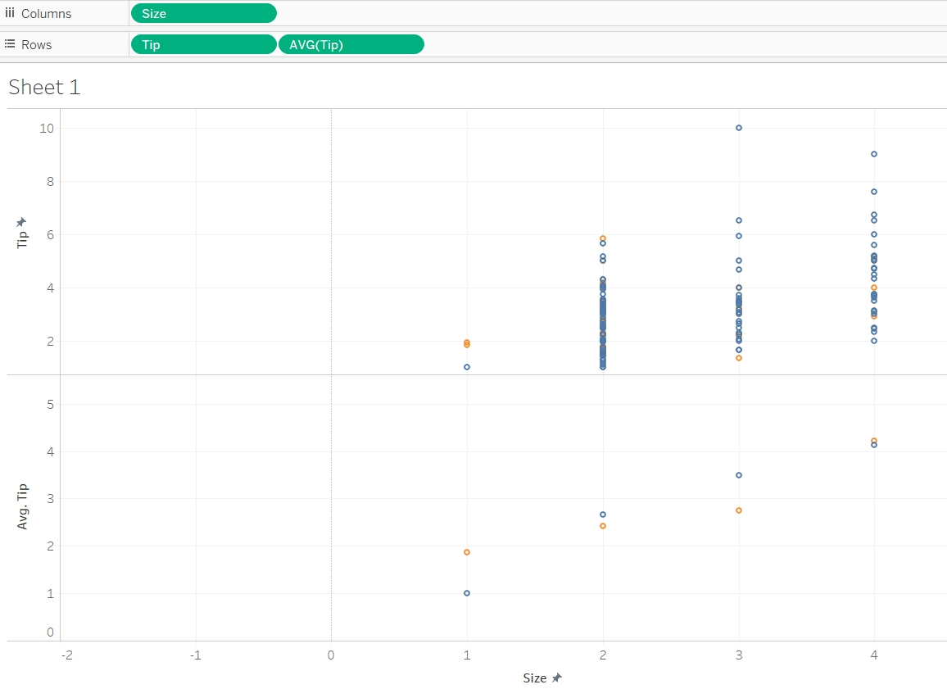

Positive correlation between average tip and party size. 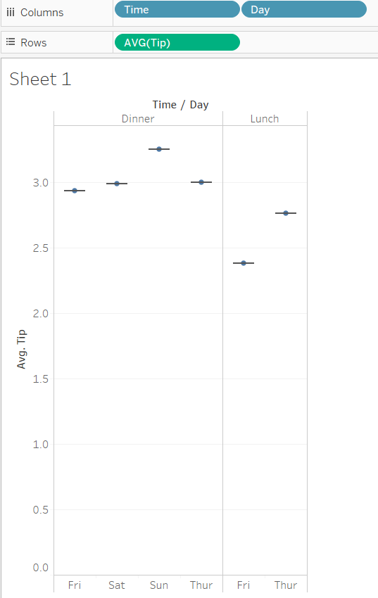

Highest average tip is for Sunday dinner.

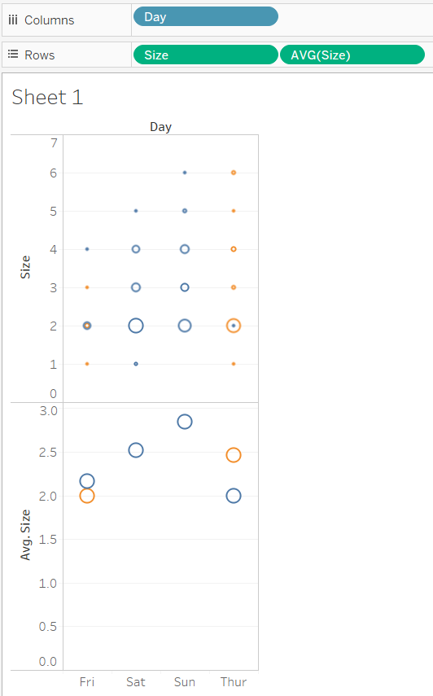

Larger average party size for Saturday and Sunday.