Reproducing Kozich et al 2013

Casey Finnicum

May 10, 2017

## Min. 1st Qu. Median Mean 3rd Qu. Max.   
## 1 4171 6314 7827 10314 30556

This is our effort to reproduce the work of Kozich et al. which is related to (1).

**Scaling up.** The advantage of the dual-index approach is that a large number of samples can be sequenced using a number of primers equal to only twice the square root of the number of samples. To fully evaluate this approach, we resequenced the V4 region of 360 samples that were previously described by sequencing the distal end of the V35 region on the 454 GS-FLX Titanium platform (2). In that study, we observed a clear separation between murine fecal samples obtained from 8 C57BL/6 mice at 0 to 9 (early) and 141 to 150 (late) days after weaning, and there was significantly less variation between the late samples than the early samples. In addition to the mouse fecal samples, we allocated 2 pairs of indices to resequence our mock community. We generated 2.8 million pairs of sequence reads from the 16S rRNA gene with an average coverage of 7,827.1 pairs of reads per sample (95% of the samples had more than 2,113.8 pairs of sequences) using a new collection of 8-nt indices (see the supplemental material). Although individual samples were expected to have various amplification efficiencies, analysis of the number of reads per index did not suggest a systematic positive or negative amplification bias that could be attributed to the indices. The combined error rate for the two mock communities was 0.07% before preclustering and 0.01% after (n = 14,094 sequences). When we used UCHIME to remove chimeras and rarefied to 5,000 sequences, there was a average of 30.4 OTUs (i.e., 10.4 spurious OTUs). Similar to our previous results, ordination of the mouse fecal samples again showed the separation between the early and late periods and increased stabilization with age (Fig. 4) (Mantel test coefficient, 0.81; P < 0.001). These results clearly indicate that our approach can be scaled to multiplex large numbers of samples.

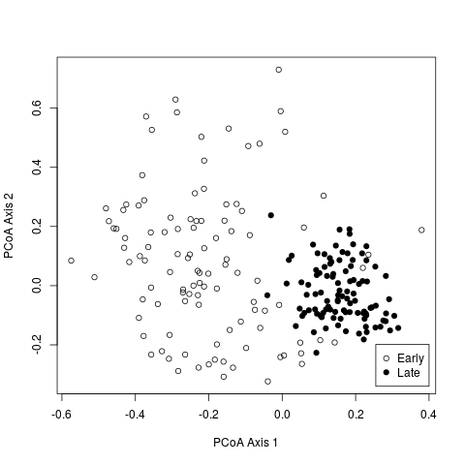

**FIG 4** Principal coordinate ordination of YC values (28) relating the community structures of the fecal microbiota from 12 mice collected on days 0 through 9 (Early) and days 141 through 150 (Late) after weaning.

1. **Schloss PD**, **Schubert AM**, **Zackular JP**, **Iverson KD**, **Young VB**, **Petrosino JF**. 2012. Stabilization of the murine gut microbiome following weaning. Gut Microbes **3**:383–393. doi:[10.4161/gmic.21008](https://doi.org/10.4161/gmic.21008).

2. **Yue JC**, **Clayton MK**. 2005. A similarity measure based on species proportions. Communications in Statistics-Theory and Methods **34**:2123–2131.