**Communications HW 1**

* 1. My IP address is 192.168.43.206
  2. The way I looked up my IP address is by going to cmd.exe, and type in the command ‘ipconfig/all’

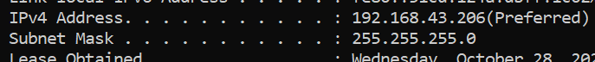

2.1) My MAC address is 40-23-43-83-8F-B3.

2.2) My mac address was achieved the same way as IP address. By asking for it from cmd.exe.

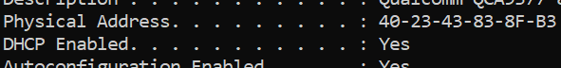

3.1) Using the display filter I asked wireshark to narrow the search down to tcp files only as shown in the picture , which can be found in the file.

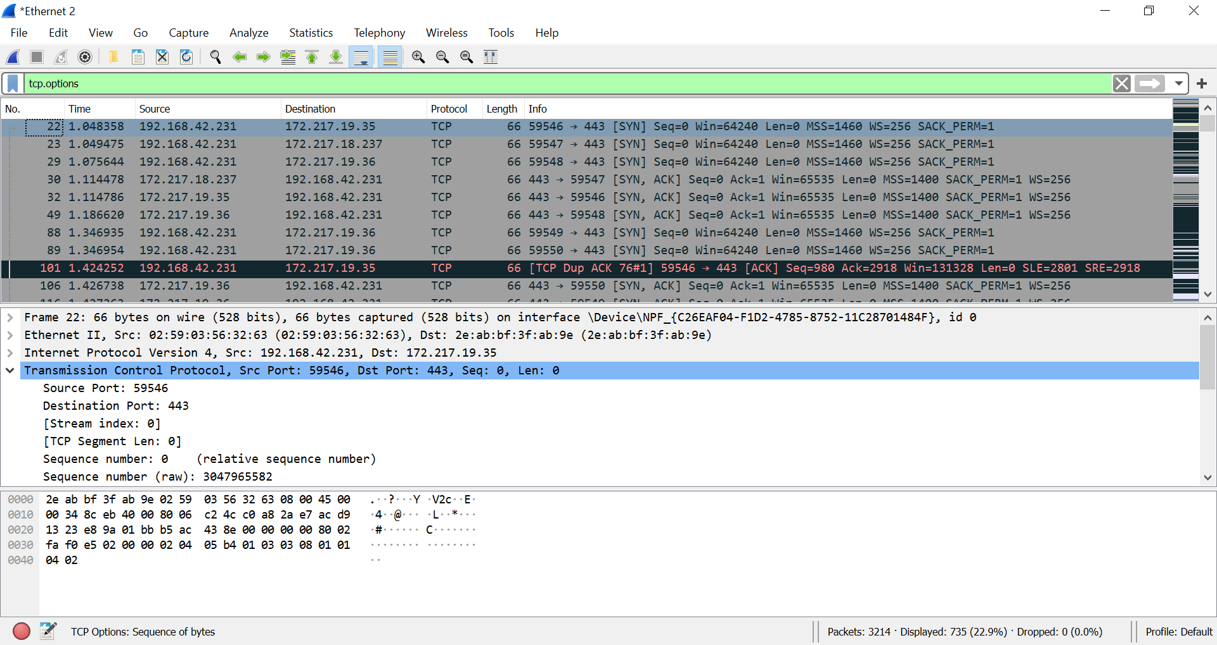

3.1.1) To narrow it down for myself I selected to follow a specific tcp stream by selecting the a tcp packet->follow->tcp stream. This took me to the conversation that was between the two parties(this process can be seen in picture .) The two packets I chose to look at are 600 and 671. Where they have identical source destination and identical ports.

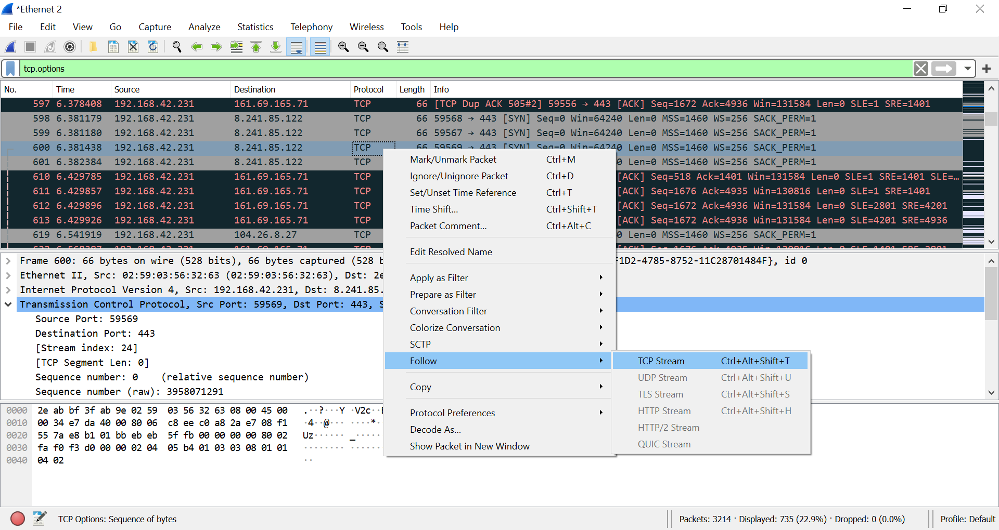

3.1.2) The length of time between these to messages is 0.000158s. The way I did this was by switching the time display format in the view options as can be seen in the photo file . It is interesting to note that between the first message and the second there was a length of time greater by around 4 times the amount it was after it had set up the connection.

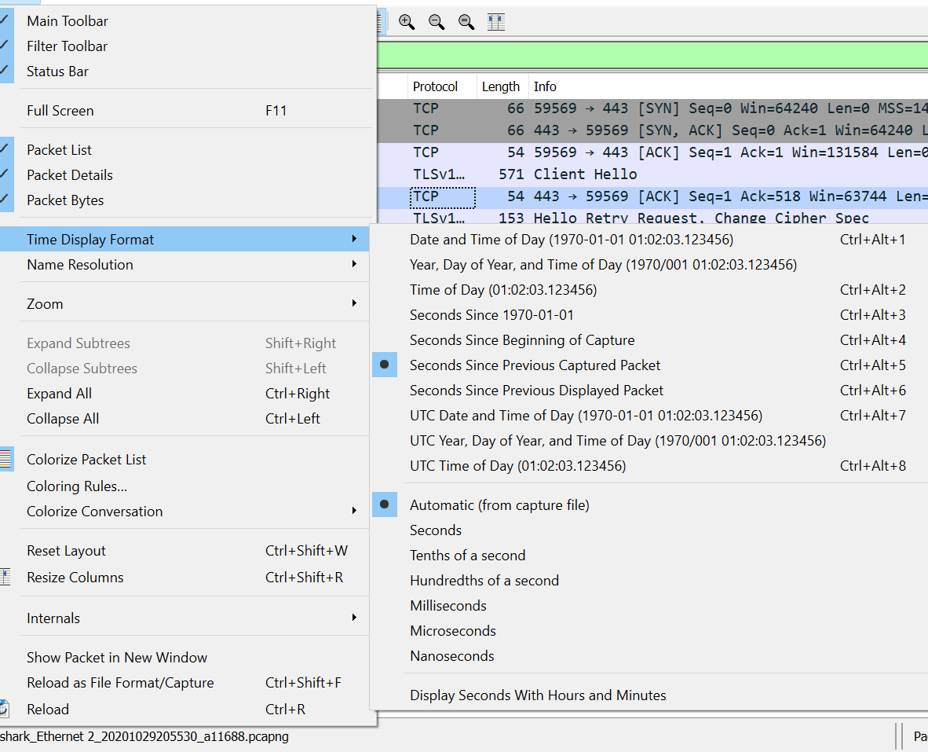

3.1.3)

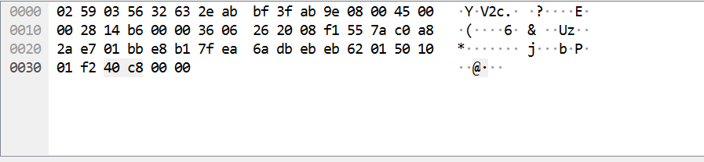

ASCII, The american standard code for information interchange is a numerical way used in the hexidecimal base to mean letters, numbers, symbols, basically everything that you find on the keyboard. The hexadecimal is what you see on the picture on the left. On the right side the the hexadecimal is translated to the human language so it could actually be read. basically the first line will take you to the second layer there you could also see the mac addresses because that is something that should not be there. Wireshark makes this really easy by allowing you to just click on the hexadecimal output and takes you to the relevant information.

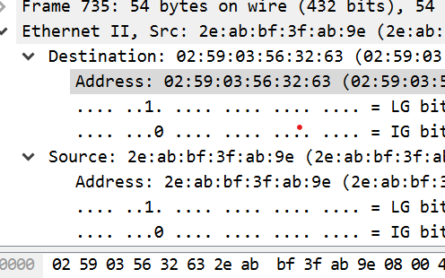

3.2.1) Filter the view based on source address

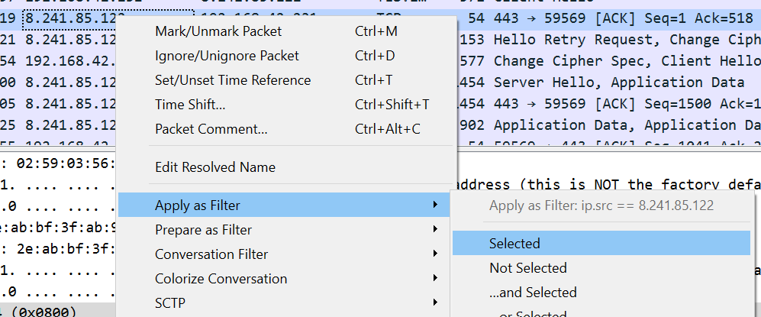

3.2.2) To filter the view for both source and destination do the above first and

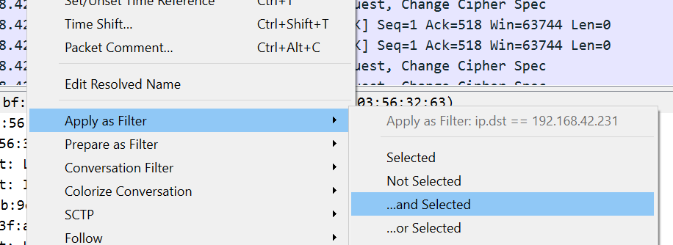

You may also type the following format into the the at the top of the screen.



4.1) A Faraday cage is a form of electric shielding. It looks like a cage from all four directions. The makeup of the cage is conductive. If you try to send communication like a wifi signal or cellular signal to the inside of the cage. The cage is important if you want to keep stuff inside the cage safe from hackers.

4.2) A Hlaf Duplex system can either receive or send but NOT at the same time. As opposed to a Duplex system that can send and receive data at the same time. A good advantage for a half duplex is that it is cheaper to make.

Three examples of half duplex: A Radio , A Television and a person to person radio.

4.3) Morse Code was the developed in the mid 1800s. The electircal telegraph machine made this form of communication. And this was a form of communication used as a common langauge to be able to send massages across oceans quickly and efficiently. Morse Code language is a sereies of dots and dashes (and spaces). Later in this home work assignement you could see a comparison between Ascii and Morse And the number of bits being sent for each letter is not that different. Morse has the ABC’s and the numeric values one through nine. Morse includes spaces between letters and spaces between words. A major advantage that morse provided was a real quick way to communicate information over a line. At this point a Major disadvantage is the amount of time it takes to learn and transmit the code. The code could also be intercepted by ears that you don’t want to share your message with.

4.4) Multiplexing is used for being able to use one connection to make more then one connection. So if You have several phone calls between America to Israel and you want to use one line to get between America to Israel. You would have a multiplexer and demoltiplexer on both sides. And what this does is it mixes up all the connections together and sends it over the line and then the demultiplexer puts it back together and sends it down the correct line.

The main advantage is that you could use one line to send information from different parties all at once. So now we don’t have to make a line for every connection we want to make. If there are only 4 people in the world that we want to connect we would need to make 6 lines. Imagine If we needed to connect a BILLION people!

There are a few disadvantages for using multiplexing. There is an extra delay for the connection. There is also a limit on how many connections you could make at the same time. The system can be overloaded.\

5.) The two main requirements for communication to take place are the ability to make a change in the source that will be detected at the destination. And a coomon language.

**TECHNICAL REASIONS FOR THE FOLLOWING LIMITATIONS:**

**Transmision rate:** The amount of time it takes a certain amount of bits ‘l’ to go from the source onto the line so ‘l/R’ length of message over rate of transmission will be the amount of delay time of the transmission.

**Speed of propagation:** The maximum rate a transmision can travel through spacre is the speed of light. If the transmition goes through copper or glass the rate will get cut in 2/3. The General for the propogation delay is distance divided by velocity.

**Reliabilty of traffic:** A network can get treffic jams, especially in big cities with a lot of information traveling through.

**Information security:** When running on a public network someone can steal your information. Although there are security prtocols, a very smark malicious blocker might still be able to steal your information.

**Minimum RTT time:** Round trip time-the amount of time it takes for signal to go from source to destination and back to source. T = (W / RTT).

**Malicious blockers**: Might steal your information with malicious code running on a website or use your connction to send you bugs.

6.) **THE ELECTRICAL TELEGRAPH:**The first electrical telegraph was built in the year 1837.Two inventions made the electrical telegraph possible. The battery and the connection between electricity and magnatism by deflecting a magnetic needle with an electiric current. The electical telegraph made it possible to get a message across countries, even across oceans in a matter of seconds. During war time it was used majorly by the different armies. And pretty quickly it became a widely used device.

The way the electrical telegraph worked was simply a person on one end pressed a “button,” which completed an electircal current so that on the receiving end a noise was made and the sender would send a sequnece of pulses so the reciever received a sequence of noises that was agreed upon as the language spoken over this telegraph machine so that the sender and reciever can communicate.

The electrical telegraph was really the beginning of what we have today. Lines were placed in the water between Europe and America already in 1865 making it possible to communicate between two continets in a few seconds!!

To build an electrical telegraph is quite simple. Simply take a magnetic coil and wrap it around a screw. Take a battery and connect a conducter to both sides and connect the coil to one side and the other side connect to your clicker to make it easy to connect the current. The other side of the coil connect under the clicker and take a piece of metal and place it near the screw hit the clicker and if your battery has a charge your screw will hit the metal and make a sound. Now you have an electrical telegraph machine.

Later many variations were made of this machine. Sometimes using radio frequency to send out pulses. I want to say that the internet is a later variation of this also. With the same one and the same zero going across a line. Though with much more sophisticated machines and algorithms.

7.) The answer is handwritten in a pdf file labeled question_7.

8.) **Network:** a communication service between a group of machines is a network. In this network you might have different machines talking that generally don’t necsasarily speak the same langauge. The network must create a common language for the machines it services.

There are many different types of networks and different types of services the networks provide.

**PAN** (personal area network,) for the meter range. This network is used very commonly. It is the connection you have between you computer and moniter, computer and keyboard, mouse and anything that might transfer information from one item to another. Bluetooth was also introduce for PAN.

**LAN** (local area network,) meter range could be anywhere between 10 and 1000 meters. Anywhere from a room to a whole campus. It is privately owned. And it connects the devices its network. It could be wired and wireless. You could have a wireless router (802.11) or wires connecting the devices through an access point connecting computers printers or any device that a home office building or a school campus might need. The cost fro setting up a LAN would obviously depend on the size, speeds and what the set up requires. The price could range any from fifty dollars to many thousands of dollars.

**MAN** (metroplitan area network,) is used to transfer information in a whole city. The typical span is 10,000 meters. The cables are typically owned by private companies that won a government contract to build the network. Orginally used for telvision cables all the way to the late 1990’s when the Internet became popular and the companies realized they could use unused space on the wires to connect homes to the Internet by making a few tweeks. The price for accessign a MAN varies greatly on the speeds you are asking for. The price from the under one hundred dollars to almost a thousand dollars a month.

**WAN** (wide area network) is used to transfer information in a country or even a whole continent. The range could varry from one hundred killometers to one thousand killometeres. You might have a company in that has offices in different cities that need to transfer information from one to another. Often compnaies will lease space on lines from communication compnaies because to put in their own lines in would be quite costly. In a WAN you could also have a virtual private network. For example if you in an office in Florida and you need to be talking from an office that is in New York you could use their network as if you’re there. Prices could vary greatly for this type of network.

**Internet** provides the world with a way to connect. Many undemocratic countires don’t necessarily give a full access to the internet that people deserve. Over four and a half billion people have access to the Internet. Access to the Internet could vary in cost based on speeds and location. Over the Internet you could also have malicious activity of trying to steal money from people or sendin bugs over to an unsuspecting user.

There are many types of networks that interconnect and often rely on eachother to get acroos. Internetworks is a fascinating thing which provides people with an enourmous amount of communication and advancement never known before. It provides people with a data base that just keeps growing. Internetwroks is a new feature known to us. And it is most certainly going to advance in the future.

9.) **Unicast -** sending information from one specific source to one specific destination. the most obvious examples is a phone call and a text message. A little less obvious maybe to some people is going on a website. You send the website a request an it returns. Not much different then a phone call.

**Broadcast** – sending information from a device to any device on the network. The most classic example I could think of is a television broadcast. A television will broadcast on a specific channel and the customer in return could switch his TV to recive this channel by simply connecting to the channel.

**Multicast** – can be information from one device to many or from many devices to many. The Torrent files downloader uses a multicast system. Where one or many users can have a video file on their computer and people can receive this video by requesting segments of it from many different users. I would like to point out that on a public multicast system your computer would be susepetible to get a virus because anyone with malicious intent could insert a virus into the file they are suppliying you with. If multicasting ever became big I would assume that firewalls would be imlemented to avoid that. Or atleast a system to know if your sources are reliable.

10.) Packet switching is a method of connectivity that does not reserve resouces and each packet sent will find it’s quickest way to the destination individualy. Circuit switching will started with a pakcet switch and reserve a line between the two sources so as to make the connection quicker and without interference. A major advantage of packet switching is that its much more efficient and it does not reserve spots in a line that would cause more ocongestion. With a connction oreinted packet switch the data transfer is more reliable as a lost packet will just get resent. So you could get a whole fiel without having distruptions and errors at the end. This method could be used but is not limited to send files, videos and voice messages.

On the other hand we have circuit switching. This is when real time data is improtant for you as in a phone call. Lost bits and pieces of the phone call will not be resent or anything like that as that would disrupt the call even more. In a phone call you want to be able to have a conversation with as little disrupstions as possible. The method of circuit switching is to reserve a channel between the parties asking for the channel, so that after the first packet the rest of the packets don’t need to search for the destination therby going straight there and getting there in super quick times. A disadvantage of circuit switching it consumes a lot more space on the line there by slowing everything else down. If you have to many phone calls on a given line it will get congested and phone calls would get messed up at that time.

Packet switching and circuit switching is not to pe confused with connection oriented and conectioneless. Both packet and circuit switching could use connection and connectionless. Conection is when you want to make sure that you reciever got the packeage in full and to make a handshake to make sure that you got to the right place. Connectionless could also be used for both. That would be when you aren’t as concerned as to whether the information got to the destionation or not.

11.)

|  |  |  |  |
| --- | --- | --- | --- |
| frequency | | Period τ | Wavelength λ |
| Hz | 2.0 | 1/2 | 1.5* |
| KHz | 2.0 | 1/2000 | 1.5* |
| MHz | 2.0 |  | 1.5* |
| GHz | 2.0 | 1/2,000,000,000 | 1.5* |
| THz | 2.0 |  | 1.5* |

12.) **ITU:** The International Telecomunicaton Union – is one of the oldest international organizations. A United Nations oraganization which is incharge of all matters and communication and information techonlogy. It is a recommended oraganization; which means all companies must follow. It is the top of the communication chain.

**IEEE:** The Institute of Electrical and Electrenics Engineers – is in charge of layer two in the iso model of communication in most of communication. The standard is knows as the 802 standard. They are also in charge of assigning MAC addresses to every device.

**ANSI:** The American National Standard institute – is the organization incharge of all products and services in the United States. It is not only for communication but all products. They decide what standards your product has to meet to be able to sell it. They might have rules about how fire resistant it has to be or any rule they could come up with.

**ETSI:** The Europeon Telecomunications standard Institute – much like the ANSI is a non-forprofit organization that is geared for communication. If someone in Europe wants to get approved they must send their request to ETSI and meet their standards to get approved. One thing that makes it easier for ETSI applicants is that they list their requirements and they are very specific.

**ISO:** The International Standards Oraganization – in 1947 a number of countries got together to create ISO so that there’s a somwhat universal standard. The reason I say somwhat is because they don’t have one standard for everything. Each country wants to have their standards so as to increase commerce for their country. So we end up with a few standards for every item. For example an electrical plug is quite different from Israel to Europe and even more different from Europe to America. And so is the standard voltage and the list goes on. **IETF:** The Internet Engineering Task Force – is a request for comment organization. Its an organization open to the community, Meaning it’s open to the public to suggest standards. If someone posts a standard for the IETF and it lasts, eventually it will become a standard. Their main goal is to make the Internet work better. And that by letting everyone post their suggested standards without the standard having to go through a beurocratic process. Rather it gets judged by the public. **EIA:** Energy Information Administration – main goal is to collect data and make an analysis and provide information. **IANA:** The Internet Assigned Numbers Authority – is incharge of giving out all ip addresses and names. Someone needs to be incharge so that we don’t start getting duplicates and to keep the order in communication we need to have an organization that keeps that order, and that’s what IANA does.