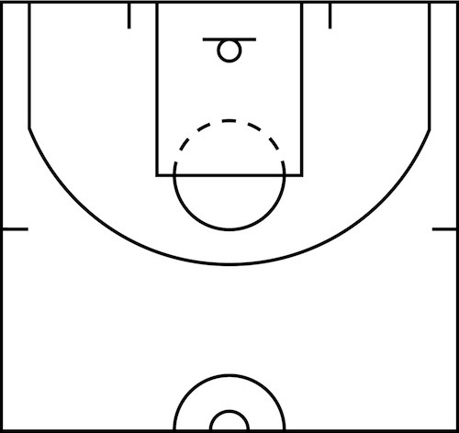

|  |  |  |  |  |  |  |  |  |  |  |
| --- | --- | --- | --- | --- | --- | --- | --- | --- | --- | --- |
| **Screens** |  | | | | | | **Contested** | Low | Med | High |
| **Passes** |  | | | | | | **Game Clock** |  | | |
| **Type** | HQ | | FB | | oreb | | **Quarter** |  | | |
| **Result** | make | miss | | foul | | oreb | **Shot Clock** |  | | |



|  |  |  |  |  |  |  |  |  |  |  |
| --- | --- | --- | --- | --- | --- | --- | --- | --- | --- | --- |
| **Screens** |  | | | | | | **Contested** | Low | Med | High |
| **Passes** |  | | | | | | **Game Clock** |  | | |
| **Type** | HQ | | FB | | oreb | | **Quarter** |  | | |
| **Result** | make | miss | | foul | | oreb | **Shot Clock** |  | | |



|  |  |  |  |  |  |  |  |  |  |  |
| --- | --- | --- | --- | --- | --- | --- | --- | --- | --- | --- |
| **Screens** |  | | | | | | **Contested** | Low | Med | High |
| **Passes** |  | | | | | | **Game Clock** |  | | |
| **Type** | HQ | | FB | | oreb | | **Quarter** |  | | |
| **Result** | make | miss | | foul | | oreb | **Shot Clock** |  | | |



|  |  |  |  |  |  |  |  |  |  |  |
| --- | --- | --- | --- | --- | --- | --- | --- | --- | --- | --- |
| **Screens** |  | | | | | | **Contested** | Low | Med | High |
| **Passes** |  | | | | | | **Game Clock** |  | | |
| **Type** | HQ | | FB | | oreb | | **Quarter** |  | | |
| **Result** | make | miss | | foul | | oreb | **Shot Clock** |  | | |



|  |  |  |  |  |  |  |  |  |  |  |
| --- | --- | --- | --- | --- | --- | --- | --- | --- | --- | --- |
| **Screens** |  | | | | | | **Contested** | Low | Med | High |
| **Passes** |  | | | | | | **Game Clock** |  | | |
| **Type** | HQ | | FB | | oreb | | **Quarter** |  | | |
| **Result** | make | miss | | foul | | oreb | **Shot Clock** |  | | |