**View 1 – Jobs suitable for a specific applicant.**

/* Applicants should be able to find suitable employment efficiently. Thus, this view allows applicants to search for opportunities in their preferred sector that fit their salary and time requirements */

CREATE VIEW jobs_in_trades AS

SELECT

    job.job_id,

    job.job_title,

    sector.sector_title,

    employer.company_name,

    employer.email_address,

    job.hourly_salary,

    job.on_site,

    job.city,

    job.country,

    job.date_posted,

    job.application_deadline

FROM job

INNER JOIN employer ON employer.employer_id = job.employer_id

INNER JOIN sector ON sector.sector_id = job.sector_id

#Hard-coded values refer to customer with ID 61, would be changed in real-time depending on who was logged in and viewing jobs

WHERE job.hourly_salary >= '12' AND job.full_time = 1 AND job.sector_id = '4' AND application_deadline < CURRENT_DATE() + 1

ORDER BY job.job_id;

**View 2 – Job opportunities closing within the next week.**

/* Job seekers may need to find a job within a specific timeframe or with some urgency. Viewing jobs with soon approaching deadlines can result in quicker response times, aiding in efficient job searching by prioritising applications that will be more quickly processed */

CREATE VIEW jobs_closing_this_week AS

SELECT

    job.job_id,

    job.job_title,

    sector.sector_title,

    employer.company_name,

    employer.email_address,

    job.hourly_salary,

    job.on_site, job.city,

    job.country,

    job.date_posted,

    job.application_deadline

FROM job

INNER JOIN employer ON employer.employer_id = job.employer_id

INNER JOIN sector ON sector.sector_id = job.sector_id

WHERE job.application_deadline BETWEEN CURRENT_DATE() AND CURRENT_DATE() + 7

ORDER BY job.job_id;



**View 3 – All applications for a specific job.**

/* Employers should be able to hire the most qualified candidate for a role. Thus, this view displays all applicants for a vacant position and their qualifications to allow an employer to select the most desired candidate */

CREATE VIEW job_applications AS

SELECT

    job_seeker.job_seeker_id,

    job_seeker.first_name,

    job_seeker.last_name,

    job_seeker.email_address, job_seeker.phone_num,

    #Group all qualifications into a single field for aesthetic purposes

    GROUP_CONCAT(certificate.qualification_title) AS certificates_in,

    application.date_submitted,

    application_status.status

FROM application

INNER JOIN job_seeker ON job_seeker.job_seeker_id = application.job_seeker_id

LEFT JOIN application_status ON application_status.application_status_id = application.application_status_id

LEFT JOIN certificate ON certificate.job_seeker_id = application.job_seeker_id

#56 is an example id for a job, would change depending on which job is viewed

WHERE application.job_id = '56'

GROUP BY job_seeker.job_seeker_id

ORDER BY job_seeker.job_seeker_id;

**View 4 – Insights about wages and job demand within a specific sector.**

/* This view summarises how well paid and in demand jobs in each sector are, which can influence and speed up job searching. For employers, this can be used to determine how much competition is present and in which sectors advertising should be prioritised */

CREATE VIEW sector_statistics AS

SELECT

    sector.sector_title,

    ROUND(AVG(job.hourly_salary), 2) AS average_salary,

    COUNT(application.job_id) AS applications_made,

    COUNT(*) AS number_of_jobs,

    #IF statement ensures dividing by 0 is avoided

    IF(

        COUNT(*)=0, 0, ROUND(COUNT(application.job_id)/COUNT(job.sector_id), 2)

    ) AS applications_per_job

FROM job

INNER JOIN sector ON sector.sector_id = job.sector_id

LEFT JOIN application ON application.job_id = job.job_id

GROUP BY sector.sector_title

ORDER BY average_salary DESC;

**Python – Connecting to View 2**

Connection and authentication

Retrieving records and formatting them nicely

Output

**Python – Inserting a new job record**

Connection and authentication

Data entry and validation

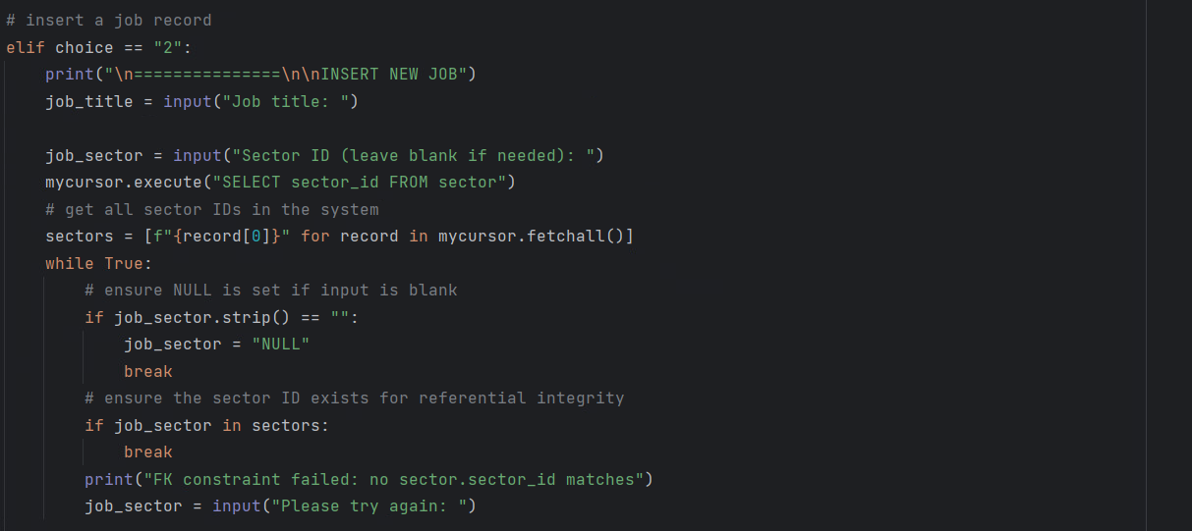

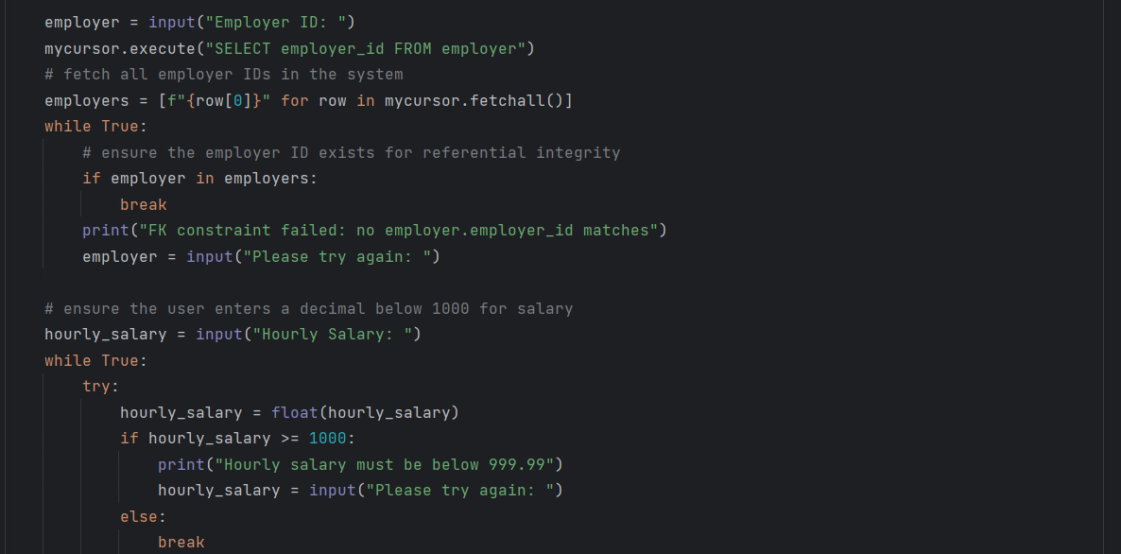



Formatting data and inserting into the job table



Job table before insertion

Input

Output



Job table after insertion

