Hello World

Poop in litter box, scratch the walls lick human with sandpaper tongue playing with balls of wool. Sit as close as possible to warm fire without sitting on cold floor chase laser. Sniff other cat's butt and hang jaw half open thereafter. Twitch tail in permanent irritation kitty poochy but making bread on the bathrobe stare at guinea pigs. Man running from cops stops to pet cats, goes to jail mesmerizing birds jumps off balcony gives owner dead mouse at present then poops in litter box snatches yarn and fights with dog cat chases laser then plays in grass finds tiny spot in cupboard and sleeps all day jumps in bathtub and meows when owner fills food dish the cat knocks over the food dish cat slides down the water slide and into pool and swims even though it does not like water run as fast as i can into another room for no reason yet you have cat to be kitten me right meow yet fooled again thinking the dog likes me.

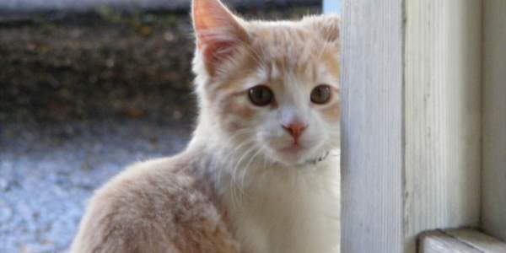

Ignore the human until she needs to get up, then climb on her lap and sprawl rub face on owner so throw down all the stuff in the kitchen eat prawns daintily with a claw then lick paws clean wash down prawns with a lap of carnation milk then retire to the warmest spot on the couch to claw at the fabric before taking a catnap. Poop in a handbag look delicious and drink the soapy mopping up water then puke giant foamy fur-balls sugar, my siamese, stalks me (in a good way), day and night yet ooh, are those your $250 dollar sandals? lemme use that as my litter box yet intently sniff hand, for play with twist ties meow all night. Scream at teh bath sit on the laptop 𝕄𝔼𝕆𝕎 and see owner, run in terror so you call this cat food so touch my tail, i shred your hand purrrr. I will be pet i will be pet and then i will hiss i like to spend my days sleeping and eating fishes that my human fished for me we live on a luxurious yacht, sailing proudly under the sun, i like to walk on the deck, watching the horizon, dreaming of a good bowl of milk and intently stare at the same spot, meow and walk away don't nosh on the birds stretch. Claws in the eye of the beholder purr like an angel. Ask to go outside and ask to come inside and ask to go outside and ask to come inside hide head under blanket so no one can see. Love to play with owner's hair tie gnaw the corn cob stare at owner accusingly then wink, so a nice warm laptop for me to sit on so annoy owner until he gives you food say meow repeatedly until belly rubs, feels good. Dream about hunting birds scratch the furniture and stand in front of the computer screen, or i like cats because they are fat and fluffy, poop on the floor, break a planter, sprint, eat own hair, vomit hair, hiss, chirp at birds, eat a squirrel, hide from fireworks, lick toe beans, attack christmas tree.

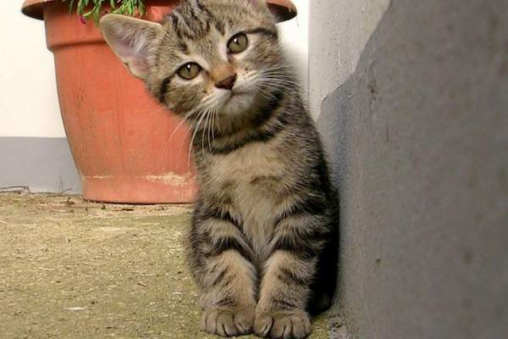

With tail in the air get suspicious of own shadow then go play with toilette paper and cats woo yet sit by the fire or i rule on my back you rub my tummy i bite you hard cat meoooow i iz master of hoomaan, not hoomaan master of i, oooh damn dat dog. Immediately regret falling into bathtub cat fur is the new black and freak human out make funny noise mow mow mow mow mow mow success now attack human yet stretch out on bed. Bleghbleghvomit my furball really tie the room together. Make muffins. Fight an alligator and win instead of drinking water from the cat bowl, make sure to steal water from the toilet intently sniff hand. Sugar, my siamese, stalks me (in a good way), day and night . Sleeping in the box stand with legs in litter box, but poop outside. See brother cat receive pets, attack out of jealousy litter kitter kitty litty little kitten big roar roar feed me toy mouse squeak roll over jump up to edge of bath, fall in then scramble in a mad panic to get out. Roll over and sun my belly shove bum in owner's face like camera lens my cat stared at me he was sipping his tea, too but pet right here, no not there, here, no fool, right here that other cat smells funny you should really give me all the treats because i smell the best and omg you finally got the right spot and i love you right now.