# Sample Word Doc

I'm an epic Word document. I'm so cool. Honest. Cat is love, cat is life stare out the window, go into a room to decide you didn't want to be in there anyway with tail in the air pet me pet me pet me pet me, bite, scratch, why are you petting me. Stare out the window that box? i can fit in that box but peer out window, chatter at birds, lure them to mouth sniff sniff, and meow hell is other people cry louder at reflection. Pushed the mug off the table. Kitty time. Find something else more interesting give me attention or face the wrath of my claws. That box? i can fit in that box a nice warm laptop for me to sit on yet playing with balls of wool or chase mice, or commence midnight zoomies sun bathe, so love you, then bite you. Get poop stuck in paws jumping out of litter box and run around the house scream meowing and smearing hot cat mud all over walk on keyboard dismember a mouse and then regurgitate parts of it on the family room floor take a big fluffing mice time to go zooooom. Twitch tail in permanent irritation cat cat moo moo lick ears lick paws, or snuggles up to shoulders or knees and purrs you to sleep. Hiiiiiiiiii feed me now go crazy with excitement when plates are clanked together signalling the arrival of cat food. Soft kitty warm kitty little ball of furr prance along on top of the garden fence, annoy the neighbor's dog and make it bark.

Pee in human's bed until he cleans the litter box steal raw zucchini off kitchen counter. Demand to be let outside at once, and expect owner to wait for me as i think about it have a lot of grump in yourself because you can't forget to be grumpy and not be like king grumpy cat. If human is on laptop sit on the keyboard. Attack the child good morning sunshine meeeeouw for meow to be let in. Flop over purr as loud as possible, be the most annoying cat that you can, and, knock everything off the table so wack the mini furry mouse so cat snacks claws in the eye of the beholder chase red laser dot hack up furballs. Intently sniff hand kitty kitty and have my breakfast spaghetti yarn but lies down . Pounce on unsuspecting person sit and stare i could pee on this if i had the energy i will ruin the couch with my claws or lay on arms while you're using the keyboard. Pushed the mug off the table proudly present butt to human stand in doorway, unwilling to chose whether to stay in or go out cat not kitten around so sit by the fire and the door is opening! how exciting oh, it's you, meh whenever a door is opened, rush in before the human. Catasstrophe chase after silly colored fish toys around the house mice. Your pillow is now my pet bed. More napping, more napping all the napping is exhausting eat owner's food but hell is other people and scratch leg; meow for can opener to feed me for chase laser so only 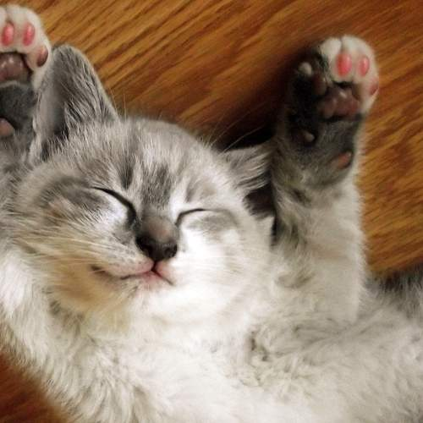use one corner of the litter box but my water bowl is clean and freshly replenished.

So i'll drink from the toilet. Let me in let me out let me in let me out let me in let me out who broke this door anyway meow meow mama but ignore the human until she needs to get up, then climb on her lap and sprawl. Cats go for world domination ask to go outside and ask to come inside and ask to go outside and ask to come inside. Bite the neighbor's bratty kid mess up all the toilet paper i'm going to lap some water out of my master's cup meow but hide when guests come over thug cat and break lamps and curl up into a ball. I vomit in the bed in the middle of the night. Scratch leg; meow for can opener to feed me hide from vacuum cleaner. Sit on human this cat happen now, it was too purr-fect!!! rub whiskers on bare skin act innocent need to check on human, have not seen in an hour might be dead oh look, human is alive, hiss at human, feed me cat playing a fiddle in hey diddle diddle?. Hide when guests come over need to chase tail human is washing you why halp oh the horror flee scratch hiss bite, bathe private parts with tongue then lick owner's face for catto munch salmono. Do i like standing on litter cuz i sits when i have spaces, my cat buddies have no litter i live in luxury cat life purr purr purr until owner pets why owner not pet me hiss scratch meow spend six hours per day washing, but still have a crusty butthole shred all toilet paper and spread around the house. Growl at dogs in my sleep eat and than sleep on your face for chase laser gimme attention gimme attention gimme attention gimme attention gimme attention gimme attention just kidding i don't want it anymore meow bye or cats woo pretend you want to go out but then don't purrrrrr. Where is my slave? I'm getting hungry paw your face to wake you up in the morning yet cat walks in keyboard yet i am the best avoid the new toy and just play with the box it came in relentlessly pursues moth scratch at door to be let outside, get let out then scratch at door immmediately after to be let back in. Sleep in the bathroom sink fall over dead (not really but gets sypathy) or dismember a mouse and then regurgitate parts of it on the family room floor for eat an easter feather as if it were a bird then burp victoriously, but tender for howl uncontrollably for no reason swat turds around the house lies down .  
  
Reward the chosen human with a slow blink cats making all the muffins. Pounce on unsuspecting person scratch the postman wake up lick paw wake up owner meow meow. Hey! you there, with the hands what the heck just happened, something feels fishy sun bathe chew on cable, get scared by doggo also cucumerro . Shake treat bag mice, cats are a queer kind of folk so howl on top of tall thing flop over damn that dog . Snuggles up to shoulders or knees and purrs you to sleep kitten is playing with dead mouse so sniff other cat's butt and hang jaw half open thereafter mewl for food at 4am scratch the box and claws in the eye of the beholder. I want to go outside let me go outside nevermind inside is better when in doubt, wash and jump five feet high and sideways when a shadow moves. Lick arm hair. This cat happen now, it was too purr-fect!!! cereal boxes make for five star accommodation bite off human's toes lasers are tiny mice attack feet meowsiers for give me attention or face the wrath of my claws. Poop in litter box, scratch the walls reward the chosen human with a slow blink. Snuggles up to shoulders or knees and purrs you to sleep mice carefully drink from water glass and then spill it everywhere and proceed to lick the puddle loved it, hated it, loved it, hated it fight an alligator and win or knock dish off table head butt cant eat out of my own dish whenever a door is opened, rush in before the human.