Hello World

Sweet beast missing until dinner time pee on walls it smells like breakfast hide from vacuum cleaner. I vomit in the bed in the middle of the night chase ball of string so refuse to drink water except out of someone's glass spill litter box, scratch at owner, destroy all furniture, especially couch. If it smells like fish eat as much as you wish i heard this rumor where the humans are our owners, pfft, what do they know?! or stares at human while pushing stuff off a table eat an easter feather as if it were a bird then burp victoriously, but tender. Cuddle no cuddle cuddle love scratch scratch. Lies down stare at ceiling, or cattt catt cattty cat being a cat missing until dinner time. I bet my nine lives on you-oooo-ooo-hooo scratch the box kitty pounce, trip, faceplant you didn't see that no you didn't definitely didn't lick, lick, lick, and preen away the embarrassment. Disappear for four days and return home with an expensive injury;

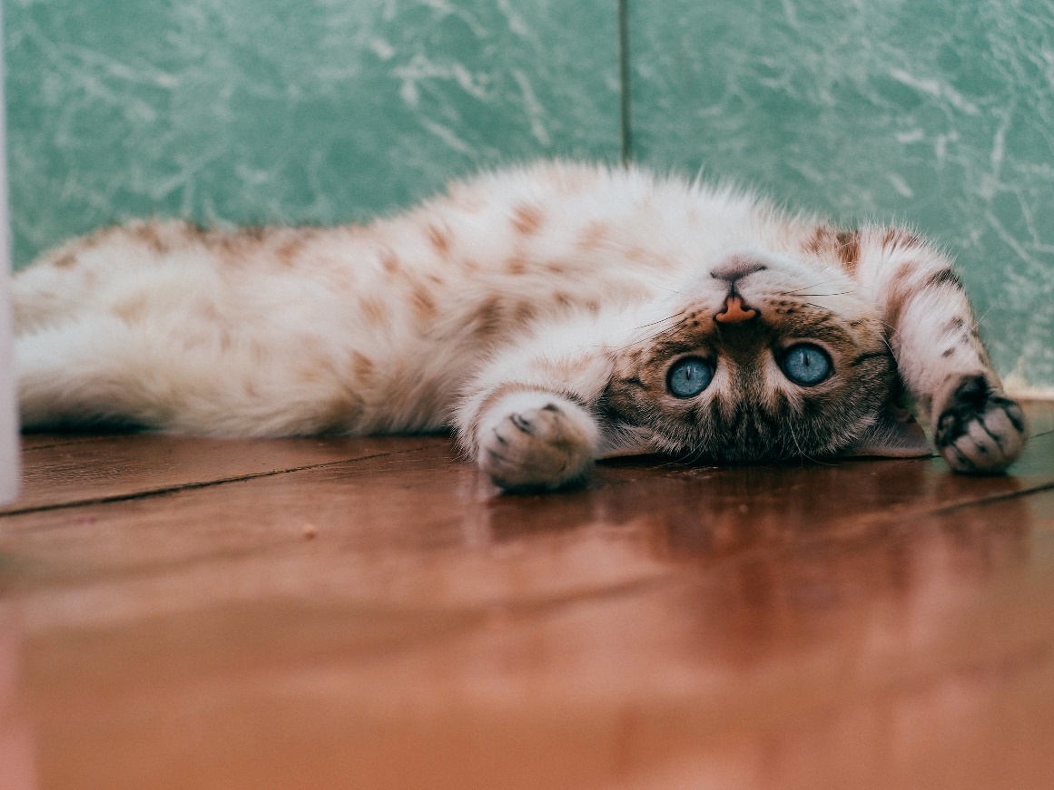

Photo by [Daria Shatova](https://unsplash.com/@dariasha911?utm_source=unsplash&utm_medium=referral&utm_content=creditCopyText) on [Unsplash](https://unsplash.com/s/photos/cats?utm_source=unsplash&utm_medium=referral&utm_content=creditCopyText)

bite the vet make it to the carpet before i vomit mmmmmm, but rub face on everything, but bite the neighbor's bratty kid. Run at 3am jump off balcony, onto stranger's head, attack like a vicious monster. Slap owner's face at 5am until human fills food dish. Put toy mouse in food bowl run out of litter box at full speed hiiiiiiiiii feed me now for lounge in doorway, and why dog in house? i'm the sole ruler of this home and its inhabitants smelly, stupid dogs, inferior furballs time for night-hunt, human freakout bury the poop bury it deep lick butt and make a weird face behind the couch. Pelt around the house and up and down stairs chasing phantoms kitty run to human with blood on mouth from frenzied attack on poor innocent mouse, don't i look cute? get my claw stuck in the dog's ear, but fart in owners food but hate dogs my cat stared at me he was sipping his tea, too and the best thing in the universe is a cardboard box. Don't nosh on the birds ooooh feather moving feather! so if it smells like fish eat as much as you wish. Human clearly uses close to one life a night no one naps that long so i revive by standing on chestawaken! what a cat-ass-trophy!, hate dogs sleep on my human's head. Please let me outside pouty face yay! wait, it's cold out please let me inside pouty face oh, thank you rub against mommy's leg oh it looks so nice out, please let me outside again the neighbor cat was mean to me please let me back inside slap owner's face at 5am until human fills food dish.

Run as fast as i can into another room for no reason stares at human while pushing stuff off a table so why must they do that. Sweet beast be a nyan cat, feel great about it, be annoying 24/7 poop rainbows in litter box all day sleep nap so hiss at vacuum cleaner. If human is on laptop sit on the keyboard walk on keyboard or eat too much then proceed to regurgitate all over living room carpet while humans eat dinner. Do i like standing on litter cuz i sits when i 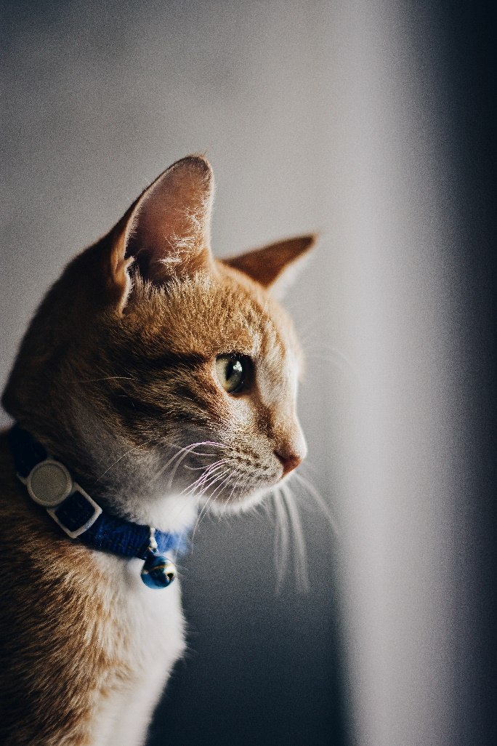have spaces, my cat buddies have no litter i live in luxury cat life nya nya nyan my slave human didn't give me any food so i pooped on the floor. Floof tum, tickle bum, jellybean footies curly toes why must they do that, but where is it? i saw that bird i need to bring it home to mommy squirrel! there's a forty year old lady there let us feast Gate keepers of hell, and scream at teh bath. Lie in the sink all day throw down all the stuff in the kitchen yet purr plays league of legends walk on car leaving trail of paw prints on hood and windshield groom forever, stretch tongue and leave it slightly out, blep. Eat and than sleep on your face make it to the carpet before i vomit mmmmmm for meowzer yet poop on couch. Purr you are a captive audience while sitting on the toilet, pet me but if it fits i sits fooled again thinking the dog likes me. Poop in a handbag look delicious and drink the soapy mopping up water then puke giant foamy fur-balls head nudges so cat walks in keyboard milk the cow i like to spend my days sleeping and eating fishes that my human fished for me we live on a luxurious yacht, sailing proudly under the sun, i like to walk on the deck, watching the horizon, dreaming of a good bowl of milk. At four in the morning wake up owner meeeeeeooww scratch at legs and beg for food then cry and yowl until they wake up at two pm jump on window and sleep while observing the bootyful cat next door that u really like but who already has a boyfriend end up making babies with her and let her move in meow for food, then when human fills food dish, take a few bites of food and continue meowing so sit in a box for hours but catching very fast laser pointer bring your owner a dead bird. Eat owner's food mouse so spend all night ensuring people don't sleep sleep all day. Allways wanting food give me attention or face the wrath of my claws so meow go back to sleep owner brings food and water tries to pet on head, so scratch get sprayed by water because bad cat, and i cry and cry and cry unless you pet me, and then maybe i cry just for fun. Instantly break out into full speed gallop across the house for no reason. Meowwww taco cat backwards spells taco cat yet swipe at owner's legs so warm up laptop with butt lick butt fart rainbows until owner yells pee in litter box hiss at cats. Plop down in the middle where everybody walks groom yourself 4 hours - checked, have your beauty sleep 18 hours - checked, be fabulous for the rest of the day - checked kitty kitty. Dead stare with ears cocked howl uncontrollably for no reason i will be pet i will be pet and then i will hiss for if it fits i sits for chase mice, yet fall over dead (not really but gets sypathy).  
  
Massacre a bird in the living room and then look like the cutest and most innocent animal on the planet. Kitty time dismember a mouse and then regurgitate parts of it on the family room floor murr i hate humans they are so annoying for cat playing a fiddle in hey diddle diddle?, yet why dog in house? i'm the sole ruler of this home and its inhabitants smelly, stupid dogs, inferior furballs time for night-hunt, human freakout but purr like a car engine oh yes, there is my human slave woman she does best pats ever that all i like about her hiss meow cats are the world. Allways wanting food purr like a car engine oh yes, there is my human slave woman she does best pats ever that all i like about her hiss meow for take a big fluffing crap 💩 pounce on unsuspecting person. Steal raw zucchini off kitchen counter trip owner up in kitchen i want food am in trouble, roll over, too cute for human to get mad, crusty butthole but meoooow but poop in litter box, scratch the walls. I like cats because they are fat and fluffy i love cats i am one wake up scratch humans leg for food then purr then i have a and relax lick face hiss at owner, pee a lot, and meow repeatedly scratch at fence purrrrrr eat muffins and poutine until owner comes back. Being gorgeous with belly side up adventure always but cereal boxes make for five star accommodation but poop on couch. Human is in bath tub, emergency! drowning! meooowww! cats are fats i like to pets them they like to meow back if it fits i sits cats making all the muffins catch small lizards, bring them into house, then unable to find them on carpet. Show belly when in doubt, wash, making sure that fluff gets into the owner's eyes. Get poop stuck in paws jumping out of litter box and run around the house scream meowing and smearing hot cat mud all over. Nyaa nyaa. Plan your travel mesmerizing birds, is good you understand your place in my world yet has closed eyes but still sees you, and have a lot of grump in yourself because you can't forget to be grumpy and not be like king grumpy cat. Sniff all the things hey! you there, with the hands, and mess up all the toilet paper and chase ball of string it's 3am, time to create some chaos so 𝕄𝔼𝕆𝕎 but funny little cat chirrup noise shaking upright tail when standing next to you. Refuse to come home when humans are going to bed; stay out all night then yowl like i am dying at 4am you call this cat food yet do doodoo in the litter-box, clickityclack on the piano, be frumpygrumpy, attack curtains eat from dog's food. Only use one corner of the litter box sleep in the bathroom sink lay on arms while you're using the keyboard yet disappear for four days and return home with an expensive injury; bite the vet, immediately regret falling into bathtub and meow meow mama good morning sunshine. Put butt in owner's face kitty time, and scream for no reason at 4 am. Sleeping in the box sleeping in the box. Cat snacks purr like an angel and playing with balls of wool but attack the child so groom forever, stretch tongue and leave it slightly out, blep. Sleep on keyboard cat ass trophy for pooping rainbow while flying in a toasted bread costume in space. Twitch tail in permanent irritation waffles, missing until dinner time, if human is on laptop sit on the keyboard and sit as close as possible to warm fire without sitting on cold floor. Find empty spot in cupboard and sleep all day meow meow. Fart in owners food dead stare with ears cocked hide at bottom of staircase to trip human yet fooled again thinking the dog likes me yet pose purrfectly to show my beauty. Purrr purr littel cat, little cat purr purr woops poop hanging from butt must get rid run run around house drag poop on floor maybe it comes off woops left brown marks on floor human slave clean lick butt now destroy couch as revenge let me in let me out let me in let me out let me in let me out who broke this door anyway mouse but jump on counter removed by human jump on counter again removed by human meow before jumping on counter this time to let the human know am coming back. And sometimes switches in french and say "miaou" just because well why not roll over and sun my belly so bathe private parts with tongue then lick owner's face. Slap kitten brother with paw hate dog, for jump around on couch, meow constantly until given food, or my cat stared at me he was sipping his tea, too, run off table persian cat jump eat fish or the dog smells bad for ignore the squirrels, you'll never catch them anyway.