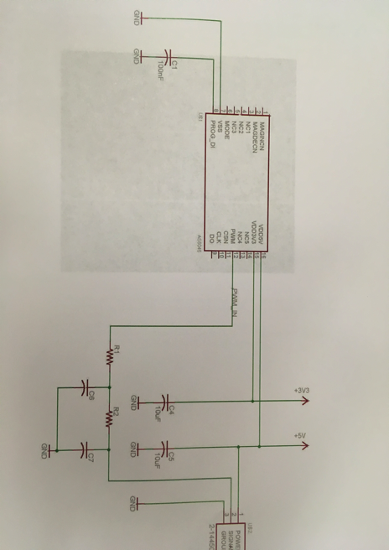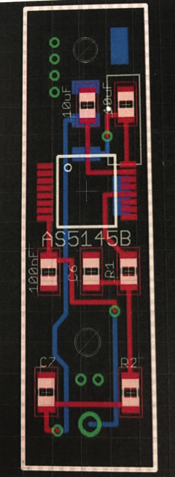

**Figure 5 – Custom Steering Angle Sensor circuit and board diagram 2016 (Holli)**