Service Name: AirCon

Pervasive Nodes
Node Name | Publish | Subscribe
TarokoSensor | RAW_DATA
AirConLogic | COMMAND | RAW_DATA
ApplianceManager |  | COMMAND

Control Rule
Temperature | Command
>30 | FAN_START
<=29.6 | FAN_STOP

Sequence Diagram
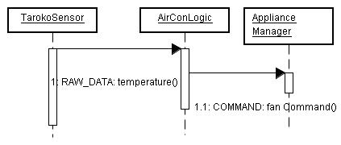

Details
- TarokoSensor會不斷搜集Sensor資訊，傳送到RAW_DATA topic
{"type":"taroko", "id":"0", "humidity":"50", "temperature":"30.2" }

  - AirConLogic只查看temperature的值，如果高於或低於一定的threshold，就發出風扇指令到Command topic調整室溫
{"value":FAN_START"}
{"value":FAN_STOP"}

