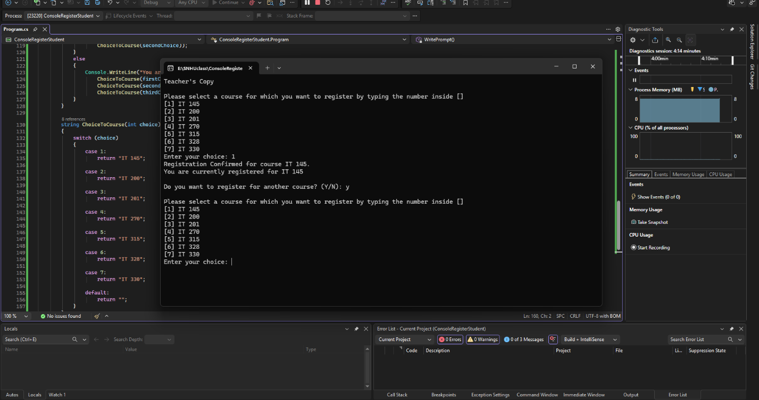
This program displays the successful registration of IT-145.
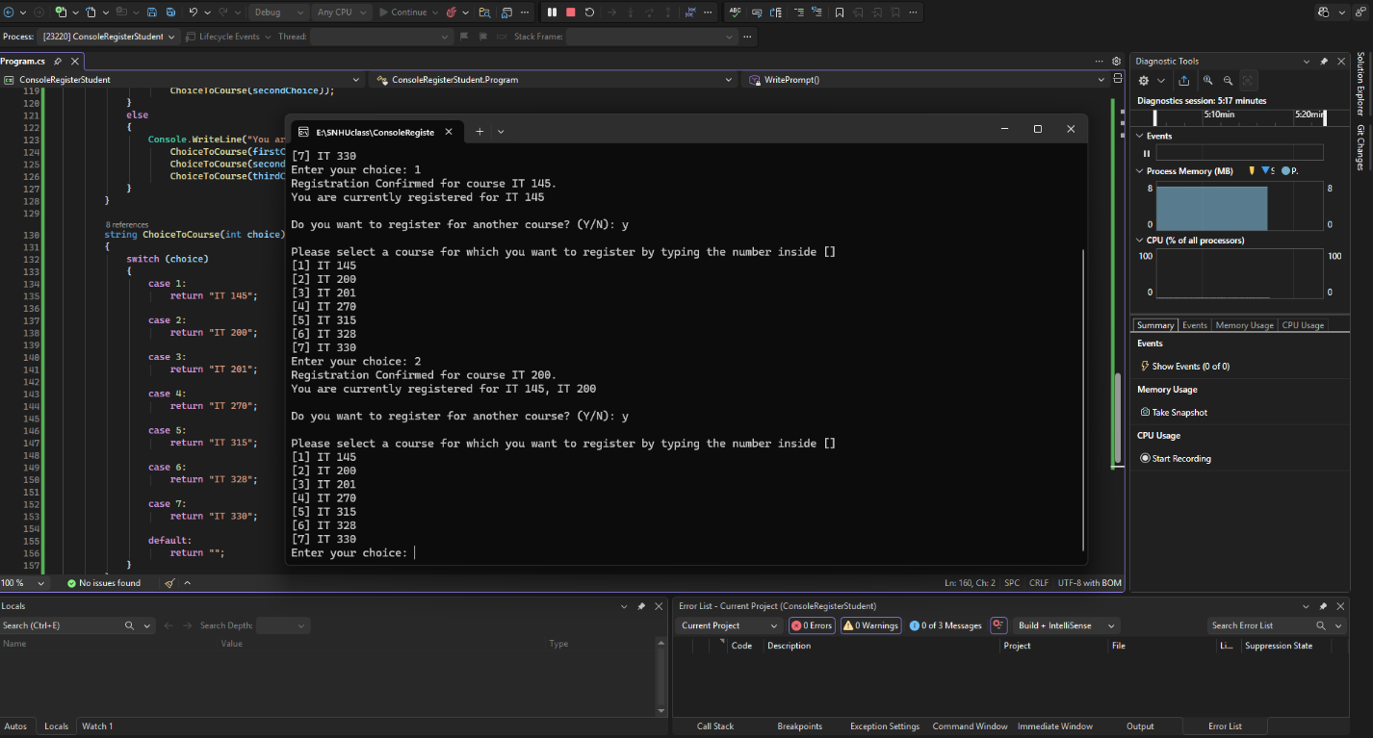
This program displays the successful registration of IT-200.
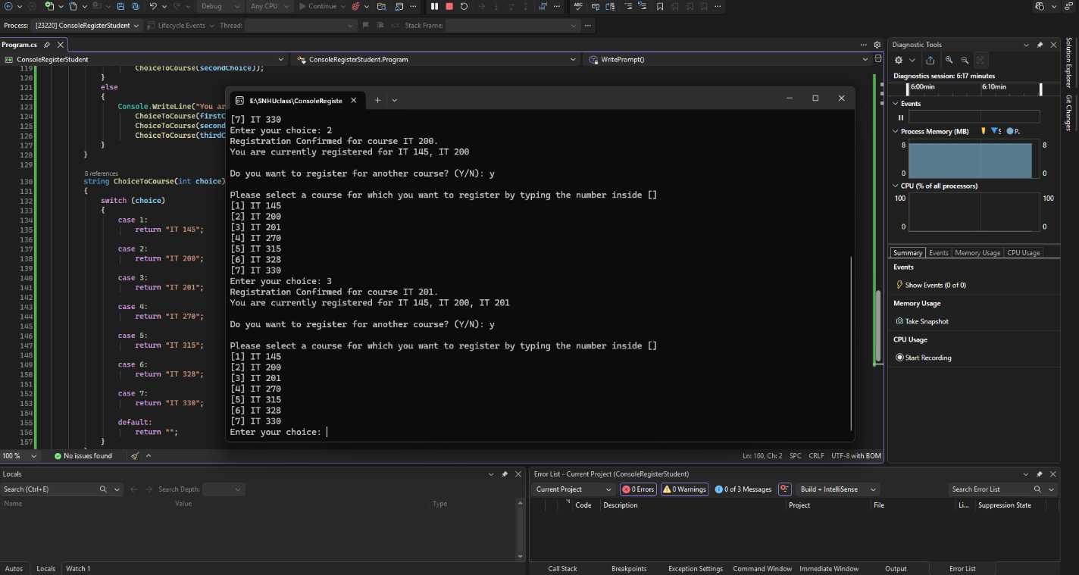
This program displays the successful registration of IT-201.
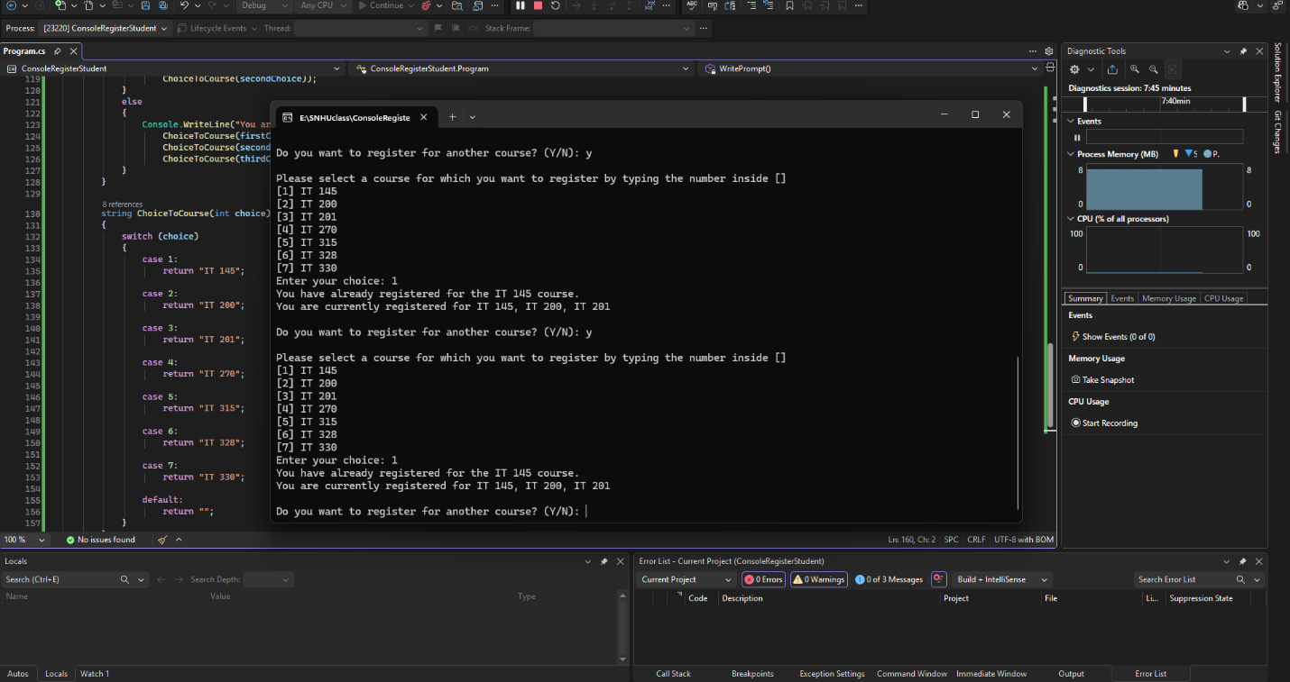
This program displays the duplicate registration of IT-145.
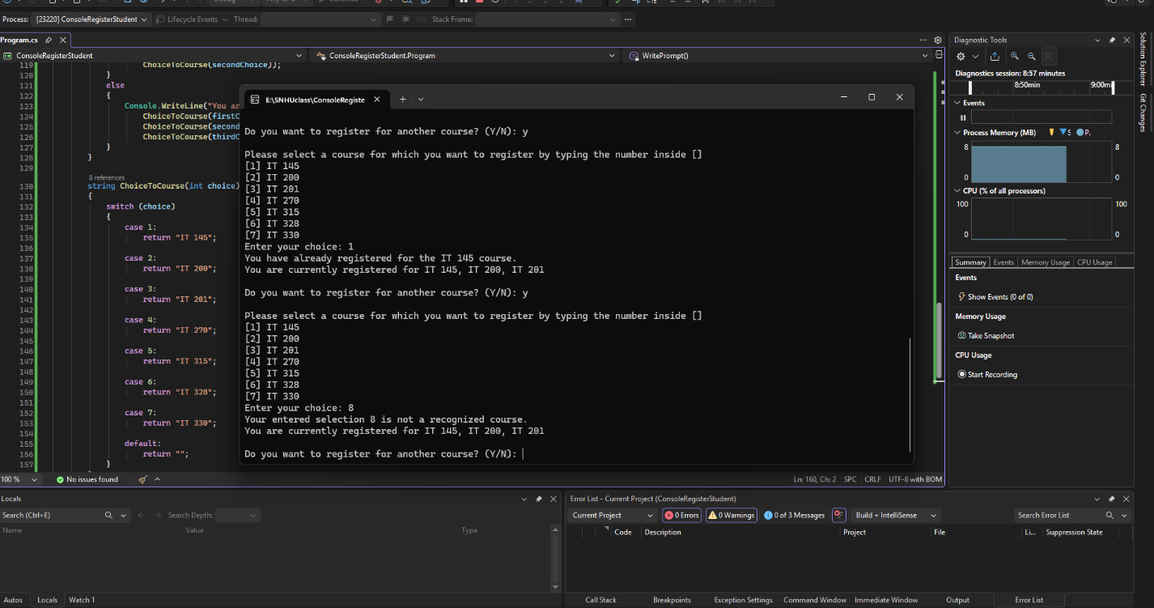
This program displays the invalid registration.
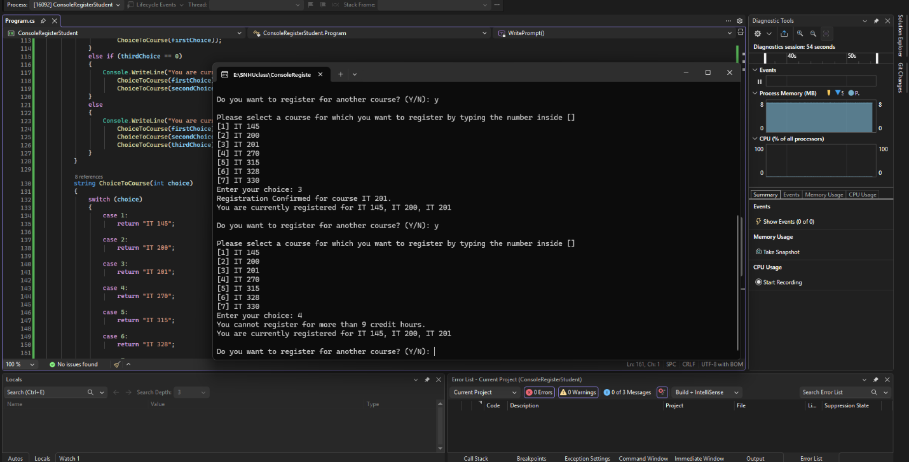
This program displays the 9 credit hour limit error.
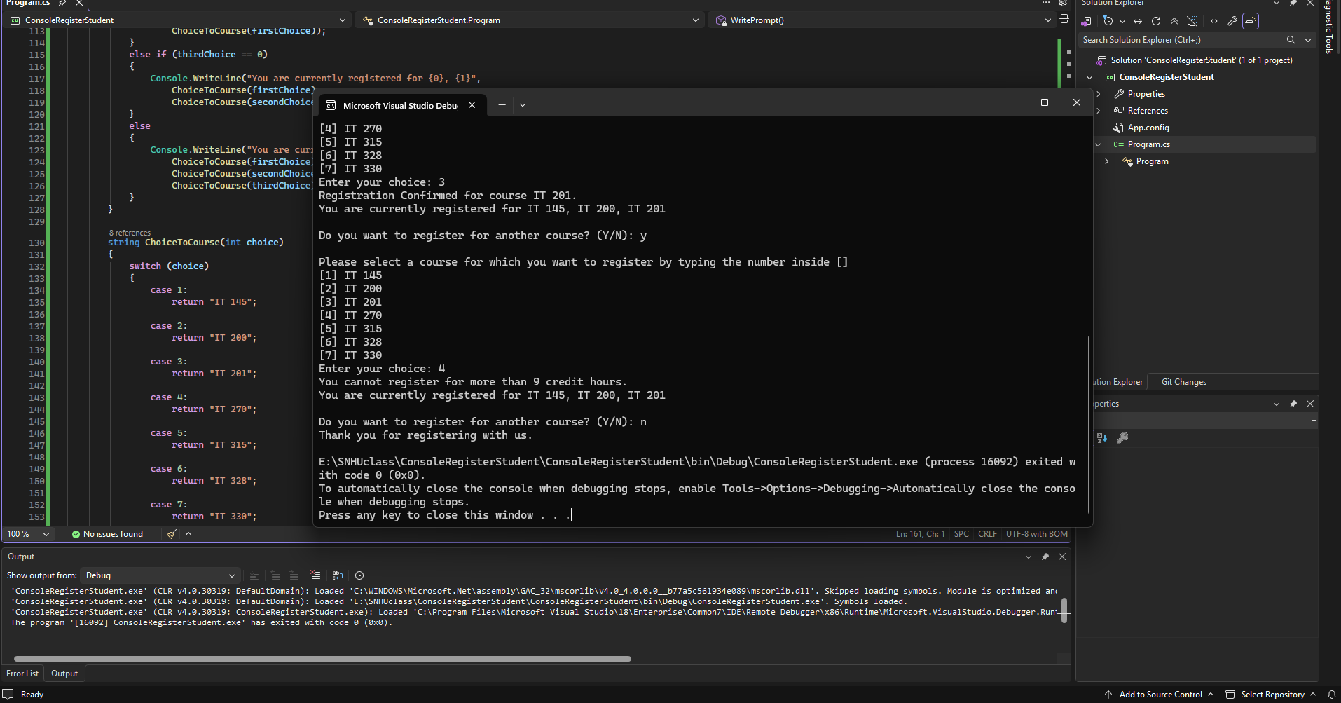
This program displays the finished registration.

using System;
namespace ConsoleRegisterStudent
{
class Program
{
static void Main(string[] args)
{
(new Program()).run();
}
void run()
{
int choice;
int firstChoice = 0, secondChoice = 0, thirdChoice = 0;
int totalCredit = 0;
string yesOrNo = "";
Console.WriteLine("Teacher's Copy");
do
{
WritePrompt();
choice = Convert.ToInt32(Console.ReadLine());
switch (ValidateChoice(choice, firstChoice, secondChoice, thirdChoice, totalCredit))
{
case -1:
Console.WriteLine("Your entered selection {0} is not a recognized course.", choice);
break;
case -2:
Console.WriteLine("You have already registered for the {0} course.",
ChoiceToCourse(choice));
break;
case -3:
Console.WriteLine("You cannot register for more than 9 credit hours.");
break;
case 0:
Console.WriteLine("Registration Confirmed for course {0}.",
ChoiceToCourse(choice));
totalCredit += 3;
if (firstChoice == 0)
firstChoice = choice;
else if (secondChoice == 0)
secondChoice = choice;
else if (thirdChoice == 0)
thirdChoice = choice;
break;
}
WriteCurrentRegistration(firstChoice, secondChoice, thirdChoice);
Console.Write("\nDo you want to register for another course? (Y/N): ");
yesOrNo = Console.ReadLine().ToUpper();
} while (yesOrNo == "Y");
Console.WriteLine("Thank you for registering with us.");
}
void WritePrompt()
{
Console.WriteLine();
Console.WriteLine("Please select a course for which you want to register by typing the number inside []");
Console.WriteLine("[1] IT 145");
Console.WriteLine("[2] IT 200");
Console.WriteLine("[3] IT 201");
Console.WriteLine("[4] IT 270");
Console.WriteLine("[5] IT 315");
Console.WriteLine("[6] IT 328");
Console.WriteLine("[7] IT 330");
Console.Write("Enter your choice: ");
}
int ValidateChoice(int choice, int firstChoice, int secondChoice,
int thirdChoice, int totalCredit)
{
// Invalid course number
if (choice < 1 || choice > 7)
return -1;
// Duplicate registration
if (choice == firstChoice ||
choice == secondChoice ||
choice == thirdChoice)
return -2;
// Credit limit exceeded
if (totalCredit >= 9)
return -3;
// Registration is valid
return 0;
}
void WriteCurrentRegistration(int firstChoice,
int secondChoice,
int thirdChoice)
{
if (firstChoice == 0)
{
Console.WriteLine("You are currently not registered for any courses.");
}
else if (secondChoice == 0)
{
Console.WriteLine("You are currently registered for {0}",
ChoiceToCourse(firstChoice));
}
else if (thirdChoice == 0)
{
Console.WriteLine("You are currently registered for {0}, {1}",
ChoiceToCourse(firstChoice),
ChoiceToCourse(secondChoice));
}
else
{
Console.WriteLine("You are currently registered for {0}, {1}, {2}",
ChoiceToCourse(firstChoice),
ChoiceToCourse(secondChoice),
ChoiceToCourse(thirdChoice));
}
}
string ChoiceToCourse(int choice)
{
switch (choice)
{
case 1:
return "IT 145";
case 2:
return "IT 200";
case 3:
return "IT 201";
case 4:
return "IT 270";
case 5:
return "IT 315";
case 6:
return "IT 328";
case 7:
return "IT 330";
default:
return "";
}
}
}
}

