Flores, Christopher
IT 230 Final Project Part 2
WPF Register Student
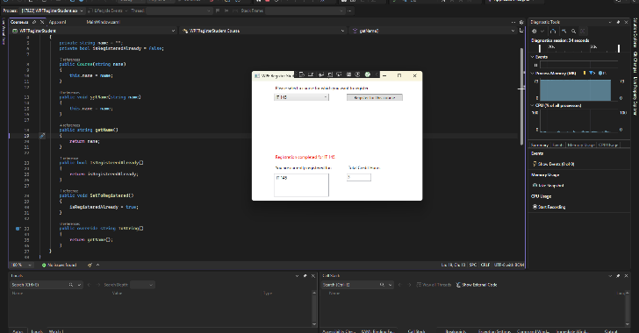
This screenshot shows a successful course registration. The selected course was added to the list and the total credit hours updated to reflect 3 credits.

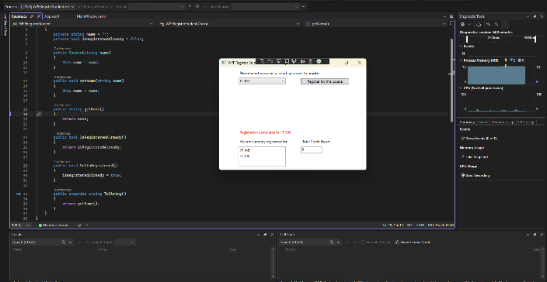
This screenshot shows multiple course registrations. The system correctly updated the total credit hours to 6 after registering 2 courses.
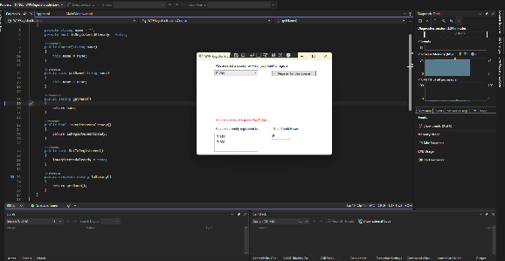

This screenshot shows an error message when attempting to register a duplicate course. The system prevents registering the same course twice.

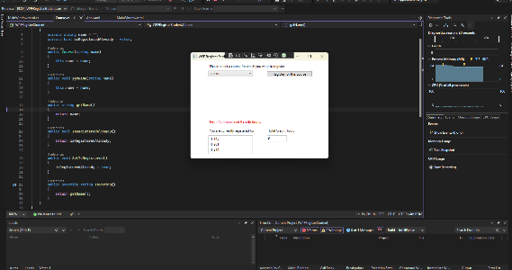
This screenshot shows the system preventing registration when the total credit hours exceed 9. The validation rule is correctly enforced.

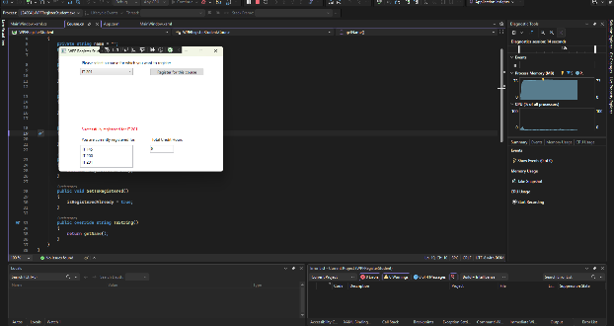
This screenshot shows the final state of the application with 9 total credit hours and all registered courses displayed.
Source Code.
using System;
using System.Windows;

namespace WPFRegisterStudent
{
public partial class MainWindow : Window
{
public MainWindow()
{
InitializeComponent();
}

// ✅ POPULATE COMBOBOX WHEN PROGRAM STARTS
private void Window_Loaded(object sender, RoutedEventArgs e)
{
comboBox.Items.Clear();

comboBox.Items.Add("IT 145");
comboBox.Items.Add("IT 200");
comboBox.Items.Add("IT 201");
comboBox.Items.Add("IT 214");
comboBox.Items.Add("IT 215");
comboBox.Items.Add("IT 235");

// start credits at 0
textBox.Text = "0";
}

// ✅ REGISTER BUTTON LOGIC
private void button_Click(object sender, RoutedEventArgs e)
{
int courseCredits = 3;

// get selected course safely
string selectedCourse = comboBox.SelectedItem?.ToString();

// clear message label
label3.Content = "";

// safely parse credits
int totalCredits;
int.TryParse(textBox.Text, out totalCredits);

// VALIDATION 1: must select course
if (string.IsNullOrWhiteSpace(selectedCourse))
{
label3.Content = "Error: Please select a course.";
return;
}

// VALIDATION 2: no duplicate registration
if (listBox.Items.Contains(selectedCourse))
{
label3.Content = "Error: You are already registered for this course.";
return;
}

// VALIDATION 3: 9 CREDIT LIMIT (KEY REQUIREMENT)
if (totalCredits + courseCredits > 9)
{
label3.Content = "Error: Cannot exceed 9 credit hours.";
return;
}

// SUCCESS: register course
listBox.Items.Add(selectedCourse);

// update credits
totalCredits += courseCredits;
textBox.Text = totalCredits.ToString();

// success message
label3.Content = "Successfully registered for " + selectedCourse;
}
}
}

