Christine Flynn

Module_4

Part 2 - Explain, in your own words: what is a Database?

A database is place for data. In this context it is an electronic repository for data that can be organized and searched.

Part 3 - Explain, in your own words: what is MySql? What is phpMyAdmin?

MySql is an open source relational database management system.

Part 4 - Show the database and table that you created in phpMyAdmin

Part 5 - What is SQL? Explain and give examples for the following SQL statements: SELECT, WHERE, INSERT INTO, CREATE TABLE, DROP DATABASE

SQL is structured query language. Like Mysql it allows for the access and management of databases.

SELECT CustomerName,City FROM Customers;

The WHERE clause is used to filter records and to extract only those records that fulfill a specified condition.

SELECT column1, column2, ...

FROM table_name

WHERE condition;

Part 4.Here is my database with one table

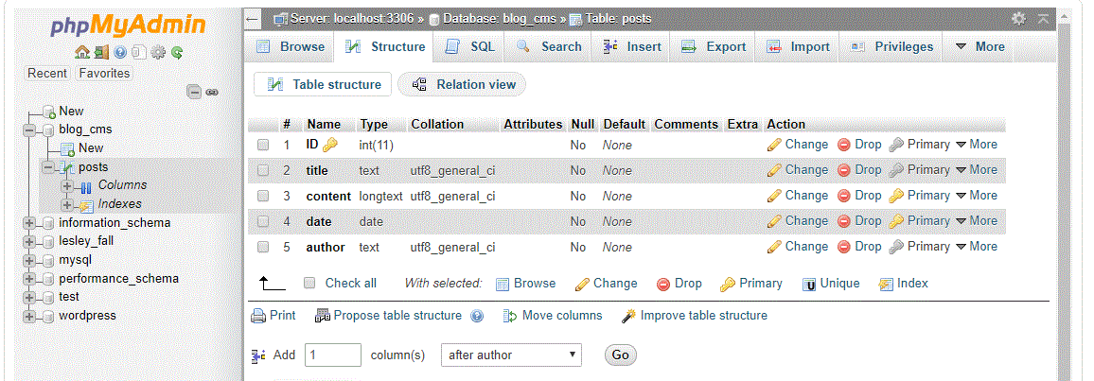

Part 6. **Query: SELECT * FROM posts**

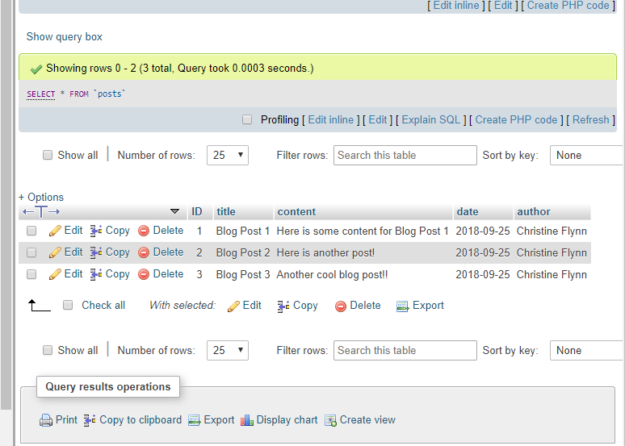

**Query: SELECT title FROM posts**

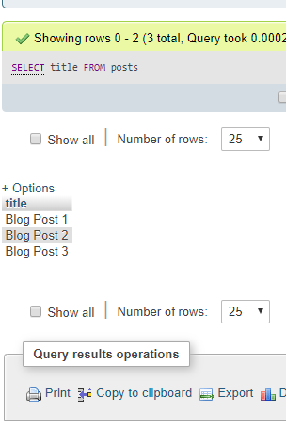

**Query: SELECT * FROM posts  WHERE title=’Hello World!’**

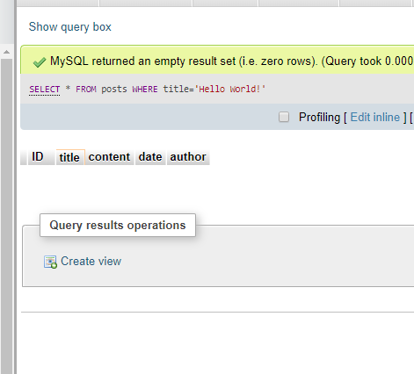

Part 8. Db connect code:

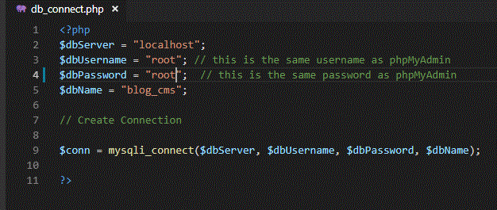

Line 2 defines localhost as the server

Line 3 defines username

Line 4 defines password

Line 5 defines name of database

Line 9 defines function $conn (putting in the variables defined in lines 2-5), which connects the page to the server.

Part 9 Getting Data from the Database:

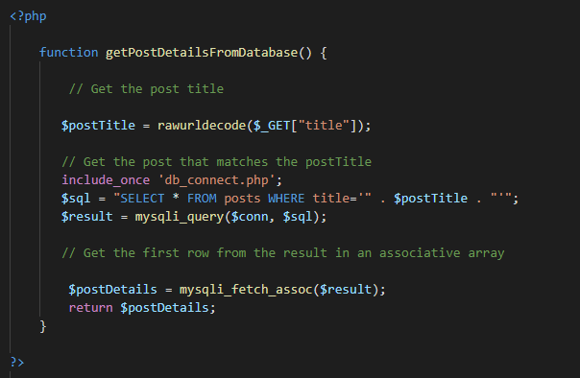

This defines the function ***getPostDetailsFromDatabase()***

***$postTitle*** is defined as the results of getting the data in the ‘title’ field of the database. ***rawurldecode*** puts back any spaces into the results that, in order to put it into a url, would have been replaced with code symbols.

***include_once ‘db_connect.php’*** calls the file which has the function to connect to the database. We can now access the database (communicate with it).

***$sql*** is defined as a variable to select all the posts from the database that have a title matching what was defined as ***$postTitle***

***$result*** is defined as being an SQLI query with the parameters of the $conn function and the $sql function.

***$postDetails*** gets the first row of the results of the query

9 (continued)

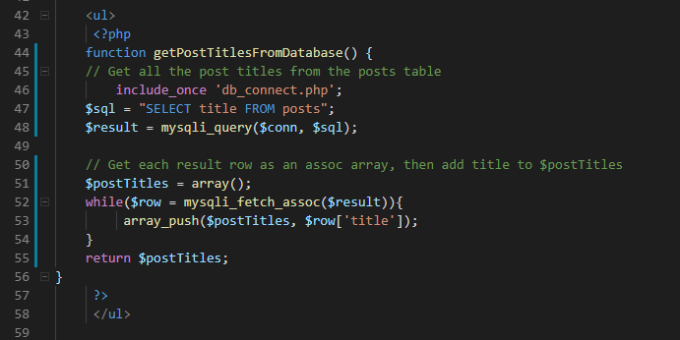

10. submitting a new post.

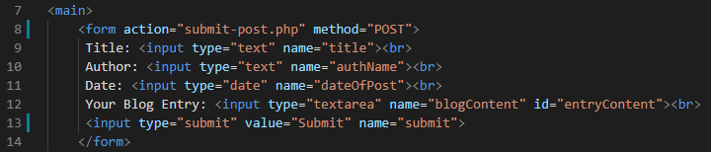

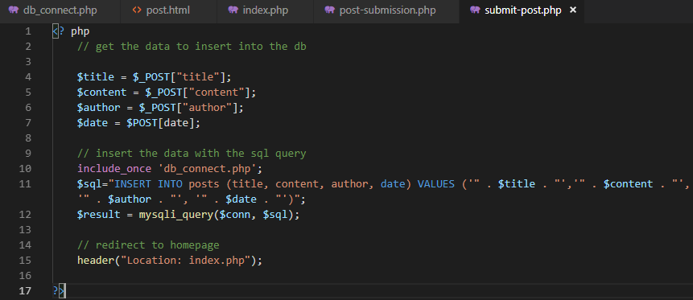

11.