Layer-First Reconstruction of Separated Two-Surface Point Clouds: Frozen Synthetic Confirmation and Building-Disjoint S3DIS Validation
Abstract
Alpha-shape surface reconstruction is controlled by a scale, but changing that scale cannot always prevent a three-dimensional complex from connecting two nearby surfaces that should remain separate. We test a layer-first alternative: infer two layers from observed coordinates, fail closed when their separation or sampling is inadequate, and triangulate each accepted layer independently in its estimated tangent plane. A shared-quadratic trend variant handles bounded surface bending. Parameters and acceptance gates were frozen before two confirmatory tests. On 144 arbitrary-pose synthetic cases, the method attained mean surface F-score 0.899, versus 0.516 for PCA-anisotropic alpha and 0.620 for weighted power-alpha, and won every paired case; aggregate topology error was zero versus 45,606 and 11,925. On a once-opened, building-disjoint S3DIS Area-5 panel of 63 automatically eligible floor–ceiling rooms, it attained mean F-score 0.806, versus 0.421 and 0.324, again winning every case, with zero topology error and 62/63 safe accepts. The shared-trend variant did not outperform the simpler global-normal layer model on the real panel. The supported contribution is therefore narrow: observed-only routing and constrained per-layer connectivity substantially improve reconstruction for sufficiently planar, overlapping, long-gap two-surface point clouds. Close layers, intersections, outliers, automatic semantic extraction, and deployment remain outside the claim.
Keywords. Point-cloud reconstruction; alpha shape; constrained connectivity; two-layer surface; fail-closed routing; S3DIS

1 Introduction
An alpha shape can represent concavity and disconnected components that a convex hull cannot, but the reconstruction depends strongly on the scale parameter α (Edelsbrunner and Mücke (1994)). A small value leaves holes; a large value fills gaps and may fuse surfaces. Density-scaled and anisotropic alpha methods improve this trade-off by adapting the size or shape of the empty ball (Teichmann and Capps (1998)). Weighted alpha complexes can additionally change the underlying regular triangulation (Edelsbrunner (1992)). These are important improvements, but all still ask one complex to decide which nearby points should be connected.
That formulation is poorly matched to a common special case: two surfaces occupy an overlapping footprint but are known, from the observed geometry, to be separate layers. Examples include the opposite sides of a thin gap, repeated sheet-like structures, and the floor and ceiling of a room. Once a tetrahedron or triangle spans the two layers, changing α must remove that cell without destroying needed within-layer cells. The difficult part is then not only the choice of scale. It is the admissible connectivity.
We study a simple layer-first principle. The input remains an unlabeled set of three-dimensional coordinates. The method estimates a common normal frame, separates the points into two clusters along the normal direction, measures whether the separation is identifiable and sufficiently sampled, and accepts the case only when frozen observed-only gates pass. It then constructs one two-dimensional Delaunay surface per inferred layer. Cross-layer faces are not penalized after construction; they are absent from the construction space (Figure 1). A shared quadratic trend can be removed before clustering when both layers bend together.
The contribution is empirical and deliberately bounded. First, a preregistered 144-case synthetic confirmatory panel tests arbitrary poses, six non-outlier stresses, and strong PCA-anisotropic and weighted-alpha comparators. Second, a separately preregistered external test uses the public Stanford Large-Scale 3D Indoor Spaces (S3DIS) data (Armeni et al. (2016)). Area 5, which belongs to a building excluded from calibration, was opened once after the extraction rule, method, parameters, metrics, and gates had been committed. This test asks whether the same observed-only method works on real floor–ceiling point clouds, not whether semantic floor and ceiling instances can be found automatically.
The result is positive in that declared domain. The layer-first reconstruction wins every paired case against both alpha comparators in both panels, while its aggregate topology error is zero. The result also sharpens the novelty boundary: the real-data shared-trend output is numerically identical to the simpler global-normal ablation at reported precision. Thus the supported advance is the combination of observed-only two-layer routing and constrained connectivity, not a new local metric, a learned α, or shared-trend superiority.
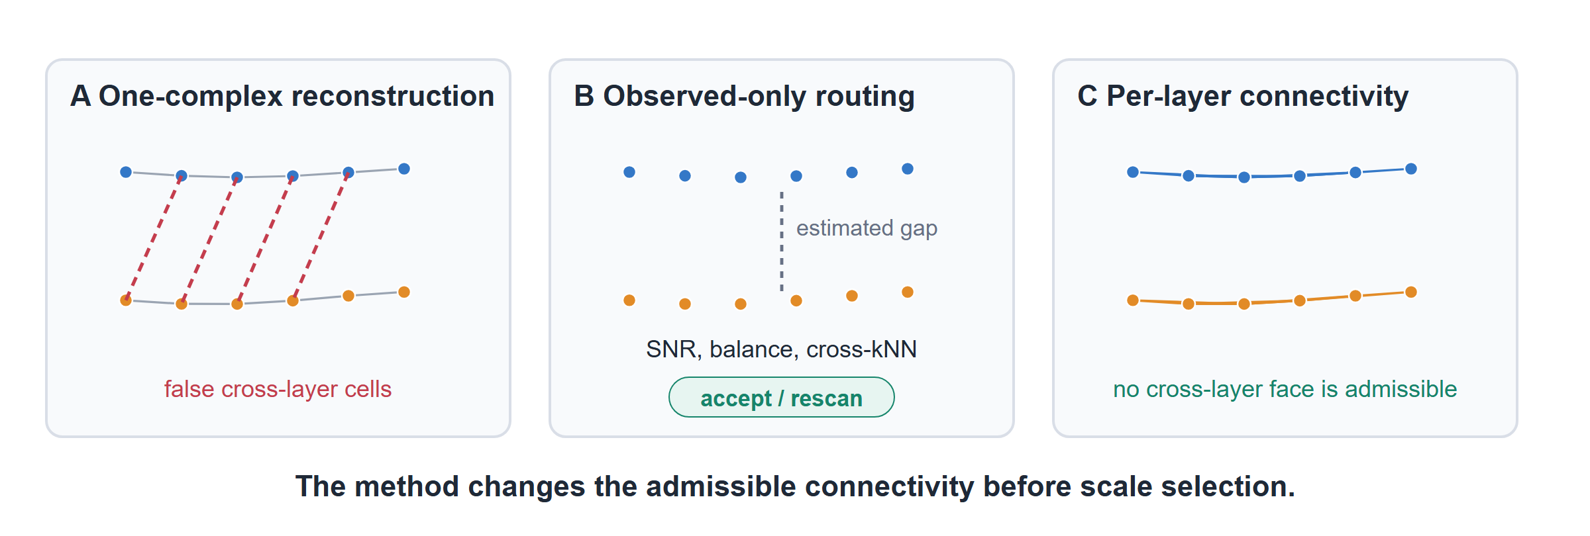
Figure 1. Layer-first reconstruction. A single three-dimensional complex can contain cross-layer cells (A). The proposed route estimates separation and sampling adequacy from observed coordinates only (B). Accepted points are triangulated independently within each inferred layer, so a cross-layer face is not admissible (C).

2 Method

2.1 Observed-only layer inference
Let X=x_i_i=1^n⊂R^3 be the observed point set. No class name, instance identity, reference point, or ground-truth layer label is available to the method. For each point we estimate a local PCA normal from its k=12 nearest neighbors. Because a normal and its negative represent the same unoriented plane, the common orientation is obtained from the second-moment tensor
Q = (1/n) Σᵢ₌₁ⁿ nᵢnᵢᵀ, n̂ = arg max‖v‖₌₁ vᵀQv. (1)
In plain terms, Q finds the direction most local planes agree is normal to the two surfaces. Each centered point is projected onto that direction, h_i=(x_i-x)^Tn, and a deterministic two-means iteration separates the two height modes.
For bounded jointly curved surfaces, the shared-trend variant first constructs a tangent frame (u,v,h) and alternates between two residual clusters and one quadratic height trend
q(u,v) = β₀ + β₁u + β₂v + β₃u² + β₄uv + β₅v². (2)
The two layers are assigned from h-q(u,v). Both surfaces share q but retain different residual centers. This conventional mixture regression is used because it repairs a measured synthetic curvature failure; it is not presented as a PFTF or local-SPD contribution.

2.2 Fail-closed routing
Three quantities summarize whether the inferred layers are usable. The smaller cluster fraction checks that neither layer has collapsed. The separation signal to noise ratio is
SNR = |μ₁ − μ₀| / √[n⁻¹ Σᵢ(rᵢ − μ_zᵢ)²]. (3)
where r_i is either normal height or trend-removed height, z_i is its inferred layer, and μ_0,μ_1 are the layer centers. Finally, the cross-kNN fraction is the proportion of directed k-nearest-neighbor relations whose endpoints receive different inferred labels. Low cross-kNN fraction means that sampling within a surface is locally denser than sampling across the gap.
The frozen route requires a minimum cluster fraction of 0.20, SNR of at least 3.0 in the final two confirmatory protocols, and cross-kNN fraction at most 0.05. An unidentifiable pair is labeled unsupported. An identifiable but inadequately sampled pair requests rescanning. A reconstruction that violates its inferred two-component structure fails closed as an algorithm failure. Only an accepted case is counted as a safe output. These decisions use observed coordinates and the reconstructed mesh; true labels enter evaluation only.

2.3 Constrained per-layer reconstruction
For each inferred layer ℓ∈0,1, its points are centered, projected onto their two leading PCA directions, and triangulated by two-dimensional Delaunay. The local triangle indices are mapped back to the original three-dimensional points, and the two triangle sets are combined without adding a cross-layer edge or face. The operation does not optimize α:
T_layer = D₂(Π₀X₀) ∪ D₂(Π₁X₁), X₀ ∩ X₁ = ∅. (4)
where Π_ℓ is the PCA tangent projection and D_2 is planar Delaunay triangulation. Equation (4) is the central design choice: layer inference changes which connections are possible before any scale decision is made.

2.4 Comparators and endpoints
B5 is a frozen PCA-normal anisotropic alpha filtration with density normalization. M1 is a frozen weighted regular triangulation scored by the proper power circumradius. Both are stronger comparators than a fixed global alpha and were frozen independently of the confirmatory endpoints.
Geometry is measured by surface F-score at a fixed distance tolerance and by a normalized two-sided distance loss (squared Chamfer plus Hausdorff; higher F-score and lower loss are better). Topology error aggregates component error, Betti-number error, and true-layer bridge edges and faces. Nonmanifold edges are also audited. A safe accept must have no component error or true-layer bridge. Topology totals are comparable between methods within a panel, not between the two panels, because their sampling budgets differ.

3 Frozen experiments

3.1 Synthetic confirmatory panel
The synthetic Phase-50 protocol was frozen before evaluation. It contains 144 cases: two observed point counts (160 and 256), six stresses (control, upper occlusion, 75:25 layer imbalance, anisotropic noise, a sinusoidal common trend, and a local bump), and 12 paired repeats. Every observed/reference pair receives the same seed-specific proper three-dimensional rotation. Dense references use 4,096 points and evaluation samples 1,024 surface points. The gates require zero false-safe accepts, at least 95% overall and 90% subgroup safe coverage, mean F-score margins of at least 0.10, at least 75% casewise wins against each comparator, lower geometry loss, zero candidate topology error, and improvement over the global-normal ablation.

3.2 Building-disjoint S3DIS panel
Calibration used S3DIS Areas 1, 2, 3, 4, and 6. Area 5, mapped by the distributed data description to a separate building, remained unopened except for archive member names and sizes until the final protocol and evaluator were committed. The fixed extractor merges every floor instance and every ceiling instance in a room. Eligibility requires normal disagreement no larger than 5^°, projected bounding-box overlap at least 0.75, at least 592 common-footprint points per layer, gap-to-plane-residual SNR at least 10, and 95th-percentile plane residual no larger than ten times median spacing. These annotation-derived rules define the evaluation corpus; they are not supplied to the reconstruction.
All eligible rooms are enumerated automatically. Each layer contributes 80 coordinate-hash-selected observed points and up to 512 disjoint reference points within the common footprint. A deterministic normalized 10^-4 general- position joggle is shared by all methods. After one opening, 63 Area-5 rooms were eligible, exceeding the preregistered minimum of 20. The gates require no false-safe accepts, safe coverage at least 0.90, comparator availability, mean F-score margins at least 0.20 versus B5 and 0.30 versus M1, at least 85% casewise wins, lower geometry loss, and topology error at most one quarter of each comparator. Non-inferiority to the global-normal ablation was also required.

4 Results
Table 1. Frozen confirmatory reconstruction results. Geometry loss and topology error are lower-is-better. All values are prespecified panel aggregates.
Panel | Method | Mean F-score | Geometry loss | Topology error
Synthetic (144) | Layer-routed | 0.898536 | 0.126043 | 0
 | B5 PCA-anisotropic alpha | 0.515603 | 0.140552 | 45,606
 | M1 weighted power-alpha | 0.620140 | 0.137152 | 11,925
S3DIS Area 5 (63) | Layer-routed | 0.805611 | 0.116385 | 0
 | B5 PCA-anisotropic alpha | 0.420983 | 0.243356 | 5,214
 | M1 weighted power-alpha | 0.323764 | 0.228920 | 13,375
On the synthetic panel, the layer-routed method exceeds B5 by 0.382933 mean F-score and M1 by 0.278396. It wins 144/144 paired cases against each comparator, and every one of the 12 point-count–stress subgroups has 12/12 safe accepts. The global-normal ablation has 138 safe accepts and six false-safe accepts; the shared-trend candidate repairs all six, reaches 144/144 safe accepts, and has no nonmanifold edge. Every preregistered safety, geometry, topology, and ablation gate passes.
On S3DIS Area 5, the method exceeds B5 by 0.384627 mean F-score and M1 by 0.481847, with 63/63 casewise wins against both. It safely accepts 62/63 rooms with no false-safe case. The one conservative rescan request, hallway 5, is nevertheless topology-safe and has F-score 0.989640. Both alpha comparators are available for all rooms. The candidate has zero aggregate topology error, while B5 and M1 accumulate 5,214 and 13,375. All frozen gates pass (Figure 2).
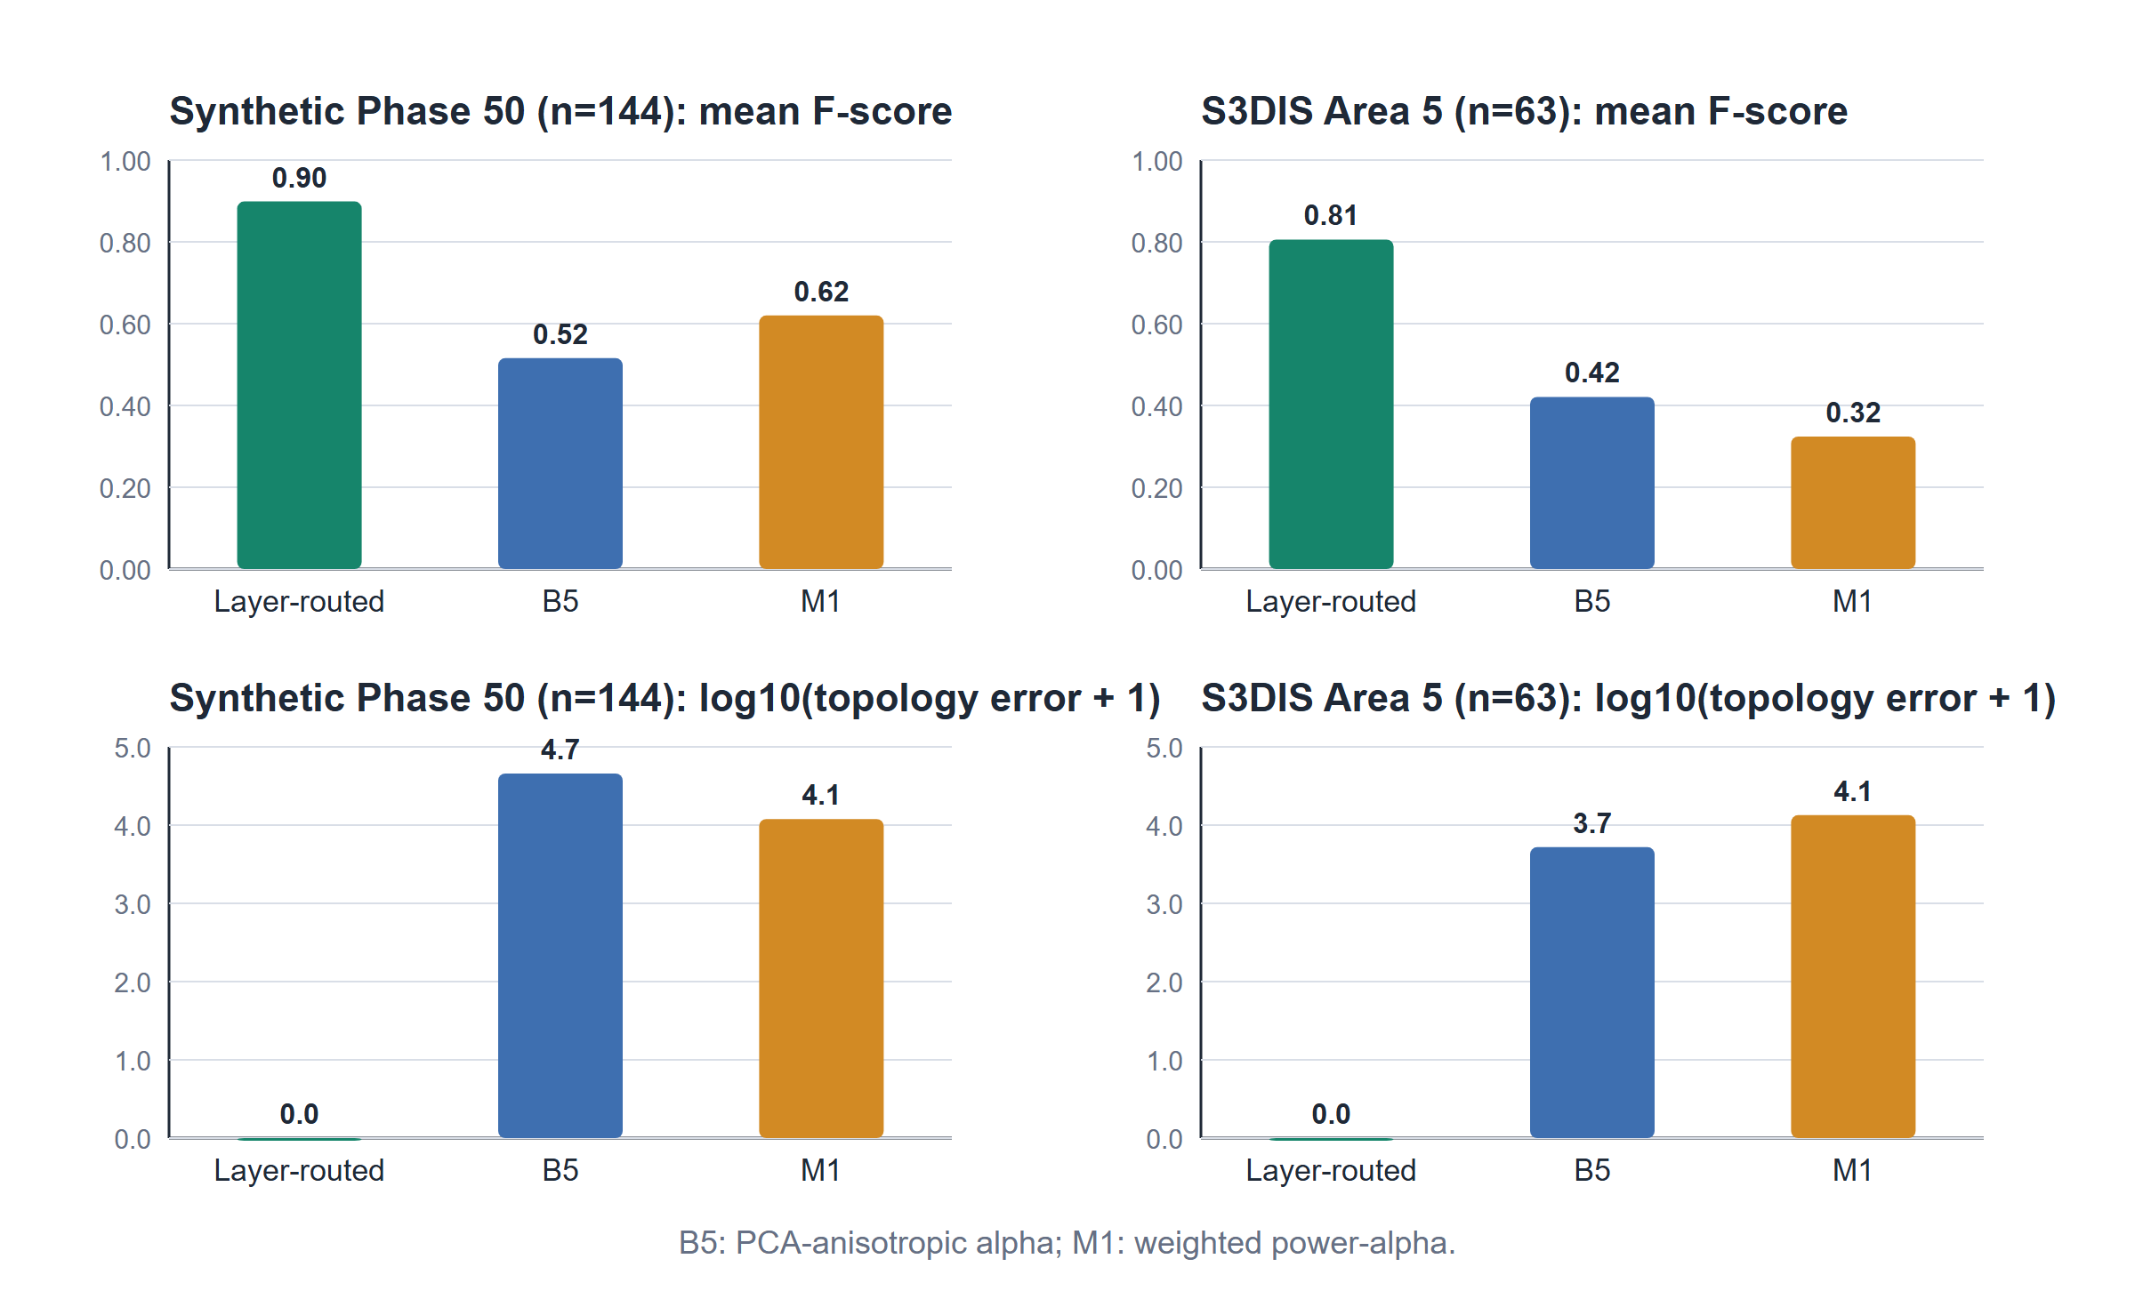
Figure 2. Confirmatory outcomes generated directly from the frozen result artifacts. The method has the highest mean F-score and zero topology error in both panels. The lower row uses log10(error + 1) only for display; Table 1 reports the raw totals.
The S3DIS global-normal ablation has the same 62/63 safe coverage, zero false-safe cases, and the same mean F-score at reported precision as the shared-trend version. This is a useful null ablation: the real floor–ceiling result validates layer-first routing and constrained connectivity, but it does not validate shared-trend superiority.

5 Discussion
The paired improvements are large because the method changes the hypothesis space. B5 changes the local metric of an alpha filtration and M1 changes the regular triangulation, but both still reconstruct the union of two surfaces as one three-dimensional complex. The layer-first method uses an observed geometric condition–-two identifiable, locally separated layers–-to factor the problem into two planar reconstructions. This structural constraint removes the entire class of cross-layer faces rather than asking a tuned threshold to suppress each one. The result therefore answers the original alpha-selection question in a specific way: for this regime, a better α is less important than declaring which connectivity is admissible.
The validation design limits optimistic bias. Synthetic parameters were frozen before an untouched arbitrary-pose panel. For S3DIS, a multi-building calibration set was used to freeze eligibility and observation rules, then Area 5 was opened once as an automatically enumerated panel. Candidate decisions used only combined XYZ coordinates; semantic annotations, reference points, and true layer labels were restricted to corpus extraction and evaluation. Casewise wins in all 207 confirmatory cases show that the aggregate result is not produced by a few large outliers. We nevertheless treat rooms, not individual points, as the unit of evidence and do not infer broader population performance beyond this protocol.
The strongest limitation is scope, not a small numerical margin. The S3DIS test selects nearly parallel floor–ceiling pairs with broad projected overlap and a large gap relative to residual and spacing. Earlier wall–board calibration showed that geometry can improve on close layers, but the current topology-safe route rejects them because physical occlusion produces non-overlapping observed support. The method is also not validated for intersecting surfaces, severe spatial outliers, fewer than 160 synthetic observed points, arbitrary multi-surface scenes, or automatic discovery of the two semantic objects. Its planar Delaunay surfaces can bridge large holes within one layer because no boundary recovery is included. Floating-point triangulation is used, so this is not an exact-predicate or deployment certificate.
These boundaries suggest concrete next tests. A visibility-aware support model is needed for close occluded layers. Boundary-aware planar meshing or a per-layer alpha restriction should be tested for incomplete footprints. A deployment study must add automatic pair discovery, sensor-specific artifacts, runtime and memory, and exact or validated geometric predicates. None of those extensions is required to interpret the present result: the current evidence already establishes a positive, reproducible advantage in the stated long-gap two-layer domain.

6 Conclusion
For sufficiently separated two-surface point clouds, constraining connectivity is more effective than continuing to tune an alpha filtration. An observed-only fail-closed route followed by independent per-layer triangulation improved mean F-score by 0.279–0.383 on the synthetic confirmatory panel and by 0.385–0.482 on building-disjoint S3DIS rooms, won all 207 paired cases against both frozen alpha comparators, and produced zero aggregate topology error. The real-data ablation shows that this success should be credited to layer-first routing and constrained connectivity, not to shared-trend or PFTF/local-SPD novelty. The resulting claim is narrow, affirmative, and testable: when two approximately parallel layers are observationally identifiable and well sampled, reconstructing them separately is substantially more accurate and topologically safer than reconstructing their union with anisotropic or weighted alpha methods.

7 References

