The Support Flow Tensor Field for Build-Orientation Candidate Search: Algorithm, External Audit, and a Budget–Complexity Map
InHwan Sul
Department of Materials Design Engineering, Kumoh National Institute of Technology
Gumi 39177, Republic of Korea
Email: snowman0@kumoh.ac.kr ORCID: 0000-0003-0105-920X
Abstract
Build orientation strongly affects support material and post-processing in additive manufacturing, but dense orientation sweeps with support-structure tomography (TOMO) or repeated slicer runs are expensive. This study presents the Support Flow Tensor Field (SFTF), a support-aware candidate generator that ranks directions before accurate verification. SFTF follows ray-cast support paths from overhanging faces to receiving faces or to the build plate, represents both cases in one tensor score, and concentrates a fixed verification budget around promising basins. Candidate generation averaged 4.57 s per mesh, compared with 131.0 s for a complete 130,321-cell TOMO sweep, while each oriented mesh required 12.54 s in CuraEngine and 2.93 s in PrusaSlicer. The method was externally audited on 60 independently selected Thingi10K meshes using dense TOMO references; 30 meshes were also evaluated with CuraEngine 5.13 and PrusaSlicer 2.9.6. At a generous 2,400-cell budget, matched uniform search was already near-saturated and SFTF did not establish noninferiority (paired normalized-regret difference 0.0214, 95% confidence interval 0.0070–0.0406). At a 10-cell budget on complex meshes (at least 50,000 faces), however, the mean contrast favored SFTF under TOMO and both slicers, although the bootstrap intervals included zero. These results identify the practical regime for support-aware candidate search: use uniform verification when thousands of evaluations are affordable, and use SFTF to reduce expensive verification to a small, targeted set when geometry is complex and the budget is tight.
Keywords: additive manufacturing; build orientation; support material; candidate generation; external validation; slicer verification

Introduction
Build orientation controls support material, build time, surface finish, and post-processing effort in support-requiring additive manufacturing, especially extrusion processes in which downward-facing overhangs beyond a critical angle require removable support.¹ Orientation can be optimized by explicit geometric analysis, voxel- or GPU-accelerated support prediction, and multi-objective search, up to simultaneous orientation–topology optimization;²⁻⁸ recent routes also cast rays to accumulate area–height support estimates or learn orientation policies directly.^{9,10} Earlier work accelerated the verification backend itself, first with per-pixel signed shadow casting (support-structure tomography, TOMO)¹¹ and then with a GPU implementation;¹² both follow the exhaustive pattern of Figure 1(a), rotating and re-evaluating the mesh for every cell of a dense yaw–pitch grid. This paper addresses the complementary question: which directions should be sent to such a backend, or to a production slicer, when the verification budget is fixed (Figure 1(b))?
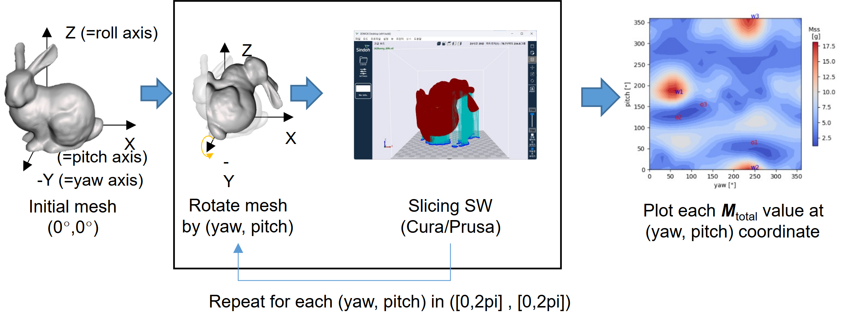 (a)
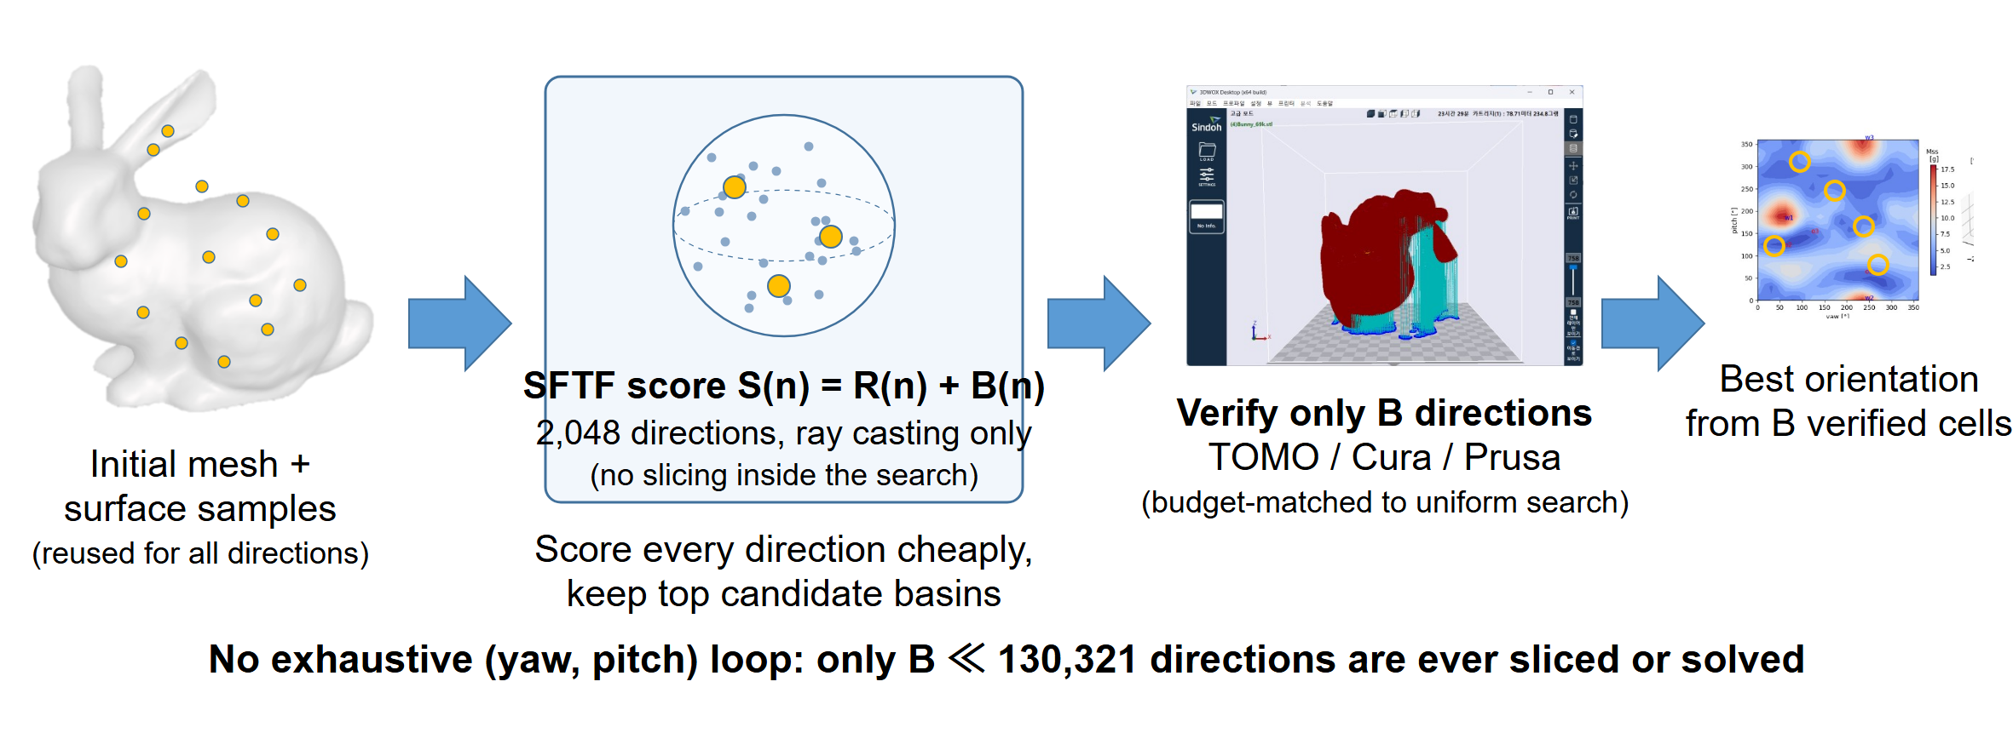
(b)
Figure 1. Two ways to find a build orientation. (a) Exhaustive orientation search in previous TOMO studies:^{11,12} the mesh is rotated and re-evaluated—sliced or shadow-cast—for every (yaw, pitch) cell of a dense grid, and the resulting support-mass landscape is plotted over the whole grid. (b) The present study: SFTF scores every direction cheaply by ray casting on one reusable surface sample, keeps a few candidate basins, and verifies only a small budget $B$ of directions with TOMO or a slicer, at a budget matched to uniform search; no exhaustive rotate-and-slice loop remains.
The Support Flow Tensor Field (SFTF) answers this question with a cheap, interpretable score. Classical orientation tensor summaries of directional data^{13,14} describe how surface normals are distributed; however, a symmetric normal tensor cannot determine whether a face is an overhang for a given build direction, whether another face can catch the falling support, or how far an unsupported face is from the build plate. Therefore, the SFTF evaluates, for each candidate direction, an asymmetric tensor—a field class studied in its own right in visualization and mechanics¹⁵—built from ray-cast source–receiver pairs, and treats the build plate as one more receiver—a virtual ground node—so that the entire support estimate becomes a single Rayleigh contraction.
In practical terms, the normal tensor describes which way the surface tends to face, but it does not say where unsupported material would fall. SFTF adds that missing route information: it asks which overhanging face starts the support, which surface or build plate receives it, and how far the support must travel.
The central engineering value of SFTF is not to replace TOMO or a production slicer, but to reduce how often they must be called. We evaluate whether this inexpensive front end can preserve useful orientations under the same verification budget, then map the budgets and geometric complexity for which the strategy is most effective.
The contributions are as follows: (i) an interpretable, dimensionless formulation that treats face-to-face and build-plate support in one score; (ii) a candidate-generation stage that is about 29 times faster than a dense TOMO sweep in the tested setup and can sharply reduce repeated slicer evaluations; (iii) an external audit on 60 sealed meshes with two slicers; and (iv) a budget–complexity map that identifies where support-aware search is useful and where uniform coverage is sufficient.

Materials and Methods

From a symmetric normal tensor to directional support flow
As a baseline, the area-weighted second moment of surface normals, M=i​Ai mimiT, summarizes shape directionality,¹³ but it is blind to the three ingredients that determine support: overhang activation, receiver visibility, and distance to the plate. SFTF restores all three while staying far cheaper than a dense verification sweep.
For a triangular surface, one deterministic area-uniform sample $\{(x_{k},m_{k})\}_{k=1}^{K}$ of points and outward normals is drawn once and reused for every unit build direction $n$; reusing one sample removes per-direction sampling noise. Let $D$ be the bounding-box diagonal. The overhang coefficient
 | $$O_{k}(n)=max\left(0, -m_{k}⋅n\right)$$ | (1)
activates only downward-facing samples. From each active source a ray is cast along $-n$; among its intersections, the source’s own face, non-positive drop heights, and back-facing receivers ($r_{k}⋅n≤{10}^{-8}$) are rejected, and the nearest remaining admissible face becomes the receiver, with normal $r_{k}$ and drop height $h_{k}$.¹⁷ Nearest-hit ray casting with area–height accumulation is shared with prior support estimators;^{9,10} what SFTF adds is the receiver normal itself, which turns each hit into a directional flow. This one-hop rule is a model assumption: it routes each source to the nearest admissible receiver rather than solving complete deposition visibility. The face-to-face (pair) flow tensor is
 | Fpair(n)=1Kk∈H(n)​Ok1+λhk/D mkrkT, | (2)
and its scalar support cost is the Rayleigh contraction $R(n)=max\{0, -n^{T}sym(F_{pair})n\}$. Two design choices distinguish Eq. (2) from our original formulation and matter in practice. First, the sum is an average over a normalized surface measure and every length appears as $h/D$, so the score is dimensionless and invariant to uniform scaling. Second, receiver triangle area does not enter: the original score multiplied source and receiver areas, which made the pair term scale differently from the plate term and made the score sensitive to how finely the receiving surface happened to be tessellated. The antisymmetric part of $F_{pair}$ cannot change the scalar, since $n^{T}(F-F^{T})n=0$; its norm is used only as an uncertainty diagnostic.
A useful way to read Eq. (2) is as a weighted vote. Each ray-cast source–receiver pair votes for directions that require less support. The weights account for overhang severity and travel distance, and the tensor collects all votes so that any trial build direction can be scored with one matrix–vector calculation.

The build plate as a virtual ground node
If no admissible receiver exists, the overhang is ultimately carried by the build plate at height $h_{k,bed}$, giving the scalar plate penalty
 | B(n)=1Kk∈P(n)​Ok1+λhk,bed/D, S(n)=R(n)+B(n). | (3)
Note the deliberate sign asymmetry: distant face-to-face support is attenuated in Eq. (2), whereas the tall plate support is amplified in Eq. (3). This matches the intuition that support printed from the plate grows with height, while an internal landing nearby is cheap.
The plate term is not an ad-hoc patch. As illustrated in Figure 2, a virtual receiver whose normal is the build direction itself is appended to the tensor:
 | F(n)=Fpair(n)+1Kk∈P(n)​1+λhk,bed/D mknT. | (4)
Because $m_{k}⋅n=-O_{k}$ for active samples, the Rayleigh contraction of the ground term contributes exactly $B(n)$, so
 | $$\tilde{R}(n)=max\left\{0, -n^{T}sym(\tilde{F}) n\right\}=R(n)+B(n)=S(n).$$ | (5)
Therefore, the entire score is a single tensor contraction, which justifies the name of the method: internal landings and the plate are one support flow, differing only in who receives it. The identity in Eq. (5), the pair contraction, antisymmetric-part cancellation, and uniform-scale invariance were verified symbolically by an independent Mathematica script and numerically in the implementation tests (§3.1).
The virtual ground node is bookkeeping rather than an additional physical assumption. If a ray reaches another face, that face receives the support flow; if it reaches no face, the build plate receives it. Writing both cases in one tensor keeps the score interpretable and avoids switching between separate formulas.
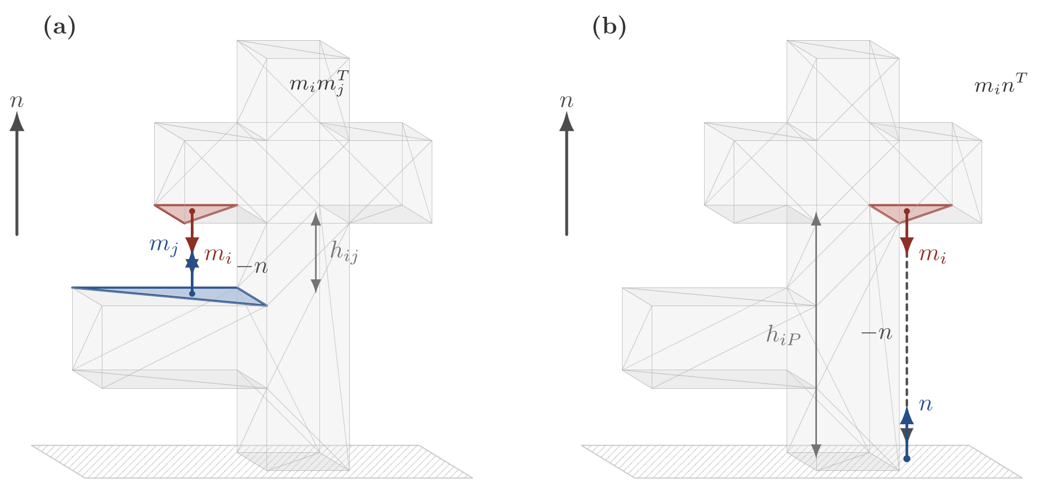
Figure 2. Unified flow interpretation: Face-to-face support uses the receiver normal $r_{k}$, while direct build-plate support is represented by a virtual receiver whose normal is the build direction $n$; the latter contributes exactly the plate penalty $B(n)$ to the Rayleigh contraction in Eq. (5).

Candidate generation and an abstaining gate
$S(n)$ is evaluated on 2,048 Fibonacci-sphere directions^{18,19} with $K=8,192$ surface samples. Angular non-maximum suppression keeps the 24 lowest-score basins separated by at least ${12}^{∘}$, and grid cells nearest these basins are added until the verification budget is filled. The competing policy—and the honest baseline any candidate generator must beat—is a matched uniform search: a deterministic near-uniform spherical design evaluated on exactly the same number of verification cells.
Uniform search spends the verification budget evenly over the sphere. SFTF instead uses its inexpensive score as a map, concentrates the same budget near low-score basins, and then lets TOMO or a production slicer make the final decision. SFTF is therefore a candidate generator, not a replacement for the high-fidelity verifier.
Because a candidate generator should also know when not to trust itself, a diagnostic gate may abstain from the SFTF branch. Three inexpensive diagnostics were fixed on development data only: cross-$K$ basin stability (mean nearest-basin angle between $K=4,096$ and $K=8,192$ solutions $≤{15}^{∘}$), relative score dispersion $≥0.08$, and a median skew-to-symmetric norm ratio $≤1.0$ over the best basins. Any failed or non-finite diagnostic selects the uniform fallback. Exact definitions, thresholds, and tie-breaking are given in the Electronic Supplementary Material (ESM).

Reference stack, sealed external set, and slicers
All 41 meshes used while developing the score, its weights, or the gate were declared development data. The external set is 60 binary STL files drawn from a strict Thingi10K mirror¹⁶ by salted-hash order within four face-count strata (1k–10k, 10k–50k, 50k–150k, 150k–250k), subject only to geometry checks (finite, watertight, single component); 30 of the 60 were independently hash-designated for cross-slicer verification. No holdout result was computed before the set was fixed, and no mesh was replaced afterwards; the manifest SHA256 and a full selection audit are in the ESM. Because a finalized pre-outcome policy lock was not archived, we report the study as a retrospective external audit rather than a prospectively locked confirmation.
Dense reference grids (1° yaw–pitch, 60° critical angle) were computed for every holdout mesh using the TOMO backend. For the 30-mesh panel, CuraEngine 5.13 and PrusaSlicer 2.9.6 evaluated an identical union of fixed directions, policy anchors, and local offsets (73–74 common directions per mesh after pairwise matching). Because slicers parameterize overhang thresholds differently, cantilever coupons were used to align the physical support onset (Cura 60° paired with Prusa’s 30° slope-from-horizontal convention);²⁰ profiles and the coupon table are in the ESM. These checks form a validation ladder—symbolic identities, a dense voxel reference, and two separate slicer engines—rather than interchangeable ground truths. No printed-part experiment was performed; therefore, all outcomes were solver- or slicer-estimated support demands.

Endpoint
For mesh $m$ and policy $p$, the primary metric is the grid-range-normalized regret
 | $${NRR}_{m}(p)=\frac{V_{m}(p)-V_{m,min}}{V_{m,max}-V_{m,min}},$$ | (6)
which is defined for every mesh including zero-support cases (no holdout mesh had a degenerate range). The primary paired contrast is selective SFTF minus matched uniform at a 2,400-cell budget; noninferiority required the upper bound of a 95% paired mesh-bootstrap interval (10,000 replicates) to lie below 0.02.^{21,22} The margin has a direct reading on the NRR scale: accepting the candidate policy could concede at most 2% of a mesh’s full best-to-worst support range on the dense grid—small enough to be practically negligible, yet roughly eight times the residual regret of the saturated uniform branch itself (0.0026) and therefore resolvable at $n=60$. Secondary analyses include a paired permutation test,²³ per-branch summaries, slicer contrasts analyzed separately per engine, and a post hoc budget sweep re-evaluated on the cached grids.

Results

Algebraic and numerical invariance
Mathematica independently returned True for the antisymmetric Rayleigh identity, pair contraction, virtual-bed identity of Eq. (5), and uniform-scale invariance. Numerically, scaling a 69k-face mesh by 0.1 and 10 changed the score by at most $4.45×{10}^{-16}$ in relative terms; uniform four-way subdivision (69,662 to 278,648 faces) changed the median score by 0.104% and preserved ranking (Spearman $ρ=0.9994$); and $K=4,096$ versus $K=8,192$ agreed with median relative difference 2.07% (minimum $ρ=0.955$). The formulation therefore behaves as a well-posed, tessellation-tolerant score, establishing the numerical stability needed before predictive comparisons.

External audit across verification budgets
Table 1 and Figure 3 summarize the TOMO audit at the 2,400-cell budget. The paired selective-minus-uniform NRR had mean 0.0214 (median 0.0000, maximum 0.3804), with 95% CI [0.0070, 0.0406] and permutation p=0.0003; the 0.02 noninferiority criterion was not met. At this budget, however, the near-uniform design was spaced roughly 4° apart and already reached mean NRR 0.0026, leaving little room for candidate placement to improve global coverage. A seeded random design performed similarly (0.0027), while the legacy dimensional SFTF was markedly worse (0.0722), showing the benefit of the dimensionless reformulation. The gate accepted 59/60 meshes, and selective and ungated SFTF produced nearly identical mean NRR values (0.0240 and 0.0237); detailed gate diagnostics are reported in the ESM. The practical boundary is clear: at a generous verification budget, uniform coverage is already effective.

Table 1. Matched-budget TOMO results on the 60-mesh external set. Lower NRR is better.
Method | Mean | Median | 90th pct. | Maximum
Uniform | 0.0026 | 0.0000 | 0.0104 | 0.0203
SFTF only | 0.0237 | 0.0000 | 0.0463 | 0.3883
Selective SFTF/uniform | 0.0240 | 0.0001 | 0.0463 | 0.3883
Seeded random | 0.0027 | 0.0000 | 0.0097 | 0.0232
Legacy SFTF | 0.0722 | 0.0258 | 0.1609 | 0.7042

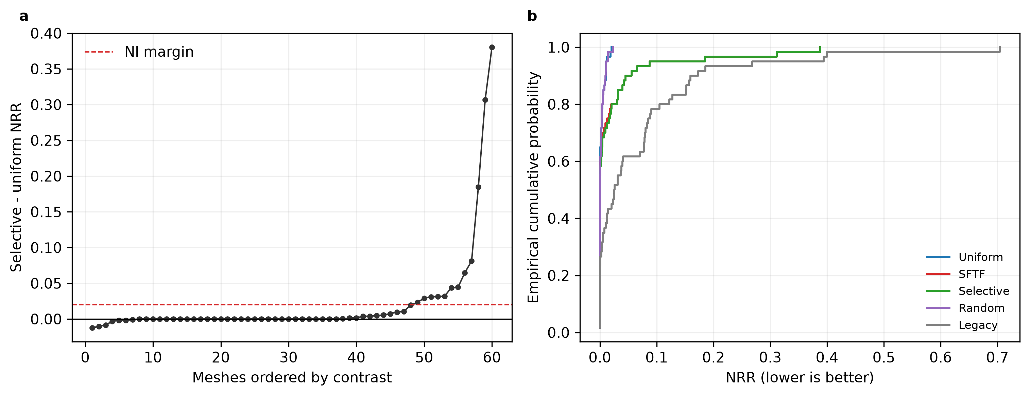
Figure 3. External TOMO audit at a 2,400-cell budget. (a) Ordered paired selective-minus-uniform NRR contrasts; positive favors a uniform search. (b) Empirical NRR distributions of all matched-budget branches.

The budget–complexity map: where candidate search matters
Re-evaluating every branch on the cached grids across budgets from 5 to 2,400 cells (no new reference computation) produces the practical map of Figure 4 and Table 2. Across all 60 meshes, uniform retained the lower mean regret because the simple-mesh strata dominated the aggregate. Stratification exposed the target regime: on the two simplest strata, uniform led at every tested budget, whereas on the two complex strata (≥50k faces) SFTF was better at tight budgets—mean contrast -0.0263 (95% CI -0.0925 to 0.0332) at 10 cells on 50k–150k meshes and -0.0259 (-0.0779 to 0.0281) at 5 cells on 150k–250k meshes. Pooling all 25 complex meshes gave -0.0168 (-0.0610 to 0.0251) at 10 cells, with a crossover near 20 cells as uniform coverage became dense enough to overtake basin clustering. The intervals included zero, but both complex strata showed the same low-budget direction and crossover. Intuitively, simple shapes have broad optima that a few uniform probes can hit, while complex shapes can contain narrow basins that a support-aware score helps locate.

Table 2. Post hoc mean paired ungated SFTF-minus-uniform NRR versus verification budget by face-count stratum (negative favors SFTF). Crossover is the smallest budget at which uniform overtakes SFTF; “—” marks strata in which uniform already led at the smallest tested budget, so no crossover exists within the tested range. These exploratory subgroup patterns were not multiplicity-controlled in the original analysis.
Stratum | $n$​ | $B=5$​ | $B=10$​ | $B=20$​ | $B=40$​ | $B=2400$​ | Crossover
1k–10k | 15 | 0.0780 | 0.0410 | 0.0080 | 0.0068 | 0.0011 | —
10k–50k | 20 | 0.0517 | 0.0287 | 0.0315 | 0.0331 | 0.0254 | —
50k–150k | 15 | -0.0214 | -0.0263 | 0.0031 | 0.0235 | 0.0321 | 20
150k–250k | 10 | -0.0259 | -0.0025 | 0.0172 | 0.0097 | 0.0256 | 20
All meshes | 60 | 0.0271 | 0.0128 | 0.0161 | 0.0202 | 0.0210 | none

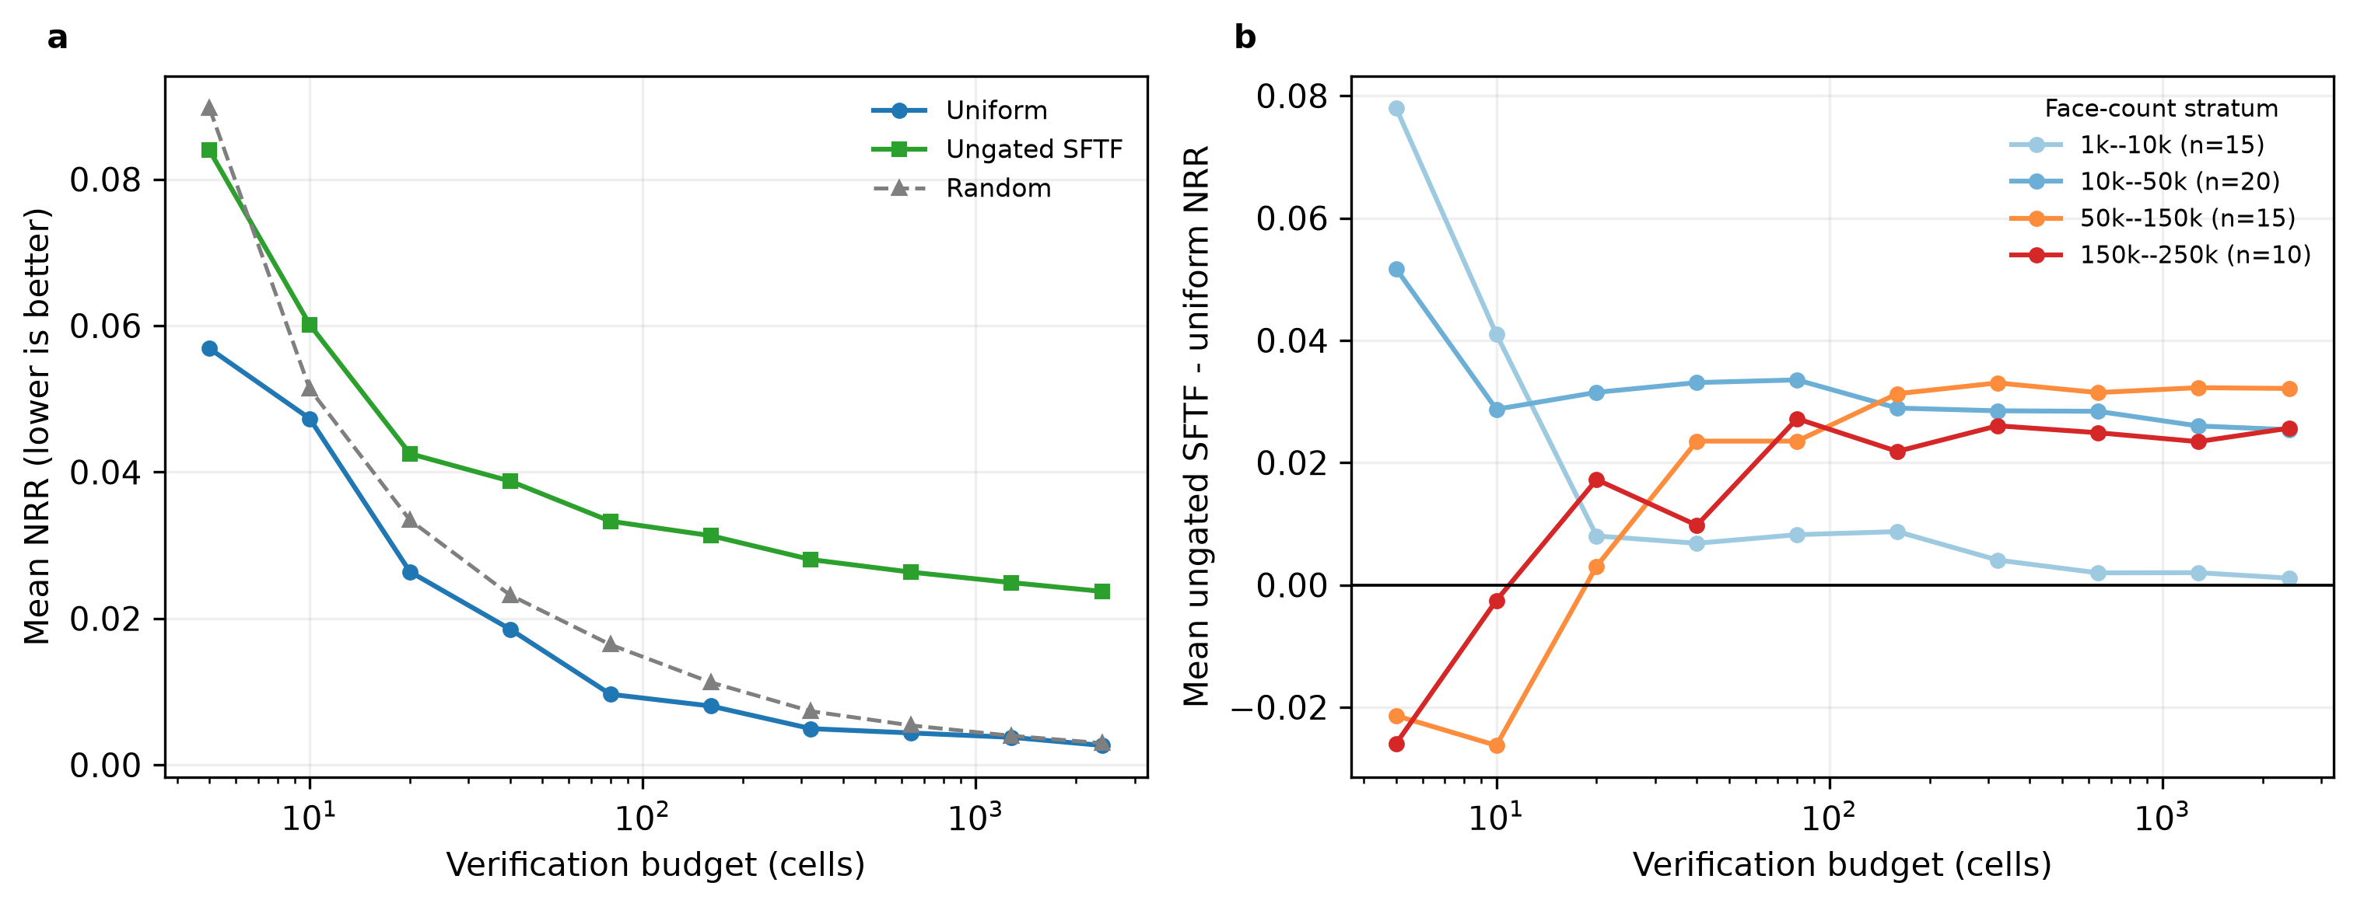
Figure 4. Budget–complexity map from cached-grid reanalysis. (a) Mean NRR of each matched-budget branch versus the verification budget (log scale). (b) Mean ungated SFTF minus uniform NRR by face-count stratum; negative favors SFTF. Subgroup patterns were exploratory and not multiplicity-controlled.

The 10-cell comparison was then repeated with both slicers on the 30-mesh panel (Table 3). On the 12 complex meshes, the mean contrast favored SFTF under all three references (TOMO -0.0329, Cura -0.0362, Prusa -0.0465), with sign agreement on 10/12 meshes for each slicer. The simplest stratum favored uniform under both engines, providing a coherent negative control. The 10k–50k stratum differed by reference: TOMO favored uniform (+0.0287), whereas Cura (-0.0418) and Prusa (-0.0353) favored SFTF. Complexity is therefore a useful but reference-dependent moderator rather than a rigid 50k-face threshold. The slicer bootstrap intervals included zero, so the map identifies the strongest regime for prospective testing rather than a universal routing rule.
Table 3. Small-budget slicer sensitivity for exploratory warm-start pattern. Mean paired selective-minus-uniform NRR at a 10-cell budget (negative favors SFTF) by pre-specified face-count stratum under TOMO and the two separately implemented slicer engines on the 30 cross-slicer meshes. Complex-stratum mean contrasts favor SFTF under all three references, whereas the simplest-stratum means favor uniform; no confirmatory subgroup superiority test was specified.
Stratum | $n$​ | TOMO $Δ$ | Cura $Δ$ | Prusa $Δ$
1k–10k | 8 | 0.0088 | 0.0105 | 0.0224
10k–50k | 10 | -0.0026 | -0.0418 | -0.0353
50k–150k | 8 | -0.0334 | -0.0108 | -0.0194
150k–250k | 4 | -0.0318 | -0.0870 | -0.1005
Complex ($≥$50k) | 12 | -0.0329 | -0.0362 | -0.0465

Cross-slicer comparison at the full budget
At the 2,400-cell budget, the two engines did not settle the question either way: mean selective-minus-uniform contrasts were -0.0218 in Cura (95% CI -0.1249 to 0.0740) and 0.0033 in Prusa (95% CI -0.0985 to 0.1075), pointing in opposite directions with intervals spanning zero (Figure 5). Direction rankings nonetheless agreed substantially—median per-mesh Spearman 0.820 (TOMO–Cura), 0.716 (TOMO–Prusa), and 0.900 (Cura–Prusa), with 66.7% mean top-five overlap—supporting TOMO’s role as an intermediate-fidelity verifier while cautioning that a favorable anchor under one engine need not transfer to another. Per-mesh slicer contrasts are intrinsically noisier than dense-grid contrasts (standard deviation about four times larger), so the slicer panel bounds rather than measures margin-scale effects; the design-sensitivity analysis is in the ESM.
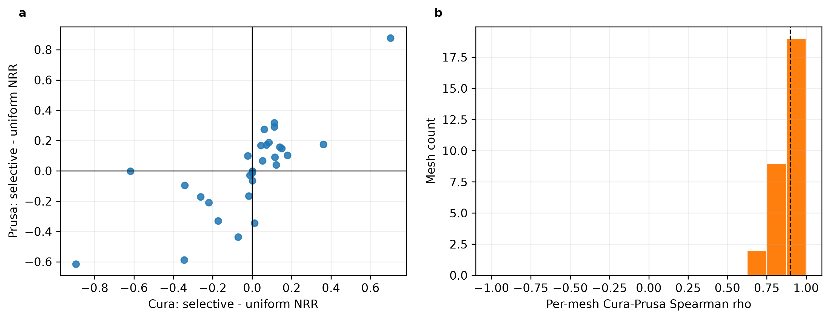
Figure 5. Separate-engine slicer comparison on a 30-mesh panel. (a) Per-mesh selective-minus-uniform NRR in Cura and Prusa. (b) Distribution of per-mesh direction-rank agreement over each mesh’s common finite panel.

Computational cost
SFTF candidate generation (2,048 directions, K=8,192, gate diagnostics included) averaged 4.57 s per mesh on the stated CPU, versus 131.0 s for a complete 130,321-cell TOMO sweep measured on non-overlapping runs—roughly a 29× gap that widens further against slicer-based verification, at 12.54 s (Cura) and 2.93 s (Prusa) per oriented mesh (Figure 6). This asymmetry makes tight-budget search practically relevant: when each verified direction costs seconds to minutes, reducing the verification set from thousands to a targeted handful can dominate the total workflow time.
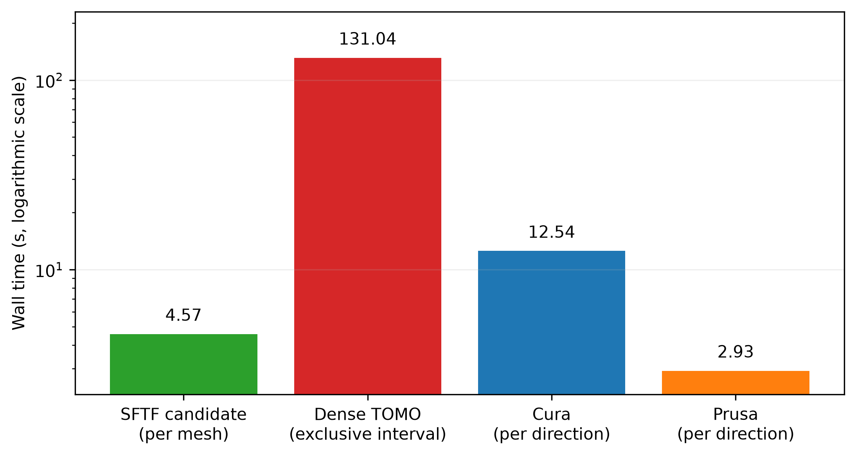
Figure 6. Measured component times: SFTF candidate generation versus dense TOMO sweeps and per-direction slicing in the two engines; raw per-mesh wall times are in the ESM.

Discussion
The main practical advantage is that SFTF moves expensive work out of the global search. It generated candidates in 4.57 s per mesh, roughly 29 times faster than the complete dense TOMO sweep, and the benefit grows when each candidate must be verified by a slicer. For complex parts under a 10-direction budget, the mean contrast favored SFTF under TOMO, Cura, and Prusa. This consistent three-reference direction supports using SFTF as a warm start when only a few high-fidelity evaluations are affordable. The low-budget subgroup intervals included zero, so this regime is a well-defined target for prospective validation rather than a universal guarantee. When thousands of inexpensive evaluations are available, the uniform design already covers the sphere well and remains the simpler choice.
The audit also carries two methodological strengths. First, budget-matched uniform search provides a demanding baseline at every verification budget. Second, the validation ladder compares the same candidate policy against dense TOMO and two production slicers rather than relying on a single support proxy. The substantial direction-rank agreement between engines (median Spearman correlations up to 0.900) supports TOMO as an intermediate-fidelity verifier while retaining a direct check against the intended slicer.
A structural observation helps explain the method. The scalar plate accumulation B(n) captures the dominant unsupported height, while the routing topology and tensor contraction retain face-to-face directionality when internal receivers matter. Equation (5) makes these components explicit and provides a direct path to later ablation and acceleration. This decomposition separates the inexpensive ranking signal from the directional information needed for support-aware interpretation.
The study is geometry-based and uses solver or slicer estimates rather than printed-part measurements; it also uses a one-hop receiver model and a retrospectively analyzed budget sweep. These constraints limit absolute manufacturing claims, while the reported computational timings and solver/slicer comparisons remain directly supported by the evaluated workflow.

Conclusions
SFTF provides a fast, interpretable front end for build-orientation search. By routing overhang support to another face or to a virtual build-plate node, it scores 2,048 directions in 4.57 s and forwards only a small set to TOMO or a slicer. The 60-mesh external audit showed the clearest value on complex geometry under tight verification budgets, where the 10-cell mean contrast favored SFTF under all three references. At the 2,400-cell budget, uniform search was already near-saturated and SFTF did not establish noninferiority, defining a useful boundary rather than removing the value of candidate generation. The resulting rule is simple: use uniform coverage when verification is cheap and plentiful; use SFTF as a targeted warm start when high-fidelity verification is expensive and the geometry is complex.

Acknowledgments

Use of AI-assisted tools
AI coding assistants, including OpenAI Codex and Anthropic Claude Code, were used to assist with portions of the research code implementation, figure-generation scripts, manuscript organization, language editing, and manuscript-support automation. All AI-assisted code and text were reviewed and validated by the author, who takes full responsibility for the methodology, data, results, references, and conclusions. No generative AI was used to generate research data, figures presented as novel research images, or references.

Author Contributions
InHwan Sul: Conceptualization, Methodology, Software, Validation, Formal analysis, Investigation, Data curation, Writing – original draft, Writing – review and editing, Visualization, and Funding acquisition.

Statements and Declarations

Ethical considerations
Not applicable. This computational study used geometrical models and software evaluations and did not involve human participants, human data, human tissue, or animals.

Consent to participate
Not applicable.

Consent for publication
Not applicable.

Declaration of conflicting interest
The author(s) declared no potential conflicts of interest with respect to the research, authorship, and/or publication of this article

Funding statement
This work was supported by the National Research Foundation of Korea (NRF) grant funded by the Korean government (MSIT) (grant number NRF-2022R1A2C1010072).

Data availability
The geometry-only holdout manifest, selection audit, SFTF implementation, tests, machine-readable TOMO/Cura/Prusa outcomes, and table and figure generators are maintained at https://github.com/cfms-lab/SFTF_2026. Access can be provided to the editor and reviewers during peer review, and the repository will be made publicly accessible upon publication. Third-party Thingi10K mesh files are not redistributed; the manifest provides model identifiers so eligible users can retrieve source meshes under their original licenses.

References
1. Gibson I, Rosen D, Stucker B, et al. Additive manufacturing technologies. 3rd ed. Cham: Springer, 2021.
2. Ezair B, Massarwi F and Elber G. Orientation analysis of 3D objects toward minimal support volume in 3D-printing. Comput Graph 2015; 51: 117–124. DOI: 10.1016/j.cag.2015.05.009.
3. Das P, Mhapsekar K, Chowdhury S, et al. Selection of build orientation for optimal support structures and minimum part errors in additive manufacturing. Comput-Aided Des Appl 2017; 14(sup1): 1–13. DOI: 10.1080/16864360.2017.1308074.
4. Langelaar M. Combined optimization of part topology, support structure layout and build orientation for additive manufacturing. Struct Multidisc Optim 2018; 57(5): 1985–2004. DOI: 10.1007/s00158-017-1877-z.
5. Vaissier B, Pernot J-P, Chougrani L, et al. Genetic-algorithm based framework for lattice support structure optimization in additive manufacturing. Comput-Aided Des 2019; 110: 11–23. DOI: 10.1016/j.cad.2018.12.007.
6. Jiang J, Xu X and Stringer J. Support structures for additive manufacturing: a review. J Manuf Mater Process 2018; 2: 64. DOI: 10.3390/jmmp2040064.
7. Mezzadri F, Bouriakov V and Qian X. Topology optimization of self-supporting support structures for additive manufacturing. Addit Manuf 2018; 21: 666–682. DOI: 10.1016/j.addma.2018.04.016.
8. Wang C and Qian X. Simultaneous optimization of build orientation and topology for additive manufacturing. Addit Manuf 2020; 34: 101246. DOI: 10.1016/j.addma.2020.101246.
9. Shi P, Qi Q, Qin Y, et al. Learn to rotate: part orientation for reducing support volume via generalizable reinforcement learning. IEEE Trans Ind Inform 2023; 19(12): 11687–11700. DOI: 10.1109/TII.2023.3249751.
10. Bacciaglia A, Liverani A and Ceruti A. Efficient part orientation algorithm for additive manufacturing in industrial applications. Int J Adv Manuf Technol 2024; 133: 5443–5462. DOI: 10.1007/s00170-024-14039-z.
11. Jung JY, Chee S and Sul IH. Support structure tomography using per-pixel signed shadow casting in human manikin 3D printing. Fash Text 2022; 9(1): 1–18. DOI: 10.1186/s40691-022-00290-z.
12. Kim JR and Sul IH. Fast prediction of 3D printing optimal orientation using general-purpose graphic processor unit calculation. 3D Print Addit Manuf 2026; 13(1): 50–62. DOI: 10.1089/3dp.2024.0165.
13. Kanatani K. Distribution of directional data and fabric tensors. Int J Eng Sci 1984; 22(2): 149–164. DOI: 10.1016/0020-7225(84)90090-9.
14. Xu J, Sheng H, Zhang S, et al. Surface accuracy optimization of mechanical parts with multiple circular holes for additive manufacturing based on triangular fuzzy number. Front Mech Eng 2021; 16: 133–150. DOI: 10.1007/s11465-020-0610-6.
15. Hung S-H, Zhang Y, Yeh H, et al. Feature curves and surfaces of 3D asymmetric tensor fields. IEEE Trans Vis Comput Graph 2022; 28(1): 33–42. DOI: 10.1109/TVCG.2021.3114808.
16. Zhou Q and Jacobson A. Thingi10K: a dataset of 10,000 3D-printing models. arXiv preprint arXiv:1605.04797, 2016.
17. Möller T and Trumbore B. Fast, minimum storage ray–triangle intersection. J Graph Tools 1997; 2(1): 21–28. DOI: 10.1080/10867651.1997.10487468.
18. Saff EB and Kuijlaars ABJ. Distributing many points on a sphere. Math Intell 1997; 19(1): 5–11. DOI: 10.1007/BF03024331.
19. González A. Measurement of areas on a sphere using Fibonacci and latitude–longitude lattices. Math Geosci 2010; 42(1): 49–64. DOI: 10.1007/s11004-009-9257-x.
20. Jiang J, Stringer J, Xu X, et al. Investigation of printable threshold overhang angle in extrusion-based additive manufacturing for reducing support waste. Int J Comput Integr Manuf 2018; 31(10): 961–969. DOI: 10.1080/0951192X.2018.1466398.
21. Piaggio G, Elbourne DR, Altman DG, et al. Reporting of noninferiority and equivalence randomized trials: an extension of the CONSORT statement. JAMA 2006; 295(10): 1152–1160. DOI: 10.1001/jama.295.10.1152.
22. Efron B and Tibshirani RJ. An introduction to the bootstrap. New York: Chapman & Hall, 1993.
23. Ernst MD. Permutation methods: a basis for exact inference. Stat Sci 2004; 19(4): 676–685. DOI: 10.1214/088342304000000396.

