Support Flow Tensor Field for Fast
Build-Orientation Candidate Generation
in Support-Requiring Additive Manufacturing

Abstract
Build orientation strongly controls the support volume in additive manufacturing; however, exhaustive orientation sweeps are costly. The proposed method targets support-requiring additive manufacturing processes in which the build orientation changes the amount of removable support material; it is not intended for inherently support-free processes. This study proposes a Support Flow Tensor Field (SFTF), a fast candidate generator that ranks promising build directions before local verification using a support-volume grid or slicer. For each sampled direction, the SFTF casts rays from the overhang faces to the actual receiver faces and forms a direction-dependent, asymmetric flow tensor. The build plate support term is further interpreted as a virtual ground receiver, which makes the dominant predictive term a unified Rayleigh cost. On five benchmark meshes with a 1° tomography grid, verifying the ±10° neighborhoods of the top-20 SFTF candidates used 3.57% of the grid on average and obtained a mean support volume ratio of 1.13 with a maximum of 1.58. Budget-matched uniform and random local window controls were weaker, with mean/maximum ratios of 1.64/2.79 and 2.62/5.44, respectively. This study also introduces the Adaptive Verification Escalation (AVE), an automatic hard-case escalation rule based on local-verification confidence signals. On the five stored 1° meshes, it reduced the worst ratio from 8.52 to 1.06 while using 2.99% of the full grid on average. On a five-group cached 3° audit, it reduced the maximum ratio from 12.44 to 1.62 at a mean budget of 4.96%. These results show that the SFTF is best viewed not as a replacement for precise support volume optimization, but as a low-cost warm start that concentrates expensive verification on a small number of likely basins.
Keywords: Support Flow Tensor Field (SFTF), build orientation, support volume, support-requiring additive manufacturing, local verification, candidate generation

Introduction
Build orientation strongly affects the support volume, material use, print time, and post-processing quality in support-requiring additive manufacturing, especially in FDM processes, in which downward overhangs beyond a critical angle require removable support [1]. Existing explicit or voxel/slicer-based orientation searches can accurately evaluate the support volume; however, exhaustive yaw–pitch sweeps remain expensive because they evaluate a dense set of directions even for simple shapes.

Related Work
Build-orientation studies include explicit support volume evaluation, voxel/depth normal acceleration, support structure design, and topology or multi-axis design approaches [2–8]. Shadow volumes and tomographic formulations estimate the support volume without full slicer generation and can be accelerated on GPUs [9–11]. In this study, TOMO_CPU and TOMO_CUDA denote the CPU and GPU tomographic support-volume evaluators used as verification and comparison backends [11], respectively, and SFTF is a candidate generator that reduces the number of directions passed to such verifiers.
Tensor or anisotropic formulations have also appeared in topology optimization: overhang constraints, anisotropic interface energy, and deposition-direction-dependent stiffness can bias a redesigned part toward a self-supporting geometry [12–14]. The present work is complementary: the input shape is fixed, and the tensor is used only to rank build orientations before an accurate TOMO or slicer verification step. A related industrial patent seeks build orientations for fixed complex parts but does not disclose an open algorithmic procedure [15].

Contribution
This study proposes the support flow tensor field (SFTF), a low-cost candidate generator rather than a replacement for precise TOMO/slicer optimization. For each sampled build direction, the SFTF estimates the internal face-to-face support flow by ray casting, adds a build-plate contribution through a virtual ground node, and then passes only a small set of promising basins for local TOMO verification. The main contributions of this study are as follows: (i) a direction-dependent asymmetric support-flow tensor for fixed parts; (ii) a ground-node derivation showing that the build-plate term is an exact Rayleigh contribution of the augmented tensor; (iii) a local-verification budget curve demonstrating that the SFTF top-20 windows recover a mean support-volume ratio of 1.13 with only 3.57% of the 1° grid; (iv) Adaptive Verification Escalation (AVE), an automatic escalation rule for narrow-basin hard cases; and (v) a five-group timing audit showing 1.4–34× Python and 10∼5,160× C++ speedups relative to TOMO_CPU on a 3° grid sweep.

Method

From Symmetric Support Tensor to Directional Flow
As a symmetric baseline, we define an area-weighted second-moment tensor of face normals
M=i​AimimiT,
following the general orientation/fabric tensor construction for directional data [16]. Here $A_{i}$ and $m_{i}$ are the area and outward normal of triangular face $i$. In this study, this tensor is used only as a support-oriented baseline: it summarizes the distribution of surface normals, but it does not encode whether a face is an overhang for a given build direction, whether another face can actually receive the support, or how far an unsupported face is from the build plate. SFTF therefore evaluates a direction-dependent asymmetric tensor for each unit build direction $n∈S^{2}$.
For face centroid $c_{i}$, the overhang coefficient is
$$O_{i}(n)=max(0,-m_{i}⋅n).$$
For sampled overhang source faces, a ray is cast along $-n$; if the first valid receiver is face $j$, the height is $h_{ij}(n)=(c_{i}-c_{j})⋅n$ and the face-to-face influence is
$$w_{ij}(n)=\frac{O_{i}(n)}{1+αh_{ij}(n)}, α=1/D,$$
where $D$ is the mesh bounding-box diagonal. The face-to-face support flow tensor is
F(n)=(i,j)∈R(n)​wij(n)AiAjmimjT,
with $R(n)$ denoting valid ray-cast support relationships. The receiver must not be the source face, must have positive height, and must face the build direction sufficiently ($m_{j}⋅n>0.05$). To bound cost, source faces are sampled deterministically in proportion to $A_{i}O_{i}(n)$ using
$$K_{ray}=clip(0.02N_{f},500,3000),$$
where $N_{f}$ is the number of mesh faces.

Ground-Node Build-Plate Term
If no valid receiver face is found, the overhang is supported by the build plate. With
$$z_{plate}(n)=\min_{v∈V}v⋅n, h_{iP}(n)=c_{i}⋅n-z_{plate}(n),$$
the scalar plate penalty is
B(n)=i∈B(n)​Oi(n)Ai(1+αhiP(n)).
This term is not ad hoc: as illustrated in Fig. 1, it is exactly the Rayleigh contribution obtained by adding a virtual receiver whose normal is the build direction $n$,
F(n)=(i,j)∈R(n)​wij(n)AiAjmimjT+i∈B(n)​Ai(1+αhiP)minT.
Since $m_{i}⋅n=-O_{i}(n)$, the symmetric Rayleigh contraction of the ground term contributes exactly $B(n)$ to the support cost, giving
$$\tilde{R}(n)=max(0,-n^{T}{\tilde{F}}_{s}(n)n)=R(n)+B(n).$$
The equality was numerically confirmed within 10^{–12} over the stored candidate pools.
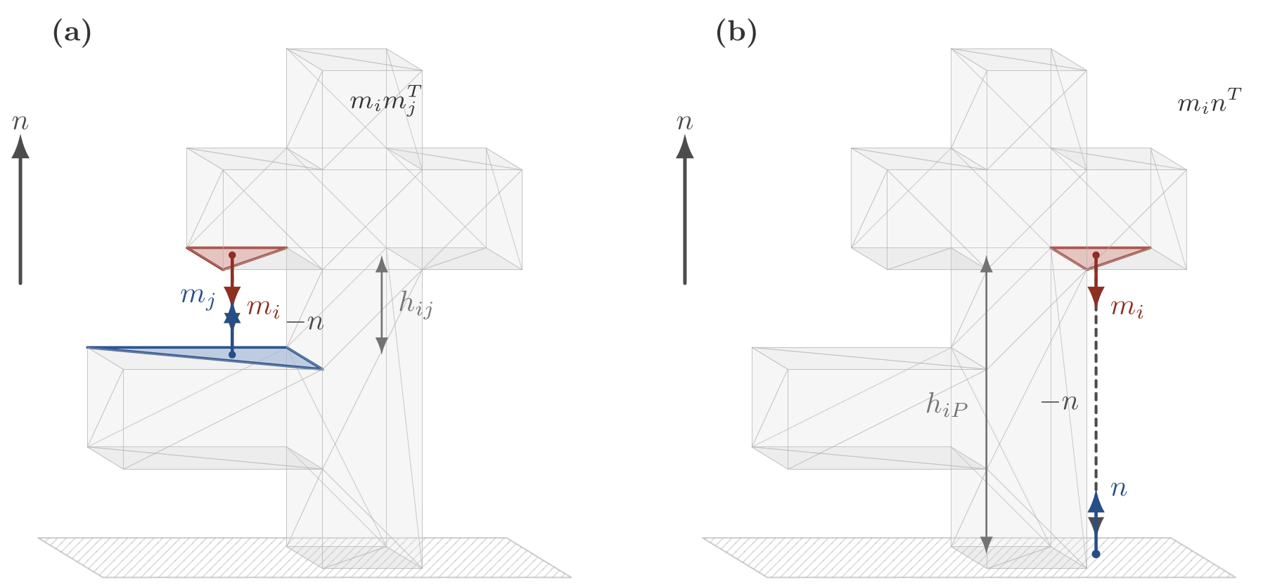
Fig. 1 Unified flow interpretation. Face-to-face support uses receiver normal $m_{j}$, while direct build-plate support is represented by a virtual receiver with normal $n$; the latter gives the Rayleigh contribution $B(n)$ in Eq. (9).

Candidate Generation and Rescoring
The deployed score is
J(n)=R(n)+P(n), P(n)=(i,j)∈R(n)​Oi(n)AiAj,
where $P$ is the face-to-face overhang amount after the height attenuation in w_{ij} cancels. A 512-direction Fibonacci-sphere sample was first evaluated, and the best directions were locally resampled to 2°∼8° cones, and angular non-maximum suppression kept the separated candidates. To avoid treating dimensionally different quantities as directly commensurate, the final candidate order uses rank-normalized features [J,R,P,B,H,S,σ₁], following the standard rank-transformation idea for scale-robust empirical modeling [17]. Here, H is the valid-hit count, and S and σ₁ are singular-value features retained only for post-processing. The reported calibration uses weights (w_{J},w_{R},w_{P},w_{B},w_{H},w_{S},w₁)=(0,0.731,-2.3897,2.1447,2.3109,-2.2922,1.6363)
Cross-validation reports the expected loss when these weights are not fitted to a sample. Implementation optimizations, including first-hit fallback and per-mesh cached geometry, reduced a 1k-direction evaluation of Bunny 69k from approximately 15.7s to 1.5s without changing the selected directions.

Evaluation Protocol and Datasets

Datasets and Experimental Environment
The dataset consists of five groups that deliberately separate and control the two axes of shape difficulty and the mesh scale. A–C set the scale in the 10¹–10⁵-face range and varied the difficulty axis from basic shapes to freeform organic shapes, revealing the fixed-cost floor of the exhaustive sweep (a cost almost independent of the mesh complexity). D and E fixed the difficulty as real manufacturing parts while pushing the scale axis from 256 faces to 1.04×10⁻⁶ faces, revealing the adaptive cost by which the candidate evaluation cost increases with mesh complexity. Therefore, A–E is not a single-size ramp, and the partial overlap of the face-count ranges of groups C and D is the result of a design that separates and controls the two axes, not an ordering error.
- A (basic shapes, 5; lower difficulty): cube, sphere, cylinder, cone, and torus (face count 10¹–10³).
- B (simple functional parts, 5; mid difficulty): u_bracket, hook, c_clamp, pipe_elbow, and hollow_box.
- C (organic/freeform benchmarks, 5; upper difficulty): standard scan/sculpture meshes, such as Bunny 69k, Manikin 13k, Dragon 100k, Happy 50k, and Lucy 50k. The Stanford grid meshes used in Section 4.3 are exactly this group.
- D (Thingi10K set 1, 10; lower scale): real manufacturing parts with 256–88,106 faces [18].
- E (Thingi10K set 2, 10; upper scale): large high-resolution meshes with approximately 5.1 × 10⁵–1.04 × 10⁶ faces.
All timing experiments were performed on a Windows 11 Education 64-bit workstation with an AMD Ryzen 9 9950X3D CPU (16 cores, 32 logical threads), 128 GB of RAM, and an NVIDIA GeForce RTX 5080 GPU (16 GB, driver 595.79). The Python implementation used Python 3.12.13 with NumPy 1.26.4, SciPy 1.17.1, Trimesh 4.4.0, Matplotlib 3.11.0, and Scikit-learn 1.9.0. TOMO_CPU and TOMO_CUDA were called through Windows dynamic-link library (DLL) interfaces, and the SFTF_C++ implementation was built as a Windows x64 C++ DLL using the Visual Studio 2022/MSVC toolchain with OpenMP parallelization.

Comparison Targets and Evaluation Protocol
First, we define the comparison targets and evaluation procedure used in the quantitative analyses up to Section 4.4. The comparison targets were as follows:
- PCA-based direction
- Existing Support Tensor eigenvector direction
- Initial eigenvector-based concave direction
- This study’s Support Flow Tensor Field direction
- TOMO_CPU or commercial-slicer-based $v_{ss}$ optimal direction
For each mesh, we generated a support structure volume(v_{ss}) contour at 1° intervals under a critical angle of 60° and evaluated how close the v_{ss} value at the top candidate directions of our method was to the global optimum. Even if the direction coordinates do not match exactly, if the v_{ss} values are similar, we regard them as optimal orientations of the same level. Also, considering the case where the global optimum appears scattered across multiple basins, we compare angularly separated top-$k$ basin representatives rather than simple top-$k$ grid points. The candidate basins proposed by the SFTF were re-input to TOMO_CPU to directly measure the support structure mass (M_{ss}), and based on that measured value, we marked the measured optimal and worst basins. Unless otherwise stated, the five-mesh accuracy results use the stored 1° TOMO_CPU grids; the A–E audit uses a coarser 3° grid only for scalability and held-out implementation checks; therefore, its ratios are not mixed with the 1° headline accuracy claims.

Results and Discussion

Stored TOMO Grid Comparison
The stored 1°and θ_{c}=60° TOMO_CPU grids were used as accuracy references. SFTF candidates were mapped to the nearest signed TOMO yaw–pitch cell, and the ratios were computed against the global TOMO best value. Table 1 presents the calibration-set comparison; the rank-tuned values are intentionally treated as in-sample values and are evaluated again by cross-validation.
Table 1 Comparison of the stored TOMO_CPU v_{ss} grid with current SFTF candidates. The ratio is the ratio of the v_{ss} of the SFTF candidate to the global optimal v_{ss} of TOMO.
Mesh | TOMO best | SFTF score1 | Ratio | SFTF best-of-3 | Ratio
Bunny 69k | 3201.39 | 4665.85 | 1.46 | 4665.85 | 1.46
Manikin 13k | 4657.72 | 8675.96 | 1.86 | 8675.96 | 1.86
Dragon 100k | 24446.98 | 45804.41 | 1.87 | 39547.57 | 1.62
Happy 50k | 2112.47 | 25467.94 | 12.06 | 23727.49 | 11.23
Lucy 50k | 5036.14 | 14192.68 | 2.82 | 14192.68 | 2.82
Raw ranking alone is insufficient for the Happy 50k hard case; therefore, SFTF is used as a warm start for local TOMO verification, rather than as a standalone optimizer.

Local Verification and Adaptive Verification Escalation
The deployed metric is a budget curve: the top-$K$ SFTF candidates define ±10° local windows, and the best TOMO grid value inside their union is selected. This changes the interpretation from whether the top-3 ranking alone solves the problem to whether the SFTF places a small verification budget near useful TOMO basins. Table 2 summarizes the budget–accuracy trade-off.
Table 2 Budget curve of top-$K$ local TOMO verification around SFTF candidates. The budget is the mean fraction of the 1° TOMO grid covered by the union of the local windows.
Top-K | Mean ratio | Median ratio | Max ratio | Mean grid budget | Ratio $≤2.0$
3 | 2.59 | 1.15 | 8.52 | 0.87% | 4/5
10 | 2.52 | 1.00 | 8.52 | 2.12% | 4/5
20 | 1.13 | 1.00 | 1.58 | 3.57% | 5/5
30 | 1.01 | 1.00 | 1.06 | 5.43% | 5/5

The budget-matched controls in Table 3 show that the gain is not only the amount of grid inspected; SFTF places the windows better than the uniform axis or random seeds.

Table 3 Budget-matched local TOMO controls at the per-mesh SFTF top-20 grid cell budget. The SFTF improves both the mean and worst-case ratios, showing that the warm-start value is the placement of local windows, not only the budget size.
Policy | Mean | Median | Max | Budget | $≤2.0$​
SFTF top-$20$ local | 1.13 | 1.00 | 1.58 | 3.57% | 5/5
Uniform-axis matched | 1.64 | 1.38 | 2.79 | 3.57% | 4/5
Random matched (median) | 2.62 | 1.75 | 5.44 | 3.57% | 3/5

Table 4 lists the resulting automatic escalation policies. Adaptive Verification Escalation (AVE) escalates only when ordinary top-$10$ local verification is uncertain. The trigger uses local-verification quantities only,
$$\begin{aligned}{trigger}_{AVE}&=\left([η≥0.03]∧[edge=1∨g≤1.5]\right)∨[edge=1∧g≥3.0], \\ η&=V_{ss}^{loc}/V_{bbox}, g=V_{ss}^{seed}/V_{ss}^{loc}.\end{aligned}$$
Here, ‘edge=1’ indicates that the best local cell lies within 1° of the window boundary. The absolute threshold $η≥0.03$ may also fire on genuinely support-heavy parts, but escalation only expands the verified candidate set; it can spend more budget but cannot worsen the selected verified value.

Table 4 Automatic Adaptive Verification Escalation (AVE) from the top-$10$ local TOMO verification. The detector of Eq. (11) selected only Happy 50k for escalation.
Policy | Expanded | Mean | Max | Budget | $≤2.0$​
Top-$10$ local | 0/5 | 2.52 | 8.52 | 2.12% | 4/5
AVE | 1/5 | 1.01 | 1.06 | 2.99% | 5/5
AVE+Pareto | 1/5 | 1.01 | 1.06 | 3.18% | 5/5
All-mesh top-$30$ | 5/5 | 1.01 | 1.06 | 5.43% | 5/5

The five stored meshes are in-sample for the detector thresholds. Table 5 lists the held-out cached A–E audits, which contain $16$ ratio-valid records after excluding $19$ records with non-positive TOMO values at θ_{c}=60°.

Table 5 Cached five-group audit of the tiered AVE policy on ratio-valid 3°, θ_{c}=60° TOMO_CPU data. The top-$10$ baseline over all ratio-valid records has mean ratio 2.07, maximum of 12.44 , mean budget 2.45%, and 13/16 records below ratio 2.0
Group | $n$​ | Expanded | Mean | Max | Budget | $≤2.0$​
A | 1 | 1 | 1.07 | 1.07 | 7.25% | 1/1
B | 1 | 0 | 1.00 | 1.00 | 2.74% | 1/1
C | 5 | 1 | 1.09 | 1.23 | 3.08% | 5/5
D | 5 | 3 | 1.26 | 1.61 | 7.20% | 5/5
E | 4 | 2 | 1.10 | 1.21 | 4.48% | 4/4
All | 16 | 7 | 1.14 | 1.62 | 4.96% | 16/16

The audit reduced the maximum ratio from 12.44 to 1.62 and maintained all ratio-valid records below 2.0, with a mean budget of 4.96%.

Representative TOMO Landscapes
Figures 2 and 3 show the contrast between the broad-basin ordinary case and the Happy 50k hard-case. Additional Bunny 69k, Manikin 13k, and Lucy 50k landscapes are shown in Supplementary Figs. S5–S7.
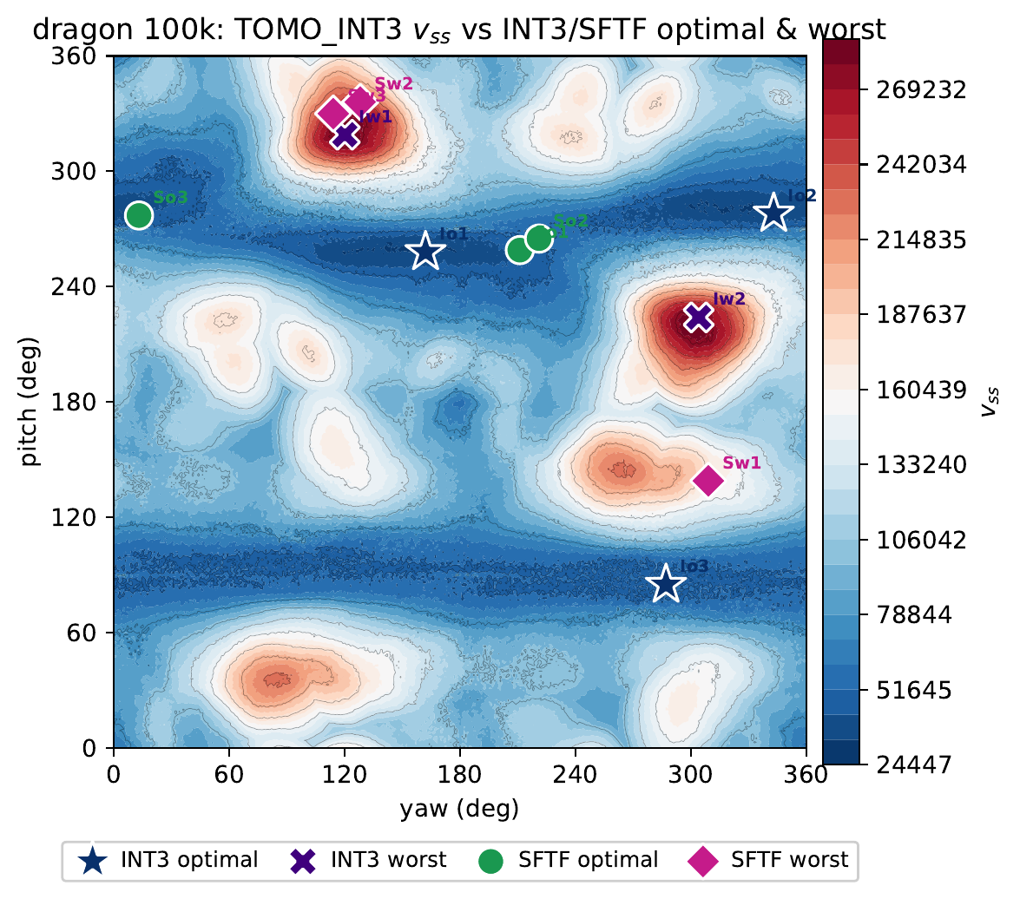
Fig. 2 Representative TOMO_CPU v_{ss} landscape of Dragon 100k. The global optimum forms a distinct low-cost basin, illustrating a non-hard case in which coarse SFTF candidates already cover useful regions.
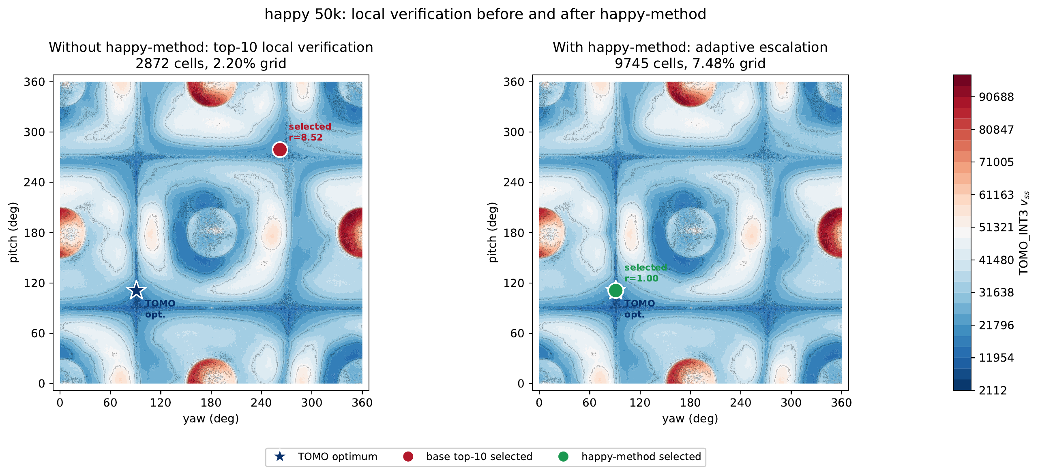
Fig. 3 Happy 50k before and after AVE on the same TOMO_CPU v_{ss} landscape. The base top-$10$ local verification selects a high-cost basin ($v_{ss}=17,991$, ratio $8.52$), whereas AVE recovers the TOMO optimum ($v_{ss}=2,112$, ratio $1.00$).

Feature Contribution and Generalization
Table 6 reports Spearman rank correlations over the full candidate pools and shows that the build-plate term is the most stable single predictor of TOMO $v_{ss}$.

Table 6 Spearman rank correlation between features and TOMO v_{ss} for the entire candidate pool. The larger the positive value, the more valid the feature is as a cost function.
Feature | Bunny 69k | Manikin 13k | Dragon 100k | Happy 50k | Lucy 50k | Average
J=R+P+B | 0.46 | 0.26 | 0.80 | 0.27 | 0.57 | 0.47
R(Rayleigh) | 0.40 | $-0.33$​ | $-0.57$​ | $-0.03$​ | 0.14 | $-0.08$​
P(pair flow) | $-0.04$​ | $-0.38$​ | $-0.72$​ | 0.00 | $-0.59$​ | $-0.34$​
B(build-plate) | 0.50 | 0.66 | 0.85 | 0.29 | 0.62 | 0.58
H(hit count) | 0.24 | $-0.53$​ | $-0.73$​ | $-0.00$​ | $-0.71$​ | $-0.35$​
S(nuclear) | $-0.02$​ | $-0.36$​ | $-0.70$​ | $-0.05$​ | $-0.26$​ | $-0.28$​
$σ_{1}$​ | $-0.03$​ | $-0.34$​ | $-0.66$​ | $-0.07$​ | 0.07 | $-0.21$​

The full objective ablation is provided in Supplementary Table S5. It shows that adding nuclear/$σ_{1}$ terms does not alter candidate selection, while tensor-only variants are weakest. Table 7 separates the unified Rayleigh term from its components. The ground-node reformulation explains why $B$ is not merely a scalar patch: the unified Rayleigh term $\tilde{R}=R+B$ is a tensor contraction and has the strongest average single-feature correlation.

Table 7 Spearman correlation of the unified Rayleigh term $\tilde{R}=R+B$ and single terms with TOMO $v_{ss}$ (higher is better). $\tilde{R}$ was computed directly from the augmented tensor and agrees with $R+B$ within 10⁻¹².
Mesh | $R$​ | $B$​ | $\tilde{R}=R+B$​ | $J=R+P+B$​
Bunny 69k | 0.40 | 0.50 | 0.52 | 0.46
Manikin 13k | $-0.33$​ | 0.66 | 0.65 | 0.26
Dragon 100k | $-0.57$​ | 0.85 | 0.89 | 0.80
Happy 50k | $-0.03$​ | 0.29 | 0.31 | 0.27
Lucy 50k | 0.14 | 0.62 | 0.62 | 0.57
Average | $-0.08$​ | 0.58 | 0.60 | 0.47
The best-of-3 comparison in Supplementary Table S6 shows the same trend: excluding the Happy 50k hard case, removing the negative-signal $P$ term improves the mean ratio from $2.82$ to $2.50$. A height-convention check also supported the current sign choice: amplification for tall build plate support and attenuation for distant face-to-face support.
Cross-validation exposes the optimism of the calibration set rank tuning. Table 8 summarizes the leave-one-mesh-out (LOMO) check: training excludes the target mesh, fits the rank-normalized weights on the others, and evaluates the held-out best-of-3 ratio.

Table 8 LOMO cross-validation best-of-3 ratio of rank tuning (lower is better). The in-sample column is the calibration set fit value presented in Table 1. The oracle is the best direction within the candidate pool, representing the upper bound of the candidate generation.
Mesh | oracle | untuned $J$ | in-sample (reported) | LOMO
Bunny 69k | 1.46 | 2.47 | 1.46 | 2.20
Manikin 13k | 1.13 | 3.99 | 1.86 | 2.62
Dragon 100k | 1.29 | 2.01 | 1.62 | 1.86
Lucy 50k | 1.02 | 2.82 | 2.82 | 2.82
Average | 1.22 | 2.82 | 1.94 | 2.37

The in-sample average 1.94 becomes 2.37 under LOMO but remains better than PCA (3.63) and the symmetric Support Tensor baseline (4.30). Table 9 summarizes the comparison between the two models. The larger five-group nested CV gives the same qualitative message: median ratios remain close to one, but a few high-angle hard cases dominate the mean. Critical angle matching and dimensional normalization did not consistently improve the ranking, and the coarse-sampling oracle in Supplementary Table S4 shows that Happy 50k is mainly a candidate-coverage/local-verification problem.
Table 9 Unified comparison of existing methods and SFTF (best-of-3 signed $v_{ss}$ ratio, lower is better). SFTF-tuned is a cross-validated generalization estimate.
Mesh | PCA | Support  Tensor | SFTF  untuned | SFTF tuned  (LOMO) | oracle
Bunny 69k | 2.82 | 3.71 | 2.47 | 2.20 | 1.46
Manikin 13k | 2.65 | 2.50 | 3.99 | 2.62 | 1.13
Dragon 100k | 2.69 | 2.33 | 2.01 | 1.86 | 1.29
Lucy 50k | 6.37 | 8.67 | 2.82 | 2.82 | 1.02
Average | 3.63 | 4.30 | 2.82 | 2.37 | 1.22

Five-Group Implementation Audit
The A–E audit separates shape difficulty from the mesh scale. This compares TOMO_CPU, TOMO_CUDA, Python SFTF, and C++ SFTF for the same 3° θ_{c}=60° sweep setting. The full per-mesh timing table is presented in Supplementary Table S1, and Table 10 presents the group averages.

Table 10 Group-wise average execution time and speed ratio. The C++ SFTF average is in ms, whereas the two TOMO’s and Python SFTF averages are in seconds. A TOMO_CUDA/TOMO_CPU ratio greater than 1 indicates a case where the CUDA backend is slower than the CPU.
Group | TOMO |  | SFTF |  | comparison
Group | t_{CPU}(s) | t_{CUDA}(s) | t_{py}(s) | t_{C++}(ms) | t_{CPU} /t_{py} | t_{CPU} /t_{C++}
A | 42.75 | 15.36 | 0.32 | 8.9 | 54.4–381.9× | 1,683–50,641×
B | 42.45 | 14.94 | 0.38 | 9.3 | 58.0–269.0× | 1,857–56,027×
C | 51.48 | 60.13 | 1.85 | 183.6 | 23.3–36.9× | 192–854×
D | 53.58 | 112.38 | 1.97 | 124.5 | 12.8–128.8× | 213–8,920×
E | 643.75 | 740.88 | 15.57 | 3123.5 | 8.3–59.1× | 56.8–258.6×

For all 35 meshes, Python SFTF was 1.434x faster than TOMO_CPU, whereas SFTF_C++ was 10-5,160 times faster. TOMO_CUDA helps with simple A/B shapes but is often slower than TOMO_CPU on organic and large meshes in this environment; thus, the dominant gain is algorithmic: reducing the number of directions to evaluate, not merely changing the exhaustive-sweep backend. Group E confirms bounded scaling: the clipped ray budget in Eq. (5) caps per-direction ray cost at 3,000 samples; thus, large meshes near 10⁶ faces remain feasible. Supplementary Table S2 lists the R/P/B / hit decomposition, Supplementary Table S3 lists the critical-angle sweeps, and Supplementary Fig. S1 shows the five-group best/worst overlay, and Supplementary Figs. S2–S4 visualize the Bunny 69k $K_{ray}$ trade-off. These results support the intended role of SFTF: a fast, interpretable candidate generator whose outputs are verified locally by TOMO or a slicer program.

Conclusion
This study proposed a direction evaluation method that combines the Support Flow Tensor Field and build plate penalty for build orientation optimization in additive manufacturing. The eigenvector interpretation of the existing symmetric tensor is useful for shape directionality; however, it does not sufficiently reflect direction-dependent overhangs, internal visibility, and build-plate support requirements.
The current algorithm directly computes an asymmetric support flow tensor for each candidate direction and constructs a basic objective function J = R + P + B, which combines the Rayleigh support cost, face-to-face support volume, and build plate penalty. In the actual final candidate selection, a rank-normalized tuning score T of J, R, P, B, H, S, and σ₁ is applied to a candidate pool created by coarse spherical sampling and small-angle refined sampling to choose promising orientations to pass to slicer/TOMO verification. When used in this way, verifying the ±10° neighborhoods of only the top-$20$ candidates recovers a mean support-volume ratio of 1.13 (maximum 1.58) while inspecting 3.57% of the 1° grid, and the AVE automatically widens this budget only for detected hard cases (§4.2.1).
The quantitative analysis (§4.3) shows the strengths and limitations of the method. The cross-validated SFTF was consistently superior to the PCA and Support Tensor eigenvector directions, supporting the initial assumption. At the same time, most of the predictive power originates from the build-plate penalty and the internal visibility evaluation, the marginal contribution of some tensor-derived terms such as nuclear/$σ_{1}$ is small, and the calibrated rank tuning weights show an optimistic bias on unseen meshes. Meanwhile, in §2.2–§4.3, we show that the build plate penalty is exactly equivalent to the Rayleigh contribution obtained by adding a virtual ground node to the flow tensor. This unifies the term driving the predictive power into the tensor contraction $\tilde{R}=R+B$, justifying the “tensor” formulation, and confirms that $\tilde{R}$, excluding the negative-signal face-to-face support volume $P$, is consistently superior to the existing $J$.
Therefore, in future work, we will (i) determine the weights on a cross-validation basis rather than a calibration set to control overfitting, (ii) remove terms with marginal contributions or replace them with features highly correlated with the actual v_{ss}, such as face-to-face self-support coverage or a support-volume proxy, (iii) normalize the dimensions of the objective function terms to secure the physical meaning and transferability of the weights, (iv) add projection-area, print-height, and contact-stability terms to extend to a multi-objective orientation optimization model, and (v) as observed in Section 4.4, since the TOMO optimal orientation shifts with the critical angle θ_{c} while the current SFTF candidates are invariant to θ_{c}, extend to θ_{c} -dependent candidate generation with overhang truncation turned on. For cases where the ordinary top-K candidate generation does not include a stable near-optimal basin, AVE provides an automatic escalation path, and future work will refine its thresholds on a larger family-held-out validation set.

Statements and Declarations

Funding
Funding information is provided separately in the submission system and title page file to preserve the double-anonymous review.

Competing interests
The author declares no conflicts of interest.

Data availability
The numerical results reported in this manuscript are based on cached mesh-evaluation records, support volume grids, and generated summary tables maintained using the research code. An anonymized repository or supplementary archive can be supplied during the peer-review process, and a permanent public repository link can be provided after acceptance. Third-party mesh models should be obtained from their original sources, subject to the respective licenses.

Code availability
The code and scripts supporting the reported results will be made publicly available upon the acceptance of the manuscript. An anonymized review archive can be provided during the peer-review process if required.

Use of artificial intelligence tools
AI coding assistants, including OpenAI Codex and Anthropic Claude Code, were used to assist with portions of the research code implementation, figure-generation scripts, and manuscript support automation. All generated codes, experimental results, and manuscript revisions were reviewed and validated by the author.

Ethics approval and consent to participate
Not applicable.

Consent for publication
Not applicable.

References
1. Gibson I, Rosen D, Stucker B (2015) Additive manufacturing technologies, 2nd ed. Springer, New York
2. Das P, Mhapsekar K, Chowdhury S, et al (2017) Selection of build orientation for optimal support structures and minimum part errors in additive manufacturing. Comput.-Aided Des. Appl. 14:1–13. https://doi.org/10.1080/16864360.2017.1308074
3. Wang CCL, Leung Y-S, Chen Y (2010) Solid modeling of polyhedral objects by layered depth-normal images on the GPU. Comput.-Aided Des. 42:535–544. https://doi.org/10.1016/j.cad.2010.02.001
4. Vaissier B, Pernot J-P, Chougrani L, Véron P (2019) Genetic-algorithm based framework for lattice support structure optimization in additive manufacturing. Comput.-Aided Des. 110:11–23. https://doi.org/10.1016/j.cad.2018.12.007
5. Jiang J, Stringer J, Xu X, Zhong RY (2018) Investigation of printable threshold overhang angle in extrusion-based additive manufacturing for reducing support waste. Int. J. Comput. Integr. Manuf. 31:961–969. https://doi.org/10.1080/0951192X.2018.1466398
6. Mirzendehdel AM, Suresh K (2016) Support structure constrained topology optimization for additive manufacturing. Comput.-Aided Des. 81:1–13. https://doi.org/10.1016/j.cad.2016.07.006
7. Langelaar M (2018) Combined optimization of part topology, support structure layout and build orientation for additive manufacturing. Struct. Multidiscip. Optim. 57:1985–2004. https://doi.org/10.1007/s00158-017-1877-z
8. Dai C, Wang CCL, Wu C, et al (2018) Support-free volume printing by multi-axis motion. ACM Trans. Graph. 37:1–14. https://doi.org/10.1145/3197517.3201342
9. Ezair B, Massarwi F, Elber G (2015) Orientation analysis of 3D objects toward minimal support volume in 3D-printing. Comput. Graph. 51:117–124. https://doi.org/10.1016/j.cag.2015.05.009
10. Jung JY, Chee S, Sul IH (2022) Support structure tomography using per-pixel signed shadow casting in human manikin 3D printing. Fash. Text. 9:1–18. https://doi.org/10.1186/s40691-022-00290-z
11. Kim JR, Sul IH (2026) Fast prediction of 3D printing optimal orientation using general-purpose graphic processor unit calculation. 3D Print. Addit. Manuf. 13:50–62. https://doi.org/10.1089/3dp.2024.0165
12. Gaynor AT, Meisel NA, Williams CB, Guest JK (2014) Topology optimization for additive manufacturing: Considering maximum overhang constraint. In: 15th AIAA/ISSMO Multidiscip. Anal. Optim. Conf. p 2036. https://doi.org/10.2514/6.2014-2036
13. Garcke H, Lam KF, Nürnberg R, Signori A (2023) Overhang penalization in additive manufacturing via phase field structural topology optimization with anisotropic energies. Appl. Math. Optim. 87:44. https://doi.org/10.1007/s00245-022-09939-z
14. Shin S, Park Y, Yoon GH (2025) Topology optimization for multi-axis additive manufacturing considering overhang and anisotropy. Int. J. Mech. Sci. 301:110443. https://doi.org/10.1016/j.ijmecsci.2025.110443
15. Smith R, Hollenbeck MC (2025) Build orientation for additive manufacturing of complex structures
16. Kanatani K-I (1984) Distribution of directional data and fabric tensors. International Int. J. Eng. Sci. 22:149–164. https://doi.org/10.1016/0020-7225(84)90090-9
17. Conover WJ, Iman RL (1981) Rank transformations as a bridge between parametric and nonparametric statistics. Am. Stat. 35:124–129. https://doi.org/10.1080/00031305.1981.10479327
18. Zhou Q, Jacobson A (2016) Thingi10K: A dataset of 10,000 3D-printing models. arXiv preprint arXiv:160504797

In this paper, rank tuning denotes fitting weights after converting each feature to its within-candidate rank; it is an empirical candidate-ranking calibration, not continuous geometric optimization.
The five-group audit uses a coarser $3^{∘}$ TOMO grid, while the main stored benchmark uses a $1^{∘}$ grid; this gives an about $9×$ smaller direction count and is used only for implementation timing and audit.

