Electronic Supplementary Material

Support Flow Tensor Field for Fast Build-Orientation Candidate

Generation in Support-Requiring Additive Manufacturing

Supplementary Tables

Table S1 Computation time of the four implementations for the $35$ meshes of the five groups. $t_{INT3}$ and $t_{CUDA}$ are the TOMO_CPU/TOMO_CUDA $1^{∘}$ exhaustive sweep ($θ_{c}={60}^{∘}$) DLL times respectively, $t_{py}$ is the Python SFTF candidate evaluation, and $t_{C++}$ is the SFTF_C++ pure computation time. hit is the number of valid face-to-face supports of the SFTF_python top direction.
ID | Shape | Faces | hit | TOMO |  | SFTF |  | comparison
 |  |  |  | t_{CPU}(s) | t_{CUDA}(s) | t_{py}(s) | t_{C++}(ms) | t_{CPU} /t_{py} | t_{CPU} /t_{C++}
A: basic shapes
A1 | cube | 12 | 0 | 49.64 | 11.45 | 0.13 | 4.1 | $$382×$$ | $$12,108×$$
A2 | sphere | 2,976 | 498 | 40.22 | 13.82 | 0.74 | 23.9 | $$54×$$ | $$1,683×$$
A3 | cylinder | 192 | 0 | 39.64 | 22.96 | 0.17 | 1.3 | $$233×$$ | $$30,494×$$
A4 | cone | 96 | 0 | 40.51 | 14.99 | 0.12 | 0.8 | $$338×$$ | $$50,641×$$
A5 | torus | 2,304 | 184 | 43.72 | 13.57 | 0.45 | 14.2 | $$97×$$ | $$3,079×$$
B: simple parts
B1 | u_bracket | 28 | 2 | 40.34 | 13.91 | 0.15 | 3.9 | $$269×$$ | $$10,344×$$
B2 | hook | 1,560 | 235 | 41.48 | 12.51 | 0.58 | 15.8 | $$72×$$ | $$2,626×$$
B3 | c_clamp | 28 | 1 | 44.82 | 17.43 | 0.17 | 0.8 | $$264×$$ | $$56,027×$$
B4 | pipe_elbow | 2,400 | 500 | 46.99 | 13.39 | 0.81 | 25.3 | $$58×$$ | $$1,857×$$
B5 | hollow_box | 24 | 4 | 38.63 | 17.47 | 0.21 | 0.9 | $$184×$$ | $$42,921×$$
C: organic benchmarks
C1 | Bunny 69k | 69,662 | 81 | 47.46 | 52.55 | 1.69 | 247.7 | $$28×$$ | $$192×$$
C2 | Manikin 13k | 13,672 | 134 | 37.85 | 30.44 | 1.02 | 44.3 | $$37×$$ | $$854×$$
C3 | Dragon 100k | 99,999 | 970 | 73.81 | 94.23 | 3.17 | 323.3 | $$23×$$ | $$228×$$
C4 | Happy 50k | 49,944 | 240 | 47.15 | 51.71 | 1.50 | 130.1 | $$31×$$ | $$363×$$
C5 | Lucy 50k | 49,999 | 542 | 51.15 | 71.73 | 1.87 | 172.5 | $$27×$$ | $$297×$$
D: Thingi10K set 1
D1 | 37009 | 23,909 | 57 | 51.46 | 144.10 | 1.37 | 114.5 | $$38×$$ | $$449×$$
D2 | 37010 | 13,247 | 35 | 45.58 | 148.94 | 1.24 | 63.5 | $$37×$$ | $$718×$$
D3 | 37011 | 17,288 | 82 | 52.65 | 59.75 | 1.15 | 89.2 | $$46×$$ | $$590×$$
D4 | 37091 | 256 | 42 | 46.38 | 21.23 | 0.36 | 5.2 | $$129×$$ | $$8,920×$$
D5 | 37095 | 468 | 65 | 38.19 | 39.54 | 0.49 | 6.2 | $$78×$$ | $$6,160×$$
D6 | 37111 | 88,106 | 386 | 99.34 | 212.38 | 3.42 | 465.4 | $$29×$$ | $$213×$$
D7 | 37137 | 64,078 | 434 | 73.92 | 233.45 | 2.90 | 305.5 | $$25×$$ | $$242×$$
D8 | 37402 | 8,322 | 119 | 40.32 | 73.76 | 2.43 | 49.7 | $$17×$$ | $$811×$$
D9 | 37415 | 13,340 | 77 | 44.51 | 126.27 | 2.96 | 65.4 | $$15×$$ | $$681×$$
D10 | 37416 | 12,036 | 496 | 43.45 | 64.44 | 3.39 | 80.4 | $$13×$$ | $$540×$$
E: Thingi10K set 2, large meshes
E1 | 39507 | 969,520 | 562 | 973.29 | 1041.71 | 16.92 | 4387.6 | $$58×$$ | $$222×$$
E2 | 45809 | 517,589 | 107 | 513.22 | 585.85 | 9.71 | 1984.5 | $$53×$$ | $$259×$$
E3 | 45811 | 1,037,876 | 1,309 | 1038.40 | 1153.79 | 18.69 | 4515.6 | $$56×$$ | $$230×$$
E4 | 46012 | 638,754 | 50 | 658.57 | 802.44 | 11.15 | 2583.8 | $$59×$$ | $$255×$$
E5 | 55280 | 900,490 | 1,072 | 939.61 | 1102.83 | 16.78 | 3957.9 | $$56×$$ | $$237×$$
E6 | 59197 | 786,432 | 699 | 776.49 | 826.30 | 17.50 | 4119.5 | $$44×$$ | $$188×$$
E7 | 61384 | 516,608 | 1,766 | 521.54 | 642.22 | 12.85 | 2065.0 | $$41×$$ | $$253×$$
E8 | 64445 | 514,938 | 2,288 | 125.46 | 211.96 | 15.05 | 2208.0 | $$8.3×$$ | $$57×$$
E9 | 64446 | 514,938 | 2,288 | 125.66 | 211.60 | 14.93 | 2211.4 | $$8.4×$$ | $$57×$$
E10 | 65942 | 754,688 | 1,175 | 765.24 | 830.14 | 22.11 | 3201.6 | $$35×$$ | $$239×$$

Table S2 Cost decomposition of the SFTF top direction of representative meshes. Convex basic shapes (cube, cone) are pure build-plate support with hit=0, R=P=0, and the rest show face-to-face self-support (P) and build-plate support (B) together.
ID | Shape | hit | $R$​ | $P$​ | $B$​
A1 | cube | 0 | 0 | 0 | 401.5
A4 | cone | 0 | 0 | 0 | 179.8
A2 | sphere | 498 | 47.3 | 109.5 | 0.02
A5 | torus | 184 | 15.9 | 40.3 | 209.1
B2 | hook | 235 | 19.9 | 55.4 | 128.7
C1 | Bunny 69k | 81 | 1.4 | 25.2 | 176.3
C3 | Dragon 100k | 970 | 109.4 | 267.6 | 417.5
D6 | 37111 | 386 | 227.9 | 932.8 | 1,613
D10 | 37416 | 496 | 6,381 | 12,190 | 1.3

Table S3 TOMO_CPU global minimum V_{ss} by critical angle (representative meshes, $3^{∘}$ grid). The support volume decreases monotonically as $θ_{c}$ increases. In the region of large $θ_{c}$, almost all faces become self-supporting and support is essentially unnecessary, in which case the numerical residual of the MSST decomposition V_{ss} = V_{tc} - V_{o} - V_{nv} can make $v_{ss}$ appear as a small negative number (effectively $0$).
ID | Mesh | $θ_{c}=0^{∘}$​ | ${30}^{∘}$​ | ${45}^{∘}$​ | ${60}^{∘}$​ | ${90}^{∘}$​
A1 | cube | 1,769 | 1,769 | 0 | 0 | 0
B2 | hook | 1,736 | 725 | 319 | 133 | 0
C1 | Bunny 69k | 49,780 | 23,660 | 13,970 | 5,147 | $-7,857$​
C3 | Dragon 100k | 217,000 | 119,400 | 84,500 | 24,450 | $-18,090$​
D1 | 37009 | 65,810 | 4,729 | 1,061 | $-941$​ | $-7,226$​
D6 | 37111 | 99,200 | 58,980 | 38,740 | 9,703 | $-6,270$​
E1 | 39507 | 26,380 | 12,510 | 6,493 | $-6,337$​ | $-13,410$​
E7 | 61384 | 75,040 | 21,140 | 17,590 | $-3,503$​ | $-14,610$​

Table S4 Oracle (best within the candidate pool) ratio by the number of coarse directions. Meshes other than Happy 50k already included a near-optimal direction at 512.
# of  coarse  directions | Bunny 69k | Manikin 13k | Dragon 100k | Happy 50k | Lucy 50k
512 | 1.46 | 1.13 | 1.29 | 4.35 | 1.02
1024 | 1.50 | 1.11 | 1.33 | 3.94 | 1.02
2048 | 1.61 | 1.06 | 1.28 | 1.91 | 1.04
4096 | 1.62 | 1.13 | 1.27 | 1.91 | 1.30

Table S5 Best-of-3 ratio when sorting candidates by J = R + P + B and the unified term $\tilde{R}=R+B$ (lower is better). On the average excluding Happy 50k (a narrow-basin hard case under the ranking-only point metric, resolved by local verification in the main text), $\tilde{R}$ outperforms $J$.
Mesh | $J=R+P+B$​ | $\tilde{R}=R+B$​
Bunny 69k | 2.47 | 2.57
Manikin 13k | 3.99 | 2.89
Dragon 100k | 2.01 | 1.70
Lucy 50k | 2.82 | 2.82
Average (excl. Happy 50k) | 2.82 | 2.50

Supplementary Figures
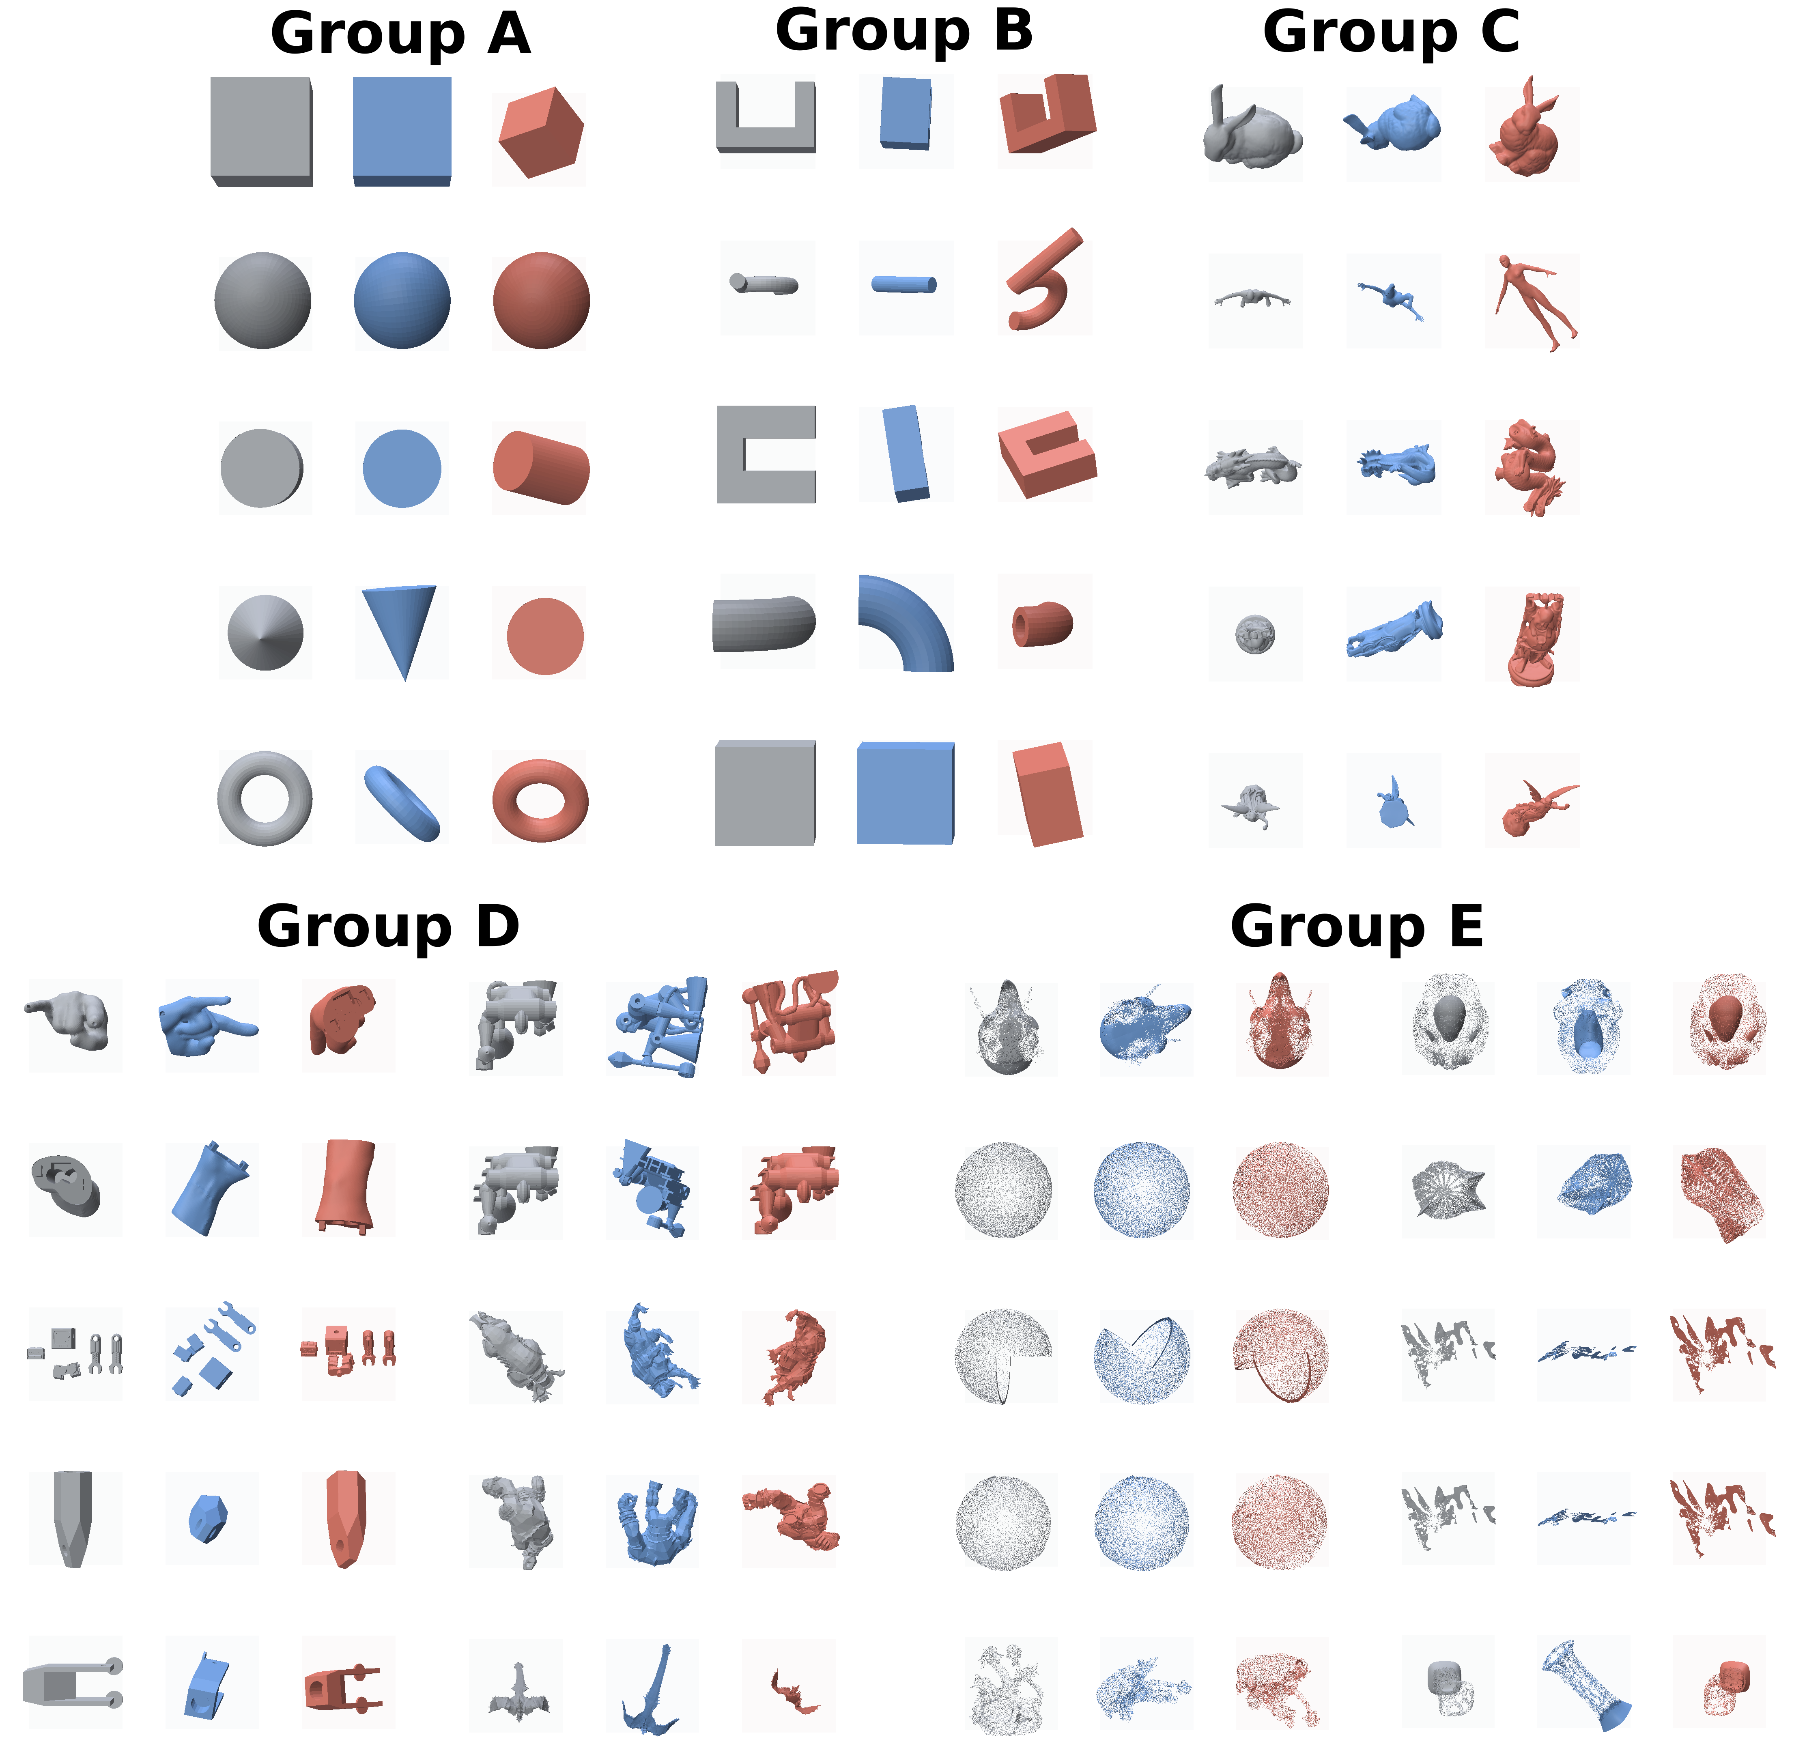
Fig. S1 Best/worst build-orientation Polyscope overlay arranged by group for the five groups (A–E) ($θ_{c}={60}^{∘}$). A label is placed atop each group, with groups A–C in the top row and groups D/E (a vertical $5$-row $2$-column layout each) in the bottom row, grouped about the page center. Each mesh shows the original (gray), optimal orientation (blue), and worst orientation (red) side by side, displayed in the actual print pose by rotating the stored build direction to world $+Z$. Since SFTF candidates are invariant to $θ_{c}$, the overlays of the five critical angles are identical.
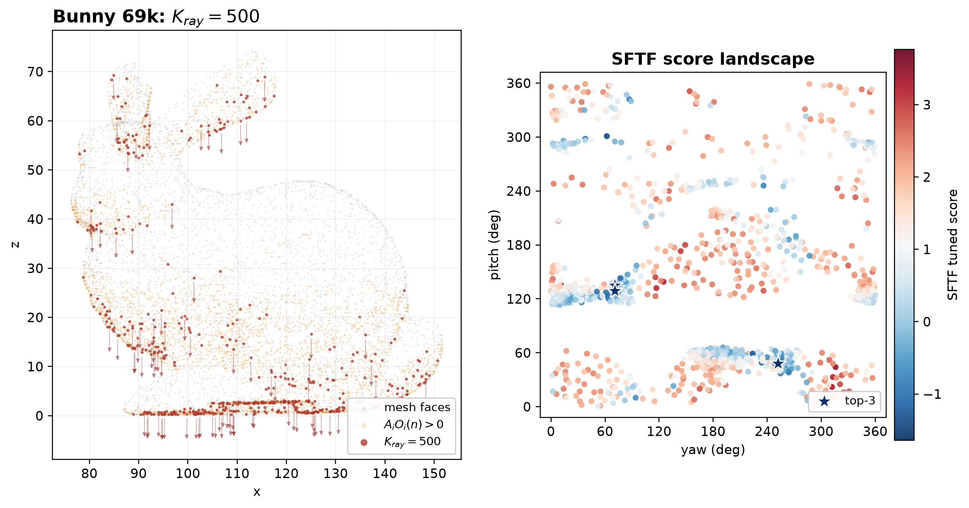
Fig. S2 Bunny 69k source-face sampling and SFTF score landscape with fixed $K_{ray}=500$. The right panel is recomputed with the same ray budget and uses the common color scale of Supplementary Figs. 3–4.
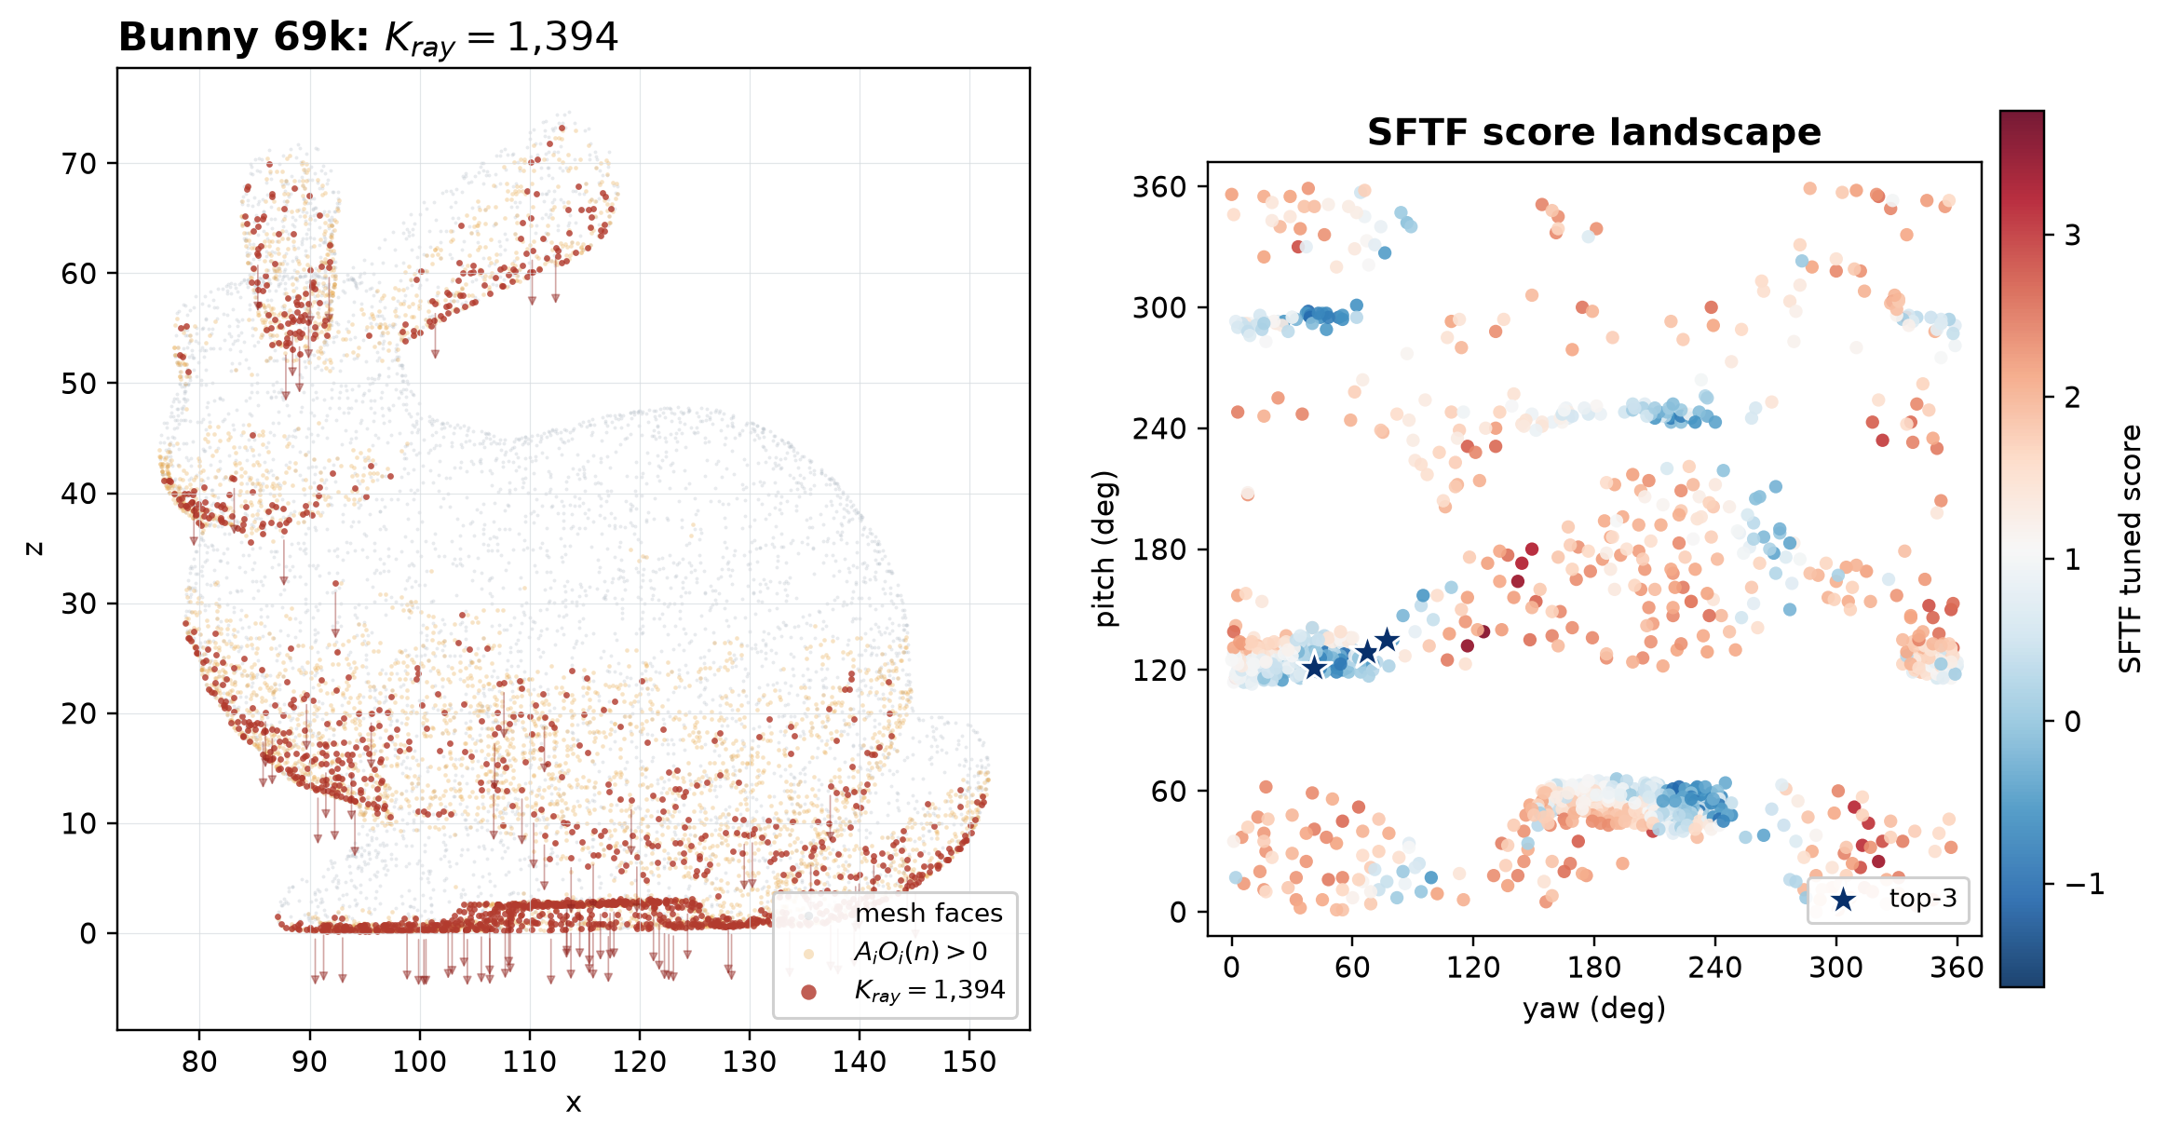
Fig. S3 Bunny 69k source-face sampling and SFTF score landscape with the adaptive rule, $K_{ray}=clip(0.02N_{f},500,3000)=1,394$.
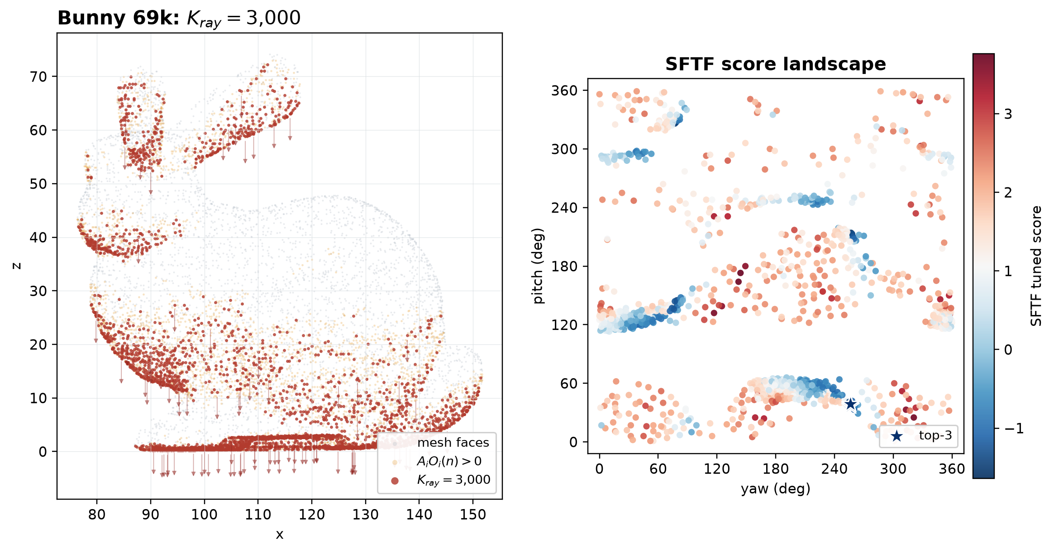
Fig. S4 Bunny 69k source-face sampling and SFTF score landscape with fixed $K_{ray}=3000$, corresponding to the upper cap used for large meshes.
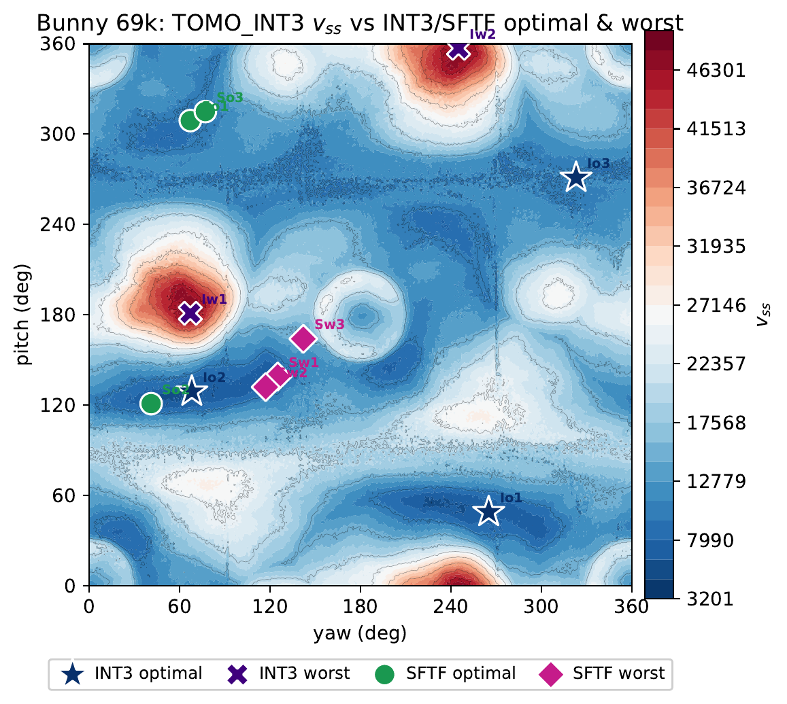
Fig. S5 Comparison of TOMO/SFTF optimal/worst orientations on the $v_{ss}$ landscape of Bunny 69k (blue is good). The markers are 3 each of INT3/SFTF optimal/worst, with kinds following the legend below the figure. The global optimum is $v_{ss}=3201$ (yaw$={265}^{∘}$, pitch$={49}^{∘}$; the main-text comparison table), and lies not at a single point but within a broad low-cost basin.
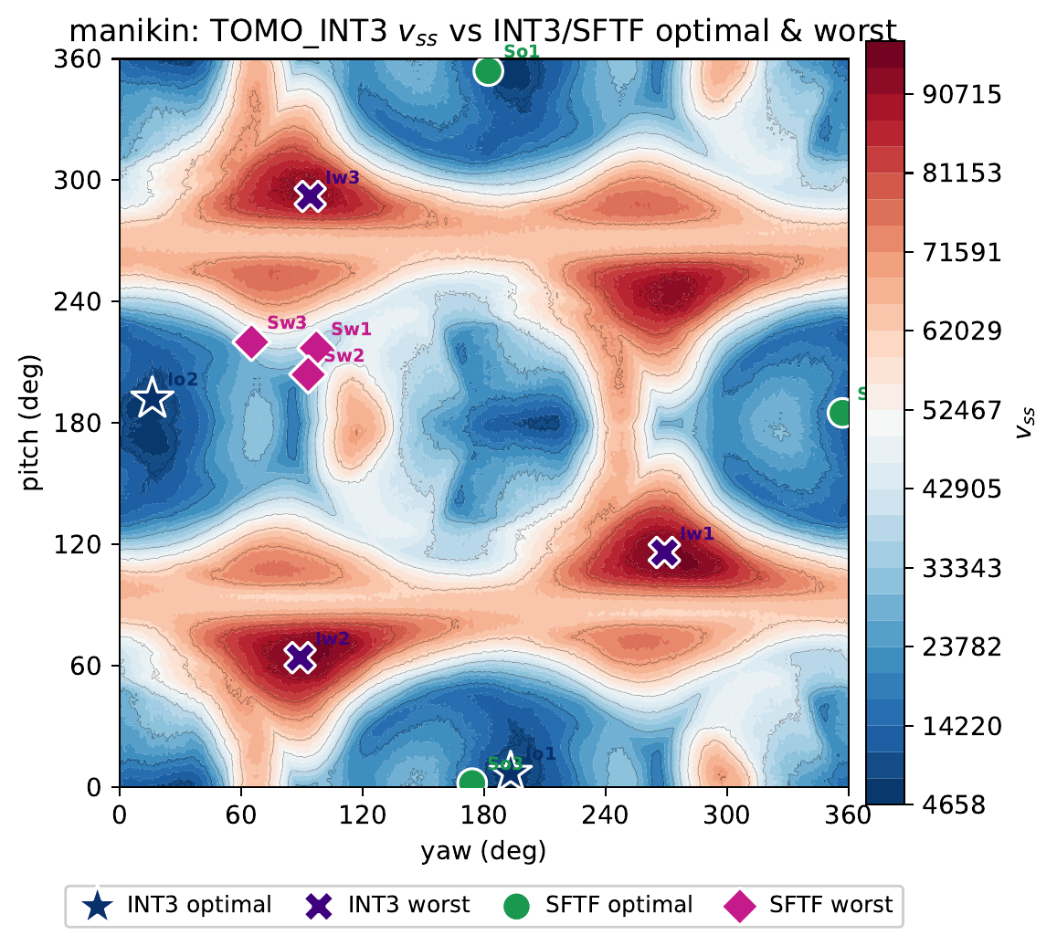
Fig. S6 Comparison of TOMO/SFTF optimal/worst orientations on the $v_{ss}$ landscape of Manikin 13k (blue is good). The markers are 3 each of INT3/SFTF optimal/worst, with kinds following the legend below the figure. The global optimum is $v_{ss}=4658$ (yaw$={193}^{∘}$, pitch$=7^{∘}$), and befitting a vertically elongated shape, the low-cost region is distributed in a narrow pitch band across the full yaw range.
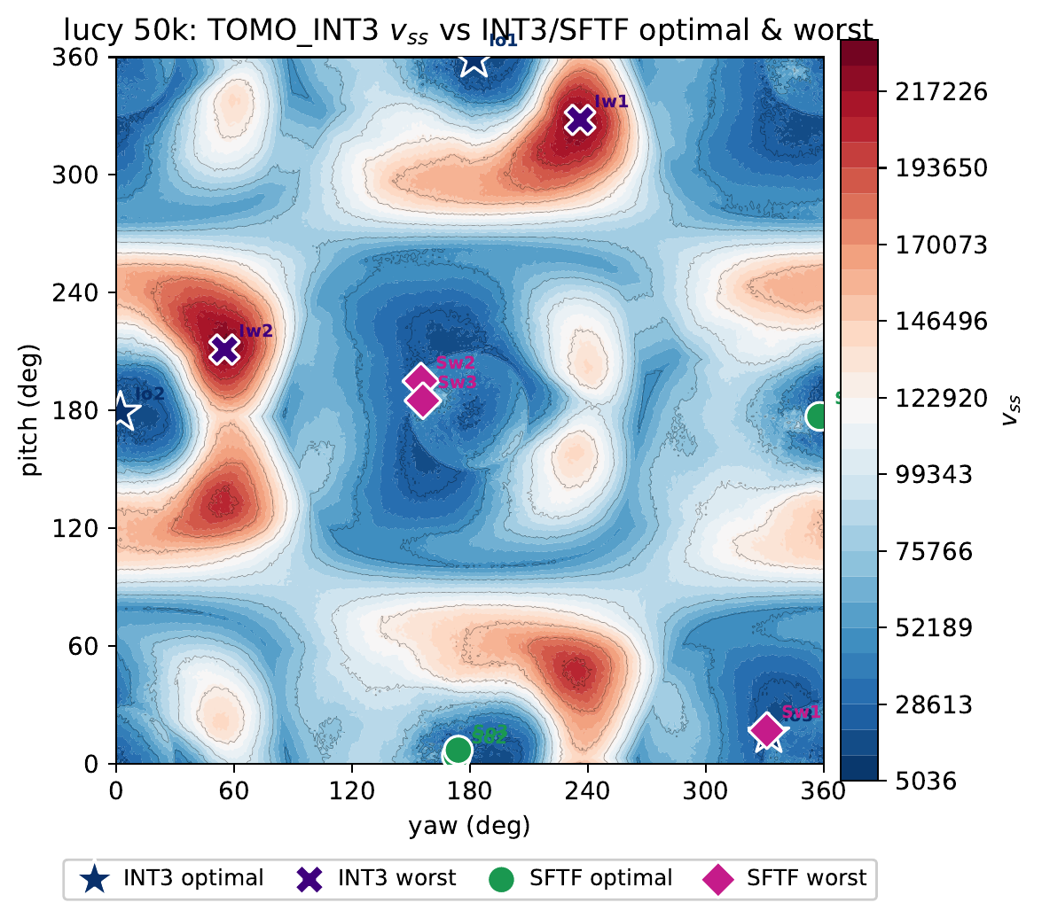
Fig. S7 Comparison of TOMO/SFTF optimal/worst orientations on the $v_{ss}$ landscape of Lucy 50k (blue is good). The markers are 3 each of INT3/SFTF optimal/worst, with kinds following the legend below the figure. The global optimum is $v_{ss}=5036$ (yaw$={182}^{∘}$, pitch$={359}^{∘}$), and being located near the pitch boundary (${359}^{∘}$), it requires basin search that considers the yaw–pitch periodicity.

