Support Flow Tensor Field for Fast Build-Orientation Candidate Generation in Support-Requiring Additive Manufacturing
InHwan Sul
Department of Materials Design Engineering, Kumoh National Institute of Technology,
Gumi 39177, Republic of Korea
Email: snowman0@kumoh.ac.kr ORCID: 0000-0003-0105-920X
Abstract
Build orientation strongly controls support volume in additive manufacturing, but exhaustive orientation sweeps remain costly. The proposed method targets support-requiring processes in which build orientation changes the amount of removable support material; it is not intended for inherently support-free processes. This paper proposes the Support Flow Tensor Field (SFTF), a fast candidate generator that ranks promising build directions before local verification by a support-volume grid or slicer. For each sampled direction, SFTF casts rays from overhang faces to actual receiver faces and forms a direction-dependent asymmetric flow tensor; the build-plate support term is interpreted as a virtual ground receiver, making the dominant predictive term a unified Rayleigh cost. On five organic freeform benchmark meshes with a $1^{∘}$ tomography grid, verifying the $±{10}^{∘}$ neighborhoods of the top-$20$ SFTF candidates uses $3.40\%$ of the grid on average and obtains a mean support-volume ratio of $1.14$ (maximum $1.66$); the tensor features $B$ and $\tilde{R}=R+B$ are the most stable single predictors of the tomographic support volume (mean Spearman $0.59$ and $0.61$). We also introduce Adaptive Verification Escalation (AVE), an automatic hard-case escalation rule based on local-verification confidence signals; on a five-group cached $1^{∘}$ audit of $21$ ratio-valid records it keeps every record below ratio $2.0$ (mean $1.14$, maximum $1.93$) at a mean budget of $13.94\%$. We report a clear limitation: on large mechanical parts (up to $1.04$M faces) the tensor features do not predict support volume, and at a matched budget a simple uniform-axis window seeding outperforms the SFTF ranking. SFTF is therefore best positioned as an interpretable warm start for organic parts that concentrates expensive verification on a small number of likely basins rather than replacing broad coverage.
Keywords: Support Flow Tensor Field (SFTF); build orientation; support volume; support-requiring additive manufacturing; local verification; candidate generation

Introduction
Build orientation strongly affects support volume, material use, print time, and post-processing quality in support-requiring additive manufacturing, especially FDM processes in which downward overhangs beyond a critical angle require removable support . Existing explicit or voxel/slicer-based orientation searches can evaluate support volume accurately, but exhaustive yaw–pitch sweeps remain expensive because they evaluate a dense set of directions even for simple shapes.

Related work
Build-orientation studies include explicit support-volume evaluation, voxel/depth-normal acceleration, support-structure design, and topology or multi-axis design approaches . Shadow-volume and tomographic formulations estimate support volume without full slicer generation and can also be accelerated on GPUs . In this manuscript, TOMO_CPU and TOMO_CUDA denote the CPU and GPU tomographic support-volume evaluators used as verification and comparison backends ; SFTF is instead a candidate generator that reduces the number of directions passed to such verifiers. Tensor or anisotropic formulations have also appeared in topology optimization, where overhang constraints, anisotropic interface energy, and deposition-direction-dependent stiffness bias a redesigned part toward self-supporting geometry . The present work is complementary: the input shape is fixed, and the tensor is used only to rank build orientations before an accurate TOMO or slicer verification step. A related industrial patent seeks build orientations for fixed complex parts but does not disclose an open algorithmic procedure .

Contribution
This paper proposes the Support Flow Tensor Field (SFTF), a low-cost candidate generator rather than a replacement for precise TOMO/slicer optimization. For each sampled build direction, SFTF estimates internal face-to-face support flow by ray casting, adds a build-plate contribution through a virtual ground node, and passes only a small set of promising basins to local TOMO verification. The main contributions are: (i) a direction-dependent asymmetric support-flow tensor for fixed parts; (ii) a ground-node derivation showing that the build-plate term is an exact Rayleigh contribution of the augmented tensor; (iii) a local-verification budget curve demonstrating that on organic freeform meshes SFTF top-$20$ windows recover a mean support-volume ratio of $1.14$ with only $3.40\%$ of the $1^{∘}$ grid; (iv) Adaptive Verification Escalation (AVE), an automatic escalation rule for narrow-basin hard cases; (v) a five-group timing audit showing $8.3$–$381.9×$ Python and $56.8$–$56,027×$ C++ speedups relative to TOMO_CPU on the same $1^{∘}$ sweep; and (vi) an honest characterization of where the method breaks down—on large mechanical parts the tensor features stop predicting support volume and a budget-matched uniform-axis control outperforms the ranking (§4.1).

Materials and Methods

From symmetric support tensor to directional flow
As a symmetric baseline, we define an area-weighted second-moment tensor of face normals
M=i​AimimiT,
following the general orientation/fabric-tensor construction for directional data . Here $A_{i}$ and $m_{i}$ are the area and outward normal of triangular face $i$. This tensor summarizes the distribution of surface normals but does not encode whether a face is an overhang for a given build direction, whether another face can receive the support, or how far an unsupported face is from the build plate. SFTF therefore evaluates a direction-dependent asymmetric tensor for each unit build direction $n∈S^{2}$. For face centroid $c_{i}$, the overhang coefficient is
$$O_{i}\left(n\right)=max\left(0,−m_{i}⋅n\right).$$
For sampled overhang source faces, a ray is cast along $−n$; if the first valid receiver is face $j$, the height is $h_{ij}\left(n\right)=\left(c_{i}−c_{j}\right)⋅n$ and the face-to-face influence is
$$w_{ij}\left(n\right)=\frac{O_{i}\left(n\right)}{1+αh_{ij}\left(n\right)}, α=1/D,$$
where $D$ is the mesh bounding-box diagonal. The face-to-face support flow tensor is
Fn=i,j∈Rn​wijnAiAjmimjT,
with $R\left(n\right)$ the valid ray-cast support relationships. The receiver must not be the source face, must have positive height, and must face the build direction sufficiently ($m_{j}⋅n>0.05$). To bound cost, source faces are sampled deterministically in proportion to $A_{i}O_{i}\left(n\right)$ using
$$K_{ray}=clip\left(0.02N_{f},500,3000\right),$$
where $N_{f}$ is the number of mesh faces. When the number of positive-weight source faces exceeds $K_{ray}$, the quantity computed is the plug-in estimator of Eq. [eq:sftf-tensor] restricted to the sampled source set $S\left(n\right)$,
Fn=i,j∈Rni∈Sn​wijnAiAjmimjT,
where $S\left(n\right)$ is selected by deterministic systematic sampling on the cumulative weight $A_{i}O_{i}\left(n\right)$ (fixed half-interval offsets, no random seed); the scalar features $R$, $P$, and $B$ inherit the same restriction, and the sum is exact whenever the positive-weight sources number at most $K_{ray}$. No inverse-probability reweighting is applied, so $\hat{F}$ is a deterministic budget-normalized surrogate used only to compare directions of the same mesh under an identical budget and sampling rule.

Ground-node build-plate term
If no valid receiver face is found, the overhang is ultimately supported from the build plate. With
$$z_{plate}\left(n\right)=\min_{v∈V}v⋅n, h_{iP}\left(n\right)=c_{i}⋅n−z_{plate}\left(n\right),$$
the scalar plate penalty is
Bn=i∈Bn​OinAi1+αhiPn.
As illustrated in Fig. 1, this term is exactly the Rayleigh contribution obtained by adding a virtual receiver whose normal is the build direction $n$,
Fn=i,j∈Rn​wijnAiAjmimjT+i∈Bn​Ai1+αhiPminT.
Since $m_{i}⋅n=−O_{i}\left(n\right)$, the symmetric Rayleigh contraction of the ground term contributes exactly $B\left(n\right)$ to the support cost, giving
$$\tilde{R}\left(n\right)=max\left(0,−n^{T}{\tilde{F}}_{s}\left(n\right)n\right)=R\left(n\right)+B\left(n\right).$$
The equality was numerically confirmed within ${10}^{−12}$ over the stored candidate pools.
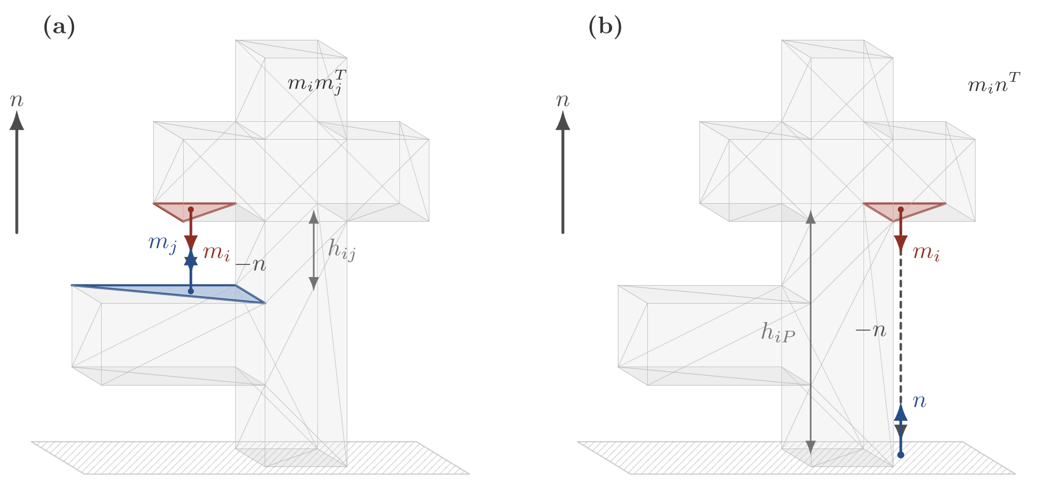
Unified flow interpretation. Face-to-face support uses receiver normal $m_{j}$, while direct build-plate support is represented by a virtual receiver with normal $n$; the latter gives the Rayleigh contribution $B\left(n\right)$ in Eq. [eq:Rtilde].

Candidate generation and rescoring
The deployed score is
Jn=Rn+Pn, Pn=i,j∈Rn​OinAiAj,
where $P$ is the face-to-face overhang amount after the height attenuation in $w_{ij}$ cancels. Because $O_{i}$, $w_{ij}$, and $αh$ are dimensionless, $R$ and $P$ carry units of area squared while $B$ carries units of area: under a uniform rescaling by $s$, $R$ and $P$ scale as $s^{4}$ whereas $B$ scales as $s^{2}$, so $J=\tilde{R}+P=R+P+B$ is unit-dependent and is treated as a screening feature only. A $512$-direction Fibonacci-sphere sample is first evaluated, the best directions are locally resampled in $2^{∘}$–$8^{∘}$ cones, and angular non-maximum suppression keeps separated candidates. To avoid treating dimensionally different quantities as commensurate, the final candidate order uses rank-normalized features $\left[J,R,P,B,H,S,σ_{1}\right]$, following the standard rank-transformation idea for scale-robust empirical modeling ; the rank transform makes the final ordering invariant to any strictly monotone rescaling of each feature. Here $H$ is the valid-hit count and $S,σ_{1}$ are singular-value features retained only for post-processing. The reported calibration uses weights $\left(w_{J},w_{R},w_{P},w_{B},w_{H},w_{S},w_{1}\right)=\left(0,0.731,−2.3897,2.1447,2.3109,−2.2922,1.6363\right)$. Implementation optimizations, including first-hit fallback and per-mesh cached geometry, reduced a 1k-direction evaluation of Bunny 69k from about $15.7$ s to $1.5$ s without changing selected directions.

Datasets and experimental environment
The dataset consists of five groups that deliberately separate shape difficulty from mesh scale. Groups A–C set the scale in the $∼$${10}^{1}$–${10}^{5}$-face range and vary difficulty from basic to freeform organic shapes, revealing the fixed-cost floor of the exhaustive sweep; groups D–E fix the difficulty as real manufacturing parts while pushing the scale from $256$ to $1.04×{10}^{6}$ faces, revealing the adaptive cost of SFTF candidate evaluation. Group A: basic shapes (cube, sphere, cylinder, cone, torus, $∼$${10}^{1}$–${10}^{3}$ faces). Group B: simple functional parts (u_bracket, hook, c_clamp, pipe_elbow, hollow_box). Group C: organic/freeform benchmarks (Bunny 69k, Manikin 13k, Dragon 100k, Happy 50k, Lucy 50k). Group D: Thingi10K set 1, $256$–$88,106$ faces . Group E: Thingi10K set 2, about $5.1×{10}^{5}$–$1.04×{10}^{6}$ faces. All timing used a Windows 11 workstation with an AMD Ryzen 9 9950X3D CPU (16 cores/32 threads), 125 GB RAM, and an NVIDIA GeForce RTX 5080 GPU (16 GB). The Python implementation used Python 3.12 with NumPy, SciPy, Trimesh, and scikit-learn; TOMO_CPU/TOMO_CUDA were called through Windows DLL interfaces, and SFTF_C++ was built as an x64 C++ DLL (MSVC, OpenMP).

Comparison targets and evaluation protocol
The comparison targets are: (1) PCA-based direction; (2) existing Support Tensor eigenvector direction; (3) initial eigenvector-based concave direction; (4) this study’s SFTF direction; and (5) TOMO_CPU or commercial-slicer-based $v_{ss}$ optimal direction. For each mesh we generate a $v_{ss}$ contour at $1^{∘}$ intervals under a critical angle of ${60}^{∘}$, and evaluate how close the $v_{ss}$ value at our top candidate directions is to the global optimum; if the $v_{ss}$ values are similar we regard directions as optimal orientations of the same level. Because the global optimum can be scattered across multiple basins, we compare angularly separated top-$k$ basin representatives, re-inputting SFTF candidate basins to TOMO_CPU to measure $M_{ss}$ directly. Unless otherwise stated, both the five-mesh accuracy results and the A–E audit use stored $1^{∘}$ TOMO_CPU grids. Ratio statistics at $θ_{c}={60}^{∘}$ exclude records whose TOMO global best is nonpositive, because those cases make a positive support-volume ratio ill-defined.

Results

Stored TOMO grid comparison
The stored $1^{∘}$, $θ_{c}={60}^{∘}$ TOMO_CPU grids were used as the accuracy reference. SFTF candidates were mapped to the nearest signed TOMO yaw–pitch cell, and ratios were computed against the global TOMO best value (Table 1). Raw ranking alone is insufficient for the Happy 50k hard case (ratio $2.34$), so SFTF is used as a warm start for local TOMO verification rather than as a standalone optimizer.
Stored TOMO_CPU $v_{ss}$ grid versus the current SFTF candidates. Ratio is the SFTF candidate’s $v_{ss}$ over the TOMO global optimum.
Mesh | TOMO best | SFTF score1 | Ratio | SFTF best-of-3 | Ratio
Bunny 69k | 4440.34 | 5217.86 | 1.18 | 5217.86 | 1.18
Manikin 13k | 2956.12 | 5565.56 | 1.88 | 5565.56 | 1.88
Dragon 100k | 28106.97 | 37640.00 | 1.34 | 36067.25 | 1.28
Happy 50k | 8512.64 | 19894.23 | 2.34 | 18592.73 | 2.18
Lucy 50k | 7605.40 | 9132.08 | 1.20 | 9132.08 | 1.20

Local verification and adaptive verification escalation
The deployed metric is a budget curve: the top-$K$ SFTF candidates define $±{10}^{∘}$ local windows, and the best TOMO grid value inside their union is selected (Table 2). At top-$20$, the mean support-volume ratio is $1.14$ (maximum $1.66$) using only $3.40\%$ of the $1^{∘}$ grid. A budget-matched farthest-point uniform-axis control performs on par with SFTF on these organic meshes and is slightly better in the worst case (Supplementary Table S7), so on organic parts the warm-start value is the small verified budget rather than the exact window placement; §4.1 shows the two diverge sharply on large parts.
Budget curve of top-$K$ local TOMO verification around SFTF candidates. The budget is the mean fraction of the $1^{∘}$ TOMO grid covered by the union of local windows.
Top-$K$ | Mean ratio | Median ratio | Max ratio | Mean grid budget | Ratio $≤2.0$
3 | 1.24 | 1.07 | 1.97 | 0.87% | 5/5
10 | 1.18 | 1.02 | 1.84 | 2.03% | 5/5
20 | 1.14 | 1.00 | 1.66 | 3.40% | 5/5
30 | 1.14 | 1.00 | 1.66 | 5.20% | 5/5
Adaptive Verification Escalation (AVE) escalates only when ordinary top-$10$ local verification is uncertain (organic-mesh result in Supplementary Table S8). The trigger uses local-verification quantities only,
$$\begin{matrix}{trigger}_{AVE} & =\left[η≥0.008\right]∧\left[edge=1∨g≤1.5∨g≥3.0\right], \\ η & =V_{ss}^{loc}/V_{bbox}, g=V_{ss}^{seed}/V_{ss}^{loc},\end{matrix}$$
where $edge=1$ means the best local cell lies within $1^{∘}$ of a window boundary, a small gain $g≤1.5$ means the window search barely improved on the seed (a plateau), and a large gain $g≥3.0$ means it moved far (an unreliable seed). Escalation only expands the verified candidate set, so it can spend more budget but cannot worsen the selected value. Table 3 reports the held-out cached A–E audit of $21$ ratio-valid records (after excluding $14$ with nonpositive TOMO best at $θ_{c}={60}^{∘}$). The valid set is larger than in the original submission because a $16$-bit per-column overflow in the TOMO_CPU voxel accumulator had corrupted the support volume of the high-face-count group-E meshes; with the accumulator corrected, those meshes yield positive optima and become ratio-valid.
Cached five-group audit of the tiered AVE policy on ratio-valid $1^{∘}$, $θ_{c}={60}^{∘}$ TOMO_CPU records. The top-$10$ baseline over all ratio-valid records has mean ratio $5.10$, maximum $62.59$, mean budget $2.26\%$, and $14/21$ below ratio $2.0$.
Group | $n$ | Expanded | Mean | Max | Budget | $≤2.0$
A | 2 | 2 | 1.03 | 1.06 | 7.59% | 2/2
B | 1 | 1 | 1.10 | 1.10 | 6.97% | 1/1
C | 5 | 3 | 1.14 | 1.66 | 9.99% | 5/5
D | 6 | 5 | 1.03 | 1.13 | 23.58% | 6/6
E | 7 | 7 | 1.26 | 1.93 | 11.30% | 7/7
All | 21 | 18 | 1.14 | 1.93 | 13.94% | 21/21
The audit reduces the maximum ratio from $62.59$ to $1.93$ and keeps all ratio-valid records below $2.0$ at a mean budget of $13.94\%$ (under one seventh of the $1^{∘}$ grid). The single hardest case is the $1.04$M-face Group_E2_790253 at ratio $1.93$, marking the practical ceiling of coarse SFTF coverage on large parts. Representative TOMO landscapes for a broad-basin case (Dragon 100k, Fig. 2) and the Happy 50k hard case before/after AVE (Fig. 3) are shown below; additional Bunny, Manikin, and Lucy landscapes are in Supplementary Figs. S5–S7.
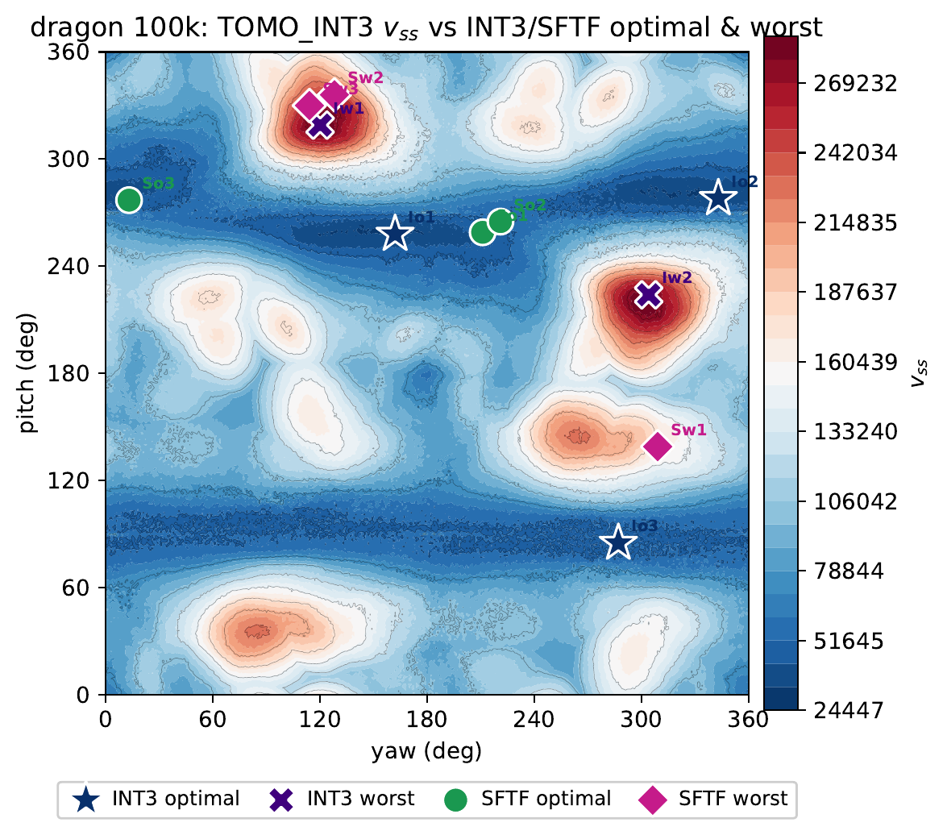
Representative TOMO_CPU $v_{ss}$ landscape of Dragon 100k. The global optimum forms a distinct low-cost basin, a non-hard case where coarse SFTF candidates already cover useful regions.
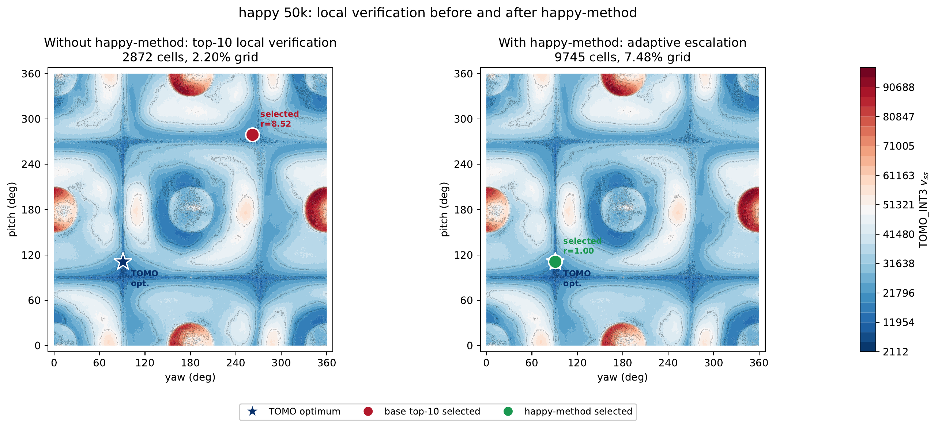
Happy 50k before and after AVE on the same TOMO_CPU $v_{ss}$ landscape (corrected grids; TOMO optimum $v_{ss}=8,513$). Base top-$10$ local verification lands at ratio $1.84$ and AVE improves it to $1.66$.

Feature contribution and generalization
Spearman rank correlations over the full candidate pools (Supplementary Table S9) show that the build-plate term is the most stable single predictor of TOMO $v_{ss}$. Table 4 separates the unified Rayleigh term from its components: the ground-node reformulation explains why $B$ is not merely a scalar patch, because $\tilde{R}=R+B$ is a tensor contraction and has the strongest average single-feature correlation ($0.61$). Excluding the Happy 50k hard case, removing the negative-signal $P$ term (from $J=R+P+B$ to build-plate-only $B$) improves the mean best-of-3 ratio from $2.00$ to $1.67$ (Supplementary Table S6).
Spearman correlation of the unified Rayleigh term $\tilde{R}=R+B$ and single terms with TOMO $v_{ss}$ (higher is better). $\tilde{R}$ was computed directly from the augmented tensor and agrees with $R+B$ within ${10}^{−12}$.
Mesh | $R$ | $B$ | $\tilde{R}=R+B$ | $J=R+P+B$
Bunny 69k | 0.36 | 0.42 | 0.43 | 0.37
Manikin 13k | $−0.35$ | 0.74 | 0.73 | 0.35
Dragon 100k | $−0.56$ | 0.84 | 0.88 | 0.80
Happy 50k | 0.13 | 0.23 | 0.29 | 0.33
Lucy 50k | 0.16 | 0.72 | 0.73 | 0.68
Average | $−0.05$ | 0.59 | 0.61 | 0.51
Cross-validation exposes the optimism of calibration-set rank tuning. A leave-one-mesh-out (LOMO) check (Supplementary Table S10) raises the in-sample average best-of-3 ratio from $1.64$ to $1.71$ on these organic meshes, still better than PCA ($1.95$) and the symmetric Support Tensor baseline ($2.46$) (Supplementary Table S11); Manikin 13k is the one case where PCA edges out the tuned SFTF ordering. This reinforces the role of rank tuning as an organic-mesh candidate-ordering heuristic, not the final optimizer; the reliable result is obtained when SFTF candidates are followed by local TOMO verification.

Five-group implementation audit
On the same $1^{∘}$, $θ_{c}={60}^{∘}$ sweep, Python SFTF is $8.3$–$381.9×$ faster than TOMO_CPU over all $35$ meshes and SFTF_C++ is $56.8$–$56,027×$ faster (group averages in Supplementary Table S12; full per-mesh timing in Supplementary Table S1). TOMO_CUDA helps on simple A/B shapes but is often slower than CPU on organic and large meshes here, so the dominant gain is algorithmic—reducing the number of directions to evaluate, not changing the exhaustive-sweep backend. The clipped ray budget in Eq. [eq:kray-budget] caps per-direction ray cost at $3000$ samples, so meshes near ${10}^{6}$ faces remain feasible.

Discussion

Limitations: candidate ranking does not transfer to large mechanical parts
The correlation and warm-start evidence above is drawn from the organic freeform meshes (group C), on which the tensor features predict TOMO $v_{ss}$ ($B$ has mean Spearman $0.59$, unified $\tilde{R}$ has $0.61$). This does not carry over to the large mechanical parts of groups D–E, where the Spearman correlation between every SFTF feature and TOMO $v_{ss}$ is near zero (for $B$, $≈0$ on D/E and $−0.40$ on Group_E10). The tuned score then carries essentially no ranking signal, its top-$20$ candidates cluster near the $3^{∘}$ non-maximum-suppression floor, and the optimum-covering candidate sits deep in the pool (rank $41$–$255$, or outside the pool for the $1.04$M-face Group_E2_790253), which is why AVE must spend a larger budget on group E (Table 3). A budget-matched control makes the consequence explicit (Table 5): on the large parts a farthest-point uniform-axis seeding clearly outperforms the SFTF ranking.
Budget-matched local TOMO controls over the full $21$-mesh ratio-valid set (top-$20$ grid-cell budget, $≈4\%$ of the $1^{∘}$ grid). On the large mechanical parts, spreading the same budget uniformly beats the SFTF candidate ranking.
Policy | Mean | Max | $≤2.0$ | D mean | E mean
SFTF top-$20$ local | 3.34 | 34.04 | 15/21 | 6.85 | 2.90
Uniform-axis matched | 1.20 | 2.10 | 20/21 | 1.09 | 1.44
Random matched (median) | 1.32 | 2.56 | 20/21 | 1.15 | 1.54
We report this openly because an earlier version of this study, before the $16$-bit overflow in the TOMO_CPU voxel accumulator was corrected, excluded all of these large parts as having nonpositive support volume; the corrected data admits them and reveals the limit. A partial explanation is that on mechanical parts the symmetric second-moment tensor M=i​AimimiT of Eq. (1) is actually the more useful predictor: its Rayleigh quotient $n^{T}Mn$ has mean Spearman $0.51$ with $v_{ss}$ over the valid set (versus $≈0$ for the asymmetric score), though it too fails on a minority of parts and does not by itself beat uniform seeding.

Positioning and future work
The practical takeaway is that SFTF is best positioned as a fast, interpretable candidate generator for organic freeform parts, and as a warm start it should be combined with, not substituted for, broad angular coverage on large mechanical geometries. Most of the predictive power originates from the build-plate penalty and internal-visibility evaluation, and the ground-node reformulation unifies this driver into the tensor contraction $\tilde{R}=R+B$, justifying the “tensor” formulation. Future work will (i) fit weights by cross-validation rather than on a calibration set; (ii) replace marginal terms with features more correlated with $v_{ss}$, such as face-to-face self-support coverage; (iii) normalize the objective terms dimensionally to secure transferable weights; (iv) add projection-area, print-height, and contact-stability terms toward multi-objective orientation optimization; and (v) extend to $θ_{c}$-dependent candidate generation, since the TOMO optimum shifts with the critical angle while current SFTF candidates are $θ_{c}$-invariant. For cases lacking a stable near-optimal basin among the top-$K$ candidates, AVE provides an automatic escalation path whose thresholds will be refined on a larger family-held-out validation set.

Conclusions
This study proposed a direction-evaluation method combining the Support Flow Tensor Field with a build-plate penalty for build-orientation screening in additive manufacturing. SFTF directly computes an asymmetric support-flow tensor for each candidate direction and forms the objective $J=R+P+B$, then selects promising orientations by rank-normalized tuning for slicer/TOMO verification. On organic freeform parts, verifying the $±{10}^{∘}$ neighborhoods of only the top-$20$ candidates recovers a mean support-volume ratio of $1.14$ (maximum $1.66$) while inspecting $3.40\%$ of the $1^{∘}$ grid, and AVE automatically widens this budget only for detected hard cases. The build-plate penalty is exactly the Rayleigh contribution of a virtual ground node added to the flow tensor, unifying the dominant predictor into $\tilde{R}=R+B$. On large mechanical parts, however, the tensor features no longer predict support volume and a budget-matched uniform control outperforms the ranking, so SFTF is best used as an interpretable warm start for organic parts rather than as a general replacement for broad coverage.

Acknowledgments

Use of AI-assisted tools.
AI coding assistants, including OpenAI Codex and Anthropic Claude Code, were used to assist with portions of the research-code implementation, figure-generation scripts, and manuscript-support automation. All generated code, experimental results, and manuscript changes were reviewed and validated by the author(s), who take full responsibility for the correctness of the methodology, data, results, and conclusions. No generative AI was used to generate research data, figures presented as novel research images, or references.

Author Contributions
InHwan Sul: Conceptualization, Methodology, Software, Validation, Formal analysis, Investigation, Data curation, Writing – original draft, Writing – review & editing, Visualization, Funding acquisition.

Statements and Declarations

Ethical considerations.
Not applicable (no human participants, human data, human tissue, or animals).

Consent to participate.
Not applicable.

Consent for publication.
Not applicable.

Declaration of conflicting interest.
The author(s) declared no potential conflicts of interest with respect to the research, authorship, and/or publication of this article.

Funding statement.
This work was supported by the National Research Foundation of Korea (NRF) grant funded by the Korean government (MSIT) (NRF-2022R1A2C1010072).

Data availability.
The datasets and code generated and analysed during the current study are available from the corresponding author on reasonable request. Third-party mesh models should be obtained from their original sources under their respective licenses.
18 urlstyle
Ian Gibson, David Rosen, and Brent Stucker. Additive Manufacturing Technologies. Springer, New York, 2 edition, 2015.
Paramita Das, Kunal Mhapsekar, Souran Chowdhury, Rutuja Samant, and Sam Anand. Selection of build orientation for optimal support structures and minimum part errors in additive manufacturing. Computer-Aided Design and Applications, 14 (sup1): 1–13, 2017. doi: 10.1080/16864360.2017.1308074.
Charlie C. L. Wang, Yong-Shun Leung, and Yong Chen. Solid modeling of polyhedral objects by layered depth-normal images on the GPU. Computer-Aided Design, 42 (6): 535–544, 2010. doi: 10.1016/j.cad.2010.02.001.
Benjamin Vaissier, Jean-Philippe Pernot, Laurent Chougrani, and Philippe Véron. Genetic-algorithm based framework for lattice support structure optimization in additive manufacturing. Computer-Aided Design, 110: 11–23, 2019. doi: 10.1016/j.cad.2018.12.007.
Jingchao Jiang, Jonathan Stringer, Xun Xu, and Ray Y. Zhong. Investigation of printable threshold overhang angle in extrusion-based additive manufacturing for reducing support waste. International Journal of Computer Integrated Manufacturing, 31 (10): 961–969, 2018. doi: 10.1080/0951192X.2018.1466398.
Amir M. Mirzendehdel and Krishnan Suresh. Support structure constrained topology optimization for additive manufacturing. Computer-Aided Design, 81: 1–13, 2016. doi: 10.1016/j.cad.2016.07.006.
Matthijs Langelaar. Combined optimization of part topology, support structure layout and build orientation for additive manufacturing. Structural and Multidisciplinary Optimization, 57 (5): 1985–2004, 2018. doi: 10.1007/s00158-017-1877-z.
Chengkai Dai, Charlie C. L. Wang, Chenming Wu, Sylvain Lefebvre, Guoxin Fang, and Yong-Jin Liu. Support-free volume printing by multi-axis motion. ACM Transactions on Graphics, 37 (4): 1–14, 2018. doi: 10.1145/3197517.3201342.
Ben Ezair, Fady Massarwi, and Gershon Elber. Orientation analysis of 3D objects toward minimal support volume in 3D-printing. Computers & Graphics, 51: 117–124, 2015. doi: 10.1016/j.cag.2015.05.009.
Jae Yeol Jung, Seokjae Chee, and In Hwan Sul. Support structure tomography using per-pixel signed shadow casting in human manikin 3D printing. Fashion and Textiles, 9 (1): 1–18, 2022. doi: 10.1186/s40691-022-00290-z.
Jae Ryoung Kim and In Hwan Sul. Fast prediction of 3D printing optimal orientation using general-purpose graphic processor unit calculation. 3D Printing and Additive Manufacturing, 13 (1): 50–62, 2026. doi: 10.1089/3dp.2024.0165.
Andrew T. Gaynor, Nicholas A. Meisel, Christopher B. Williams, and James K. Guest. Topology optimization for additive manufacturing: Considering maximum overhang constraint. In 15th AIAA/ISSMO Multidisciplinary Analysis and Optimization Conference, page 2036, 2014. doi: 10.2514/6.2014-2036.
Harald Garcke, Kei Fong Lam, Robert Nürnberg, and Andrea Signori. Overhang penalization in additive manufacturing via phase field structural topology optimization with anisotropic energies. Applied Mathematics & Optimization, 87 (3): 44, 2023. doi: 10.1007/s00245-022-09939-z.
Seungheon Shin, Yujin Park, and Gil Ho Yoon. Topology optimization for multi-axis additive manufacturing considering overhang and anisotropy. International Journal of Mechanical Sciences, 301: 110443, 2025. doi: 10.1016/j.ijmecsci.2025.110443.
Robert Smith and Michael C. Hollenbeck. Build orientation for additive manufacturing of complex structures. U.S. Patent No. 12,343,928, 2025. Assignee: Optisys, Inc.
Ken-Ichi Kanatani. Distribution of directional data and fabric tensors. International Journal of Engineering Science, 22 (2): 149–164, 1984. doi: 10.1016/0020-7225(84)90090-9.
W. J. Conover and Ronald L. Iman. Rank transformations as a bridge between parametric and nonparametric statistics. The American Statistician, 35 (3): 124–129, 1981. doi: 10.1080/00031305.1981.10479327.
Qingnan Zhou and Alec Jacobson. Thingi10k: A dataset of 10,000 3D-printing models. arXiv preprint arXiv:1605.04797, 2016.

Rank tuning denotes fitting weights after converting each feature to its within-candidate rank; it is an empirical candidate-ranking calibration, not continuous geometric optimization.

