Electronic Supplementary Material:
Support Flow Tensor Field for Fast Build-Orientation Candidate Generation

Supplementary Tables
Cost decomposition of the SFTF top direction of representative meshes. Convex basic shapes (cube, sphere, cone) are pure build-plate support with hit$=0$, $R=P=0$, and the rest show face-to-face self-support ($P$) and build-plate support ($B$) together.
ID | Shape | hit | $R$​ | $P$​ | $B$​
A1 | cube | 0 | 0 | 0 | 401.5
A2 | sphere | 0 | 0 | 0 | 136.6
A4 | cone | 0 | 0 | 0 | 179.8
A5 | torus | 184 | 15.9 | 40.3 | 209.1
B2 | hook | 235 | 19.9 | 55.4 | 128.7
C1 | Bunny 69k | 81 | 1.4 | 25.2 | 176.3
C3 | Dragon 100k | 970 | 109.4 | 267.6 | 417.5
D6 | 37111 | 386 | 227.9 | 932.8 | 1,613
D10 | 37416 | 66 | 26.3 | 196.4 | 1,111

TOMO_CPU global minimum $v_{ss}$ by critical angle on the int16-corrected grids (representative meshes; ${60}^{∘}$ from the $1^{∘}$ grid, other angles from the $3^{∘}$ grid). The support volume decreases monotonically as $θ_{c}$ increases, and at $θ_{c}={90}^{∘}$ almost all faces are self-supporting so $v_{ss}$ is $0$. Before the accumulator fix a $16$-bit overflow made these minima appear as large negative numbers at high $θ_{c}$; the corrected values are non-negative throughout.
ID | Mesh | $θ_{c}=0^{∘}$​ | ${30}^{∘}$​ | ${45}^{∘}$​ | ${60}^{∘}$​ | ${90}^{∘}$​
A1 | cube | 1,769 | 1,769 | 0 | 0 | 0
B2 | hook | 1,557 | 645 | 273 | 120 | 0
C1 | Bunny 69k | 51,083 | 24,460 | 14,442 | 4,440 | 0
C3 | Dragon 100k | 223,214 | 111,032 | 78,935 | 28,107 | 0
D1 | 37009 | 67,646 | 4,618 | 1,520 | 277 | 0
D6 | 37111 | 105,094 | 53,508 | 31,326 | 6,638 | 0
E1 | 39507 | 20,635 | 4,214 | 2,716 | 442 | 0
E7 | 61384 | 89,728 | 11,188 | 6,426 | 987 | 0

Oracle (best within candidate pool) ratio by the number of coarse directions. Meshes other than Happy 50k already include a near-optimal direction at $512$.
# coarse directions | Bunny 69k | Manikin 13k | Dragon 100k | Happy 50k | Lucy 50k
512 | 1.46 | 1.13 | 1.29 | 4.35 | 1.02
1024 | 1.50 | 1.11 | 1.33 | 3.94 | 1.02
2048 | 1.61 | 1.06 | 1.28 | 1.91 | 1.04
4096 | 1.62 | 1.13 | 1.27 | 1.91 | 1.30

Best-of-3 ratio when sorting candidates by $J=R+P+B$ and the unified term $\tilde{R}=R+B$ (lower is better). On the average excluding Happy 50k (a narrow-basin hard case under the ranking-only point metric, resolved by local verification in the main text), $\tilde{R}$ outperforms $J$.
Mesh | $J=R+P+B$​ | $\tilde{R}=R+B$​
Bunny 69k | 1.38 | 1.43
Manikin 13k | 5.02 | 3.06
Dragon 100k | 1.40 | 1.20
Lucy 50k | 1.20 | 1.20
Average (excl. Happy 50k) | 2.25 | 1.72

Supplementary Figures
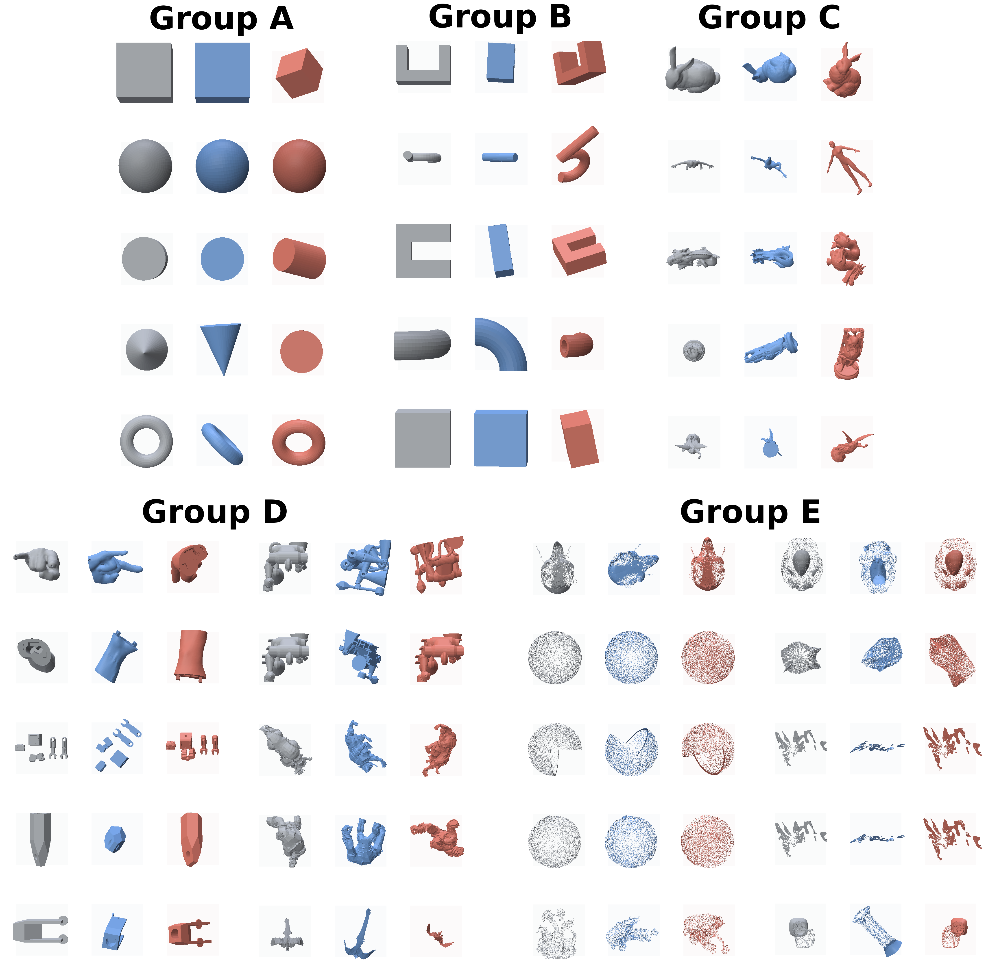
Best/worst build-orientation Polyscope overlay arranged by group for the five groups (A–E) ($θ_{c}={60}^{∘}$). A label is placed atop each group, with groups A–C in the top row and groups D/E (a vertical $5$-row $2$-column layout each) in the bottom row, grouped about the page center. Each mesh shows the original (gray), optimal orientation (blue), and worst orientation (red) side by side, displayed in the actual print pose by rotating the stored build direction to world $+Z$. Since SFTF candidates are invariant to $θ_{c}$, the overlays of the five critical angles are identical.
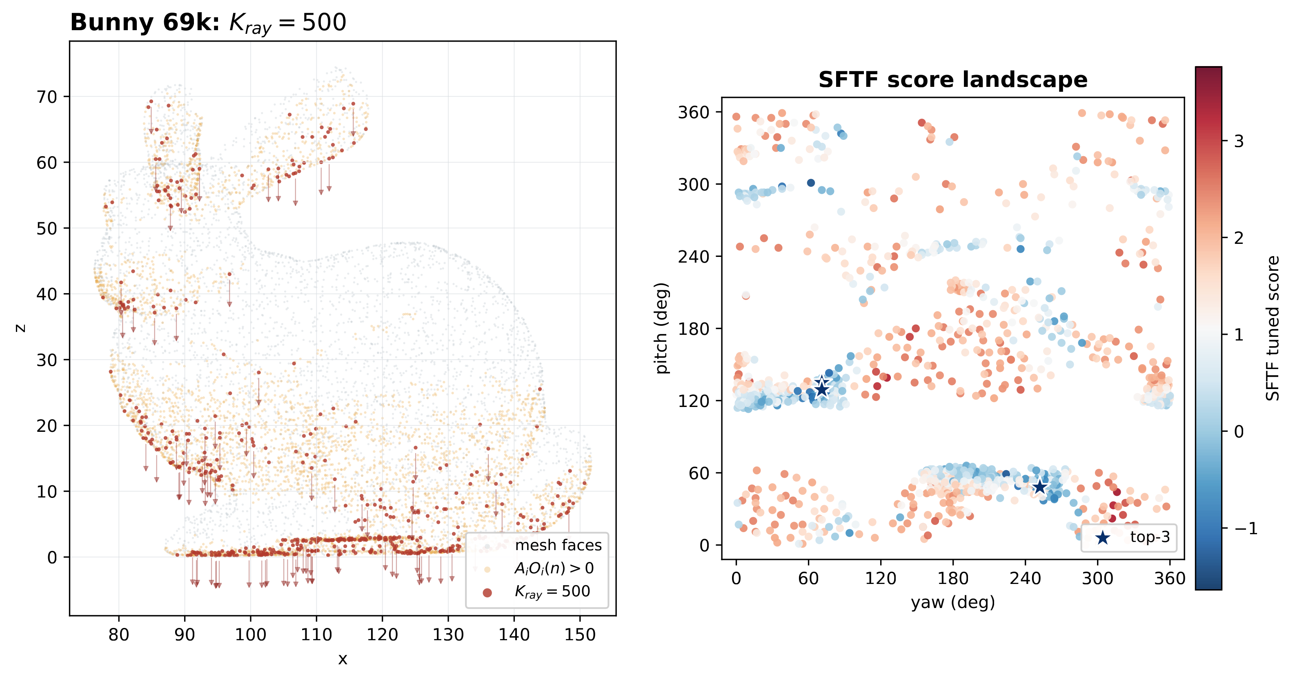
Bunny 69k source-face sampling and SFTF score landscape with fixed $K_{ray}=500$. The right panel is recomputed with the same ray budget and uses the common color scale of Supplementary Figs. 3–4.
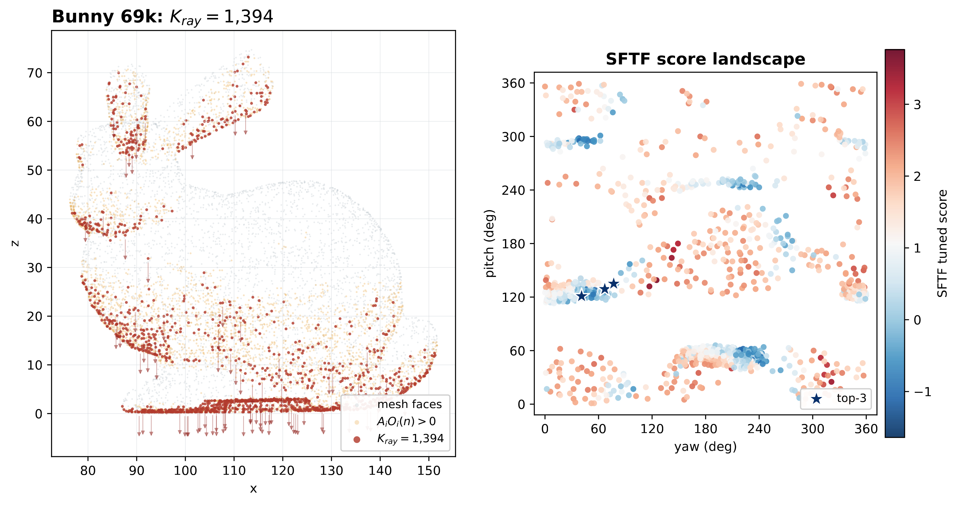
Bunny 69k source-face sampling and SFTF score landscape with the adaptive rule, $K_{ray}=clip(0.02N_{f},500,3000)=1,394$.
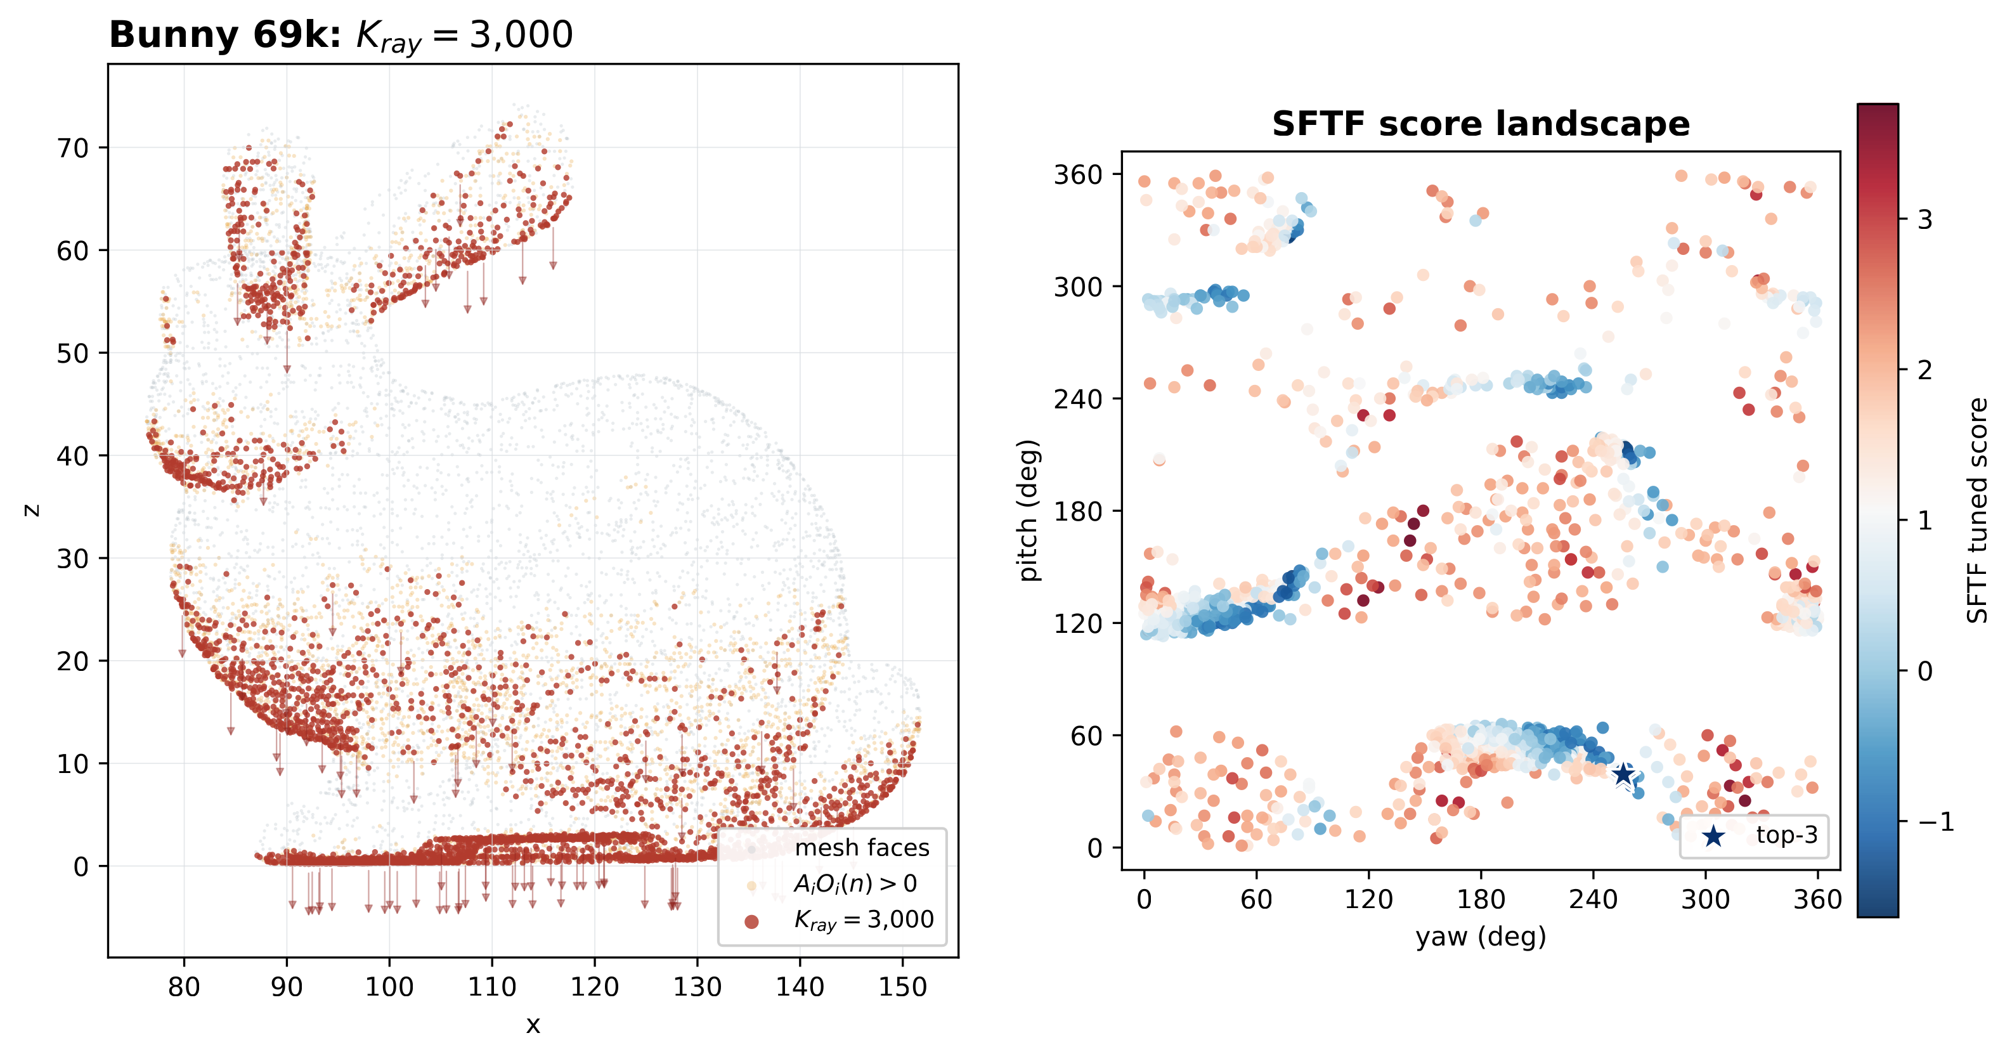
Bunny 69k source-face sampling and SFTF score landscape with fixed $K_{ray}=3000$, corresponding to the upper cap used for large meshes.
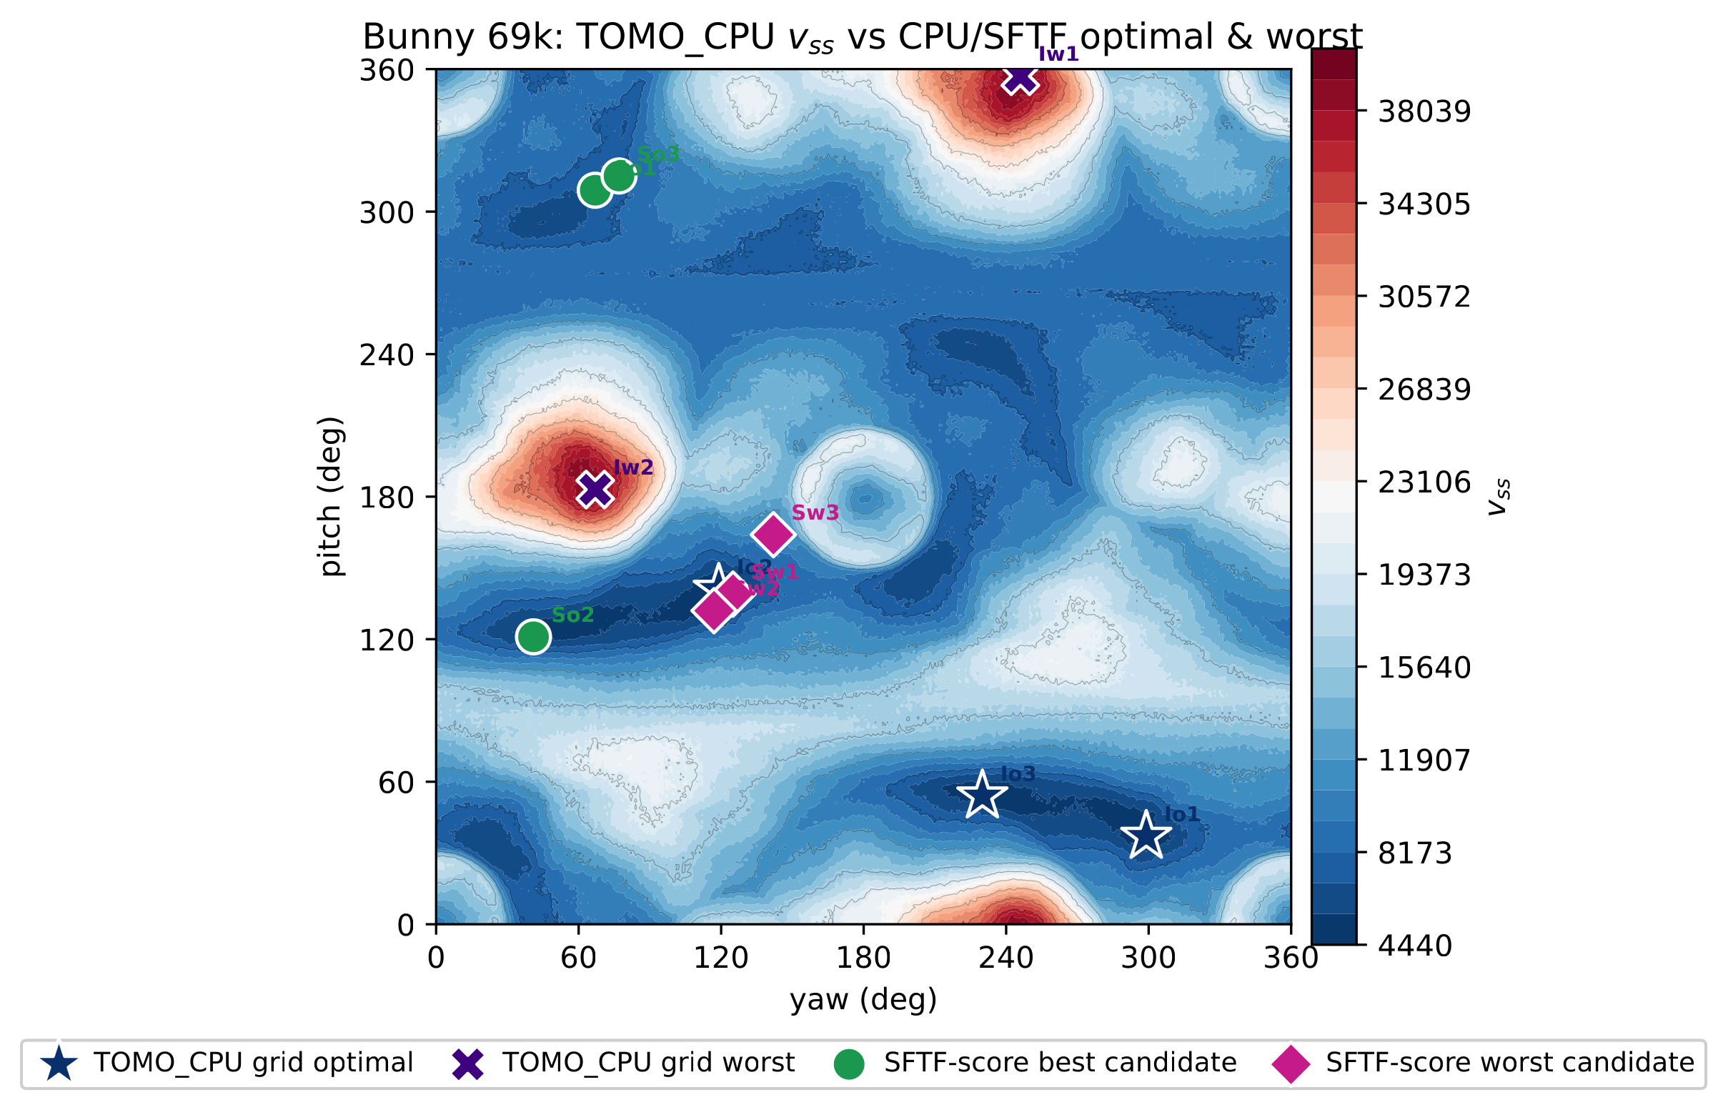
Comparison of CPU/SFTF optimal/worst orientations on the TOMO_CPU $v_{ss}$ landscape of Bunny 69k (blue is good). The markers are 3 each of CPU/SFTF optimal/worst, with kinds following the legend below the figure. The global optimum is $v_{ss}=4440$ (yaw$={299}^{∘}$, pitch$={37}^{∘}$; the corrected main-text comparison table), and lies not at a single point but within a broad low-cost basin.
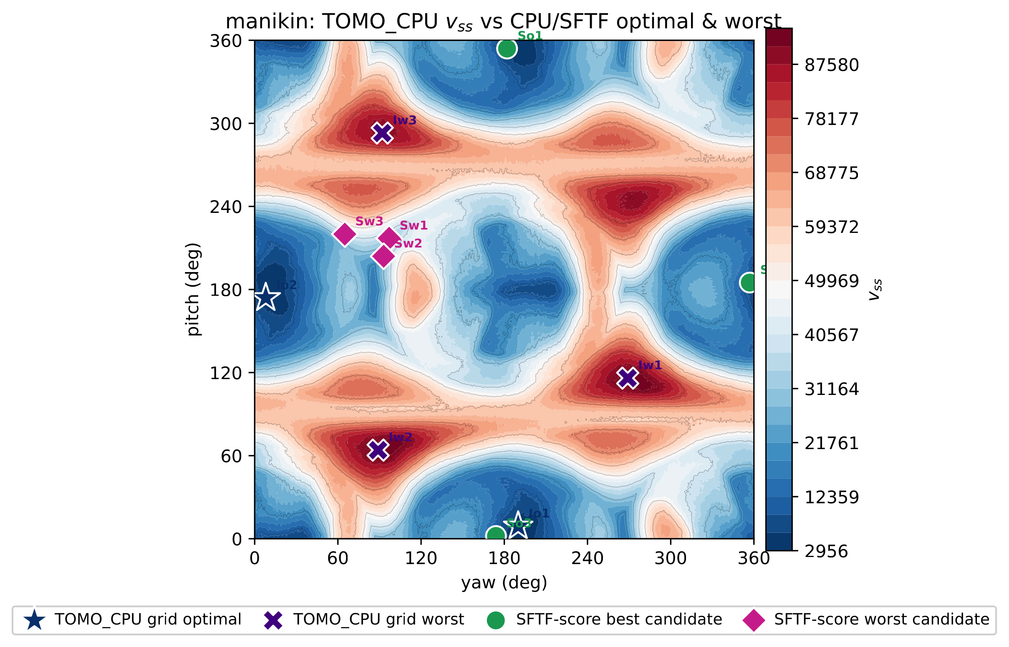
Comparison of CPU/SFTF optimal/worst orientations on the TOMO_CPU $v_{ss}$ landscape of Manikin 13k (blue is good). The markers are 3 each of CPU/SFTF optimal/worst, with kinds following the legend below the figure. The global optimum is $v_{ss}=2956$ (yaw$={190}^{∘}$, pitch$=9^{∘}$), and befitting a vertically elongated shape, the low-cost region is distributed in a narrow pitch band across the full yaw range.
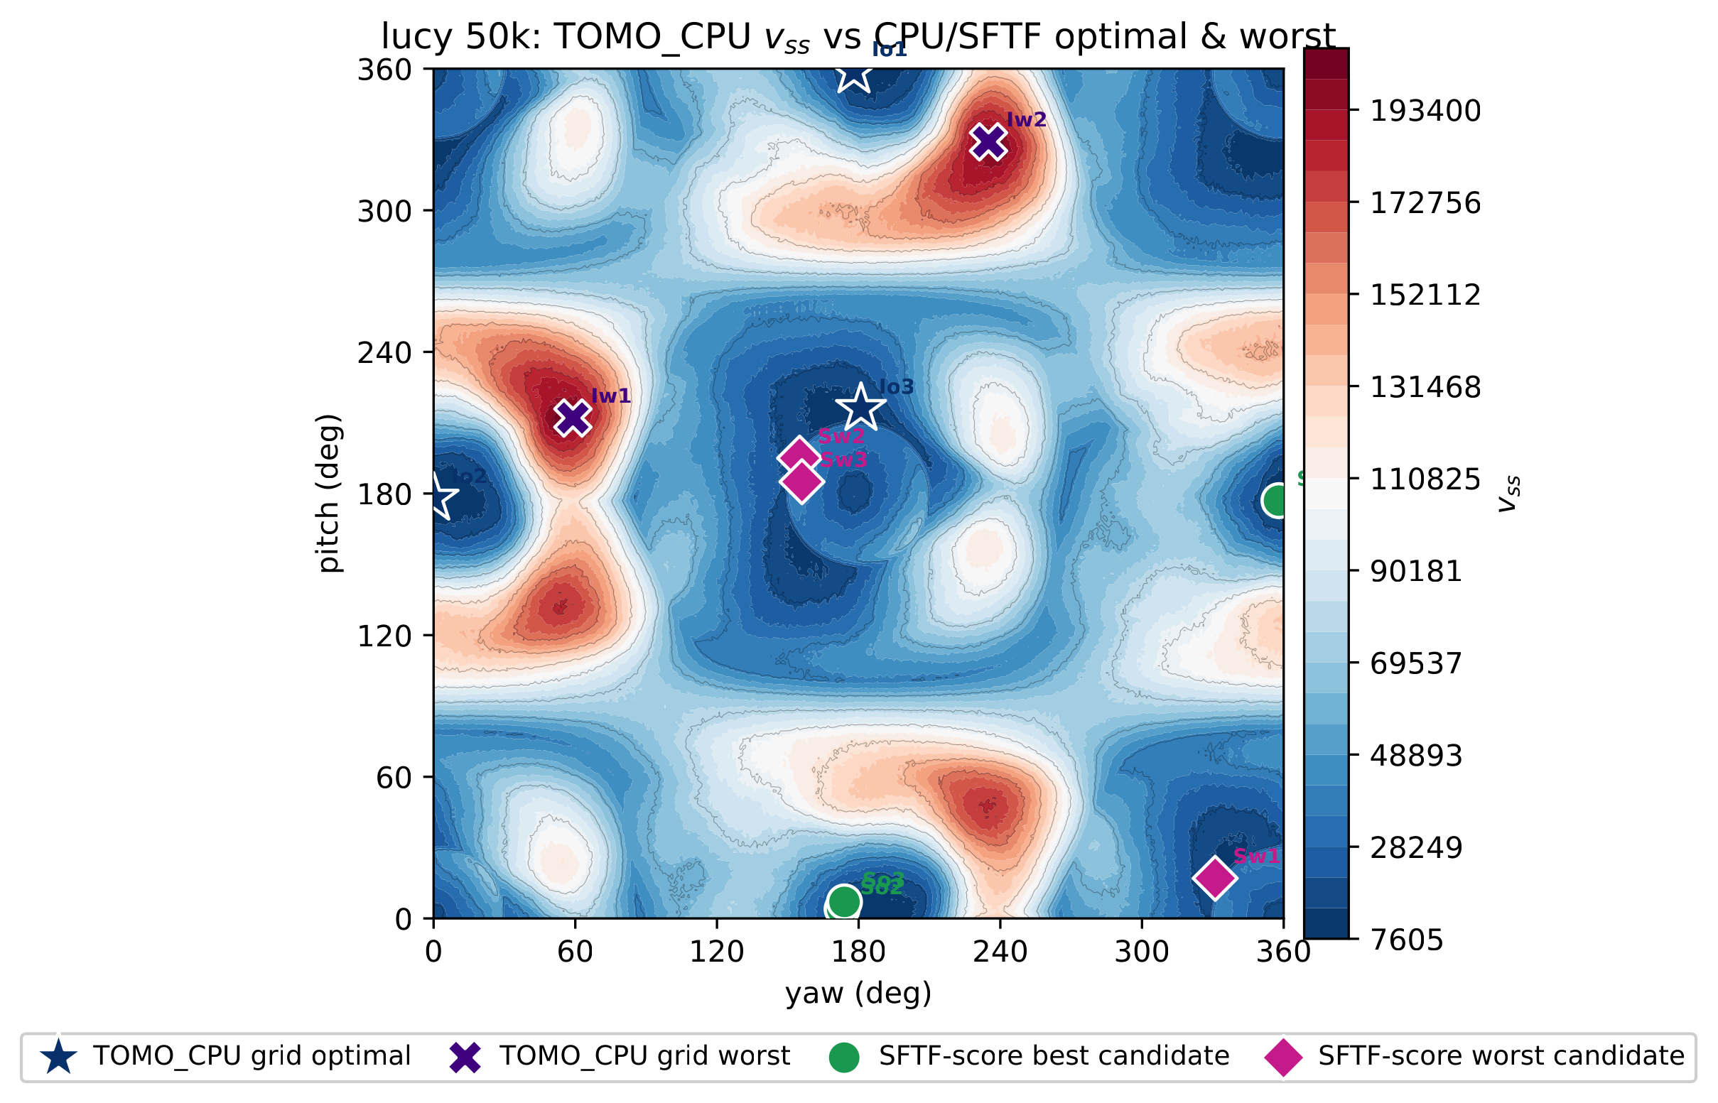
Comparison of CPU/SFTF optimal/worst orientations on the TOMO_CPU $v_{ss}$ landscape of Lucy 50k (blue is good). The markers are 3 each of CPU/SFTF optimal/worst, with kinds following the legend below the figure. The global optimum is $v_{ss}=7605$ (yaw$={178}^{∘}$, pitch$={359}^{∘}$), and being located near the pitch boundary (${359}^{∘}$), it requires basin search that considers the yaw–pitch periodicity.

