Part 1 – Formal Game Proposal

# Intro

For reasons still being researched, volcanoes started to appear all over Antarctica, flushing resources of unprecedented value onto the earth's surface. Although the resources legally belong to the state of Antarctica, the immense value of said resources led other fractions to claim ownership. Day after day, new gatherers arrived, trying to capture as much as they could. As the situation got out of control, the world union decided to legally distribute the resources all over the planet. In a time of great decadence it was decided that shares shall be dispensed based on the outcomes of deadly robot-matches inside the volcanoes. Since then, engineers all over the world have constantly been working on improving their robots in order to be able to explore and to claim the deadly depths of Antarctica's volcanoes.

# Informal Description

## Overview

The game features 2-4 players competing against each other (mainly in death match, but other modes such as control point or capture-the-flag are also conceivable) on one screen, viewed from a fixed angle (no scrolling, but automatic zoom has to be tested). The screen wraps around: if a player leaves to the right he will enter from the left and vice versa.

The competition takes place around a lake of lava. Large pillars stick out of the lava into the sky. Between the pillars, there are islands hovering on different heights. The players can stand on these islands, change the paths of the islands and go from one island to another. Islands can collide with each other and pillars, which can result in islands and/or pillars falling down and taking other objects with them. When a player stands on an island, it will slowly lose height because of the added weight. If a player leaves the island before it eventually sinks into the lava, it hovers back to its original position. Sunken islands can be replaced by new ones using a ray of cold water.

## Game elements

### Environment

The game environment consists of a rectangular field where all the action takes place. The borders wrap around, meaning that everything disappearing on one side reappears on the other side. This battle ground basically consists of the following three different elements:

* A sea of lava covers the ground and is - of course - deadly to the players
* Rock pillars of different sizes stick out of the lava
* Rock islands hover on a specific height above the field of lava.

A more precise definition of these elements follows.

### Pillars

Pillars just stick out of the lava. Islands can collide with them and tilt them over. When a pillar falls, it can take other pillars or islands with it. On the top, the pillars are covered in ice which is constantly melting – therefore, water runs down along the pillars.

### Hovering islands

Islands hover on a specific height (Y axis) on a specific path between the pillars. When islands collide with each other or pillars, they are only deflected from their path on the XZ plane and never leave their fixed position on the Y axis. Players can stand on islands, but they will slowly lose height and eventually melt in the lava below. Islands are covered by grass and other flora. Islands in the upper heights can also be covered in ice.

### Player characters

Players control characters, which have a certain amount of health and energy. A player can move between the islands and attack other players. While melee attack is free, energy is consumed if a player performs some special attack (see **Player Interactions**). Health is deduced when a player gets hit by another players attack. If a player’s health is zero or below, he dies and loses. A player also dies when falling into the lava.

### Player Interactions

Every player can perform the following actions without using any finite resource:

#### Island attraction (Use the Force, Luke)

Islands can be attracted using some fancy force which makes them slowly move towards the island the player is standing on, so he can switch to the other island.

#### Island jump (Up and at them)

The player can activate his jet pack for a very short amount of time which allows him to go from one island to another.

#### Island repulsion (Gassy emission)

The player can change the path of an island either temporarily or completely. He does so by grasping the island and emits a burst of air using his jet pack.

#### Direct combat (Mano-a-Mano)

Every player has a melee attack ability which costs no energy. A melee attack will both deduce health from his enemy as well as physically push the opponent away from the attacker. The latter one can be exploited to push an opponent over the edge of an island.

Furthermore, every player has energy as a resource. Energy will recharge itself with time and can be used to perform the following actions:

#### Indirect combat (Chicken tactics)

A player has various means of indirect combat in the form of special abilities:

* Ice spike. The player can specify a direction in which, subsequently, a spike is sent off. If the spike hits an enemy, he will get hurt and pushed back. If the spike hits a rising fire ball, an island will be built.
* Snow storm. The player can specify a point in range; a cloud will appear and start snowing on the creatures below it, causing damage.
* Fire wall. The player can lighten up a fire on the floor which will remain there for a fixed amount of time. Players stepping on the fire will be hurt.
* Small robot spawning: The player can spawn a robot on the current island which will be there for a fixed amount of time and attack all enemies stepping on the island.

## Concept Sketches

### Typical In-Game Situation

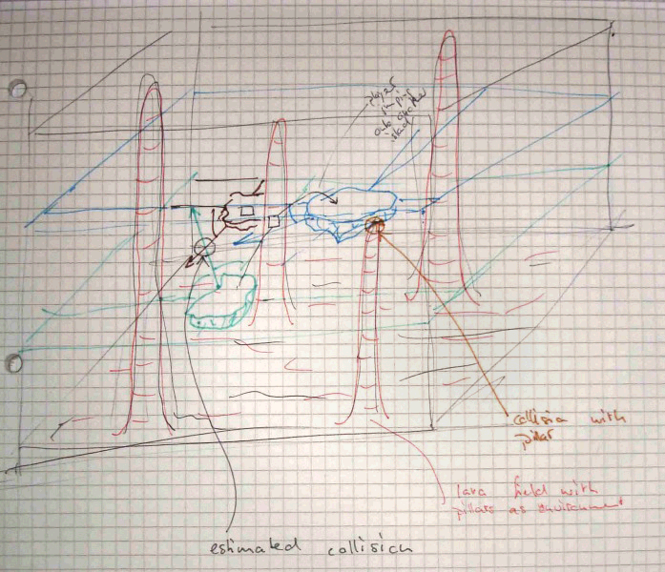

On this image one sees:

* 4 pillars
* 3 Islands floating, two of them on the same height
* Estimated collision point between the green and the brown island. After the collision, they will change their movement direction.
* Players are visualized by rectangles. Player 1 sits on the brown island waiting to shoot at player 2. Player two on the other hand flees from the crash onto the blue island.

### Visual Impression

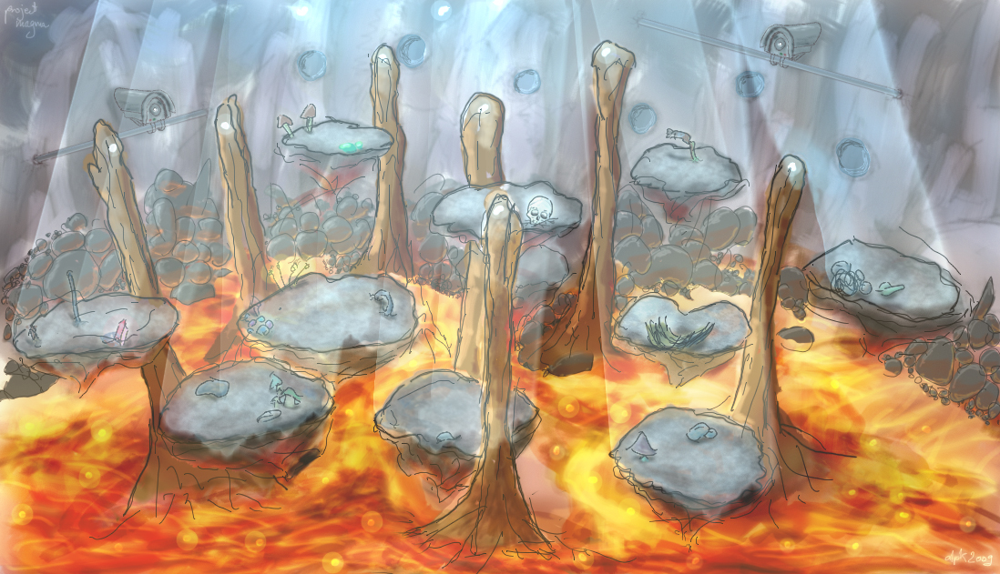

### Perspective Studies

|  |  |
| --- | --- |
| 77_mid.pngText | 31_high.pngText |
| 31_mid.pngText | |
| 21_mid.pngText | 31_low.pngText |

# Formal Requirements

## General

|  |  |  |
| --- | --- | --- |
| **ID** | **Requirement** | **Description** |
| ReqG01 | Basic Camera | The basic camera films the scene from a predefined position. The whole game area is always visible. |
| ReqG02 | Advanced Camera | The camera films the scene from a varying position. It always films from the same side, but height an zoom may vary depending on the optimal setting. |
| ReqG03 | Basic Software Framework | Setting up a generic framework that is expandable, embeds the game logic, graphics and similar. The framework should be built as much on XNA as possible. But still every new feature should be addable as a separate component. |
| ReqG04 | HDR Rendering | Setting up the renderer to render with high definition textures and effects. This feature significantly improves the visual appearance of the game. |
| ReqG05 | Shadow Rendering | Rendering the scene with shadows using a state-of-the art technique. |
| ReqG06 | Statistics | Keep track about players win and looses, their longest live, their fastest kill and their fastest death. |

## GUI AND HUD

|  |  |  |
| --- | --- | --- |
| **ID** | **Requirement** | **Description** |
| ReqUI01 | Start Screen | There is a start screen from where one can start a new game and view the high score. |
| ReqUI02 | High Score | The high score features statistics (defined in Req06) about past games. |
| ReqUI03 | Text Input | Text can be entered using the controller. |
| ReqUI04 | Player Selection | Players can select their desired character and enter their name. |
| ReqUI05 | Map Selection | The first player can select a map to play in. |
| ReqUI06 | Simple HUD | A HUD showing each players health and energy has to be available. |
| ReqUI07 | Fancy HUD | A beautifully designed HUD that nicely integrates with the game environment has to be available. |
| ReqUI08 | Intro | An intro explains the game’s background story. |

## Lava

|  |  |  |
| --- | --- | --- |
| **ID** | **Requirement** | **Description** |
| ReqL01 | Lava Ground | The ground is covered by lava. This requirement represents the game-logic of the lava. |
| ReqL02 | Basic Lava Effect | A basic effect to render the lava lake. A basic red rectangle is enough for a first prototype. |
| ReqL03 | Polished Lava Effect | A polished and nice effect to render the lava lake. This includes advanced shaders. |
| ReqL04 | Deadly Lava | If the player gets into contact with the lava he dies. |
| ReqL05 | Fire Eruptions | At random there are fire eruptions emerging from the lake. |
| ReqL06 | Harmful Fire Eruptions | If such a fire eruption hits a player he endures damage or dies. If the eruption hits an island it throws the island off its course. |

## Pillars

|  |  |  |
| --- | --- | --- |
| **ID** | **Requirement** | **Description** |
| ReqPi01 | Pillars | Pillars of different sizes stick out of the lava. This requirement represents the need to model pillars with respect to in-game logic. |
| ReqPi02 | Basic Pillar Rendering | There is some model representing pillars which stick out of the lava. |
| ReqPi03 | Sophisticated Pillar Rendering | Realistically rendered pillars stick out of the lava. |
| ReqPi04 | Tilt Pillars | Pillars can be tilt over by islands. The resulting fall can affect other islands and pillars. |
| ReqPi05 | Icy Pillars | Pillars have a top consisting of ice, which melts to water that runs down the pillar and drops into the lava. |

## Floating Islands

|  |  |  |
| --- | --- | --- |
| **ID** | **Requirement** | **Description** |
| ReqI01 | Floating Islands | Initially there is a set of floating islands of rock. The islands hover above the lake of lava in different heights. |
| ReqI02 | Basic Island Rendering | A basic rendering such that the islands are visible and useable inside a game. |
| ReqI03 | Sophisticated Island Rendering | A polished and nice effect to render the islands. |
| ReqI04 | Moving Floating Islands | Islands have the ability to move. They move with a given velocity. |
| ReqI05 | Crashing Islands | If an island crashes into another island the collision will be resolved according to physics. The resulting movement should be locked onto the x/z plane the resulting rotation only respective to the y-axis. |
| ReqI06 | Islands and Pillars | If an island crashes into a pillar the collision will be resolved according to physics. The resulting movement should be locked onto the x/z plane the resulting rotation only respective to the y-axis. |
| ReqI07 | Sinking Islands | If a player stands on an island it will lose height. |
| ReqI08 | Rising Islands | If the island does not carry the player it regains its original height. |
| ReqI09 | Melting Islands | If an island gets into contact with lava it melts. |
| ReqI10 | Destructible Islands | If an island takes enough damage, either by a players special ability or by falling pillars it will fall apart. |
| ReqI11 | Icy Islands | Islands hovering above a specific height are slightly or fully covered in ice. |

## Player

|  |  |  |
| --- | --- | --- |
| **ID** | **Requirement** | **Description** |
| ReqP01 | Player | The player has to be represented with the game-logic. |
| ReqP02 | Basic Player Model | A model for the player is available. |
| ReqP03 | Sophisticated Player Model | A realistic model for the player is available. |
| ReqP04 | Island Attraction | A player can use attract an island so it floats to the side of the island the player is standing on. As soon as the island is not attracted anymore, it hovers back to its original position. |
| ReqP05 | Island Walking | The player can walk to an island he attracted. |
| ReqP06 | Island Jumping | A player can use the jetpack to move from one island to another. |
| ReqP07 | Island Repulsion | A player can use the jetpack to emit bursts of air which will for a short period of time get an island to drift off its original course. If it collides with a pillar it could change its course completely. |
| ReqP08 | Direct Combat 1 | Every player has a melee attack ability which costs no energy. This will deduce health from his enemy. |
| ReqP09 | Direct Combat 2 | A realistic attack animation is displayed. |
| ReqP10 | Direct Combat 3 | Melee attacks will also physically push the opponent away from the attacker. |
| ReqP11 | Energy | Every player has an energy bar which is displayed in the UI. Energy will recharge itself with time. Every used skill will use a fixed amount of energy. |
| ReqP12 | Ice Spike | The player can specify a direction in which, subsequently, a spike is sent off. If the spike hits an enemy, he will get hurt and pushed back. |
| ReqP13 | Flame Thrower Damage | The player can use a flame thrower to cause damage to another player. |
| ReqP14 | Flame Thrower Island Destruction | The player can use a flame thrower to target and destroy islands. |
| ReqP15 | Building Islands with Ice Spikes | If the spike hits a rising fire ball, an island will be built. |
| ReqP16 | Snow storm | The player can specify a point in range, a cloud will appear and start snowing on the creatures below it, causing damage. |
| ReqP17 | Fire Wall | The player can lighten up a fire on the floor which will remain there for a fixed amount of time. Players stepping on the fire will be hurt. |
| ReqP18 | Small Robot Spawning | The player can spawn a robot on the current island which will be there for a fixed amount of time and attack all enemies stepping on the island. |

# Development Schedule

The development shall be divided into consecutive layers. All of the requirements defined under Formal Requirements are classified and assigned to one of them. Those layers are:

1. **Functional minimum**: This first layer contains the set of requirements minimally required to play the game. It is the bare minimum. If any feature is removed from this part the prototype will degrade from a game into a technical prototype. The functional minimum is also a milestone.
2. **Low target**: The low target is the second layer and also a milestone. Though it contains more features than the bare minimum, it is still essentially not what should be achieved during the timeframe of fourteen weeks. Still it will serve as a good indicator if the development is still inside the timeframe laid out in this chapter.
3. **Desirable target**: This layer and milestone is what the project aims at. It contains all the requirements that make up a well polished and fun to play game.
4. **High target**: The high target contains additional features that will make it into the final deliverable if the team has some free time to implement them. There is no milestone defined for it. After finishing the Desirable Target it will be decided which features of this target will make it into the gold version milestone.
5. **Extras**: This part of the schedule defines some additions to the game that would be fun but are not realistic to achieve. However in a future project they could be added.

The layers then are assigned to milestones to be reached on a specific date. Those milestones contain a detailed timetable determining when each requirement will be implemented and who is responsible for the implementation. This timetable shall be filled out iteratively during the projects development.

## Deliverables

### Prototype

|  |  |
| --- | --- |
| ID | Requirement |
| ReqG01 | Basic Camera |
| ReqG03 | Basic Software Framework |
| ReqL01 | Lava Ground |
| ReqL02 | Basic Lava Effect |
| ReqL04 | Deadly Lava |
| ReqPi01 | Pillars |
| ReqPi02 | Basic Pillar Rendering |
| ReqI01 | Floating Islands |
| ReqI02 | Basic Island Rendering |
| ReqI04 | Moving Floating Islands |
| ReqP01 | Player |
| ReqP02 | Basic Player Model |
| ReqP06 | Island Jumping |
| ReqP08 | Direct Combat 1 |
| ReqP10 | Direct Combat 3 |
| ReqP12 | Ice Spike |

### Functional Minimum

|  |  |
| --- | --- |
| ID | Requirement |
| ReqI05 | Crashing Islands |
| ReqI06 | Islands and Pillars |
| ReqP09 | Direct Combat 2 |
| ReqI07 | Sinking Islands |
| ReqI08 | Rising Islands |
| ReqP13 | Flame Thrower Damage |
| ReqP14 | Flame Thrower Island Destruction |
| ReqP11 | Energy |
| ReqUI06 | Simple HUD |

### Low target

|  |  |
| --- | --- |
| ID | Requirement |
| ReqL03 | Polished Lava Effect |
| ReqPi03 | Sophisticated Pillar Rendering |
| ReqI03 | Sophisticated Island Rendering |
| ReqP03 | Sophisticated Player Model |
| ReqUI04 | Player Selection |
| ReqUI07 | Fancy HUD |

### Desirable target

|  |  |
| --- | --- |
| ID | Requirement |
| ReqG02 | Advanced Camera |
| ReqP04 | Island Attraction |
| ReqP05 | Island Walking |
| ReqP07 | Island Repulsion |
| ReqG05 | Shadow Rendering |
| ReqG06 | Statistics |
| ReqUI03 | Text Input |
| ReqUI01 | Start Screen |
| ReqUI02 | High Score |
| ReqUI05 | Map Selection |

### High target

|  |  |
| --- | --- |
| ID | Requirement |
| ReqG04 | HDR Rendering |
| ReqL05 | Lava Eruptions |
| ReqL06 | Harmful Fire Eruptions |
| ReqPi04 | Tilt Pillars |
| ReqPi05 | Icy pillars |
| ReqI09 | Melting Islands |
| ReqP15 | Building Islands with Ice Spikes |
| ReqUI08 | Intro |

### Extras

|  |  |
| --- | --- |
| ID | Requirement |
| ReqI10 | Destructible Islands |
| ReqP16 | Snow Storm |
| ReqP17 | Fire Wall |
| ReqP18 | Small Robot Spawning |
| ReqI11 | Icy Islands |

## Milestones

|  |  |  |  |
| --- | --- | --- | --- |
| ID | Milestone | Description | Due Date |
| MS01 | Prototype Chapter Written | With this milestone the prototype chapter must have been written and added to the game notebook. Everyone in the team should also have installed and experimented with XNA in order to be ready for development.  Additionally a game prototype according to the prototype specification has been created. | March 16, 5pm |
| MS02 | Functional Minimum | With this milestone the functional minimum must be implemented, working and tested. | March 23, 12pm |
| MS03 | Interim Report Written | With this milestone the chapter with the interim report must have been written and added to the game notebook. | April 6, 5pm |
| MS04 | Low Target | With this milestone the low target shall be hit. | April 13, 12pm |
| MS05 | Desirable Target | With this milestone the team must have fulfilled the requirements for the desirable target. The prototype must be tested and in presentable order since it is needed for play testing in the week after. | May 4, 12pm |
| MS06 | Play test Chapter Written | With this milestone the play test chapter must have been written and added to the game notebook. This concludes that to this date all the play testing must be done. | May 11, 5pm |
| MS07 | Gold Version | With this milestone the development must have been concluded. All testing must have been finished and some of the high target functionality should be implemented. | May 25, 12pm |
| MS08 | Conclusion and Presentation | With this milestone the conclusion chapter must have been written and added to the game notebook. In addition the public presentation of the game must be ready to be held. | May 29, 5pm |

## Task Assignments and Work Estimation

### Functional Minimum

|  |  |  |  |
| --- | --- | --- | --- |
| ID | Requirement | Assignee | Work Estimate |
| ReqG01 | Basic Camera | cob | 2h |
| ReqG03 | Basic Software Framework | cob | 8h |
| ReqL01 | Lava Ground | jab | 3h |
| ReqL02 | Basic Lava Effect | cob | 2h |
| ReqL04 | Deadly Lava | jab | 3h |
| ReqPi01 | Pillars | cob | 3h |
| ReqPi02 | Basic Pillar Rendering | cob | 2h |
| ReqI01 | Floating Islands | jab | 2h |
| ReqI02 | Basic Island Rendering | dpk | 4h |
| ReqP01 | Player | jab | 4h |
| ReqP02 | Basic Player Model | dpk | 10h |
| ReqP06 | Island Jumping | jab | 4h |
| ReqP08 | Direct Combat | jab | 4h |

## Development Timetable

Week 12: 16.3.-22.3. Working towards MS02

|  |  |  |  |  |  |  |  |  |  |
| --- | --- | --- | --- | --- | --- | --- | --- | --- | --- |
| ID | Requirement | Assignee | Mo | Tue | Wed | Thu | Fri | Sat | Sun |
| ReqG01 | Basic Camera | cob |  | 2 |  |  |  |  |  |
| ReqG03 | Basic Software Framework | cob | 8 |  |  |  |  |  |  |
| ReqL01 | Lava Ground | jab |  | 3 |  |  |  |  |  |
| ReqL02 | Basic Lava Effect | cob |  |  | 2 |  |  |  |  |
| ReqL04 | Deadly Lava | jab |  | 3 |  |  |  |  |  |
| ReqPi01 | Pillars | jab |  |  | 3 |  |  |  |  |
| ReqPi02 | Basic Pillar Rendering | cob |  |  | 2 |  |  |  |  |
| ReqI01 | Floating Islands | jab |  |  | 2 |  |  |  |  |
| ReqI02 | Basic Island Rendering | dpk |  | 4 |  |  |  |  |  |
| ReqP01 | Player | jab |  |  |  | 4 |  |  |  |
| ReqP02 | Basic Player Model | dpk |  | 4 | 4 | 2 |  |  |  |
| ReqP06 | Island Jumping | jab |  |  |  | 4 |  |  |  |
| ReqP08 | Direct Combat 1 | jab |  |  |  |  | 4 |  |  |
| None | Testing | jab/dpk/cob |  |  |  |  |  | 4 | 4 |
| None | Work Estimates and Plan for MS05 | jab/dpk/cob |  |  |  |  |  | 1 | 1 |

Week 13: 23.3.-29.3. Working towards MS03 and MS04

Exact schedule to be determined.

Week 14: 30.3.-05.4. Working towards MS03 and MS04

Exact schedule to be determined.

Week 15: 06.4.-12.4. Working towards MS04

Exact schedule to be determined.

Week 16: 13.4.-19.4. Working towards MS05

Exact schedule to be determined.

Week 17: 20.4.-26.4. Working towards MS05

Exact schedule to be determined.

Week 18: 27.4.-03.5. Working towards MS05

Exact schedule to be determined.

Week 19: 04.5.-10.5. Working towards MS06

Exact schedule to be determined.

Week 20: 11.5.-17.5. Working towards MS07

Exact schedule to be determined.

Week 21: 18.5.-24.5. Working towards MS07

Exact schedule to be determined.

Week 22: 25.5.-29.5. Working towards MS08

Exact schedule to be determined.

# Assessment

The game features various possibilities of interaction with the game world and other players. Thus, it offers a very varied game play and diverse tactics a player can employ in order to ingeniously defeat its opponent. On the other hand, it should still be simple enough for everyone to learn the controls in a matter of minutes and enjoy playing.

A game world mainly consisting of lava is a challenge, but should reward us - and the player - with a beautiful, animated environment. Additionally, there is some cool physics involved when islands collide with each other or pillars.

We regard the game to be successful if players can make real use of the floating islands - and the involved physics - to fight each other.