Janick Bernet

Dominik Käser

Christian Oberholzer

29.05.2009

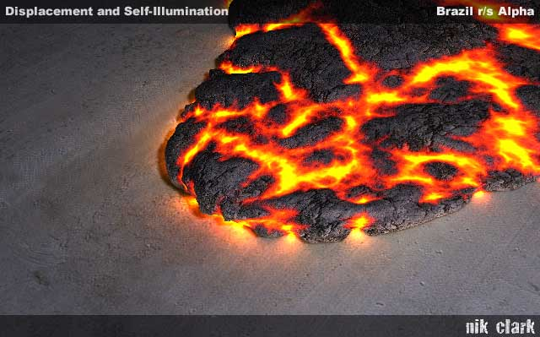

Game Notebook

Project Magma

Table of Contents

[Table of Contents 2](#_Toc225873101)

[Part 1 – Formal Game Proposal 3](#_Toc225873102)

[Intro 3](#_Toc225873103)

[Informal Description 3](#_Toc225873104)

[Overview 3](#_Toc225873105)

[Game elements 3](#_Toc225873106)

[Concept Sketches 3](#_Toc225873107)

[Formal Requirements 3](#_Toc225873108)

[General 3](#_Toc225873109)

[GUI AND HUD 3](#_Toc225873110)

[Lava 3](#_Toc225873111)

[Pillars 3](#_Toc225873112)

[Floating Islands 3](#_Toc225873113)

[Player 3](#_Toc225873114)

[Development Schedule 3](#_Toc225873115)

[Deliverables 3](#_Toc225873116)

[Milestones 3](#_Toc225873117)

[Task Assignments and Work Estimation 3](#_Toc225873118)

[Development Timetable 3](#_Toc225873119)

[Assessment 3](#_Toc225873120)

[Part 2 – Prototype 3](#_Toc225873121)

[Gameplay Screenshots 3](#_Toc225873122)

[Findings 3](#_Toc225873123)

[Positioning 3](#_Toc225873124)

[Player movement 3](#_Toc225873125)

[Island Travel 3](#_Toc225873126)

[Parameter Tuning 3](#_Toc225873127)

[Part 3 – Interim Report 3](#_Toc225873128)

[Week 1: Functional Minimum 3](#_Toc225873129)

[Changes 3](#_Toc225873130)

[achievements 3](#_Toc225873131)

[Problems 3](#_Toc225873132)

[The Product 3](#_Toc225873133)

[Planning 3](#_Toc225873134)

[Week 2: Low Target Part 1 3](#_Toc225873135)

[Week 2: Low Target Part 2 3](#_Toc225873136)

[Part 4 – Alpha Release 3](#_Toc225873137)

[Part 5 – Playtesting 3](#_Toc225873138)

[Part 6 – Public Presentation and Conclusion 3](#_Toc225873139)

Part 1 – Formal Game Proposal

# Intro

For reasons still being researched, volcanoes started to appear all over Antarctica, flushing resources of unprecedented value onto the earth's surface. Although the resources legally belong to the state of Antarctica, the immense value of said resources led other fractions to claim ownership. Day after day, new gatherers arrived, trying to capture as much as they could. As the situation got out of control, the world union decided to legally distribute the resources all over the planet. In a time of great decadence it was decided that shares shall be dispensed based on the outcomes of deadly robot-matches inside the volcanoes. Since then, engineers all over the world have constantly been working on improving their robots in order to be able to explore and to claim the deadly depths of Antarctica's volcanoes.

# Informal Description

## Overview

The game features 2-4 players competing against each other (mainly in death match, but other modes such as control point or capture-the-flag are also conceivable) on one screen, viewed from a fixed angle (no scrolling, but automatic zoom has to be tested). The screen wraps around: if a player leaves to the right he will enter from the left and vice versa.

The competition takes place around a lake of lava. Large pillars stick out of the lava into the sky. Between the pillars, there are islands hovering on different heights. The players can stand on these islands, change the paths of the islands and go from one island to another. Islands can collide with each other and pillars, which can result in islands and/or pillars falling down and taking other objects with them. When a player stands on an island, it will slowly lose height because of the added weight. If a player leaves the island before it eventually sinks into the lava, it hovers back to its original position. Sunken islands can be replaced by new ones using a ray of cold water. Periodically, eruptions from the lava in the form of fireballs will appear and hurt players if they get hit.

## Game elements

### Environment

The game environment consists of a rectangular field where all the action takes place. The borders wrap around, meaning that everything disappearing on one side reappears on the other side. This battle ground basically consists of the following three different elements:

* A sea of lava covers the ground and is - of course - deadly to the players
* Rock pillars of different sizes stick out of the lava
* Rock islands hover on a specific height above the field of lava.

A more precise definition of these elements follows.

### Pillars

Pillars just stick out of the lava. Islands can collide with them and tilt them over. When a pillar falls, it can take other pillars or islands with it. On the top, the pillars are covered in ice which is constantly melting – therefore, water runs down along the pillars.

### Hovering islands

Islands hover on a specific height (Y axis) on a specific path between the pillars. When islands collide with each other or pillars, they are only deflected from their path on the XZ plane and never leave their fixed position on the Y axis. Players can stand on islands, but they will slowly lose height and eventually melt in the lava below. Islands are covered by grass and other flora. Islands in the upper heights can also be covered in ice.

### Player characters

Players control characters, which have a certain amount of health and energy. A player can move between the islands and attack other players. While melee attack is free, energy is consumed if a player performs some special attack (see Indirect combat (Chicken tactics)). Health is deduced when a player gets hit by another players attack. If a player’s health is zero or below, he dies and loses. A player also dies when falling into the lava.

### Power-ups

Simple power ups for health and energy are distributed over the islands. They will randomly re-appear if collected.

### Player Interactions

Every player can perform the following actions without using any finite resource:

#### Walking (boring but necessary)

Players can walk around the islands, though they cannot fall from them just by walking.

#### Collect power-ups (red bull gives you wings!)

If a player gets in contact with a power-up he can collect it and will receive the power accordingly.

#### Island attraction (Use the Force, Luke)

Islands can be attracted using some fancy force which makes them slowly move towards the island the player is standing on, so he can switch to the other island.

#### Island jump (Up and at them)

The player can activate his jet pack for a very short amount of time which allows him to go from one island to another.

#### Island repulsion (Gassy emission)

The player can change the path of an island either temporarily or completely. He does so by grasping the island and emits a burst of air using his jet pack.

#### Direct combat (Mano-a-Mano)

Every player has a melee attack ability which costs no energy. A melee attack will both deduce health from his enemy as well as physically push the opponent away from the attacker. The latter one can be exploited to push an opponent over the edge of an island.

Furthermore, every player has energy as a resource. Energy will recharge itself with time and can be used to perform the following actions:

#### Indirect combat (Chicken tactics)

A player has various means of indirect combat in the form of special abilities:

* **Ice spike**: The player can specify a direction in which, subsequently, a spike is sent off. If the spike hits an enemy, he will get hurt and frozen for a short period. If the spike hits lava, an island will be created.
* **Snow storm**: The player can specify a point in range; a cloud will appear and start snowing on the creatures below it, causing damage.
* **Fire wall**: The player can lighten up a fire on the floor which will remain there for a fixed amount of time. Players stepping on the fire will be hurt.
* **Small robot spawning (aka binary fission)**: The player can spawn a robot on the current island which will be there for a fixed amount of time and attack all enemies stepping on the island.

## Concept Sketches

### Typical In-Game Situation

On this image one sees:

* 4 pillars
* 3 Islands floating, two of them on the same height
* Estimated collision point between the green and the brown island. After the collision, they will change their movement direction.
* Players are visualized by rectangles. Player 1 sits on the brown island waiting to shoot at player 2. Player two on the other hand flees from the crash onto the blue island.

### islands_overdrawn3b.jpgVisual Impression

How the game could look when it is done.

### Perspective Studies

|  |  |  |
| --- | --- | --- |
| 77_mid.pngAn alternate view angle of 18 degrees. It is difficult here to navigate in the XZ plane. | 31_high.pngAn alternate tilt angle of 38 degrees. The notion of height is difficult to grasp here. | |
| 31_mid.pngWe deemed this view to be optimal in both perspective (f=21) and tilt angle (26 degrees ). | | |
| 21_mid.pngAn alternate perspective, f=21. The distortion is too large, players would stay in the front. | | 31_low.pngA more orthographic perspective, f=71. There is no dramatics, the look and feel is too static. |

### player_animations.pngModel Animation States

A finite state automata model of player animations. Colors denote priorities of realization (green is high, red is low). Outlined states denote looping animations.

### ROBOT MODELS

We particularly like the look and feel of this robot we found on the web. The head is over proportional to the body which yields a more comic look and feel. We might want to go for a longer head to make it look more aggressive, though.

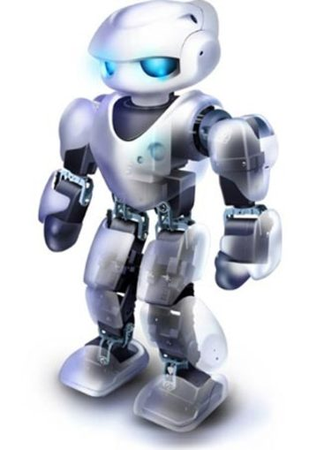

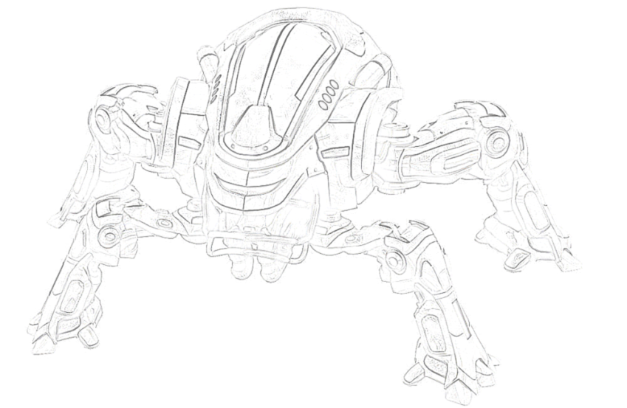

A concept of little prop robots which are spawned on islands to make an island hostile (high target).

# Formal Requirements

## General

|  |  |  |
| --- | --- | --- |
| **ID** | **Requirement** | **Description** |
| ReqG01 | Basic Camera | The basic camera captures the scene from a predefined position. The whole game area is always visible. |
| ReqG02 | Advanced Camera | The camera films the scene from a varying position. It always films from the same side, but height an zoom may vary depending on the optimal setting. |
| ReqG03 | Basic Software Framework | Setting up a generic framework that is expandable, embeds the game logic, graphics and similar. The framework should be built as much on XNA as possible. But still every new feature should be addable as a separate component. |
| ReqG04 | HDR Rendering | Setting up the renderer to render with high definition textures and effects. This feature significantly improves the visual appearance of the game. |
| ReqG05 | Shadow Rendering | Rendering the scene with shadows using a state-of-the art technique. |
| ReqG06 | Statistics | Keep track about players win and looses, their longest live, their fastest kill and their fastest death. |

## GUI AND HUD

|  |  |  |
| --- | --- | --- |
| **ID** | **Requirement** | **Description** |
| ReqUI01 | Start Screen | There is a start screen from where one can start a new game and view the high score. |
| ReqUI02 | High Score | The high score features statistics (defined in Req06) about past games. |
| ReqUI03 | Text Input | Text can be entered using the controller. |
| ReqUI04 | Player Selection | Players can select their desired character and enter their name. |
| ReqUI05 | Map Selection | The first player can select a map to play in. |
| ReqUI06 | Simple HUD | A HUD showing each players health and energy has to be available. |
| ReqUI07 | Fancy HUD | A beautifully designed HUD that nicely integrates with the game environment has to be available. |
| ReqUI08 | Intro | An intro explains the game’s background story. |

## Lava

|  |  |  |
| --- | --- | --- |
| **ID** | **Requirement** | **Description** |
| ReqL01 | Lava Ground | The ground is covered by lava. This requirement represents the game-logic of the lava. |
| ReqL02 | Basic Lava Effect | A basic effect to render the lava lake. A basic red rectangle is enough for a first prototype. |
| ReqL03 | Polished Lava Effect | A polished and nice effect to render the lava lake. This includes advanced shaders. |
| ReqL04 | Deadly Lava | If the player gets into contact with the lava he dies. |
| ReqL05 | Fire Eruptions | At random there are fire eruptions emerging from the lake. |
| ReqL06 | Harmful Fire Eruptions | If such a fire eruption hits a player he endures damage or dies. If the eruption hits an island it throws the island off its course. |

## Pillars

|  |  |  |
| --- | --- | --- |
| ID | Requirement | Description |
| ReqPi01 | Pillars | Pillars of different sizes stick out of the lava. This requirement represents the need to model pillars with respect to in-game logic. |
| ReqPi02 | Basic Pillar Rendering | There is some model representing pillars which stick out of the lava. |
| ReqPi03 | Sophisticated Pillar Rendering | Realistically rendered pillars stick out of the lava. |
| ReqPi04 | Tilt Pillars | Pillars can be tilt over by islands. The resulting fall can affect other islands and pillars. |
| ReqPi05 | Icy Pillars | Pillars have a top consisting of ice, which melts to water that runs down the pillar and drops into the lava. |

## Floating Islands

|  |  |  |
| --- | --- | --- |
| ID | Requirement | Description |
| ReqI01 | Floating Islands | Initially there is a set of floating islands of rock. The islands hover above the lake of lava in different heights. |
| ReqI02 | Basic Island Rendering | A basic rendering such that the islands are visible and useable inside a game. |
| ReqI03 | Sophisticated Island Rendering | A polished and nice effect to render the islands. |
| ReqI04 | Moving Floating Islands | Islands have the ability to move. They move with a given velocity. |
| ReqI05 | Crashing Islands | If an island crashes into another island the collision will be resolved according to physics. The resulting movement should be locked onto the x/z plane the resulting rotation only respective to the y-axis. |
| ReqI06 | Islands and Pillars | If an island crashes into a pillar the collision will be resolved according to physics. The resulting movement should be locked onto the x/z plane the resulting rotation only respective to the y-axis. |
| ReqI07 | Sinking Islands | If a player stands on an island it will lose height. |
| ReqI08 | Rising Islands | If the island does not carry the player it regains its original height. |
| ReqI09 | Melting Islands | If an island gets into contact with lava it melts. |
| ReqI10 | Destructible Islands | If an island takes enough damage, either by a players special ability or by falling pillars it will fall apart. |
| ReqI11 | Icy Islands | Islands hovering above a specific height are slightly or fully covered in ice. |
| ReqI12 | Power-Ups | Power-Ups are lying on the islands. |
| ReqI13 | Power-Up Re-spawn | Power-Ups re-spawn if consumed on a random island |
| ReqI14 | Island Health Indication | If islands are being destroyed by heat the progress of destruction shall be indicated by an increasing glow. |

## Player

|  |  |  |
| --- | --- | --- |
| ID | Requirement | Description |
| ReqP01 | Player | The player has to be represented within the game-logic. |
| ReqP02 | Basic Player Model | A model for the player is available. |
| ReqP03 | Sophisticated Player Model | A realistic model for the player is available. |
| ReqP04 | Island Attraction | A player can use attract an island so it floats to the side of the island the player is standing on. As soon as the island is not attracted anymore, it hovers back to its original position. |
| ReqP05 | Island Walking | The player can walk to an island he attracted. |
| ReqP06 | Island Jumping | A player can use the jetpack to move from one island to another. |
| ReqP07 | Island Repulsion | A player can use the jetpack to emit bursts of air which will for a short period of time get an island to drift off its original course. If it collides with a pillar it could change its course completely. |
| ReqP08 | Direct Combat 1 | Every player has a melee attack ability which costs no energy. This will deduce health from his enemy. |
| ReqP09 | Direct Combat 2 | A realistic attack animation is displayed. |
| ReqP10 | Direct Combat 3 | Melee attacks will also physically push the opponent away from the attacker. |
| ReqP11 | Energy | Every player has an energy bar which is displayed in the UI. Energy will recharge itself with time. Every used skill will use a fixed amount of energy. |
| ReqP12 | Ice Spike | The player can specify a direction in which, subsequently, a spike is sent off. If the spike hits an enemy, he will get hurt and frozen for a short period. |
| ReqP13 | Flame Thrower Damage | The player can use a flame thrower to cause damage to another player. |
| ReqP14 | Flame Thrower Island Destruction | The player can use a flame thrower to target and destroy islands. |
| ReqP15 | Building Islands with Ice Spikes | If the spike hits a rising fire ball, an island will be built. |
| ReqP16 | Snow storm | The player can specify a point in range, a cloud will appear and start snowing on the creatures below it, causing damage. |
| ReqP17 | Fire Wall | The player can lighten up a fire on the floor which will remain there for a fixed amount of time. Players stepping on the fire will be hurt. |
| ReqP18 | Small Robot Spawning | The player can spawn a robot on the current island which will be there for a fixed amount of time and attack all enemies stepping on the island. |
| ReqP19 | Aiming Aids | Visual aids for helping the player aim (during ranged combat or islands jumping) shall be implemented to simplify controlling a player. |
| ReqP20 | Collecting Power-Ups | Players can collect power-ups and get their respective bonuses. |
| ReqP21 | Slow Indication | If a player has been slowed, this state shall be indicated graphically. |

# Development Schedule

The development shall be divided into consecutive layers. All of the requirements defined under are classified and assigned to one of them. Those layers are:

1. **Prototype**: The prototype serves to play test the central game-logic and contains only the most minimal graphical features needed to represent the game state. If any feature is removed from this part the prototype will degrade from a game into a technical prototype.
2. **Functional minimum**: This first layer contains the set of requirements minimally required to play the game and also some first simple visuals. The functional minimum is the first milestone.
3. **Low target**: The low target is the second layer and also a milestone. Though it contains more features than the bare minimum, it is still essentially not what should be achieved during the timeframe of fourteen weeks. Still it will serve as a good indicator if the development is still inside the timeframe laid out in this chapter.
4. **Desirable target**: This layer and milestone is what the project aims at. It contains all the requirements that make up a well polished and fun to play game.
5. **High target**: The high target contains additional features that will make it into the final deliverable if the team has some free time to implement them. There is no milestone defined for it. After finishing the Desirable Target it will be decided which features of this target will make it into the gold version milestone.
6. **Extras**: This part of the schedule defines some additions to the game that would be fun but are not realistic to achieve. However in a future project they could be added.

The layers then are assigned to milestones to be reached on a specific date. Those milestones contain a detailed timetable determining when each requirement will be implemented and who is responsible for the implementation. This timetable shall be filled out iteratively during the projects development.

## Deliverables

### Prototype

|  |  |
| --- | --- |
| ID | Requirement |
| ReqG01 | Basic Camera |
| ReqG03 | Basic Software Framework |
| ReqL01 | Lava Ground |
| ReqL02 | Basic Lava Effect |
| ReqL04 | Deadly Lava |
| ReqPi01 | Pillars |
| ReqPi02 | Basic Pillar Rendering |
| ReqI01 | Floating Islands |
| ReqI02 | Basic Island Rendering |
| ReqI04 | Moving Floating Islands |
| ReqP01 | Player |
| ReqP02 | Basic Player Model |
| ReqP06 | Island Jumping |
| ReqP08 | Direct Combat 1 |
| ReqP10 | Direct Combat 3 |
| ReqP12 | Ice Spike |
| ReqI12 | Power-Ups |
| ReqP20 | Collecting Power-Ups |

### Functional Minimum

|  |  |
| --- | --- |
| ID | Requirement |
| ReqI05 | Crashing Islands |
| ReqI06 | Islands and Pillars |
| ReqP09 | Direct Combat 2 |
| ReqI07 | Sinking Islands |
| ReqI08 | Rising Islands |
| ReqP13 | Flame Thrower Damage |
| ReqP14 | Flame Thrower Island Destruction |
| ReqP11 | Energy |
| ReqUI06 | Simple HUD |
| ReqP19 | Aiming Aids |
|  |  |

### Low target

|  |  |
| --- | --- |
| ID | Requirement |
| ReqL03 | Polished Lava Effect |
| ReqPi03 | Sophisticated Pillar Rendering |
| ReqI03 | Sophisticated Island Rendering |
| ReqP03 | Sophisticated Player Model (may be moved) |
| ReqUI04 | Player Selection |
| ReqUI07 | Fancy HUD |
| ReqI14 | Island Health Indication |
| ReqP21 | Slow Indication |
|  |  |
|  |  |
| ReqI13 | Power-Up Re-spawn |

### Desirable target

|  |  |
| --- | --- |
| ID | Requirement |
| ReqG02 | Advanced Camera |
|  |  |
|  |  |
| ReqP07 | Island Repulsion |
|  |  |
| ReqG06 | Statistics |
| ReqUI03 | Text Input |
| ReqUI01 | Start Screen |
| ReqUI02 | High Score |
| ReqUI05 | Map Selection |

### High target

|  |  |
| --- | --- |
| ID | Requirement |
| ReqG04 | HDR Rendering |
| ReqL05 | Lava Eruptions |
| ReqL06 | Harmful Fire Eruptions |
| ReqPi04 | Tilt Pillars |
| ReqPi05 | Icy pillars |
| ReqI09 | Melting Islands |
| ReqP15 | Building Islands with Ice Spikes |
| ReqUI08 | Intro |

### Extras

|  |  |
| --- | --- |
| ID | Requirement |
| ReqI10 | Destructible Islands |
| ReqP16 | Snow Storm |
| ReqP17 | Fire Wall |
| ReqP18 | Small Robot Spawning |
| ReqI11 | Icy Islands |

## Milestones

|  |  |  |  |
| --- | --- | --- | --- |
| ID | Milestone | Description | Due Date |
| MS01 | Prototype Chapter Written | With this milestone the prototype chapter must have been written and added to the game notebook. Everyone in the team should also have installed and experimented with XNA in order to be ready for development.  Additionally a game prototype according to the prototype specification has been created. | March 16, 5pm |
| MS02 | Functional Minimum | With this milestone the functional minimum must be implemented, working and tested. | March 23, 12pm |
| MS03 | Interim Report Written | With this milestone the chapter with the interim report must have been written and added to the game notebook. | April 6, 5pm |
| MS04 | Low Target | With this milestone the low target shall be hit. | April 13, 12pm |
| MS05 | Desirable Target | With this milestone the team must have fulfilled the requirements for the desirable target. The prototype must be tested and in presentable order since it is needed for play testing in the week after. | May 4, 12pm |
| MS06 | Play test Chapter Written | With this milestone the play test chapter must have been written and added to the game notebook. This concludes that to this date all the play testing must be done. | May 11, 5pm |
| MS07 | Gold Version | With this milestone the development must have been concluded. All testing must have been finished and some of the high target functionality should be implemented. | May 25, 12pm |
| MS08 | Conclusion and Presentation | With this milestone the conclusion chapter must have been written and added to the game notebook. In addition the public presentation of the game must be ready to be held. | May 29, 5pm |

## Task Assignments and Work Estimation

### Prototype

|  |  |  |  |
| --- | --- | --- | --- |
| ID | Requirement | Assignee | Work Estimate |
| ReqG01 | Basic Camera | cob | 2h |
| ReqG03 | Basic Software Framework | cob | 8h |
| ReqL01 | Lava Ground | jab | 3h |
| ReqL02 | Basic Lava Effect | cob | 2h |
| ReqL04 | Deadly Lava | jab | 3h |
| ReqPi01 | Pillars | cob | 3h |
| ReqPi02 | Basic Pillar Rendering | cob | 2h |
| ReqI01 | Floating Islands | jab | 2h |
| ReqI02 | Basic Island Rendering | dpk | 4h |
| ReqI04 | Moving Floating Islands | jab | 4h |
| ReqP01 | Player | dpk | 10h |
| ReqP02 | Basic Player Model | jab | 4h |
| ReqP06 | Island Jumping | jab | 4h |
| ReqP08 | Direct Combat 1 | jab | 1h |
| ReqP10 | Direct Combat 3 | jab | 2h |
| ReqP12 | Ice Spike | jab | 3h |
| ReqI12 | Power-Ups | cob | 2h |
| ReqP20 | Collecting Power-Ups | cob | 1h |

### Functional Minimum

|  |  |  |  |
| --- | --- | --- | --- |
| ID | Requirement | Assignee | Work Estimate |
| ReqI05 | Crashing Islands | cob | tbd |
| ReqI06 | Islands and Pillars | cob | tbd |
| ReqP09 | Direct Combat 2 | jab | tbd |
| ReqI07 | Sinking Islands | dpk | tbd |
| ReqI08 | Rising Islands | dpk | tbd |
| ReqP13 | Flame Thrower Damage | jab | tbd |
| ReqP14 | Flame Thrower Island Destruction | cob | tbd |
| ReqP11 | Energy | jab | tbd |
| ReqUI06 | Simple HUD | jab | tbd |
| ReqP19 | Aiming Aids | dpk | 8h |

### Low Target

|  |  |  |  |
| --- | --- | --- | --- |
| ID | Requirement | Assignee | Work Estimate |
| ReqL03 | Polished Lava Effect | dpk |  |
| ReqPi03 | Sophisticated Pillar Rendering | dpk |  |
| ReqI03 | Sophisticated Island Rendering | dpk |  |
| ReqP03 | Sophisticated Player Model |  |  |
| ReqUI04 | Player Selection | jab | 3h |
| ReqUI07 | Fancy HUD | jab | 3h |
| ReqI14 | Island Health Indication | cob |  |
| ReqP21 | Slow Indication | cob |  |
| ReqP04 | Island Attraction | jab | 4h |
| ReqP05 | Island Walking | jab | 2h |
| ReqI13 | Power-Up Re-spawn | jab | 1h |
| None | Advanced Collision Detection | cob |  |
| None | Gamplay testing | jab | 4h |

## Development Timetable

Week 11: 9.3.-15.3. Working towards MS01

|  |  |  |  |  |  |  |  |  |  |
| --- | --- | --- | --- | --- | --- | --- | --- | --- | --- |
| ID | Requirement | Assignee | Mo | Tue | Wed | Thu | Fri | Sat | Sun |
| ReqG01 | Basic Camera | cob |  | 2 |  |  |  |  |  |
| ReqG03 | Basic Software Framework | cob | 8 |  |  |  |  |  |  |
| ReqL01 | Lava Ground | jab |  | 3 |  |  |  |  |  |
| ReqL02 | Basic Lava Effect | cob |  |  | 2 |  |  |  |  |
| ReqL04 | Deadly Lava | jab |  | 3 |  |  |  |  |  |
| ReqPi01 | Pillars | cob |  |  | 3 |  |  |  |  |
| ReqPi02 | Basic Pillar Rendering | cob |  |  | 2 |  |  |  |  |
| ReqI01 | Floating Islands | jab |  |  | 2 |  |  |  |  |
| ReqI02 | Basic Island Rendering | dpk |  | 4 |  |  |  |  |  |
| ReqI04 | Moving Floating Islands | jab |  |  |  | 4 |  |  |  |
| ReqP01 | Player | dpk |  | 4 | 4 | 2 |  |  |  |
| ReqP02 | Basic Player Model | jab |  |  |  | 4 |  |  |  |
| ReqP06 | Island Jumping | jab |  |  |  |  | 4 |  |  |
| ReqP08 | Direct Combat 1 | jab |  |  | 1 |  |  |  |  |
| ReqP10 | Direct Combat 3 | jab |  |  | 2 |  |  |  |  |
| ReqP12 | Ice Spike | jab |  |  |  | 3 |  |  |  |
| ReqI12 | Power-Ups | cob |  |  |  | 2 |  |  |  |
| ReqP20 | Collecting Power-Ups | cob |  |  | 1 |  |  |  |  |
| None | Testing | jab/dpk/cob |  |  |  |  |  | 4 | 4 |
| None | Work Estimates and Plan for MS05 | jab/dpk/cob |  |  |  |  |  | 1 | 1 |

Week 12: 16.3.-22.3. Working towards MS02

|  |  |  |  |  |  |  |  |  |  |
| --- | --- | --- | --- | --- | --- | --- | --- | --- | --- |
| ID | Requirement | Assignee | Mo | Tue | Wed | Thu | Fri | Sat | Sun |
| ReqG01 | Basic Camera | cob |  | 2 |  |  |  |  |  |
| ReqG03 | Basic Software Framework | cob | 8 |  |  |  |  |  |  |
| ReqL01 | Lava Ground | jab |  | 3 |  |  |  |  |  |
| ReqL02 | Basic Lava Effect | cob |  |  | 2 |  |  |  |  |
| ReqL04 | Deadly Lava | jab |  | 3 |  |  |  |  |  |
| ReqPi01 | Pillars | jab |  |  | 3 |  |  |  |  |
| ReqPi02 | Basic Pillar Rendering | cob |  |  | 2 |  |  |  |  |
| ReqI01 | Floating Islands | jab |  |  | 2 |  |  |  |  |
| ReqI02 | Basic Island Rendering | dpk |  | 4 |  |  |  |  |  |
| ReqP01 | Player | jab |  |  |  | 4 |  |  |  |
| ReqP02 | Basic Player Model | dpk |  | 4 | 4 | 2 |  |  |  |
| ReqP06 | Island Jumping | jab |  |  |  | 4 |  |  |  |
| ReqP08 | Direct Combat 1 | jab |  |  |  |  | 4 |  |  |
| None | Testing | jab/dpk/cob |  |  |  |  |  | 4 | 4 |
| None | Work Estimates and Plan for MS05 | jab/dpk/cob |  |  |  |  |  | 1 | 1 |

Week 13: 23.3.-29.3. Working towards MS03 and MS04

Exact schedule to be determined.

Week 14: 30.3.-05.4. Working towards MS03 and MS04

Exact schedule to be determined.

Week 15: 06.4.-12.4. Working towards MS04

Exact schedule to be determined.

Week 16: 13.4.-19.4. Working towards MS05

Exact schedule to be determined.

Week 17: 20.4.-26.4. Working towards MS05

Exact schedule to be determined.

Week 18: 27.4.-03.5. Working towards MS05

Exact schedule to be determined.

Week 19: 04.5.-10.5. Working towards MS06

Exact schedule to be determined.

Week 20: 11.5.-17.5. Working towards MS07

Exact schedule to be determined.

Week 21: 18.5.-24.5. Working towards MS07

Exact schedule to be determined.

Week 22: 25.5.-29.5. Working towards MS08

Exact schedule to be determined.

# Assessment

The game features various possibilities of interaction with the game world and other players. Thus, it offers a very varied game play and diverse tactics a player can employ in order to ingeniously defeat its opponent. On the other hand, it should still be simple enough for everyone to learn the controls in a matter of minutes and enjoy playing.

A game world mainly consisting of lava is a challenge, but should reward us - and the player - with a beautiful, animated environment. Additionally, there is some cool physics involved when islands collide with each other or pillars.

We regard the game to be successful if players can make real use of the floating islands - and the involved physics - to fight each other.

Part 2 – Prototype

This chapter describes a first software prototype of the main game mechanics and shows our findings based on its evaluation. The prototype already incorporates the following concepts of the final game:

* Pseudo-randomly moving islands with colliding pillar interactions.
* Players who can move in the XZ plane and jump from platform to platform using a jetpack.
* Long-range attacks of players using the ice spike skill.
* Melee attacks of players.
* Visualization aids assisting players to navigate in the 3D space using shadows.
* Power-ups which are placed on islands.

We decided to approximate all the game elements with very simple geometric primitives. Although later islands might not have a flat surface in the final game, this simplified contact and collision detection a lot. Their movement is based on two forces: First, they get attracted by all the pillars whereas the force is quadratic to the distance. Second, we add a random force in each frame to prevent them from converging at one point.

The player’s movement is divided into two parts: using the gamepads left analog-stick he can move in the XZ plane, while pressing A activates the jetpack allowing him to move up the y-axis. This movement is calculated by a simple acceleration of the jetpack, which is added to the player’s velocity vector in each time step. Gravity acceleration works against the jetpack and keeps a player standing on an island – and (in the worst case) falling down into the lava. If players walk into each other they receive a minor velocity-based pushback. A stronger pushback is encountered, if one player hits another.

Shadows are realized by real-time shadow maps. At the moment, they use no interpolation in the look-up stage which leads to very jagged artifacts at steep angles. However, the sole purpose of a shadow implementation at this stage was to determine whether or not shadows would serve well to support players navigating on the islands.

The ice spike implements a homing mechanism. After the spike is set off, the spike gets slightly pulled into the direction of an enemy. However, we have an upper bound for this force in order not to make aiming too easy.

For easier tracking of hits (either melee or through ice-spikes) appropriate sounds were also added.

Evaluation

We have tested the game (and will continue to do so a lot within the upcoming days) with respect to the following criteria:

* Is it easy and intuitive to move the player and perform attack actions?
* Does the core game play make fun, even after playing it for several minutes?

While the latter question is common and crucial for every game concept, the former one is one raised by multiple reviewers of our original concept. By testing this point in a very early phase, we want to react properly to the feedback we’ve got in the first stage.

# Gameplay Screenshots

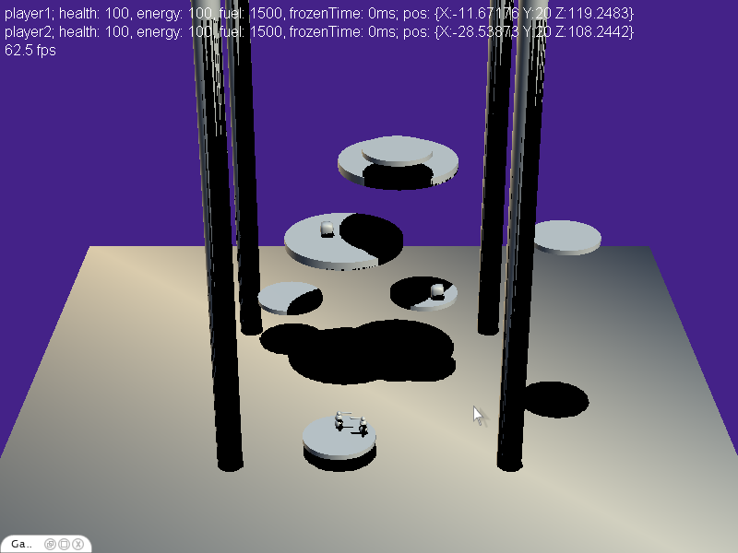

Two players are standing on a moving island. Two collectable power-ups are on other islands. A player’s health, energy and fuel level is currently shown as a text label. Later, this will be replaced by a graphical HUD.

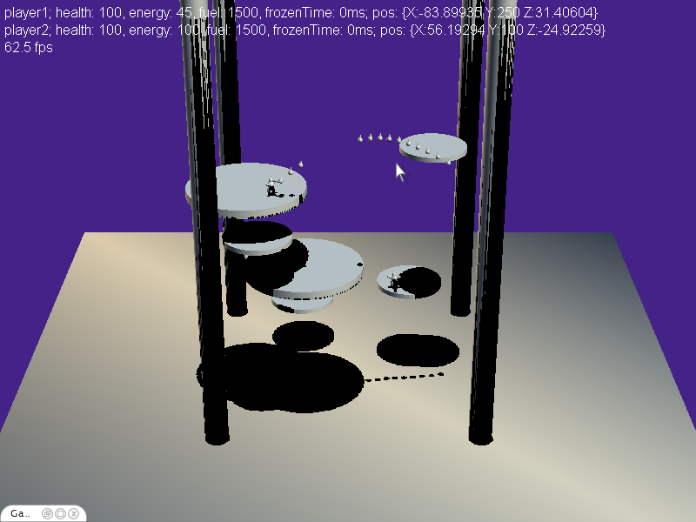

A player is shooting a bunch of ice-spikes, although missing his enemy.

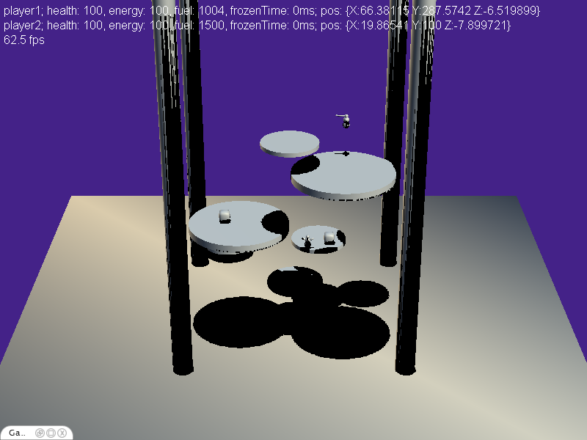

A player is using his jetpack to move to the smaller, upper island. As visible in the text on top, using the jetpack needs fuel.

# Findings

## Positioning

It is still quite tough to position yourself in the 3D environment. To make the task easier, we added shadows to enable the player to look at the projection of the island and his robot to more easily track his position. To control a player hidden behind an island or another object, we will implement some feature showing his contours projected onto such an object. This could also be combined with shadowing in a way a player gets a marker on all islands below and above him.

The addition of shadows unfortunately leads to the problem that a player is completely in the dark and not visible. Nevertheless, this can easily be solved by having the player emit his own light and adding ambient lights.

Finally, we will have to do further experiments with the angle and focal length used for the camera to reduce positioning problems.

## Player movement

Currently, a player can walk off an island, which is a very unfortunate and leads to sudden death. It would make sense to only allow the player from falling of an island if he explicitly uses his jetpack or other means of traveling between the islands. Otherwise, He should not be able to walk beyond the edge of the island. We will implement this behavior in a further version.

## Island Travel

Using free jetpack movement, it is nearly impossible to move between islands, because of mentioned 3D positioning and tracking problems. Therefore, a more passive approach (like selecting the island and automatic flying) should be taken. This could also have the advantage that a player can look around and shoot spikes at his opponents while flying. Additionally, the path on which an island moves should be visualized in the future (for instance by small rings of dust). Therefore the path of an island will have to be fixed or at least calculated in advanced to visualize where an island will move to some time from now.

## Parameter Tuning

Without the need to drastically change certain implementations and aspects of the game, one can heavily improve the experience by tuning parameters (e.g. attack damage, gravity or jetpack acceleration). To simplify this task and in order to allow fast testing of different parameters, we implemented a game console which shows the state of all active entities on the screen and enables the user to directly manipulate them:

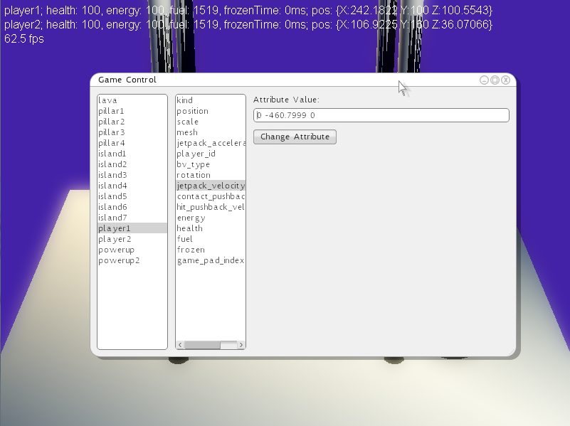

An in-game console which allows the modification of parameters and attributes of all the present entities.

Part 3 – Interim Report

This chapter describes how the game developed from an early prototype to nearly the finished low target. It describes step by step the work that has been done and the changes to the original planning and schedule that have been made.

# Week 1: Functional Minimum

## Changes

One change as been applied to the requirements fulfilled by Milestone 2. The team agreed to delay the requirement “ReqP09 – Direct Combat 2” to the next milestone since it was not possible to implement the attack visualization without having a player model.

## achievements

Compared to the prototype the game has further matured. The major improvements that have been applied are in detail:

* ReqP13 and ReqP14: A new type of ranged weapon has been added: The flamethrower. Using the flamethrower it is possible to either attack the opponent or to destroy islands. The flamethrower has not the same range as the ice spike but whatever is hit by its flames gets heavy damage.
* ReqP12: The ice spike that was had only a primitive implementation for the prototype has been redefined and improved. The aiming is now easier than before.
* ReqI07 and ReqI08: Islands now constantly loose height while they have to carry a player. As soon as a player jumps off the island it regains its original height. This feature improves the dynamics of the game making it faster and less static.
* ReqI05: Islands can now collide with each other allowing to place different islands on the same height.
* ReqUI06: The status strings have been replaced by a first and simple HUD.
* ReqP19: Failed

## Problems

The game still has several shortcomings. Some of them have been mentioned in detail in chapter two. This is a short recapitulation of the problems persisting:

* Navigation is not trivial
* Ice spike aiming could be better
* The game play is overloaded and needs to be streamlined
* The collision response has to be improved in certain places

## The Product

The working product features the moving islands in an already well fleshed-out form, but without any textures. Movement between the islands is still restricted to the jetpack, while a new gadget, the flamethrower is available. It can be used to harm players, or islands. The ice-spike aiming has been improved, but is still lacking accuracy. Collision detection is only done using simple collision-primitives (cylinders, spheres and boxes).

# Week 2: Low Target Part 1

## Changes

The realistic player model (ReqP03) has been moved to the desirable target, which further delays the direct combat animation (ReqP09). Some additional requirements were introduced, as a result of some additional play testing and findings from the prototype: ReqI14 is a new requirement for a visual indication of an islands health (it should glow when it gets damaged by flamethrower). Similarly ReqP21 is the visual indication of a player’s frozen state (which could also be solved through the HUD). Also, ReqP04 Island Attraction, has been extended to also include an easy way to jump from

## achievements

The game made a huge step forward in the visual department compared to the functional minimum. But also the problems of island travel have been addressed and quite successfully so in the form of island jump. The collision detection is also much finer grained compared to the simple primitives of Milestone 2. Those changes are in detail:

* ReqL03: A shader for realistic Lava rendering has been written, which is described in-depth under the corresponding section.
* ReqPi03: More sophisticated pillar models have been included, though they are not textured yet.
* ReqI03: Three different island models have been included.
* ReqUI04: An in-game menu has been added which will allow the selection of maps and players.
* ReqP04: Islands can be selected using the right analog stick; the closest island in the direction the stick points at is selected and the player can attract that island by pressing the right trigger. He can jump to that island by pressing the left trigger.
* ReqP05: A player can walk – or fly using the jetpack – to an attracted island.
* ReqI13: Power-ups re-spawn on a random island a random amount of time after consumption.

## Problems

Some problems still remain, such as:

* The collision response for standing on top of an island has some flaws; it can happen that a player oscillates on top of an island or gets set on top although he collided with the island’s border.
* Islands don’t collide with the cave at the back, nor are they stopped from leaving the screen to the left, right or bottom.
* On island attraction some collision response is not correct; islands can sometimes go through pillars.