Welcome to the Linduino Home Page!

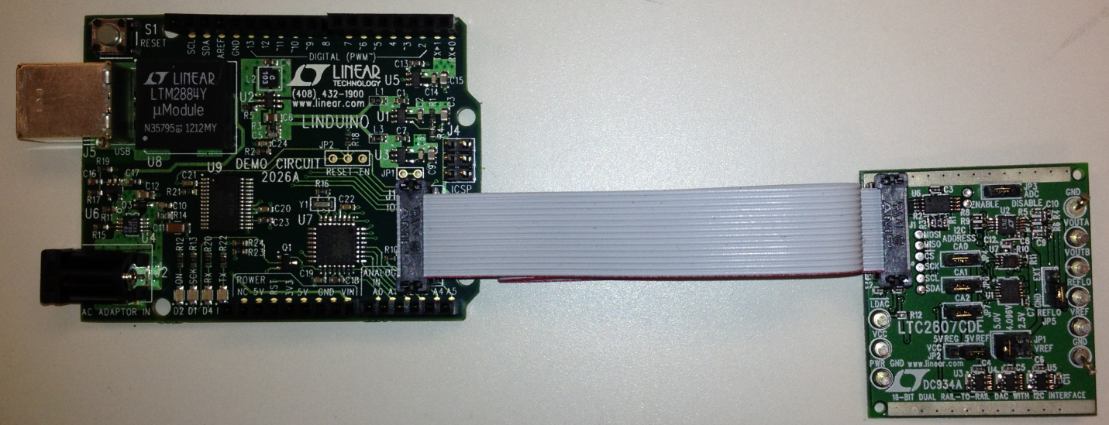

What is Linduino?

Linduino is Linear Technology’s Arduino compatible system for developing and distributing firmware libraries and example code for Linear Technology’s integrated circuits. The code is designed to be highly portable to other microcontroller platforms, and is written in C using as few processor specific functions as possible. The code libraries can be downloaded below and used as-is in your project. The Linduino One board (Demonstration Circuit DC2026A) allows you to test out the code directly, using the standard demo board for the particular IC.

The Linduino One board is compatible with the Arduino Uno, using the Atmel ATMEGA328 processor. This board features a 14-pin “QuikEval” connector that can be plugged into nearly 100 daughter boards for various Linear Technology parts, including Analog to Digital converters, Digital to Analog Converters, high-voltage power monitors, temperature measurement devices, RF synthesizers, battery stack monitors, and more.

An LTM2884 USB Isolator breaks the ground connection to the PC, allowing projects to operate at a different ground potential than the computer that is controlling it.

Setup is simple:

Download the Demo Manual for detailed instructions. Three files are required to follow the complete procedure in the demo manual:

1) The latest Linduino sketchbook. This file contains the Linduino code base, demo board schematics and board files. If you are only interested in the code, stop here.

2) The QuikEval program. The Linduino board ships with firmware that allows it to communicate with the QuikEval program, which provides all of the GUIs for compatible demo boards. Installing QuikEval is also the recommended way to install the correct USB drivers for the Linduino One board.

3) The Arduino 1.0.4 IDE. This is the development environment for the Arduino, and is required to modify the code, and to load programs into the Linduino One.

Complete Documentation:

Design File (including schematic, board, gerbers)

Schematic PDF

We also recommend:

Notepad Plus Plus, an excellent code editor:

<http://notepad-plus-plus.org/>

Atmel Studio, for more advanced development and debugging with the Linduino hardware, and Atmel processors in general: <http://www.atmel.com/microsite/atmel_studio6/>