Design of an Embedded Fast Fourier Transform for 8-bit Processors

Submitted To:
Roel Hurkens, M.Sc., P.Phys.
Co-op Coordinator, Faculty of Engineering, University of Victoria
PO Box 3055, STN CSC, Victoria, BC V8W 3P6
Ph: (250)721-8906; Fax: (250)721-8200
E-mail: rhurkens@engr.uvic.ca

Submitted By:
Chris Fogelklou
Computer Engineering
0027625

Monday, January 6, 2003
Table Of Contents
1.0 Introduction ii
1.1 FFT Applications iii
2.0 Theory: 1
2.1 Deriving the FFT from the DFT 1
2.2 The Recursive FFT 3
2.3 The Non-Recursive FFT 3
3.0 The Embedded Algorithm 6
3.1 Tradeoffs 6
3.1.1 Speed vs. Accuracy 6
3.1.2 Memory Size vs. Accuracy 6
3.2 Analysis 7
Executed Once: 8
Executed log(N) times: 8
Executed N-1 times: 8
Executed (N/2)log(N)times: 8
3.2.1 Loop Impact 8
3.2.2 Inner Loop 9
3.2.2.1 Complex Memory Load/Complex Memory Store 9
3.2.2.2 Complex Multiplication 10
3.2.2.3 Complex Twiddle Factor 11
3.2.2.4 Complex Addition 13
3.2.2.5 Additional Inner Loop Overhead 13
3.2.3 Estimating Execution Time 13
4.0 Performance Measurements 14
4.1 Accuracy 14
4.2 Speed Measurements 16
5.0 Summary and Suggestions 16
5.1 Suggestions 16
Speed 16
Extending FFT Length 16
Increasing Accuracy 16
5.2 Applications 16
5.3 Summary 17
6.0 References 18
Appendix A: Embedded FFT Development Steps 19
Step 1: Pseudocode to Matlab code 19
Pseudocode for a recursive FFT: 19
Pseudocode for a non-recursive FFT: 19
Step 2: Simulating the Embedded Implementation 20
Step 3: Converting Matlab code to C++ code 22
Step 4: Converting Windows C++ code to IP2022 code 22
Step 5: Optimizing the IP2022 Code 23
Appendix B: fft.c - IP2022 FFT C code 24
Appendix C: FFT_asm.S - Optimized IP2022 Assembly Routines 26

1.0 Introduction

This document details the analysis of a Fast Fourier Transform (FFT) algorithm for embedded processors. Most of the tests and calculations have been done by hand, and by running simulations in Matlab. It was necessary to choose a small, embedded processor as a model system for the algorithm, and the Ubicom IP2022 Internet Processor was used as a model.

The initial topic and brief outline of this report was:

“Design and analysis of an embedded FFT on an 8-bit processor. FFT’s are easy and fast on larger, 32-bit processors, but very difficult on small processors due to limited memory and data movement capabilities. I am interested in optimizing the FFT for small controllers, and analyzing the algorithm for speed and accuracy (in comparison with a high-level language on the same chip, and in comparison with a PC running Matlab.)”

An optimized algorithm was developed for an 8-bit processor, but not a fully native algorithm, as was the original goal. Developing optimized assembly code is a time consuming process, and the result is not easily modified or ported to other systems.

The speed of the algorithm was not analyzed in comparison with Matlab. This would be pointless, as Matlab is a powerfully optimized mathematics tool running on a high-end processor. The speed was estimated, then measured, and the measurements compared with the estimates.

The accuracy of the algorithm was compared with that of Matlab. This was done by using Matlab as a simulation tool for the quantized 16-bit algorithm, and by verifying the results with those from the embedded FFT. The error introduced by quantization in comparison with Matlab’s own FFT program was also investigated.

The IP2022 has 4k bytes of on-board data RAM and 16k bytes of on-board program RAM. These numbers are limiting in comparison to a modern-day PC: a 512-element FFT with 16-bit complex results would use 2k of data RAM, 50% of the IP2022’s resources. Using 32-bit results for a 512-point FFT would consume the entire 4k of data RAM, leaving no available memory for application code. These RAM considerations are overcome by using the program space of the IP2022 to store data. The IP2022 has only an 8-bit hardware signed-multiply instruction (with 16-bit results), and an 8-bit ‘add with carry’ instruction. Software must be written to extend the capabilities of the IP2022 to 16- or 32-bit signed multiplications, and 16- or 32-bit signed additions. These customizations have a significant impact on the speed of the FFT, and the tradeoffs are analyzed later in this document.

1.1 FFT Applications

The usefulness of the FFT spans many applications in the digital signal-processing world. It is used for frequency detection, to pick out the presence of DTMF tones on a telephone line, for instance, or simply for a spectrum analyzer display. In compression algorithms such as MPEG and JPEG, an FFT can act as a component of the discrete cosine transform (DCT.) Manipulation of Short Time Fourier Transforms (STFTs) will change the tempo of music without changing its pitch, or will disguise a voice by changing its pitch. Speech recognition algorithms use the patterns in consecutive FFTs to pick out combinations of frequencies that make up common words.

Many of the applications listed above are out of the domain of smaller 8-bit processors, being either too computationally intensive or memory hungry to be practically implemented. With optimizations, however, there are applications of the FFT that are practical on a smaller processor (DTMF detection, voice manipulation, the spectrum analyzer on a stereo.)

The key limitations of a smaller processor are small data memory size, little or no built-in math capabilities, and small data movement pipeline. The advantage of lower cost sometimes outweighs the disadvantages, especially if the application does not need an extremely fast FFT implementation. There are several areas where the FFT can be optimized by trading off computational accuracy for computational load and trading off RAM requirements for FFT size and precision.

2.0 Theory:

The Fast Fourier Transform (FFT) is a common digital-signal-processing algorithm used to determine the frequency contents of a given input. It is a digital implementation of the Fourier Transform, and it operates on a sequence of discrete input samples, and produces a sequence of discrete outputs.

2.1 Deriving the FFT from the DFT
When the number of elements to be used for the DFT is a multiple of two, a divide-and-conquer technique can be used to simplify the DFT. Mathematically, there are two ways that a single DFT of a size that is a power of two can be divided into two half-sized DFTs; one is called Decimation in Time (DIT) and the other is called Decimation in Frequency (DIF). The DIT algorithm will be used for the embedded FFT. The DIT algorithm breaks the larger DFT into two smaller DFTs, one that operates on the even-index elements of the input array, and the other that operates on the odd-index elements of the input array. The process of breaking the DFT of size N into two smaller DFTs of size N/2 leaves one exponential term outside of the odd-indexed DFT, commonly called the Twiddle Factor.

From the definition of the DFT (when N is a power of 2):
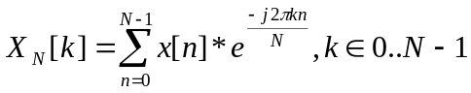

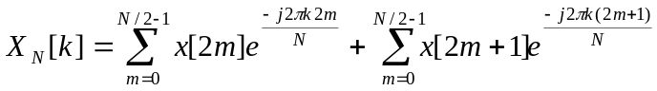

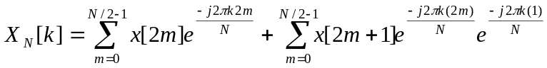

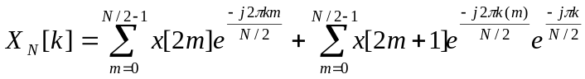

if we let M = N/2

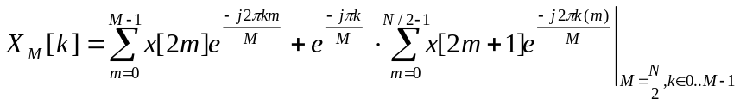
The DFT of size N has been reduced to the sum of two smaller DFT’s of size N/2, one of which operates on the even-indexed elements of the input array, and the other operating on the odd-indexed elements of the input array. This can be implemented directly as a recursive subroutine:

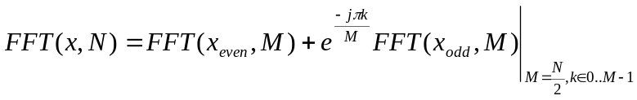

The first call to FFT triggers two subsequent calls to FFT, the first of which is passed only the N/2 ‘even’ elements from the array of inputs, and the second is passed only the N/2 ‘odd’ elements. Each FFT is only on N/2 elements long and thus only returns N/2 results, and the resulting FFT is therefore only N/2 elements long. The FFT results are not meshed together as in even-odd-even-odd, but are added together (even + odd, even + odd). For instance:
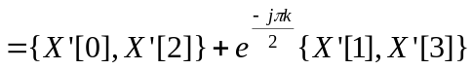
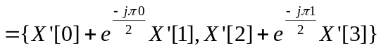

As can be seen above, there are only N/2 resulting elements when the two FFTs are combined in this way. Obtaining N elements is possible due to the symmetry of each of the smaller FFTs: it is known that X_{N}(k)=X_{N}(k+N/2), and the results from the two N/2-sized FFTs are combined to form a set of results with size N using this knowledge. For all odd-indexed elements below N/2, the twiddle factor is
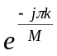
However, for odd-indexed elements above N/2, the periodicity of the exponential term can be exploited to rewrite the twiddle factor as:
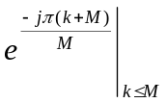
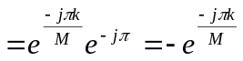
Therefore, for k terms that are less than or equal to N/2, the elements can be generated with
X(k) = (Xeven(k) + twiddle(k)*Xodd(k))| k < N/2

and for k terms that are greater than or equal to N/2, the elements can be generated with

X(k) = (Xeven(k-N/2) - twiddle(k-N/2)*odd(k-N/2))| k >= N/2

example for N=4

2.2 The Recursive FFT
The recursive routine can be implemented in Matlab as in Figure 1.

function [a] = myfft(N,x);
% Recursive FFT
% Chris Fogelklou
% Written to demonstrate the recursive steps required to perform an FFT
% Array indexes in Matlab start at 1, therefore, where in the theory
% an element is referred to as x[n], in the following program, it is
% referred to as x[n+1]
if (N==1)
a=x;
else
M=N/2;
for m=0:1:M-1
x_even(m+1)=x(2*m+1); % even
x_odd(m+1)=x(2*m+2);% odd
end
X_even=myfft(M,x_even);
X_odd=myfft(M,x_odd);
for k=0:1:M-1
y=X_odd(k+1)*exp(-i*pi*(k)/M);
a(k+1)=X_even(k+1)+y;
a(k+M+1)=X_even(k+1)-y;
end
end
Figure 1: Matlab Code for a recursive FFT

The recursive algorithm is both elegant and fast, but requires a relatively powerful system with a large call stack and an ample supply of memory for larger FFTs. Each recursive call puts more data onto the stack, and requires data to be copied from the original input array into two new arrays to be passed to the next recursive call. As a result, Θ(NlogN) complex storage elements are required to store all of the copied arrays, and there will be a maximum of logN recursive calls at any one time. On a modern personal computer (PC) the amount of overhead required for even a large FFT (>5000 elements) is not an issue. However, this algorithm is to be tailored to operate on a small embedded system with a limited amount of data memory and stack space, and the call overhead must be minimized. A non-recursive algorithm overcomes this problem.

2.3 The Non-Recursive FFT
It is tricky to convert the recursive algorithm into a non-recursive form. Luckily, this has been done and documented many times in the past. The recursive algorithm is broken down to its base cases (when N = 1) and the non-recursive form works back up to the initial value of N. A graph of the way the elements are passed from one layer to the next in the recursive FFT with N = 8 is shown in figure 2.

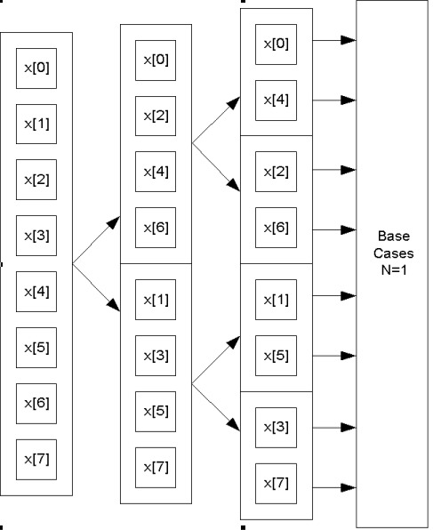
Figure 2: Breaking an 8-point DFT into four 2-point DFT’s

As it turns out, the base case calculations are done on the elements as if they were indexed in bit-reversed order. For instance, if an 8-point FFT were performed on an array of inputs x[0..7], the operations are carried out on each of the elements as if the elements in the array were indexed in bit-reversed order as in figure 3.

0: 000b, reversed: 000b therefore x[0],
1: 001b, reversed: 100b therefore x[4],
2: 010b, reversed: 010b therefore x[2],
3: 011b, reversed: 110b therefore x[6],
4: 100b, reversed: 001b therefore x[1],
5: 101b, reversed: 101b therefore x[5],
6: 110b, reversed: 011b therefore x[3],
7: 111b, reversed: 111b therefore x[7]
Figure 3: Indexing in bit-reversed order

The simplest way to convert the recursive algorithm to a non-recursive form is to start with the base-case array ordering and work backwards. To produce base-case array ordering, the entire input array can be copied and remapped into bit-reversed indexed order. This process takes time, but the time it takes (O(N)) is insignificant when compared to the time that is saved in the FFT itself (O((N/2)log(N)).

The Matlab code in figure 4 returns a bit-reverse-indexed copy of the input array ‘a’ in ‘f’.

function [f] = arraybitrev(nbits,a);
% Re-index the input array, a, in bit-reversed order.
N = 2^(nbits);
for i = 0:1:N-1
nIndex = i;
nRev = 0;
for j=0:1:nbits-1
nRev = bitor(bitshift(nRev,1), bitand(nIndex,1));
nIndex = bitshift(nIndex,-1);
end
f(nRev+1) = a(i+1);
end

Figure 4: Matlab Code for bit-reverse indexing of an input array

The function is called by the FFT routine to initialize the FFT. This allows the array to be indexed with simple calculations, and for the calculation results to overwrite input data (an in-place algorithm), saving memory space.

A non-recursive form of the FFT must do all of its calculations in a nested-loop form, with each new loop iteration representing another recursive operation. Matlab code was written that closely matched an algorithm whose pseudocode was available on the Internet [4.]. (See Appendix A)

function [f] = myfft2(N,f);
% My FFT program
% Written to test the theory in the DIT algorithm from the web
% Chris Fogelklou
p = log2(N);
f = arraybitrev(p,f)
Bp = N/2;
Np = 2;
for P=0:1:(p-1)
Npp = Np/2;
BaseT = 0
for b=0:1:(Bp-1)
BaseB = BaseT + Npp
for k=0:1:(Npp-1)
top = f(BaseT + k + 1);
bot = f(BaseB + k + 1) * exp(-i*2*pi*k/Np);
f(BaseT + k + 1) = top + bot;
f(BaseB + k + 1) = top - bot;
end
BaseT = BaseT + Np;
end
Bp = Bp / 2;
Np = Np * 2;
end
Figure 4: Matlab Source Code for Non-Recursive FFT

The code consists of 3 nested loops. It is tested, produces the same results in every case as Matlab’s built-in FFT routine, and provides an excellent starting point for evaluation changes to the algorithm that must be made for a simple processor (changes such as quantization, rounding, data size, etc.) Indeed, much of the preliminary testing needed to begin this report was performed using modified versions of the code in figure 4.

3.0 The Embedded Algorithm

3.1 Tradeoffs

Digital Signal Processing algorithms such as the FFT are normally implemented on processors with powerful mathematical capabilities such as DSPs or high-end microprocessors. These chips can perform 16- or 32-bit signed multiplications in a single clock cycle, as opposed to the processors targeted in this report, which have either no multiplication capabilities or only very simple capabilities (only an 8-bit signed multiplication is possible, for which the conversion to a 16-bit or 32-bit multiplication is not trivial.)

3.1.1 Speed vs. Accuracy

Tradeoffs that balance the accuracy of the FFT with its speed will sacrifice bits of resolution for decreased data movement and manipulation requirements. The fastest implementation would use only 8-bit multiplications on an 8-bit processor. Extending 8-bit multiplications to 16-bit multiplications quadruples the number of required 8-bit multiplies, and adds a significant amount of overhead. Extending again to 32 bits requires four 16-bit multiplications and therefore sixteen 32-bit multiplications. The accuracy of the FFT is reduced significantly if only 8-bit calculations are exploited, and the results may only be good enough for such simple applications as the spectrum analyzer display on a stereo.

3.1.2 Memory Size vs. Accuracy

In addition to trading off speed for accuracy, there is also the tradeoff between memory size and accuracy. Both the real and the imaginary part of the complex FFT must be stored in the processor at the desired resolution until the FFT is completely calculated. For this reason, a 512 point FFT with 16-bit complex results requires 512 points * 2 complex types * 2 bytes = 2kb of memory for the results, in addition to 512 bytes of input data and a few more bytes of overhead. In processors that commonly have less than 8kb of data memory, almost 3kb of memory for the FFT is quite a chunk.

The FFT size (in number of points) and the amplitude of the input have an impact on the number of storage bits required for the FFT results. The final output of an FFT can require log₂((M bits of FFT resolution)*(FFT input elements)) bits for each storage element, worst case. The worst-case scenario occurs when all of the power of the input signal is concentrated at a single frequency. For instance, if an FFT is performed on a sequence of numbers 1024 elements long, and the sequence consists of a DC signal with an amplitude of 1 (x[0..1023] = 1), then all of the power in the signal is focused at the frequency represented by X[0]. X[0] will therefore have an amplitude 1024 times greater than the amplitude of the input signal (X[0] = 1024. X[1..1023] = 0)

Increasing the FFT length increases the maximum potential FFT value, meaning either the input amplitude must be decreased or the number of bits used for storage must be increased.

3.2 Analysis

To discover the impact that certain tradeoffs impose on the speed of the FFT, it is necessary to analyze the number of times each shifting, addition, multiplication, storage, and retrieval operation is performed. From this data, it is possible to produce an algorithm speed estimate for virtually any combination of data-size, memory types, FFT size, etc.

A quick glance at the Matlab code in figure 4 reveals that the loops are nested 3-deep. Each of the loops consists of a combination of well-defined operations such as shifts, additions, multiplications, data storage, data retrieval and others. If a variable name is assigned to the number of clock cycles taken for each of the operations for a given size, then a formula can be generated that calculates the number of instruction cycles necessary to perform an FFT of an arbitrary length and data size. The results of this can be used to calculate the maximum sampling frequency for the FFT, based on the clock frequency of the processor.

The outer loop in the algorithm begins:
for P=0:1:(p-1)
The variable ‘p’ is initialized to log₂(N) and therefore all of the instructions in the outer loop are performed log₂(N) times.

The next nested loop of the algorithm begins:
for b=0:1:(Bp-1)
The variable ‘Bp’ is initialized to
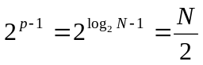
on the first pass of the loop and is divided by two on each successive pass of the outermost loop. On each pass of the outer loop, everything inside this loop is executed (N/(2*2^{P})) times, where P is the iterator for the outermost loop. The total number of instruction executions is therefore:
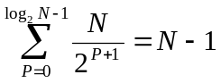.

The innermost nested loop of the algorithm begins:
for k=0:1:(Npp-1)
The variable ‘Npp’ is initialized to 1on the first execution and is multiplied by two on each successive pass of the outer loop. Therefore, on each pass of the middle loop, the innermost loop executes 2^{P} times. The number of times the instructions in the innermost loop execute is also expressible as a sum:
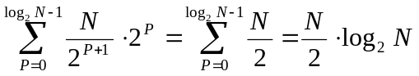

The FFT algorithm consists of two parts, the initialization, in which the input data is ordered with bit-reversed indexing, which is O(N), and the nested loop. The nested loop can be broken down into:
Instructions executed once (outside the loop)
Instructions executed log₂(N) times (outer loop)
Instructions executed N-1 times (middle loop)
Instructions executed (N/2)*log(N) times (inner loop).

Aside from the number of bits used to represent the data, another slowdown will occur if the length of the FFT (N) is allowed to exceed 256 (for 512 or 1024 point FFTs, for instance.) All data indexes must then be expanded to 16-bits to allow for addressing beyond the first 256 elements.

Figure 5 lists each operation in the Matlab code of figure 4, and the attributes that affect that operation’s execution time (MaxN if the length of the FFT affects the operation, or DataSize if the width of the calculation affects the operation.)

Executed Once:
GetNumBits(MaxN)
ArrayBitRev(MaxN,N)
RegisterShift(MaxN)
RegisterStore(MaxN)
RegisterStore(256)

Executed log(N) times:
2*RegisterShift(MaxN)
RegisterStore(DataSize)
2*RegisterShift(MaxN)
LoopEnd(256)

Executed N-1 times:
2*RealAddition(MaxN)
2*RegisterStore(MaxN)
LoopEnd(MaxN)

Executed (N/2)log(N)times:
2*ComplexMemoryLoad(MaxN, DataSize)
TwiddleFactorLoad(MaxN, DataSize)
ComplexMultiplication(DataSize)
2*ComplexAddition(DataSize)
2*ComplexMemoryStore(MaxN, DataSize)
LoopEnd(MaxN)
Figure 5: FFT Operations for this Algorithm

3.2.1 Loop Impact
Regardless of which operations are executed within each loop, the inner loop consumes a majority of the execution time, as is clearly shown in a log-log graph of each loop’s complexity (Figure 6.)

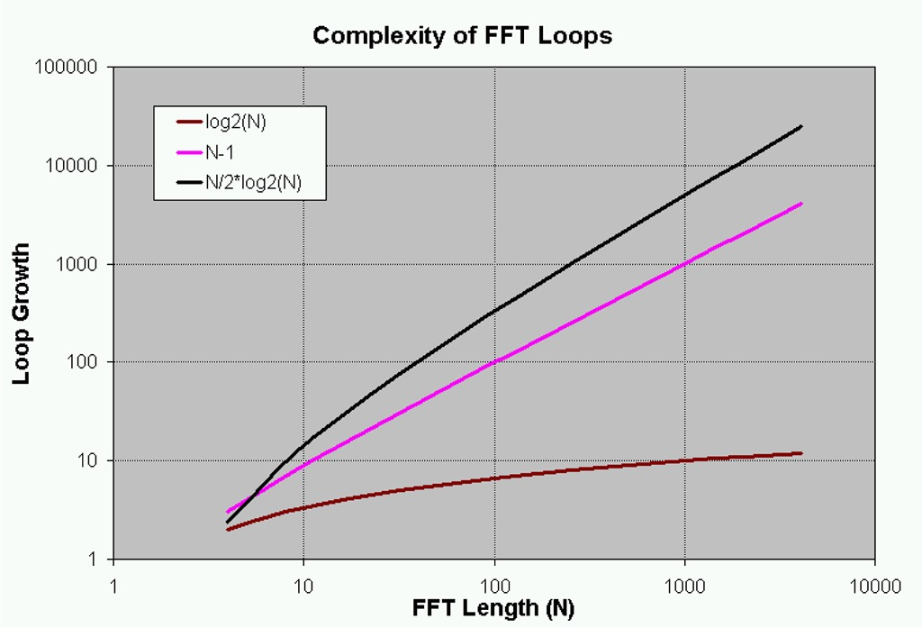
Figure 6: Logarithmic Graph of the Growth of Each Loop: N/2log2(N) has the highest complexity.

3.2.2 Inner Loop

Based on 3.2.1, only the operations in the inner loop of the FFT must be investigated to provide a rough estimate of the execution time. These inner-loop routines have the most dramatic impact on the execution time of the FFT, and were therefore written in optimized assembly for the IP2022. These are listed in Appendix C.

The routines must operate on complex variables; a new complex struct was defined in C for storage of complex variables. The struct contains both the imaginary and the real parts of the complex variable.

typedef struct {
s16_t real; //16-bit signed real part
s16_t imag; //16-bit signed imaginary part
} complex16, c16_t;

3.2.2.1 Complex Memory Load/Complex Memory Store

There must be optimized memory load/memory store functions because of memory constraints on storage of the input and output data. The load/store operations abstract the process of fetching or writing data with either on-chip memory or external RAM or FLASH.

All operations such as memory load, memory store, complex multiplication, and complex addition take the c16_t struct as an argument and return arguments of type c16_t. In the IP2022, the FFT data can be stored in either program FLASH (64kb) or program PRAM (16kb), allowing support for FFTs of a size greater than 1024 points (Each complex variable consumes 4 bytes of data memory). The process of writing to/reading from program memory on the IP2022 requires the setup of some system registers and some memory read/write instructions (iread/iwrite.)

c16_t get_fft_result (u16_t index);

The function created for loading complex variables from memory is called get_fft_result. It takes a 16-bit unsigned integer as an index and returns the complex variable that the index represents. Worst case, it takes ~40 instructions to load a new complex variable from program RAM and return it to the calling function.

void set_fft_result (u16_t index, c16_t data);

The function written to store complex variables back to memory is called set_fft_result. It takes an index and a complex type as arguments and writes the complex data to the location represented by the index. Worst case, it takes ~40 instructions to store complex data containing 16-bit real and imaginary parts to program RAM.

If one were to desire 32-bit data widths rather than 16-bit data widths, it is likely that the operations to load and store from memory would almost exactly double in length, from ~40 cycles to ~80 cycles.

3.2.2.2 Complex Multiplication

(A_{re} + jA_{im})(B_{re} + jB_{im}) = (A_{re}B_{re} - A_{im}B_{im}) + j(A_{re}B_{im} + A_{im}B_{re})

c16_t as_mul_c16_c16 (c16_t a, c16_t b);

A complex multiplication routine was written in native assembly code to multiply signed 16-bit numbers and return a rounded 16-bit result (to fit back into the result register.) Each complex multiplication requires four signed 16-bit multiplications and two signed 32-bit additions, plus rounding. In turn, each 16-bit signed multiplication requires four 8-bit unsigned multiplications: a total of sixteen 8-bit multiplications. The complex multiplication routine executes the pseudocode of figure 7 to perform the complex multiplication:

c = a * b
c.real = a.real * b.real - a.imag * b.imag
c.imag = a.real * b.imag + a.imag * b.real

1.0 Save all signs of multiplies
1.1 fft_sign[0] = sign(a.real) XOR sign (b.real)
1.2 fft_sign[1] = !(sign(a.imag) XOR sign(b.imag))
1.3 fft_sign[2] = sign(a.real) XOR sign(b.real)
1.4 fft_sign[3] = sign(a.real) XOR sign(b.real)

2.0 Make all parts positive
2.1 if sign(a.real) then a.real = ~a.real + 1
2.2 if sign(a.imag) then a.imag = ~a.imag + 1
2.3 if sign(b.real) then b.real = ~b.real + 1
2.4 if sign(b.imag) then b.imag = ~b.imag + 1

3.0 Calculate c.real
3.1 c.real = a.real * b.real
3.2 if fft_sign[0] then c.real = ~c.real + 1
3.3 temp = a.imag * b.imag
3.4 if fft_sign[1] then temp = ~temp + 1
3.5 c.real = c.real + temp

4.0 Calculate c.imag
4.1 c.imag = a.real * b.imag
4.2 if fft_sign[2] then c.imag = ~c.imag + 1
4.3 temp = a.imag * b.real
4.4 if fft_sign[3] then temp = ~temp + 1
4.5 c.imag = c.imag + temp

5.0 Return c
Figure 7: Pseudocode for Complex Multiplication Routine

The complex multiplication routine was written as efficiently as possible, and makes use of the 8x8 multiplication hardware of the IP2022. The running time for the multiplication routine varies from ~ 190 cycles to ~ 230 cycles. Using only 8-bit multiplies would decrease the running time to approximately 50 cycles, but would also decrease the resulting accuracy.

3.2.2.3 Complex Twiddle Factor
The twiddle factor is an exponential, , which can be expressed as 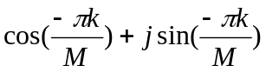. Many processors use a truncated Taylor Series to approximate the values of sine and cosine, but this necessitates a significant amount of math. The least-computationally-intensive method of generating sine and cosine values in the IP2022 is to implement a table lookup. The advantage of using a table lookup is the speed with which new values can be calculated, and the disadvantage is that a table of sine values must be stored in program memory and the maximum size of the FFT is limited by the size of the table. For these tests, one-half of a 16-bit precision 512-point sine wave was stored in the program FLASH of the IP2022 (Figure 8).

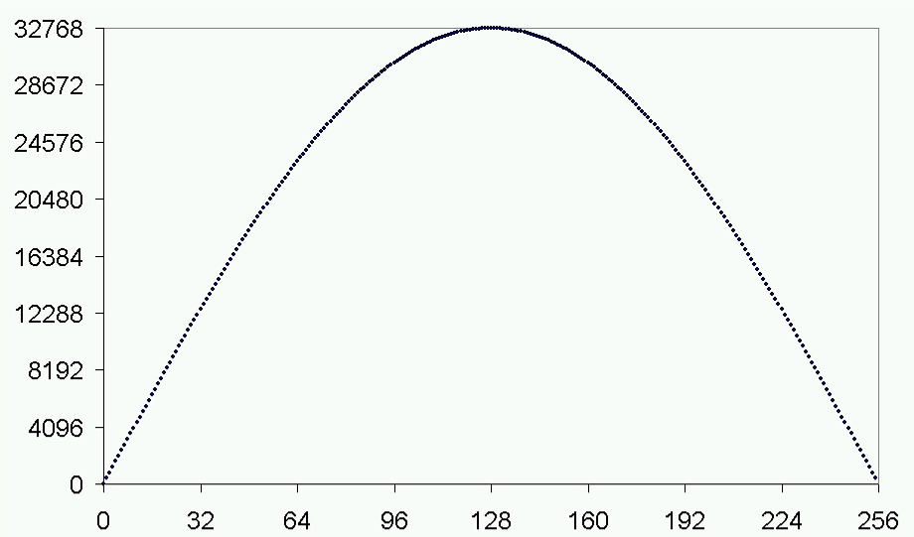

;-----------------------------------------------------------------
.section .text, "ax" ; locate in flash
.global _sine_table
_sine_table:
;.org sine_table_org
.hword 0
.hword 402
.hword 804
.hword 1206
.hword 1608
.hwo...
Figure 8: A graph and code from the sine wave look up table.

The table consists of 256 entries, good for an FFT size of up to 512. For FFT sizes greater than 512, a new table can be generated in EXCEL, copied and pasted into the source code, and the relevant #define statement changed to compensate for the change in the code.

Both the sine and the cosine parts of the twiddle factor are generated from the same table. To fetch a cosine angle, the same sine table is read but a value of ((π/2) * 512/(2π)) = 128 is added to the input index before retrieving the value at the index.

The assembly routine used to read each sine value from the program memory takes approximately 50 cycles to execute. There is C-language overhead in calculating the index from which the new sine or cosine value should be read, adding anywhere from 30 cycles to 250 cycles to the lookup (Varying based on the input variables, which control loops inside the routine). The total twiddle-factor lookup overhead is consequently an average of approximately 400 cycles.

3.2.2.4 Complex Addition

(A_{re} + jA_{im}) + (B_{re} + jB_{im}) = (A_{re}+B_{re}) + j(A_{im} + B_{im})

A routine was written in native IP2022 assembly to perform complex addition.

c16_t add_c16_c16 (c16_t a, c16_t b );

The pseudocode for the Complex Addition routine follows:

1.0) c = a + b
1.1) c.real = a.real + b.real
1.2) c.imag = a.imag + b.imag
2.0) return c

The function is straightforward in implementation, and takes a mere 27 cycles to execute.

3.2.2.5 Additional Inner Loop Overhead

Additional inner loop overhead is present in the form of C- function calls and loop end logic. Disassembling the source code reveals that the loop itself consists of 137 instruction cycles, including the overhead at the end of the loop.

3.2.3 Estimating Execution Time

Based on just the inner loop calculations (Rough Estimates), it is possible to estimate the amount of time it will take to execute an FFT of a certain size, based on the clock speed of the IP2022.

The inner-loop of the FFT consists of:
2x complex memory load: 80 cycles
Twiddle Factor Load: 400 cycles
Complex Multiplication: 230 cycles
2x Complex Addition: 54 cycles
2x complex memory store: 80 cycles
C logic and Loop Overhead: 137 cycles

Total: 981 cycles

The time to execute a single 512 point FFT on the IP2022 at 40MHz is consequently
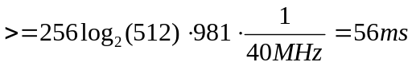
Therefore, the maximum sampling rate is <= 512/56ms = 9kHz.

The actual execution speed is measured in section 4.0

4.0 Performance Measurements

4.1 Accuracy

The algorithm’s accuracy depends on the amplitude of the input. The maximum amplitude of the input, on the other hand, is defined by the size of the FFT. For an FFT size of 512, the input data must have a maximum amplitude of 7 bits (+/- 127) or there is a POSSIBILITY that the calculations will exceed the 16-bits set aside for real or imaginary data. This will only occur if all of the power in the input data is focused at a single frequency; if the input data contains signal at many frequencies, a single FFT location won’t need to contain all of the power.

To measure the algorithm’s accuracy, a comparison was made of the output of Matlab’s FFT routine and the output of the embedded FFT routine on the input signal of figure 9.
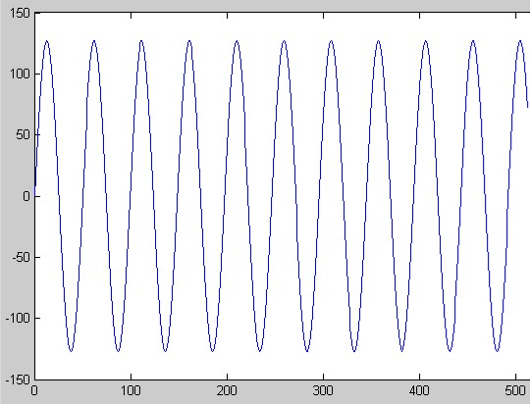
Figure 9: Input x[n] = 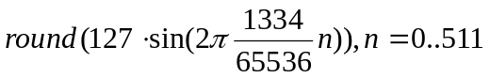
When placed one on top of another, the FFT outputs look indiscernible from one another, as in Figure 10.
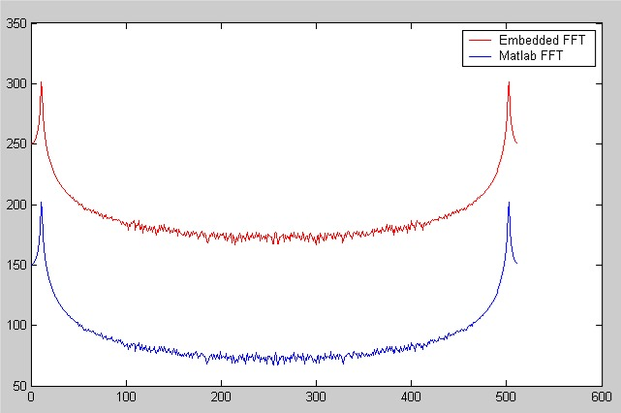
Figure 10: Logarithmic View of Matlab’s FFT Output and the Embedded FFT’s Output

The error, however small, becomes visible when the difference is graphed, as in Figure 11.

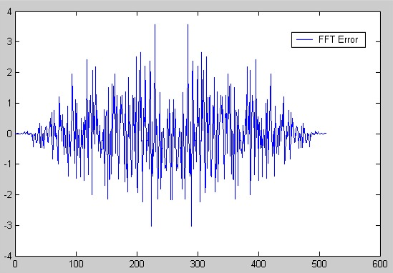
Figure 11: Absolute value of Matlab Output – Absolute Value of IP2022 Output

The error in figure 11 is low as is expected due to the low amplitude of the input signal. If the input amplitude had been any higher, the disadvantage of this algorithm would have shown its weaken; the location storing the peak amplitude of the input would have overflowed, resulting in a vastly flawed result.

4.2 Speed Measurements

The speed of the FFT was measured with the FFT Test Bench. One-hundred and twenty-eight consecutive FFTs consumed a total of 10737ms before the twiddle factor index calculation was optimized in C, and 7162ms afterward. With the complex multiplication routine in Program FLASH memory (running at 40MHz), the IP2022 took 62664ms to run 1024 consecutive FFTs, or 61ms per FFT, only 5ms slower than the predicted execution time. When the multiplication routine was moved into high-speed program RAM (120MHz), the execution time per FFT dropped to 53ms, 3ms below the estimated 56ms.

5.0 Summary and Suggestions

5.1 Suggestions

Speed
Both the algorithm analysis and the empirical measurements indicate that significant performance increases can be realized by optimizing only those functions that lie in the inner loop of the FFT. Speed increases can be realized through further optimizations, such as moving all of the inner loop routines into the high-speed PRAM area of the IP2022.

Extending FFT Length
Extending the maximum length of the FFT is possible if the Twiddle Factor lookup table is extended past its current 256 entries. For a maximum FFT size of 2048, for instance, a lookup table of 1024 entries would be required, consuming 2kb of the IP2022’s 64kb of memory. To extend the maximum length of the FFT, the calculations should be extended from 16-bits to 24- or 32-bits, due to the requirement that

BitsOfCalculation >= log₂((Input Amplitude)*(FFT length)).

and either Input Amplitude must decrease or BitsOfCalculation must increase in order for FFT length to increase and BitsOf Calculation to stay the same.

Increasing Accuracy
To increase accuracy, increase both the number of bits used for calculation and storage, and the number of bits used to in the twiddle factor lookup table.

5.2 Applications for this Implementation
Due to the current speed of the implemented FFT, useful applications for the FFT are limited to lower-sample rate applications such as telephone-line devices or power-line monitoring devices. If the suggested speed optimizations were implemented, higher-sample-rate applications may be realized.

5.3 Summary
It was the initial goal of this report to produce a highly optimized algorithm for the IP2022 based on pure native assembly code that would run at the highest IP2022 clock speed. This goal was discarded for two reasons:
Producing a native-assembly FFT would limit the implementation to only the IP2022, whereas writing the algorithm in machine-optimized C allows for portability to other platforms supported by a C compiler. Porting to another platform requires only that the inner-loop functions be re-written for the platform.
C-code is easily modified. If the programmer wishes to use 32-bit data rather than 16-bit data, he or she must just change the variable definitions and the C compiler will handle the code modifications automatically, whereas 16-bit assembly code must be completely rewritten for 32-bit data.

The goals of the project were accomplished. A proven embedded FFT was developed for 8-bit processors. Estimates of its running time were consistent with the empirical measurements. Optimizations based on theory were shown to have a dramatic effect on the actual execution time of the algorithm. The algorithm was written in both C for the PC and C/Assembly for the IP2022; it can therefore be ported to other embedded processors that support a C compiler.

6.0 References

[1.] James H. McClellan, Ronald W. Schafer, and Mark A. Yoder. “DSP First, A Multimedia Approach”: pp 334 - 340, pp 371 - 374. Upper Saddle River, NJ: Prentice-Hall, Inc., 1998.

[2.] Samuel D. Stearns, Ruth A. David. “Signal Processing Algorithms in Matlab”: pp 38 - 48. Upper Saddle River, NJ: Prentice Hall P T R, 1996.

[3.] Mark Allen Weiss. “Data Structures & Algorithm Analysis in Java”: pp 29 - 37. Addison Wesley Longman, Inc., 1999

[4.] “The FFT Demystified”: [Online] http://www.eptools.com/tn/T0001/INDEX.HTM, Engineering Productivity Tools Inc., 1999.

Appendix A: Embedded FFT Development Steps

Presented here is a summary of the steps taken to create an optimized FFT that would run on the IP2022.

Step 1: Pseudocode to Matlab code

The first step was to convert pseudocode from the internet to a working Matlab program. The following pseudocode was obtained from [4.] for a recursive FFT and a non-recursive FFT:

Pseudocode for a recursive FFT:
{f is an array of size N=2^p}
FUNCTION DIT(N,f);
LOCAL N',n',fe,fo,Fe,Fo,k,x,F;
IF N==1
THEN RETURN(f); {trivial if N==1}
ELSE BEGIN {perform 2 sub-transforms}
N':=N/2; {size of sub-transforms}
FOR n':=0 TO (N'-1) DO
BEGIN
fe[n']:= f[2*n' ]; {even n}
fo[n']:= f[2*n'+1]; {odd n}
END;
Fe:=DIT(N',fe); {even n}
Fo:=DIT(N',fo); {odd n}
FOR k:=0 TO (N'-1) DO {perform N' DIT 'butterflies'}
BEGIN
x=Fo[k]*T(N,k); {twiddle the odd n results}
F[k ]:= Fe[k]+x; {top subset}
F[k+N']:= Fe[k]-x; {bottom subset}
END;
RETURN(F);
END;

This code was converted to the Matlab code of Figure 1.

Pseudocode for a non-recursive FFT:

PROCEDURE DIT(p,VAR f);
LOCAL Bp,Np,Np',P,b,k,BaseT,BaseB,top,bot;
BEGIN {DIT}
{initialise pass parameters}
Bp:=1<<(p-1);{No. of blocks}
Np:=2; {No. of points in each block}
{perform p passes}
FOR P:=0 TO (p-1) DO
BEGIN {pass loop}
Np':=Np>>1; {No. of butterflies}
BaseT:=0; {Reset even base index}
FOR b:=0 TO (Bp-1) DO
BEGIN {block loop}
BaseB:=BaseT+Np'; {calc odd base index}
FOR k:=0 TO (Np'-1) DO
BEGIN {butterfly loop}
top:=f[BaseT+k];
bot:=f[BaseB+k]*T(Np,k); {twiddle the odd n results}
f[BaseT+k]:= top+bot; {top subset}
f[BaseB+k]:= top-bot; {bottom subset}
END; {butterfly loop}
BaseT:=BaseT+Np; {start of next block}
END; {block loop}
{calc parameters for next pass}
Bp:=Bp>>1; {half as many blocks}
Np:=Np<<1; {twice as many points in each block}
END; {pass loop}
END; {DIT}

This code was converted to the Matlab code of Figure 4.

Once the non-recursive Matlab code’s output was found to match that of Matlab’s built-in FFT, a the Matlab code could be used to debug the same algorithm in C.

Step 2: Simulating the Embedded Implementation
To test the effect of quantization error on the calculations and in the sine/cosine table lookups, the working Matlab code was modified to operate on quantized sine/cosine values and to round all results before re-storing. It was also changed so that error messages would be generated if any of the interim calculation values exceeded their 16-bit limits. The new Matlab code is shown below:

function [f] = myfft4(N,f,twiddleQuant);
% My FFT test program
% Written to measure the effect of quantization on the FFT algorithm.
% Chris Fogelklou
p = log2(N);
f = arraybitrev(p,f);
Bp = 2^(p-1);
Np = 2;
for P=0:1:(p-1)
Npp = Np/2;
BaseT = 0;
for b=0:1:(Bp-1)
BaseB = BaseT + Npp;
for k=0:1:(Npp-1)
top = f(BaseT + k + 1)*twiddleQuant; % left shift of multiply
twiddleFactor = round(exp(-i*2*pi*k/Np)*twiddleQuant);
bot = round((f(BaseB + k + 1) * twiddleFactor)); %16*16 multiply
f(BaseT + k + 1) = round((top + bot)/(twiddleQuant));
f(BaseB + k + 1) = round((top - bot)/(twiddleQuant));

if or((abs(real(f(BaseT + k + 1))) > 2^15 ),
(abs(imag(f(BaseT + k + 1))) > 2^15))
disp('Even base index exceeded 16 bit capacity');
end
if or((abs(real(f(BaseB + k + 1))) > 2^15 ),
(abs(imag(f(BaseB + k + 1))) > 2^15))
disp('Odd base index exceeded 16 bit capacity');
end
end
BaseT = BaseT + Np;
end
Bp = Bp / 2;
Np = Np * 2;
end

Another Matlab program was created that would automatically measure the effect of various quantization levels on the amount of quantization error and create a comma-delimited text file to be opened and graphed in EXCEL.

% Print the results of the filtering.
disp('writing results to file...');
fid2 = fopen('QuantTradeoff.csv','w');

for fftbits = 9:-1:5
disp('performing calcs for fftbits = ');
disp(fftbits);
fprintf(fid2,'\nfftbits: %2.0f\ntwiddle bits, bottomshift, error',fftbits);
t = 0:1:2^fftbits-1;
for twiddlebits = 4:1:12
for bottomshift = 0:1:twiddlebits
error = 0;
for f = 0:1:512
x = 2^(15-fftbits)*cos(2*pi*f/1024*t);
X=(abs(myfft4(2^fftbits,x,2^twiddlebits,2^bottomshift)));
Y=(abs(fft(x,2^fftbits)));
error = error + sum(abs(Y-X));
end
error = error/513;
fprintf(fid2,'\n %2.0f, %2.0f, %3.3f',twiddlebits, bottomshift, error);
end
end
end
status2 = fclose(fid2);
disp('done! ');

The program generated data that was used to optimize the operation of the FFT. It was found that the least error was generated when the number of bits in the exponential twiddle factor was maximized.

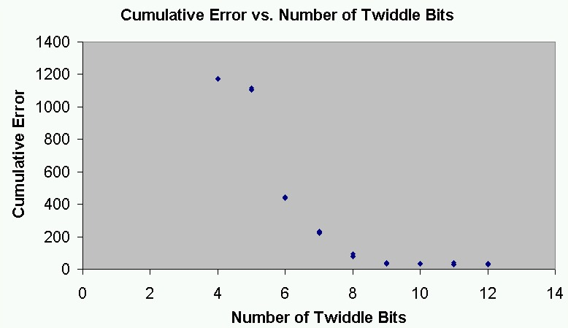
Cumulative Error vs. Number of Twiddle Bits

Step 3: Converting Matlab code to C++ code

Once the algorithm was shown to run in Matlab, it was converted to C++ code to run on the PC. The programming tool used was Borland C++ Builder 6. It was the lookup-table version that was written, so that once the code ran properly on the PC, it would be a simple port over to the IP2022.

void nonrecursiveFFT(int N, fft_type *f)
{
fft_type top, bot, twiddleFactor;
unsigned int b, k, p, Bp, Np, P, Npp, BaseT, BaseB;
fft_type *temp;
p = CalcBits(N);
temp = new fft_type[N];
memcpy((void *)temp, (void *)f, sizeof(fft_type)*N);
BitRevArrayIndexes(p, temp, f);
delete temp;
Bp = 1<<(p-1);
Np = 2;
for (P = 0; P < p; P++) {
Npp = Np>>1;
BaseT = 0;
for (b = 0; b < Bp; b++) {
BaseB = BaseT + Npp;
for (k = 0; k < Npp; k++) {
top = f[BaseT + k]*32768.0;
twiddleFactor = fft_type((
(long double)TwiddleFactorCosine(k, Np)),(
(long double)TwiddleFactorSine(k, Np)));
bot = f[BaseB + k] * twiddleFactor;
f[BaseT + k] = (top + bot)/(32768.0);
f[BaseB + k] = (top - bot)/(32768.0);
}
BaseT = BaseT + Np;
}
Bp = Bp >> 1;
Np = Np << 1;
}
}

The lookup table was implemented as a large case statement.

When the results of the C++ code were found to match those of the Matlab routines, the next step was to port the working C++ code to the IP2022 processor.

Step 4: Converting Windows C++ code to IP2022 code

Porting to the IP2022 processor was the most difficult task. The toolset for the IP2022 has not yet reached maturity. Writing assembly language routines was time consuming, because the C-calling conventions had to be first learned, and then emulated in assembly language. Fortunately, the IP2022 comes with a built-in hardware debugger.

An application (Figure A1) was written for the IP2022 that could communicate with the PC over a serial cable. A Windows C++ test program was written with a serial interface so that each of the IP2022’s inner-loop assembly routines could be tested. The Windows Application:
- Established serial communications with the IP2022
- Tests the signed multiplication routine 100 times using random signed numbers, and checking for correct values
- Tests the ability of the IP2022 to write to and read from the FLASH memory by first writing 512 complex variables to the IP2022, and then reading them back.
- Tests all of the FFT math routines by performing two FFT’s in parallel, one utilizing the C++ FFT on the PC, and the other utilizing the math routines on the IP2022. At each step of the FFT, the values in the internal FFT are compared to those returned by the IP2022.
- Writes a 512-byte array of input data to the IP2022 and commands it to perform FFT on it, then outputs the result to a text file.

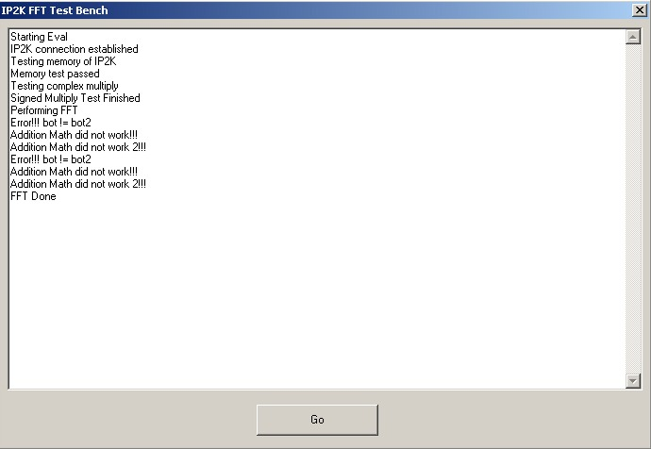
Figure A1: Screenshot of the Windows FFT testbench application

The test bench ensured that the results from the embedded FFT matched those from the PC version, which in turn was proven to match those from Matlab.

Step 5: Optimizing the IP2022 Code

Once the C++ code was proven to work when directly converted to IP2022 C code, each of the inner-loop functions was optimized in IP2022 assembly code. See Appendix C for the optimized assembly functions.

Appendix B: fft.c - IP2022 FFT C code
//---------------------------------------------------------------------------
//function [f] = myfft4(N,f,twiddleQuant,bottomDiv);

c16_t top, bot, temp_c16, twiddleFactor;
u16_t b, k, Bp, Np, P, Npp, BaseT, BaseB;
u8_t p;
initialize_fft_data(x, N);
p = fft_bits;
Bp = 1<<(p-1);
Np = 2;
//for P=0:1:(p-1)
for (P = 0; P < p; P++) {
Npp = Np>>1;
BaseT = 0;
//for b=0:1:(Bp-1)
for (b = 0; b < Bp; b++) {
BaseB = BaseT + Npp;
//for k=0:1:(Npp-1)
for (k = 0; k < Npp; k++) {
top = get_fft_result(BaseT + k);
double)Np)),sinl(-2.0*pi*(long double)k/((long double)Np)));
twiddleFactor.real = TwiddleFactorCosine(k, Np);
twiddleFactor.imag = TwiddleFactorSine(k, Np);
temp_c16 = get_fft_result(BaseB + k);
temp_c16.real = temp_c16.real<<1;
temp_c16.imag = temp_c16.imag<<1;
bot = mul_c16_c16(temp_c16,twiddleFactor);
temp_c16 = add_c16_c16(top, bot);
set_fft_result(BaseT + k, temp_c16);
temp_c16 = sub_c16_c16(top, bot);
set_fft_result(BaseB + k, temp_c16);
}
BaseT = BaseT + Np;
}
Bp = Bp >> 1;
Np = Np << 1;
}
}

s16_t TwiddleFactorCosine(volatile u16_t k, volatile u16_t N)
{
u16_t newk;
u16_t table_progress;
newk = k ;
//table_progress = newk*(MAXFFTSIZE/N) + MAXFFTSIZE/4;
/*
if (newk == 0) {
table_progress = MAXFFTSIZE>>2;
} else {
//MAXFFTSIZE/N
table_progress = MAXFFTSIZE;
while (N != 1) {
N = N>>1;
table_progress = table_progress>>1;
}
//*NEWK
while (newk != 1) {
newk = newk>>1;
table_progress = table_progress<<1;
}
table_progress = table_progress + (MAXFFTSIZE>>2);
}
return get_sine_val(table_progress);
}

s16_t TwiddleFactorSine(volatile u16_t k, volatile u16_t N)
{
u16_t newk;
u16_t table_progress;
newk = k;
//table_progress = newk*(MAXFFTSIZE/N);
if (newk == 0) {
table_progress = 0;
} else {
table_progress = MAXFFTSIZE;
//MAXFFTSIZE/N
while (N != 1) {
N = N>>1;
table_progress = table_progress>>1;
}
//*NEWK
while (newk != 1) {
newk = newk>>1;
table_progress = table_progress<<1;
}
}
return get_sine_val(table_progress);
}

Appendix C: FFT_asm.S - Optimized IP2022 Assembly Routines

#include "user_config.h"
#include <ip2k/ip2000_asm.h>
#include <ip2k/ip2022_asm.h>

;-----------------------------------------------------------------
;u16_t add_u16_u16 (u16_t a, u16_t b ); // passing two parameters
.section .pram, "ax" ; locate in flash
.global _add_u16_u16
.func add_u16_u16, _add_u16_u16
_add_u16_u16:
; --- Prologue: Save the current stack frame
push $fe
push $fd
; Load the new stack frame
mov w,SPL
mov $fe,w
mov w,SPH
mov $fd,w
; --- End Prologue
; Assembly function implementation.
; Perform the desired assembly operation
; on the passed parameters and return the result.
; ----
mov w,4(SP) ; Add low byte of u16_t
add w,6(SP) ; to low byte of b
mov $81,w ; and store in low byte of return value
mov w,#0 ; Add carry
addc w,3(SP) ; to high byte of a
add w,5(SP); and add high byte b
mov $80,w ; and move to high byte of return value
; ----
; --- Epilogue: Restore the saved stack frame
pop $fd
pop $fe
; Adjust the stack to account for the parameters passed
mov w,#4 ; add 4 (2 for u16_t a + 2 for u16_t b)
add SPL,w
; --- End Epilogue
ret
.endfunc

;-----------------------------------------------------------------
;u16_t sub_c16_c16 (c16_t a, c16_t b ); // passing two parameters
.section .pram, "ax" ; locate in flash
.global _sub_c16_c16
.func sub_c16_c16, _sub_c16_c16
_sub_c16_c16:
; --- Prologue: Save the current stack frame
push $fe
push $fd
; Load the new stack frame
mov w,SPL
mov $fe,w
mov w,SPH
mov $fd,w
; --- End Prologue
; Assembly function implementation.
; Perform the desired assembly operation
; on the passed parameters and return the result.
; ----

mov w,8(SP); Sub low byte of b.real
sub w,4(SP) ; From low byte of a.real
mov $81,w ; and store in low byte of return value.real
mov w,7(SP) ; Sub high byte of b.real
subc w,3(SP) ; from high byte of a.real
mov $80,w ; and move to high byte of return value.real

mov w,10(SP); Sub low byte of b.imag
sub w,6(SP) ; From low byte of a.imag
mov $83,w ; and store in low byte of return value.imag
mov w,9(SP) ; Sub high byte of b.imag
subc w,5(SP) ; from high byte of a.imag
mov $82,w ; and move to high byte of return value.imag

; ----
; --- Epilogue: Restore the saved stack frame
pop $fd
pop $fe
; Adjust the stack to account for the parameters passed
mov w,#8 ; add 8 (4 for c16_t a + 4 for c16_t b)
add SPL,w
; --- End Epilogue
ret
.endfunc

;-----------------------------------------------------------------
;c16_t add_c16_c16 (c16_t a, c16_t b ); // passing two parameters
.section .pram, "ax" ; locate in flash
.global _add_c16_c16
.func add_c16_c16, _add_c16_c16
_add_c16_c16:
; --- Prologue: Save the current stack frame
push $fe
push $fd
; Load the new stack frame
mov w,SPL
mov $fe,w
mov w,SPH
mov $fd,w
; --- End Prologue
; Assembly function implementation.
; Perform the desired assembly operation
; on the passed parameters and return the result.
; ----
mov w,4(SP) ; Add low byte of a.real
add w,8(SP) ; to low byte of b.real
mov $81,w ; and store in low byte of return value.real
mov w,#0 ; Add carry
addc w,3(SP) ; to high byte of a.real
add w,7(SP); and add high byte b.real
mov $80,w ; and move to high byte of return value.real
mov w,6(SP) ; Add low byte of a.imag
add w,10(SP) ; to low byte of b.imag
mov $83,w ; and store in low byte of return value.imag
mov w,#0 ; Add carry
addc w,5(SP) ; to high byte of a.imag
add w,9(SP); and add high byte b.imag
mov $82,w ; and move to high byte of return value.imag
; ----
; --- Epilogue: Restore the saved stack frame
pop $fd
pop $fe
; Adjust the stack to account for the parameters passed
mov w,#8 ; add 4 (2 for u16_t a + 2 for u16_t b)
add SPL,w
; --- End Epilogue
ret
.endfunc

;-----------------------------------------------------------------
;u32_t mul_u16_u16 (u16_t a, u16_t b ); // passing two parameters
.section .pram, "ax" ; locate in flash
.global _mul_u16_u16
.func mul_u16_u16, _mul_u16_u16
_mul_u16_u16:
; --- Prologue: Save the current stack frame
push $fe
push $fd
; Load the new stack frame
mov w,SPL
mov $fe,w
mov w,SPH
mov $fd,w
; --- End Prologue
; Assembly function implementation.
; Perform the desired assembly operation
; on the passed parameters and return the result.
; ----
; a = 3(sp) b = 4(sp) c = 5(sp) d = 6(sp)
; $83 = bd_l, $82 = bd_h
mov w,4(SP) ; Multiply low byte of u16_t a
mulu w,6(SP) ; with low byte of b
mov $83,w
mov w,mulh
mov $82,w
; $82 += ad_l, $81 = ad_h + bd_c
mov w, 3(SP)
mulu w, 6(SP)
add $82,w
clr $81
mov w,mulh
addc $81,w
; $82 += cb_l, $81 += cb_h + cb_c
mov w, 4(SP)
mulu w, 5(SP)
add $82,w
mov w,mulh
addc $81,w
clr $80
snb STATUS,C
inc $80
; $81 += ac_l, $80 = ac_h + ac_c
mov w, 3(SP)
mulu w, 5(SP)
add $81,w
clr $80
mov w,mulh
addc $80,w
; ----
; --- Epilogue: Restore the saved stack frame
pop $fd
pop $fe
; Adjust the stack to account for the parameters passed
mov w,#4 ; add 4 (2 for u16_t a + 2 for u16_t b)
add SPL,w
; --- End Epilogue
ret
.endfunc

#define ROUNDING 1
;-----------------------------------------------------------------
;c16_t as_mul_c16_c16 (c16_t a, c16_t b); // passing two parameters
; return.real = (a.real*b.real - a.imag*b.imag)>>16
; return.imag = (a.real*b.imag + a.imag*b.real)>>16
.section .pram, "ax" ; locate in flash
.global _mul_c16_c16
.func mul_c16_c16, _mul_c16_c16
_mul_c16_c16:
; --- Prologue: Save the current stack frame
push $fe
push $fd
; Load the new stack frame
mov w,SPL
mov $fe,w
mov w,SPH
mov $fd,w
; --- End Prologue
; save signs of all multiplies
clr _fft_sign
mov w, 3(SP) ; MSB of a.real
xor w, 7(SP) ; MSB of b.real
and w, #%10000000
sz
setb _fft_sign, 4
mov w, 5(SP) ;MSB of a.imag
xor w, 9(SP) ;MSB of b.imag
and w, #%10000000
snz ; snz since this is negative (j*j = -1)
setb _fft_sign, 5
mov w, 3(SP) ;MSB of a.real
xor w, 9(SP) ;MSB of b.imag
and w, #%10000000
sz
setb _fft_sign, 6
mov w, 5(SP);MSB of a.imag
xor w, 7(SP);MSB of b.real
and w, #%10000000
sz
setb _fft_sign, 7
; make all inputs positive
a_real_sign:
sb 3(SP),7
jmp a_imag_sign
not 4(SP)
not 3(SP)
inc 4(SP)
snz
inc 3(SP)
a_imag_sign:
sb 5(SP),7
jmp b_real_sign
not 6(SP)
not 5(SP)
inc 6(SP)
snz
inc 5(SP)
b_real_sign:
sb 7(SP),7
jmp b_imag_sign
not 8(SP)
not 7(SP)
inc 8(SP)
snz
inc 7(SP)
b_imag_sign:
sb 9(SP),7
jmp do_areal_breal
not 10(SP)
not 9(SP)
inc 10(SP)
snz
inc 9(SP)

; ----

do_areal_breal:
mov w, 3(SP); mov w, arh
mulu w, 7(SP); mul w, brh
mov ipl, w ; mov ipl, w
mov w, mulh ; mov iph, mulh
mov iph, w
mov w, 3(SP) ; mov w, arh
mulu w, 8(SP) ; mul w, brl
mov $86, w ; mov _fft_a_l, w
mov w, mulh ; add ipl, mulh
add ipl, w
mov w, 4(SP) ; mov w, arl
mulu w, 7(SP) ; mulu w, brh
add $86, w ; add _fft_a_l, w
mov w, mulh ; add ipl, mulh
addc ipl, w
mov w, 4(SP) ; mov w, arl
mulu w, 8(SP) ; mulu w, brl
mov $87,w
mov w, mulh ; add _fft_a_l, mulh
add $86, w
snb STATUS, C ; snc
inc ipl ; inc ipl

; do sign
sb _fft_sign, 4
jmp do_aimag_bimag
not $86
not $87
not ipl
not iph
inc $87
snz
inc $86
snz
inc ipl
do_aimag_bimag:
; move to return loc
mov w, iph
mov $80, w
mov w, ipl
mov $81, w

; Next multiply... a.imag * b.imag
mov w, 5(SP); mov w, aih
mulu w, 9(SP); mul w, bih
mov ipl, w ; mov ipl, w
mov w, mulh ; mov iph, mulh
mov iph, w
mov w, 5(SP) ; mov w, aih
mulu w, 10(SP) ; mul w, bil
mov $88, w ; mov 86, w
mov w, mulh ; add ipl, mulh
add ipl, w
mov w, 6(SP) ; mov w, ail
mulu w, 9(SP) ; mulu w, bih
add $88, w ; add 86, w
mov w, mulh ; add ipl, mulh
addc ipl, w
mov w, 6(SP) ; mov w, ail
mulu w, 10(SP) ; mulu w, bil
mov $89,w
mov w, mulh ; add 86, mulh
add $88, w
snb STATUS, C ; snc
inc ipl ; inc ipl

; do sign
sb _fft_sign, 5
jmp do_areal_bimag
not $88
not $89
not ipl
not iph
inc $89
snz
inc $88
snz
inc ipl

do_areal_bimag:

; propagate the carry up to the ipl registers
mov w, $87 ; add the two least significant bytes
add w, $89
mov w, $88 ; add the next two bytes with carry
addc $86, w
mov w, ipl ; add the next two bytes with carry
addc $81, w
mov w, iph ; add to the upper byte with carry
addc $80, w
#ifdef ROUNDING
sb $86,7
jmp no_round1
inc $81
snz
inc $80
no_round1:
#endif
mov w, 3(SP); mov w, arh
mulu w, 9(SP); mul w, bih
mov ipl, w ; mov ipl, w
mov w, mulh ; mov iph, mulh
mov iph, w
mov w, 3(SP) ; mov w, arh
mulu w, 10(SP) ; mul w, bil
mov $86, w ; mov 86, w
mov w, mulh ; add ipl, mulh
add ipl, w
mov w, 4(SP) ; mov w, arl
mulu w, 9(SP) ; mulu w, bih
add $86, w ; add 86, w
mov w, mulh ; add ipl, mulh
addc ipl, w
mov w, 4(SP) ; mov w, arl
mulu w, 10(SP) ; mulu w, bil
mov $87, w
mov w, mulh ; add 86, mulh
add $86, w
snb STATUS, C ; snc
inc ipl ; inc ipl

; do sign
sb _fft_sign, 6
jmp do_aimag_breal
not $87
not $86
not ipl
not iph
inc $87
snz
inc $86
snz
inc ipl
do_aimag_breal:
; move to return loc
mov w, iph
mov $82, w
mov w, ipl
mov $83, w

; Next multiply... a.imag * b.real
mov w, 5(SP); mov w, aih
mulu w, 7(SP); mul w, brh
mov ipl, w ; mov ipl, w
mov w, mulh ; mov iph, mulh
mov iph, w
mov w, 5(SP) ; mov w, aih
mulu w, 8(SP) ; mul w, brl
mov $88, w ; mov 86, w
mov w, mulh ; add ipl, mulh
add ipl, w
mov w, 6(SP) ; mov w, ail
mulu w, 7(SP) ; mulu w, brh
add $88, w ; add 86, w
mov w, mulh ; add ipl, mulh
addc ipl, w
mov w, 6(SP) ; mov w, ail
mulu w, 8(SP) ; mulu w, brl
mov $89, w
mov w, mulh ; add 86, mulh
add $88, w
snb STATUS, C ; snc
inc ipl ; inc ipl

; do sign
sb _fft_sign, 7
jmp mul_c16_c16_done
not $89
not $88
not ipl
not iph
inc $89
snz
inc $88
snz
inc ipl
mul_c16_c16_done:
; add to return loc
; propagate the carry up to the ipl registers
mov w, $87 ; add the two least significant bytes
add w, $89
mov w, $88 ; add the next two bytes with carry
addc $86,w
mov w, ipl ; add the next two bytes with carry
addc $83, w
mov w, iph ; add to the upper byte with carry
addc $82, w
#ifdef ROUNDING
sb $86,7
jmp no_round2
inc $83
snz
inc $82
no_round2:
#endif
; --- Epilogue: Restore the saved stack frame
pop $fd
pop $fe
; Adjust the stack to account for the parameters passed
mov w,#8 ; add 8 (4 for c16_t a + 4 for c16_t b)
add SPL,w
; --- End Epilogue
ret
.endfunc

;-----------------------------------------------------------------
;s32_t as_mul_s16_s16 (void); // passing two parameters
.section .pram, "ax" ; locate in flash
.global _as_mul_s16_s16
.func as_mul_s16_s16, _as_mul_s16_s16
_as_mul_s16_s16:
mov w, _fft_a_h
xor w, _fft_b_h
mov _fft_sign, w
sb _fft_a_h, 7
jmp b_sign
not _fft_a_l
not _fft_a_h
inc _fft_a_l
snz
inc _fft_a_h
b_sign:
sb _fft_b_h, 7
jmp multiply
not _fft_b_l
not _fft_b_h
inc _fft_b_l
snz
inc _fft_b_h
multiply:
; ----
; a_h = 3(sp) a_l = 4(sp) b_h = 5(sp) b_l = 6(sp)
; $83 = bd_l, $82 = bd_h
mov w,_fft_a_l ; Multiply low byte of u16_t a
mulu w,_fft_b_l ; with low byte of b
mov $83,w
mov w,mulh
mov $82,w
; $82 += ad_l, $81 = ad_h + bd_c
mov w, _fft_a_h
mulu w, _fft_b_l
add $82,w
clr $81
mov w,mulh
addc $81,w
; $82 += cb_l, $81 += cb_h + cb_c
mov w, _fft_a_l;4(SP)
mulu w, _fft_b_h;5(SP)
add $82,w
mov w,mulh
addc $81,w
clr $80
snb STATUS,C
inc $80
; $81 += ac_l, $80 = ac_h + ac_c
mov w, _fft_a_h;3(SP)
mulu w, _fft_b_h;5(SP)
add $81,w
clr $80
mov w,mulh
addc $80,w
result_sign:
sb _fft_sign, 7
ret
not $80
not $81
not $82
not $83
incsz $83
ret
incsz $82
ret
incsz $81
ret
inc $80
ret
.endfunc

;-----------------------------------------------------------------
;c16_t get_fft_result (u16_t index);
.section .text, "ax" ; locate in flash
.global _get_fft_result
.func _get_fft_result, _get_fft_result
_get_fft_result:
; --- Prologue: Save the current stack frame
push $fe
push $fd
; Load the new stack frame
mov w,SPL
mov $fe,w
mov w,SPH
mov $fd,w
; --- End Prologue

mov w, 4(sp)
and w, #((MAXFFTSIZE-1))
mov addrl,w
mov w, 3(sp)
and w, #((MAXFFTSIZE-1)/256)
mov addrh,w
clrb STATUS, C
rl addrl
rl addrh
mov w, #%hi8insn(_fft_results)
add addrh,w
mov w, #%lo8insn(_fft_results)
add addrl, w
rl addrl;
rl addrh;
mov w,#PRAM_ADDRX
mov addrx, w
ireadi ; get real data (blocking - reading RAM)
mov w,DATAL ; get data retrieved from iread.
mov $81,w
mov w,DATAH
mov $80,w
iread ; get imaginary data (blocking - reading RAM)
mov w,DATAL
mov $83,w
mov w,DATAH
mov $82,w
; ----
; --- Epilogue: Restore the saved stack frame
pop $fd
pop $fe
; Adjust the stack to account for the parameters passed
mov w,#2 ; add 2 (2 for u16_t)
add SPL,w
; --- End Epilogue

ret
.endfunc
;-----------------------------------------------------------------
;void set_fft_result (u16_t index, c16_t data);
.section .text, "ax" ; locate in flash
.global _set_fft_result
.func _set_fft_result, _set_fft_result
_set_fft_result:
; --- Prologue: Save the current stack frame
push $fe
push $fd
; Load the new stack frame
mov w,SPL
mov $fe,w
mov w,SPH
mov $fd,w
; --- End Prologue

mov w, 4(sp)
and w, #((MAXFFTSIZE-1))
mov addrl,w
mov w, 3(sp)
and w,#((MAXFFTSIZE-1)/256)
mov addrh,w
clrb STATUS, C
rl addrl
rl addrh
mov w, #%hi8insn(_fft_results)
add addrh,w
mov w, #%lo8insn(_fft_results)
add addrl, w
rl addrl;
rl addrh;
mov w,#PRAM_ADDRX
mov addrx, w
mov w,5(sp)
mov DATAH,w
mov w,6(sp)
mov DATAL,w
iwritei ; set real data (blocking - reading RAM)
mov w,7(sp) ; get data retrieved from iread.
mov DATAH,w
mov w,8(sp)
mov DATAL,w
iwrite ; set imaginary data (blocking - reading RAM)
; ----
; --- Epilogue: Restore the saved stack frame
pop $fd
pop $fe
; Adjust the stack to account for the parameters passed
mov w,#6 ; add 6 (2 for u16_t, 4 for c16_t)
add SPL,w
; --- End Epilogue

ret
.endfunc

;-----------------------------------------------------------------
; as_copy_scrambled();
;void as_copy_scrambled(void); // passing one parameter
.section .text, "ax" ; locate in flash
.global _as_copy_scrambled
.func as_copy_scrambled, _as_copy_scrambled
_as_copy_scrambled:
; --- Prologue: Save the current stack frame
push $fe
push $fd
; Load the new stack frame
mov w,SPL
mov $fe,w
mov w,SPH
mov $fd,w
; --- End Prologue

clr _fft_count1_h
clr _fft_count1_l
mov w, _fft_dp1_lo
mov ipl, w
mov w, _fft_dp1_hi
mov iph, w
mov w,#PRAM_ADDRX
mov addrx, w

cs_loop1:
; bit_reverse count1 into (bits) bits.
mov w, _fft_N_l
mov _fft_N_mask_l,w
mov w, _fft_N_h
mov _fft_N_mask_h,w
clr _fft_index_l
clr _fft_index_h
mov w, _fft_count1_l
mov _fft_temp1, w
mov w, _fft_count1_h
cs_loop2:
rr wreg
rr _fft_temp1
rl _fft_index_l
rl _fft_index_h
rr _fft_N_mask_h
rr _fft_N_mask_l
sb _fft_N_mask_l, 0
jmp cs_loop2
cs_index_done:
; now have correct write index in _fft_index
; address the new location in pram
clrb STATUS, C
rl _fft_index_l
rl _fft_index_h

mov w, _fft_index_l
add w, #%lo8insn(_fft_results)
mov ADDRL, w
mov w, _fft_index_h
mov w, #%hi8insn(_fft_results)
addc w, _fft_index_h
mov ADDRH,w
setb STATUS, C
rl ADDRL;
rl ADDRH;
mov w, (IP)
mov DATAH, w
inc IPL
mov w, (IP)
mov DATAL, w
iwritei
inc IPL
mov w, #0
mov DATAL, w
mov DATAH, w
iwrite
inc _fft_count1_l
snz
inc _fft_count1_h
mov w, _fft_N_l
xor w, _fft_count1_l
sz
jmp cs_loop1
mov w, _fft_N_h
xor w, _fft_count1_h
sz
jmp cs_loop1
; ----
; --- Epilogue: Restore the saved stack frame
pop $fd
pop $fe
; Adjust the stack to account for the parameters passed
mov w,#0 ; add 6 (2 for u16_t, 4 for c16_t)
add SPL,w
; --- End Epilogue

ret
.endfunc

;-----------------------------------------------------------------
;void as_calc_bits (void);
.section .pram, "ax" ; locate in flash
.global _as_calc_bits
.func as_calc_bits, _as_calc_bits
_as_calc_bits:
mov w, _fft_N_l
mov _fft_temp1,w
mov w, _fft_N_h
clr _fft_bits
bitsloop:
inc _fft_bits
rr wreg
rr _fft_temp1
sb _fft_temp1, 0
jmp bitsloop
ret
.endfunc
;-----------------------------------------------------------------
;s16_t get_sine_val (u16_t index); // passing one parameter
.section .text ; locate in flash
.global _get_sine_val
.func get_sine_val, _get_sine_val
_get_sine_val:
; --- Prologue: Save the current stack frame
push $fe
push $fd
; Load the new stack frame
mov w,SPL
mov $fe,w
mov w,SPH
mov $fd,w
; --- End Prologue

mov w, 4(sp)
and w, #((FFTTABLESIZE-1))
mov addrl, w
mov w, 3(sp)
and w, #((FFTTABLESIZE-1)/256)
mov addrh,w
mov w, #%hi8insn(_sine_table)
add addrh, w
mov w, #%lo8insn(_sine_table)
add addrl,w
clrb STATUS, C
rl addrl;
rl addrh;
mov w,#TEXT_ADDRX
mov addrx, w
iread ; have to wait a few cycles, so do epilogue now
nop
nop
nop
nop
mov w,DATAL ; get data retrieved from iread.
mov $81,w
mov w,DATAH
mov $80,w
sb 3(sp),(FFTTABLESIZE/512)
jmp sine_done
not $80
not $81
inc $81
snz
inc $80
sine_done:
; ----
; --- Epilogue: Restore the saved stack frame
pop $fd
pop $fe
; Adjust the stack to account for the parameters passed
mov w,#2 ; add 6 (2 for u16_t, 4 for c16_t)
add SPL,w
; --- End Epilogue
ret
.endfunc
;-----------------------------------------------------------------
.section .pram, "ax"
.global _fft_results
_fft_results:
.space MAXFFTSIZE * 4, 0xFE

;-----------------------------------------------------------------
.section .text, "ax" ; locate in flash
.global _sine_table
_sine_table:
;.org sine_table_org
.hword 0
.hword 402
.hword 804
.hword 1206
.hword 1608
.hword 2009
.hword 2411
.hword 2811
.hword 3212
.hword 3612
.hword 4011
.hword 4410
.hword 4808
.hword 5205
.hword 5602
.hword 5998
.hword 6393
.hword 6787
.hword 7180
.hword 7571
.hword 7962
.hword 8351
.hword 8740
.hword 9127
.hword 9512
.hword 9896
.hword 10279
.hword 10660
.hword 11039
.hword 11417
.hword 11793
.hword 12167
.hword 12540
.hword 12910
.hword 13279
.hword 13646
.hword 14010
.hword 14373
.hword 14733
.hword 15091
.hword 15447
.hword 15800
.hword 16151
.hword 16500
.hword 16846
.hword 17190
.hword 17531
.hword 17869
.hword 18205
.hword 18538
.hword 18868
.hword 19195
.hword 19520
.hword 19841
.hword 20160
.hword 20475
.hword 20788
.hword 21097
.hword 21403
.hword 21706
.hword 22006
.hword 22302
.hword 22595
.hword 22884
.hword 23170
.hword 23453
.hword 23732
.hword 24008
.hword 24279
.hword 24548
.hword 24812
.hword 25073
.hword 25330
.hword 25583
.hword 25833
.hword 26078
.hword 26320
.hword 26557
.hword 26791
.hword 27020
.hword 27246
.hword 27467
.hword 27684
.hword 27897
.hword 28106
.hword 28311
.hword 28511
.hword 28707
.hword 28899
.hword 29086
.hword 29269
.hword 29448
.hword 29622
.hword 29792
.hword 29957
.hword 30118
.hword 30274
.hword 30425
.hword 30572
.hword 30715
.hword 30853
.hword 30986
.hword 31114
.hword 31238
.hword 31357
.hword 31471
.hword 31581
.hword 31686
.hword 31786
.hword 31881
.hword 31972
.hword 32058
.hword 32138
.hword 32214
.hword 32286
.hword 32352
.hword 32413
.hword 32470
.hword 32522
.hword 32568
.hword 32610
.hword 32647
.hword 32679
.hword 32706
.hword 32729
.hword 32746
.hword 32758
.hword 32766
.hword 32767 ; This should be 32768, which cannot be represented in 16-bit signed format
.hword 32766
.hword 32758
.hword 32746
.hword 32729
.hword 32706
.hword 32679
.hword 32647
.hword 32610
.hword 32568
.hword 32522
.hword 32470
.hword 32413
.hword 32352
.hword 32286
.hword 32214
.hword 32138
.hword 32058
.hword 31972
.hword 31881
.hword 31786
.hword 31686
.hword 31581
.hword 31471
.hword 31357
.hword 31238
.hword 31114
.hword 30986
.hword 30853
.hword 30715
.hword 30572
.hword 30425
.hword 30274
.hword 30118
.hword 29957
.hword 29792
.hword 29622
.hword 29448
.hword 29269
.hword 29086
.hword 28899
.hword 28707
.hword 28511
.hword 28311
.hword 28106
.hword 27897
.hword 27684
.hword 27467
.hword 27246
.hword 27020
.hword 26791
.hword 26557
.hword 26320
.hword 26078
.hword 25833
.hword 25583
.hword 25330
.hword 25073
.hword 24812
.hword 24548
.hword 24279
.hword 24008
.hword 23732
.hword 23453
.hword 23170
.hword 22884
.hword 22595
.hword 22302
.hword 22006
.hword 21706
.hword 21403
.hword 21097
.hword 20788
.hword 20475
.hword 20160
.hword 19841
.hword 19520
.hword 19195
.hword 18868
.hword 18538
.hword 18205
.hword 17869
.hword 17531
.hword 17190
.hword 16846
.hword 16500
.hword 16151
.hword 15800
.hword 15447
.hword 15091
.hword 14733
.hword 14373
.hword 14010
.hword 13646
.hword 13279
.hword 12910
.hword 12540
.hword 12167
.hword 11793
.hword 11417
.hword 11039
.hword 10660
.hword 10279
.hword 9896
.hword 9512
.hword 9127
.hword 8740
.hword 8351
.hword 7962
.hword 7571
.hword 7180
.hword 6787
.hword 6393
.hword 5998
.hword 5602
.hword 5205
.hword 4808
.hword 4410
.hword 4011
.hword 3612
.hword 3212
.hword 2811
.hword 2411
.hword 2009
.hword 1608
.hword 1206
.hword 804
.hword 402
.end

