SX IrDA Implementation

The IrDA (Infra-Red Data Association) standard is wireless replacement for traditional wired connections between computing devices and peripherals. It uses an infra-red LED and photo-diode to transmit information at up to 4Mbps over one metre.
This technical note describes the implementation of the lower levels of the IrDA protocol stack and the high level IrComm protocol for a secondary device on a Scenix 8-bit microcontroller. The implementation of this reliable protocol on a small microcontroller is achieved by relying on the application’s ability to re-send data upon request rather than the traditional use of large data buffers.
The implementation communicates at up to 115.2kbps and makes use of the SX’s high clock speed to shape the IrDA pulses without external hardware. It uses two virtual peripheral UARTs: one for the IrDA port and one for a debugging serial port.

The IrDA Stack
Figure 1 shows the IrDA protocol stack. The boxes in white are included in the SX implementation.
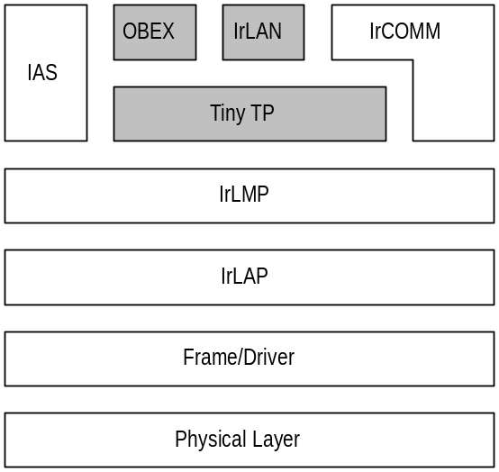
IrDA Protocol Stack

Virtual Peripheral Features
- The VP implements IrDA according to the standard and will inter-operate with any other IrDA compliant device.
- Three sample applications have been implemented:
- Transparent serial communication over IrDA. This can be used to communicate between multiple PCs or between a PC and a printer.
- PC to SX communication. Here the PC can request information from the SX which the SX replies with. Both the request and the reply occur over the IrDA link using a reliable connection.
- SX to SX communication. The implementation includes the ability for the SX to initiate IrDA discovery. Here the SX can determine what other devices are in range and can transmit various information to these devices, such as the current inputs on port C.
- Both reliable and unreliable communication is possible at speeds from 9600 to 115,200 bits per second.
- The IrDA VP fits in a 2K word SX and leaves 64 bytes of RAM free for application code.

Virtual Peripheral Applications
The VP could be used in a variety of applications where short-range wireless communication is required. It is especially useful where there is a need to work with other IrDA devices.
- An IrDA dongle. A non-IrDA device such as a printer could be given IrDA capabilities by plugging in a board with an SX running the IrDA VP. The IrComm implementation will allow transparent printing from Windows, over the IrDA link.
- Giving IrDA capabilities to a portable device. The SX could be integrated in a portable measuring equipment and used to download readings to a PC with the need for cables.
- IR communications with toys. The one chip SX solution could be used to implement IR communications in a toy with the control logic for the toy also running on the SX.

