Use JQueryUI standard widget styling. Use lightness theme to build. I will use my own custom UI theme later.

Dashboard:

UI should allow user to choose a layout for the dashboard.

|  |  |
| --- | --- |
| Button text = Edit Layout  location top right of screen. |  |

OnClick of Edit Layout button a lightbox should display options for layout. The current user layout should be marked by a css class to display the color image. The items should be in a styled <ul>

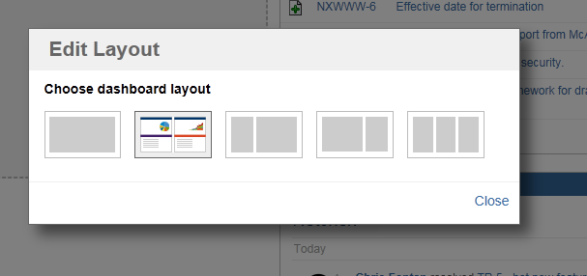

Rows that do not contain widgets will contain a CSS droppable container showing where a widget can go. Only 1 space at top of the column for an empty column should show this.

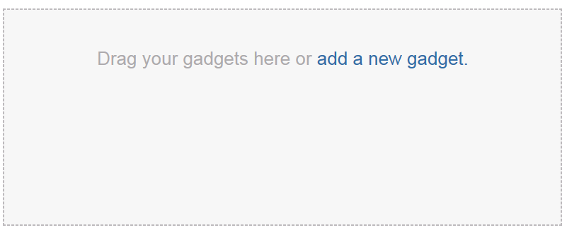

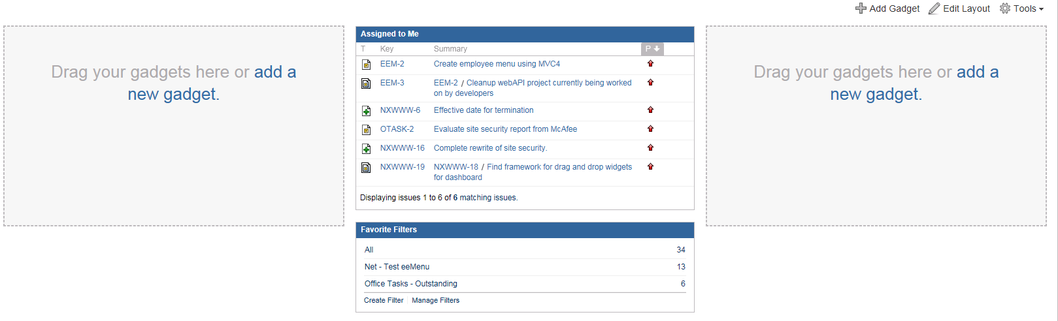

Draggable, droppable zones resize to the size of the currently being dragged widget and text says “ Drag your widget here”.

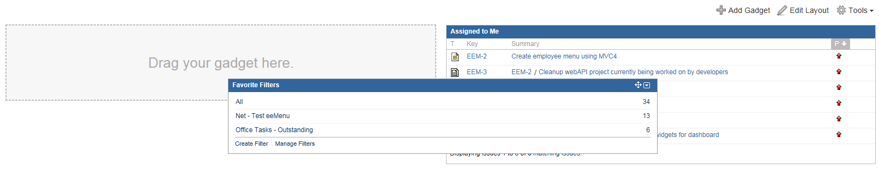

Add a new widget button placed top left corner will do an ajax call and open a lightbox where widgets can be selected with returned data. When a user selects a widget, you can see the widget be placed behind the lightbox on the dashboard. When a widget is selected it will do an ajax call to get the script to create the widget parameter form initially. Once widget parameters are saved then it will show the functioning widget.

Select a new widget lightbox.. the below picture just shows what it would look like.. Please just stub out a static option or two.

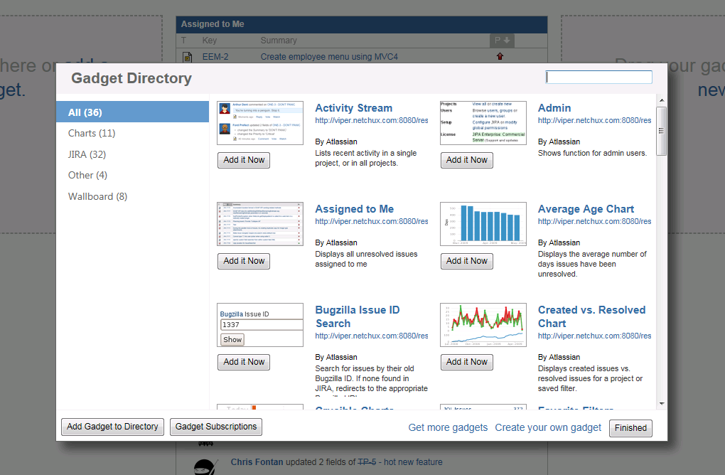

|  |  |
| --- | --- |
| Initial form parameter will look something like this.. You can stub out with just a single dropdown and textbox with a save button. Once click save show the widget with just a header and show the values input in the parameter form. |  |

|  |  |
| --- | --- |
| On hover of the widget you should see a button in the header top right and on click of the button that appears in the header a div should pop up with the option to delete the widget. Which will fire an event in JQuery to remove the widget.  Also the user could choose to minimize the widget to just the header. All other widgets would shift up. Then could expand the widget back to where it was. |  |

Copyright Atlassian

Notice all credits for JIRA dashboard go to Atlassian. Screen shots used for educational purposes only.